Statistical Analysis:
Quantifying the statistical metrics mirror the robustness of the proposed pre-training model. To evaluate the stability of the proposed work, the model was assessed for twenty times and the 95% confidence interval for each stage of the model is obtained. From Fig. 1-3, it is clear that the proposed work has more stability and narrower variance.
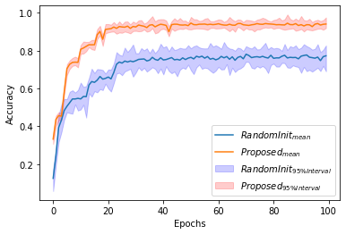
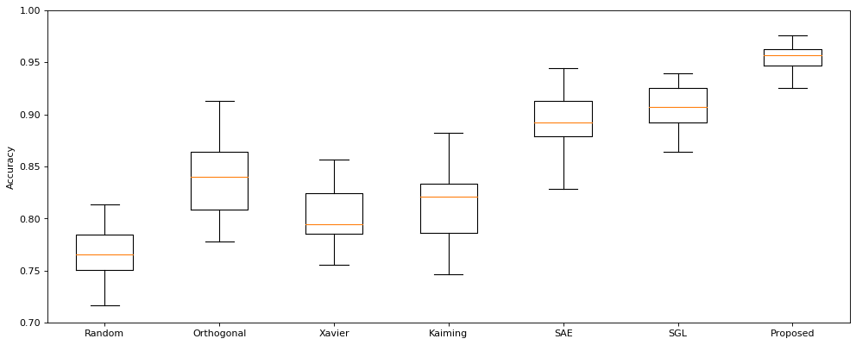

Fig. 1. (a) Validation accuracy plot with mean and 95% confidence interval for proposed and randomly initialized and
Fig. 1. (b) Box plot representing final accuracy of various methods for MNIST dataset
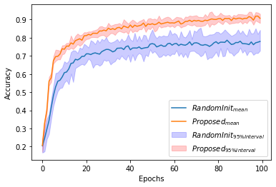
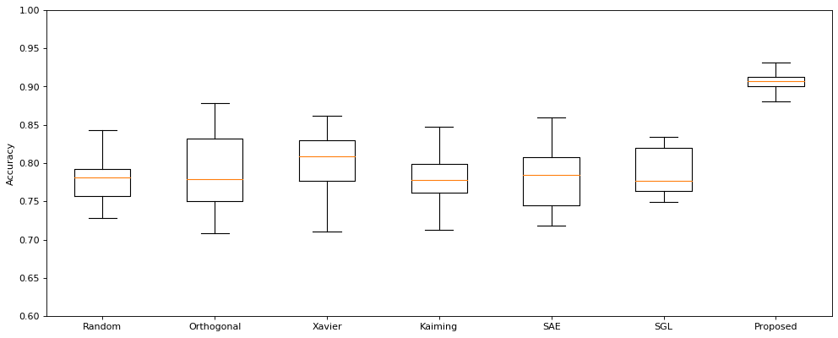
Fig. 2. (a) Validation accuracy graph with mean and 95% confidence interval for proposed and randomly initialized and
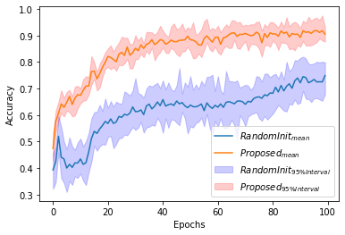
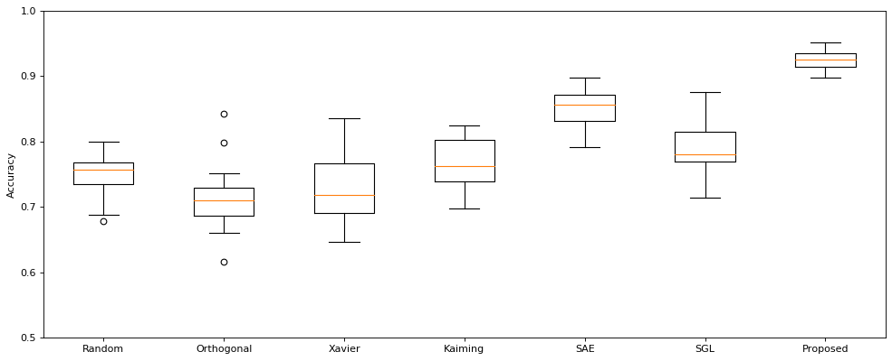
Fig. 2. (b) Box plot depicting result accuracy of various methods for Zalando’s article images dataset

Fig. 2. (a) Validation accuracy plot with mean and 95% confidence interval for proposed and randomly initialized and
Fig. 2. (b) Box plot representing the result accuracy of various methods for University of Bern-Barcelona EEG dataset.
Ablation study:

The proposed work's superior performance is contingent upon various novel components and to visualize the contribution of each entity, ablation analysis was carried out.

Performance with/without using Novel parameter updation:
Information Theory based objective was used in the pre-training’s parameter updation to capture intermediate features. Although the pre-training was intended to increase MI between input data and neuron activation, it indirectly helps the learning model for later fine-tuning phase during which the model effectively filters generalization-relevant features from the rich available features. Hence to estimate the contribution of the proposed parameter updation, $ W_{k,j}^{new} = W_{k,j}^{old} - \eta1/2\sqrt{(M^{i}_{k} - M^{i}_{best})^2}$ was used instead of Eqn. 15 & Eqn. 16, where $\eta$ is the decay parameter identical to [\epsilon] in Eqn. 15 & 16. The new updation step uses Euclidean distance between bins in terms of MI as the error factor. Without any other changes the model was evaluated using MNIST dataset and compared with the overall work in terms of generalization and rate of convergence. The rate of convergence can be visualized effectively using gradient loss vs epochs graph. Figure 1 and 2 shows the validation loss and gradient loss plots respectively. From the Figure 1 and 2, it is clear that the generalization and rate of convergence were affected without the usage of KL-divergence based error function in parameter updation step. Also the effect was much pronounced with rate of convergence and concluding that the KL-divergence used in the proposed parameter step effectively captures the difference of information amount between two bins and reflects in error term of the updation step.
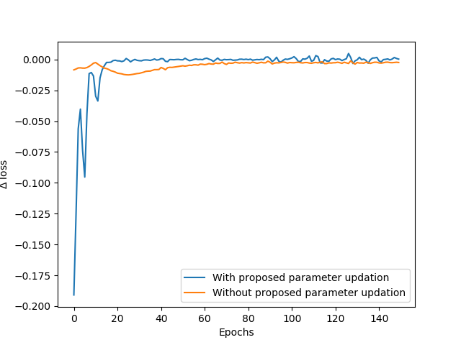
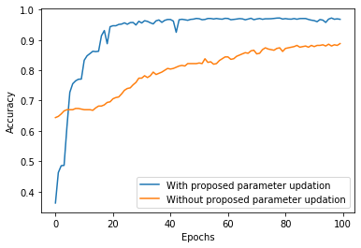

Fig. 1. Rate of change of Validation loss vs Epochs for MNIST dataset
Fig. 2. Validation accuracy for overall proposed model and proposed parameter updation step ablated

Performance with/without using k-helly property:
We isolated the model from k-helly based stopping for pre-training and the resultant model used the maximum iteration condition for pre-training termination. Fig. 3. shows that the k-helly property can able to efficiently identify the optimal convergence and avoids many less significant learning steps. This property of achieving better starting point for fine-tuning without much resource is crucial for any pre-training model.
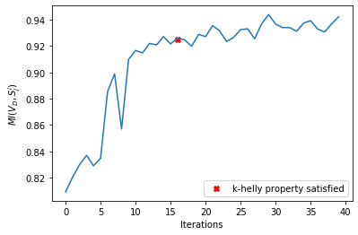

Fig. 3. MI value change during pre-training for 40 Iterations when MNIST dataset is given as input. At iteration 16, k-helly propoerty was satisfied

Performance with/without using Partial Information Decomposition:
Partial Information Decomposition was absorbed to identify the b_i hyper-parameter (number of bins in ith layer) and the value of b_i should be decreased as layer deepens. The proportion of decrease of b_i across the layers must be determined by the level of synergency among the neurons in the particular layer. To highlight the contribution of PID in selecting b_i, we incurred a small change in the proposed model to avoid PID by setting same bin size across the layers and evaluated against the overall model which uses PID. Rate of convergence graph shown in Fig.[], clearly indicates the penalty in speed of convergence with bypassing PID.

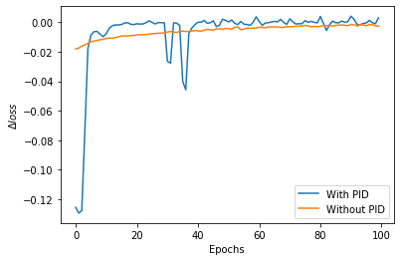
Fig. 4. Rate of change of loss for MNIST dataset with inclusion of PID vs ablation of PID

