INTERNSHIP / UDP / TRAINING REPORT
(Monthly Progress Report)
1. Student Information
Student Name | VIGNESHWARI SUBHANJI
Enrollment Number | 23SE02CS110
Program/Branch | B. Tech, Computer Science Engineering
Semester | 7th
Contact Number | 7435081624
Email ID | 23se02cs110@ppsu.ac.in

2. Internship / UDP / Training Details
Type | UDP(Undergraduate Project)
Company/Organization | N/A – Institute-based UDP(P P Savani University)
Department/Domain | Computer Science & Engineering
Mentor Name (Company) | N/A
Mentor Name (Institute) | Ms. Khushi Vaishnav
Start Date | 29-07-26
End Date | 15-10-26

3. Work Progress Summary
- Project Title:
Ghost Worker Detector: AI-Based Employee Attendance and Payroll Fraud Detection System
- Problem Statement:
Many small businesses manage employee attendance and payroll manually. Because of this, fake employees, inactive workers, or proxy attendance can remain in the payroll system, causing financial losses. The purpose of this project is to detect such fraudulent activities using attendance data and machine learning techniques.
- Objectives:
- To create a secure employee attendance system.
- To record employee attendance using QR code scanning.
- To verify that employees are present at the workplace using GPS location.
- To track device information to identify proxy attendance.
- To detect suspicious attendance and payroll patterns.
- To calculate a risk score for each employee.
- To provide a dashboard for business owners to monitor possible fraud.

- Proposed Methodology:
1) Register employees and store their details.
2) Employees scan a dynamic QR code to mark attendance.
3)The system checks whether the employee is inside the workplace using GPS.
4) The system records the device ID used during attendance.
5) Attendance, leave, and payroll data are stored in the database.
6) Rule-based checks identify suspicious activities such as:
- Salary paid but no attendance.
- Same device used by multiple employees.
- Attendance during approved leave.
7) An Isolation Forest machine learning model analyzes employee behavior and detects unusual patterns.
8) The system generates a Ghost Risk Score and displays flagged employees on the dashboard.
- Expected Outcomes:
1) Detection of fake or inactive employees.
2) Reduction of payroll fraud.
3) Improved transparency in attendance management.
4) Automatic identification of suspicious employee activities.
5) Better decision-making for business owners.
- Future Scope:
1) Add facial recognition for employee verification.
2) Develop a mobile application.
3) Send real-time fraud alerts.
4) Integrate with ERP and payroll systems.
5) Improve fraud detection using advanced AI models.
4. Tasks Accomplished
- Studied the problem of ghost worker fraud.
- Finalized the project idea and requirements.
- Designed the system workflow and architecture.
- Identified security checks and fraud detection rules.
- Researched machine learning algorithms for anomaly detection.

5. Tasks in Progress / Next Plan
- Design database schema.
- Develop employee registration and attendance modules.
- Implement QR code and GPS verification.
- Build fraud detection algorithms.
- Develop dashboard and reporting features.
- Test and deploy the system._
6. Learnings / Skills Acquired
- Problem analysis and system design.
- MERN stack development concepts.
- Database design using MongoDB.
- QR code and GPS integration.
- Machine learning using Python.
- Fraud detection and anomaly analysis.
- Full-stack project planning and implementation.
7. Gantt Chart
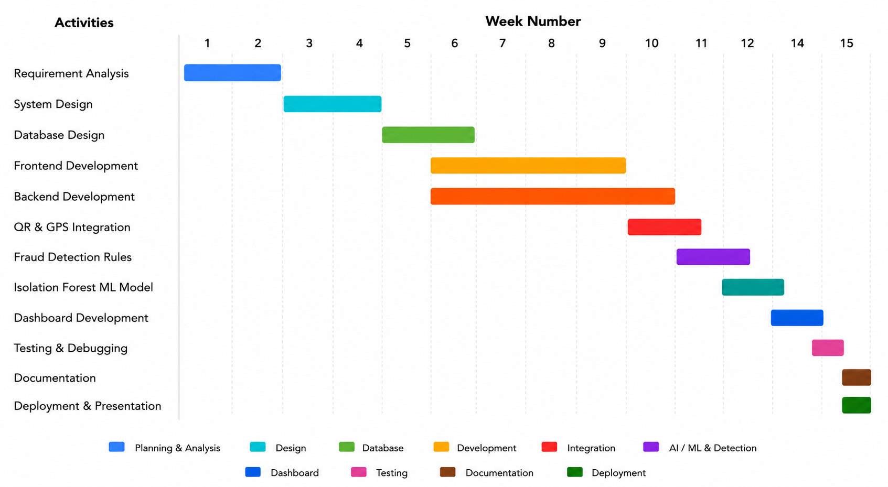

8. PERT Chart
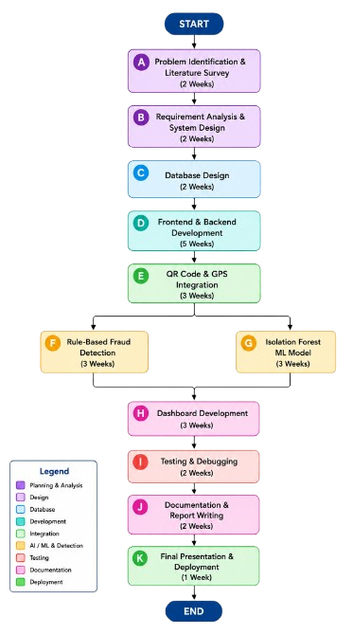

Evaluation (To be filled by Mentor (Institute))
Criteria | Bloom’s Level | Excellent (20) | Good (15) | Average (10) | Poor (5) | Marks Obtained (Out of 20)
Problem Definition | L4–Analyze | Clearly defined, justified real-world problem | Defined but lacks depth | Vague problem | No clear problem
Project Title Relevance | L2–Understand | Highly precise and aligned | Mostly relevant | Partially relevant | Misleading
Scope of Work | L5–Evaluate | Well-defined scope, deliverables, constraints | Defined with minor gaps | Broad/unclear | No scope
Literature Study | L4–Analyze | 3–5 sources analyzed critically | Sources listed | Minimal references | No study
Clarity & Presentation | L3–Apply | Structured, professional | Minor issues | Some confusion | Poor
Total Marks

Evaluation
Student Signature | Mentor (Company)  Signature | Mentor (Institute)  Signature

Mentor (Institute) Remarks
________________________________________________________________________________________________________________________________________________________________________________________________________________________________________________________________________________________________________________________________________________________________________________________________________________________________________________________________________________________________________________________________________________________________________________________________________________________________________________________________________________________________________________________________________________________________________________________________________________________________________________________________________________________________________________________________________________________________________________________________________________________________________________________________________________________________________________________________________________________________________________________________________________________________________________________________________________________________________________________________________________________________________

