**Problem1**

**(a) list all possible function: *f*:{a, b, c} → {0, 1}**

1. *f*1(x) = 0 for all x∈{a, b, c}

2. *f2*(x) = 1 for all x∈{a, b, c}

3. *f*3:{a, b, c} → {0, 1} where *f*(a) = 1, *f*(b) = 0, *f*(c) = 0  
4. *f*4:{a, b, c} → {0, 1} where *f*(a) = 0, *f*(b) = 1, *f*(c) = 0  
5. *f*5:{a, b, c} → {0, 1} where *f*(a) = 0, *f*(b) = 0, *f*(c) = 1

6. *f*6:{a, b, c} → {0, 1} where *f*(a) = 1, *f*(b) = 1, *f*(c) = 0

7. *f*7:{a, b, c} → {0, 1} where *f*(a) = 0, *f*(b) = 1, *f*(c) = 1

8. *f*8:{a, b, c} → {0, 1} where *f*(a) = 1, *f*(b) = 0, *f*(c) = 1

**(b) Describe a connection between your answer for (a) and Pow({ a, b, c}).**

1. The number of all listed functions equals to |Pow({a, b, c})|

2. Assume 0 represent True, being included in the set. And 1 represent False, not included in the set. Then the functions listed in (a) and elements of Pow({a, b, c}) are of one-to-one correspondence. And the set related to the functions, which are listed below, are all subsets of Pow({a, b, c}).

*f*1.→ {} *f*5 → {c}

*f2*.→ {a, b, c} *f*6 → {a, b}

*f*3 → {a} *f*7 → {b, c}

*f*4 → {b} *f*8 → {a, c}

**(c) In general, if card(A) = m and card( B) = n, how many:**

**(i) functions are there from A to B?**

Since a functiton f: S → T require for each element s in S, we can find exactly one element t from T that make (s, t ) in the relationship

Then in this case, each of n elements in B maybe mapped by m elements from A

So the number of possibilities are:

m · n = mn

There are mn functions from A to B

**(ii) relations are there between A and B?**

From (i), there are mn posible pairs of element from A to B and each of them may be included in a relation or not

So the possible number of relations: 2m·n

**(iii) symmetric relations are there on A?**

For A = {a, b, c} , if i need to achieve a symmertric relation on A1 x A2, everytime when I include a element a1 from A1 mapping any element b2 of A2. Then i need to exclude b1 from A1 because it should map a2 of A2.

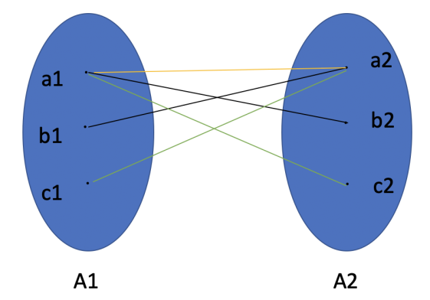

And for each pair of them, a1 may map |A| elements from A2 or not. So the posibilty is 23. Then i need to consider the left elements in A1 and A2 and ignore the situations refering a1 or a2 because they have been included in the first mapping mentioned above. similarly, the posibilities are 22 and 21 respectivly for the second and third maping.

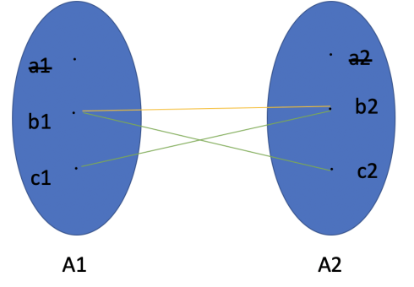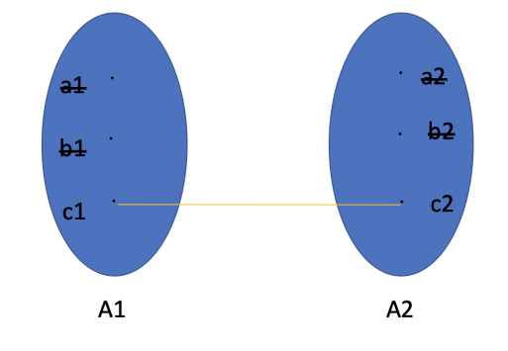

At last, the total posibility is ：23 × 22 × 21 = 26 = 64

For A which contain m elements, the number of symmetric relations are：

2m + 2m-1 + 2m-2 ... + 2 = 21+2+3+...+m= 2(1+m)m/2

**Problem 2**

**For x, y ∈ Z we define the set:**

**Sx,y = {mx+ny: m, n ∈ Z}**

**(a) Give ﬁve elements of S2,−3**

S2,−3 = {2m - 3n:m, n ∈Z}

1. When m=n=0 , S2,−3 ={0}
2. When m=n=1 , S2,−3 ={-1}
3. When m=n=2 , S2,−3 ={-2}
4. When m=n=3 , S2,−3 ={-3}
5. When m=n=4 , S2,−3 ={-4}

**(b) Give ﬁve elements of S12,16**

S**12,16**= {12m + 16n : m, n ∈Z}

1)When m=n=0 , S**12,16**={0}

2)When m=n=1 , S**12,16**={28}

3)When m=0, n=1 , S**12,16**={16}

4)When m=1, n=0 , S**12,16**={12}

5)When m=2, n=0 , S**12,16**={24}

**(c) Show that Sx,y ⊆ {n : n ∈ Z and d|n}. Let d = gcd(x, y).**

Since d = gcd(x, y)

Assume that there are *g*x，*g*y ∈ Z such that:

x = *g*xd y = *g*yd

So *S*x, y = {m*g*xd+n*g*yd: m, n ∈ Z}

= {(m*g*x+n*g*y)d: m, n ∈ Z}

For all m, n ∈ Z, we can have d | (m*g*x+n*g*y)d

So *S*x,y = {n : n ∈ Z and d|n} when k = m*g*x+n*g*y

andSx,y ⊆ {n : n ∈ Z and d|n}

**(d) Show that {n : n∈Z and z|n} ⊆ Sx,y.Let z be the smallest positive number in Sx,y .**

Asuume there are some k∈Z such that n = zk

Then {n: n ∈ Z and z | n} = {zk: k∈Z}

Since Sx,y = {mx + ny: m, n ∈Z}

Let x = x1, y = y1 such that (mx + ny) is least:  
 mx1 + ny1 = z

k(mx1+ny1) = kz

kmx1+kny1 = kz

kx1 ·m + ky1 ·n = kz

For any k,m,n∈Z, {kx1 ·m + ky1 ·n} ∈ Sx,y

So {zk: k∈Z} = Sx,y ，when x = kx1 , y = ky1

And {n: n ∈ Z and z | n} ⊆ Sx,y

**(e) Show that d ≤ z. (Hint: use (c))**

From (c) we have Sx,y = {mx + ny: m, n ∈Z} ⊆ {n : n ∈ Z and d|n}

Thus for all x, y, m, n ∈Z, d | (mx + ny) as Sx,y= {(m*g*x+n*g*y)d: m, n ∈ Z}

For x1, y1 in (d) such that:

mx1 + ny1 = z

So d | (mx1 + ny1)

Then d | z

Thus d ≤ z

**(f) Show that z ≤ d. (Hint: use (d))**

Let wpsoffice

Then r = m mod z

= m - q(mx + ny)

= m(1-qx) + n(-qy)

Thus r is also a linear combination of m, n

Since z is the smallest positive number in Sx,y，0 ≤ r＜z

So r = 0

Thus z | m

And similarly we can prove:

z | n

Thus z | d

So z ≤ d

**Problem 3**

**We deﬁne the operation ∗ on subsets of a universal set U as follows. For any two sets A and B: A ∗ B := Ac ∪ Bc**

**Answer the following questions using the Laws of Set Operations (and any derived results given in lectures) to justify your answer:**

First, we have:

(I) A \* B = Ac ∪ Bc = (A ∩ B)c (de Morgan’s laws)

(II) A \* A = Ac ∪ Ac =Ac (Idempotence)

**(a) What is (A ∗ B) ∗ (A ∗ B)?**

(A \* B) \* (A \* B)

= (A ∩ B)c \* (A ∩ B)c (I)

**= (**(A ∩ B)c)c (I)

**=** A ∩ B (Double complementation)

**(b) Express Ac using only A, ∗ and parentheses (if necessary).**

Ac = Ac ∪ Ac = A \* A (II)

**(c) Express ∅ using only A, ∗ and parentheses (if necessary).**

∅

= A ∩ Ac (Idempotence)

= ((A ∩ (A \* A))c)c (II)

= (A \* (A \* A))c (I)

=(A \* (A \* A))\* (A \* (A \* A))(I)

**(d) Express A \ B using only A, B, ∗ and parentheses (if necessary).**

A \ B

= A ∩ Bc

= (A ∩ Bc)\* (A ∩ Bc) (I)

= [A \* (B \* B)] \* [A \* (B \* B)] (I)

**Problem 4**

**Let Σ = { a, b}. Deﬁne R ⊆ Σ∗ × Σ∗ as follows:**

**(w, v) ∈ R if there exists z ∈ Σ∗ such that v = wz.**

1. **Give two words w, v ∈Σ\* such that (w, v) ∉ R and (v, w) ∉ R.**

If w = bab, v = aba, w ≠ v is constantly true

If w = aba, v = bab, w ≠ v is constantly true

**(b) What is R←({aba})?**

Suppose v = aba,

Since (w, v) ∈R**←**,So: wz = aba, z ∈ Σ∗

List all possible answer:

1 .w = λ, z = aba

2 .w = a, z = ba

1. w = ab, z = a
2. w = aba, z = λ

**(c) Show that R is partial order.**

If R satisfies Reflexity, Antisymmertry, Transitivity then it is a partial order

1. for any x ∈Σ∗ such that:

x = xz

When z = λ , it is true. For all x ∈Σ∗, (x, x) ∈R, R satisfies reflexity

1. for any x, y ∈Σ∗ such that: (x, y) ∈R and (y, x) ∈R

Then 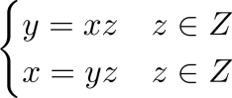

Since 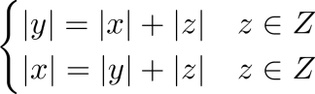

So | z | = 0, z = λ

And 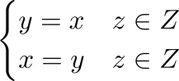

R satisfies Antisymmertry such that if (x, y) ∈R and (y, x) ∈R, then x = y

1. assume (x, y) ∈R and (y, h) ∈R, then we have:

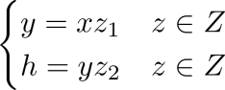

Let wpsoffice

Then /var/folders/_5/62fs6ggx6h17xpq01cjvw_8m0000gn/T/com.kingsoft.wpsoffice.mac/wpsoffice.SxU757wpsoffice

/var/folders/_5/62fs6ggx6h17xpq01cjvw_8m0000gn/T/com.kingsoft.wpsoffice.mac/wpsoffice.DAz757wpsoffice

So /var/folders/_5/62fs6ggx6h17xpq01cjvw_8m0000gn/T/com.kingsoft.wpsoffice.mac/wpsoffice.fvd757wpsoffice

R satisfies Transitivity such that for (x, y) ∈R and (y, h) ∈R, then (x, h)∈R

Thus R satisfies Reflexity(R), Antisymmertry(AS) and Transitivity(T) and it is a partial order

**Problem 5**

**Show that for all x, y, z ∈ Z:**

**If x | yz and gcd(x, y) = 1**

**then x | z. (Hint: Use the connection between gcd(x, y) and Sx,y shown in Problem 2.)**

From Problem 2, we have proved that z ≤ d and d ≤ z, so z = d

For any x, y ∈Z, there are some m, n ∈Z such that:

/var/folders/_5/62fs6ggx6h17xpq01cjvw_8m0000gn/T/com.kingsoft.wpsoffice.mac/wpsoffice.BX5340wpsoffice

Since x | yz, it can be represented as:

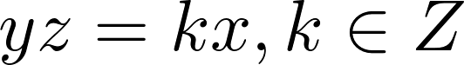

When z = 0, x | z is constantly true, then when z ≠ 0:

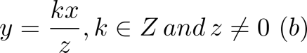

Then Assign (b) to (a):

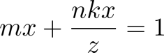

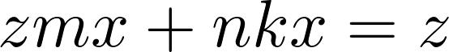

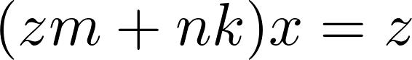

Since z, m, n, k∈Z, then zm + nk∈ Z and x | z

Thus For both z = 0 and z ≠ 0, x | z is true.