**Problem 1**

**For this question, let F denote the set of well-formed formulas over a set Prop of propositional variables.**

**(a) Show that the logical equivalence relation, ≡, is an equivalence relation on F.**

To prove that ≡ is an equivalence relation, just show that it satisfy Reflexivity(R), Symmetry(S) and Transitivity(T)

(R): for any well-formed formula(wff) ϕ on F

v(ϕ) = v(ϕ) holds for all truth assignments v

So ϕ ≡ ϕ holds, ≡ is reflexive

(S): for any wff ϕ and ψ on F; if ϕ ≡ ψ holds, then:

v(ϕ) = v(ψ) holds for all truth assignments v

So v(ψ) = v(ϕ) holds for all truth assignments v

Thus ψ ≡ ϕ, the relation ≡ is symmetric.

(T): for any wff ϕ, ϕ and ψ on F;

If ϕ ≡ ϕ and ϕ ≡ ψ holds, then:

v(ϕ) = v(ϕ) and

v(ϕ) = v(ψ) holds

Then v(ϕ) = v(ψ) holds for all truth assignments v

Thus ϕ ≡ ψ, the relation ≡ is Transitive.

In conclusion, ≡ is

**(b) List four elements in [⊥], the equivalence class of ⊥.**

the elements ϕ in [⊥], equivalence class of ⊥ must satisfy that for all truth assignments:

v(ϕ) = False

listing 4 possible solutions as below:

(1) (⊥∧⊥)

(2) (⊥∧ ϕ) (ϕ is any wff on F)

(3) (⊥∨⊥)

(4) ((⊥∧⊥)∧⊥)

**(c) For all ϕ, ϕ’, ψ, ψ’ ∈ F with ϕ ≡ ϕ’ and ψ ≡ ψ’; show that:**

**(i) ¬ϕ ≡ ¬ϕ’**

Since ϕ ≡ ϕ’ then:

(ϕ ↔ ϕ’) is tautology

Thus for all truth assignments

v(ϕ ↔ ϕ’) = True holds

Then ϕ and ϕ’ are either both true or both false, listing all possible truth assignments as below:

|  |  |  |  |  |  |
| --- | --- | --- | --- | --- | --- |
| ϕ | ϕ’ | ¬ϕ | ¬ϕ’ | ϕ↔ϕ’ | ¬ϕ↔¬ϕ’ |
| T | T | F | F | T | T |
| F | F | T | T | T | T |

Thus (¬ϕ↔¬ϕ’) is True for all truth assignments and it is a tautology, ¬ϕ ≡ ¬ϕ’ holds

**(ii) ϕ ∧ ψ ≡ ϕ**’**∧ ψ**’

Since ϕ ≡ ϕ’ and ψ ≡ ψ’ then:

Both (ϕ ↔ϕ’) and (ψ ↔ ψ’) are tautology

Similarly, listing all possible truth assignments as below, ϕ(ψ) and ϕ’(ψ’) are either both true or both false:

|  |  |  |  |  |  |  |
| --- | --- | --- | --- | --- | --- | --- |
| ϕ | ϕ’ | ψ | ψ’ | ϕ ∧ ψ | ϕ’ ∧ ψ’ | ((ϕ’∧ ψ) ↔ (ϕ’∧ ψ’)) |
| T | T | T | T | T | T | T |
| T | T | F | F | F | F | T |
| F | F | T | T | F | F | T |
| F | F | F | F | F | F | T |

Thus ((ϕ’∧ ψ)↔(ϕ’∧ ψ’)) is True for all truth assignments. So it is a tautology and ϕ ∧ ψ ≡ ϕ’∧ ψ’ holds.

**(iii) ϕ ∨ ψ ≡ ϕ’ ∨ ψ’**

Similarly, listing all possible truth assignments as below, ϕ(ψ) and ϕ’(ψ’) are either both true or both false:

|  |  |  |  |  |  |  |
| --- | --- | --- | --- | --- | --- | --- |
| ϕ | ϕ’ | ψ | ψ’ | ϕ ∨ ψ | ϕ’ ∨ ψ’ | ((ϕ’∨ ψ) ↔(ϕ’∨ ψ’)) |
| T | T | T | T | T | T | T |
| T | T | F | F | T | T | T |
| F | F | T | T | T | T | T |
| F | F | F | F | F | F | T |

Thus ((ϕ’∨ ψ)↔(ϕ’∨ ψ’)) is True for all truth assignments. So it is a tautology and ϕ ∨ ψ ≡ ϕ’ ∨ ψ’ holds.

**(d) Show that F≡ together with the operations deﬁned above forms a Boolean Algebra. Note: you will have to give a suitable deﬁnition of a zero element and a one element in F≡ .**

Defining a zero element and a one element:

For any equivalence class [ϕ] on F**≡**, according to the complementation of Boolean Algebra:

x ∨ x’ = 1

x ∧ x’ = 0

Then [ϕ] ∨ [**¬**ϕ] = 1

[ϕ ∨ **¬**ϕ] = [Τ]

Thus 1 = [Τ]

Also [ϕ] ∧ [**¬**ϕ] = 0

[ϕ ∧ **¬**ϕ] = [⊥]

0 = [⊥]

Proof:

To show that F≡ together with the operations forms a Boolean Algebra, we need to prove laws below

1) For any [x], [y] on F**≡**, as [x], [y] ∈ F≡, it can be proved that:

[x] ∨ [y] ∈ F≡

[x] ∧ [y] ∈ F≡

[**¬**x] ∈ F≡

2) commutativity: For any [x], [y] on F**≡**

[x] ∨ [y] = [x ∨ y]

= [y ∨ x]

= [y] ∨ [x]

Similarly, [x] ∧ [y] = [y] ∧ [x]

3) association: For any [x], [y], [z] on F**≡**

([x] ∨ [y]) ∨ [z] = [x ∨ y] ∨ [z]

= [(x ∨ y) ∨ z]

= [x ∨ (y ∨ z)]

= [x] ∨ [y ∨ z]

= [x] ∨ ([y] ∨[z])

Similarly, ([x] ∧ [y]) ∧ [z] = [x] ∧ ([y] ∧ [z])

4) distributivity: For any [x], [y], [z] on F**≡**

[x] ∨ ([y] ∧ [z]) = [x] ∨ [y ∧ z]

= [x ∨ (y ∧ z)]

= [(x ∨ y) ∧ (x ∨ z)]

= [x ∨ y] ∧ [x ∨ z]

= ([x] ∨ [y]) ∧ ([x] ∨ [z])

similarly, [x] ∧ ([y] ∨ [z]) = ([x] ∧ [y]) ∨ ([x] ∧ [z])

5) identity: For any [x] on F**≡**

[x] ∨ 0 = [x] ∨ [⊥]

= [x ∨ ⊥]

= [x]

[x] ∧ 1 = [x] ∧ [Τ]

= [x ∧ Τ]

= [x]

6) complementation:

since complementation is used to define 1 and 0, so it has been proven

**Problem 2**

**This is the Petersen graph:**

**(a) Show that the Petersen graph not contains a subdivision of K5.**

In the Petersen graph, the degree of each vertex deg(vp) = 3.

For K5, the degree of each vertex deg(vk5) = 4.

According to the specification of subdivision, the degree of a vertex cannot increase with subdivision.

Hence, Petersen graph not contains a subdivision of K5.

**(b) Show that the Petersen graph contains a subdivision of K3,3.**

Starting from the Petersen graph as graph_1 shows:

1. remove the edges 6 - 9 and 2 - 3, then we get the graph_2

2. remove the vertices 2 and 3, and connect 1 – 7 and 4 – 8 with edges, then we get graph_3

3. remove the vertices 6 and 9, and connect 1 – 8 and 4 – 7. Then the remained vertices and edges form the K3,3

as graph_4 shows.

**Problem 3**

**Harry would like to take each of the following subjects: Defence against the Dark Arts; Potions; Herbology; Transﬁguration; and Charms. Unfortunately some of the classes clash, meaning Harry cannot take them both. The list of clashes are:**

**• Defence against the Dark Arts clashes with Potions and Charms**

**• Potions also clashes with Herbology**

**• Herbology also clashes with Transﬁguration, and**

**• Transﬁguration also clashes with Charms.**

**Harry would like to know the maximum number of classes he can take.**

**(a) Model this as a graph problem. Remember to:**

**(i) Clearly deﬁne the vertices and edges of your graph.**

model the problem with a graph G(V, E) as below:

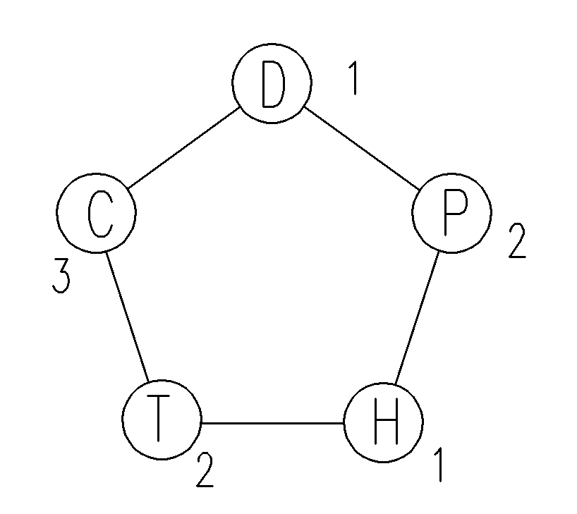

* vertex D stands for the course Defence against the Dark Arts

* vertex C stands for the course Charms

* vertex T stands for the course Transﬁguration

* vertex H stands for the course Herbology

* vertex P stands for the course Potions

* 1, 2, 3 stands for different colors assigned to each vertex

For the graph G(V, E), vertices v(G) represent different courses, edges e(G) represent the clash of different courses

**(ii) State the associated graph problem that you need to solve.**

The graph problem is to give the max number of the vertices with same color

**(b) Give the solution to the graph problem corresponding to this scenario; and solve Harry’s problem.**

Assigning colors(1, 2, 3) to each vertex of the graph, then the max number of the vertices with same colors is 2 thus:

Harry can take 2 courses at most.