Lab 2

**Exercise 3: Using Wireshark to understand basic HTTP request/response messages**

**Question 1: What is the status code and phrase returned from the server to the client browser?**

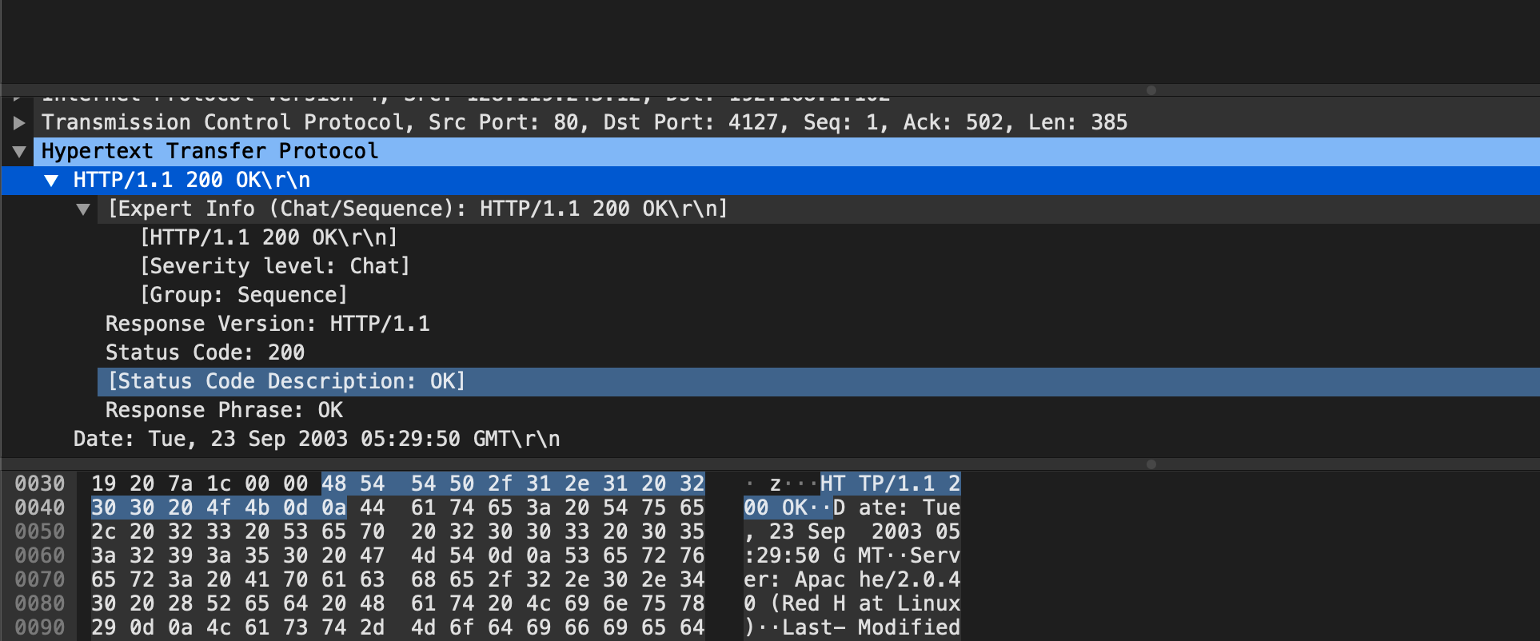

Here are the status code and the phrase. 200 OK

**Question 2: When was the HTML file that the browser is retrieving last modified at the server? Does the response also contain a DATE header? How are these two fields different?**

(1) Using the command http.last_modified to filter out the detail of last modification. Its last modification occurred in Tue, 23 Sep 2003 05:29:00

(2) It also contains a DATE header. In general, these two field is almost the same. Except the seconds of time displayed, where the Date header (05:29:50) is slightly later than Last-Modified (05:29:00), other details are the same.

**Question 3: Is the connection established between the browser and the server persistent or non-persistent? How can you infer this?**

As the screen shot shows, the connection keeps alive, which is persistent. Actually, this is also a default option of HTTP/1.1.

**Question 4: How many bytes of content are being returned to the browser?**

73 bytes are being returned

**Question 5: What is the data contained inside the HTTP response packet?**

text/html

**Exercise 4: Using Wireshark to understand the HTTP CONDITIONAL GET/response interaction**

**Question 1: Inspect the contents of the ﬁrst HTTP GET request from the browser to the server. Do you see an “IF-MODIFIED-SINCE” line in the HTTP GET?**

NO

**Question 2:** **Does the response indicate the last time that the requested ﬁle was modiﬁed?**

Yes, it was modified on Tue, 23 Sep 2003 05:35:00 GMT

**Question 3: Now inspect the contents of the second HTTP GET request from the browser to the server. Do you see an “IF-MODIFIED-SINCE:” and “IF-NONE-MATCH” lines in the HTTP GET? If so, what information is contained in these header lines?**

If-Modified-Since: Tue, 23 Sep 2003 05:35:00 GMT\r\n

If-None-Match: "1bfef-173-8f4ae900"\r\n

**Question 4: What is the HTTP status code and phrase returned from the server in response to this second HTTP GET? Did the server explicitly return the contents of the ﬁle? Explain.**

(1) The status code and phrase: 304 Not Modified\r\n

(2) No, because the status code is Not modified, which is a response for the **“IF-MODIFIED-SINCE:”** line in second GET request. It means that the contents in the cache is up to date. Then the server would not return the whole file and the content would be displayed for clients directly from cachew

**Question 5: What is the value of the Etag ﬁeld in the 2nd response message and how it is used? Has this value changed since the 1 st response message was received?**

(1) Here are the values of Etag field in 1st and 2nd responses. The value has not changed during two responses.

(2) It allows a client to make conditional request, which makes the caches to be more efficient and saves bandwidth, as a Web server does not need to send a full response if the content has not changed.

1st:

2nd:

**Exercise 5: Ping Client**

sample output as follows:

client (PingClient.py):

Server (PingServer.java)

