General Probability Questions (these questions will test your basic probability skills. The exam will not have such questions, however you will see questions where similar concepts can be applied for networking related problems)

1) If there are N students taking COMP 3331/9331, what is the probability that none of them has a birthday on the first day of the class? (Assume there are exactly 365 days in a year)

**(364 / 365)^N**

2) How many students would there need to be in the class for the probability in (1) to be less than 50%?

**252**

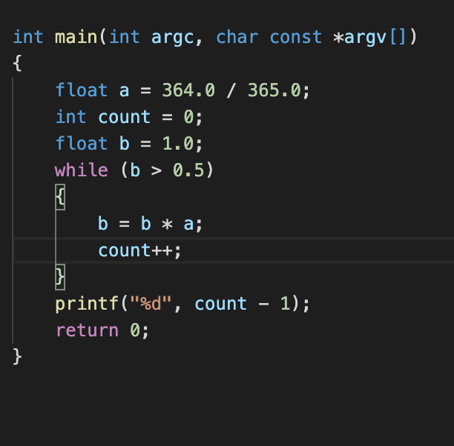

3) What is the probability that five years running, no student has a birthday on the first day of the class? (Assume the same number of students take the class each year, and no one repeats the class.)

assume the number of student is n

**P = (364/365)^(5n)**

4) Would your answer to (3) above be larger or smaller if one or more students retook the class within the five-year period?

smaller

Q1) What is meant by the term statistical multiplexing?

**For statistical multiplexing, no link resources are reserved in advance. The bandwidth is allocated according to users’ demand. If one user does not use the bandwidth he is currently using. The bandwidth would be freed for those in need**

Q2) Consider two hosts, A and B, connected by a single link of rate R bps. Suppose that the two hosts are separated by m meters, and suppose the propagation speed along the link is s meters/sec. Host A is to send a packet of size L bits to Host B.

(a) Express the propagation delay, dprop in terms of m and s.

dprop **= m / s (m is the length of the physical link and s is the propagation speed)**

(b) Determine the transmission time of the packet, dtrans in terms of L and R.

dtran **= L / R (L is the packet length and R is the link bandwidth)**

(c) Ignoring the processing and queuing delays, obtain an expression for the end-to-end delay.

dend-to-end = dtran + dprop

(d) Suppose Host A begins to transmit the packet at time t=0. At time t=dtrans,where is the last bit of the packet?

the bit is just leaving Host A

(e) Suppose dprop is greater than dtrans. At time t= dtrans, where is the first bit of the packet?

the first bit is on the physical link to B and not yet reached

(f) Suppose dprop is less than dtrans. At time t= dtrans, where is the first bit of the packet?

has already at host B

Q3) It takes a single bit ten times longer to propagate over a 10Mb/s link than over a 100Mb/s link.

True or False?

it’s not related with the bandwidth.False

Q4) Suppose users share a 1Mbps link. Also suppose each user requires 100 kbps when transmitting, but each user transmits only 10 percent of the time.

(a) When circuit switching is used, how many users can be supported?

10 users can be supported(1 Mbps / 100 kbps)

(b) Suppose packet switching is used for the rest of the problem. Find the probability that a given user is transmitting.

since each user transmits only 10 percent of the time.

p = 0.1.

(c) Suppose there are 40 users. Find the probability that at any given time, exactly n users are transmitting simultaneously. (Note: You should simply express this as an expression rather than computing the exact probability value)

(40

n ) pn(1 – p)40-n

Q5) Suppose there is exactly one packet switch between a sending host and the receiving host. Assume that the transmission speed of the links between the sending host and the switch and the switch and the receiving host are R1 and R2 respectively. Assuming that the switch uses store-and-forward packet switching, what is the total end-to-end delay to send a packet of length L? Ignore queuing, propagation and processing delays.