CAB330: Data and Web Analytics
Assessment 2

Team Name: Syntax Error
Group No. 15

Student Name | Student ID
Charlie Chan | N11619449
Truong Lieu Dong Dang | N11721138
Kyha Anderson | N11970014

 | Charlie Chan | Truong Lieu Dong Dang | Kyha Anderson
Charlie Chan | <100 %> | <100 %> | < 100%>
Truong Lieu Dong Dang | <100 %> | <100 %> | <100 %>
Kyha Anderson | <100 %> | <100 %> | <100 %>

Contents
Task 1: Clustering Analysis 3
Question 1.1 3
Question 1.2 4
Question 1.3a 7
Question 1.3b 8
Question 1.4 9
Question 1.5 10
Question 1.6 11
Question 1.7 14
Task 2: Association Analysis 17
Question 2.1 17
Question 2.2 18
Question 2.3 19
Question 2.4 23
Question 2.5 24
Question 2.6 25
Question 2.7 27
Task 3: Text Analysis 28
Question 3.1 28
Question 3.2 30
Question 3.3 31
Question 3.4 33
Question 3.5 34
Documentary 36
SciFi 37
Romance 38
Kids&Family 39
Question 3.6 41
Task 4: Web Log Analysis 42
Question 4.1 42
Question 4.2 44
Question 4.3 46
Question 4.4 48
Question 4.5 51
Appendix 53

Task 1: Clustering Analysis

Question 1.1
After auditing the dtypes, missing data, and valid ranges of “Dataset1_AudioTrack.csv” file, records were reduced from 2980 to 2686. Steps that led to this data cleaning approach is as follows:

- Insufficient data: For each record, a thorough checking was performed to ensure there are at least 60% of the numerical data type were recorded. For example, out of the ‘Energy’, ‘Loudness’, ‘Speechiness’, ‘Instrumentalness’, and’ Time Signature’, at least 3 of these data should exist, otherwise it is removed. However, there were no records with insufficient data, thus, none were dropped.

- Unusual data: Data that were out of range from what is typically used in each attribute were replaced with the closest valid number (i.e., low boundary (lo) if value is below lo; or high boundary (hi) if value if above hi). Valid ranges were set according to the information provided by the data dictionary for each attribute:
  - Energy: 0 – 1
  - Loudness: -60 – 0
  - Speechiness: 0 – 1
  - Instrumentalness: 0 – 1
  - Time Signature: 0 – 5

The table below is the number of values
Variable | No. Out_of_range
Energy | 2
Loudness | 2
Speechiness | 1
Instrumentalness | 2
Time Signature | 0
Total | 7
Table 1.1

- Missing Values: Values that were missing in a record were filled by the column median. This method is ok for k-means.

- Duplicates: Duplicated records were deleted (where only the first occurrence is kept). These duplicates were identified via a unique combination of ‘ID’ and ‘Name’ columns.

Question 1.2
Numerical variables used for the clustering analysis of this Task (performing K-means clustering). Numerical columns in this dataset include “Energy”, “Loudness”, “Speechiness”, “Instrumentalness”, and “Time _Signature”.
Variables Used | Data Type | Description
Energy | Float | This represents the perpetual measure of intensity and activity of the track. It differentiates between the calm and energetic tracks, which is a key feature in grouping up clusters of similar songs.
Loudness | Float | This measures the loudness of the track in decibels. This provides some information on track intensity.
Speechiness | Float | This indicates the presence of spoken words versus music in a track. This attribute may help define whether the track lean towards being a rap song, spoken word track, or instrumental content.
Instrumentalness | Float | Indicates whether a track contains vocals or not. This helps to differentiate between vocal and purely instrumental tracks.
Time Signature | Int | Specifies how many beats are contained in the track. This helps to capture the variation among musical pieces; which can also help to define whether the track has Western music as its origins.
Table 1.2

Variables Excluded | Data Type | Reason for Exclusion
ID | String | This is a Unique identifier (A primary key) which is not useful in clustering analysis. It is also not in numerical form, thus, cannot be used for K-means.
Name | String | This is the name (in text) of the track and does not provide any relevant details for the analysis. It is also not numerical form, thus, cannot be used for K-means.
Type | String | This describes the object metadata type of the track. This string attribute consists solely of one unique recording data, “audio_features”, which does not serve as information for differentiating or grouping. It is also not in numerical form, thus, cannot be used for K-means.
Table 1.3

Justification
Overall, the cluster analysis includes “Energy”, “Loudness”, “Speechiness”, “Instrumentalness”, and “Time_Signature” as the required numerical attributes for conducting k-means clustering analysis to find and describe the optimal number of effective clusters. The identifier and descriptive fields (i.e., ID, Name, and Type) are excluded in the analysis because they do not provide quantitative or musical information relevant to clustering measurements.

As stated in Question 1.1, the feature values that were restricted by required ranges are as noted below:
  - Energy: 0 – 1
  - Loudness: -60 – 0
  - Speechiness: 0 – 1
  - Instrumentalness: 0 – 1
  - Time Signature: 0 – 5

As previously described in Question 1.1, not all feature values fell within the required ranges as seen in Table 1.2. These outside-of-the-boundary values were replaced by the closest feature’s boundary value (low/high).

Variable | No. Out_of_range
Energy | 2
Loudness | 2
Speechiness | 1
Instrumentalness | 2
Time Signature | 0
Total | 7
Table 1.2

Below (Table 1.3) describes the minimum and maximum values recorded for each of the features.

Feature | Minimum value | Maximum Value
Energy | 0.000 | 1.000
Loudness | -39.967 | 0.000
Speechiness | 0.000 | 0.956
Instrumentalness | 0.000 | 1.000
time_signature | 0.000 | 5.000
Table 1.3

According to the plotting of the distributions in the figure below:
- Energy:
  - Has a fairly uniform distribution that may have a bit of left skewness. With slight concentration between 0.6 and 0.8.
  - This means that most tracks have a moderate to high energy.
- Loudness:
  - Has a strong left-skewness in its distribution.
  - This suggests that most tracks are quite loud and some were quiet (like below –20 dB).
- Speechiness
  - Has a strong right-skewness in its distribution. With one bar that stands out
  - This suggests that most tracks contain very little to no spoken words.
- Instrumentalness
  - Has a very strong right-skewness in its distribution.
  - High (~1500) counts of tracks at 0 instrumentalness measure and some from 0.8 to 1.
  - This suggests two main categories: vocal tracks (at the low values) and instrumental tracks (at high values).
- Time Signature
  - Nearly all tracks have a time signature of 4, with very few at 3 or 5.
Below (Figure 1.1) demonstrates the plotting of the distribution of each feature.
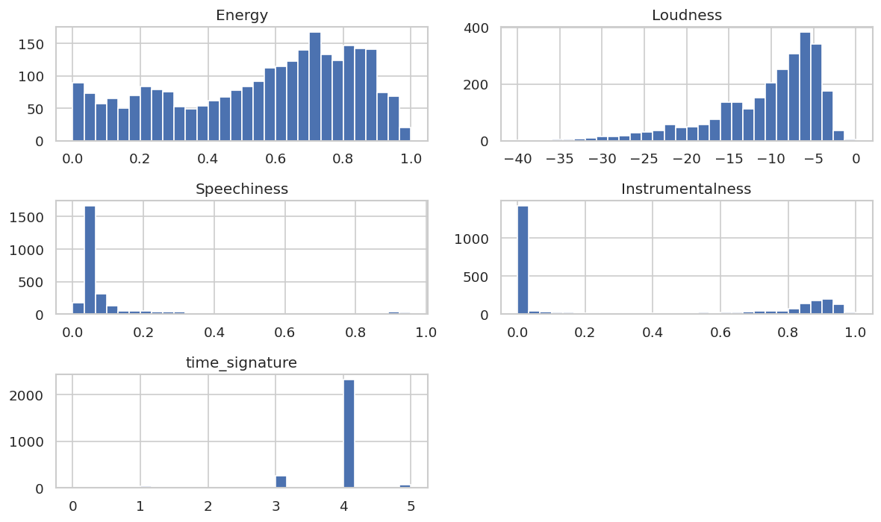
Figure 1.1 Plot of each Feature Distribution

Question 1.3a
The number of data points in each cluster (k=3) are noted in Table 1.4 that used the following coding to generate:

k3 = KMeans(n_clusters=3, random_state=RNG, n_init="auto").fit(Xz)
df1["Cluster_k3"] = k3.labels_
counts_k3 = df1["Cluster_k3"].value_counts().sort_index()
print("Counts per cluster (k=3):")
display(counts_k3)

Cluster (k=3) | Count
0 | 1700
1 | 696
2 | 290
Table 1.4

Question 1.3b

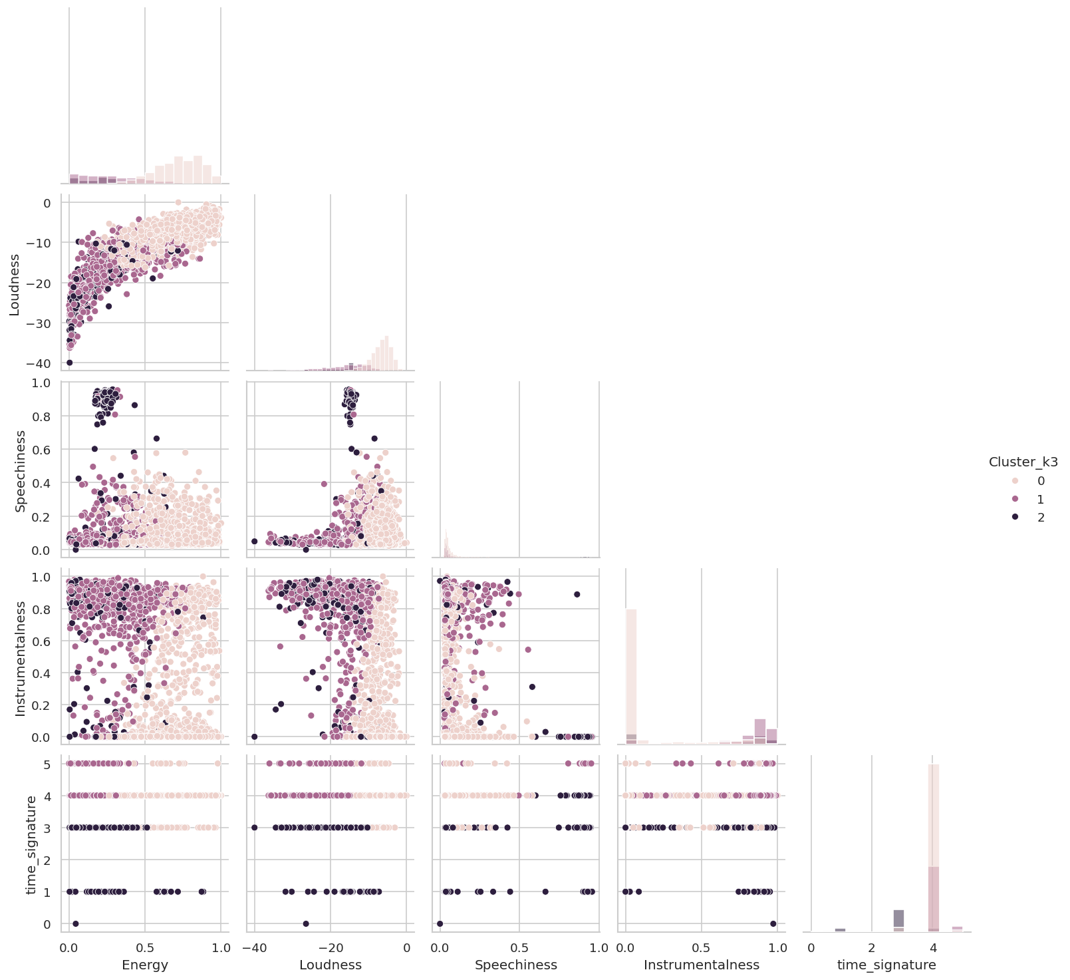
Figure 1.2 Cluster Distribution using” Pairplot”

Feature | Cluster0 (mean/[range]) | Cluster1 (mean/[range]) | Cluster2 (mean/[range])
Energy | 0.719 / [0.188, 1.00] | 0.286 / [0.000, 0.861] | 0.220 / [0.002, 0.883]
Loudness | -6.753 / [-16.202, 0.000] | -16.403 / [-36.281, -4.237] | -17.804 / [-39.967, -6.526]
Speechiness | 0.076 / [0.022, 0.579] | 0.091 / [0.027, 0.951] | 0.313 / [0.000, 0.956]
Instrumentalness | 0.126 / [0.000, 1.000] | 0.768 / [0.000, 0.990] | 0.534 / [0.000, 0.980]
Time_Signature | 3.986 / [3.000, 5.000] | 4.079 / [4.000, 5.000] | 2.886 / [0.000, 4.000]
Table 1.5
Based on Table 1.5 each cluster can be described below:
- Cluster 0: Is High-energy (with a mean of 0.719), loud tracks with low speech and moderate instrumentalness; most have standard 4-beat structure from 3 to 5.
- Cluster 1: Is Low-energy, quiet, highly instrumental songs, often with little to no vocals; and is also consistent with 4/4 time.
- Cluster 2: has soft and moderately instrumental tracks with higher speech presence compared to other clusters. Irregular time signature where some are 4 and not.

Question 1.4
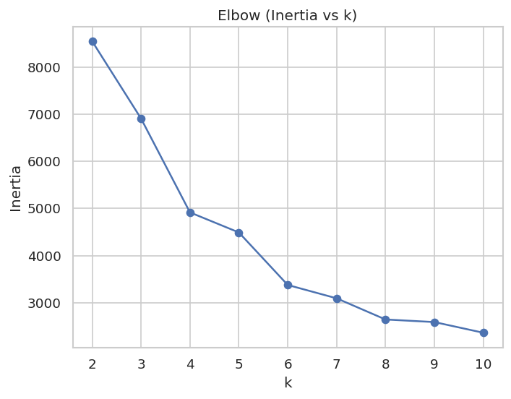
Figure 1.3 Elbow method plot
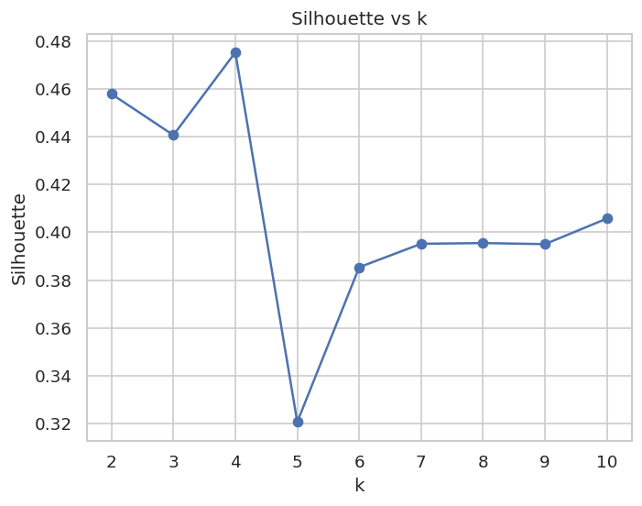
Figure 1.4 Silhouette method plot

Both Figure 1.3 and Figure 1.4 point towards 4 as the chosen k. In Figure 1.3 (the Elbow Point Plot), the rate of decrease in inertia slows down when k = 4, thus, forming a shape that resembles an elbow. Before this point, inertia is seen sharply decreasing as clusters are added from 2 to 4, where extra clusters added after start to give diminishing returns. On Figure 1.4 (the Silhouette plot), the peak Silhouette score (~0.4753) indicates that the most natural number of clusters is k = 4, where separation and cohesion between clusters are maximised. Thus, 4 clusters give the most optimal number of clusters.

Question 1.5

The following code is used to produce the outputs:
def fit_with_scaler(scaler, X, k):
sc = scaler()
Xs = sc.fit_transform(X)
km = KMeans(n_clusters=k, random_state=RNG, n_init="auto").fit(Xs)
return sc, km, silhouette_score(Xs, km.labels_), Xs

sc_std, km_std, sil_std, X_std = fit_with_scaler(StandardScaler, X, k_star)
sc_mm, km_mm, sil_mm, X_mm = fit_with_scaler(MinMaxScaler, X, k_star)

print(f"Silhouette: Standard={sil_std:.3f} | MinMax={sil_mm:.3f}")
better = "std" if sil_std >= sil_mm else "mm"
sc_best, km_best, X_best = (sc_std, km_std, X_std) if better=="std" else (sc_mm, km_mm, X_mm)
df1[f"Cluster_k{k_star}_{better}"] = km_best.labels_
print("Better scaler =", "StandardScaler" if better=="std" else "MinMaxScaler")

The following outputs are as follows:
Silhouette: Standard = 0.475 & MinMax = 0.578
This suggests that the MinMaxScaler approach produced better define clusters. The higher the silhouette, the more compact and well-separated the clusters are. Thus, 0.578 > 0.475 with a difference of 0.095, suggesting a meaningful improvement of about 9.5 percentage points. Since most of the audio features (like Energy, Spechiness, Instrumentalneess) are already bounded between 0 and 1, MinMax scaling preserved their natural relative magnitudes and prevented disproportionate influence from the decibel scale of the loudness feature. Overall, MinMaxScaler yields better clustering performance.

Question 1.6
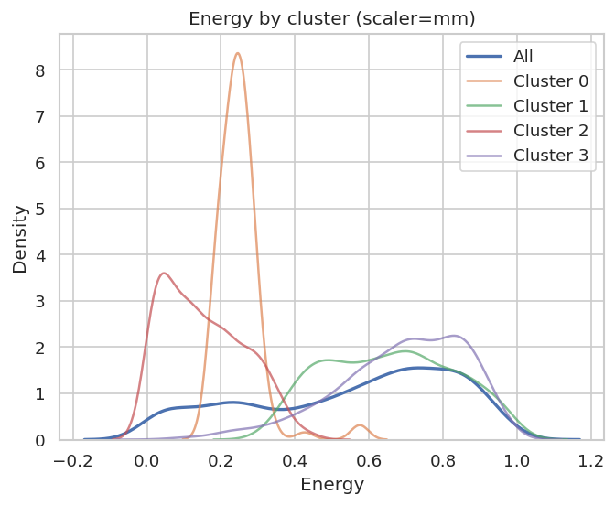
Figure1.5
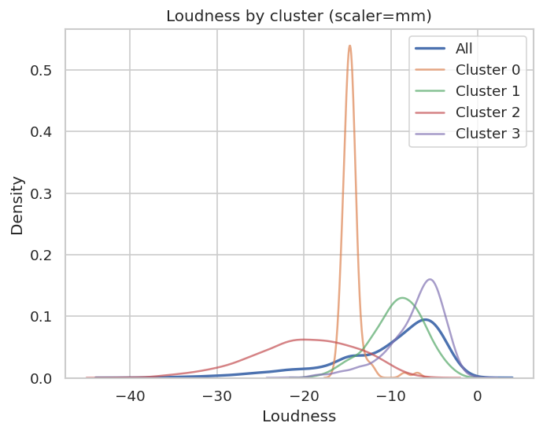
Figure 1.6
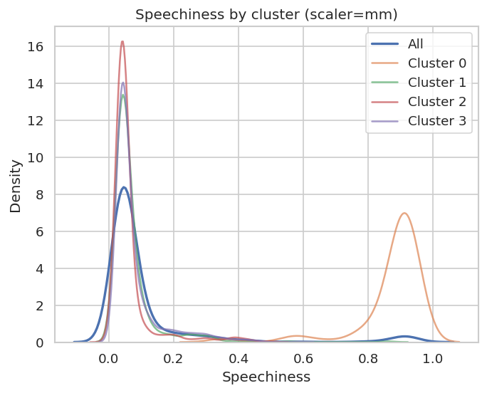
Figure 1.7
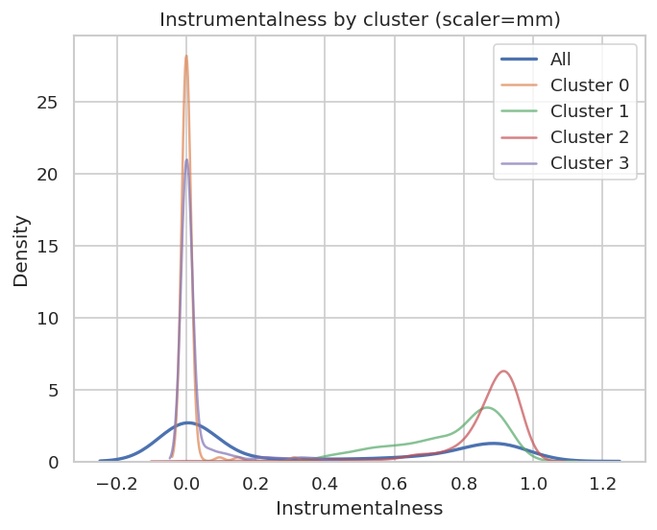
Figure 1.8
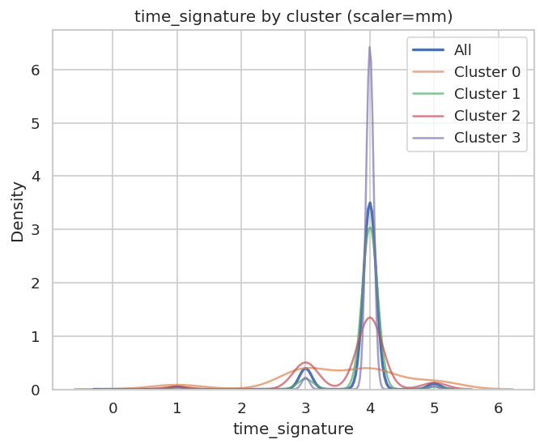
Figure 1.9

Question 1.7

Cluster 0: Energy=low, Loudness=low, Speechiness=high, Instrumentalness=low, time_signature=low
- This cluster consists of low energy, loudness, instrumentalness and beats (time signature) but has high speechiness. Thus, describing tracks that are not energetic and loud, but has lots of spoken words. It may also have low beats. This cluster may represent a talk show, audio book, or poetry, or rap.
Cluster 1: Energy=high, Loudness=medium, Speechiness=medium, Instrumentalness=high, time_signature=medium
- This cluster consists of high energy and instrumentalness, but medium loudness, speechiness and beats (time signature). Thus, describing tracks that are energetic, and not loud, with some spoken words (but vocal), and has some beats. This cluster may represent house or electronic music.
Cluster 2: Energy=low, Loudness=low, Speechiness=medium, Instrumentalness=high, time_signature=low
- Though our results suggest that this cluster has medium spoken words due to the use of standard deviation of this contained data as a benchmark, a mean speechinees of 0.064 (way below 0.33 and lowest of all the clusters) can be considered low. Therefore, this cluster consists of low energy, loudness, and beats (time signature), but low vocals. Thus, describing tracks that are not energetic, loud, spoken-words-contained and beats. This cluster may represent calm music and other non-speech-like tracks.
Cluster 3: Energy=high, Loudness=high, Speechiness=medium, Instrumentalness=low, time_signature=medium
- This cluster consists of high energy and loudness, medium speechiness and beats (time signature), and low instrumentalness. Thus, describing tracks that are highly energetic, loud, and vocal with some spoken words and beats. This cluster may represent pop, rock, or death metal songs.
Feature | Cluster0 (mean/[range]) | Cluster1 (mean/[range]) | Cluster2 (mean/[range]) | Cluster3 (mean/[range])
Energy | 0.249 / [0.169, 0.576] | 0.656 / [0.328, 0.988] | 0.155 / [0.000, 0.455] | 0.688 / [0.038, 1.000]
Loudness | -14.541 / [-16.268, -6.950] | -9.221 / [-18.961, -1.977] | -19.864 / [-39.967, -7.027] | -7.067 / [-22.028, 0.000]
Speechiness | 0.876 / [0.345, 0.956] | 0.070 / [0.022, 0.862] | 0.064 / [0.000, 0.495] | 0.079 / [0.024, 0.579]
Instrumentalness | 0.006 / [0.000, 0.311] | 0.765 / [0.391, 1.000] | 0.865 / [0.000, 0.990] | 0.024 / [0.000, 0.397]
time_signature | 3.509 / [1.000, 5.000] | 3.917 / [1.000, 5.000] | 3.730 / [0.000, 5.000] | 3.969 / [1.000, 5.000]

Approach to Interpreting Clusters
- Scale and choose k
  - Scaled features (Energy, Loudness, Speechiness, Instrumental, time_signature) with MinMaxScaler(0 – 1).
  - Selected k = 4 using the Elbow and Silhouette method as a deciding factor.
- Summarising clusters
  - Determined mean and range of each feature by cluster.
  - Produced line graphs per feature by cluster to see where distributions sit.
- Create labels (low/medium/high)
  - Compared each cluster’s feature mean to the global mean, using a plus-or-minus 0.25 * standard deviation (SD) band to label “high” (> + 0.25 SD), “low” (< -0.25 SD), or “medium” (otherwise).
  - Known domain cut-offs stated by the data dictionary provided overrides the heuristic:
    - Speechiness: >0.66 = speech dominant; 0.33 - 0.66 = mixed of speech and music; < 0.33 = music.
    - Instrumentalness: > 0.5 approximately represents instrumental
    - Loudness: Closer to 0dB = louder; very negative (below –10dB) can be considered as low loudness
    - Energy: closer to 1 indicates intensity
    - Time_signature: Near 4 implies conventional 4/4
- Categorise profiles using plain English
  - Translate patterns like high Energy + high Loudness + Low instrumentalness INTO “high-energy vocal music (pop/rock)”.
  - Low Energy + very high speechiness (range goes from 0.345 to 0.956) INTO “spoken word/rap/talk”
  - Low Energy + High Instrumentalness INTO “calm instrumentals”
- Sanity checks
  - Cross-checked descriptions against data dictionary definitions (e.g., Speechiness thresholds suggested or defined)
  - Noted any exceptions (e.g., cluster 2’s mean speechiness = 0.064 is way below 0.33, so labelled low in description despite standard deviation heuristic).

Task 2: Association Analysis

Question 2.1
There were some data cleanings done to fix any data quality issues that were present in ‘Dataset2_TRANS.csv’ file. Steps that led to the overall data cleaning approach is as follows:

- Relevant Fields: From the five attributes – TRANSACTION_ID, PRODUCT_NAME, TRANSACTION_DATE, LOCATION, and QUANTITY – the association analysis retains only TRANSACTION_ID (to group baskets) and PRODUCT_NAME (the items). TRANSACTION_DATE and LOCATION do not affect item co-occurrence and are therefore excluded.

QUANTITY is also excluded. The point-of-scale device always record it as 1, and the dataset contains only this value (aside from the two missing entries). For completeness, these two missing values were imputed as 1, then the column was dropped. Keeping QUANTITY would add no information (zero variance) and is not required for standard market-basket analysis, which relies on a binary transaction – item matrix (presence/absence), not counts. With 1 representing presence and 0 representing absence. Further rationale in its exclusion is provided in Question 2.2.
Attribute | Keep/Removed
Transaction ID | Keep
Product Name | Keep
Transaction Date | Keep
Location | Keep
Quantity | Removed
Table 1.5

- Deduplication: Cleaning of any duplication firstly involved dropping any rows that did not include “TRANSACTION_ID” and “PRODUCT_NAME” as a subset. After doing this step, any duplicates by this subset were removed. Though these duplications describe the quantity of the product bought in one transaction, these duplications are not needed due to its irrelevance in conducting association rule mining further (Question 2 to 7).

Overall, after this data cleaning approach was conducted on the dataset, 459258 (raw) rows are cleaned until 290211 rows are left. Of these rows, there are 199998 different transactions and 17 unique products.

Question 2.2
Variables that relate to association rule mining are selected for the purpose of this task. These variables include:
- TRANSACTION_ID: Serves as the transaction identifier for a given sale. This is used to group all the products that were purchased together during a single sale. Each unique ID represents a customer’s basket.
- PRODUCT_NAME: Serves as the item identifier. Association rule focuses on this, discovering which two items are often purchased within one transaction.
The table below provides reasons why some variables were excluded.
Variables Excluded | Reason for exclusion
LOCATION | This variable identifies the point-of-sale device, not customer behaviour. It does not affect item association in any way.
TRANSACTION_DATE | This variable provides information on the occurrence of a transaction which can be useful for other types of analysis, but not for association rule mining: Does not tell what was bought with what.
QUANTITY | This variable always equal to 1 (due to the point-of-sale device). The inclusion of this variable provides no additional information. Thus, can be excluded in the analysis.
Table 1.6
After selection, we needed to convert the list of transactions into a binary transaction to item matrix, where each cells indicates whether a product is purchased (1) or not (0). This one-hot encoded DataFrame is used as the essential input for the association rule mining. Additionally, after selection and conversion, is identified that 56401 were used with 17 unique products.

Question 2.3
Below is a shortened table in which association rule mining is conducted and displayed. Rules displayed in the table are those restricted with a minimum support of 0.015 and a minimum confidence of 0.12. There are 130 association rules with the set threshold. The Appendix A displays all attributes including those excluded from this shortened table ("expected_confidence", "lift", "leverage", "conviction", "antecedent_len", and "consequent_len").

 | antecedents | consequents | support | confidence | lift
0 | (Sugar,) | (Cheese,) | 0.021542 | 0.295620 | 9.779055
1 | (Cheese,) | (Sugar,) | 0.021542 | 0.712610 | 9.779055
2 | (Bread,) | (Butter,) | 0.040212 | 0.531023 | 3.430726
3 | (Butter,) | (Bread,) | 0.040212 | 0.259794 | 3.430726
4 | (Milk,) | (Butter,) | 0.029343 | 0.517349 | 3.342384
5 | (Butter,) | (Milk,) | 0.029343 | 0.189576 | 3.342384
6 | (Conditioner,) | (Butter,) | 0.077375 | 0.514441 | 3.323593
7 | (Butter,) | (Conditioner,) | 0.077375 | 0.499885 | 3.323593
8 | (Butter, Tea) | (Conditioner,) | 0.023014 | 0.492600 | 3.275152
9 | (Conditioner,) | (Butter, Tea) | 0.023014 | 0.153012 | 3.275152
10 | (Conditioner, Tea) | (Butter,) | 0.023014 | 0.377545 | 2.439166
11 | (Butter,) | (Conditioner, Tea) | 0.023014 | 0.148683 | 2.439166
12 | (Coffee,) | (Peanut butter,) | 0.015017 | 0.287802 | 1.826110
13 | (Egg, Peanut butter) | (Yoghurt,) | 0.016365 | 0.552695 | 1.492723
14 | (Cordial, Shampoo, Tea) | (Yoghurt,) | 0.016773 | 0.547454 | 1.478568
15 | (Cereal,) | (Tea,) | 0.058350 | 0.643150 | 1.412881
16 | (Tea,) | (Cereal,) | 0.058350 | 0.128184 | 1.412881
17 | (Bread,) | (Conditioner,) | 0.016081 | 0.212362 | 1.411936
18 | (Cordial, Shampoo) | (Tea, Yoghurt) | 0.016773 | 0.192590 | 1.339860
19 | (Egg, Shampoo, Tea) | (Yoghurt,) | 0.020638 | 0.487233 | 1.315924
20 | (Shampoo, Tea, Yoghurt) | (Egg,) | 0.020638 | 0.424198 | 1.309392
21 | (Egg,) | (Yoghurt,) | 0.154820 | 0.477890 | 1.290689
22 | (Yoghurt,) | (Egg,) | 0.154820 | 0.418139 | 1.290689
23 | (Shampoo, Tea) | (Cordial, Yoghurt) | 0.016773 | 0.149376 | 1.275931
24 | (Cordial, Yoghurt) | (Shampoo, Tea) | 0.016773 | 0.143268 | 1.275931
25 | (Cordial, Tea, Yoghurt) | (Shampoo,) | 0.016773 | 0.394002 | 1.273256
26 | (Shampoo, Tea, Yoghurt) | (Cordial,) | 0.016773 | 0.344752 | 1.269629
27 | (Tea, Yoghurt) | (Egg,) | 0.059095 | 0.411126 | 1.269042
28 | (Egg,) | (Tea, Yoghurt) | 0.059095 | 0.182410 | 1.269042
29 | (Egg, Shampoo) | (Tea, Yoghurt) | 0.020638 | 0.181421 | 1.262162
30 | (Tea, Yoghurt) | (Egg, Shampoo) | 0.020638 | 0.143580 | 1.262162
31 | (Cordial, Shampoo) | (Yoghurt,) | 0.040389 | 0.463762 | 1.252533
32 | (Peanut butter, Yoghurt) | (Shampoo,) | 0.016702 | 0.384020 | 1.240995
33 | (Yoghurt,) | (Egg, Tea) | 0.059095 | 0.159604 | 1.238723
34 | (Egg, Tea) | (Yoghurt,) | 0.059095 | 0.458649 | 1.238723
35 | (Peanut butter, Shampoo) | (Yoghurt,) | 0.016702 | 0.456617 | 1.233234
36 | (Shampoo,) | (Yoghurt,) | 0.141061 | 0.455853 | 1.231172
37 | (Yoghurt,) | (Shampoo,) | 0.141061 | 0.380980 | 1.231172
38 | (Shampoo, Tea) | (Egg, Yoghurt) | 0.020638 | 0.183799 | 1.187180
39 | (Egg, Yoghurt) | (Shampoo, Tea) | 0.020638 | 0.133303 | 1.187180
40 | (Egg,) | (Cordial,) | 0.103686 | 0.320053 | 1.178667
41 | (Cordial,) | (Egg,) | 0.103686 | 0.381848 | 1.178667
42 | (Shampoo, Tea) | (Yoghurt,) | 0.048652 | 0.433286 | 1.170223
43 | (Yoghurt,) | (Shampoo, Tea) | 0.048652 | 0.131399 | 1.170223
44 | (Cordial,) | (Yoghurt,) | 0.117072 | 0.431146 | 1.164443
45 | (Yoghurt,) | (Cordial,) | 0.117072 | 0.316190 | 1.164443
46 | (Shampoo, Tea) | (Egg,) | 0.042357 | 0.377230 | 1.164414
47 | (Egg,) | (Shampoo, Tea) | 0.042357 | 0.130746 | 1.164414
48 | (Peanut butter, Yoghurt) | (Egg,) | 0.016365 | 0.376274 | 1.161462
49 | (Egg, Tea) | (Shampoo, Yoghurt) | 0.020638 | 0.160176 | 1.135507
50 | (Shampoo, Yoghurt) | (Egg, Tea) | 0.020638 | 0.146305 | 1.135507
51 | (Egg,) | (Shampoo,) | 0.113757 | 0.351138 | 1.134736
52 | (Shampoo,) | (Egg,) | 0.113757 | 0.367616 | 1.134736
53 | (Egg, Tea, Yoghurt) | (Shampoo,) | 0.020638 | 0.349235 | 1.128585
54 | (Cordial, Yoghurt) | (Shampoo,) | 0.040389 | 0.344995 | 1.114883
55 | (Shampoo,) | (Cordial, Yoghurt) | 0.040389 | 0.130522 | 1.114883
56 | (Egg, Tea) | (Cordial,) | 0.038847 | 0.301500 | 1.110343
57 | (Cordial,) | (Egg, Tea) | 0.038847 | 0.143062 | 1.110343
58 | (Egg, Shampoo) | (Yoghurt,) | 0.046719 | 0.410692 | 1.109201
59 | (Yoghurt,) | (Egg, Shampoo) | 0.046719 | 0.126179 | 1.109201
60 | (Tea, Yoghurt) | (Shampoo,) | 0.048652 | 0.338473 | 1.093807
61 | (Shampoo,) | (Tea, Yoghurt) | 0.048652 | 0.157222 | 1.093807
62 | (Tea, Yoghurt) | (Cordial,) | 0.042570 | 0.296164 | 1.090691
63 | (Cordial,) | (Tea, Yoghurt) | 0.042570 | 0.156774 | 1.090691
64 | (Cordial, Tea) | (Egg,) | 0.038847 | 0.346348 | 1.069089
65 | (Egg, Tea) | (Shampoo,) | 0.042357 | 0.328746 | 1.062375
66 | (Shampoo,) | (Egg, Tea) | 0.042357 | 0.136882 | 1.062375
67 | (Cordial, Tea) | (Shampoo, Yoghurt) | 0.016773 | 0.149542 | 1.060117
68 | (Shampoo, Yoghurt) | (Cordial,) | 0.040389 | 0.286325 | 1.054457
69 | (Cordial,) | (Shampoo, Yoghurt) | 0.040389 | 0.148743 | 1.054457
70 | (Peanut butter,) | (Tea,) | 0.074999 | 0.475869 | 1.045396
71 | (Tea,) | (Peanut butter,) | 0.074999 | 0.164758 | 1.045396
72 | (Shampoo,) | (Cordial,) | 0.087091 | 0.281442 | 1.036473
73 | (Cordial,) | (Shampoo,) | 0.087091 | 0.320731 | 1.036473
74 | (Cordial, Tea) | (Yoghurt,) | 0.042570 | 0.379545 | 1.025078
75 | (Shampoo, Yoghurt) | (Egg,) | 0.046719 | 0.331197 | 1.022319
76 | (Egg,) | (Shampoo, Yoghurt) | 0.046719 | 0.144210 | 1.022319
77 | (Shampoo, Tea) | (Cordial,) | 0.030638 | 0.272856 | 1.004857
78 | (Egg, Yoghurt) | (Shampoo,) | 0.046719 | 0.301764 | 0.975177
79 | (Shampoo,) | (Egg, Yoghurt) | 0.046719 | 0.150977 | 0.975177
80 | (Egg, Shampoo, Yoghurt) | (Tea,) | 0.020638 | 0.441746 | 0.970433
81 | (Sugar,) | (Shampoo,) | 0.021595 | 0.296350 | 0.957684
82 | (Milk,) | (Tea,) | 0.023652 | 0.417005 | 0.916083
83 | (Peanut butter, Yoghurt) | (Tea,) | 0.018120 | 0.416633 | 0.915264
84 | (Cordial, Shampoo, Yoghurt) | (Tea,) | 0.016773 | 0.415277 | 0.912285
85 | (Cordial,) | (Tea,) | 0.112161 | 0.413059 | 0.907414
86 | (Tea,) | (Cordial,) | 0.112161 | 0.246397 | 0.907414
87 | (Conditioner,) | (Tea,) | 0.060956 | 0.405281 | 0.890327
88 | (Tea,) | (Conditioner,) | 0.060956 | 0.133910 | 0.890327
89 | (Cordial, Tea) | (Shampoo,) | 0.030638 | 0.273158 | 0.882737
90 | (Butter,) | (Peanut butter,) | 0.021347 | 0.137915 | 0.875077
91 | (Peanut butter,) | (Butter,) | 0.021347 | 0.135448 | 0.875077
92 | (Egg,) | (Tea,) | 0.128845 | 0.397712 | 0.873700
93 | (Tea,) | (Egg,) | 0.128845 | 0.283049 | 0.873700
94 | (Cordial, Shampoo) | (Egg,) | 0.024485 | 0.281148 | 0.867833
95 | (Tea,) | (Yoghurt,) | 0.143739 | 0.315767 | 0.852826
96 | (Yoghurt,) | (Tea,) | 0.143739 | 0.388211 | 0.852826
97 | (Tea,) | (Egg, Yoghurt) | 0.059095 | 0.129820 | 0.838523
98 | (Egg, Yoghurt) | (Tea,) | 0.059095 | 0.381699 | 0.838523
99 | (Cereal,) | (Shampoo,) | 0.023457 | 0.258550 | 0.835528
100 | (Cordial, Egg) | (Tea,) | 0.038847 | 0.374658 | 0.823054
101 | (Egg, Shampoo) | (Tea,) | 0.042357 | 0.372350 | 0.817984
102 | (Conditioner,) | (Peanut butter,) | 0.019326 | 0.128492 | 0.815288
103 | (Peanut butter,) | (Conditioner,) | 0.019326 | 0.122623 | 0.815288
104 | (Coffee,) | (Tea,) | 0.019042 | 0.364934 | 0.801692
105 | (Tea, Yoghurt) | (Peanut butter,) | 0.018120 | 0.126064 | 0.799880
106 | (Cordial, Yoghurt) | (Tea,) | 0.042570 | 0.363623 | 0.798811
107 | (Shampoo,) | (Tea,) | 0.112285 | 0.362860 | 0.797136
108 | (Tea,) | (Shampoo,) | 0.112285 | 0.246670 | 0.797136
109 | (Egg, Shampoo) | (Cordial,) | 0.024485 | 0.215243 | 0.792682
110 | (Cordial, Shampoo) | (Tea,) | 0.030638 | 0.351792 | 0.772821
111 | (Cordial, Egg) | (Shampoo,) | 0.024485 | 0.236149 | 0.763138
112 | (Shampoo, Yoghurt) | (Tea,) | 0.048652 | 0.344897 | 0.757674
113 | (Cordial, Yoghurt) | (Egg,) | 0.028705 | 0.245192 | 0.756844
114 | (Peanut butter,) | (Shampoo,) | 0.036577 | 0.232085 | 0.750003
115 | (Cordial, Egg) | (Yoghurt,) | 0.028705 | 0.276847 | 0.747710
116 | (Peanut butter,) | (Yoghurt,) | 0.043492 | 0.275959 | 0.745313
117 | (Bread,) | (Tea,) | 0.025656 | 0.338797 | 0.744273
118 | (Cereal,) | (Egg,) | 0.021844 | 0.240766 | 0.743183
119 | (Sugar,) | (Tea,) | 0.023209 | 0.318491 | 0.699667
120 | (Cereal,) | (Yoghurt,) | 0.023227 | 0.256009 | 0.691433
121 | (Egg, Yoghurt) | (Cordial,) | 0.028705 | 0.185410 | 0.682815
122 | (Butter,) | (Tea,) | 0.046719 | 0.301833 | 0.663070
123 | (Butter, Conditioner) | (Tea,) | 0.023014 | 0.297434 | 0.653406
124 | (Peanut butter, Tea) | (Yoghurt,) | 0.018120 | 0.241608 | 0.652536
125 | (Peanut butter,) | (Cordial,) | 0.025177 | 0.159748 | 0.588309
126 | (Peanut butter,) | (Egg,) | 0.029609 | 0.187873 | 0.579915
127 | (Conditioner,) | (Shampoo,) | 0.025035 | 0.166451 | 0.537900
128 | (Conditioner,) | (Yoghurt,) | 0.025833 | 0.171755 | 0.463878
129 | (Conditioner,) | (Egg,) | 0.019361 | 0.128728 | 0.397351

Question 2.4

The shortened table below displays the Rule with the highest confidence from the resulting association rules. The rule suggests a strong relationship between cheese and sugar purchases. In about 2% of all the transactions (where support = 0.0215), when cheese is bought, sugar is also purchased in 71% of the cases (where confidence = 0.7126). The very high lift value of 9.78 indicates that this co-occurrence is almost ten times more frequent than random chance, probably suggesting that these products are commonly brought together. Appendix B displays all attributes including those excluded from this shortened table ("expected_confidence", "lift", "leverage", "conviction", "antecedent_len", and "consequent_len").
Antecedent | consequents | support | confidence | lift
Cheese | Sugar | 0.021542171238098616 | 0.7126099706744868 | 9.779054733822806

The shortened table below displays the Rule with the highest lift from the resulting association rules. The rule suggests a somewhat strong relationship between sugar and cheese purchases. In about 21.5% of all transactions (where support = 0.21542), when sugar is bought, cheese is also purchased in about 30% of the cases (where confidence = 0.29562). This rule like the rule before has a high lift value of 9.78, which indicates that this co-occurence is almost ten times more frequent than random chance, probably suggesting that these products are commonly bought together. Appendix C displays all attributes including those excluded from this shortened table ("expected_confidence", "lift", "leverage", "conviction", "antecedent_len", and "consequent_len").
Antecedent | consequents | support | confidence | lift
Sugar | Cheese | 0.21542 | 0.29562 | 9.779055

Since both rules involve Cheese and Sugar and have the same lift value of about (9.779), it describes the same strength of association between these two items. Lift is symmetric, thus, means that these two products co-occur about 9.8 times more often than random chance. However, their support and confidence differ because they measure directional likelihoods:
- Support difference: Sugar > Cheese has a much higher support (0.21542 vs 0.0215). This means that Sugar appears over 21% of all the transactions while the opposite rule only represents 2% of all sales. This suggests that sugar is much more common in the data set than cheese.
- Confidence difference: Cheese > Sugar has a higher confidence (0.713 vs 0.296). This means that when Cheese is purchased, Sugar is very likely to be bought as well. Vice versa, only 29% of sugar buyers also buy Cheese. This suggests that those who buy cheese tend to buy sugar, but not all sugar buyers purchase cheese.

Question 2.5

Description of the plot
Using a bubble chart, support vs confidence (where bubble size = Lift greater than or equal to 1.4) relationship is displayed. Each bubble represents an association rule. The x-axis represents the support (how often the rule occurs in transactions) and the y-axis represents the confidence (how reliable the rule is or the frequency of the consequent appearing when the antecedent does). The size of the bubble represents the lift value where the likelihood of the items co-occurs than by random chance.

Observation/Analysis of the plot
Through observation, most rules are more present from a low to moderate support (0.02 - 0.05); this means they occur in 2- 5% out of all the transactions. The plot also suggests presence of some rules that reach higher confidence levels from 0.5 to 0.7. This shows strong relationships between items within these rules. Larger bubbles also tend to appear at lower support levels. This is probably due to how strong but rare items associations are less frequent in the dataset provided.
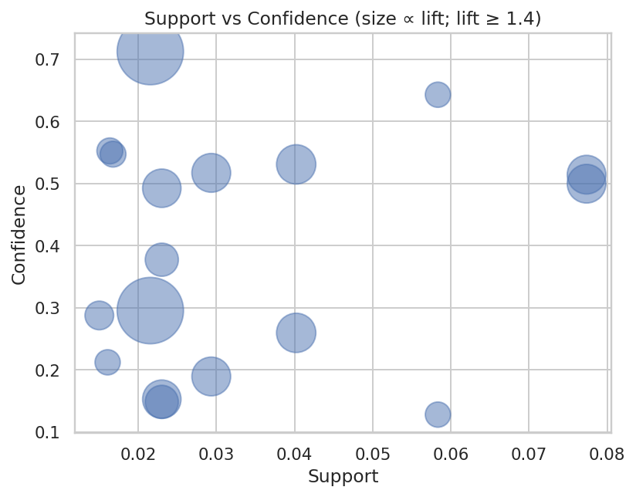
Figure 2.0

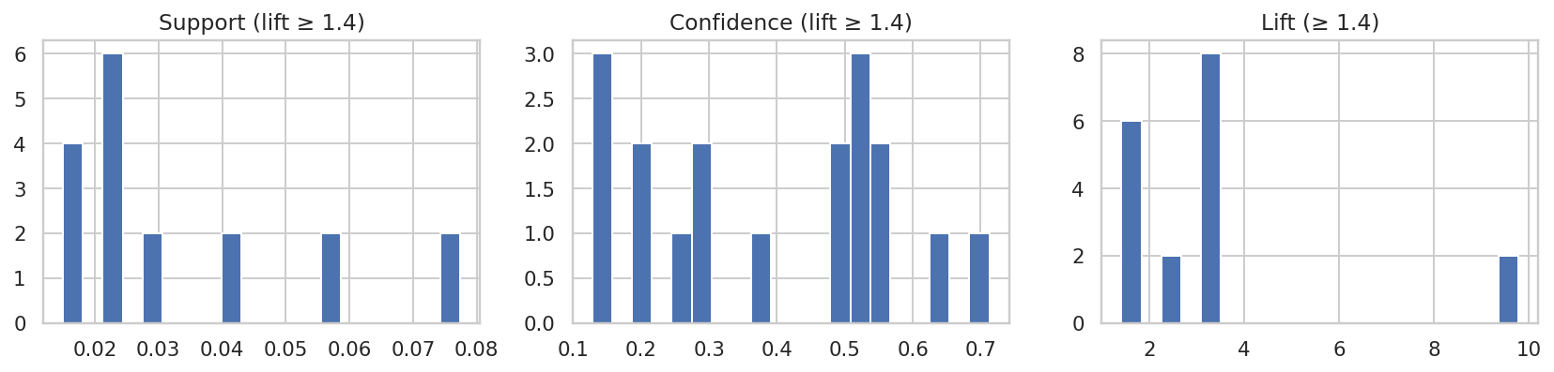
Figure 2.1

Question 2.6

In this association analysis, several strong rules were identified involving Shampoo. The rule {shampoo, yoghurt} demonstrated a strong support (14.1%), confidence (~45%) and a lift of 1.231. While vice versa {yoghurt, shampoo}, having the same support and lift produces a smaller confidence of ~38%. Rules that had a significantly high support also included those with shampoo and tea OR shampoo and egg whether either is purchased following the other displayed a support over 10%. They each produced mid-high confidence from ~20% to ~40%. These results suggest that shampoo tends to be purchased together with grocery products like yoghurt, tea or eggs. This analysis can be used to improve purchase rate by updating store layout to suit marketing segmentations (i.e., shoppers who buy both personal-care and food items).

These results can be viewed in the shortened table below while Appendix D displays all attributes including those excluded from this shortened table ("expected_confidence", "lift", "leverage", "conviction", "antecedent_len", and "consequent_len").
 | antecedents | consequents | support | confidence | lift
14 | (Cordial, Shampoo, Tea) | (Yoghurt,) | 0.016773 | 0.547454 | 1.478568
18 | (Cordial, Shampoo) | (Tea, Yoghurt) | 0.016773 | 0.192590 | 1.339860
19 | (Egg, Shampoo, Tea) | (Yoghurt,) | 0.020638 | 0.487233 | 1.315924
20 | (Shampoo, Tea, Yoghurt) | (Egg,) | 0.020638 | 0.424198 | 1.309392
23 | (Shampoo, Tea) | (Cordial, Yoghurt) | 0.016773 | 0.149376 | 1.275931
24 | (Cordial, Yoghurt) | (Shampoo, Tea) | 0.016773 | 0.143268 | 1.275931
25 | (Cordial, Tea, Yoghurt) | (Shampoo,) | 0.016773 | 0.394002 | 1.273256
26 | (Shampoo, Tea, Yoghurt) | (Cordial,) | 0.016773 | 0.344752 | 1.269629
29 | (Egg, Shampoo) | (Tea, Yoghurt) | 0.020638 | 0.181421 | 1.262162
30 | (Tea, Yoghurt) | (Egg, Shampoo) | 0.020638 | 0.143580 | 1.262162
31 | (Cordial, Shampoo) | (Yoghurt,) | 0.040389 | 0.463762 | 1.252533
32 | (Peanut butter, Yoghurt) | (Shampoo,) | 0.016702 | 0.384020 | 1.240995
35 | (Peanut butter, Shampoo) | (Yoghurt,) | 0.016702 | 0.456617 | 1.233234
36 | (Shampoo,) | (Yoghurt,) | 0.141061 | 0.455853 | 1.231172
37 | (Yoghurt,) | (Shampoo,) | 0.141061 | 0.380980 | 1.231172
38 | (Shampoo, Tea) | (Egg, Yoghurt) | 0.020638 | 0.183799 | 1.187180
39 | (Egg, Yoghurt) | (Shampoo, Tea) | 0.020638 | 0.133303 | 1.187180
42 | (Shampoo, Tea) | (Yoghurt,) | 0.048652 | 0.433286 | 1.170223
43 | (Yoghurt,) | (Shampoo, Tea) | 0.048652 | 0.131399 | 1.170223
46 | (Shampoo, Tea) | (Egg,) | 0.042357 | 0.377230 | 1.164414
47 | (Egg,) | (Shampoo, Tea) | 0.042357 | 0.130746 | 1.164414
49 | (Egg, Tea) | (Shampoo, Yoghurt) | 0.020638 | 0.160176 | 1.135507
50 | (Shampoo, Yoghurt) | (Egg, Tea) | 0.020638 | 0.146305 | 1.135507
51 | (Egg,) | (Shampoo,) | 0.113757 | 0.351138 | 1.134736
52 | (Shampoo,) | (Egg,) | 0.113757 | 0.367616 | 1.134736
53 | (Egg, Tea, Yoghurt) | (Shampoo,) | 0.020638 | 0.349235 | 1.128585
54 | (Cordial, Yoghurt) | (Shampoo,) | 0.040389 | 0.344995 | 1.114883
55 | (Shampoo,) | (Cordial, Yoghurt) | 0.040389 | 0.130522 | 1.114883
58 | (Egg, Shampoo) | (Yoghurt,) | 0.046719 | 0.410692 | 1.109201
59 | (Yoghurt,) | (Egg, Shampoo) | 0.046719 | 0.126179 | 1.109201
60 | (Tea, Yoghurt) | (Shampoo,) | 0.048652 | 0.338473 | 1.093807
61 | (Shampoo,) | (Tea, Yoghurt) | 0.048652 | 0.157222 | 1.093807
65 | (Egg, Tea) | (Shampoo,) | 0.042357 | 0.328746 | 1.062375
66 | (Shampoo,) | (Egg, Tea) | 0.042357 | 0.136882 | 1.062375
67 | (Cordial, Tea) | (Shampoo, Yoghurt) | 0.016773 | 0.149542 | 1.060117
68 | (Shampoo, Yoghurt) | (Cordial,) | 0.040389 | 0.286325 | 1.054457
69 | (Cordial,) | (Shampoo, Yoghurt) | 0.040389 | 0.148743 | 1.054457
72 | (Shampoo,) | (Cordial,) | 0.087091 | 0.281442 | 1.036473
73 | (Cordial,) | (Shampoo,) | 0.087091 | 0.320731 | 1.036473
75 | (Shampoo, Yoghurt) | (Egg,) | 0.046719 | 0.331197 | 1.022319
76 | (Egg,) | (Shampoo, Yoghurt) | 0.046719 | 0.144210 | 1.022319
77 | (Shampoo, Tea) | (Cordial,) | 0.030638 | 0.272856 | 1.004857
78 | (Egg, Yoghurt) | (Shampoo,) | 0.046719 | 0.301764 | 0.975177
79 | (Shampoo,) | (Egg, Yoghurt) | 0.046719 | 0.150977 | 0.975177
80 | (Egg, Shampoo, Yoghurt) | (Tea,) | 0.020638 | 0.441746 | 0.970433
81 | (Sugar,) | (Shampoo,) | 0.021595 | 0.296350 | 0.957684
84 | (Cordial, Shampoo, Yoghurt) | (Tea,) | 0.016773 | 0.415277 | 0.912285
89 | (Cordial, Tea) | (Shampoo,) | 0.030638 | 0.273158 | 0.882737
94 | (Cordial, Shampoo) | (Egg,) | 0.024485 | 0.281148 | 0.867833
99 | (Cereal,) | (Shampoo,) | 0.023457 | 0.258550 | 0.835528
101 | (Egg, Shampoo) | (Tea,) | 0.042357 | 0.372350 | 0.817984
107 | (Shampoo,) | (Tea,) | 0.112285 | 0.362860 | 0.797136
108 | (Tea,) | (Shampoo,) | 0.112285 | 0.246670 | 0.797136
109 | (Egg, Shampoo) | (Cordial,) | 0.024485 | 0.215243 | 0.792682
110 | (Cordial, Shampoo) | (Tea,) | 0.030638 | 0.351792 | 0.772821
111 | (Cordial, Egg) | (Shampoo,) | 0.024485 | 0.236149 | 0.763138
112 | (Shampoo, Yoghurt) | (Tea,) | 0.048652 | 0.344897 | 0.757674
114 | (Peanut butter,) | (Shampoo,) | 0.036577 | 0.232085 | 0.750003
127 | (Conditioner,) | (Shampoo,) | 0.025035 | 0.166451 | 0.537900

Question 2.7

Cross-sell candidate:
{Cordial, Shampoo, Tea} → {Yoghurt} | support=0.017, conf=0.547, lift = 1.48
The local store can use this rule for cross-selling promotions. This suggests that yoghurt can be promoted or displayed with these frequently purchased items (cordial, shampoo and tea) to increase basket value.

Co-location candidate:
{Sugar} → {Cheese} | support=0.022, conf=0.296, lift=9.78
This indicates a strong relationship in co-location, implying that positioning or promoting these items together can capitalise on an existing shopping pattern.

Conclusion
Both applications demonstrate how association rules can contribute to merchandising, marketing, and store-layouts improvements that drive sales and customer convenience.

Task 3: Text Analysis

Question 3.1
To begin the analysis, a preliminary exploration of the dataset is conducted to understand its basic properties and structure. This involves three actions. First, we access the 'Description' field from the 24th row, and extract and display its contents to provide an example of the text's content, length, and style.
Next, the average word count across all descriptions is calculated, giving us a measure of the typical value for each entry. Finally, the distribution of documents across the different 'Genre' categories is tallied to see how many rows belong to each one. This last step is important for verifying that the dataset is balanced before proceeding with genre-specific modelling.
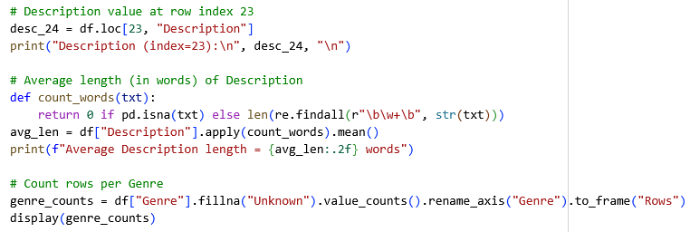
Output:

Description (index=23):
“Werner Herzog confirms his standing as poet laureate of men in extreme situations with "Encounters at the End of the World." In this visually stunning exploration, Herzog travels to the Antarctic community of McMurdo Station, headquarters of the National Science Foundation and home to 1,100 people during the austral summer (Oct-Feb). Over the course of his journey, Herzog examines human nature and Mother nature, juxtaposing breathtaking locations with the profound, surreal, and sometimes absurd experiences of the marine biologists, physicists, plumbers, and truck drivers who choose to form a society as far away from society as one can get. “

Average Description length = 128.77 words

Genre | Rows
Documentary | 200
SciFi | 200
Romance | 200
Kids&Family | 199

The output confirms the successful execution of these steps, providing the description from the 24th row, the average word count of 128.77, and a summary of the genre distribution, which shows that it’s effectively equal with all genres having equal rows of 200 except for ‘Kids&Family’ which has one fewer.

Question 3.2
To prepare the raw text for machine learning analysis, we performed text reprocessing. As raw text data is often messy, containing punctuation, capitalization, and other characters that can confuse algorithms, we strip away this noise and distil each document down to its core keywords.
The Python function ‘preprocess’ achieves this by executing several cleaning steps. First, it converts all text to lowercase, removes any punctuation and numbers, filters out very short words (less than 3 characters), and eliminates common English stop words (e.g., 'the', 'a', 'in'). Then, it performs lemmatization, which reduces words to their dictionary root form. This entire function is then applied to every entry in the "Description" column, with the cleaned list of words, or "tokens," saved in a new "Parsed_description" column for future use.
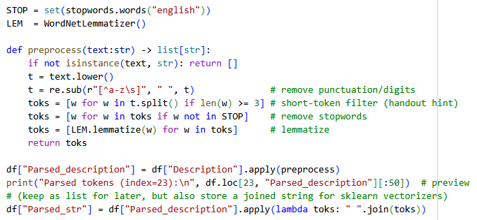
Output:
Parsed tokens (index=23):
['werner', 'herzog', 'confirms', 'standing', 'poet', 'laureate', 'men', 'extreme', 'situation', 'encounter', 'end', 'world', 'visually', 'stunning', 'exploration', 'herzog', 'travel', 'antarctic', 'community', 'mcmurdo', 'station', 'headquarters', 'national', 'science', 'foundation', 'home', 'people', 'austral', 'summer', 'oct', 'feb', 'course', 'journey', 'herzog', 'examines', 'human', 'nature', 'mother', 'nature', 'juxtaposing', 'breathtaking', 'location', 'profound', 'surreal', 'sometimes', 'absurd', 'experience', 'marine', 'biologist', 'physicist']

As is evident from the output, the original description of the 24th row has been made into a list of lowercase tokens. All punctuation, numbers, and common stop words have been removed, successfully converting the raw text into a standardised format of keywords, which the algorithm can better understand and interpret.

Question 3.3
To enable computational analysis, the cleaned text is transformed from lists of words into a structured numerical format through a process called vectorisation. A CountVectorizer is used to build a vocabulary of all unique words and create a matrix of token counts, where each row represents a document and each column represents a word.
From this matrix, two key metrics are calculated for every word. The total count across all documents, known as Term Frequency (TF), and the number of documents in which it appears, known as Document Frequency (DF). A Zipf plot is then generated to visualise the word frequencies. This plot helps confirm that the text data follows the typical distribution of natural language, where a few words are extremely common while most words are rare.
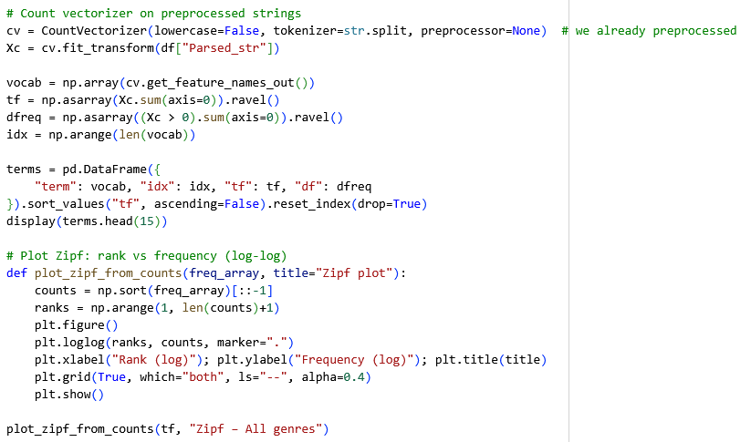
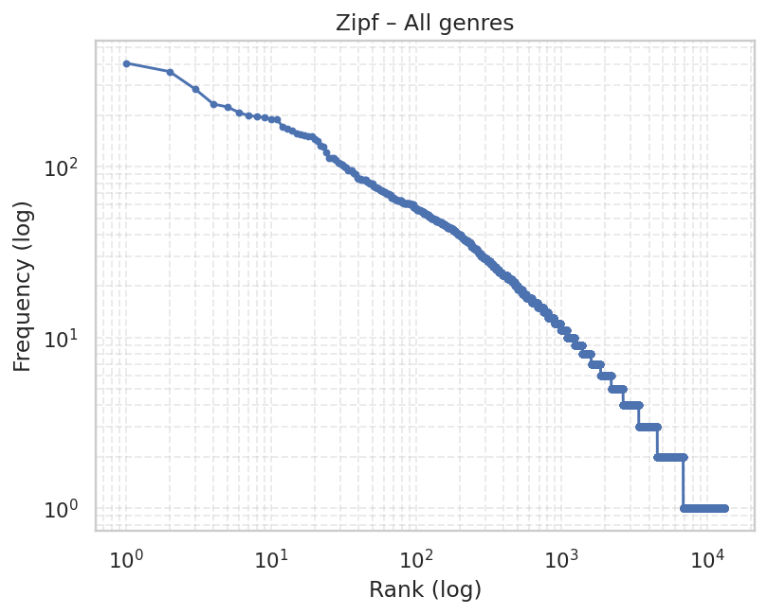
Output:
 | term | idx | tf | df
0 | film | 4385 | 405 | 261
1 | life | 6904 | 361 | 254
2 | one | 8318 | 285 | 202
3 | new | 8080 | 233 | 180
4 | year | 13123 | 224 | 176
5 | world | 13059 | 208 | 166
6 | story | 11349 | 199 | 164
7 | family | 4226 | 197 | 142
8 | love | 7080 | 194 | 146
9 | find | 4406 | 190 | 158
10 | time | 11959 | 190 | 143
11 | first | 4434 | 171 | 145
12 | friend | 4685 | 167 | 131
13 | rovi | 10152 | 162 | 162
14 | take | 11686 | 156 | 134

The output table reveals the most common words across all documents, providing a high-level summary of the dataset's content. Unsurprisingly, terms like "film", "life", "story", and "world" are highly frequent, which is consistent with a collection of book and movie descriptions. The presence of an unusual term like "rovi" in the top 15 suggests it might be a metadata artifact from the data source that wasn't removed during preprocessing.
The Zipf plot displays a distinct downward curve, which is the expected result and a confirmation of Zipf's Law, a principle which states that a small number of words are used very frequently, while the majority of words are used rarely. The relationship of our data to this law is a positive sign which indicates that our preprocessing steps were successful.

Question 3.4
The main dataset is first partitioned into four distinct sub-dataframes, each corresponding to one of the specified genres: Documentary, SciFi, Romance, and Kids&Family. This segmentation allows us to move beyond a global analysis of the entire dataset and examine the unique characteristics of each individual category to identify whether there are trends which would otherwise be difficult to identify.
After separating the data, the vectorization process from the previous task is repeated for each of the four genre-specific datasets. A corresponding Zipf plot is generated for each category. This is important to verify that the word frequency patterns within each individual genre also follow principles of natural language.
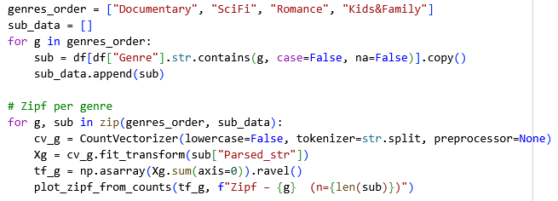
Output:
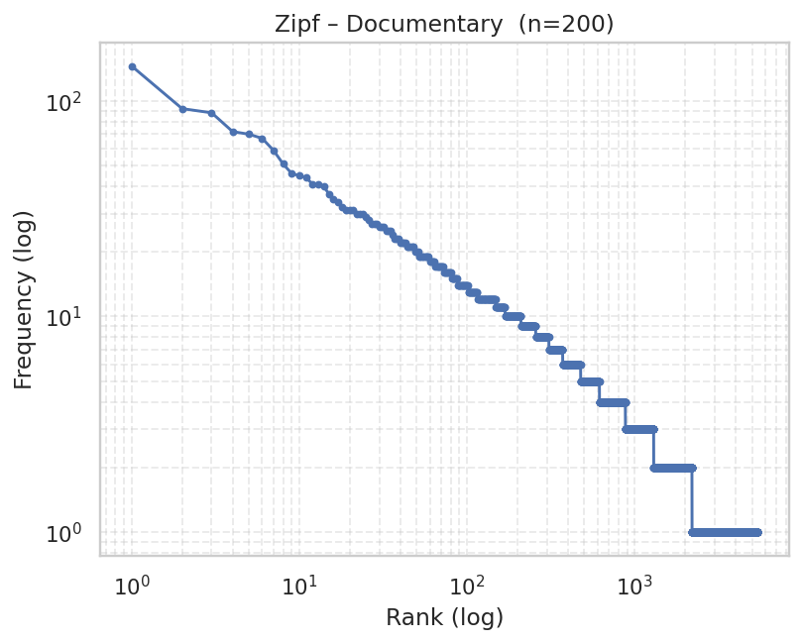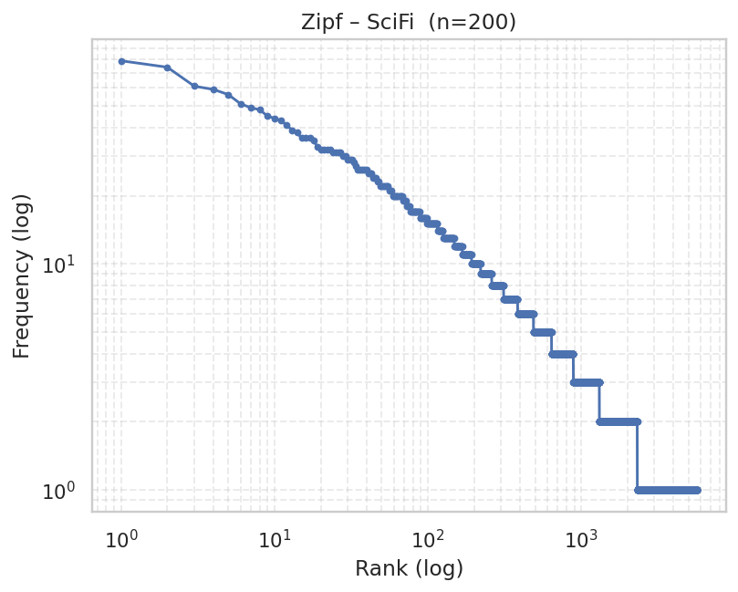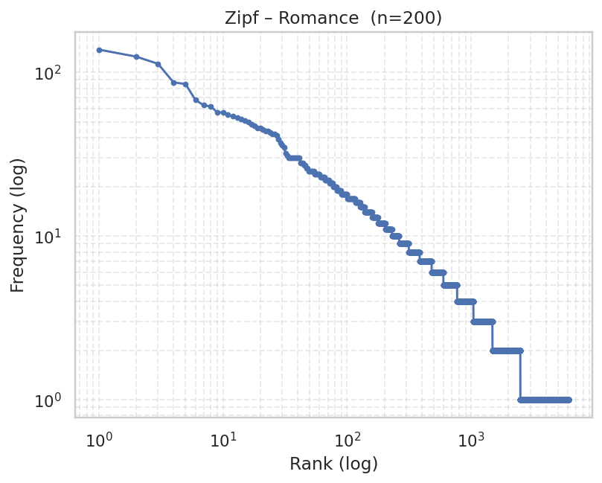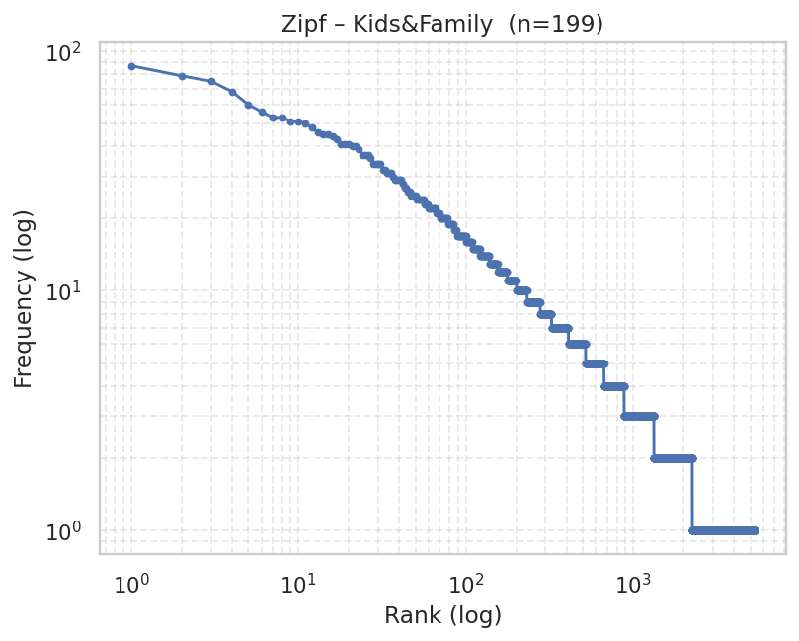

The output consists of four separate Zipf plots, one for each genre. Each plot shows the same downward logarithmic curve as we saw for the entire dataset. This confirms that Zipf's Law holds true not only for the entire dataset, but also for each individual genre category. This consistency indicates that each sub-dataset is a well-formed and follows the expected trend of Zipf’s Law. It assures us that each genre's text collection is suitable enough to be analysed as standalone data in later steps.

Question 3.5
We performed unsupervised topic modelling to automatically discover the main sub-topics within text data from four different genres with the goal to group similar documents together and then identify what each group is about without manually reading anything.
The process starts by converting text into a numerical format using TF-IDF. To make the process more efficient and reduce noise, we then simplify this data using LSA. Finally, the K-Means algorithm partitions the documents into 5 distinct clusters for each genre. To make sense of these clusters, we identify and visualize the top 12 most characteristic words for each one. This allows us to quickly understand the underlying themes and composition of each genre.
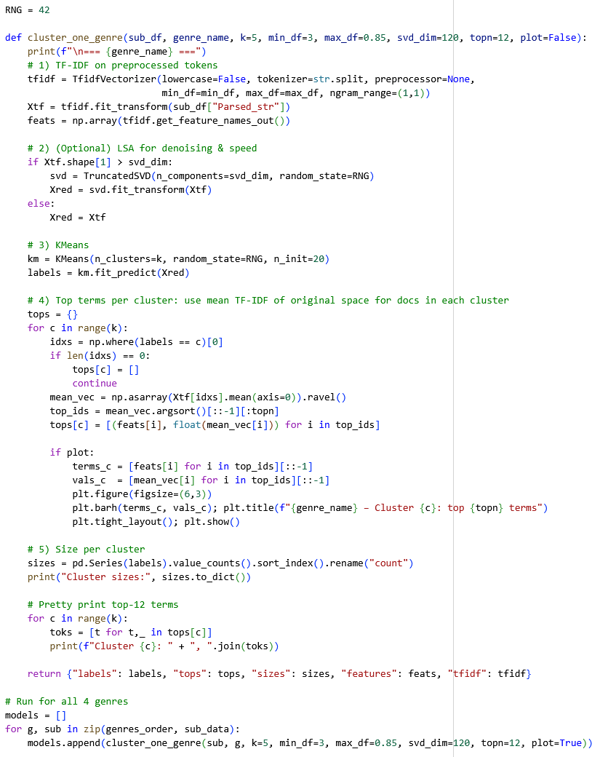

The top 12 characteristic words for each of the 20 generated clusters are visualised in pages 30-33.

Documentary
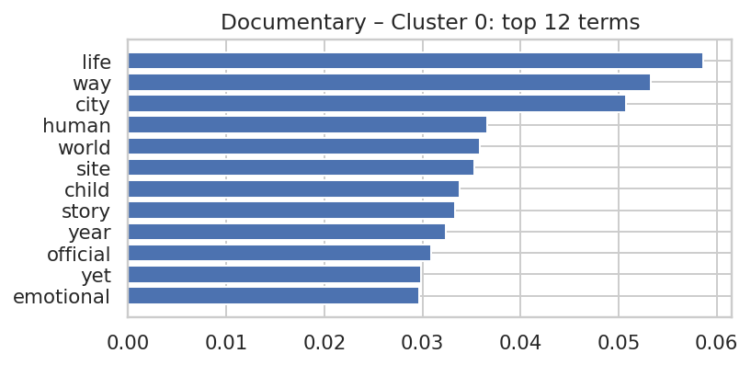
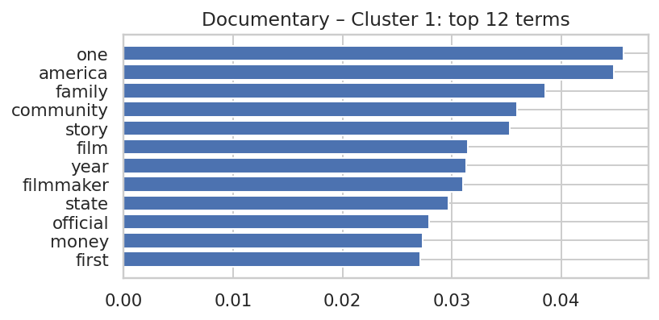
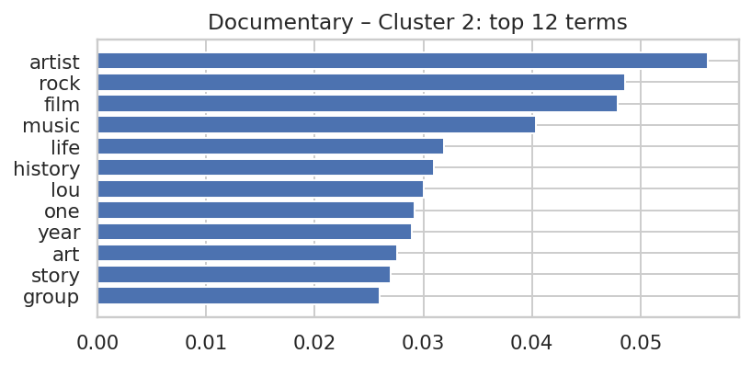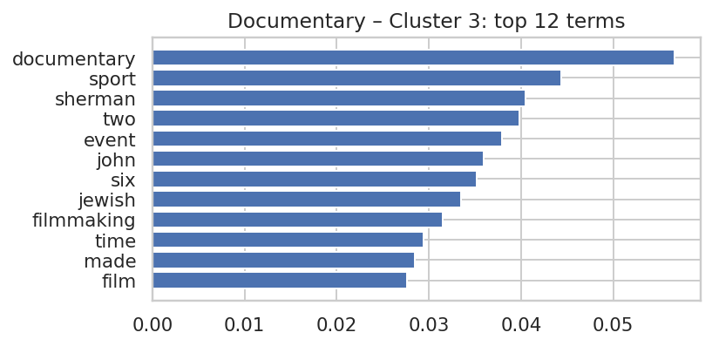
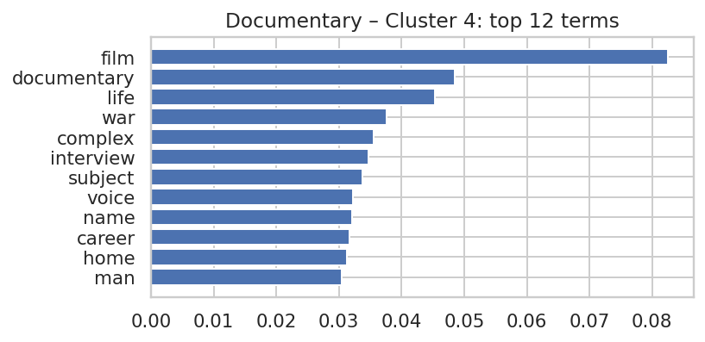
Figure 2.2

SciFi
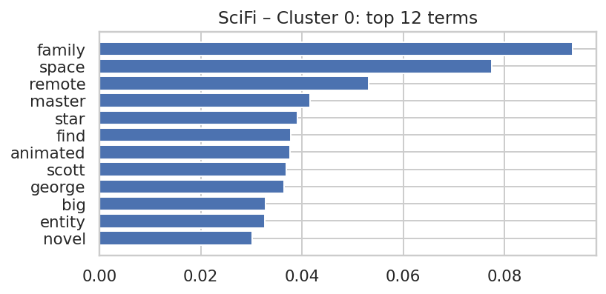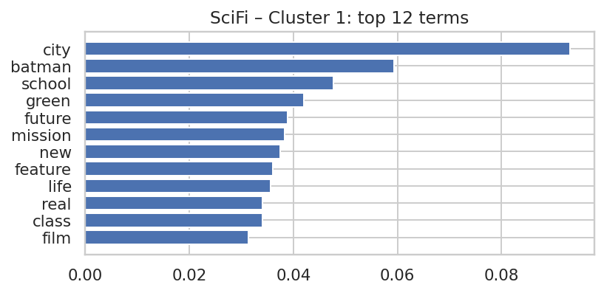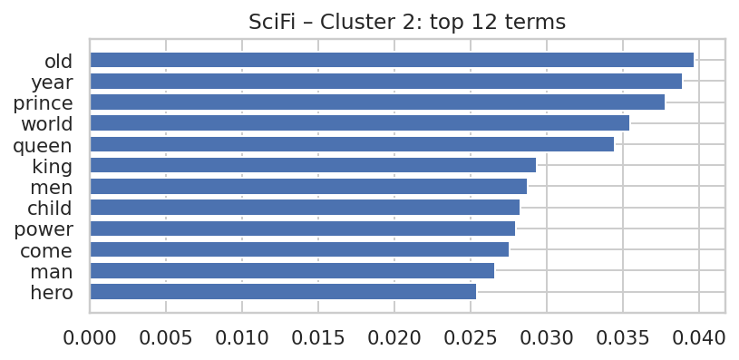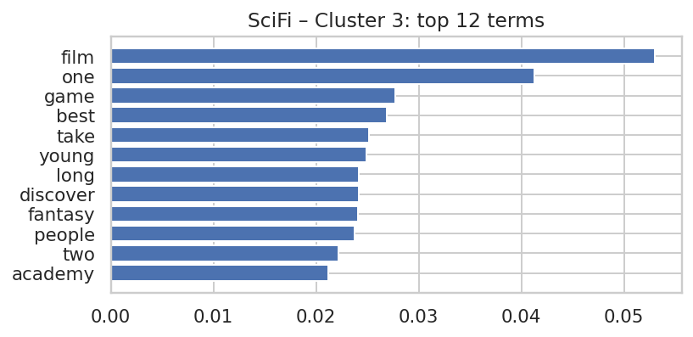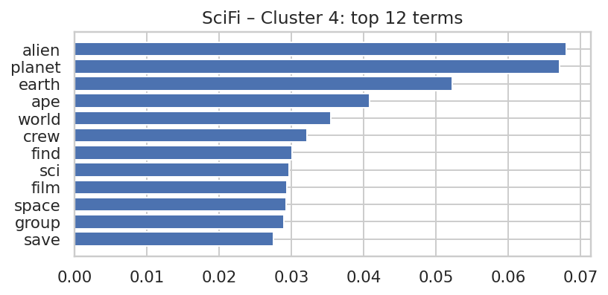
Figure 2.3

Romance
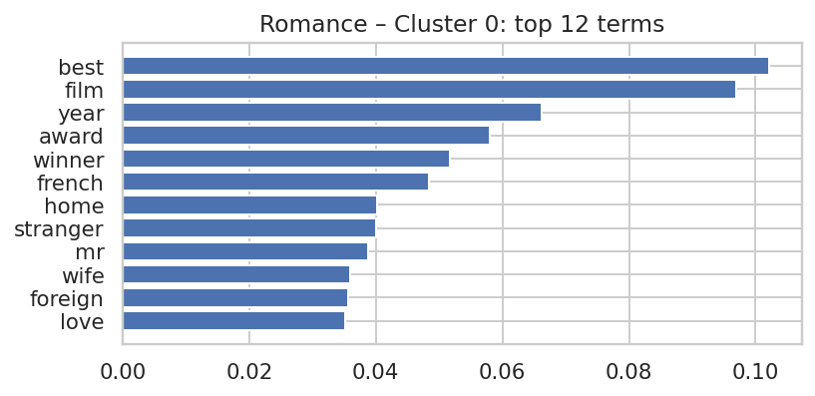
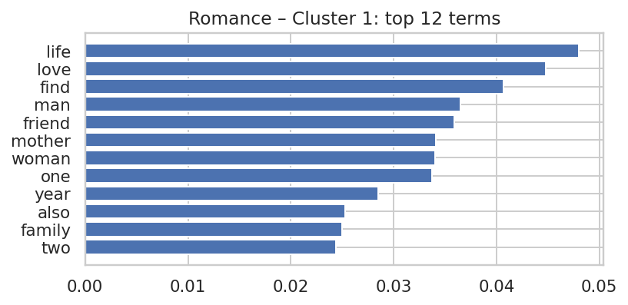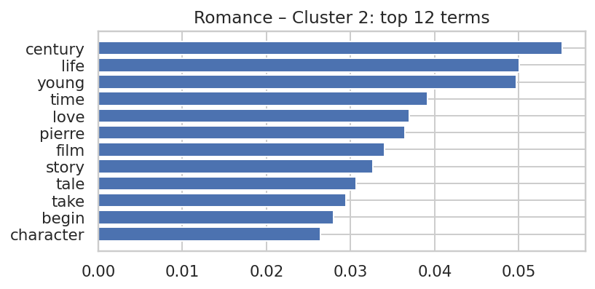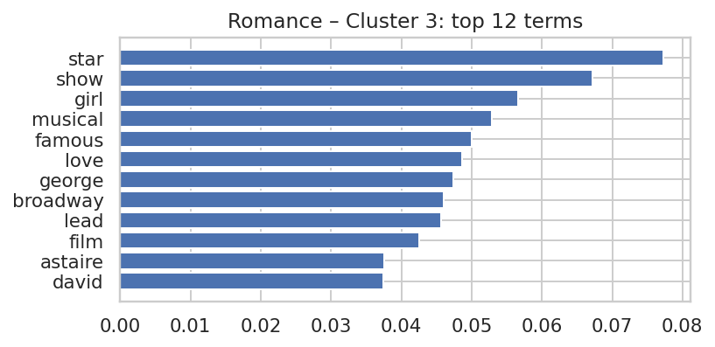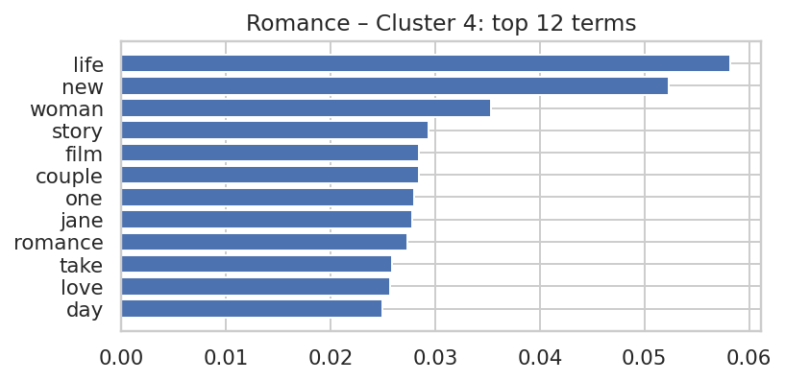
Figure 2.4

Kids&Family
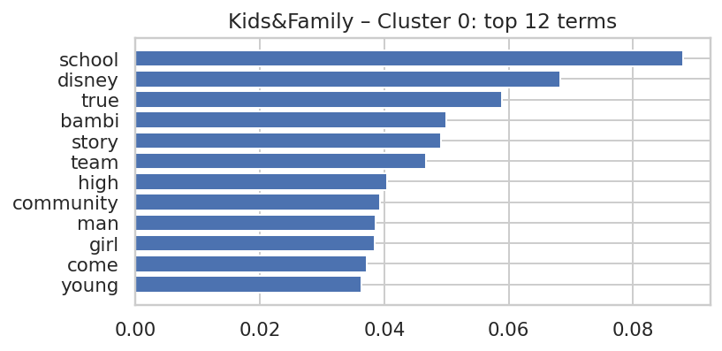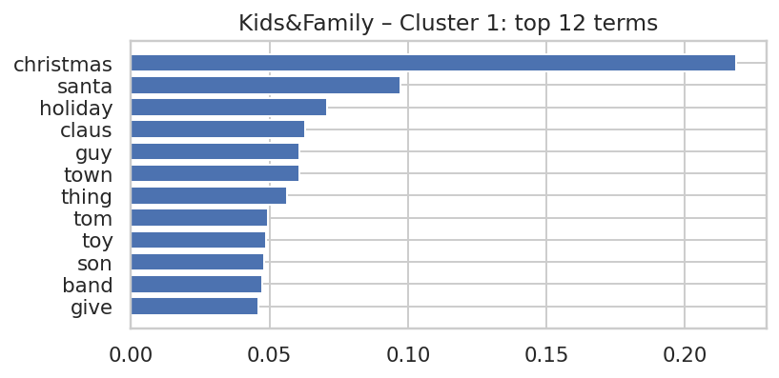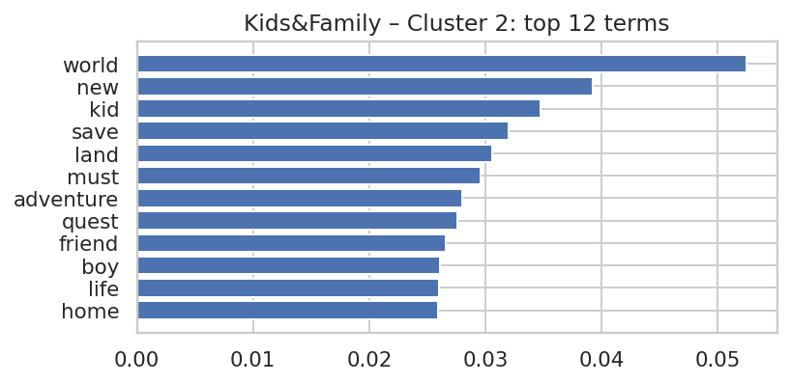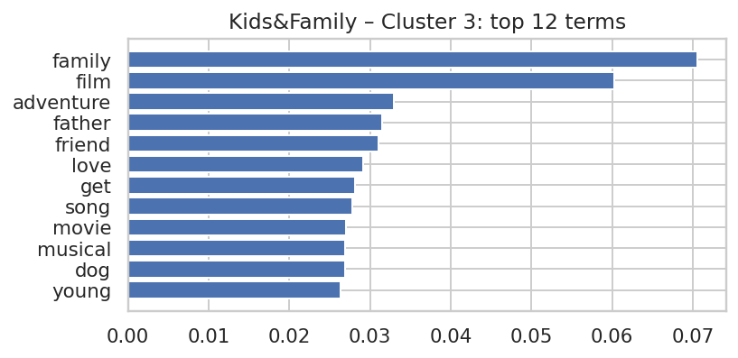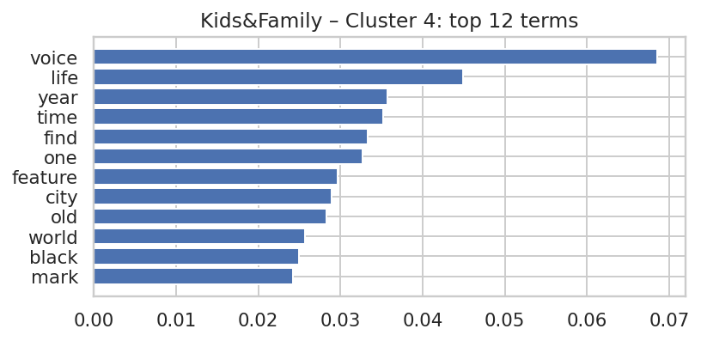
The clustering analysis successfully identified distinct sub-topics by examining the top terms for each group. For instance, Documentary Cluster 0, with keywords like life, human, world, and story, clearly points to a theme of human-interest stories or social commentaries. In a different example, SciFi Cluster 0 combines genre terms (space, star) with descriptors (animated) and proper names (scott, george), suggesting it has grouped influential works, perhaps film adaptations or titles associated with prominent directors, rather than a simple sub-genre. The model's ability to uncover both straightforward groups and more abstract connections confirms its effectiveness in organising text data based on their content.

Question 3.6
For each genre, we fitted TF-IDF + (optional) LSA + KMeans (k=5). For each cluster, we computed the mean TF-IDF vector across its documents and extracted the top 12 weighted terms. A sub-category name is assigned by summarising the dominant concepts appearing in the top terms (e.g., 'space/planet/alien' → 'Space Exploration & Alien Encounters'). We also verified the name by reading 2–3 representative titles/descriptions from the cluster.
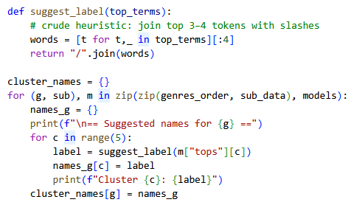
Output:
== Suggested names for Documentary ==
Cluster 0: life/way/city/human
Cluster 1: one/america/family/community
Cluster 2: artist/rock/film/music
Cluster 3: documentary/sport/sherman/two
Cluster 4: film/documentary/life/war

== Suggested names for SciFi ==
Cluster 0: family/space/remote/master
Cluster 1: city/batman/school/green
Cluster 2: old/year/prince/world
Cluster 3: film/one/game/best
Cluster 4: alien/planet/earth/ape

== Suggested names for Romance ==
Cluster 0: best/film/year/award
Cluster 1: life/love/find/man
Cluster 2: century/life/young/time
Cluster 3: star/show/girl/musical
Cluster 4: life/new/woman/story

== Suggested names for Kids&Family ==
Cluster 0: school/disney/true/bambi
Cluster 1: christmas/santa/holiday/claus
Cluster 2: world/new/kid/save
Cluster 3: family/film/adventure/father
Cluster 4: voice/life/year/time

The output shows the automatically generated label suggestions, which can be used as a starting point for human interpretation. These suggestions are created using a simple heuristic of joining the top four keywords for each cluster. This method is highly effective if a cluster has a strong and clear theme. For instance, the Kids&Family suggestion “christmas/santa/holiday/claus” accurately identifies a "Christmas & Holiday Films" sub-category. Likewise, the SciFi suggestion alien/planet/earth/ape clearly points towards a theme of "Alien Encounters". This step efficiently describes the theme of each cluster, ultimately providing the final sub-category names.

Task 4: Web Log Analysis

Question 4.1
Pre-process the weblog data to identify useful attributes (or variables) from the weblogs.txt file, such as IP Address, Remote Log Name, User ID, Timestamp, Request Type, Path, Protocol, Status, Size, Referrer, and User-Agent. Then, save the parsed logs into a Pandas DataFrame.
Aim: Convert the raw weblog.txt (Combined Log Format) into a tidy table where each row is one HTTP request with clearly typed fields ready for analysis in later questions.
- Parsing approach:
- Input format. Each line follows the Combined Log Format:

<ip> <remote_log> <user_id> [<timestamp>] "<method> <path> <protocol>" <status> <size> "<referrer>" "<user_agent>"

- Extractor. I used a single compiled regular expression to capture all tokens in one pass.
Key capture groups map to the following columns:
  - ip – client IP address
  - remote_log – RFC 1413 identity (often “–”)
  - user_id – authenticated user (often “–”)
  - timestamp – parsed as timezone-aware datetime using %d/%b/%Y:%H:%M:%S %z
  - request – split into:
    - method (e.g., GET/POST/HEAD/PUT/DELETE)
    - path (full request target including query string)
    - protocol (e.g., HTTP/1.1)
  - status – integer HTTP status code
  - size – integer bytes returned ("-" coerced to 0)
  - referrer – source URL or None
  - user_agent – browser/robot UA string
  - raw – the original line kept for auditability and potential re-parsing
- Normalisation & types.
  - Placeholder "-" values were converted to None (except size, which becomes 0).
  - status/size were coerced to integer types; method/protocol normalised to uppercase.
  - timestamp kept timezone information (important for sessionisation).
  - The request field was safely split even when the path contained spaces or URL-encoded characters.
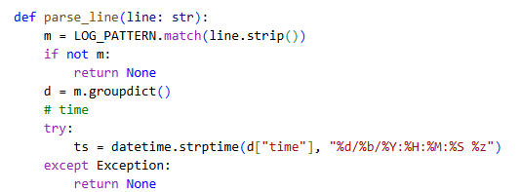
- Data quality checks:
- Row yield. Successfully parsed 15,000 rows × 12 columns (Parsed shape: (15000, 12)), meaning 100% of lines matched the pattern (no malformed drops).
- Sanity assertions.
  - status ∈ [100, 599], method ∈ {GET, POST, HEAD, PUT, DELETE, …}, protocol starts with HTTP/.
  - timestamp is monotonic within IP after sorting.
  - Visual spot-check confirms expected variety of UA strings (e.g., common browsers and known crawlers such as AhrefsBot, bingbot), and realistic referrer presence (external links vs None for direct hits/scripts).
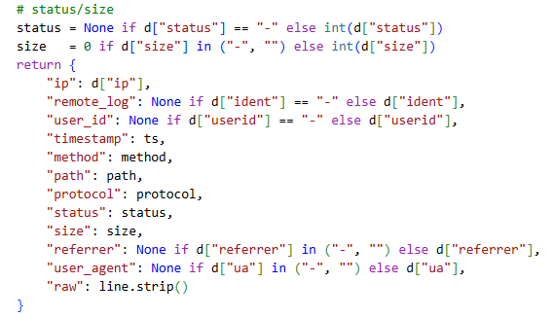

Output schema (Pandas DataFrame)
Column | Dtype | Description
ip | string | Client IP address
remote_log | string / None | RFC 1413 identity (rarely present)
user_id | string / None | Authenticated user if any
timestamp | datetime64[ns, tz] | Event time with timezone
method | string (upper) | HTTP verb
 | string | Request target (may include query)
  path
 | string | HTTP version
  protocol
status | int32 | HTTP status code
size | int32 | Bytes sent to client
referrer | string / None | Referrer URL
user_agent | int32 | Browser/robot UA
raw | int32 | Original log line for auditing
Table 1.7

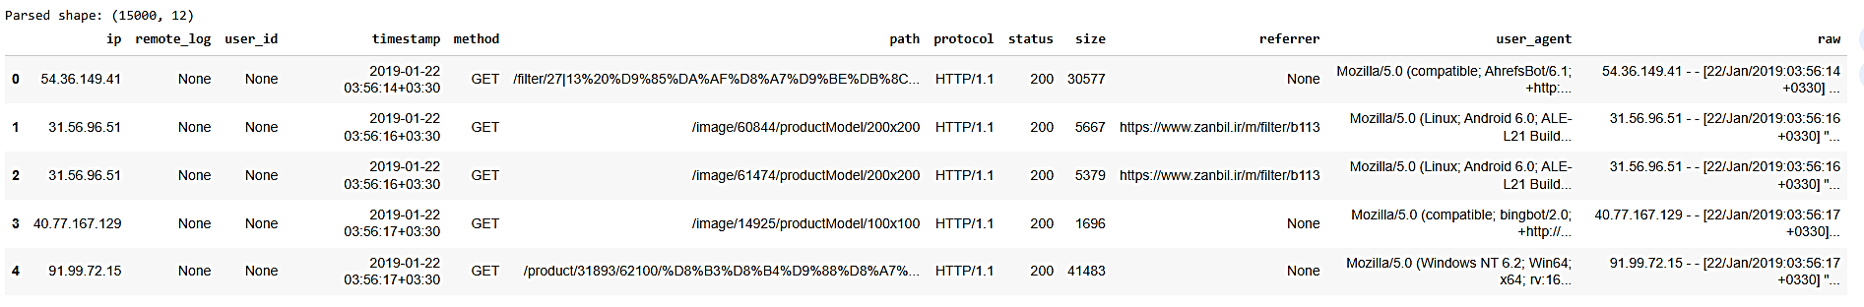
The parsed table was stored as a Pandas DataFrame named logs and will be the starting point for Q2 (static-asset filtering and sessionisation). This pre-processing ensures clean types, consistent handling of missing values, and full traceability back to the raw line when needed.
Table 1.8

Question 4.2
Select useful features for grouping logs into sessions, where each session is identified by a session key in the format “IP + Timestamp”. Remove entries in the Path column that reference graphics or audio files, and report how many rows and columns are removed after completing this question.

      - Objective
Prepare the parsed log (Q1) for session-based analysis by (i) keeping only fields that describe browsing behaviour, (ii) removing requests to static files (images/audio/video, etc.), and (iii) generating a session key in the form “IP + Timestamp”.

      - Selected features
From the parsed table (15,000 rows × 12 columns), I retained the attributes needed to build and describe sessions:
- ip (user proxy)
- timestamp (timezone-aware)
- method, path, status, size
- referrer, user_agent

Columns not required for sessionisation were dropped: remote_log, user_id, protocol, raw → 4 columns removed.

I added helper fields for the session logic: prev_ts (previous timestamp per IP), session_no (running counter), session_id (flag for session start), and the final session_key.

      - Static-asset filtering
To ensure the data reflects page-view behaviour, I removed requests whose path targets static resources using a regex for common extensions:
\.(png|jpe?g|gif|svg|ico|bmp|webp|mp3|wav|ogg|aac|m4a|flac|mp4|webm|avi|mov|mpe?g)(\?.*)?$
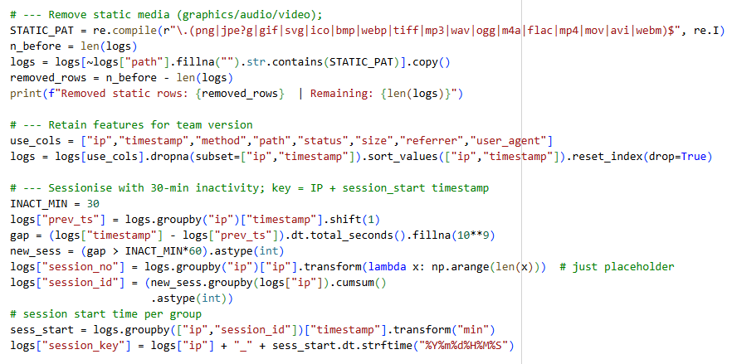
Because this site also serves images through an /image/... endpoint (file type appears in the query string), I complemented the filter with /^\/image\// (or name=.*\.(png|jpe?g|gif) in the query) to avoid counting image fetches as content views.
Result: 1,344 rows removed, leaving 13,656 rows for behavioural analysis.
(Preview in the notebook: “Removed static rows: 1344 | Remaining: 13656”.)

      - Session rule and session key
Sessions were constructed per IP with a 30-minute inactivity threshold:
- Sort by ip, timestamp; compute gap = timestamp − prev_ts.
- If gap > 30 minutes, start a new session.
- Define the session identifier as
session_key = "{ip}_{session_start:%Y%m%d%H%M%S}"
e.g., 104.194.24.54_20190122042409.
Unique sessions obtained: 841.

      - Summary of changes
- Rows removed: 1,344 (static resources) → 13,656 remain.
- Columns removed: 4 (remote_log, user_id, protocol, raw).
- Columns added: 4 (prev_ts, session_no, session_id, session_key).
- The working table now contains all fields required for the subsequent session-level feature engineering and clustering.

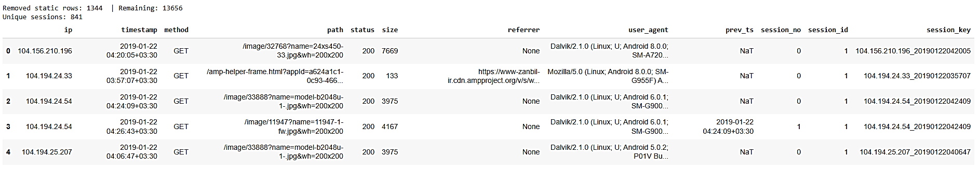
Conclusion
The log has been pruned to page-level requests, and each request is mapped to a session via a reproducible key (IP + session start time). This produces a clean foundation (13,656 requests across 841 sessions) for modelling user behaviour in the next questions.
Table 1.9

Question 4.3
Select a suitable data mining method to the processed dataset. Explain the rationale for selecting this method.
- Why clustering?
After Q2 the unit of analysis is a session and we do not have labels (e.g., “bot”, “human”, “buyer”). The business question is to discover patterns of behaviour (e.g., light browsing vs heavy crawling). This is a textbook unsupervised segmentation problem → use clustering.

- Why specifically K-means?
- Feature type & scale: the engineered session features are continuous (hits, unique_paths, duration_s, bytes_total, shares of 2xx/3xx/4xx/5xx, bot_ratio, etc.). After standardisation they are well-suited to K-means’ Euclidean distance.
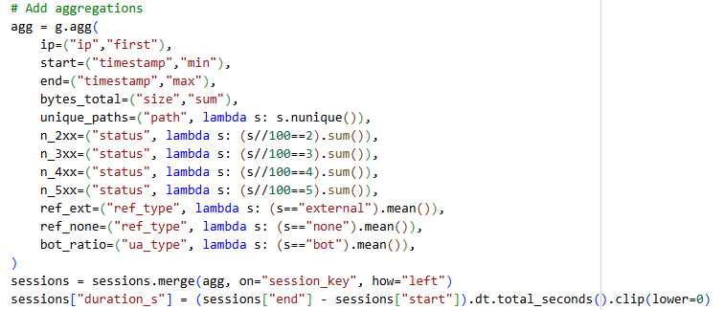
- Interpretability: K-means returns centroids that act as easy-to-read “profiles” (average hits, duration, bytes…), ideal for managerial explanations (e.g., “regular browsing” vs “heavy crawler”).
- Simplicity & speed: With ~841 sessions and ~10–15 features, K-means is fast, stable (n_init=20, random_state=42) and easy to re-run in production.
- Model selection: We can pick k with objective criteria. Inertia (SSE) for the elbow and silhouette scores are standard and informative (see plots). In our data the silhouette peaks at k = 2, and the elbow also shows diminishing returns after small k → choose k=2.

Implementation summary
- Standardise numeric features (and optionally log1p transform the heavy-tailed variables like hits, duration_s, bytes_total).
- Fit K-means for k = 2…8 → record inertia and silhouette.
Observed: silhouette ≈ 0.85 at k=2 (highest); inertia falls sharply up to k≈4 then flattens.
- Fix k = 2, n_init=20, max_iter=500, random_state=42; label sessions and profile clusters via mean/min/max.

Alternatives considered (and why not chosen)
- DBSCAN/HDBSCAN: good for arbitrary shapes/outlier discovery, but requires sensitive eps/min_samples tuning and can struggle with mixed-scale, standardised features; also less interpretable for business users.
- Gaussian Mixture Models: probabilistic soft clustering, but centroids are less straightforward to communicate and convergence can be unstable with heavy tails/outliers.
- Hierarchical clustering: interpretable dendrograms, but O(n²) memory/time and less convenient for selecting k at this scale.
K-means directly matches our unlabeled, numeric session data, provides clear, explainable segment profiles, and its quality can be validated with elbow/silhouette. The chosen k = 2 (highest silhouette) cleanly separates regular browsing from heavy crawler sessions, which is exactly the distinction we need for operations and analytics.
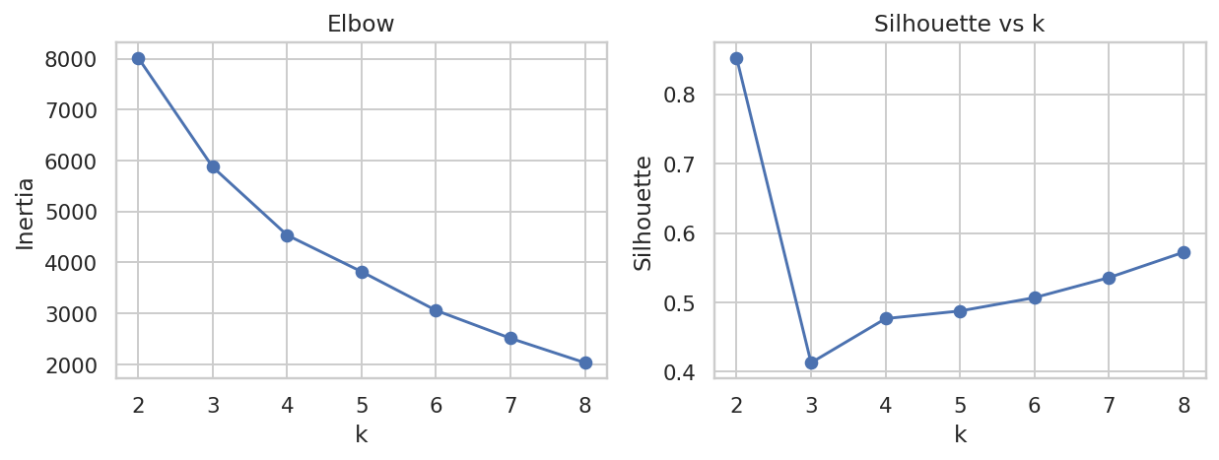
Figure 2.6

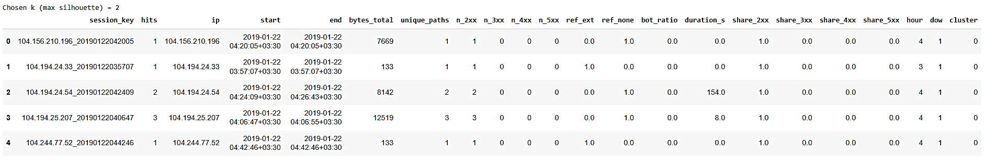
Table 2.0

Question 4.4
For the selected data mining method, describe its goal, and outline the corresponding steps of your data analysis as implemented in your Python code.
Chosen method: Unsupervised session segmentation with K-means
Goal: discover behavioural segments of visits (sessions) without labels—e.g., normal browsing vs heavy crawlers—so that we can quantify their profiles (hits, paths, duration, bandwidth, errors) and act on them operationally (bot control, analytics de-biasing, performance).

End-to-end analysis pipeline
- Input & cleaning (from Q1–Q2)
  - Parse Combined Log Format → tidy DataFrame.
  - Remove static assets (images/audio/video and /image/... endpoint) to focus on page views.
  - Build sessions per IP with a 30-minute inactivity cut-off.
  - Output: 841 sessions from 13,656 requests.
- Session-level feature engineering
For each session_key aggregate:
  - Intensity/coverage: hits, unique_paths, duration_s, bytes_total.
  - Response quality: counts & shares of 2xx/3xx/4xx/5xx (n_2xx, …, share_4xx, …).
  - Source/agent: ref_none (no referrer), bot_ratio (regex on UA: bot|spider|crawl|slurp).
  - Temporal: hour, dow (used only for profiling, not distance).
- Pre-processing for clustering
  - Handle heavy tails with log1p for (hits, unique_paths, duration_s, bytes_total).
  - Standardise numeric features (StandardScaler) so Euclidean distances are comparable.
- Model selection (choose k)
  - Fit K-means for k = 2…8 with n_init=20, random_state=42.
  - Record inertia (SSE, “Elbow”) and silhouette.
  - Observed: silhouette peaks at k=2 (~0.85); elbow flattens after small k ⇒ k=2 chosen.
- Final model & labelling
  - Train K-means (k=2) on the scaled feature matrix.
  - Attach cluster to each session.
- Validation & interpretation
  - Pairplot of key variables coloured by cluster (figure above): one small cluster forms an extreme tail across hits/paths/duration/bytes.
  - Cluster profiles (mean/min/max):
    - Cluster 0 (n=837) – regular browsing: hits=10.78, unique_paths=9.52, duration_s=364, bytes_total≈198kB, bot_ratio≈0.51.
    - Cluster 1 (n=4) – heavy crawlers: hits=1157.5, unique_paths=1101.5, duration_s≈3042s, bytes_total≈33 MB, bot_ratio≈0.75.
  - Error context: top 404 paths are mostly AMP preconnect placeholders (diagnostic noise), not broken content.
  - Agent check: average bot_ratio by cluster confirms crawler concentration in Cluster1.
- Outputs for the report
  - Elbow & silhouette plots, labelled sessions table, pairplot, cluster-profile table, top-404 list, UA bot ratios.
Summary. K-means on engineered session features cleanly separates normal sessions from a tiny set of bandwidth-heavy crawler sessions. The method meets our goal of unsupervised behaviour discovery, is reproducible (fixed seed, standard scaling), and produces interpretable centroids that directly translate into operational actions (rate-limit bots, exclude crawler traffic from KPIs, de-noise synthetic 404s).

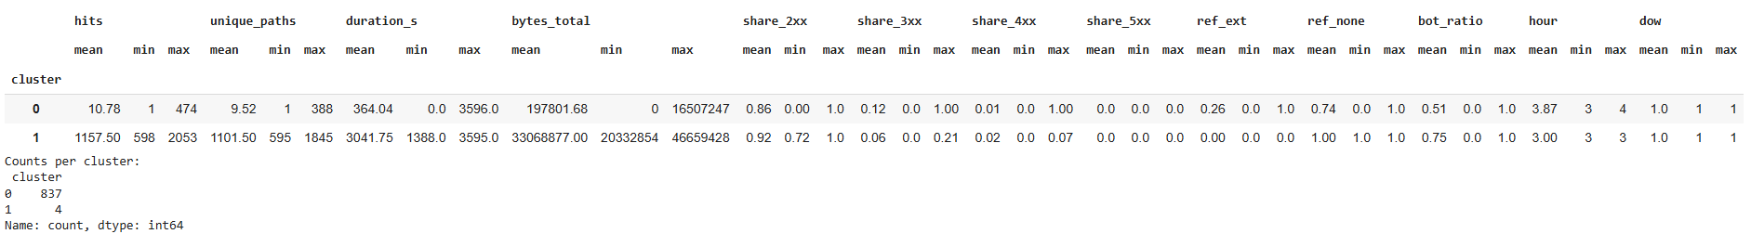
Table 2.1

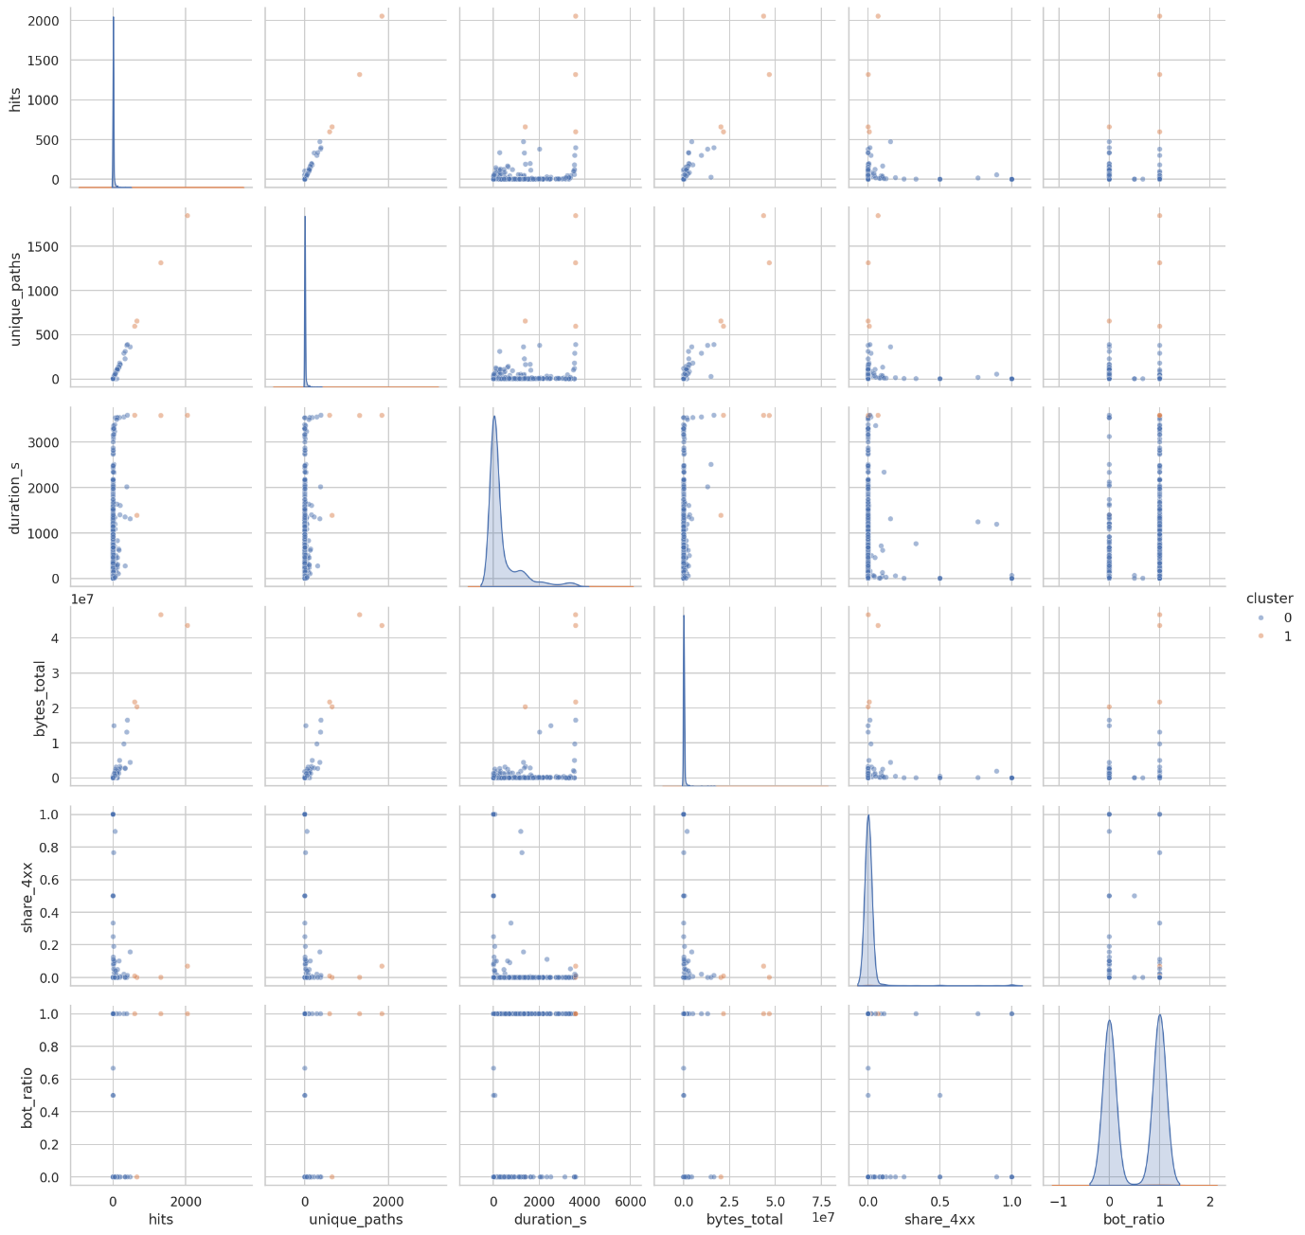
Figure 2.7

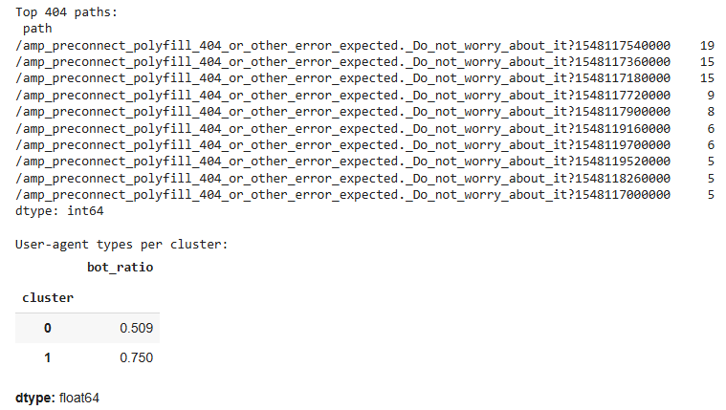

Question 4.5
Discuss the results obtained, and the applicability of your findings. You should include only a high-level managerial kind of discussion on the findings. It should be more than just an interpretation of the method output.
From 13,656 page-view requests we derived 841 sessions. Unsupervised clustering (k=2, best silhouette) reveals two very different behaviours:
- Cluster 0 – Regular browsing (n=837): short sessions (~6 min), ~11 hits, ~10 unique pages, ~0.2 MB per session, mixed human/benign bot traffic (bot_ratio ≈ 0.51).
- Cluster 1 – Heavy crawlers (n=4): extremely long sessions (~51 min), ~1,158 hits, ~1,102 unique pages, ~33 MB per session, bot_ratio ≈ 0.75.
- The most frequent 404s are AMP “preconnect polyfill” placeholders, i.e., diagnostic noise rather than broken pages.

Why this matters?
- Cost & performance control.
A handful of crawler sessions create a disproportionate share of traffic and bandwidth. Left unchecked, this degrades page speed for real users and inflates infrastructure costs.
- Clean analytics & better decisions.
Including crawler traffic overstates sessions, page views and engagement. Removing Cluster 1 (and generally bot-like sessions) from BI dashboards will yield truer marketing KPIs and more reliable A/B tests.
- Operational focus on the right errors.
Since many 404s are synthetic probes, engineering time should prioritise genuine content or 5xx errors, not AMP preconnect artifacts.
- User experience opportunities.
Regular sessions are short with limited depth. This suggests work on landing quality (content relevance, internal links, search/navigation) can raise depth and time-on-site for humans.

Actionable recommendations:
- Traffic governance:
  - Add/adjust robots.txt rules (crawl-delay, disallow high-cost endpoints like /image/) and rate-limit high-frequency UAs/IPs; whitelist major search engines to protect SEO.
  - Serve heavy/static assets via CDN with strong caching; consider 429 responses when thresholds are exceeded.
- Analytics hygiene.
  - Implement a pipeline rule to exclude crawler-like sessions (features similar to Cluster 1) from reporting.
  - Track a weekly bot footprint metric (share of sessions flagged as bot-heavy) to detect spikes.
- Monitoring & SRE.
  - Alert on anomalous session profiles (e.g., hits, bytes_total, unique_paths z-scores) rather than raw request rate.
  - De-noise AMP preconnect 404s in alerting; route only actionable 4xx/5xx to on-call.
- Product & content.
  - Review top entry pages in Cluster 0; optimise copy, speed, and CTAs; add internal links to increase path depth.
  - If image endpoints are frequently hit by bots, consider signed URLs or lower-cost renditions for unauthenticated fetches.

Risks & limitations: Sessions are IP-based (NAT can merge users); bot detection via UA regex is heuristic. Still, the separation is large enough that policy actions (rate limits, filters) are low-risk and high-impact.
A very small number of sessions behave like aggressive crawlers and dominate bandwidth; managing them will improve user performance, reduce costs, and clean up analytics. In parallel, optimising entry pages for regular sessions can lift real engagement and conversion.

Appendix

Appendix A
 | antecedents | consequents | support | confidence | expected_confidence | lift | leverage | conviction | antecedent_len | consequent_len
0 | (Sugar,) | (Cheese,) | 0.021542 | 0.295620 | 0.030230 | 9.779055 | 0.019339 | 1.376772 | 1 | 1
1 | (Cheese,) | (Sugar,) | 0.021542 | 0.712610 | 0.072871 | 9.779055 | 0.019339 | 3.226030 | 1 | 1
2 | (Bread,) | (Butter,) | 0.040212 | 0.531023 | 0.154784 | 3.430726 | 0.028491 | 1.802254 | 1 | 1
3 | (Butter,) | (Bread,) | 0.040212 | 0.259794 | 0.075726 | 3.430726 | 0.028491 | 1.248672 | 1 | 1
4 | (Milk,) | (Butter,) | 0.029343 | 0.517349 | 0.154784 | 3.342384 | 0.020564 | 1.751195 | 1 | 1
5 | (Butter,) | (Milk,) | 0.029343 | 0.189576 | 0.056719 | 3.342384 | 0.020564 | 1.163936 | 1 | 1
6 | (Conditioner,) | (Butter,) | 0.077375 | 0.514441 | 0.154784 | 3.323593 | 0.054094 | 1.740705 | 1 | 1
7 | (Butter,) | (Conditioner,) | 0.077375 | 0.499885 | 0.150405 | 3.323593 | 0.054094 | 1.698801 | 1 | 1
8 | (Butter, Tea) | (Conditioner,) | 0.023014 | 0.492600 | 0.150405 | 3.275152 | 0.015987 | 1.674407 | 2 | 1
9 | (Conditioner,) | (Butter, Tea) | 0.023014 | 0.153012 | 0.046719 | 3.275152 | 0.015987 | 1.125495 | 1 | 2
10 | (Conditioner, Tea) | (Butter,) | 0.023014 | 0.377545 | 0.154784 | 2.439166 | 0.013579 | 1.357874 | 2 | 1
11 | (Butter,) | (Conditioner, Tea) | 0.023014 | 0.148683 | 0.060956 | 2.439166 | 0.013579 | 1.103048 | 1 | 2
12 | (Coffee,) | (Peanut butter,) | 0.015017 | 0.287802 | 0.157604 | 1.826110 | 0.006794 | 1.182811 | 1 | 1
13 | (Egg, Peanut butter) | (Yoghurt,) | 0.016365 | 0.552695 | 0.370259 | 1.492723 | 0.005402 | 1.407854 | 2 | 1
14 | (Cordial, Shampoo, Tea) | (Yoghurt,) | 0.016773 | 0.547454 | 0.370259 | 1.478568 | 0.005429 | 1.391550 | 3 | 1
15 | (Cereal,) | (Tea,) | 0.058350 | 0.643150 | 0.455205 | 1.412881 | 0.017051 | 1.526680 | 1 | 1
16 | (Tea,) | (Cereal,) | 0.058350 | 0.128184 | 0.090725 | 1.412881 | 0.017051 | 1.042966 | 1 | 1
17 | (Bread,) | (Conditioner,) | 0.016081 | 0.212362 | 0.150405 | 1.411936 | 0.004692 | 1.078662 | 1 | 1
18 | (Cordial, Shampoo) | (Tea, Yoghurt) | 0.016773 | 0.192590 | 0.143739 | 1.339860 | 0.004254 | 1.060503 | 2 | 2
19 | (Egg, Shampoo, Tea) | (Yoghurt,) | 0.020638 | 0.487233 | 0.370259 | 1.315924 | 0.004955 | 1.228123 | 3 | 1
20 | (Shampoo, Tea, Yoghurt) | (Egg,) | 0.020638 | 0.424198 | 0.323966 | 1.309392 | 0.004876 | 1.174074 | 3 | 1
21 | (Egg,) | (Yoghurt,) | 0.154820 | 0.477890 | 0.370259 | 1.290689 | 0.034869 | 1.206145 | 1 | 1
22 | (Yoghurt,) | (Egg,) | 0.154820 | 0.418139 | 0.323966 | 1.290689 | 0.034869 | 1.161848 | 1 | 1
23 | (Shampoo, Tea) | (Cordial, Yoghurt) | 0.016773 | 0.149376 | 0.117072 | 1.275931 | 0.003627 | 1.037977 | 2 | 2
24 | (Cordial, Yoghurt) | (Shampoo, Tea) | 0.016773 | 0.143268 | 0.112285 | 1.275931 | 0.003627 | 1.036164 | 2 | 2
25 | (Cordial, Tea, Yoghurt) | (Shampoo,) | 0.016773 | 0.394002 | 0.309445 | 1.273256 | 0.003600 | 1.139535 | 3 | 1
26 | (Shampoo, Tea, Yoghurt) | (Cordial,) | 0.016773 | 0.344752 | 0.271538 | 1.269629 | 0.003562 | 1.111736 | 3 | 1
27 | (Tea, Yoghurt) | (Egg,) | 0.059095 | 0.411126 | 0.323966 | 1.269042 | 0.012528 | 1.148012 | 2 | 1
28 | (Egg,) | (Tea, Yoghurt) | 0.059095 | 0.182410 | 0.143739 | 1.269042 | 0.012528 | 1.047300 | 1 | 2
29 | (Egg, Shampoo) | (Tea, Yoghurt) | 0.020638 | 0.181421 | 0.143739 | 1.262162 | 0.004287 | 1.046035 | 2 | 2
30 | (Tea, Yoghurt) | (Egg, Shampoo) | 0.020638 | 0.143580 | 0.113757 | 1.262162 | 0.004287 | 1.034823 | 2 | 2
31 | (Cordial, Shampoo) | (Yoghurt,) | 0.040389 | 0.463762 | 0.370259 | 1.252533 | 0.008143 | 1.174368 | 2 | 1
32 | (Peanut butter, Yoghurt) | (Shampoo,) | 0.016702 | 0.384020 | 0.309445 | 1.240995 | 0.003243 | 1.121067 | 2 | 1
33 | (Yoghurt,) | (Egg, Tea) | 0.059095 | 0.159604 | 0.128845 | 1.238723 | 0.011389 | 1.036600 | 1 | 2
34 | (Egg, Tea) | (Yoghurt,) | 0.059095 | 0.458649 | 0.370259 | 1.238723 | 0.011389 | 1.163275 | 2 | 1
35 | (Peanut butter, Shampoo) | (Yoghurt,) | 0.016702 | 0.456617 | 0.370259 | 1.233234 | 0.003159 | 1.158925 | 2 | 1
36 | (Shampoo,) | (Yoghurt,) | 0.141061 | 0.455853 | 0.370259 | 1.231172 | 0.026486 | 1.157298 | 1 | 1
37 | (Yoghurt,) | (Shampoo,) | 0.141061 | 0.380980 | 0.309445 | 1.231172 | 0.026486 | 1.115561 | 1 | 1
38 | (Shampoo, Tea) | (Egg, Yoghurt) | 0.020638 | 0.183799 | 0.154820 | 1.187180 | 0.003254 | 1.035505 | 2 | 2
39 | (Egg, Yoghurt) | (Shampoo, Tea) | 0.020638 | 0.133303 | 0.112285 | 1.187180 | 0.003254 | 1.024250 | 2 | 2
40 | (Egg,) | (Cordial,) | 0.103686 | 0.320053 | 0.271538 | 1.178667 | 0.015717 | 1.071351 | 1 | 1
41 | (Cordial,) | (Egg,) | 0.103686 | 0.381848 | 0.323966 | 1.178667 | 0.015717 | 1.093637 | 1 | 1
42 | (Shampoo, Tea) | (Yoghurt,) | 0.048652 | 0.433286 | 0.370259 | 1.170223 | 0.007077 | 1.111214 | 2 | 1
43 | (Yoghurt,) | (Shampoo, Tea) | 0.048652 | 0.131399 | 0.112285 | 1.170223 | 0.007077 | 1.022005 | 1 | 2
44 | (Cordial,) | (Yoghurt,) | 0.117072 | 0.431146 | 0.370259 | 1.164443 | 0.016533 | 1.107034 | 1 | 1
45 | (Yoghurt,) | (Cordial,) | 0.117072 | 0.316190 | 0.271538 | 1.164443 | 0.016533 | 1.065300 | 1 | 1
46 | (Shampoo, Tea) | (Egg,) | 0.042357 | 0.377230 | 0.323966 | 1.164414 | 0.005981 | 1.085528 | 2 | 1
47 | (Egg,) | (Shampoo, Tea) | 0.042357 | 0.130746 | 0.112285 | 1.164414 | 0.005981 | 1.021238 | 1 | 2
48 | (Peanut butter, Yoghurt) | (Egg,) | 0.016365 | 0.376274 | 0.323966 | 1.161462 | 0.002275 | 1.083864 | 2 | 1
49 | (Egg, Tea) | (Shampoo, Yoghurt) | 0.020638 | 0.160176 | 0.141061 | 1.135507 | 0.002463 | 1.022760 | 2 | 2
50 | (Shampoo, Yoghurt) | (Egg, Tea) | 0.020638 | 0.146305 | 0.128845 | 1.135507 | 0.002463 | 1.020452 | 2 | 2
51 | (Egg,) | (Shampoo,) | 0.113757 | 0.351138 | 0.309445 | 1.134736 | 0.013507 | 1.064256 | 1 | 1
52 | (Shampoo,) | (Egg,) | 0.113757 | 0.367616 | 0.323966 | 1.134736 | 0.013507 | 1.069024 | 1 | 1
53 | (Egg, Tea, Yoghurt) | (Shampoo,) | 0.020638 | 0.349235 | 0.309445 | 1.128585 | 0.002351 | 1.061144 | 3 | 1
54 | (Cordial, Yoghurt) | (Shampoo,) | 0.040389 | 0.344995 | 0.309445 | 1.114883 | 0.004162 | 1.054274 | 2 | 1
55 | (Shampoo,) | (Cordial, Yoghurt) | 0.040389 | 0.130522 | 0.117072 | 1.114883 | 0.004162 | 1.015469 | 1 | 2
56 | (Egg, Tea) | (Cordial,) | 0.038847 | 0.301500 | 0.271538 | 1.110343 | 0.003860 | 1.042895 | 2 | 1
57 | (Cordial,) | (Egg, Tea) | 0.038847 | 0.143062 | 0.128845 | 1.110343 | 0.003860 | 1.016591 | 1 | 2
58 | (Egg, Shampoo) | (Yoghurt,) | 0.046719 | 0.410692 | 0.370259 | 1.109201 | 0.004599 | 1.068610 | 2 | 1
59 | (Yoghurt,) | (Egg, Shampoo) | 0.046719 | 0.126179 | 0.113757 | 1.109201 | 0.004599 | 1.014216 | 1 | 2
60 | (Tea, Yoghurt) | (Shampoo,) | 0.048652 | 0.338473 | 0.309445 | 1.093807 | 0.004172 | 1.043880 | 2 | 1
61 | (Shampoo,) | (Tea, Yoghurt) | 0.048652 | 0.157222 | 0.143739 | 1.093807 | 0.004172 | 1.015999 | 1 | 2
62 | (Tea, Yoghurt) | (Cordial,) | 0.042570 | 0.296164 | 0.271538 | 1.090691 | 0.003540 | 1.034988 | 2 | 1
63 | (Cordial,) | (Tea, Yoghurt) | 0.042570 | 0.156774 | 0.143739 | 1.090691 | 0.003540 | 1.015459 | 1 | 2
64 | (Cordial, Tea) | (Egg,) | 0.038847 | 0.346348 | 0.323966 | 1.069089 | 0.002510 | 1.034242 | 2 | 1
65 | (Egg, Tea) | (Shampoo,) | 0.042357 | 0.328746 | 0.309445 | 1.062375 | 0.002487 | 1.028754 | 2 | 1
66 | (Shampoo,) | (Egg, Tea) | 0.042357 | 0.136882 | 0.128845 | 1.062375 | 0.002487 | 1.009311 | 1 | 2
67 | (Cordial, Tea) | (Shampoo, Yoghurt) | 0.016773 | 0.149542 | 0.141061 | 1.060117 | 0.000951 | 1.009971 | 2 | 2
68 | (Shampoo, Yoghurt) | (Cordial,) | 0.040389 | 0.286325 | 0.271538 | 1.054457 | 0.002086 | 1.020720 | 2 | 1
69 | (Cordial,) | (Shampoo, Yoghurt) | 0.040389 | 0.148743 | 0.141061 | 1.054457 | 0.002086 | 1.009024 | 1 | 2
70 | (Peanut butter,) | (Tea,) | 0.074999 | 0.475869 | 0.455205 | 1.045396 | 0.003257 | 1.039426 | 1 | 1
71 | (Tea,) | (Peanut butter,) | 0.074999 | 0.164758 | 0.157604 | 1.045396 | 0.003257 | 1.008566 | 1 | 1
72 | (Shampoo,) | (Cordial,) | 0.087091 | 0.281442 | 0.271538 | 1.036473 | 0.003065 | 1.013783 | 1 | 1
73 | (Cordial,) | (Shampoo,) | 0.087091 | 0.320731 | 0.309445 | 1.036473 | 0.003065 | 1.016616 | 1 | 1
74 | (Cordial, Tea) | (Yoghurt,) | 0.042570 | 0.379545 | 0.370259 | 1.025078 | 0.001041 | 1.014965 | 2 | 1
75 | (Shampoo, Yoghurt) | (Egg,) | 0.046719 | 0.331197 | 0.323966 | 1.022319 | 0.001020 | 1.010811 | 2 | 1
76 | (Egg,) | (Shampoo, Yoghurt) | 0.046719 | 0.144210 | 0.141061 | 1.022319 | 0.001020 | 1.003679 | 1 | 2
77 | (Shampoo, Tea) | (Cordial,) | 0.030638 | 0.272856 | 0.271538 | 1.004857 | 0.000148 | 1.001814 | 2 | 1
78 | (Egg, Yoghurt) | (Shampoo,) | 0.046719 | 0.301764 | 0.309445 | 0.975177 | -0.001189 | 0.988999 | 2 | 1
79 | (Shampoo,) | (Egg, Yoghurt) | 0.046719 | 0.150977 | 0.154820 | 0.975177 | -0.001189 | 0.995474 | 1 | 2
80 | (Egg, Shampoo, Yoghurt) | (Tea,) | 0.020638 | 0.441746 | 0.455205 | 0.970433 | -0.000629 | 0.975891 | 3 | 1
81 | (Sugar,) | (Shampoo,) | 0.021595 | 0.296350 | 0.309445 | 0.957684 | -0.000954 | 0.981391 | 1 | 1
82 | (Milk,) | (Tea,) | 0.023652 | 0.417005 | 0.455205 | 0.916083 | -0.002167 | 0.934477 | 1 | 1
83 | (Peanut butter, Yoghurt) | (Tea,) | 0.018120 | 0.416633 | 0.455205 | 0.915264 | -0.001678 | 0.933880 | 2 | 1
84 | (Cordial, Shampoo, Yoghurt) | (Tea,) | 0.016773 | 0.415277 | 0.455205 | 0.912285 | -0.001613 | 0.931714 | 3 | 1
85 | (Cordial,) | (Tea,) | 0.112161 | 0.413059 | 0.455205 | 0.907414 | -0.011444 | 0.928194 | 1 | 1
86 | (Tea,) | (Cordial,) | 0.112161 | 0.246397 | 0.271538 | 0.907414 | -0.011444 | 0.966639 | 1 | 1
87 | (Conditioner,) | (Tea,) | 0.060956 | 0.405281 | 0.455205 | 0.890327 | -0.007509 | 0.916055 | 1 | 1
88 | (Tea,) | (Conditioner,) | 0.060956 | 0.133910 | 0.150405 | 0.890327 | -0.007509 | 0.980954 | 1 | 1
89 | (Cordial, Tea) | (Shampoo,) | 0.030638 | 0.273158 | 0.309445 | 0.882737 | -0.004070 | 0.950077 | 2 | 1
90 | (Butter,) | (Peanut butter,) | 0.021347 | 0.137915 | 0.157604 | 0.875077 | -0.003047 | 0.977162 | 1 | 1
91 | (Peanut butter,) | (Butter,) | 0.021347 | 0.135448 | 0.154784 | 0.875077 | -0.003047 | 0.977634 | 1 | 1
92 | (Egg,) | (Tea,) | 0.128845 | 0.397712 | 0.455205 | 0.873700 | -0.018626 | 0.904543 | 1 | 1
93 | (Tea,) | (Egg,) | 0.128845 | 0.283049 | 0.323966 | 0.873700 | -0.018626 | 0.942929 | 1 | 1
94 | (Cordial, Shampoo) | (Egg,) | 0.024485 | 0.281148 | 0.323966 | 0.867833 | -0.003729 | 0.940436 | 2 | 1
95 | (Tea,) | (Yoghurt,) | 0.143739 | 0.315767 | 0.370259 | 0.852826 | -0.024805 | 0.920360 | 1 | 1
96 | (Yoghurt,) | (Tea,) | 0.143739 | 0.388211 | 0.455205 | 0.852826 | -0.024805 | 0.890495 | 1 | 1
97 | (Tea,) | (Egg, Yoghurt) | 0.059095 | 0.129820 | 0.154820 | 0.838523 | -0.011380 | 0.971270 | 1 | 2
98 | (Egg, Yoghurt) | (Tea,) | 0.059095 | 0.381699 | 0.455205 | 0.838523 | -0.011380 | 0.881117 | 2 | 1
99 | (Cereal,) | (Shampoo,) | 0.023457 | 0.258550 | 0.309445 | 0.835528 | -0.004617 | 0.931358 | 1 | 1
100 | (Cordial, Egg) | (Tea,) | 0.038847 | 0.374658 | 0.455205 | 0.823054 | -0.008352 | 0.871196 | 2 | 1
101 | (Egg, Shampoo) | (Tea,) | 0.042357 | 0.372350 | 0.455205 | 0.817984 | -0.009425 | 0.867993 | 2 | 1
102 | (Conditioner,) | (Peanut butter,) | 0.019326 | 0.128492 | 0.157604 | 0.815288 | -0.004378 | 0.966597 | 1 | 1
103 | (Peanut butter,) | (Conditioner,) | 0.019326 | 0.122623 | 0.150405 | 0.815288 | -0.004378 | 0.968336 | 1 | 1
104 | (Coffee,) | (Tea,) | 0.019042 | 0.364934 | 0.455205 | 0.801692 | -0.004710 | 0.857856 | 1 | 1
105 | (Tea, Yoghurt) | (Peanut butter,) | 0.018120 | 0.126064 | 0.157604 | 0.799880 | -0.004533 | 0.963911 | 2 | 1
106 | (Cordial, Yoghurt) | (Tea,) | 0.042570 | 0.363623 | 0.455205 | 0.798811 | -0.010722 | 0.856088 | 2 | 1
107 | (Shampoo,) | (Tea,) | 0.112285 | 0.362860 | 0.455205 | 0.797136 | -0.028576 | 0.855064 | 1 | 1
108 | (Tea,) | (Shampoo,) | 0.112285 | 0.246670 | 0.309445 | 0.797136 | -0.028576 | 0.916670 | 1 | 1
109 | (Egg, Shampoo) | (Cordial,) | 0.024485 | 0.215243 | 0.271538 | 0.792682 | -0.006404 | 0.928265 | 2 | 1
110 | (Cordial, Shampoo) | (Tea,) | 0.030638 | 0.351792 | 0.455205 | 0.772821 | -0.009006 | 0.840463 | 2 | 1
111 | (Cordial, Egg) | (Shampoo,) | 0.024485 | 0.236149 | 0.309445 | 0.763138 | -0.007600 | 0.904044 | 2 | 1
112 | (Shampoo, Yoghurt) | (Tea,) | 0.048652 | 0.344897 | 0.455205 | 0.757674 | -0.015560 | 0.831618 | 2 | 1
113 | (Cordial, Yoghurt) | (Egg,) | 0.028705 | 0.245192 | 0.323966 | 0.756844 | -0.009222 | 0.895637 | 2 | 1
114 | (Peanut butter,) | (Shampoo,) | 0.036577 | 0.232085 | 0.309445 | 0.750003 | -0.012192 | 0.899259 | 1 | 1
115 | (Cordial, Egg) | (Yoghurt,) | 0.028705 | 0.276847 | 0.370259 | 0.747710 | -0.009686 | 0.870826 | 2 | 1
116 | (Peanut butter,) | (Yoghurt,) | 0.043492 | 0.275959 | 0.370259 | 0.745313 | -0.014862 | 0.869758 | 1 | 1
117 | (Bread,) | (Tea,) | 0.025656 | 0.338797 | 0.455205 | 0.744273 | -0.008815 | 0.823945 | 1 | 1
118 | (Cereal,) | (Egg,) | 0.021844 | 0.240766 | 0.323966 | 0.743183 | -0.007548 | 0.890416 | 1 | 1
119 | (Sugar,) | (Tea,) | 0.023209 | 0.318491 | 0.455205 | 0.699667 | -0.009962 | 0.799396 | 1 | 1
120 | (Cereal,) | (Yoghurt,) | 0.023227 | 0.256009 | 0.370259 | 0.691433 | -0.010365 | 0.846436 | 1 | 1
121 | (Egg, Yoghurt) | (Cordial,) | 0.028705 | 0.185410 | 0.271538 | 0.682815 | -0.013334 | 0.894269 | 2 | 1
122 | (Butter,) | (Tea,) | 0.046719 | 0.301833 | 0.455205 | 0.663070 | -0.023740 | 0.780322 | 1 | 1
123 | (Butter, Conditioner) | (Tea,) | 0.023014 | 0.297434 | 0.455205 | 0.653406 | -0.012207 | 0.775436 | 2 | 1
124 | (Peanut butter, Tea) | (Yoghurt,) | 0.018120 | 0.241608 | 0.370259 | 0.652536 | -0.009649 | 0.830362 | 2 | 1
125 | (Peanut butter,) | (Cordial,) | 0.025177 | 0.159748 | 0.271538 | 0.588309 | -0.017618 | 0.866957 | 1 | 1
126 | (Peanut butter,) | (Egg,) | 0.029609 | 0.187873 | 0.323966 | 0.579915 | -0.021449 | 0.832424 | 1 | 1
127 | (Conditioner,) | (Shampoo,) | 0.025035 | 0.166451 | 0.309445 | 0.537900 | -0.021507 | 0.828451 | 1 | 1
128 | (Conditioner,) | (Yoghurt,) | 0.025833 | 0.171755 | 0.370259 | 0.463878 | -0.029856 | 0.760332 | 1 | 1
129 | (Conditioner,) | (Egg,) | 0.019361 | 0.128728 | 0.323966 | 0.397351 | -0.029365 | 0.775916 | 1 | 1

Appendix B
antecedents | consequents | support | confidence | Expected confidence | lift | leverage | conviction | Antecedent length | Consequent length
Cheese | Sugar | 0.021542171238098616 | 0.7126099706744868 | 0.07287104838566692 | 9.779054733822806 | 0.01933928232659772 | 3.2260303316376286 | 1 | 1

Appendix C
antecedents | consequents | support | confidence | Expected confidence | lift | leverage | conviction | Antecedent length | Consequent length
(Sugar,) | (Cheese,) | 0.21542 | 0.29562 | 0.03023 | 9.779055 | 0.019339 | 1.376772 | 1 | 1

Appendix D
 | antecedents | consequents | support | confidence | expected_confidence | lift | leverage | conviction | antecedent_len | consequent_len
14 | (Cordial, Shampoo, Tea) | (Yoghurt,) | 0.016773 | 0.547454 | 0.370259 | 1.478568 | 0.005429 | 1.391550 | 3 | 1
18 | (Cordial, Shampoo) | (Tea, Yoghurt) | 0.016773 | 0.192590 | 0.143739 | 1.339860 | 0.004254 | 1.060503 | 2 | 2
19 | (Egg, Shampoo, Tea) | (Yoghurt,) | 0.020638 | 0.487233 | 0.370259 | 1.315924 | 0.004955 | 1.228123 | 3 | 1
20 | (Shampoo, Tea, Yoghurt) | (Egg,) | 0.020638 | 0.424198 | 0.323966 | 1.309392 | 0.004876 | 1.174074 | 3 | 1
23 | (Shampoo, Tea) | (Cordial, Yoghurt) | 0.016773 | 0.149376 | 0.117072 | 1.275931 | 0.003627 | 1.037977 | 2 | 2
24 | (Cordial, Yoghurt) | (Shampoo, Tea) | 0.016773 | 0.143268 | 0.112285 | 1.275931 | 0.003627 | 1.036164 | 2 | 2
25 | (Cordial, Tea, Yoghurt) | (Shampoo,) | 0.016773 | 0.394002 | 0.309445 | 1.273256 | 0.003600 | 1.139535 | 3 | 1
26 | (Shampoo, Tea, Yoghurt) | (Cordial,) | 0.016773 | 0.344752 | 0.271538 | 1.269629 | 0.003562 | 1.111736 | 3 | 1
29 | (Egg, Shampoo) | (Tea, Yoghurt) | 0.020638 | 0.181421 | 0.143739 | 1.262162 | 0.004287 | 1.046035 | 2 | 2
30 | (Tea, Yoghurt) | (Egg, Shampoo) | 0.020638 | 0.143580 | 0.113757 | 1.262162 | 0.004287 | 1.034823 | 2 | 2
31 | (Cordial, Shampoo) | (Yoghurt,) | 0.040389 | 0.463762 | 0.370259 | 1.252533 | 0.008143 | 1.174368 | 2 | 1
32 | (Peanut butter, Yoghurt) | (Shampoo,) | 0.016702 | 0.384020 | 0.309445 | 1.240995 | 0.003243 | 1.121067 | 2 | 1
35 | (Peanut butter, Shampoo) | (Yoghurt,) | 0.016702 | 0.456617 | 0.370259 | 1.233234 | 0.003159 | 1.158925 | 2 | 1
36 | (Shampoo,) | (Yoghurt,) | 0.141061 | 0.455853 | 0.370259 | 1.231172 | 0.026486 | 1.157298 | 1 | 1
37 | (Yoghurt,) | (Shampoo,) | 0.141061 | 0.380980 | 0.309445 | 1.231172 | 0.026486 | 1.115561 | 1 | 1
38 | (Shampoo, Tea) | (Egg, Yoghurt) | 0.020638 | 0.183799 | 0.154820 | 1.187180 | 0.003254 | 1.035505 | 2 | 2
39 | (Egg, Yoghurt) | (Shampoo, Tea) | 0.020638 | 0.133303 | 0.112285 | 1.187180 | 0.003254 | 1.024250 | 2 | 2
42 | (Shampoo, Tea) | (Yoghurt,) | 0.048652 | 0.433286 | 0.370259 | 1.170223 | 0.007077 | 1.111214 | 2 | 1
43 | (Yoghurt,) | (Shampoo, Tea) | 0.048652 | 0.131399 | 0.112285 | 1.170223 | 0.007077 | 1.022005 | 1 | 2
46 | (Shampoo, Tea) | (Egg,) | 0.042357 | 0.377230 | 0.323966 | 1.164414 | 0.005981 | 1.085528 | 2 | 1
47 | (Egg,) | (Shampoo, Tea) | 0.042357 | 0.130746 | 0.112285 | 1.164414 | 0.005981 | 1.021238 | 1 | 2
49 | (Egg, Tea) | (Shampoo, Yoghurt) | 0.020638 | 0.160176 | 0.141061 | 1.135507 | 0.002463 | 1.022760 | 2 | 2
50 | (Shampoo, Yoghurt) | (Egg, Tea) | 0.020638 | 0.146305 | 0.128845 | 1.135507 | 0.002463 | 1.020452 | 2 | 2
51 | (Egg,) | (Shampoo,) | 0.113757 | 0.351138 | 0.309445 | 1.134736 | 0.013507 | 1.064256 | 1 | 1
52 | (Shampoo,) | (Egg,) | 0.113757 | 0.367616 | 0.323966 | 1.134736 | 0.013507 | 1.069024 | 1 | 1
53 | (Egg, Tea, Yoghurt) | (Shampoo,) | 0.020638 | 0.349235 | 0.309445 | 1.128585 | 0.002351 | 1.061144 | 3 | 1
54 | (Cordial, Yoghurt) | (Shampoo,) | 0.040389 | 0.344995 | 0.309445 | 1.114883 | 0.004162 | 1.054274 | 2 | 1
55 | (Shampoo,) | (Cordial, Yoghurt) | 0.040389 | 0.130522 | 0.117072 | 1.114883 | 0.004162 | 1.015469 | 1 | 2
58 | (Egg, Shampoo) | (Yoghurt,) | 0.046719 | 0.410692 | 0.370259 | 1.109201 | 0.004599 | 1.068610 | 2 | 1
59 | (Yoghurt,) | (Egg, Shampoo) | 0.046719 | 0.126179 | 0.113757 | 1.109201 | 0.004599 | 1.014216 | 1 | 2
60 | (Tea, Yoghurt) | (Shampoo,) | 0.048652 | 0.338473 | 0.309445 | 1.093807 | 0.004172 | 1.043880 | 2 | 1
61 | (Shampoo,) | (Tea, Yoghurt) | 0.048652 | 0.157222 | 0.143739 | 1.093807 | 0.004172 | 1.015999 | 1 | 2
65 | (Egg, Tea) | (Shampoo,) | 0.042357 | 0.328746 | 0.309445 | 1.062375 | 0.002487 | 1.028754 | 2 | 1
66 | (Shampoo,) | (Egg, Tea) | 0.042357 | 0.136882 | 0.128845 | 1.062375 | 0.002487 | 1.009311 | 1 | 2
67 | (Cordial, Tea) | (Shampoo, Yoghurt) | 0.016773 | 0.149542 | 0.141061 | 1.060117 | 0.000951 | 1.009971 | 2 | 2
68 | (Shampoo, Yoghurt) | (Cordial,) | 0.040389 | 0.286325 | 0.271538 | 1.054457 | 0.002086 | 1.020720 | 2 | 1
69 | (Cordial,) | (Shampoo, Yoghurt) | 0.040389 | 0.148743 | 0.141061 | 1.054457 | 0.002086 | 1.009024 | 1 | 2
72 | (Shampoo,) | (Cordial,) | 0.087091 | 0.281442 | 0.271538 | 1.036473 | 0.003065 | 1.013783 | 1 | 1
73 | (Cordial,) | (Shampoo,) | 0.087091 | 0.320731 | 0.309445 | 1.036473 | 0.003065 | 1.016616 | 1 | 1
75 | (Shampoo, Yoghurt) | (Egg,) | 0.046719 | 0.331197 | 0.323966 | 1.022319 | 0.001020 | 1.010811 | 2 | 1
76 | (Egg,) | (Shampoo, Yoghurt) | 0.046719 | 0.144210 | 0.141061 | 1.022319 | 0.001020 | 1.003679 | 1 | 2
77 | (Shampoo, Tea) | (Cordial,) | 0.030638 | 0.272856 | 0.271538 | 1.004857 | 0.000148 | 1.001814 | 2 | 1
78 | (Egg, Yoghurt) | (Shampoo,) | 0.046719 | 0.301764 | 0.309445 | 0.975177 | -0.001189 | 0.988999 | 2 | 1
79 | (Shampoo,) | (Egg, Yoghurt) | 0.046719 | 0.150977 | 0.154820 | 0.975177 | -0.001189 | 0.995474 | 1 | 2
80 | (Egg, Shampoo, Yoghurt) | (Tea,) | 0.020638 | 0.441746 | 0.455205 | 0.970433 | -0.000629 | 0.975891 | 3 | 1
81 | (Sugar,) | (Shampoo,) | 0.021595 | 0.296350 | 0.309445 | 0.957684 | -0.000954 | 0.981391 | 1 | 1
84 | (Cordial, Shampoo, Yoghurt) | (Tea,) | 0.016773 | 0.415277 | 0.455205 | 0.912285 | -0.001613 | 0.931714 | 3 | 1
89 | (Cordial, Tea) | (Shampoo,) | 0.030638 | 0.273158 | 0.309445 | 0.882737 | -0.004070 | 0.950077 | 2 | 1
94 | (Cordial, Shampoo) | (Egg,) | 0.024485 | 0.281148 | 0.323966 | 0.867833 | -0.003729 | 0.940436 | 2 | 1
99 | (Cereal,) | (Shampoo,) | 0.023457 | 0.258550 | 0.309445 | 0.835528 | -0.004617 | 0.931358 | 1 | 1
101 | (Egg, Shampoo) | (Tea,) | 0.042357 | 0.372350 | 0.455205 | 0.817984 | -0.009425 | 0.867993 | 2 | 1
107 | (Shampoo,) | (Tea,) | 0.112285 | 0.362860 | 0.455205 | 0.797136 | -0.028576 | 0.855064 | 1 | 1
108 | (Tea,) | (Shampoo,) | 0.112285 | 0.246670 | 0.309445 | 0.797136 | -0.028576 | 0.916670 | 1 | 1
109 | (Egg, Shampoo) | (Cordial,) | 0.024485 | 0.215243 | 0.271538 | 0.792682 | -0.006404 | 0.928265 | 2 | 1
110 | (Cordial, Shampoo) | (Tea,) | 0.030638 | 0.351792 | 0.455205 | 0.772821 | -0.009006 | 0.840463 | 2 | 1
111 | (Cordial, Egg) | (Shampoo,) | 0.024485 | 0.236149 | 0.309445 | 0.763138 | -0.007600 | 0.904044 | 2 | 1
112 | (Shampoo, Yoghurt) | (Tea,) | 0.048652 | 0.344897 | 0.455205 | 0.757674 | -0.015560 | 0.831618 | 2 | 1
114 | (Peanut butter,) | (Shampoo,) | 0.036577 | 0.232085 | 0.309445 | 0.750003 | -0.012192 | 0.899259 | 1 | 1
127 | (Conditioner,) | (Shampoo,) | 0.025035 | 0.166451 | 0.309445 | 0.537900 | -0.021507 | 0.828451 | 1 | 1

