Violet Gonzalez

Assignment 7.2

July 6, 2024

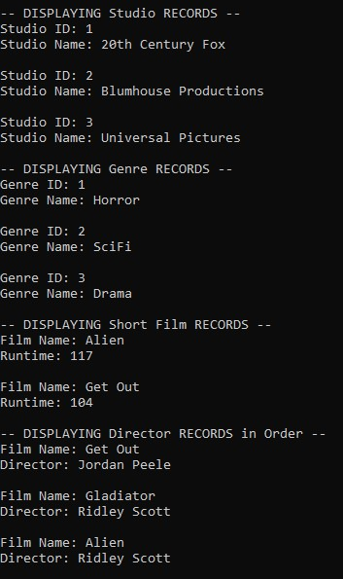

[Vigonzz/csd-310: A repository containing coding assignments (github.com)](https://github.com/Vigonzz/csd-310)