**CMPT 370 D1**

**USER MANUAL**

Dec 3, 2016

Contents

1 INTRODUCTION 2

2 INSTALLING AND RUNNING THE GAME 2

2.1 JOINING A GAME 3

2.2 HOSTING A GAME 4

2.3 EXITING THE GAME 4

3 RULES OF THE GAME 4

4 HOW TO PLAY 5

4.1 THE LOBBY VIEW 5

4.2 THE GAME VIEW 6

5 LIMITATIONS AND RESTRICTIONS 7

# **1 INTRODUCTION**

This User Manual is intended to give the user the information needed to play the Robot Game. It will include instructions for installing the game, the rules for the game, a guide to using the user interface, and an overview of limitations and restrictions.

# **2 INSTALLING AND RUNNING THE GAME**

Download the executable jar file and run it to start the application. This will present you with the start menu, shown in FIG 2.0. There are three options to choose from.

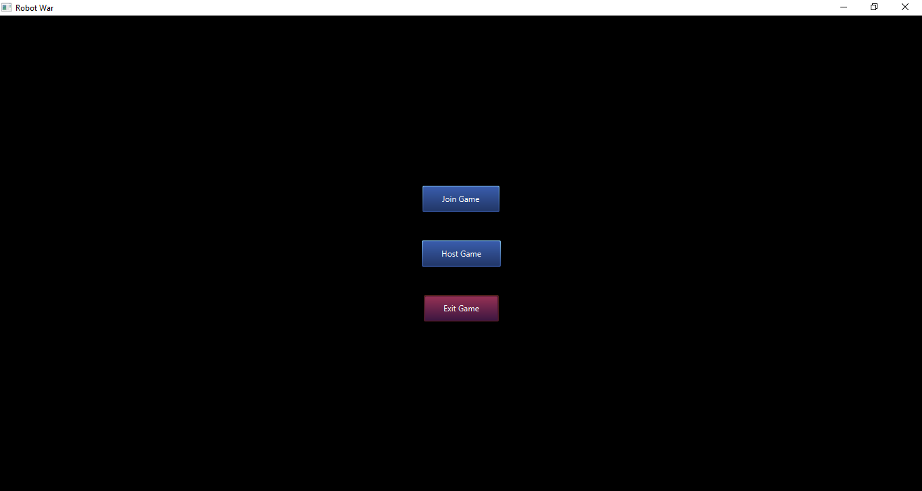

FIG 2.0: *The above figure shows the start screen that is shown when the application is started*

## 2.1 JOINING A GAME

The first option that you may choose is the join game option. This is the option you should use when another player is hosting a match that you would like to join. This allows you to join their session. Choosing this option will present a dialogue box that will request a username and an address. The username is a name you wish to be identified by. The address is the private IP address of the game you wish to connect to. You must obtain this IP from the user hosting the match.

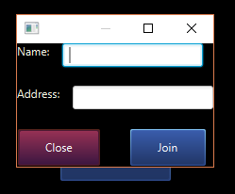

FIG 2.1.1:  *The above figure shows the dialogue box that appears when you choose to join the game. You may enter any username. The address field is where the private IP of the host is entered to join their game.*

IMPORTANT NOTE: YOU MUST BE ON THE SAME NETWORK AS THE HOST YOU ARE CONNECTING TO

Once you have entered the correct information you will be taken to the Lobby Screen. The Lobby Screen is described under section 4: How to Play.

## 2.2 HOSTING A GAME

You may also choose to host a game. There must be one and only one host for a match to take place. This allows other users to connect to your computer and join the game. When you select host game, you will be presented with a dialogue box for a user name. This is the name you will be identified by for the duration of the game. You will then be taken to the lobby screen. The Lobby Screen is described under section 4: How to Play.

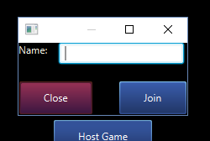

FIG 2.2: *The above figure shows the dialogue box that appears when you select host game. The username you choose determines how you will be identified throughout the game. Once you select join you will be sent to the lobby screen*

## 2.3 EXITING THE GAME

Selecting the exit game button will exit the game and close the application.

# **3 RULES OF THE GAME**

The rules of the game are as follows. These rules were provided by Christopher Dutchyn for *CMPT 370: Intermediate Software Engineering* at the University of Saskatchewan.

* With two players, red and green are used, and the board has 5 spaces on a side.
* With three players, red and yellow and blue are used, and the board can have 5.
* With six players, all colours are used, and the board has 7 spaces on a side. The colours are assigned randomly.
* All robots enter in their home space, facing along the arrow.
* Any number of robots, including ones from opposing teams, can occupy the same space.
* A turn begins with Red team playing its robot with greatest movement; then orange plays its robot with greatest movement, ..., finally blue plays its greatest-movement robot — this completes one round
* Then a second round is played where Red plays its next-highest movement robot, then orange, ..., up to blue. Then a third round where Red’s

lowest-movement robot plays, ..., finally blue’s lowest-movement robot plays.

Thus, every robot gets one play per turn, and fastest robots move first.

* Note that, Red’s highest-movement robot might not be its scout, because that robot might be dead.
* If a team does not have a robot to play during a round, skip to the next colour.
* A play consists of moving, shooting, and moving again. It costs no movement point to turn to face any direction (0—5), and one movement point to enter a space. If a robot runs out of movement points, it cannot move any further during that turn. Different robots have different movement amounts. At the end of every turn, robots regenerate their movement points—i.e. they can move again next turn.
* Robots can only see and shoot at robots in range. As they move, new spaces become visible.
* Shooting at a space means selecting a range and direction causes the shooting-robot’s attack-rating to be subtracted from the health of all robots in that targeted space. If a robot’s health drops to (or below) zero, the robot is dead and removed from play. Until a robot is dead, its movement and damage ratings are unimpaired. Note that range=0, direction=0 is valid.
* If more than one team’s robots are still alive, another turn starts with Red’s highest-movement robot.
* If only one team’s robots are still alive, that team wins the game.

# **4 HOW TO PLAY**

Here we will provide a short description on how the game is played using our user interface.

## 4.1 THE LOBBY VIEW

Once you have joined or hosted a game you will be presented with the lobby screen.

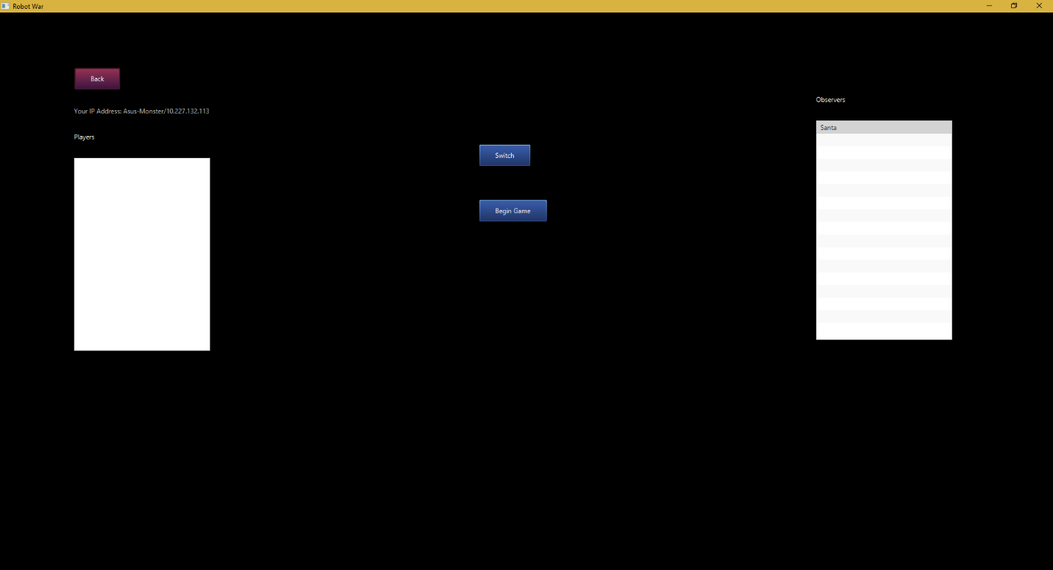

FIG 4.1: *The above figure shows the lobby view. This is where you can see all users who have joined your session.*

While in the lobby view, there are two lists displayed. The one on the far right of the screen is the list of observers. These are users who are not participating in the gameplay, but will be able to watch the match on their own machines. To switch a user to become a player, select their name in the observer list and select the switch button. This will move their name to the player list, on the far left side of the screen. Once all players have joined, select the begin game button to start the match. This will take you to the game view.

NOTE: You can only start a match if there are 2,3, or 6 players.

## 4.2 THE GAME VIEW

The game view is where the gameplay takes place. You will be shown the hexagonal grid, with your robots on their home space. Each robot will display the tiles they can see within their view. All other tiles will appear grayed out. The current player’s turn is displayed at the top of the screen. When it is not your turn, the move, attack, and end turn buttons will be disabled.

On your turn, you may move your current robot and attack one tile. To move a robot, select the move button on the left side of the screen, then select the tile you wish to move to. You may only move to tiles within the range of your robot. The number of spaces your robot can move will be displayed below the dashboard on the right side of the screen, above the move button.

You may also attack a tile on your turn if it is range of your current robot. As the game progresses and you move your robots around the board, you will encounter other player’s robots. Attack and destroy them before they attack you! The last team with a live robot wins the game. At the end of the game, you may exit by closing the application, or choosing the back button. When you have finished your turn, select the end turn button.

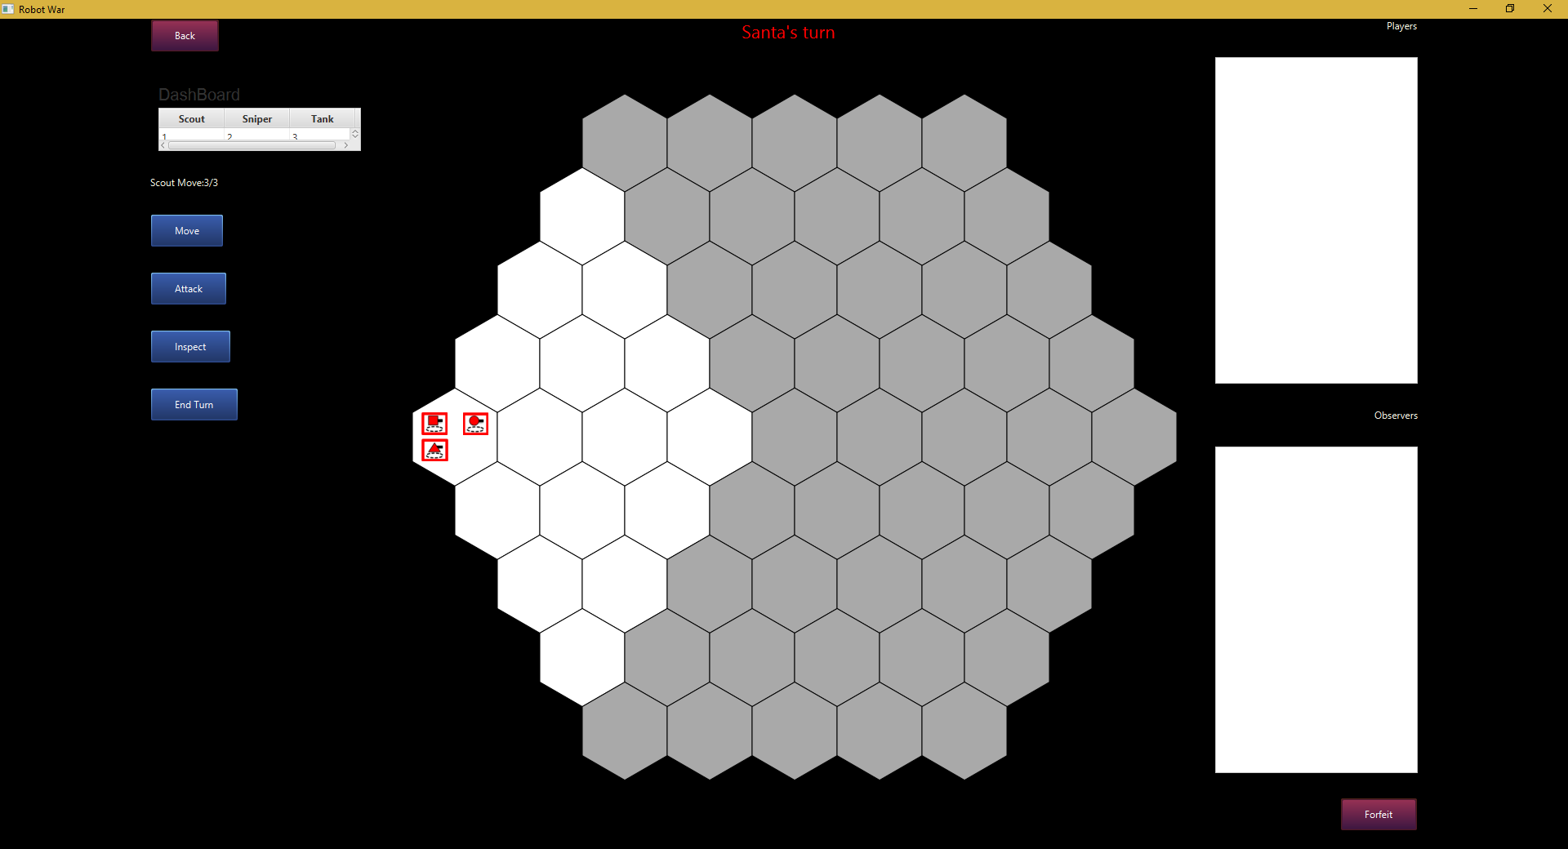

FIG 4.2: *The above figure shows the game view for Santa when he starts the game. His username is displayed at the top of the screen indicating it is his turn. He may move the scout robot by selecting the move button and then a tile within the range of the scout. The current robot and its available movement is displayed above the move button.*

# **5 LIMITATIONS AND RESTRICTIONS**

* The game can only be played with two, three, or six players. This is a constraint of the rules of the game.
* You must be on the same network as the host computer.
* You must have an internet connection to play the game

**Version History:**

* **12/04/2016 – Initial Deployment Version – DEPLOY-V1.0**