COSMO VIDEO SYMPHONY
Premium Local Multi-Video Workspace & AI Processing Suite

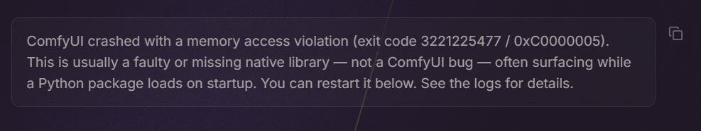
Figure 1: Cosmo Video Symphony - High-Density Sovereign Video Workspace

Product Overview
Cosmo Video Symphony is a premium, high-performance local video orchestration workstation designed for multi-stream monitor rooms, video wall layouts, and advanced content creation. Combining a high-speed, secure Rust backend with an elegant glassmorphic React interface, it offers complete data sovereignty and zero cloud dependencies.

Key Product Pillars
- Symphony Playback Engine: Synchronize play, pause, seek, volume, and looping across all display channels dynamically. Take control with a master panel or fine-tune individual tiles.
- Freeform Collage Canvas: Create complex visual compositions, overlay grids, or promotional assets. Drag, scale, rotate, and re-order elements dynamically on an infinite canvas.
- Local GPU AI Enhancements: Upscale images and videos in real time using Real-ESRGAN and restore facial details with GFPGAN. Perform background subject cutouts instantly via local neural networks.
- 100% Data Sovereignty: All media loads via secure local protocols ('cosmo://'). Your data never leaves your computer, and all operations remain entirely offline.

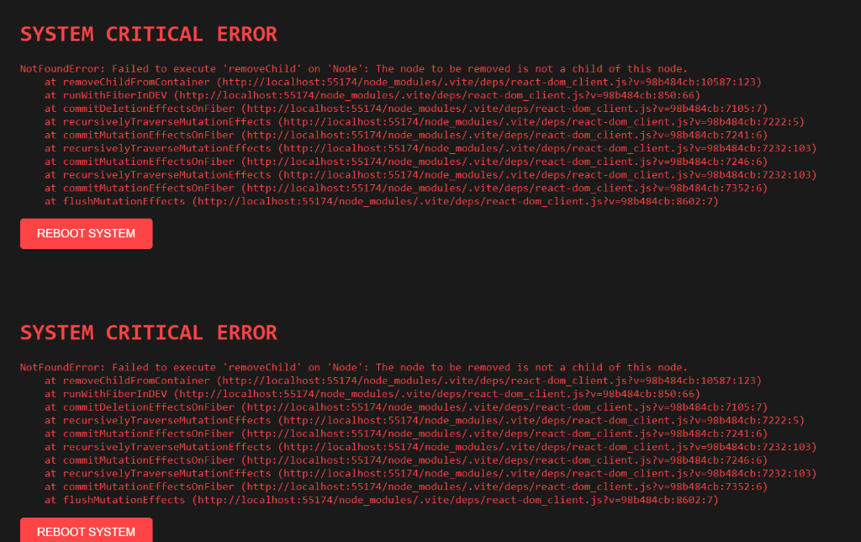
Figure 2: Dynamic Settings Panel & Onboarding Wizard

Core Features In-Depth
⚡ Workspace Sets (Collections): Serialize your entire active grid layout, speed levels, volume configurations, and file paths to recall them instantly at any time.
⚡ Sovereign Telemetry Cockpit: A real-time status bar displaying RAM, CPU load, VRAM, and active GPU temperatures querying directly from nvidia-smi.
⚡ Wi-Fi Share QR Portal: Upload files wirelessly from your smartphone (iOS/Android) straight to your workspace folder by scanning a secure local network QR code.
⚡ Precision Filters & Adjustments: Apply real-time GPU-accelerated adjustments for brightness, contrast, hue, saturation, temperature, mirroring, and rotation.
⚡ Watermark Eraser Brush: Paint out channel logos, stamps, or watermark overlays cleanly with smart local inpainting algorithms.
⚡ In-App Browser Previews: Scan and preview local directories. Widescreen previews load instantly using aspect-ratio contain fitting and hover-play triggers (#t=0.01) to eliminate system lag.

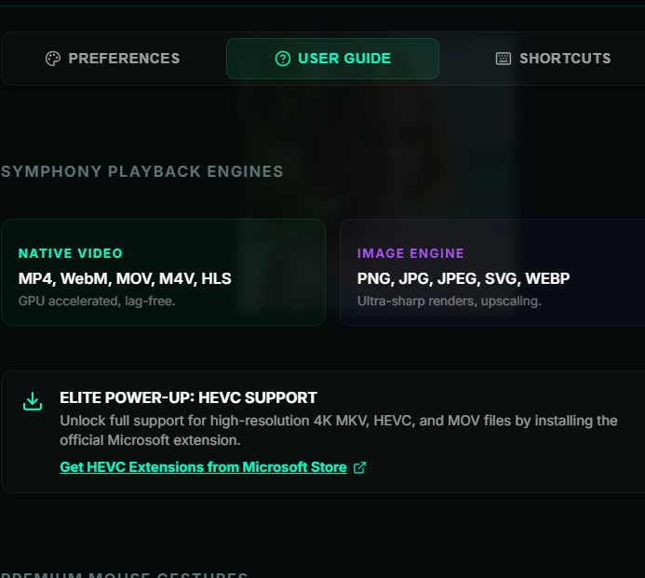
Figure 3: High-Density Control bar & Interactive Tools

Hardware-Aware Secure Deletion
Cosmo Symphony prioritizes file sanitization according to your drive hardware to prevent file recovery while preserving SSD lifespan:
Drive Media Class | Erase Method | Security & Drive Lifespan Rating
NVMe / SSD | Native Windows FSCTL_FILE_LEVEL_TRIM block-deallocation | Maximum Security (immediate zeroing) / Zero Device Wear
HDD (Mechanical) | 3-pass cryptographic wipe (Zero, 0xFF, Random passes) & Truncation | High Security (prevents residual read) / Standard platter wear

