A Project Report On

Workout Tracker

Submitted in partial fulfillment of the requirement for the award of the degree

BACHELOR OF COMPUTER APPLICATIONS

Academic Year 2024 – 25
For subject
05BC3504-Data Visualisation

Padiya Vigyat(92300527222)
Makwana Dhruv(92300527203)

Internal Guide

Prof Kinjal Raval


Rajkot-Morbi Road, At & PO : Gauridad, Rajkot 360 003. Gujarat. India.

DECLARATION

We hereby declare that this project work entitled Workout Tracker is a record done by us.

We also declare that the matter embodied in this project is genuine work done by
us and has not been submitted whether to this University or to any other University for the fulfillment of any course of study.

Place: Marwadi University
Date: 25/08/2025

Padiya Vigyat (92300527222)
Dhruv Makwana(92300527203)

ACKNOWLEDGEMENT

It is indeed a great pleasure to express our thanks and gratitude to all those who helped us. No serious and lasting achievement one can ever achieve without the help of friendly guidance and co-operation of so many people involved in the work.

We are very thankful to our faculty guide Prof. Kingal Raval, the person who makes us follow the right steps during project work.We express deep sense of gratitude to her guidance, suggestions and expertise at every stage.

Thanks to our friends who have been a source of inspiration and motivation that helped us during this project work. We are also thankful to our Head Dr. Sunil Bajeja and Dean Dr. R. Sridaran for their support as and when required.We would like to extend our gratitude towards all who directly or indirectly supported and helped us to accomplish our project work.

Padiya Vigyat(92300527222)
Makwana Dhruv(92300527203)

CONTENTS

Chapters | Particulars | Page No
1 | Introduction | 7
1.1 | Overview of the Project
1.2 | Objective of the Analysis
1.3 | Scope and Importance of Identifying Patterns and Trends in Data
1.4 | Dataset Overview
2 | Data Collection | 8
2.1 | Dataset Description
2.2 | Source of the Data
2.3 | Data Collection Methodology
2.4 | Data Format and Structure
2.5 | Initial Data Exploration
3 | Data Analysis and Data Visualisation: | 9
3.1 | Write a problem statement, solution (Implementation code for the statement) and then data visualisation for the statement
4 | Conclusion | 10
4.1 | Summary of Findings
4.2 | Implications of the Analysis
4.3 | Limitations of the Project
4.4 | Future Work and Recommendations
5 | References | 11
5.1 | Data Sources
5.2 | Tools and Libraries Used

FIGURE INDEX

Sr. No. | Figure No. | Particulars | Page No.
 |  | Python
1 | 1 | Scatter Plot – Calories vs Duration | 11
2 | 2 | Box Plot – Heart Rate by Category
3 | 3 | Histogram – Workout Duration Frequency | 12
4 | 4 | Line Plot – Average Calories per Day
5 | 5 | Bar Chart – Total Workouts per User
 |  | Excel
6 | 6 | Stacked Bar Chart – Cardio vs Strength Workouts per User | 13
7 | 7 | Horizontal Bar Chart – Top Workouts by Average Calories
8 | 8 | Histogram – Calories Burned Frequency
9 | 9 | Box Plot – Duration Distribution per User | 14
10 | 10 | Grouped Bar Chart – Average Heart Rate by Category per User
 |  | Tableau
11 | 11 | Pie Chart – Share of Calories Burned by User | 15
12 | 12 | Scatter Plot – Difficulty vs Calories
13 | 13 | Line + Marker Chart – Heart Rate Trend per User
14 | 14 | Area Chart – Total Calories Burned Over Time | 16
15 | 15 | Bubble Chart – Calories vs Duration (Bubble Size = Heart Rate) | 17

1. Introduction
1.1 Overview of the Project
This project focuses on analyzing workout and fitness data using three different platforms: Python (Matplotlib), Excel, and Tableau.
Each platform is used to generate a different set of charts and visualizations to explore workout trends, user performance, and fitness insights.
The purpose is to compare the strengths of each tool and demonstrate how they complement each other for data-driven decision making.
1.2 Objective of the Analysis
- To apply multiple data visualization techniques on workout data.
- To compare three tools (Python, Excel, Tableau) for their effectiveness in exploring insights.
- To identify workout patterns (duration, calories, heart rate) across users.
- To create a consolidated reporting framework that combines static reports, coded analysis, and interactive dashboards.
1.3 Scope and Importance of Identifying Patterns and Trends in Data
Identifying workout trends helps in:
- Tracking calorie burn and exercise consistency.
- Comparing users’ workout behaviors (duration, intensity, category).
- Understanding the relationship between heart rate, duration, and calories.
- Helping trainers and individuals optimize workout plans.
1.4 Dataset Overview
- Type of Data: Tabular (workout sessions per user).
- Key Attributes: User, Workout Type, Duration, Calories, Heart Rate, Difficulty, Date.
- Nature: Mixed (categorical + numerical + time series).
- Purpose: To analyze trends in fitness activity and compare visualization techniques across tools.

2. Data Collection
2.1 Dataset Description
- Users: Multiple users performing workouts.
- Attributes: Duration (minutes), Calories, Heart Rate, Workout Category (Cardio/Strength), Difficulty, Date.
2.2 Source of the Data
The dataset was simulated for academic purposes, inspired by real-world fitness tracking applications.
2.3 Data Collection Methodology
Data was structured to reflect realistic patterns of fitness activity. Each record represents one workout session by a user.
2.4 Data Format and Structure
- Format: CSV / Excel file
- Structure: Tabular, with rows = workouts, columns = attributes
2.5 Initial Data Exploration
- Checked for missing values.
- Verified numerical ranges (e.g., heart rate, calories).
- Categorized workouts into Cardio and Strength for comparisons.

3. Data Analysis and Data Visualization
3.1 Problem Statements, Solutions & Visualizations
(A) Python (Matplotlib) – 5 Charts
- Scatter Plot – Calories vs Duration
- Box Plot – Heart Rate by Category
- Histogram – Workout Duration Frequency
- Line Plot – Average Calories per Day
- Bar Chart – Total Workouts per User
(B) Excel – 5 Charts
- Stacked Bar Chart – Cardio vs Strength Workouts per User
- Horizontal Bar Chart – Top Workouts by Average Calories
- Histogram – Calories Burned Frequency
- Box Plot – Duration Distribution per User
- Grouped Bar Chart – Average Heart Rate by Category per User
(C) Tableau – 5 Charts
- Pie Chart – Share of Calories Burned by User
- Scatter Plot – Difficulty vs Calories
- Line + Marker Chart – Heart Rate Trend per User
- Area Chart – Total Calories Burned Over Time
- Bubble Chart – Calories vs Duration (Bubble Size = Heart Rate)

4. Conclusion
4.1 Summary of Findings
- Python: Best for reproducible, code-based analysis.
- Excel: Best for static summaries & pivot-style comparisons.
- Tableau: Best for interactive dashboards and live exploration.
4.2 Implications of the Analysis
- Trainers can identify users who need performance improvement.
- Calories and duration correlation shows efficiency of workouts.
- Heart rate monitoring reveals workout intensity levels.
4.3 Limitations of the Project
- Dataset is small and simulated (not from live sensors).
- Analysis depends on accuracy of recorded data.
- Tableau requires a licensed tool for full functionality.
4.4 Future Work and Recommendations
- Expand dataset with real fitness tracker data.
- Apply machine learning to predict calories based on duration & difficulty.
- Develop a combined dashboard integrating Python, Excel, and Tableau outputs.

5. References
5.1 Data Sources
- Simulated fitness dataset (created for academic analysis).
5.2 Tools and Libraries Used
- Python: Matplotlib
- Excel: Pivot Tables, Charts
- Tableau: Public Desktop Edition

Figures
  - Python

- Scatter Plot – Calories vs Duration

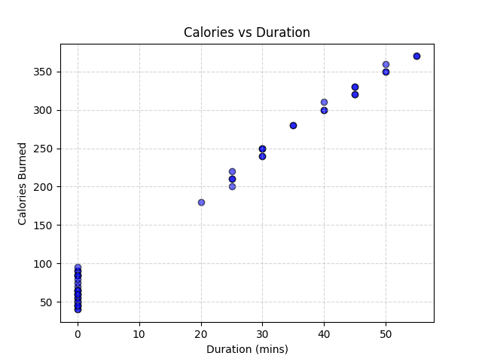

- Box Plot – Heart Rate by Category

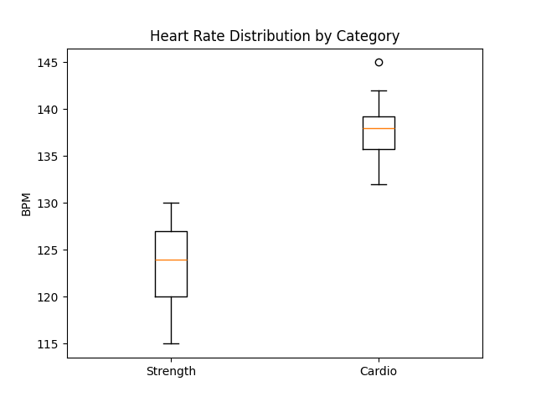

- Histogram – Workout Duration Frequency
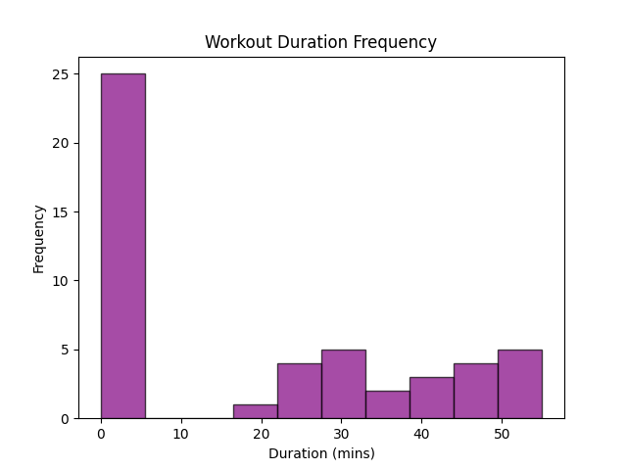
- Line Plot – Average Calories per Day

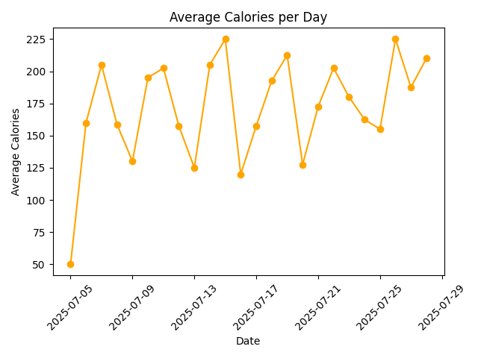
- Bar Chart – Total Workouts per User

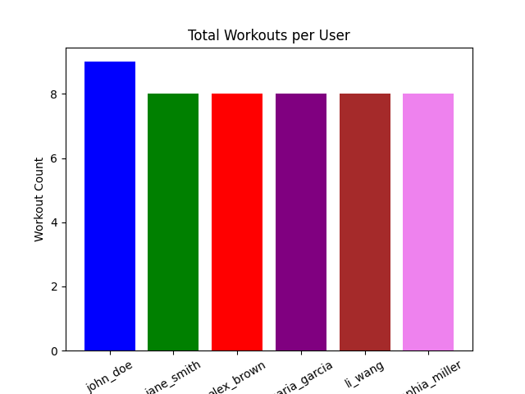

  - Excel

    - Stacked Bar Chart – Cardio vs Strength Workouts per User
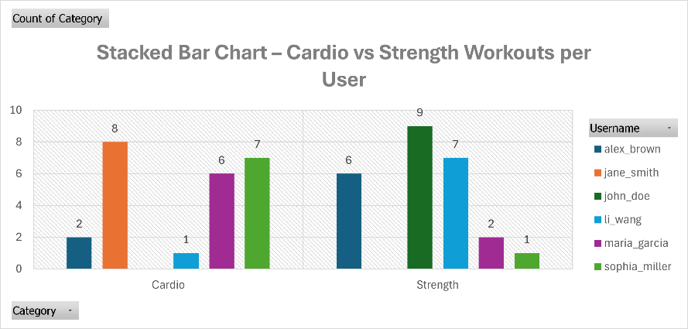

    - Horizontal Bar Chart – Top Workouts by Average Calories
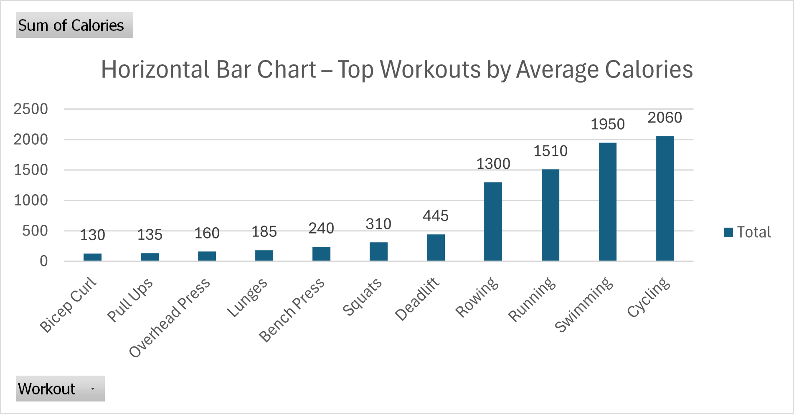

    - Histogram – Calories Burned Frequency
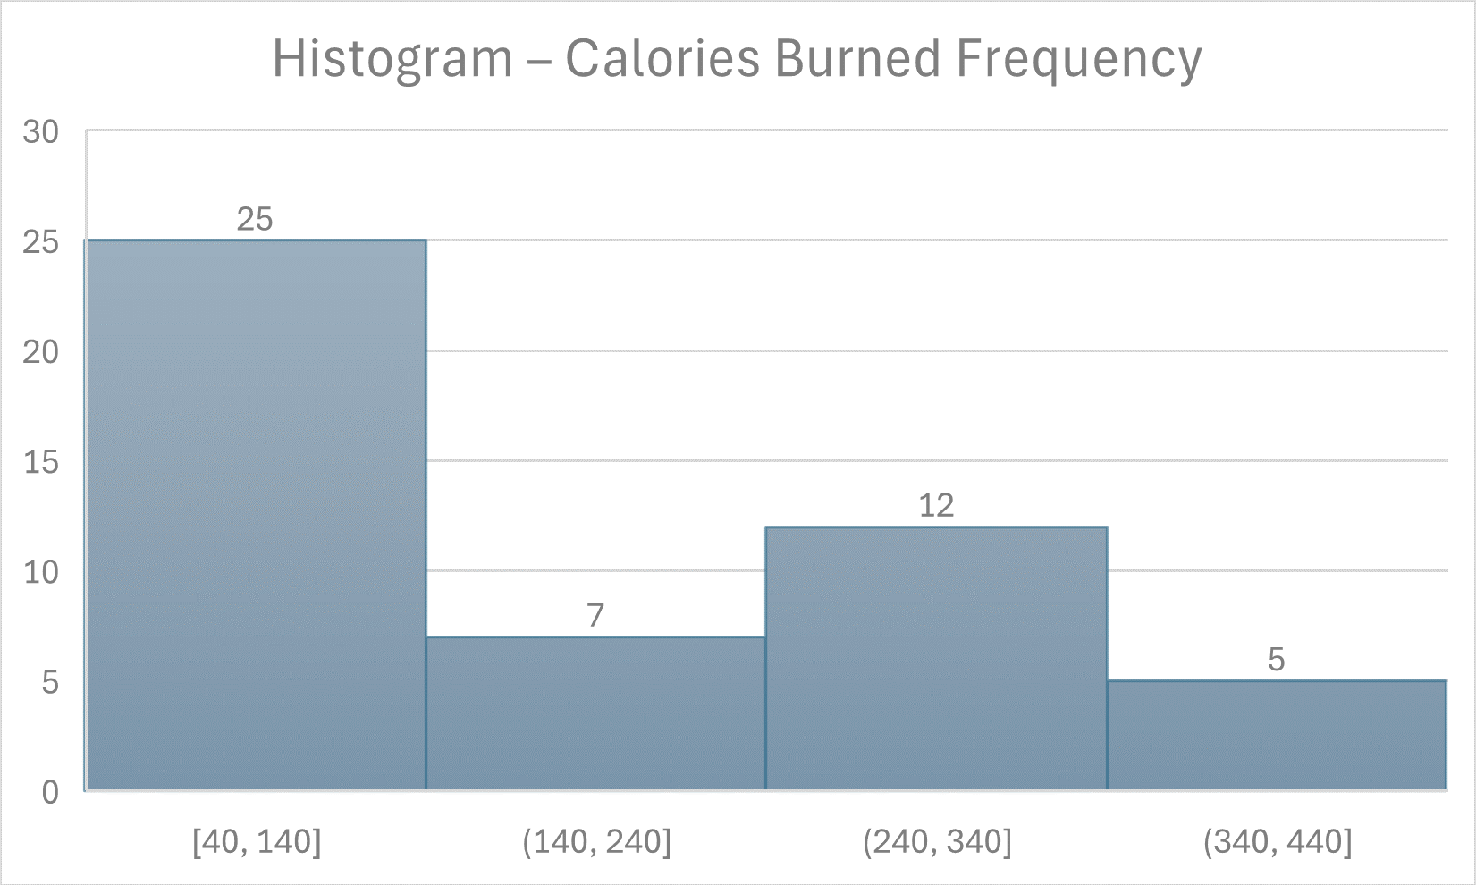

    - Box Plot – Duration Distribution per User

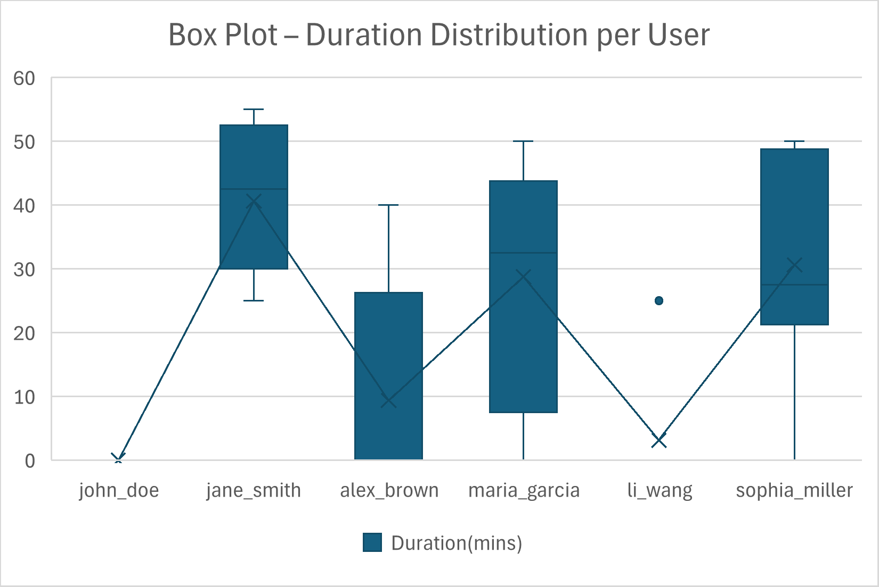

    - Grouped Bar Chart – Average Heart Rate by Category per User
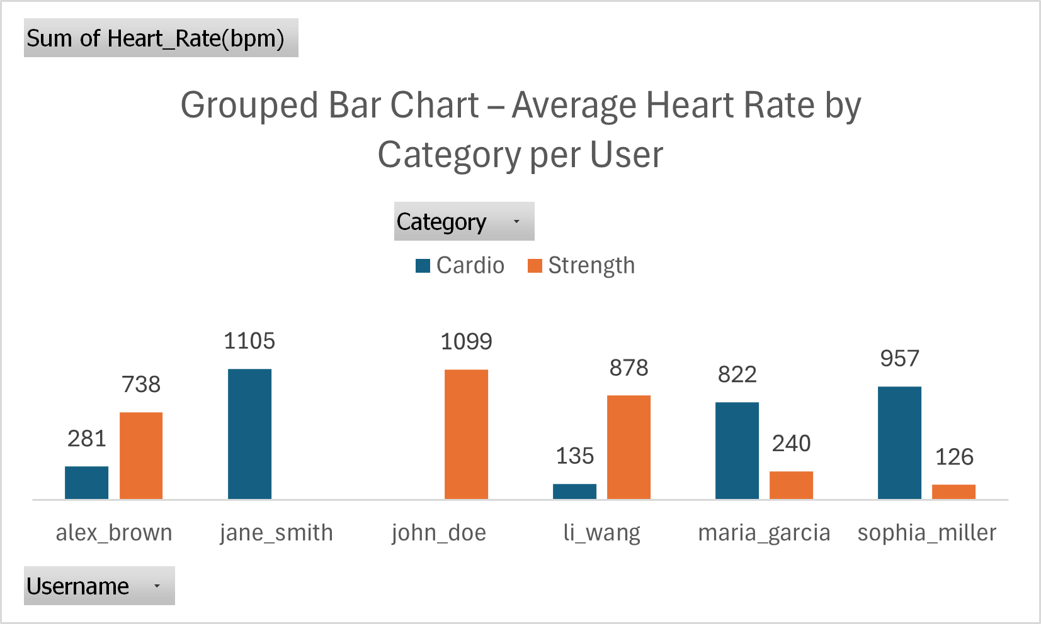

  - Tableau

- Pie Chart – Share of Calories Burned by User
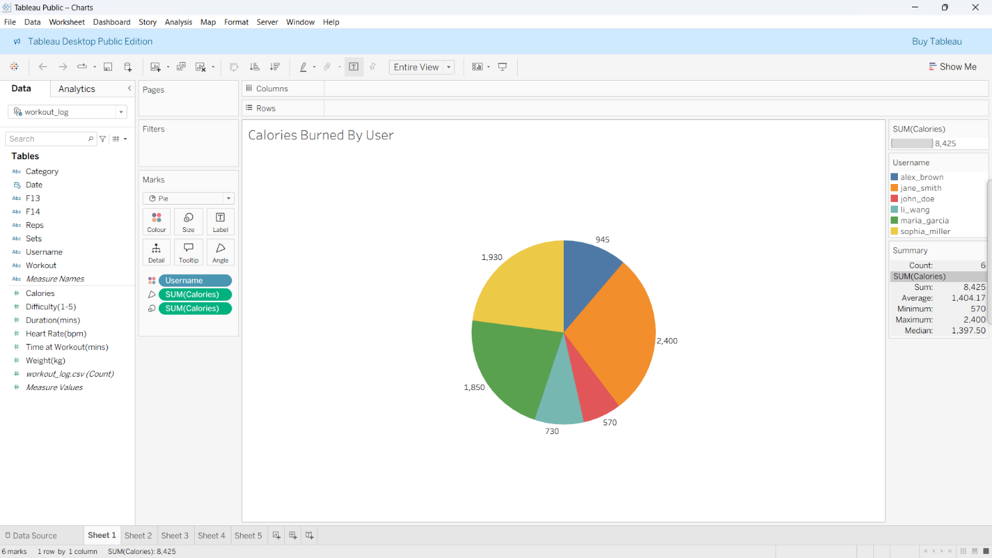
- Scatter Plot – Difficulty vs Calories
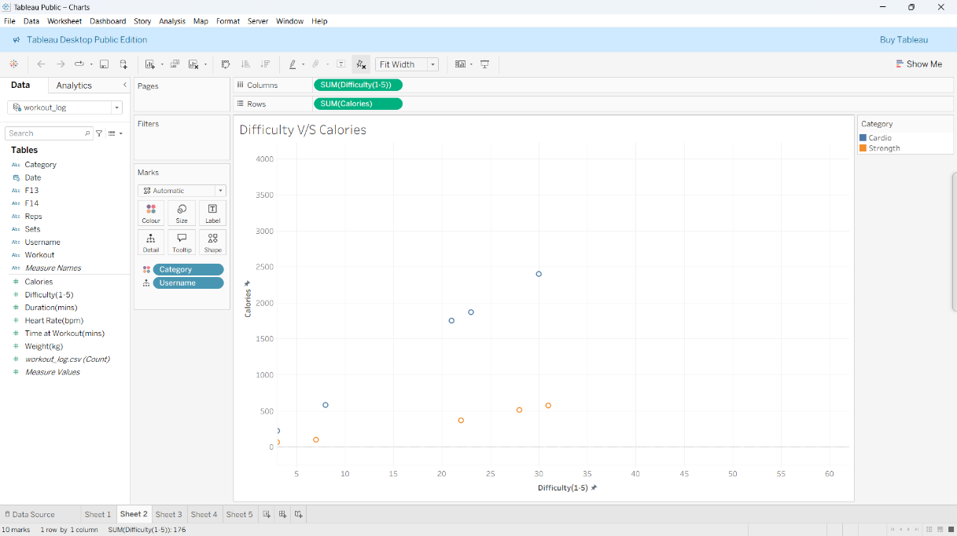

- Line + Marker Chart– Heart Rate Trend per User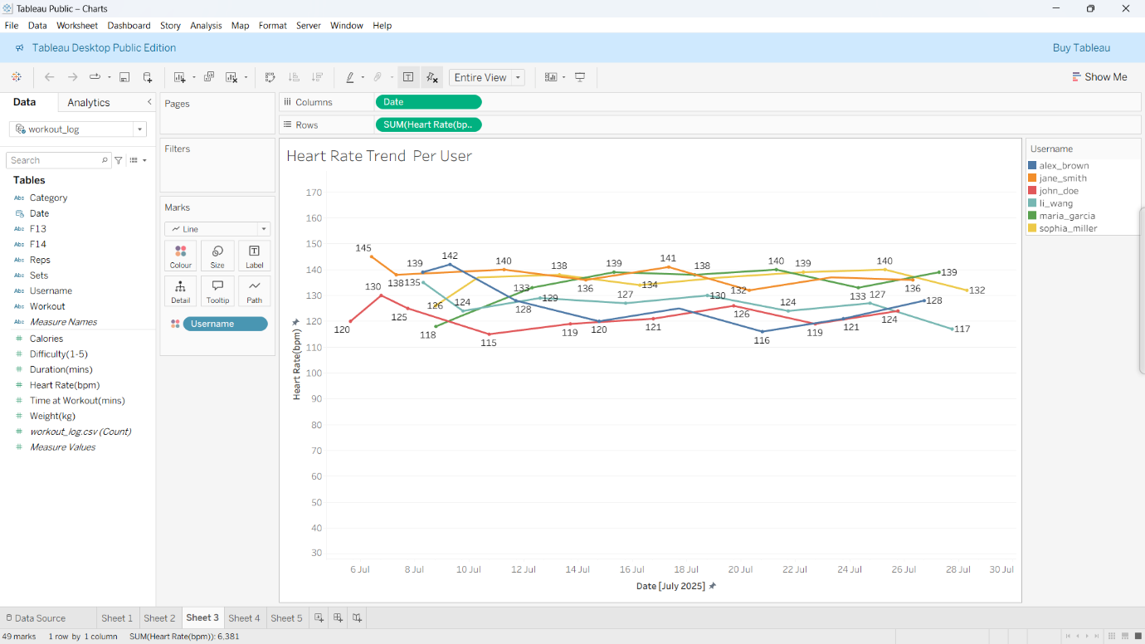

  - Area Chart – Total Calories Burned Over Time

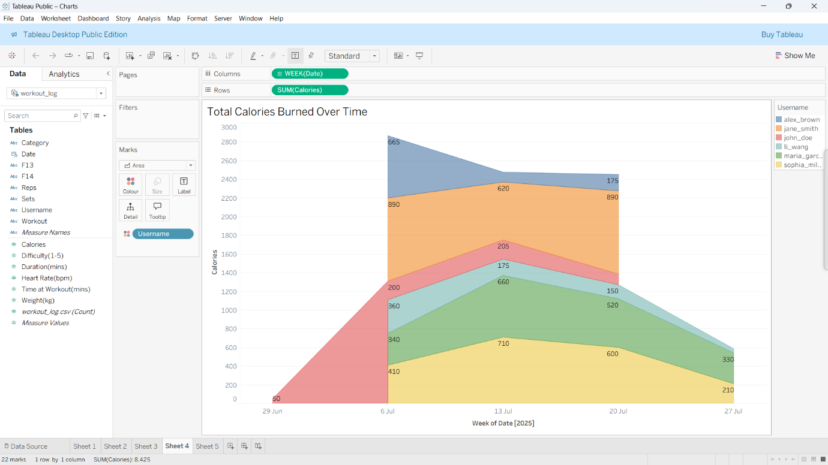

  - Bubble Chart – Calories vs Duration (Bubble Size = Heart Rate)
