A Project Report On

mood based music player

Submitted in partial fulfillment of the requirement for the award of the degree

Bachelor of Computer Application
BCA

Academic Year 2025 – 26

Dhruv Makwana Vigyat padiya raj chatwani
92300527203 92300527222 92420527001

Internal Guide
(Name of Internal Guide)



Rajkot-Morbi Road, At & PO : Gauridad, Rajkot 360 003. Gujarat. India.

Faculty of Computer Applications (FCA)



This is to certify that the project work entitled

Mood based music player

submitted in partial fulfillment of the requirement for

the award of the degree of

Bachelor of Computer Application
BCA

of the

Marwadi University

is a result of the bonafide work carried out by

Dhruv Makwana (92300527203)

Vigyat padiya (92300527222)

Raj Chatwanai (92420527001)

during the academic year 2025-26

Faculty Guide |  | HOD |  | Dean

DECLARATION

I/We hereby declare that this project work entitled mood based music player is a record done by me.

I also declare that the matter embodied in this project is genuine work done by me and has not been submitted whether to this University or to any other University / Institute for the fulfillment of the requirement of any course of study.

Place :
Date :

Dhruv Makwana (92300527203) Signature :
Vigyat Padiya (92300527222) Signature :
Raj Chatwani (92420527001) Signature :

CONTENTS

Chapters | Particulars | Page No.
1 | SYNOPSIS
2 | PREAMBLE  General Introduction  Module description
3 | TECHNICAL DESCRIPTION  Hardware Requirement  Software Requirement
4 | SYSTEM DESIGN AND DEVELOPMENT  (Only applicable diagrams)  - Flowchart  - Data Flow Diagram, Use Case Diagram,  - Sequential Diagram, Class Diagram,  - Activity Diagram  Database Design (If applicable)  Screen Design & Coding
5 | CONCLUSION
6 | LEARNING DURING SIP
7 | BIBLIOGRAPHY  Online References  Offline References

- Synopsis
In this project, emotion recognition and music playback are combined. It will continuously use the computer's webcam to scan the user's face. The dominant emotion is identified by processing each frame using the Deep Face library. A matching song is played using Pygame according to the result, which could be joyful, depressed, irate, etc. The goal is to automate music selection in an entertaining and intelligent manner.
- PREAMBLE
The majority of us listen to music during happy, sad, or even boring moments. What if, without our help, our devices could sense our feelings and play the perfect song? A music player that reads your emotions and selects a song according to your mood is the idea behind this project.
Overview of the Module
There are four modules in the project:
1. Using OpenCV to integrate webcams
2. DeepFace Emotion Recognition
3. Using Pygame to Play Music
4. Keyboard Inputs for User Interaction
- TECHNICAL OVERVIEW
Hardware specifications:
A computer with a webcam and at least 4 GB of RAM
An Intel i3 or higher processor
Prerequisites for software:
Python 3.8 or higher
Libraries that are required: IDE for DeepFace, Pygame, and OpenCV: Visual Studio Code or PyCharm

- DESIGN AND DEVELOPMENT OF THE SYSTEM
A flowchart, use case diagram, and activity diagram are included in the appendix.
GUI design and coding
The user interface is straightforward, utilizing OpenCV to show the camera feed and terminal messages to indicate the detected mood and playback status.

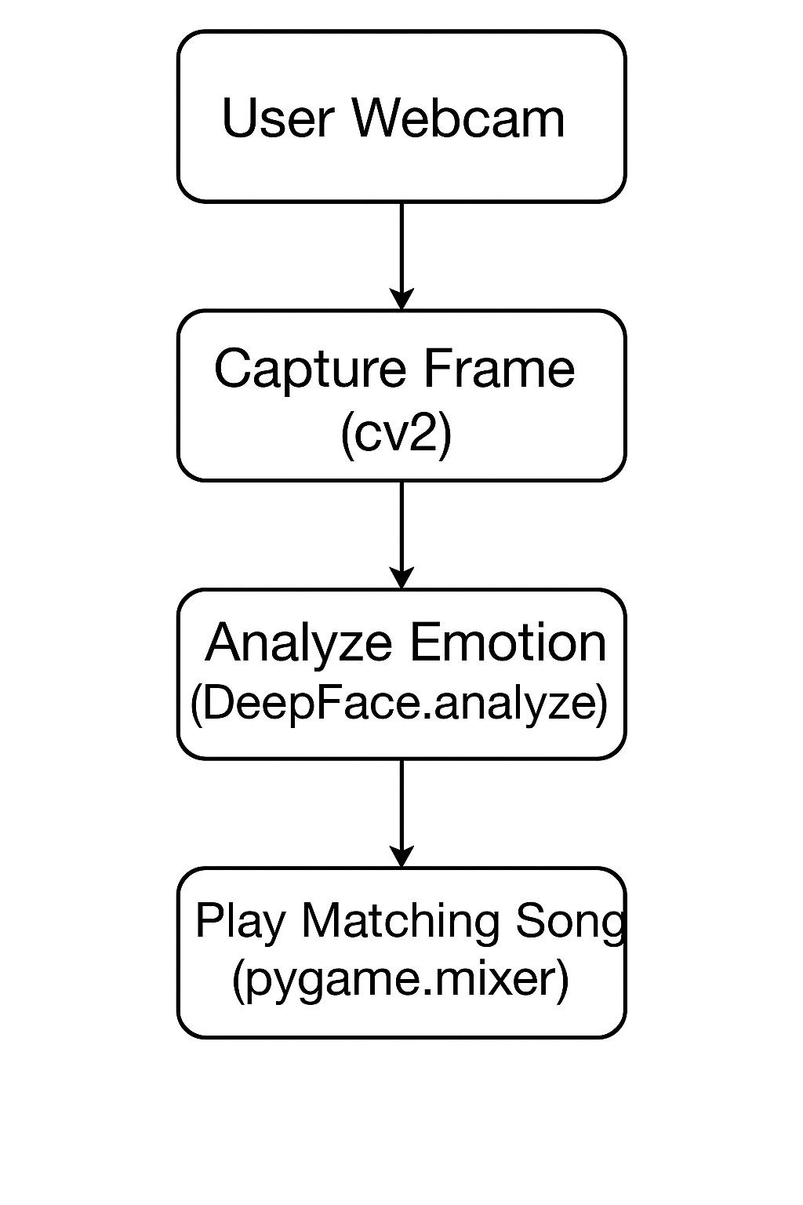

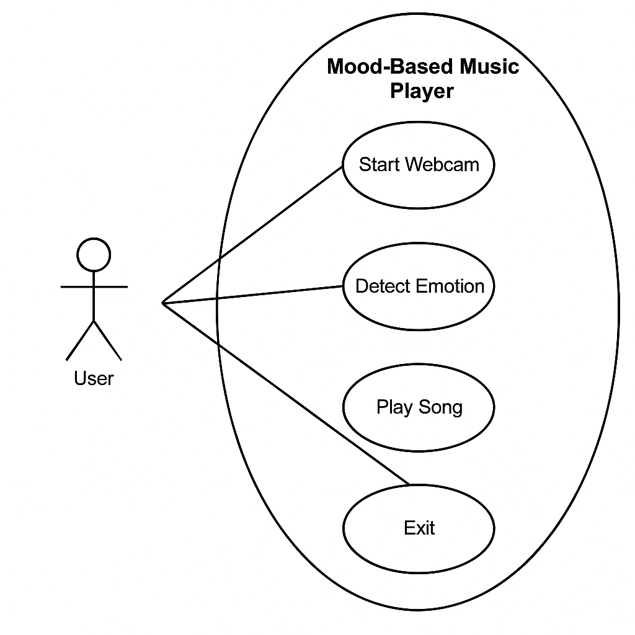

- conclusion
The Mood-Based Music Player demonstrates how emotion recognition can improve user experience through music in a way that is highly relatable. Despite having a straightforward interface, it has a strong and engaging feature: it plays music based on your mood.

- LEARNING DURING SIP

- Hands-on experience using Python libraries such as Deep Face and OpenCV
- Application of deep learning in the real world
Using webcam data in real time
- Debugging and handling errors in real-time systems

- BIBLIOGRAPHY
- Online References:
- https://github.com/serengil/deepface
- https://opencv.org/
- https://www.pygame.org/docs/
- https://docs.python.org

