I2C device scanning :

// #include <Wire.h>
// #include<Arduino.h>

// void setup() {
// Serial.begin(115200);
// Wire.begin(21, 22); // SDA = GPIO21, SCL = GPIO22

// Serial.println();
// Serial.println("ESP32 I2C Scanner");
// Serial.println("-----------------");
// }

// void loop() {
// byte error, address;
// int devicesFound = 0;

// Serial.println("Scanning...");

// for (address = 1; address < 127; address++) {

// Wire.beginTransmission(address);
// error = Wire.endTransmission();

// if (error == 0) {
// Serial.print("I2C device found at 0x");
// if (address < 16)
// Serial.print("0");
// Serial.print(address, HEX);
// Serial.println();
// devicesFound++;
// }
// else if (error == 4) {
// Serial.print("Unknown error at 0x");
// if (address < 16)
// Serial.print("0");
// Serial.println(address, HEX);
// }
// }

// if (devicesFound == 0)
// Serial.println("No I2C devices found.");
// else
// Serial.println("Scan complete.");

// Serial.println();
// delay(3000);
// }

Upload this code to esp32 :

#include <Wire.h>
#include <Arduino.h>

#define AS5600_ADDR 0x36

int64_t totalCounts = 0;
uint16_t prevRaw = 0;

uint16_t readRawAngle()
{
Wire.beginTransmission(AS5600_ADDR);
Wire.write(0x0C);
Wire.endTransmission(false);

if (Wire.requestFrom(AS5600_ADDR, 2) != 2)
return prevRaw;

uint8_t high = Wire.read();
uint8_t low = Wire.read();

return ((high << 8) | low) & 0x0FFF;
}

void setup()
{
Serial.begin(115200);
Wire.begin(21,22);

prevRaw = readRawAngle();
totalCounts = prevRaw;
}

void loop()
{
uint16_t raw = readRawAngle();

int diff = (int)raw - (int)prevRaw;

if(diff > 2048)
diff -= 4096;
else if(diff < -2048)
diff += 4096;

totalCounts += diff;
prevRaw = raw;

Serial.print(micros());
Serial.print(",");
Serial.println(totalCounts);

delay(1);
}

Platform ini file :

[env:esp32doit-devkit-v1]
platform = espressif32
board = esp32doit-devkit-v1
framework = arduino
lib_deps = madhephaestus/ESP32Encoder@^0.12.0
monitor_speed = 115200

Storing encoder values :
Put below code in a python file and run this file to store the cummulative continuous unwrapped encoder values into a text file :

import serial

# Serial port settings
PORT = "/dev/ttyUSB0"
BAUDRATE = 115200

# Output file
OUTPUT_FILE = "encoder_log.txt"

try:
ser = serial.Serial(PORT, BAUDRATE, timeout=1)
print(f"Connected to {PORT} at {BAUDRATE} baud")
except Exception as e:
print(f"Could not open serial port: {e}")
exit()

with open(OUTPUT_FILE, "w") as f:
print(f"Logging data to {OUTPUT_FILE}...")
print("Press Ctrl+C to stop.\n")

try:
while True:
line = ser.readline().decode("utf-8", errors="ignore").strip()

if line:
# Print to terminal
print(line)

# Save exactly as received
f.write(line + "\n")
f.flush()

except KeyboardInterrupt:
print("\nLogging stopped.")

ser.close()

Store cumulative continuous unwrapped encoder values to the file using above code and using it calculate the CPR for both the motors separately. Below is a table(table 1.1) showing the results of our experimentation.

Process of finding CPR : Attach wheel on the output shaft, Put a mark on the wheel and a marker in environment to synchronize the 2 markers and get a reference (similar to img 1.1). Now move the motor by giving it power through battery manually and note the values given by encoder at the beginning and the end of 1 complete rotation. Do this again and again and average the differneces to get the approximate CPR.

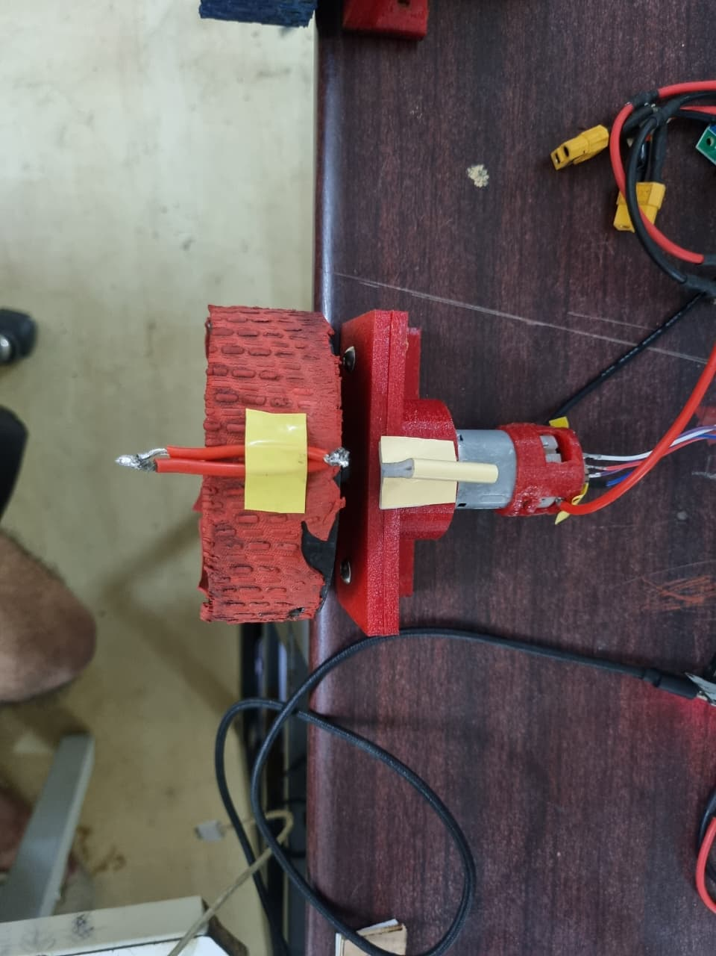
Diagram 1.1

(2 red small wires are taped on the wheel, they represent a mark. And then we have a tape on the motor holder also. So we now get a reference and we power the motor using small voltage so that the wheel rotates slowly and then after one complete rotation we stop it, note the values at beginning and at the end both and take their difference.)

BLUE : right motor
RED : left motor

Table 1.1
BLUE wheel
start | end | difference
2373 | 997706 | 995333
3758488 | 4758435 | 999947
5753227 | 6755671 | 1002444
6755671 | 7745192 | 989521
7745192 | 8743961 | 998769
8743961 | 9732009 | 988048
9732009 | 10720784 | 988775
 | Avg of diff/CPR | 994691
RED wheel
start | end | difference
998896 | 1993876 | 994980
1993875 | 2997601 | 1003726
2997600 | 4001175 | 1003575
4001175 | 4990616 | 989441
4990616 | 5991596 | 1000980
5991596 | 6983283 | 991687
 | Avg of diff/CPR | 997398.166666667
(results of the experimentation for both the motors)

Now we will make the controller. We will make a ros2 node that will take input from our keyboard or joystick in twist format and then our controller will give final motor velocities. Then this value will be used by hardware interface and it will give final pwm for each motor which will be fed to the motor driver.

Before making controller I will check if the motor driver are working or not. The drivers we are using are : cytron md10c r3.

To check there working, upload this code on to microcontroller and do the following connections :

code to test driver :

// =======================================================
// MD10C R3 Motor Driver Test
// ESP32 DOIT DevKit V1
//
// PWM -> GPIO25
// DIR -> GPIO26
// =======================================================
#include <Wire.h>
#include <Arduino.h>

const int PWM_PIN = 25;
const int DIR_PIN = 26;

// PWM settings
const int PWM_CHANNEL = 0;
const int PWM_FREQ = 20000; // 20 kHz
const int PWM_RESOLUTION = 8; // 0-255

void setup()
{
Serial.begin(115200);

pinMode(DIR_PIN, OUTPUT);

ledcSetup(PWM_CHANNEL, PWM_FREQ, PWM_RESOLUTION);
ledcAttachPin(PWM_PIN, PWM_CHANNEL);

ledcWrite(PWM_CHANNEL, 0);

Serial.println("Motor Driver Test Started");
}

void loop()
{
// -------------------------
// Forward
// -------------------------
Serial.println("Forward");

digitalWrite(DIR_PIN, HIGH);

ledcWrite(PWM_CHANNEL, 150); // about 60% duty cycle

delay(3000);

// -------------------------
// Stop
// -------------------------
Serial.println("Stop");

ledcWrite(PWM_CHANNEL, 0);

delay(2000);

// -------------------------
// Reverse
// -------------------------
Serial.println("Reverse");

digitalWrite(DIR_PIN, LOW);

ledcWrite(PWM_CHANNEL, 150);

delay(3000);

// -------------------------
// Stop
// -------------------------
Serial.println("Stop");

ledcWrite(PWM_CHANNEL, 0);

delay(2000);
}

Connections :

Wiring (One Motor)

1. ESP32 → MD10C (Control Signals)
ESP32 GPIO25 -----> PWM

ESP32 GPIO26 -----> DIR

ESP32 GND -----> GND (MD10C)
✅ Correct.

2. Motor → MD10C
Motor wire 1 -----> MOTOR A

Motor wire 2 -----> MOTOR B
✅ Correct.
If the motor rotates in the opposite direction from what you expect, don't worry. We can either:
- swap the A and B wires, or
- invert the DIR signal in software.

3. Buck Converter → MD10C
Instead of writing "Battery", write:
Buck Converter +10V -----> POWER+

Buck Converter GND ------> POWER-
Because the battery is not connected directly anymore.
The power path is:
22V LiPo
│
▼
Buck Converter (22V → 10V)
│
▼
MD10C POWER terminals

4. ESP32 Power
ESP32 -----> USB Laptop

I checked with the motor drivers and they were working fine. Now we will proceed to create the teleoptwist cmds to pwm pipeline.

Problem :
Wiring electronics connections !
Well this is not that big problem you may think, you can tell all the specifications to some good ai model and that will give you the connections. But I faced an issue. The jetson agx orin needs good constant voltage supply and if there are big fluctuations in current or voltage (even if it drops by high amounts) then it may get fuckedup.
Some members in the club were using jetson agx orin and the ssd got fucked up really bad and we couldn’t recover it. So we had to buy a new one. And even before that, when we had old orin, that also seniors told that the reason that it got fucked up was that its voltage or current whatsoever was really shit and got fucked up.
So keeping these incidents in mind, I thought lets not take risk and I asked sandy and vaithee to help. They told that they are searching for some method (the actuall method to power orin). SO I am not continuing with working on this minibot temporarily.

Alrigth then I thought after 1 day almost that lets not wait and use direct orin’s charger and connect it from wall socket. I will manage like this for sometime.

Few details before writing esp32 firmware :
Platform | espressif32 6.13.0
Framework | Arduino-ESP32 3.20017.241212+sha.dcc1105b

Got it using this command in terminal with platformio in the path :

vihaan@vihaan-Inspiron-14-5430:~/minibot-controller-firmware$ pio pkg list
Resolving esp32doit-devkit-v1 dependencies...
Platform espressif32 @ 6.13.0 (required: espressif32)
├── framework-arduinoespressif32 @ 3.20017.241212+sha.dcc1105b (required: platformio/framework-arduinoespressif32 @ ~3.20017.0)
├── tool-esptoolpy @ 2.41100.0 (required: platformio/tool-esptoolpy @ ~2.41100.0)
├── tool-mkfatfs @ 2.0.1 (required: platformio/tool-mkfatfs @ ~2.0.0)
├── tool-mklittlefs @ 1.203.210628 (required: platformio/tool-mklittlefs @ ~1.203.0)
├── tool-mkspiffs @ 2.230.0 (required: platformio/tool-mkspiffs @ ~2.230.0)
├── tool-openocd-esp32 @ 2.1100.20220706 (required: platformio/tool-openocd-esp32 @ ~2.1100.0)
└── toolchain-xtensa-esp32 @ 8.4.0+2021r2-patch5 (required: espressif/toolchain-xtensa-esp32 @ 8.4.0+2021r2-patch5)

vihaan@vihaan-Inspiron-14-5430:~/minibot-controller-firmware$

