**(PART - B)**

(TO BE COMPLETED BY STUDENTS)

(Students must submit the soft copy as per following segments within two hours of the practical.

The soft copy must be uploaded on the Blackboard or emailed to the concerned lab in charge faculties at the end of the practical in case there is no Black board access available)

|  |  |
| --- | --- |
| Roll.No. : C130 | Name: Vihaan Bhulla |
| Sem/Year : Sem 4 Year 2 | Batch: C2 |
| Date of Experiment : 11/3/22 | Date of Submission: |
| Grade -- |  |

# B.1: Procedure of performed experiment

1.To find simple interest

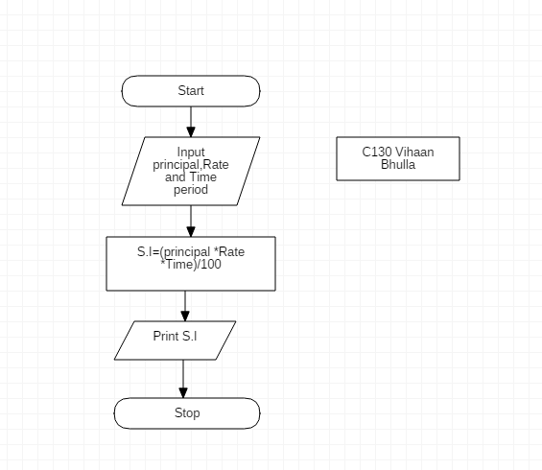

2.To find area of Circle

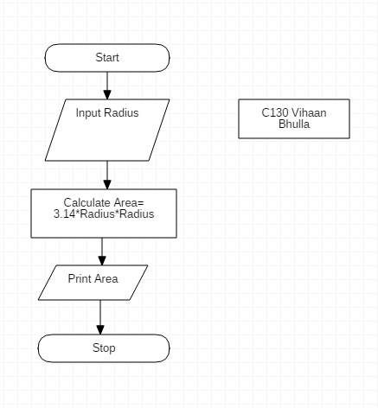

\

3,To Find sum digits of given integer number

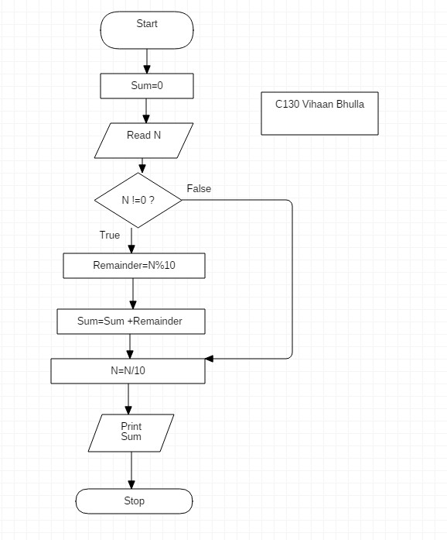

4.To check whether a given number is divisible by 3 and 7 or nor

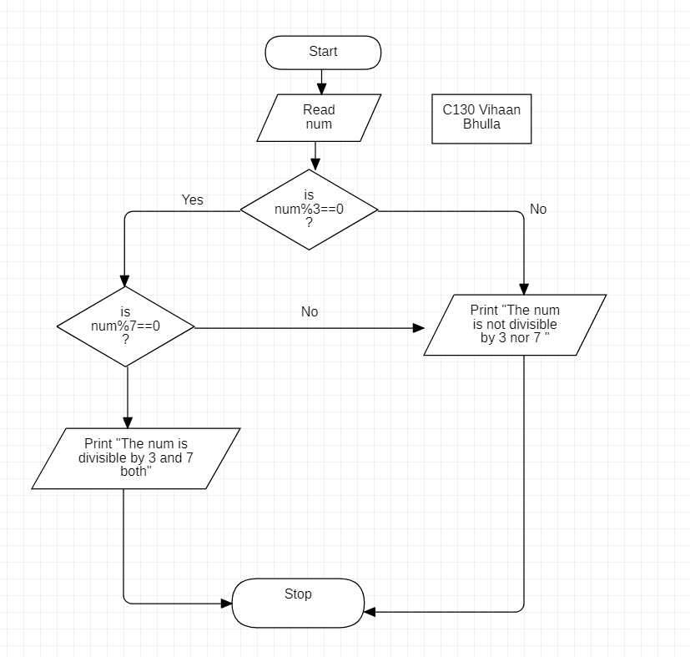

5. To check whether the given number is prime number or not

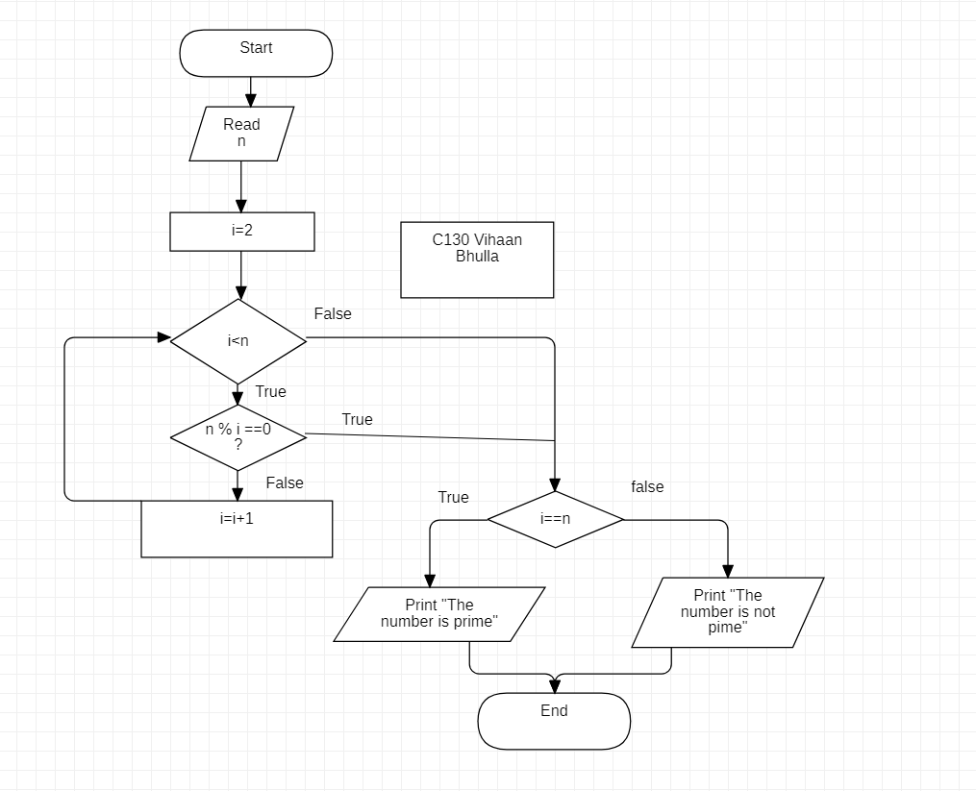

6. To Print all prime numbers in the given range

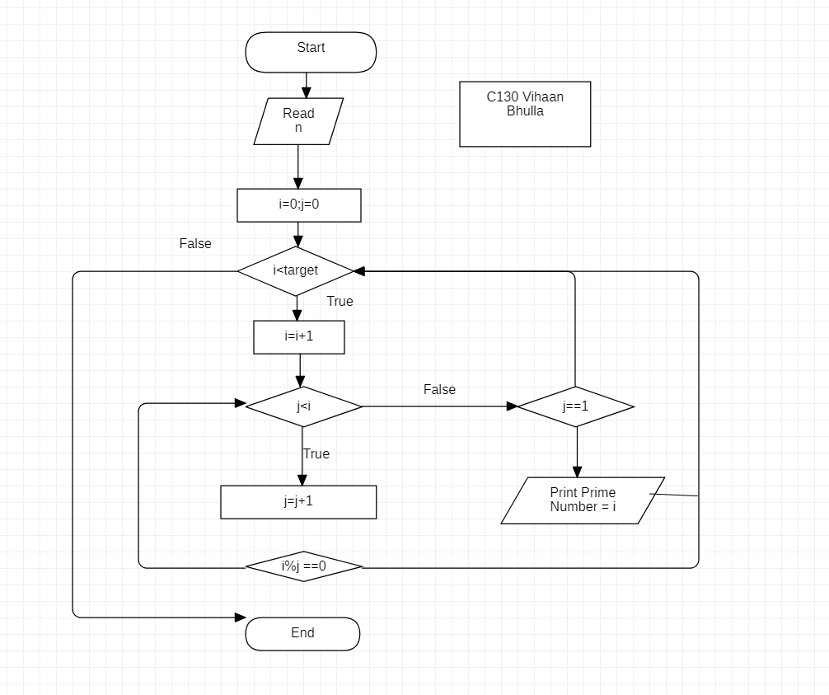

# B.2: Observations and Learning’s:

# 

I learnt how to navigate and draw flowcharts of STAR UML

# B.3: Conclusion:

All the tasks were done sucessfully