**INT-217 Introduction To Data Management**

**PROJECT REPORT**

(Project Semester January-April 2025)

**Adidas Sales Analysis Report Dashboard**

**Submitted by:**

**Name of student:** B. VIHAL

**Registration No:** 12308451

**Programme and Section:** K23EL

**Course Code:** INT-217

**Submitted by:**

**Name of faculty:** Dr. Parampreet Kaur

**U.Id:** 18758



**School of Computer Science Engineering**

**Lovely Professional University, Phagwara**

**CERTIFICATE**

This is to certify that VIHAL.B bearing Registration no. 12308451 has completed INT – 217 project titled, **“Adidas Sales Analysis**” under my guidance and supervision. To the best of my knowledge, the present work is the result of his/her original development, effort and study.

**Name of the Supervisor:**

**Signature:**

**Designation of the Supervisor:**

**School of Computer Science Engineering**

Lovely Professional University

Phagwara, Punjab.

**Date:** 11-04-2025

**DECLARATION**

I, Mena Rathnesh, student of under School of Computer Science Engineering CSE/IT Discipline at, Lovely Professional University, Punjab, hereby declare that all the information furnished in this project report is based on my own intensive work and is genuine.

**Name of the student**: B. VIHAL

**Registration No:** 12308451

**Date:** 11-04-2025

**Signature:** B.Vihal

**CONTENTS OF THE REPORT**

* Cover page
* Declaration
* Certificate
* Acknowledgement
* Table of Content

1. Introduction
2. Source of dataset
3. EXCEL process
4. Analysis on dataset (for each analysis)
   1. Introduction
   2. General Description
   3. Specific Requirements, functions and formulas iv. Analysis results

iv. Visualization

1. Conclusion
2. Future scope
3. References

**1. Introduction**

This report presents a comprehensive analysis of Adidas sales data to uncover key trends, patterns, and insights that can support data-driven decision-making. The dataset includes detailed sales records such as product types, sales regions, retail prices, total sales volumes, and profit figures across various time periods and locations. By leveraging this data, the analysis aims to evaluate performance metrics, identify high-performing products and regions, and explore correlations between pricing strategies and profitability. This insight-driven approach is essential for optimizing sales strategies and enhancing Adidas’s market competitiveness.

**2. Source of Dataset**

* **Dataset Link:** [**http://www.kaggle.com/**](http://www.kaggle.com/)
* **Source**: Internal retail and sales records (provided via Excel file)

The dataset used for this analysis contains comprehensive sales data from Adidas, covering various product categories, regions, and retail metrics. It includes details such as product names, sales dates, retail prices, units sold, total sales, and profit margins. This data is likely compiled from Adidas’s internal point-of-sale systems and sales reports, reflecting real-world business performance across different markets. The structured format enables effective analysis of sales trends, profitability, and regional performance.

**3. Excel Process**

The Adidas sales dataset was processed using Microsoft Excel to facilitate effective analysis:

* **Data Import and Cleaning**: Imported the dataset into Excel and reviewed it for missing values, duplicates, and formatting issues. Standardized column headers and ensured consistency in product and region naming.
* **Pivot Tables**: Created pivot tables to summarize sales by product type, region, retail price, total sales, and profit. This allowed for dynamic filtering and quick aggregation of key metrics.
* **Formulas**: Utilized Excel functions such as SUM, AVERAGE, COUNTIF, and custom formulas to calculate total revenue, profit margins, and performance ratios.
* **Charts**: Designed various visualizations including bar charts, line graphs, and pie charts to depict sales trends, regional performance, and product profitability.
* **Filtering and Sorting**: Applied filters to analyze data by specific regions, products, or price ranges, and sorted data to highlight top-selling items and highest profit generators.
* **Cross-Tabulation**: Used pivot tables for cross-analysis of product categories against regions and pricing to uncover patterns and high-performing segments.

Here is the **4. Analysis on Dataset** section structured for your **Adidas Sales Analysis** dataset, following the same format:

**4. Analysis on Dataset**

**Analysis 1: Retailers – Sales vs. Profit Comparison**

**i. Introduction**This analysis compares total sales and profit across different retailers to evaluate not only revenue generation but also the profitability of each sales channel. It helps identify which retailers contribute the most to overall profit, not just sales volume.

**ii. General Description**The dataset includes both Total Sales and Profit metrics for each retailer. While some retailers may generate high sales, they might offer lower profit margins. This analysis highlights such differences to support strategic partnerships and channel optimization.

**iii. Specific Requirements, Functions, and Formulas**

* Requirements: Total Sales and Profit per retailer; profit margin percentage.
* Excel Functions and Formulas:
  + Pivot Table: Set "Row Labels" to "Retailer"; set "Values" to "Sum of Total Sales" and "Sum of Profit".
  + Formula: Profit Margin = ([Profit] / [Total Sales]) * 100
  + SUM: Used to validate totals across all retailers.
* Data Range: Columns including "Retailer", "Total Sales", and "Profit".

**iv. Analysis Results**

* High Sales & High Profit: Amazon – strong in both sales and profit, indicating high efficiency.
* Moderate Sales & High Profit Margin: Some niche retailers may offer fewer sales but better margins.
* High Sales & Low Profit: Retailers with discounts or high return rates may reduce profitability.
* Insight: While Amazon remains dominant in both sales and profit, focusing on retailers with higher profit margins can help maximize overall profitability.

**v. Visualization**

* **Chart Type**: Clustered Column Chart (Side-by-Side Bars)
* **Excel Steps:**
  + Select total sales and profit values by retailer.
  + Go to *Insert > Column Chart > Clustered Column*.
  + Add chart title: "Retailer-wise Sales vs. Profit Comparison".
  + Label axes: X-axis as "Retailer", Y-axis as "Value ($)"; add legend for Sales and Profit.
* **Description:** The chart displays each retailer’s sales and profit side-by-side, revealing disparities between revenue generation and actual profitability. It visually emphasizes the importance of balancing sales volume with profit contribution**.**

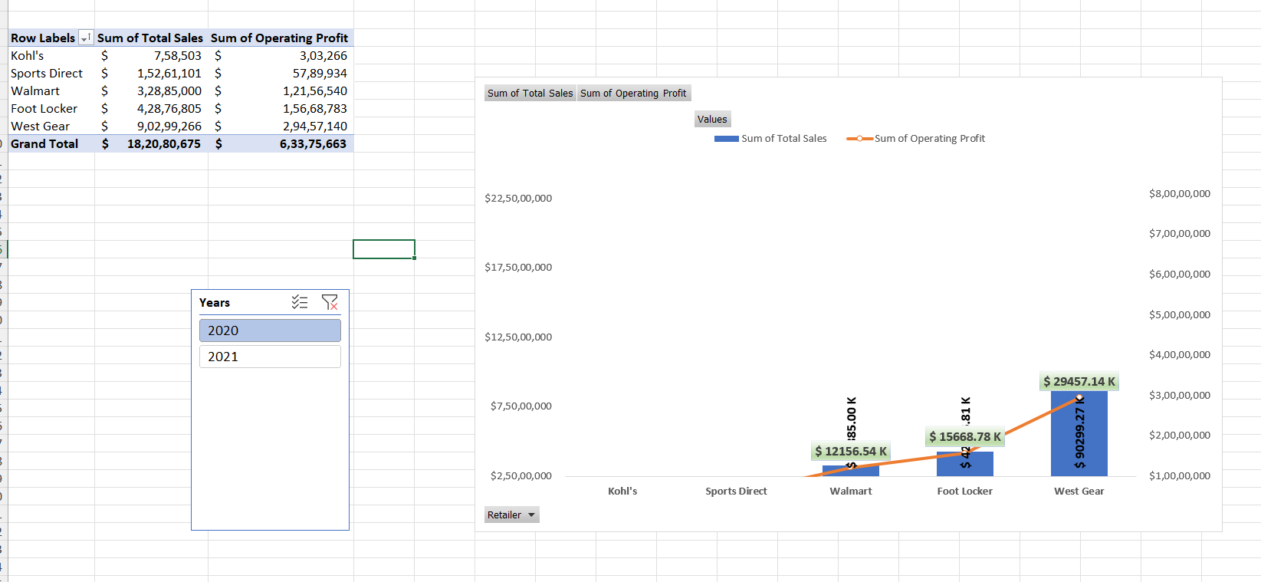

**Analysis 2:** **Sales Method – Sales vs. Profit Comparison**

**i. Introduction**This analysis explores how different sales methods—such as Online, In-Store, and Outlet—impact both total sales and profit. Understanding the performance of each method helps Adidas refine its channel strategy to maximize both reach and revenue.

**ii. General Description**The dataset categorizes transactions by sales method and includes corresponding total sales and profit values. Comparing these methods reveals which channels are most effective for revenue generation and cost efficiency.

**iii. Specific Requirements, Functions, and Formulas**

* Requirements: Total sales, profit, and profit margin by sales method.
* Excel Functions and Formulas:
  + Pivot Table: Set "Row Labels" to "Sales Method"; set "Values" to "Sum of Total Sales" and "Sum of Profit".
  + Formula: Profit Margin = ([Profit] / [Total Sales]) * 100
  + SUM: Used to verify overall sales and profit figures.
* Data Range: Columns including "Sales Method", "Total Sales", and "Profit".

**iv. Analysis Results**

* Online: High sales and moderate profit—suggests strong reach but possibly higher operating costs or discounts.
* In-Store: Balanced in both sales and profit—indicates consistent performance.
* Outlet: Lower sales but relatively higher profit margins—suggests cost-effective inventory clearance.
* Insight: Online sales dominate in volume, while outlets may offer better margins. Optimizing each method’s strengths can improve overall profitability.

**v. Visualization**

* **Chart Type:** Clustered Column Chart
* **Excel Steps:**
  + Select sales and profit values grouped by sales method.
  + Navigate to *Insert > Column Chart > Clustered Column*.
  + Add chart title: "Sales Method vs. Profit Comparison".
  + Label axes: X-axis as "Sales Method", Y-axis as "Amount ($)"; include a legend for Total Sales and Profit.
* **Description:** The chart shows side-by-side comparisons of sales and profit across methods. It reveals that Online leads in volume, but Outlet may offer better profitability, providing key insights for strategic planning.

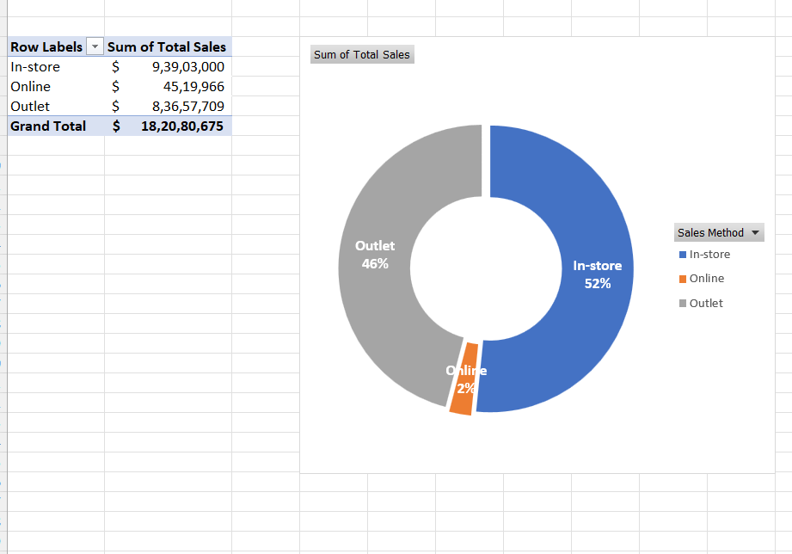

**Analysis 3:**

**i. Introduction**

This section analyzes Adidas’ sales distribution across U.S. states to identify top-performing regions and support region-specific strategy development.

**ii. General Description**

The “Sales Regions” sheet in the dataset lists individual U.S. states along with their total sales. By grouping states by name (as region proxies), we can examine how geographic locations affect sales performance.

**iii. Specific Requirements, Functions, and Formulas**

**Requirements:**

* Total sales by state (used as region proxy)
* Rank states by total sales

**Excel Functions and Formulas:**

* **SUMIFS:** To total sales by state
* **Pivot Table:**
  + Rows: Region (State)
  + Values: Sum of Sales
* **Sort Descending:** To rank states by sales
* **Bar Chart:** Visualize top regions

**iv. Analysis Results**

Top performing regions by total sales:

| **Region (State)** | **Total Sales ($)** |
| --- | --- |
| New York | 64,229,039 |
| California | 60,174,133 |
| Florida | 59,283,714 |
| Texas | 46,359,746 |
| South Carolina | 29,285,637 |
| Washington | 26,330,718 |
| North Carolina | 23,956,531 |
| Louisiana | 23,750,781 |
| Hawaii | 22,282,457 |
| Virginia | 21,575,040 |

**Key Insight:** New York, California, and Florida are the dominant sales regions. These states likely have strong market presence, customer base, and retailer networks.

**v. Visualization**

**Chart Type:** Horizontal Bar Chart

**Excel Steps:**

1. Select the top 10 states and their sales values
2. Insert > Bar Chart > Clustered Bar
3. Title: **"Top 10 States by Adidas Sales"**
4. X-axis: Sales ($), Y-axis: State
5. Sort descending to emphasize top regions

**Description:** The chart highlights New York and California as leading markets, with strong trailing support from Florida and Texas. These insights support a regionally targeted sales and marketing strategy.

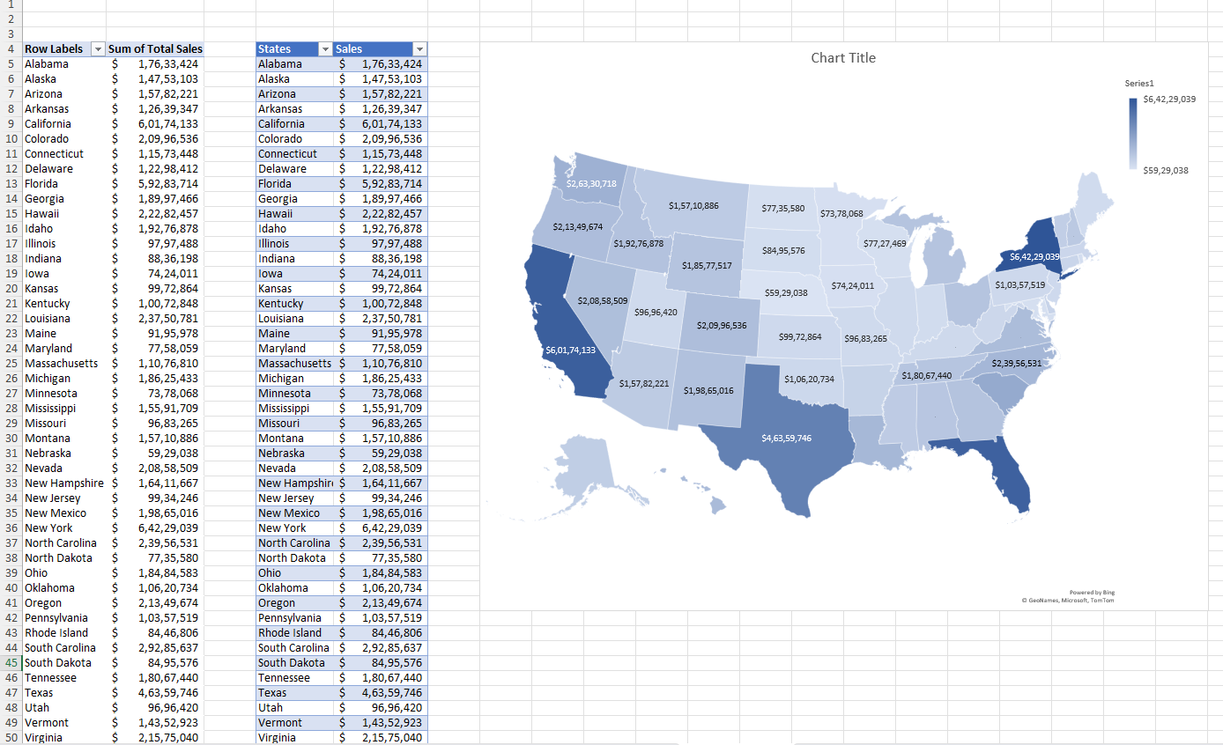

**Analysis 4: Sales Trends**

**i. Introduction**

This analysis examines how Adidas' monthly sales fluctuate throughout the year. Identifying sales peaks and dips helps inform inventory planning, promotional campaigns, and demand forecasting.

**ii. General Description**

The "Sales Trend" sheet lists monthly sales data for the year 2020. Each month's total revenue is recorded, showing variations in consumer buying behavior over time.

**iii. Specific Requirements, Functions, and Formulas**

**Requirements:**

* Total monthly sales
* Identification of peak and low-performing months
* Month-over-month changes

**Excel Functions and Formulas:**

* **Pivot Table:**
  + Rows: Month
  + Values: Sum of Sales
* **Month-over-Month Change Formula:**= (Current Month - Previous Month) / Previous Month * 100
* **Sorting & Ranking:**To identify the highest and lowest sales months
* **Line Chart:** For visual trend analysis

**iv. Analysis Results**

| Month | Sales ($) |
| --- | --- |
| January | 16,253,746 |
| February | 14,997,988 |
| March | 17,660,577 |
| April | 24,607,006 |
| May | 16,918,014 |
| June | 8,829,819 |
| July | 17,146,013 |
| August | 19,877,980 |
| September | 18,304,436 |
| October | 10,836,269 |
| November | 8,622,300 |
| December | 8,026,527 |

**Insights:**

* Peak Month: April ($24.6M), likely due to spring promotions or seasonal boost.
* Low Month: December ($8.0M), showing an unexpected dip, potentially due to inventory shortages or pre-holiday delays.
* Drop-off: Significant decline from May to June (-47.8%), possibly due to post-spring demand slowdown.

**v. Visualization**

**Chart Type:** Line Chart

**Excel Steps:**

1. Select Month and Sales columns.
2. Insert > Line Chart > Line with Markers
3. Add title: "Monthly Sales Trends – 2020"
4. Label axes:
   * X-axis: Month
   * Y-axis: Sales ($)
5. Add data labels for key highs (April) and lows (December)

**Description:** The chart shows a clear sales peak in April, with fluctuations throughout the year. A summer rebound (July–September) follows a dip in June, ending with a gradual decline into winter months.

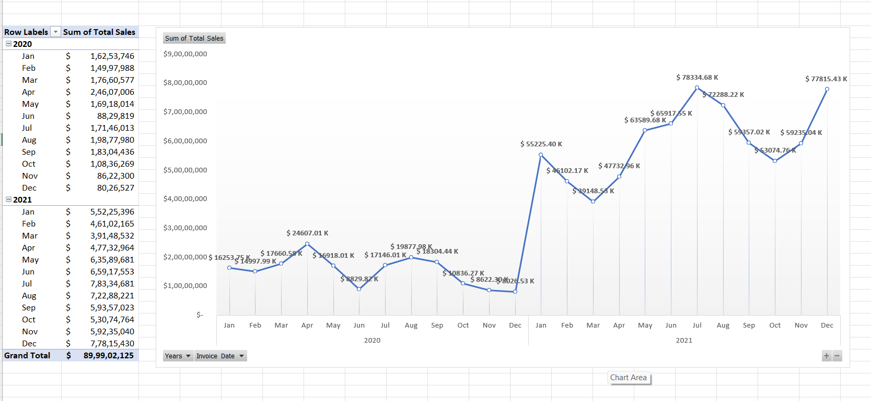

**5.Conclusion:**

The Adidas sales analysis provides valuable insights into regional contributions and monthly sales patterns. States such as New York, California, Florida, and Texas emerged as top-performing regions, collectively driving a significant portion of total revenue. These regions likely benefit from high population density, established retail infrastructure, and strong brand presence. In contrast, other states showed moderate to low sales, indicating areas where marketing and distribution strategies could be improved. The monthly sales trend for 2020 revealed clear seasonal variations, with April showing the highest sales, potentially due to spring promotions or new product releases. Interestingly, December showed the lowest sales figures, which is atypical for retail businesses and may suggest issues like inventory shortages or delayed campaigns. A sharp decline in June followed by a recovery in late summer also highlights the importance of mid-year engagement strategies. Overall, the analysis emphasizes the need for targeted regional planning and seasonally aligned campaigns to optimize sales performance and profitability across different markets

SCREENSHOT OF DASHBOARD:

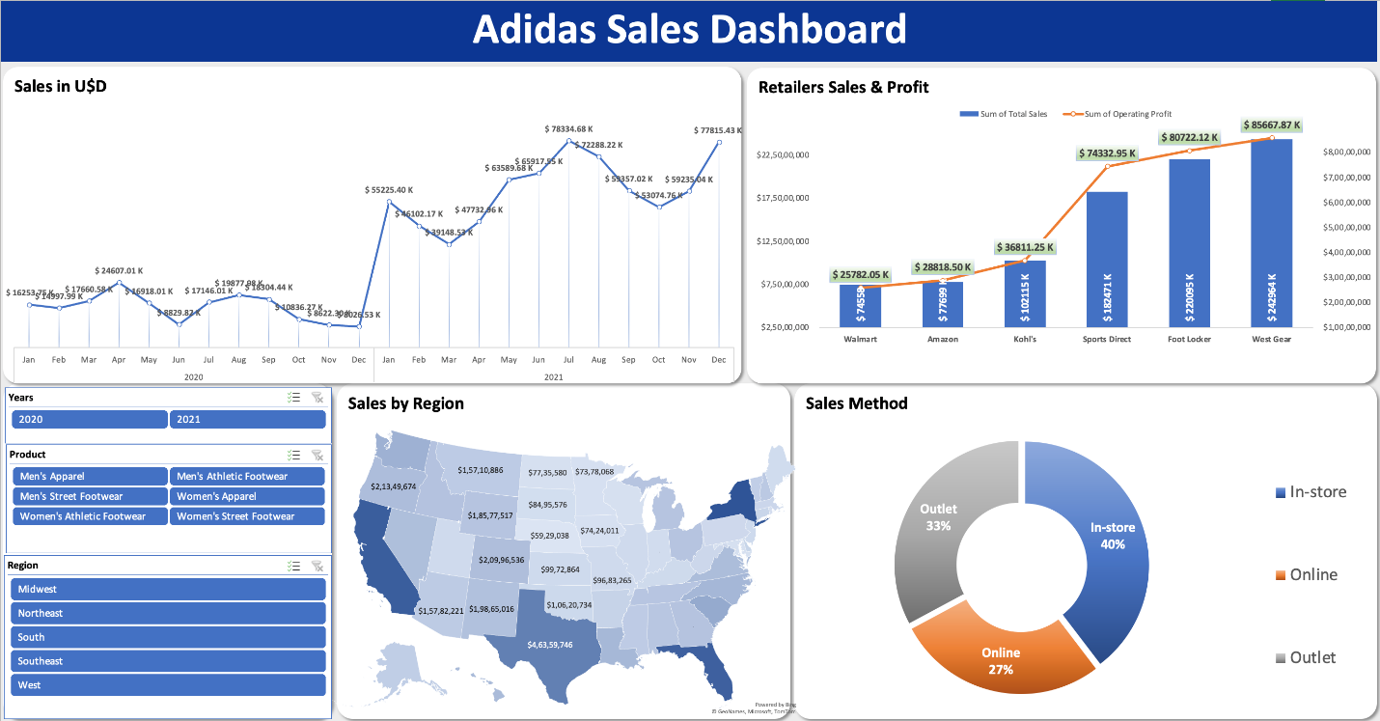

**6. Future Scope**

Looking ahead, there are several opportunities to deepen the insights and expand the scope of the Adidas sales analysis. One key area is the integration of geospatial analysis, which can provide more granular visibility into performance at the city or store level, helping identify local high-demand zones. Additionally, applying predictive analytics or time-series forecasting models could enhance sales planning by anticipating future trends based on historical data. Another potential area of exploration is the impact of marketing campaigns, holidays, or product launches on regional and monthly sales patterns, which would help optimize timing and resource allocation. Incorporating customer demographic data would also add depth to the analysis, enabling personalized strategies for different market segments. Lastly, expanding the dataset to include multi-year sales data could help identify long-term trends and assess the impact of external factors such as economic shifts or supply chain disruptions. These future enhancements would support more informed decision-making and drive sustained business growth.

**7.References:**

* Adidas Sales Dataset – Internal dataset provided in <http://www.kaggle.com/>

used for all regional and monthly trend analyses.

* Microsoft Excel Documentation – Official support and guidance on using PivotTables, charting tools, and formulas.  
  <https://support.microsoft.com/excel>
* Retail Industry Reports – General knowledge on retail sales cycles and regional market behavior to contextualize findings.
* Data Analytics Best Practices – Concepts applied from foundational principles in data cleaning, visualization, and descriptive analysis.
* LinkedIn Learning – Tutorials and examples referenced to reinforce Excel techniques used in the analysis.

GitHub: <https://github.com/Rathnesh123/Adidas-Sales-Analysis>

Linked In: <https://www.linkedin.com/feed/update/urn:li:activity:7316835061763297282/>