Vihan

Map file manager - documentation

## Introduction

The app’s purpose is to help users manage their files on a specific location (mostly created by them). These locations are indicated by markers and each marker has its own set of files that the user can download, preview and delete. The user can also upload files from their local computers. The markers as well can be created and deleted with ease.

## Create a new marker

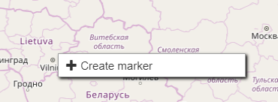

Figure 1: “Create marker” context menu

Markers can be created by simply left-clicking on the location where the user want the marker to be and a context menu will pop up, as shown in figure 1. Clicking on “Create marker” will open a window, that occupies half of the page. To close the window simply click on the X or anywhere on the map. On the “Create a new marker” there are four main fields, the marker name and description must be provided by the user, but the longitude and latitude are given. The longitude and latitude are the exact position where the user has clicked and if the user wishes, they may enter the coordinates of the location themselves.

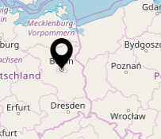

Figure 2: Marker

## Managing marker files

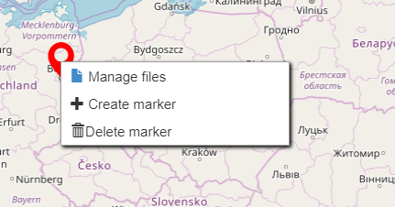

Figure 3: Marker context menu

Once a marker is created, the files of that marker can be managed by the user, this includes uploading downloading, viewing and deleting. To go into file manager simply open the context menu and click on “Manage files” (see figure 3).

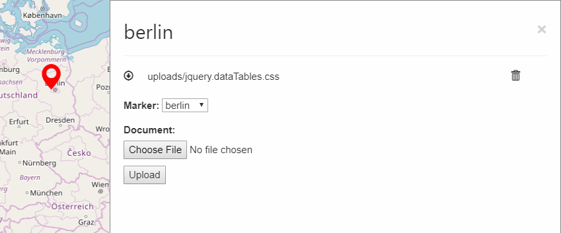

Figure 4: File manager

### Uploading

Uploading files is done in the file manager by selecting a marker, choosing a file and clicking upload. Once the upload starts a progress bar will appear to indicate how far the file is from complete (see figure 5) and once complete the page should reload and the file will show on the file manager.

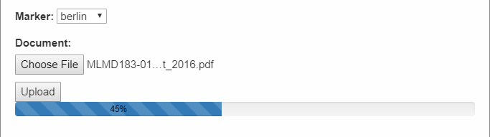

Figure 5: Uploading File

### Downloading

To download one of the files in the file manager, click on the download icon located to the left of the file name and choose a folder on a local computer to download the file to.

### Viewing

Viewing a file is done by clicking on the file name located in the file manager. This will open a new tab that displays the file without leaving the main page.

### Deleting

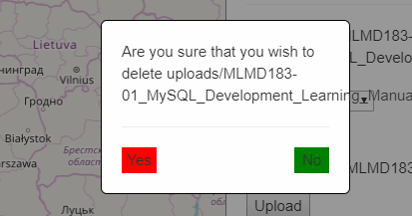

Figure 6: Delete file

Deleting a file is permanent and there is no retrieving it after deletion. It is done by clicking on the delete icon to the right of the file. There will appear a message to make sure that this is what the user wants to do (see figure 6). To proceed with the deletion click “Yes”. The page will reload and the file will no longer be visible.

## Deleting a marker

This is also permanent and there is no retrieving it after deletion. Note that this action will also delete any files associated with the marker. It is done by opening the marker context menu and clicking on “Delete marker”. Again a message will appear to make sure that this is what the user wants to do. To proceed with the deletion click “Yes”. The marker will no longer appear on the map.