**Q1. How do metrics like precision, recall, F1-score, and area under the receiver operating characteristic curve (AUC-ROC) perform in assessing the performance of machine learning models on imbalanced datasets, and which metrics are more informative in such scenarios?**

Imbalanced data, particularly in the context of classification machine learning, arises when one target class constitutes a substantial majority of observations. This scenario is a common occurrence in real-world applications, frequently requiring data scientists to address it. Imbalanced data can lead to challenges in assessing a model's performance. When evaluating model performance on imbalanced datasets, models that excel in predicting the majority class may appear to perform exceptionally well based on straightforward metrics like accuracy. However, in reality, the model may be performing inadequately.

Metrics like precision, recall, F1-score, and the area under the receiver operating characteristic curve (AUC-ROC) are commonly used to assess the performance of machine learning models, especially in binary classification tasks. However, their performance and informativeness can vary depending on the imbalance in the dataset.

Precision and Recall

* + **Precision:** Precision measures the ratio of true positive predictions to all positive predictions made by the model. It answers the question, "Of all the positive predictions made, how many were correct?"
  + **Recall (Sensitivity or True Positive Rate):** Recall measures the ratio of true positive predictions to all actual positive instances in the dataset. It answers the question, "Of all the actual positive instances, how many did the model correctly identify?"

On imbalanced datasets where the negative class greatly outnumbers the positive class, precision tends to be high because false positives are relatively rare. However, recall may suffer because the model may miss many of the actual positive instances. Depending on the problem and the relative importance of false positives and false negatives, might prioritize one over the other. For an example, in medical diagnosis, recall might be more important because missing a disease (false negative) can be critical.

1. **F1-Score:**
   * The F1-score is the harmonic mean of precision and recall. It balances the trade-off between precision and recall. It can be useful when to consider both false positives and false negatives, and want a single metric that takes both into account.
   * The F1-score is particularly useful when the class imbalance is severe, as it provides a single score that summarizes both precision and recall. It can be informative in such scenarios to assess overall model performance.
2. **AUC-ROC (Area Under the Receiver Operating Characteristic Curve):**
   * The ROC curve is a graphical representation of a model's performance across different thresholds. AUC-ROC quantifies the overall ability of the model to distinguish between the positive and negative classes.
   * AUC-ROC is less affected by class imbalance because it focuses on the model's ranking of instances rather than absolute counts of true positives, false positives, etc. AUC-ROC can provide insights into how well the model is performing across different thresholds and is useful for comparing models.
   * However, in highly imbalanced datasets, where the negative class is dominant, the ROC curve might look excellent even if the model is poor at identifying the minority class. In such cases, **AUC-PR (Area Under the Precision-Recall Curve)** can be more informative as it focuses on the performance of the model on the positive class.

In summary, the choice of metrics in imbalanced datasets depends on the specific problem and the relative importance of false positives and false negatives. Precision, recall, and F1-score are useful for assessing class-specific performance, while AUC-ROC and AUC-PR provide a more comprehensive view of model performance. Furthermore, G-mean and average precision are both metrics that are less sensitive to class imbalance than precision, recall, and F1-score. **G-mean** is the geometric mean of precision and recall. It is a good metric to use when to balance the trade-off between precision and recall. **Average precision (AP)** is a measure of the overall performance of a model at predicting the positive class. It is calculated by averaging the precisions at different recall levels. Both G-mean and average precision have been shown to be effective for evaluating machine learning models on imbalanced datasets.

It's often recommended to consider a combination of these metrics to get a complete understanding of a model's performance in imbalanced datasets.

**Q2. How does dimensionality reduction affect the accuracy, training time, and interpretability of various classification or regression models, and how does it interact with different regularization techniques?**

Dimensionality reduction techniques, such as **Principal Component Analysis (PCA) and t-Distributed Stochastic Neighbor Embedding (t-SNE)**, can significantly impact the accuracy, training time, and interpretability of classification and regression models. However, the specific effects can vary depending on the dataset and the model used. Below are the general impacts:

**Accuracy:**

* **Positive Impact:** Dimensionality reduction can improve accuracy in some cases by removing noisy or irrelevant features in classification and regression models. It can help the model focus on the most informative features, reducing overfitting and improving generalization.
* **Negative Impact:** In certain situations, dimensionality reduction can lead to loss of information, causing a drop in accuracy. This happens when important features are discarded or when the reduced dimensions cannot capture complex relationships in the data.

**Training Time:**

* **Positive Impact:** Reducing the number of features through dimensionality reduction often leads to faster training times. With fewer dimensions, the model requires less computation during training.
* **Negative Impact:** Some dimensionality reduction techniques can be computationally intensive, particularly when dealing with very high-dimensional data. Additionally, the time required for dimensionality reduction itself must be considered.

**Interpretability:**

* **Positive Impact:** Dimensionality reduction can enhance interpretability by reducing the number of features to a manageable level. This simplifies the understanding of the model's decision-making process.
* **Negative Impact:** Reduced dimensions may not directly correspond to the original features, making it challenging to interpret the model's decisions in terms of the original data.

The effects of dimensionality reduction on the accuracy, training time, and interpretability of different classification and regression models will vary depending on the specific model and the dataset. However, in general, dimensionality reduction can be expected to improve the accuracy and interpretability of these models, while reducing their training time.

**Interaction with regularization techniques**

Regularization is the process of penalizing complex models in order to prevent overfitting. Overfitting occurs when a model learns the training data too well and is unable to generalize to new data. Regularization can be used to prevent overfitting by penalizing models with large weights or complex structures.

Dimensionality reduction and regularization can interact in a number of ways. The impact of dimensionality reduction on regularization depends on the specific regularization method used and the nature of the dataset. For example, dimensionality reduction can be used to reduce the number of features before applying regularization. This can make the regularization process more effective and reduce the risk of overfitting. Another way that dimensionality reduction and regularization can interact is that some regularization techniques can also lead to dimensionality reduction.

1. **L1 (Lasso) Regularization:**
   * **Positive Interaction:** L1 regularization encourages sparsity in the feature space by penalizing the absolute magnitude of feature coefficients. Dimensionality reduction can complement L1 regularization by further reducing the number of non-zero coefficients, making the model more interpretable and potentially improving generalization.
   * **Negative Interaction:** If dimensionality reduction is performed before applying L1 regularization, important features might be discarded, leading to a suboptimal model. It's often advisable to apply L1 regularization after dimensionality reduction to avoid this issue.
2. **L2 (Ridge) Regularization:**
   * **Positive Interaction:** L2 regularization penalizes the square of feature coefficients, encouraging smaller coefficients. Dimensionality reduction can help by reducing the number of features, making it easier for L2 regularization to shrink the coefficients effectively and avoid overfitting.
   * **Negative Interaction:** If dimensionality reduction is too aggressive, it may remove useful features, and L2 regularization alone may not be sufficient to recover the necessary information.
3. **Elastic Net Regularization:**
   * **Positive Interaction:** Elastic Net combines L1 and L2 regularization, offering a balance between feature selection and coefficient shrinkage. Dimensionality reduction can enhance the feature selection aspect of Elastic Net, leading to a more interpretable and potentially better-performing model.
   * **Negative Interaction:** Over-aggressive dimensionality reduction might still lead to the loss of important features, even with Elastic Net regularization.
4. **Regularization Techniques with Embedding Methods (e.g., Sparse Autoencoders):**
   * Dimensionality reduction techniques like autoencoders can be combined with various regularization techniques within the neural network architecture. These combinations can be tailored to specific goals and dataset characteristics.

**Q3. How do bagging, boosting, and stacking differ in terms of their underlying principles, ensemble construction methods, handling of base learner diversity, and overall impact on model performance, and what are the common characteristics and shared benefits that these ensemble techniques offer in terms of improving prediction accuracy and robustness in machine learning tasks?**

There are many ensemble techniques, out of them bagging, boosting and stacking are commonly used. **Bagging**, also known as Bootstrap Aggregating, improve the accuracy and stability of a predictive model. It creates multiple models using bootstrapped samples of the training data. The comparatively weaker models are taken as base learners and are trained independently, and then their predictions are combined using averaging or voting to make the final, more accurate prediction. The bagging helps to reduce the variance, reduce the overfit , improve the stability of the predictions, reduce the impact of outliers

**Boosting** is particularly employed to address elevated bias in machine learning models, resulting in a diminishment of errors in predictions. The amalgamation of weaker learners into a more resilient model significantly enhances the predictive accuracy. This methodology entails the training of weaker models and subsequently amalgamating them into stronger models through an iterative procedure.

**Stacking** is an ensemble learning technique that improves the overall accuracy of multiple models by training a meta-model to combine the predictions of the base models.

**Ensemble construction methods**

* Bagging: Bagging constructs an ensemble by training multiple models on different subsets of the training data, with replacement. This means that the same data point can be selected more than once to be included in a subset. Parallel and independent training of base learners. No specific focus on correcting errors of previous learners.
* Boosting: Boosting constructs an ensemble by training multiple models sequentially, with each new model trained on a weighted version of the training data, where the weights are determined by the performance of the previous model on the training data.
* Stacking: Stacking constructs an ensemble by first training multiple base models on the training data. Then, a meta-model is trained on the predictions of the base models to combine them into a single prediction. Parallel training of base learners. A meta-learner is trained to combine base learner outputs.

**Handling of base learner diversity**

* Bagging: Bagging typically uses homogeneous base learners, meaning that the base learners are all of the same type. This is because bagging is focused on reducing variance, and homogeneous base learners are less likely to produce predictions that are widely different from each other.
* Boosting: Boosting can use either homogeneous or heterogeneous base learners. However, homogeneous base learners are more commonly used in boosting, as this can help to reduce the risk of overfitting.
* Stacking: Stacking can use either homogeneous or heterogeneous base learners. In fact, stacking is often used to combine the predictions of heterogeneous base learners, as this can lead to improved prediction accuracy.

**Overall impact on model performance**

* Bagging: Bagging typically reduces the variance of a model, but it may not significantly reduce the bias. As a result, bagging can improve the overall performance of a model, but it may not be as effective as boosting at reducing overfitting.
* Boosting: Boosting typically reduces both the variance and bias of a model. As a result, boosting is often very effective at improving the overall performance of a model, including reducing overfitting.
* Stacking: Stacking can improve the overall accuracy of multiple models, but its effectiveness depends on the quality of the base models. If the base models are not performing well, then stacking will not be able to significantly improve their performance.

**Common characteristics and shared benefits**

Bagging, boosting, and stacking all share a number of common characteristics and shared benefits. Such as :

* Improved prediction accuracy: All three ensemble techniques can improve the prediction accuracy of machine learning models. This is because they combine the predictions of multiple models, which helps to reduce the overall error rate.
* Reduced overfitting: All three ensemble techniques can help to reduce overfitting by averaging or combining the predictions of multiple models. This is because overfitting is less likely to occur when multiple models are used to make a prediction.
* Increased robustness: All three ensemble techniques can help to increase the robustness of machine learning models to noise and outliers in the data. This is because they combine the predictions of multiple models, which makes them less likely to be affected by individual data points.

**Q4. What are the key similarities and differences between Gradient Boosting, Adaptive Boosting, XGBoost, LightGBM, and CatBoost? How do these gradient boosting techniques differ in terms of their algorithmic approaches, feature handling capabilities, computational efficiency, and performance metrics?** **Which technique demonstrates superior performance and efficiency for different types of machine learning tasks?**

Gradient Boosting, Adaptive Boosting (AdaBoost), XGBoost, LightGBM, and CatBoost are all ensemble machine learning algorithms that aim to improve predictive accuracy by combining the outputs of multiple weak learners (usually decision trees). Here are the key similarities and differences among these algorithms:

**Similarities:**

1. **Ensemble Learning:** All these algorithms are ensemble methods, which means they combine the predictions of multiple base models (usually decision trees) to create a stronger predictive model.
2. **Sequential Learning:** They are based on the idea of building models sequentially, with each new model focusing on correcting the errors made by the previous ones.
3. **Classification and Regression:** They can be used for both classification and regression tasks.

**Differences:**

1. **Gradient Boosting:**
   * **Base Model:** Gradient Boosting typically uses shallow decision trees as base models.
   * **Loss Function:** It minimizes the residual errors (the difference between predictions and actual values) using gradient descent.
   * **Parallelism:** Gradient Boosting is inherently sequential and not parallelizable.
   * **Implementation:** Common libraries for Gradient Boosting include scikit-learn's GradientBoostingClassifier and GradientBoostingRegressor.
2. **AdaBoost (Adaptive Boosting):**
   * **Base Model:** AdaBoost also uses decision trees but assigns different weights to each data point to focus on misclassified samples.
   * **Loss Function:** It adjusts the weights of samples to prioritize those that are misclassified.
   * **Parallelism:** AdaBoost can be parallelized because each model is built independently.
   * **Implementation:** Can use scikit-learn's AdaBoostClassifier and AdaBoostRegressor.
3. **XGBoost (Extreme Gradient Boosting):**
   * **Base Model:** XGBoost extends Gradient Boosting by using optimized decision trees and adding regularization terms to the loss function.
   * **Parallelism:** It supports parallelization and is designed for efficient distributed computing.
   * **Implementation:** XGBoost has its own Python package, 'xgboost,' which is widely used in machine learning competitions and applications.
4. **LightGBM:**
   * **Base Model:** LightGBM uses gradient-based leaf-wise tree growth and histogram-based techniques to construct decision trees.
   * **Parallelism:** It is highly optimized for parallel and distributed computing, making it faster than many other algorithms.
   * **Implementation:** LightGBM has its own Python package and is known for its speed and efficiency.
5. **CatBoost:**
   * **Base Model:** CatBoost is specifically designed for categorical features and handles them naturally without preprocessing.
   * **Regularization:** It includes built-in regularization and is less prone to overfitting.
   * **Parallelism:** CatBoost supports parallelization.
   * **Implementation:** CatBoost has its own Python package and is known for its ease of use with categorical data.

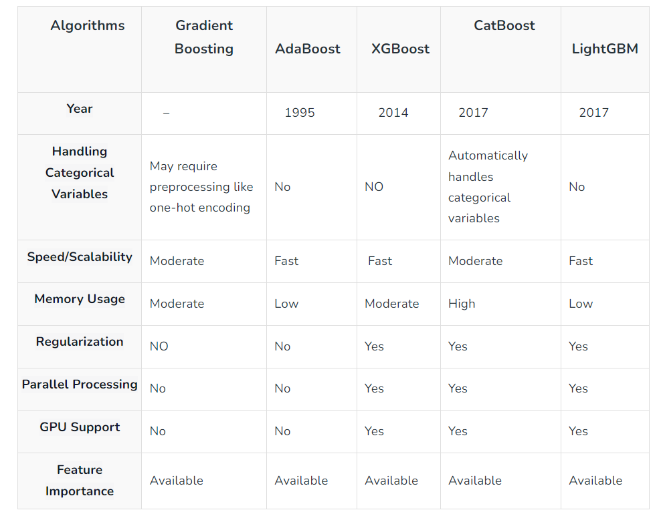Summary of the differences are as follows:

Gradient boosting techniques, including Gradient Boosting, XGBoost, LightGBM, and CatBoost, differ in various aspects such as their algorithmic approaches, feature handling capabilities, computational efficiency, and performance metrics. Here's a breakdown of these differences:

**Algorithmic Approaches:**

1. **Gradient Boosting:**
   * **Algorithm:** Gradient Boosting uses gradient descent to minimize the loss function (usually mean squared error for regression or log loss for classification) by adding weak learners (typically shallow decision trees) sequentially.
   * **Tree Building:** It uses depth-first tree growth.
   * **Regularization:** It generally lacks built-in regularization.
2. **XGBoost (Extreme Gradient Boosting):**
   * **Algorithm:** XGBoost extends Gradient Boosting by optimizing tree construction and adding regularization terms to the loss function, which helps control overfitting.
   * **Tree Building:** It uses a more efficient and optimized algorithm for tree construction.
   * **Regularization:** XGBoost incorporates L1 and L2 regularization terms.
3. **LightGBM:**
   * **Algorithm:** LightGBM uses gradient-based leaf-wise tree growth and histogram-based techniques, which can lead to faster training.
   * **Tree Building:** It uses leaf-wise tree growth, which can be more efficient than depth-first growth in some cases.
   * **Regularization:** LightGBM supports built-in L1 and L2 regularization.
4. **CatBoost:**
   * **Algorithm:** CatBoost is designed for categorical feature handling, automatically handling categorical data without preprocessing. It also uses gradient boosting with a symmetric tree structure.
   * **Tree Building:** It uses a symmetric tree structure, which simplifies the optimization process.
   * **Regularization:** CatBoost includes built-in regularization and is less prone to overfitting.

**Feature Handling Capabilities:**

1. **Gradient Boosting:**
   * Requires one-hot encoding or other preprocessing for categorical features.
2. **XGBoost:**
   * Supports one-hot encoding of categorical features but also provides options for handling them more efficiently.
3. **LightGBM:**
   * Can handle categorical features naturally without one-hot encoding, making it efficient for datasets with many categorical features.
4. **CatBoost:**
   * Automatically handles categorical features without preprocessing, which simplifies the data preparation process.

**Computational Efficiency:**

1. **Gradient Boosting:**
   * May be slower compared to other gradient boosting libraries due to its lack of optimization.
2. **XGBoost:**
   * Is known for its speed and efficiency, thanks to optimized tree construction and parallelization.
3. **LightGBM:**
   * Is designed for computational efficiency and is known for its speed, especially with large datasets.
4. **CatBoost:**
   * Offers good computational efficiency and can be faster than some other algorithms when handling categorical data.

**Performance Metrics:**

Performance metrics such as accuracy, precision, recall, F1-score, AUC-ROC, and mean squared error (MSE) can be applied to all these gradient boosting techniques. The choice of metric depends on the specific problem (classification or regression) and the business objectives.

In summary, these gradient boosting techniques differ in their underlying algorithms, feature handling capabilities, computational efficiency, and built-in regularization techniques. The choice of which algorithm to use should be based on the characteristics of the dataset, the problem at hand, and the need for computational efficiency. Each of these techniques has its strengths and may perform better in different scenarios.

**Which technique demonstrates superior performance and efficiency for different types of machine learning tasks?**

The choice of which gradient boosting technique to use depends on various factors, including the specific machine learning task, the characteristics of the dataset, and computational resources. Each technique has its strengths and may outperform the others in certain scenarios. Here are some general guidelines for selecting a gradient boosting technique for different types of machine learning tasks:

1. **XGBoost:**
   * **Strengths:** XGBoost is a versatile and widely used gradient boosting library known for its efficiency, scalability, and excellent performance on a wide range of machine learning tasks. It often performs well out of the box and is a popular choice for structured/tabular data.
   * **Use Cases:** XGBoost is a strong choice for classification and regression tasks on structured data with a moderate to large number of features.
2. **LightGBM:**
   * **Strengths:** LightGBM is known for its computational efficiency and speed, making it a great choice for large datasets and time-sensitive applications. It also handles categorical features well.
   * **Use Cases:** LightGBM is particularly suitable for classification and regression tasks with large datasets, especially when feature engineering has been performed, and when dealing with categorical data.
3. **CatBoost:**
   * **Strengths:** CatBoost excels in handling categorical features without preprocessing, which simplifies the data preparation process. It also includes built-in regularization and can be more resistant to overfitting.
   * **Use Cases:** CatBoost is an excellent choice for classification and regression tasks, especially when dealing with datasets containing a significant number of categorical features or when interpretability is essential.
4. **Gradient Boosting (scikit-learn):**
   * **Strengths:** While scikit-learn's GradientBoostingClassifier and GradientBoostingRegressor may not be as efficient as the specialized libraries mentioned above, they are still capable and can be useful for smaller datasets or when computational resources are not a major concern.
   * **Use Cases:** Can use scikit-learn's Gradient Boosting for various classification and regression tasks, particularly when working with small to moderate-sized datasets.

**Section 2: Machine Learning Used CaseTop of Form**

To the task I have taken bank churn prediction data set in available in Kaggle. After downloading the dataset, I looked at the data set in high level to have an understand. After that I have load the necessary packages to read and analyze the data.

Load the data set and checking the data set, what are the columns are and the rows and columns

Checked the data types , count of the data set and found out there were no null values in the dataset

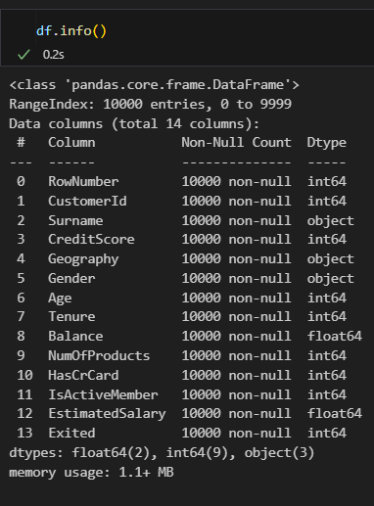

Since the focus is to identify the churn customers we are removing the unwanted columns from the data set such as row number, customer ID and the Surname

EDA

Perform EDA on the dataset to gain insights into its structure, summary statistics, and visualize key variables using tools.

Churn vs Retained Customers

In the data set almost 1/5 customers are going to churn. The pie chart represents 20.4% is churned out of 10000 customers.

Categorical data analysis

According to the above analysis we found out there are 3 nations in the dataset. France having majority of the customers in the analysis and the least is Germans. Germans and the Frenches are churned in same number of customers. But as a Nation German are churned higher than other 2 nations

Higher proportion of the data set contains Males. Considering the gender against the churn Females tend to churn higher than the Males.

Customers who have one product is prominent in the data set. Almost 50% of customers have 1 product in the bank. Out of the 50%, 14% were churned. 47% Customers have 2 products and out of them 3.5% churned.

Almost 70% of the customers have a credit card. From the entire data set 14% churn came from those who has a credit card.

Correlation between numerical variables

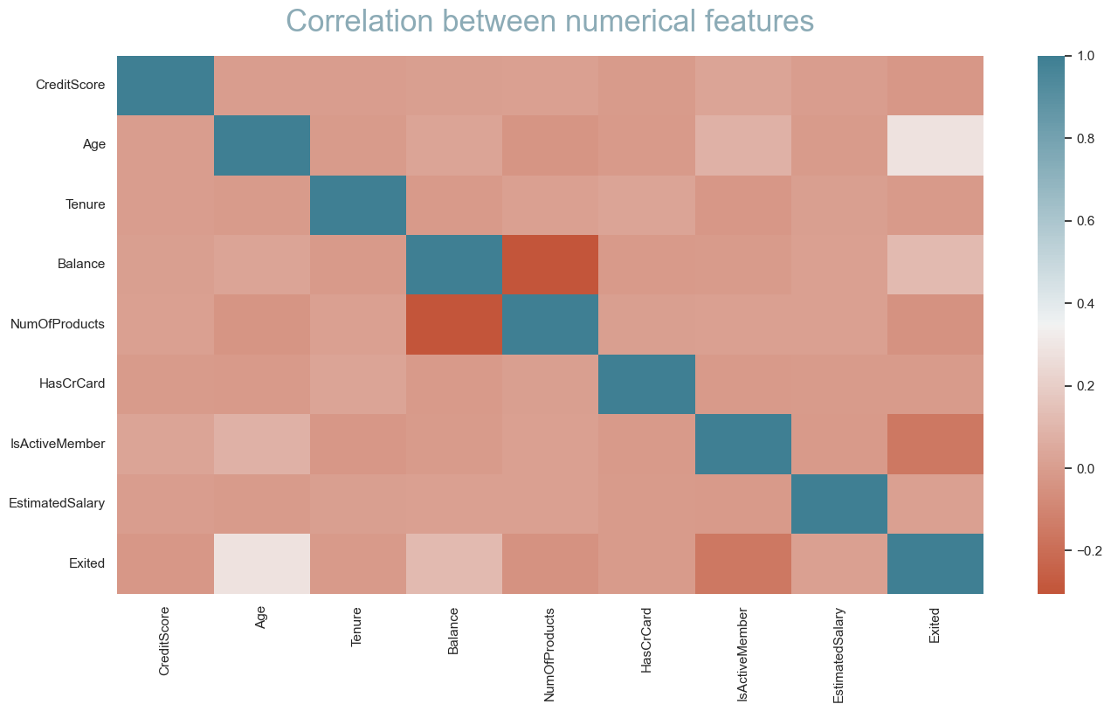

According to the heatmap there were no positive correlation

Feature Engineering

1st the data set is split for train and test data. I have split the data as train 70% and the test as 30%.

Introduced a new variable to the train data set named “BalanceSalaryRatio”. BalanceSalaryRatio derived by dividing the 'Balance' column by the 'EstimatedSalary' column. This ratio represents the balance of a customer relative to their estimated salary. Essentially, it's a measure of how much of their salary is stored in the bank. For the customer churning new variable having a smaller impact. For the churn customers some have higher bank balance salary ratio. It might leads to funding bank’s available funds to loans.

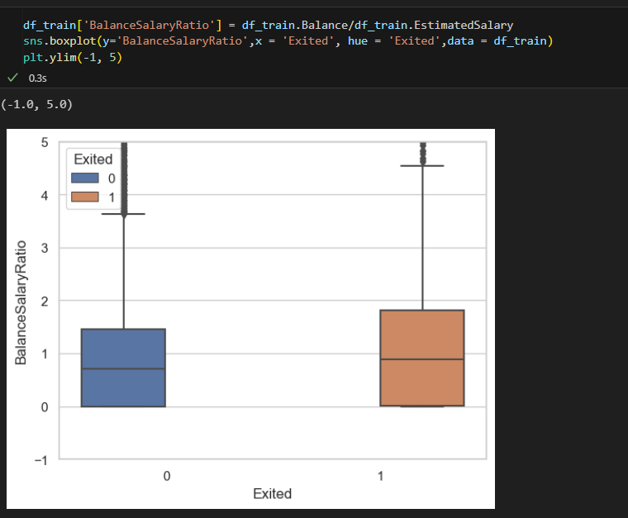

Another new feature was introduced. New feature called 'TenureByAge' by dividing the 'Tenure' (the number of years a customer has been with the bank) by the 'Age' of the customer. Essentially, it calculates the ratio of how long a customer has been with the bank relative to their age. This new variable aims to standardize the tenure by age.

Encoding

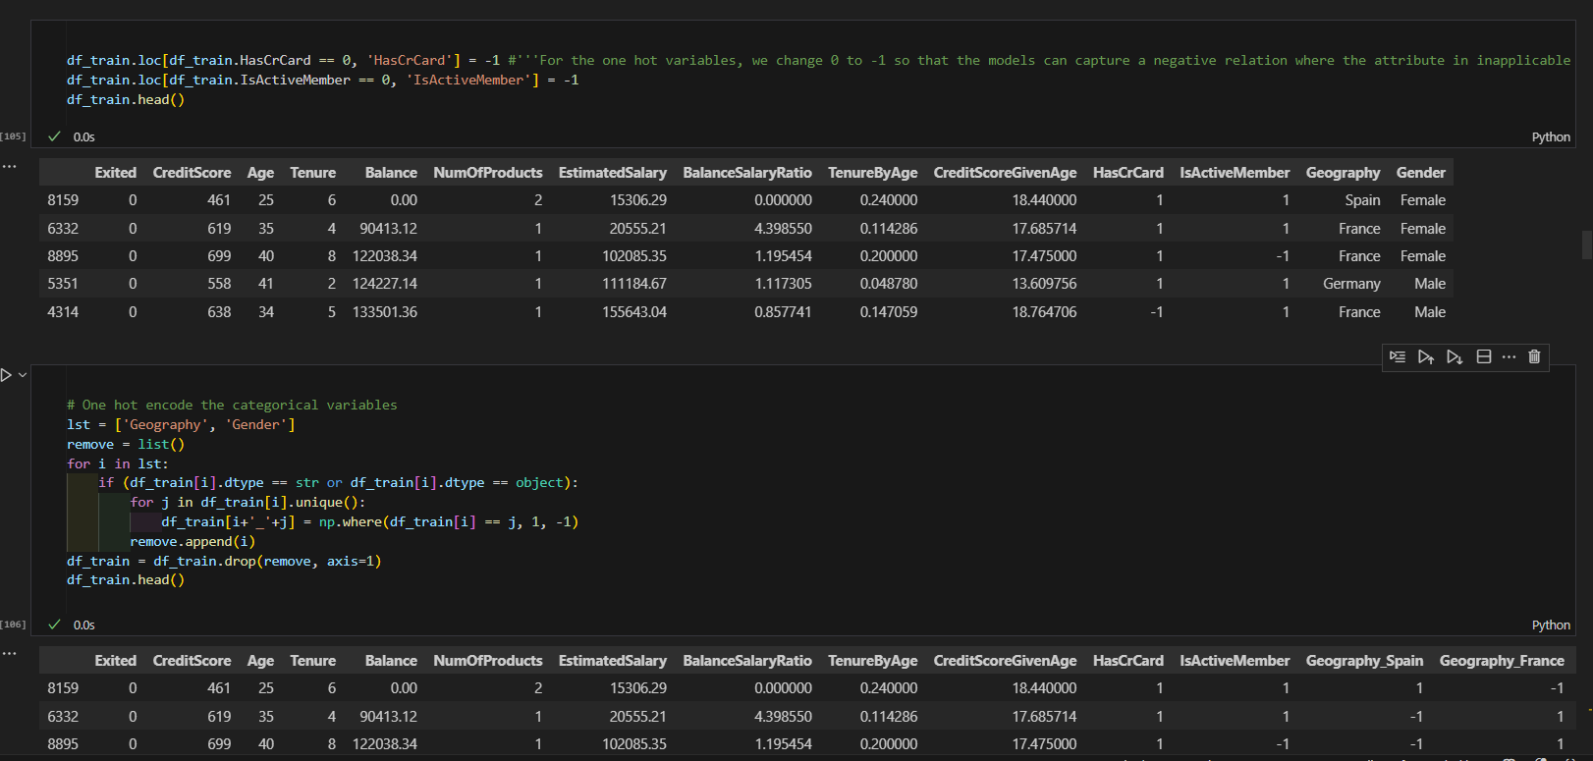

Changing 0 to -1 in one-hot encoded variables like HasCrCard and IsActiveMember is a technique used to represent the absence or inapplicability of a certain attribute with a negative value. This transformation is often applied when training machine learning models that assume linear relationships or when to emphasize the absence of a feature.

Categorical variables also encoded by one hot encoding.

After that continuous variables were scaled by min max scalar.

Once loading the support and scoring functions, checked the model which can be use to get the optimum output for the study. For the model fitting, I tried out the Logistic regression SVM and Ensemble models

After that checked the accuracy of the models

Then I drew the area under the curve

With reference to the ROC-AUC Random forest provides 0.75 to the Random Forest. Furthermore, recall and the precision from the random forest gave 0.51 and 0.90.