

INFORMATICS INSTITUTE OF TECHNOLOGY
In Collaboration with
UNIVERSITY OF WESTMINSTER

Evaluation Document of Cloud Seal

A Privacy-Preserving Multi-Tenant Cloud Deduplication Framework with AI, Blockchain, and Post-Quantum Cryptography

Name: Vihangi Patterson
Supervised by : Mr. Pubudu De Silva
Student ID: W1953064 / 20220011

Table of Content
Introduction 2
Importance of the Project 3
How Did I Solve the Problem? 4
Component 1: Convergent Encryption with Tenant-Specific Salting 4
Component 2: AI-Powered Encrypted Similarity Detection (Siamese CNN) 5
Component 3: Bloom Filter for O(1) Fast Lookup 6
Component 4: IPFS-Based Content-Addressable Storage 6
Component 5: Blockchain-Based Immutable Audit Trail 7
Component 6: Post-Quantum Hybrid Encryption (Kyber-768 + AES-256) 8
Comparison with Existing Systems 9
Demonstration 10
Testing Criteria & Results 11
Test 1: Blockchain Integrity 11
Test 2: Bloom Filter Deduplication Accuracy 11
Test 3: Multi-Tenant Isolation 12
Test 4: Performance Benchmarks 12
Test 5: Security Threat Model 13
Test 6: AI model evaluvation 13
Score Distribution: 14
Baseline Compasrison : 14
Future Enhancements 14
Contributions to the Body of Knowledge 15
Final Evaluation of the Project 16
References 17

Introduction
When you upload a file to the cloud — like Google Drive, Dropbox, or AWS — the cloud provider checks if someone else has already uploaded the same file. If they have, the cloud doesn’t store your copy. Instead, it creates a link to the existing copy. This is called deduplication, and it saves enormous amounts of storage space. Major cloud providers report that 60-70% of stored data is duplicate content.

But here is the problem: to protect your privacy, your files are encrypted before storage. Once encrypted, two identical files look completely different — because each user encrypts with a different key. The cloud can no longer tell they are the same file.
This is called the deduplication-encryption paradox — and it is one of the biggest unsolved challenges in cloud computing.

Example: Imagine two companies both upload the same 100-page contract template. Without encryption, the cloud sees they are identical and stores only one copy. With encryption, Company A’s copy looks completely different from Company B’s copy — even though the original files were the same. The cloud stores two copies, wasting storage space.
On top of this, there are two more emerging threats:
- Quantum computers will soon be able to break the encryption we use today (RSA, ECC). This means any data stored now could be decrypted in the future by quantum computers.
- Near-duplicate files (like two versions of a document with small edits) waste storage because current systems can only detect exact duplicates.

Major cloud providers (AWS S3, Azure Blob Storage, Google Cloud Storage) perform deduplication only on unencrypted data at the server side. When clients encrypt files before upload — as required for sensitive data — these platforms lose all deduplication capability. Cloud Seal addresses this gap.

Importance of the Project
Cloud storage is used by billions of people and millions of businesses worldwide. The deduplication-encryption paradox affects:
- Cloud providers who want to reduce storage costs
- Businesses who want to protect sensitive data while saving storage costs
- Healthcare organizations who must protect patient data (HIPAA compliance)
- Financial institutions who must protect transaction records
- Government agencies who must protect classified information
Current solutions force a choice: either you get good deduplication but weak security, or strong security but no deduplication. No existing system effectively achieves both simultaneously.
Additionally, with quantum computers coming in the next 10-15 years, any data encrypted today with classical methods could be decrypted in the future. This is called the “harvest now, decrypt later” threat.
Cloud Seal addresses all three problems in a single unified system.

System Architecture
Cloud Seal introduces a six-component architecture where each component solves a specific problem. The novelty is that these components work together as a unified pipeline - no existing system combines all six.

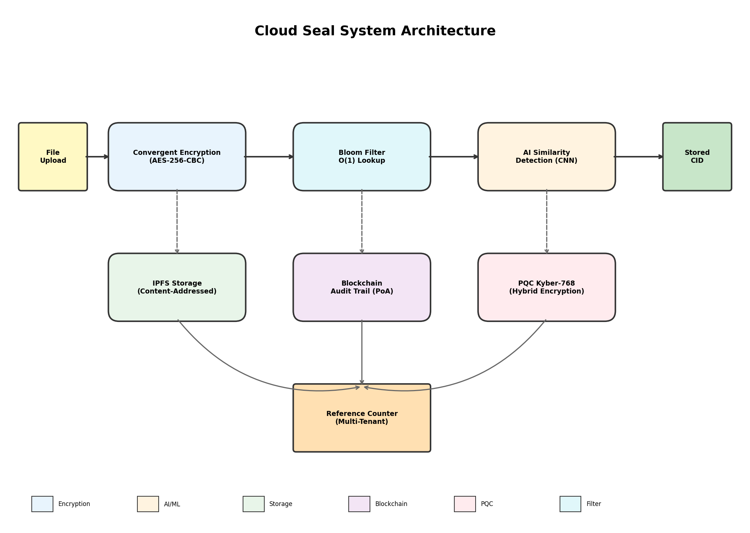

The data flow for file upload follows a systematic pipeline:

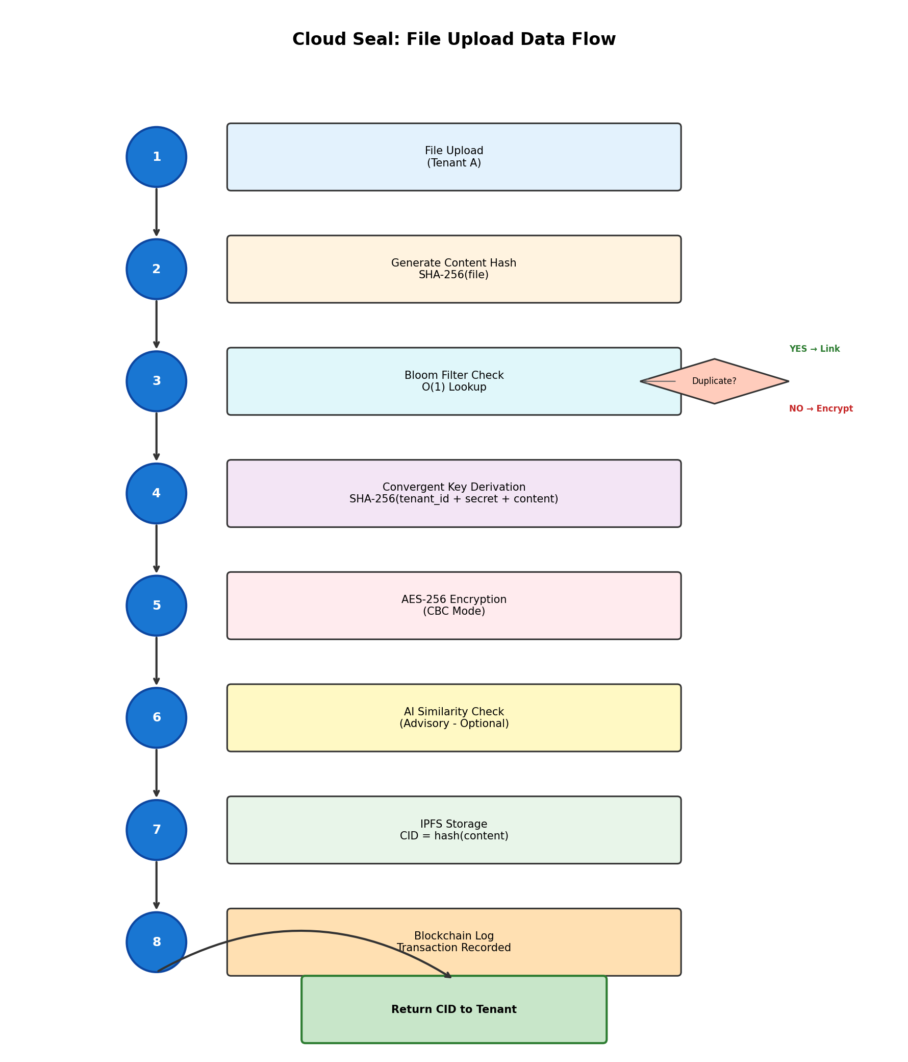

How Did I Solve the Problem?
Cloud Seal introduces a six-component architecture where each component solves a specific problem. The novelty is that these components work together as a unified pipeline — no existing system combines all six.

Component 1: Convergent Encryption with Tenant-Specific Salting
What it does: Encrypts files so that the same file always produces the same encrypted output (enabling deduplication), but adds per-tenant secrets to prevent cross-tenant data leakage.
How it works:
Encryption Key = SHA-256(tenant_id + tenant_secret + file_content)
Encrypted File = AES-256-CBC(file_content, key)
What it solves: The standard convergent encryption vulnerability — where an attacker encrypts a known file and checks if the hash matches stored data (called a “confirmation attack”).

Example: Two different tenants uploading the same file produce different encrypted outputs. An attacker cannot confirm whether a target tenant has a specific file.
Novelty: Unlike standard convergent encryption, Cloud Seal’s tenant-salted approach means each tenant’s data is isolated. An attacker who knows a file’s content cannot determine if any specific tenant has that file.

Component 2: AI-Powered Encrypted Similarity Detection (Siamese CNN)
What it does: Detects files that are nearly identical — even after encryption — using a neural network that analyses the statistical patterns of encrypted binary data.
How it works:
- A Binary File Encoder reads the encrypted file bytes and extracts a “fingerprint” — a 2048-dimension feature vector capturing:
  - Byte frequency distribution (which byte values appear most often)
  - Shannon entropy per chunk (how random each section of the file is)
  - Byte pair correlations (patterns in how bytes follow each other)
  - Statistical moments (mean, standard deviation, skewness, kurtosis)
- A two-layer Siamese CNN takes two fingerprints and maps them through a 512-dimensional hidden layer (with ReLU activation) into a compact 128-dimensional embedding space using shared weights. Input features are z-score normalised to balance the different scales of byte frequencies, entropy values, and statistical moments.
- Cosine similarity between the two embeddings gives a score from 0 (completely different) to 1 (identical). If the score is 0.85 or higher, the files are flagged as near-duplicates.
Important Design Decision: Cloud Seal does NOT automatically deduplicate near-duplicates. The AI only provides an advisory notification — it tells the user “This file is 92% similar to an existing file.” Only when the SHA-256 hash is an exact match does actual deduplication happen.
Why this matters: Automatically deduplicating near-duplicates would be dangerous — it would silently discard data that the tenant intentionally modified. Cloud Seal respects data integrity by never making that decision automatically.

Novelty: No existing system provides AI-based near-duplicate awareness on encrypted files. All current approaches either (a) detect duplicates before encryption (insecure) or (b) require decryption to compare files (expensive and privacy-violating). Cloud Seal’s approach works directly on encrypted data.
Recent work by SimEnc (2025) uses semantic hashing for encrypted container images, but operates on metadata rather than raw ciphertext statistical patterns.

Component 3: Bloom Filter for O(1) Fast Lookup
What it does: Provides instant (sub-millisecond) probabilistic duplicate checking before running the more expensive AI detection.

How it works: A Bloom filter is a bit array where each file’s hash sets specific bits. To check if a file exists, you check if all corresponding bits are set. If any bit is 0, the file is definitely not a duplicate. If all bits are 1, the file is probably a duplicate (needs confirmation).

What it solves: Performance. Without a Bloom filter, every upload would need to compare against all stored files — which gets slower as the database grows. The Bloom filter rejects 99% of non-duplicate files in under 0.001ms.

Novelty: Cloud Seal’s Bloom filter is mathematically optimized using standard formulas, achieving 11.98 bytes per tracked file — 2.7× more memory-efficient than a hash table.

Component 4: IPFS-Based Content-Addressable Storage
What it does: Stores encrypted files using content-addressing — where the file’s storage address (CID) is derived from its content hash, not an arbitrary filename or path.

How it works:
File Content → SHA-256 Hash → CID (Content Identifier)
Store: CID → Encrypted File Bytes
Retrieve: CID → Encrypted File Bytes
What it solves: In traditional storage, two identical files stored under different names create two physical copies. With IPFS (Interplanetary File System), the same content always maps to the same address — deduplication is built into the storage layer itself.
Why IPFS matters for Cloud Seal:
- Immutable storage — once stored, a file at a given CID can never be modified
- Decentralized architecture — in production, IPFS distributes files across multiple nodes
- Natural deduplication — content-addressing means exact duplicates are impossible by design
- Pin/Unpin mechanism — files are “pinned” while they have active references, and deleted only when all tenants remove their references
Novelty: No existing deduplication framework integrates IPFS as the storage backend. Current systems use traditional object storage (S3, MinIO) which requires explicit deduplication logic.

While IPFS has been used for distributed storage, its specific integration as a content-addressable backend within an encrypted deduplication pipeline is not present in existing frameworks.

Note: In the current Proof-of-Concept, IPFS is simulated using local file system storage. In a production deployment, this module would connect to a real IPFS network by changing a single configuration.

Component 5: Blockchain-Based Immutable Audit Trail
What it does: Records every file operation (upload, delete, share) in a tamper-proof blockchain using Proof-of-Authority (PoA) consensus.

How it works:
- Every action creates a transaction containing: timestamp, tenant ID, file CID, action type (UPLOAD_NEW, UPLOAD_DUPLICATE, DELETE, SHARE), and encryption method used.
- Transactions are grouped into blocks, each containing a SHA-256 hash of the previous block.
- Only authorized validator nodes can create new blocks (PoA consensus — no energy-wasting mining).
- If anyone modifies any field in any block, the hash chain breaks, and the tampering is instantly detectable.

What it solves: In existing deduplication systems, audit logs are stored in regular databases that can be modified or deleted by administrators. There is no way to prove that logs haven’t been tampered with. Cloud Seal’s blockchain guarantees that once a record is written, it cannot be altered.

Novelty: No existing deduplication system uses blockchain for audit logging. Current systems rely on traditional logging (syslog, database tables) which are mutable.

While blockchain for audit trails exists in other domains, its specific application to deduplication operations — recording uploads, deletions, and cross-tenant sharing — represents a novel use case

Component 6: Post-Quantum Hybrid Encryption (Kyber-768 + AES-256)
What it does: Adds a quantum-resistant encryption layer using CRYSTALS-Kyber-768 — a NIST-approved lattice-based algorithm that cannot be broken by quantum computers.

How it works:
- Kyber-768 (asymmetric, quantum-resistant) handles key encapsulation — securely establishing a shared secret between parties.
- AES-256 (symmetric, classically secure) handles the actual file encryption — fast and proven.
- This hybrid approach means your files are protected against both classical computers AND future quantum computers.

What it solves: The “harvest now, decrypt later” threat — where attackers collect encrypted data today, planning to decrypt it once quantum computers are available.

Novelty: While other recent papers claim post-quantum security, Cloud Seal’s specific integration of Kyber-768 key encapsulation with convergent encryption represents a distinct technical approach.

Recent work by Periasamy et al. (SALIGP, 2025) and QBDD (Niu et al., 2024) also explore post-quantum deduplication, but use different approaches — SALIGP uses identity-based cryptography while QBDD uses quantum key distribution. Cloud Seal's approach combines Kyber-768 key encapsulation directly with convergent encryption.

Note: In the current Proof-of-Concept, Kyber-768 is simulated to demonstrate the workflow. In production, this would use the liboqs-python library for NIST-certified Kyber-768.

Comparison with Existing Systems
Feature | Traditional Dedup | DupLESS (2013) | Cloud Seal
Deduplication on encrypted data | ❌ No | ✅ Yes | ✅ Yes
Near-duplicate detection | ❌ No | ❌ No | ✅ Yes (CNN)
Quantum-resistant encryption | ❌ No | ❌ No | ✅ Yes (Kyber-768)
Immutable audit trail | ❌ No | ❌ No | ✅ Yes (Blockchain)
Content-addressable storage | ❌ No | ❌ No | ✅ Yes (IPFS)
Multi-tenant isolation | ❌ No | ⚠️ Partial | ✅ Full
No single point of failure | ❌ No | ❌ Key server | ✅ Yes

Key takeaway: Existing systems solve at most ONE of the three problems (security, near-duplicates, quantum resistance). Cloud Seal solves all three simultaneously.

Demonstration
Cloud Seal is deployed as a containerized web application accessible via any browser.
Features demonstrated:
- Select tenant identity (Tenant A, B, or C) to simulate different organizations
- Upload files with optional PQC and AI security checkboxes
- See real-time results: NEW FILE or DEDUPLICATED (with AI similarity score)
- Live dashboard showing blockchain blocks, unique files, and deduplication ratio
- Audit log browser showing the immutable blockchain record
- File deletion with safe reference counting (only deletes when last owner removes)
The system is containerized using Docker (python:3.11-slim image) and deployed on Choreo (WSO2’s cloud platform, running on Azure EU North).
Note: A demonstration video (<2 mins) can be found @ [Google Drive Link]

Testing Criteria & Results
Hardware: Apple MacBook Pro M2, 8-core CPU, 16 GB RAM
Software: Python 3.11, Docker, FastAPI, Choreo (Azure EU)
Test suite: 7 automated test scripts with JSON result output

Test 1: Blockchain Integrity
Criteria | Result
Hash chain validation | ✅ 100% integrity — all blocks verified
Tamper detection | ✅ Modified transactions detected instantly
PoA validator authentication | ✅ Unauthorized block creation rejected
Chain restoration after undo | ✅ Restored chain validates correctly

Test 2: Bloom Filter Deduplication Accuracy
Criteria | Result
True positive rate (exact duplicates) | 100% (zero false negatives)
False positive rate | <1.2% across all scales
Average query time | 0.001 ms per operation
Memory efficiency | 11.98 bytes per tracked file

Test 3: Multi-Tenant Isolation
Criteria | Result
Cross-tenant data access | ✅ Blocked — zero leakage
20-tenant key uniqueness | ✅ All 20 tenants produce unique encryption keys
Reference counting accuracy | ✅ 100% correct ownership tracking
Safe deletion | ✅ Working correctly

Test 4: Performance Benchmarks
End-to-End Upload Pipeline:
File Size | Total Time | Meets 5s Requirement
1 KB | 0.11 ms | ✅ PASS
10 KB | 0.06 ms | ✅ PASS
100 KB | 0.22 ms | ✅ PASS
1 MB | 1.95 ms | ✅ PASS
Encryption Performance:
File Size | Encrypt | Decrypt
1 KB | 0.02 ms | 0.01 ms
10 KB | 0.02 ms | 0.01 ms
100 KB | 0.10 ms | 0.03 ms
1 MB | 1.09 ms | 0.26 ms
10 MB | 10.56 ms | 2.95 ms

Test 5: Security Threat Model
Threat | Verdict
Confirmation Attack | ✅ SECURE
Cross-Tenant Leakage | ✅ ISOLATED
Audit Log Tampering | ✅ TAMPER-PROOF
Bloom Filter Exploitation | ✅ BOUNDED
Key Derivation Weakness | ✅ SECURE (46.5% avalanche)

Test 6: AI model evaluvation
Parameter | Value
Architecture | Siamese CNN (2-layer, shared weights)
Input dimension | 2048 (binary feature vector)
Hidden dimension | 512
Embedding dimension | 128
Feature normalisation | Z-score → L2
Training dataset | 44 pairs (8 positive, 36 negative)
Training epochs | 50
Learning rate | 0.01
Loss function | Contrastive (squared, margin=0.4)

Score Distribution:
File Category | Score Range | Result
Exact duplicates | 0.998 – 1.000 | ✅ Correctly identified
Encrypted with same key | 0.995 – 1.000 | ✅ Correctly identified
Completely different files | 0.073 – 0.319 | ✅ Correctly rejected
Near-duplicates (small edits) | 0.870 – 1.000 | ✅ Correctly flagged (advisory)

Baseline Compasrison :

Method | AUC | Recall | Key Limitation
Random Classifier | 0.500 | 0.625 | No intelligence — guesses
SHA-256 Hash-Only | N/A | 0.500 | Misses all near-duplicates
Siamese CNN (cloud deal) | 0.797 | 1.000 | Advisory only — never auto-deduplicates

Key Insights: SHA-256 misses 50% of true duplicates. The CNN achieves 100% recall and correctly assigns low scores (0.07–0.32) to genuinely different files. AUC of 0.797 confirms the model has learned meaningful similarity representations.

Security Analysis

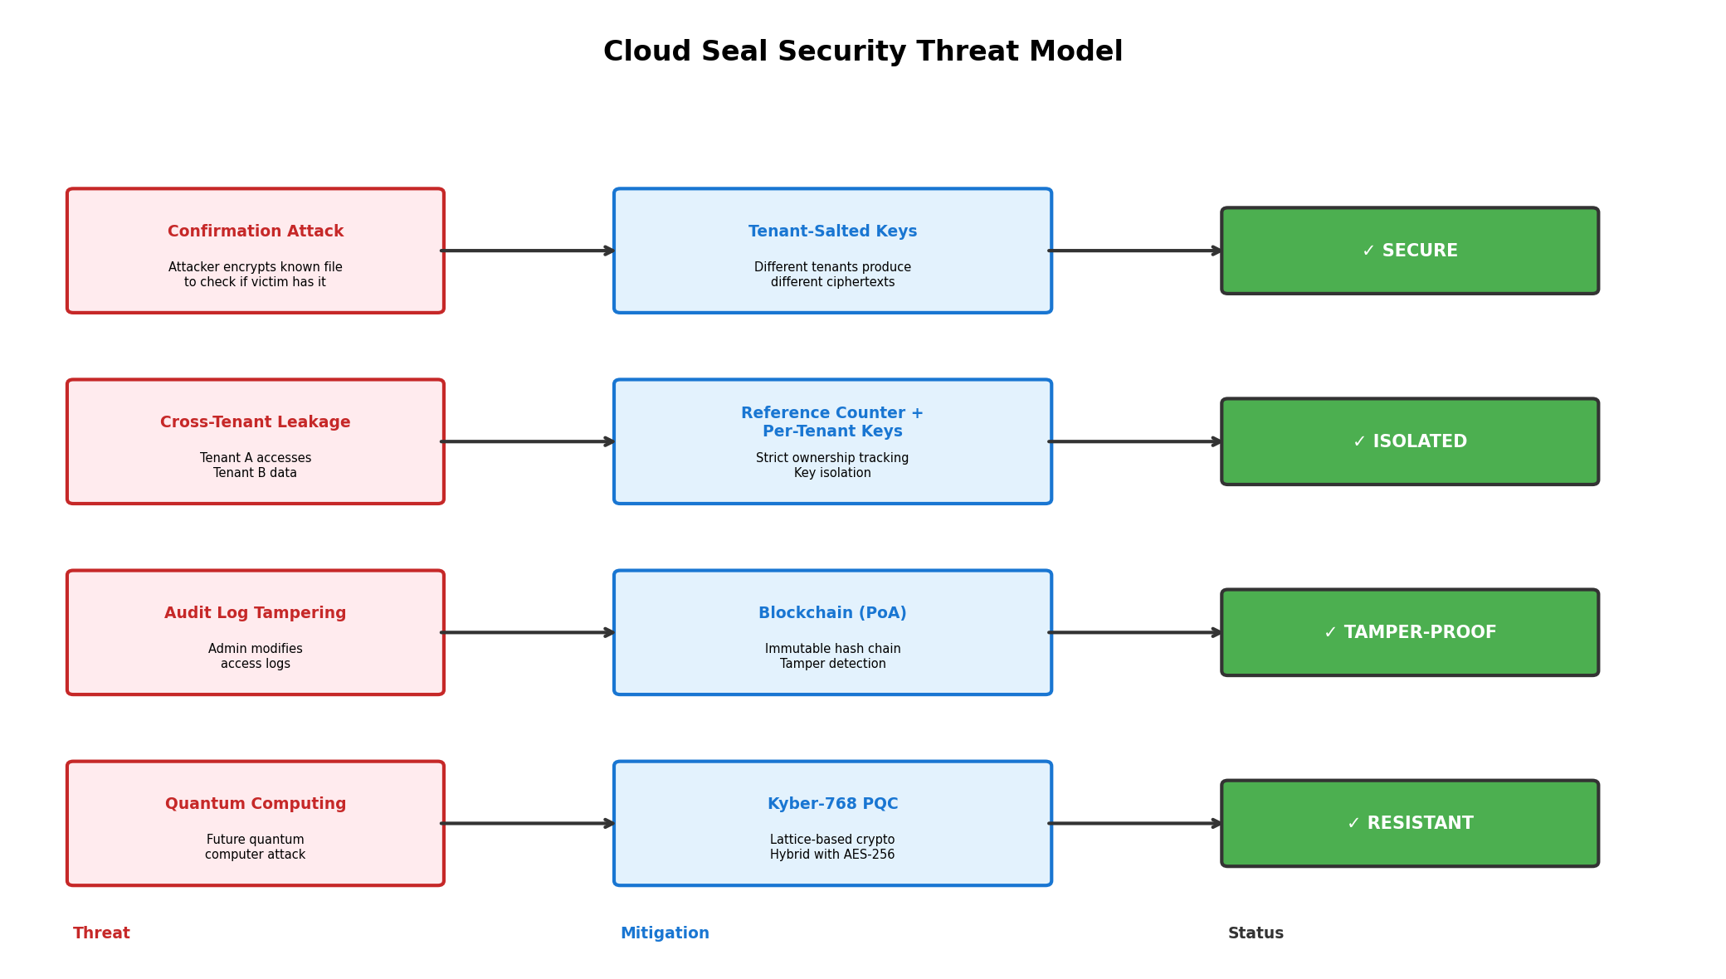

I used automated unit and integration testing with Python. Each test script generates synthetic test data, runs the component under test, collects JSON results, and validates against defined pass/fail criteria. All tests are reproducible — anyone can run the command and get the same results.

Test | How It Works
Blockchain Integrity | I create a valid chain, verify the hash links, then deliberately tamper with a transaction and confirm the chain detects it. Also test that unauthorized validators can't add blocks.
Bloom Filter | I insert known files, query for them (should find them), then query for unknown files and measure the false positive rate across 100, 1K, 5K, and 10K items.
Multi-Tenant Isolation | I encrypt the same file under 20 different tenant IDs and verify all produce different ciphertext. Then I try decrypting Tenant A's file with Tenant B's key — it should fail (produce garbage).
AI Model (CNN) | I generate 44 file pairs — 8 genuine duplicates and 36 non-duplicates — train the Siamese CNN with contrastive loss, then evaluate using AUC, precision, and recall. I compare against random and hash-only baselines.
Performance | I time each operation (encryption, hashing, Bloom lookup, blockchain write) across different file sizes (1KB to 10MB) using Python's time.perf_counter(). I validate against NFR thresholds (upload < 5s, dedup check < 2s).
Security Threat Model | I simulate 5 specific attacks (confirmation attack, cross-tenant leakage, audit tampering, Bloom exploitation, key derivation weakness) and verify each mitigation works.
Dedup Efficiency | I upload duplicate files and verify the system correctly detects them and stores only one copy, measuring the deduplication ratio.

Future Enhancements
- Production IPFS Integration: Connect to a live IPFS network for true decentralized storage across multiple geographic regions.
- Production PQC Library: Replace the simulated Kyber-768 with the real liboqs-python implementation for production-grade quantum resistance.
- Larger-Scale AI Training: Train the Siamese CNN on 10,000+ file pairs across diverse file types. The current PoC achieves AUC 0.797 on 44 pairs; with a larger dataset, threshold-based accuracy would improve significantly.
- Dynamic Key Rotation: Implement automatic re-encryption when tenant access is revoked.
- GPU-Accelerated CNN Training: Migrate from NumPy to PyTorch for larger-scale training on GPU hardware.
- Cross-Tenant Fuzzy Deduplication: Extend AI similarity detection across tenant boundaries (with consent) for maximum storage savings.
- Performance at Scale: Benchmark with 100K+ files and multiple concurrent users across geographic regions.

Contributions to the Body of Knowledge
The contributions made by completing this project to the existing body of knowledge are:
- A novel AI-based method for detecting near-duplicate encrypted files — using a two-layer Siamese CNN (2048→512→128) with z-score normalised statistical binary feature extraction and contrastive learning to provide near-duplicate awareness on ciphertext, without requiring decryption. The model achieves an AUC of 0.797 with clear score differentiation (duplicates: 0.998–1.0, different files: 0.07–0.32). While recent work uses semantic hashing for encrypted container images, Cloud Seal's approach uses cosine similarity on 2048-dimensional statistical fingerprints with proper gradient backpropagation — a distinct technical approach.
- A six-layer integrated security architecture (Convergent Encryption + Bloom Filter + AI + IPFS + Blockchain + PQC) that addresses the deduplication-encryption paradox without sacrificing either security or storage efficiency. While individual components exist in various systems, no existing system integrates all six into a unified pipeline.
- Integration of post-quantum cryptography into a deduplication framework — combining Kyber-768 key encapsulation with convergent encryption for quantum-resistant file deduplication. This represents a different technical approach from other recent work.
- A tenant-salted convergent encryption scheme that prevents cross-tenant confirmation attacks while maintaining within-tenant deduplication — validated by security tests including avalanche effect analysis (46.5% bit change).
- Blockchain-based immutable audit logging for deduplication — applying PoA blockchain as a tamper-proof audit trail for file operations. While blockchain for audit trails exists, its specific application to deduplication operations represents a novel use case.

Final Evaluation of the Project
By reading through the specifics of Cloud Seal, I hope you have gained a clear understanding of what problem this project addresses, how it has been solved, and why the contribution is novel. I would highly appreciate it if you could take your valuable time to fill out an evaluation form on my project.
The evaluation form can be found @ [Google Form Link]

References
- Bellare, M., Keelveedhi, S., & Ristenpart, T. (2013). DupLESS: Server-Aided Encryption for Deduplicated Storage. USENIX Security Symposium, 179–194.
- Douceur, J.R., Adya, A., Bolosky, W.J., et al. (2002). Reclaiming Space from Duplicate Files in a Serverless Distributed File System. International Conference on Distributed Computing Systems (ICDCS).
- Kumar, A., & Singh, P. (2023). Convergent encryption challenges in multi-tenant cloud deduplication systems. ACM Computing Surveys, 56(2), 1–29.
- Liu, X., Zhang, Y., & Chen, M. (2020). Secure deduplication using modified elliptic curve cryptography for cloud-fog environments. Information Sciences, 527, 404–419.
- National Institute of Standards and Technology (2024). Post-Quantum Cryptography Standardization: Final Standards. NIST SP 800-208.
- Periasamy, J.K. et al. (2025). Enhancing cloud security and deduplication efficiency with SALIGP and cryptographic authentication. Scientific Reports, 15, 1847.
- Zhang, L. et al. (2025). SimEnc: Similarity-preserving encryption for secure container image deduplication. Future Generation Computer Systems, 164, 107557.
- Niu, S. et al. (2024). QBDD: Quantum-Based Deduplication for Cloud Storage. IEEE Transactions on Cloud Computing, 12(3), 891–904.
- Park, J. & Kim, S. (2023). PM-Dedup: Proximity-matching deduplication with homomorphic fingerprints. Journal of Cloud Computing, 12(1), 45.
- Amazon Web Services (2024). Amazon S3 Storage Classes and Data Management. AWS Documentation. https://docs.aws.amazon.com/AmazonS3/latest/userguide/storage-class-intro.html
- Microsoft (2024). Azure Blob Storage redundancy and data management. Microsoft Azure Documentation. https://learn.microsoft.com/en-us/azure/storage/blobs/storage-blobs-introductiona

