Single contour to LineString:
k is contour from iterating over cv2 list of contours

rCont = np.squeeze(k, axis=1)
polyGon = shapely.geometry.LineString(rCont)

Separate x,y arrays to a point/coord array:
stack = np.stack((xs,ys), axis=-1)

How to create Shapely Multipolygon:
allPolys is a list of Shapely Polygons

multipolygon = shapely.MultiPolygon(allPolys)
polys = list(multipolygon.geoms)

Change plot figure dimensions
plt.rcParams["figure.figsize"] = (12,3)

Change plot tick frequency
plt.xticks(np.arange(min(a), max(a)+1, 10.0))

Plot titles and labels
plt.title('Projection')
plt.ylabel('Ortho. Distance')
plt.xlabel('Distance between points')

Plot legend
If you plot everything for one style in one go:
plt.plot(x,y,'b.-',label='Exact contour')
…
plt.legend()

If data points are added incrementally:
plt.gca().legend(('Exact contour','Baseline',…))

Draw ROI patch on plot
currentAxis = plt.gca()
currentAxis.add_patch(patches.Rectangle((cropCoord[0] - .5, cropCoord[1] - .5), cropCoord[2], cropCoord[3], facecolor="grey"))

Create numpy array image
numpy.full(shape, fill_value, dtype = None, order = ‘C’)

Python-ppt

Create a presentation

Prs = Presentation()

Add a slide
Prs.slides.add_slide(somethingSlide)

Create a slide
Slide = prs.slide_layouts[6]
Number represents type of layout

Add a table:
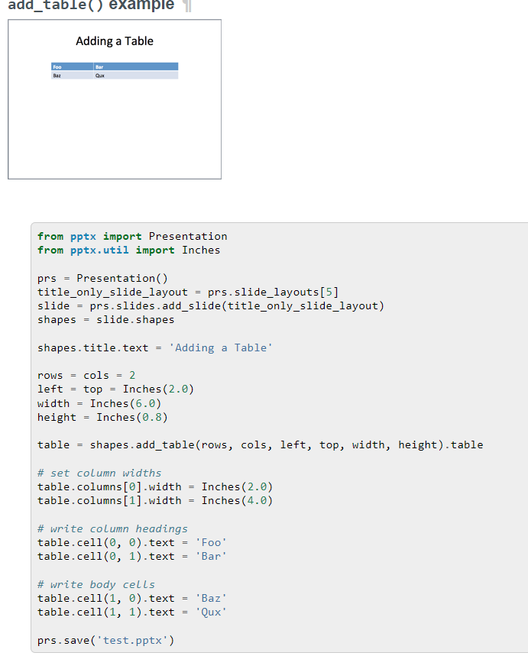

How to create a dataframe from a list
df = pd.DataFrame(data=imageRoughness, columns=['Surface Roughness'], index=imageID)
df.to_csv(csvPath)

Switch Backslash
path = input("Enter path: ")

FixedPath = path.replace("\\", "/")
print('\n')
print(FixedPath)

