**Lab 6 Cache Stimulator Report**

**2)a)**

Larger block size can decrease compulsory misses through spatial locality. It has disadvantage of increase miss penalty and decrease the number of entities in cache. The raise of miss rate in 64 Bytes Cache is due to the associativity set to 1, which make the conflict misses occur more often.

However, if we increase the cache size, we can lower the miss rate since we reduce the capacity misses.

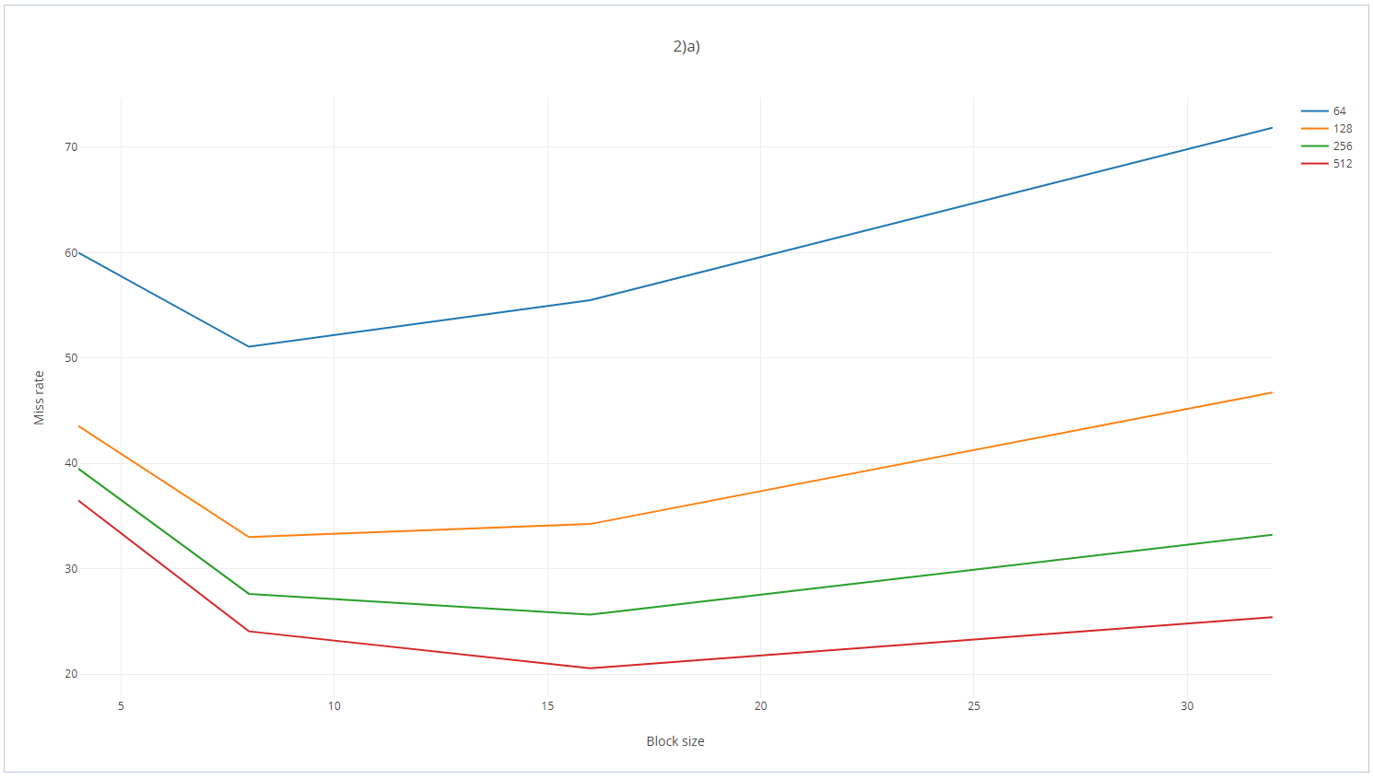

**2)b)**

Higher associative decrease can decrease great amount of conflict misses. In addition, the increase in cache size result in lesser capacity misses.

In conclusion, miss rate can be reduced vastly if we increase both associative and the cache size.

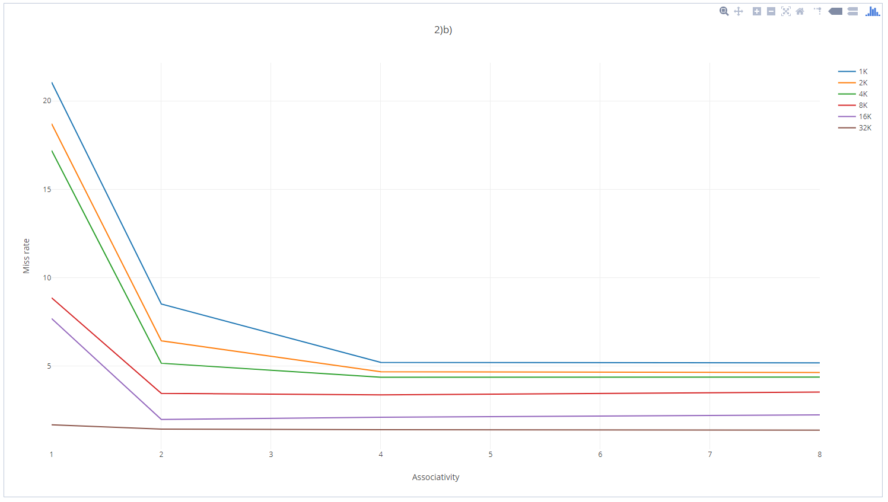

**Remark:**

After running the program, a result.txt that stores the stimulation result will be generated.