**Progress and Practices of Internationalization of Chinese Multinational Enterprises (MNEs)**

# Abstract

The history of international entrepreneurship in China dates to the Reform and Opening-up policy in 1978. Academically, there has been sizable academic research on the international entrepreneurship of Chinese companies (e.g., Deng 2014), focusing on both qualitative and quantitative analysis. In this article, we analyze the historical, political, and economic factors of Chinese internationalization. We also explore the statistical relationship between multiple indicators for internationalization in MNEs, ranging from the MNEs’ brands to R&D, Human Resources, to Asset Distribution. The results show that the location and sector differences matter the most for MNEs’ internationalization. Our findings may provide some implications for Chinese MNEs when developing internationalization strategies and plans for the future.

Key Words: Internationalization Strategy, Regression Analysis, Entrepreneurship, Outward FDI

JEL code:

# Introduction

Since China implemented the reform and opening-up policy in 1978, economic growth has been impressive. From 1978 to 2018, the GDP in China increased by 24373.6%. At the same time, the past 40 years have witnessed the transition of the Chinese economy from a centralized planning economy to a market economy. The exports and imports by Chinese companies' have increased by 12960.6% from 1978 to 2020.[1] Recently, the total amount in exports for the largest 500 firms in China is 460 billion USD.

In this article, we attempt to review the past of the Chinese firms' internationalization journey the status and offer some prospects for the future.

To conduct the statistical analyses, we select the Internationalization Index as the significant indicator. The United Nations Commission on Trade and Development (UNCTAD) ranks the world's 100 largest multinational corporations (TNCs) by the total foreign assets and index every year.

The average of three ratios measures the degree of internationalization for the multinational enterprises (MNEs) in China. To be more specific, the Internationalization Index = (foreign assets / total assets + foreign sales / total sales + number of foreign employees / total number of employees) × 100%/3

Sullivan Daniel (1994) pointed out that the internationalization degree of an enterprise is composed of the sum of five indicators,

* The degree of internationalization (DOI) = the proportion of overseas sales in total sales + the ratio of overseas assets in total assets (FATA) + the proportion of overseas subsidiaries in all subsidiaries + the international experience of senior managers (time) + the psychological dispersion of overseas operations

The above equations demonstrate the impliable relationship between internationalization and distribution from home and abroad in assets, employees, and revenue. Based on that, China Enterprise Association has arranged the ranking survey since 2018 to recognize the relationship as the table shows below.(The y variables as Transnational Index is measured by the developing assessments which has been authorized by National Public Statistics Agency in China)

The following table shows the overview of survey result of China Enterprise Association

Table 2 Head of 2021 Transnational Index of China's top 100 enterprises

|  |  |  |  |  |  |  |  |
| --- | --- | --- | --- | --- | --- | --- | --- |
| 2021 Transnational Index of China's top 100 enterprises | | | | | | | |
| Position | Name | Oversea Asset | Oversea Revenue (billion RMB) | Oversea Employees (billion RMB) | Transnational Index | Transnational Index | Unit |
| 1 | China National Petroleum Corporation Limited | 121197 | 845.33 | 770.06 | 121197 | 23.24 | % |
| 2 | Tencent Holdings Limited | 6353 | 629.28 | 33.40 | 6353 | 20.51 | % |
| 3 | China Petrochemical Corporation Limited | 34222 | 514.372 | 520.76 | 34222 | 18.58 | % |
| 4 | China Ocean Shipping Group Co., Ltd | 15865 | 495.85 | 193.19 | 15865 | 43.68 | % |
| 5 | China National Offshore Oil Group Corporation Limited | 3885 | 491.44 | 330.11 | 3885 | 33.75 | % |

Table note: Name:Enterprise’s legal registed name

Table 1: The relationship between oversea employees, revenues, and asset[2]

|  |  |  |  |
| --- | --- | --- | --- |
| Logical Regression Result-Simplified Edition | | | |
|  | Regression Coefficient | 95% CI | VIF |
| Constant | 0 | -0.000 ~ 0.000 | - |
| (-0.841) |
| Oversea Asset | 1.000** | 1.000 ~ 1.000 | 1.05 |
| -7.75988E+15 |
| Oversea Revenue | 0.000** | 0.000 ~ 0.000 | 1.019 |
| -3.459 |
| Oversea Employees | 0 | -0.000 ~ 0.000 | 1.031 |
| 0 |
| Sample Amount | 5000 | | |
| R ² | 0.98 | | |
| Adjusted R ² | 0.99 | | |
| F value | F (3,46)=2.107662385284877e+31,p=0.001 | | |
| Y Variables： Transnational Index | | | |
| D-W Value：0.087 | | | |
| * p<0.05 ** p<0.01 | | | |

Table note:

Y variable:Transnational Index,X variable:Oversea Revenue,Oversea Employee,Oversea Asset

And the table above shows the significant relationship among the x variables

However, there is a distinction between the degree of internationalization and the ability of internationalization.

In this proposal,we will discuss further on the mechanism behind that in the later pages

The degree of internationalization focuses on the proportion of overseas projects (assets, income, etc.) in the total corresponding projects of the enterprise. In addition to the internationalization degree of the enterprise, the internationalization ability also includes some total indicators (such as the total scale of international business assets), which are used to characterize the economic strength of the enterprise. In economic globalization, the internationalization ability of enterprises determines the success or failure of enterprises to participate in international competition and win the global market. Carrying out corresponding research may also offer some important practical implications.

Considering the diversity in IntInternationalization download statistics from Chinese Enterprise Association Official Website which reveals the past out-performance of 100 Chinese enterprises which will be discussed further in the proposal.

# Literature Review

## Section One

### 1.History and Development

#### Domestic Entrepreneurship Internationalization

Research on Social Entrepreneurship Internationalization in past 20 years mainly focuses on empirical perspective instead of practical perspective. While the history of the development of Social Entrepreneurship under official policy are also referential

In the Social Entrepreneurship Internationalization, domestic Chinese markets have gone through three distinctive stages (Qin,2019), which can be interpreted as the 1.0 stage, the 2.0 stage, and the 3.0 stage.

In the "1.0 stage", from 1978 to 1992, with an established socialist market economic system and entering foreign capital, Chinese enterprises were driven by the forces of globalization to enter global market. Foreign capital brings Chinese enterprises with cost advantages into the international division of labor, mainly in processing and manufacturing, through "Three Sources and One Subsidy."

The "2.0 stage" began in 1992, especially after China acceded to the WTO in 2001. Numerous Chinese local enterprises started to "go global" through OEM strategically and purposefully. With political emphasis on high-level introduction, large-scale and high-quality exports in the 18th CPC National Congress, Chinese enterprises began to establish a globalization framework and a new value chain with global competitiveness and flexibility, with the multinational ambition

The "3.0 stage" diverts the leading party from China itself to the Global World from the aspects of capital, investment, supply chain organization, enterprise organization, and culture.

#### Domestic policy supports

The policy support from the Chinese Government also reveals that the time varied economic status is also closely connected with enterprises’ decisions on globalization

The system reform in domestic China after 1978 revoked a new era called Market Economy compared with Planned Economy between 1949 and 1978 and the Feudal Economy before 1949. Consistent support from Chinese Head Offices has implemented the first Cardiotonic towards the conventional mechanism in Chinese enterprises.

In the Chinese Government's decision on strengthening technological innovation, developing high technology, and realizing industrialization (1999), Technological innovation is defined as: "technological innovation refers to the application of innovative knowledge, new technology, and new process, the adoption of new production mode and management mode, the improvement of product quality, the development and production of new products, the provision of new services, the occupation of the market and the realization of market value" which indicates the first step ahead

#### 1.3 Entrepreneurship Internationalization Analysis

Out of the bottleneck in empirical analysis, the lack of quantitative sections must be considered first.

Although qualitative and quantitative sections both support the result, the complexity of multiple factors has laid obstacles already when some generative dimensions can be established. For instance, the most two ranking dimensions to analyze the Chinese high-tech enterprises are capital and human operation, which can be further depicted from 6 perspectives including R&D Investment, back-terminal scientists' intensity (Xu ,2010)

Apart from that, wider-ranged scholars still followed the empirical framework with a dated origin of analysis, including analyzing new production functions or supply functions in the production system, introducing a unique combination of production factors and production conditions (Schumpeter, 1912), the analysis focusing on transformation in the process of technological innovation activities, essentials and power(Fu, 1998), the more mathematical focus of the technological innovation ability on the Profitability in new output which implies a more objective and accurate evaluation(e.g., Xie1997), and more specific analysis taking into account more diverse indicators including R & D capacity, input capacity, production capacity, Output ability, marketing ability, financial ability and organization, management ability, etc.(Cao and Wang 1998; Li, Xu ,2004; Pang, 2007; Ben 2008) which always utilizing Paste Analysis Model

Although scholars have carried out few primary quantitative analyses on Social Entrepreneurship Internationalization, the current bottleneck still exists out of the overwhelm of qualitative research.

### 2.Categories in Internationalizations

Under the topic of Social Entrepreneurship Internationalization, there are multiple categories, including Technology Innovation Internationalization, Research & Development Internationalization, Marketing Internationalization

Figure 1: Relationship Between Technology and Internationalization

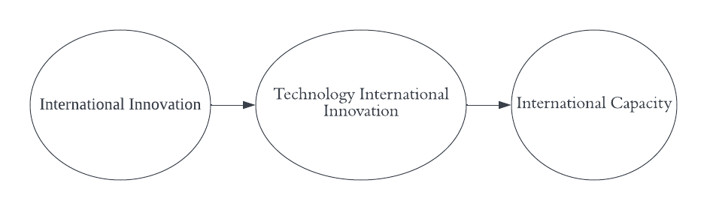[3]

Technology Innovation Internationalization refers to (Tan, 2011) the strategy that enterprises expand technological innovation activities abroad by directly establishing foreign R&D institutions, cross-border M&A, and establishing international technological alliances, characterized by the globalization of innovation sources, the multinational of innovative talents and the networking of technological innovation organizations

The explicit benefit of Technology Innovation Internationalization is that it forms a huge knowledge trading network within the enterprise when also establishing the connection between the enterprise and external organizations. It changes the situation that the enterprise obtains the required technical knowledge only from the inside. Enterprises can build their technical knowledge structure with the help of external expertise and information sources

Here, we need to distinguish between R&D Internationalization and Technological Innovation Internationalization concept. Technological Innovation Internationalization is more extensive than

R&D Internationalization which is initially an essential feature of the earlier one when still representing enterprise's Innovation Internationalization Performance

## Section Two

### 3. Asset Distribution Model

In this section, we will apply the Asset Distribution Model to explore the costs, profits, revenues of cross-board companies and find the possible relationship behind that.

In this specific field, Lustau (1988) proposed a six-factor model to measure internationalization (Lu, 2000), used the cobweb model evaluation method to evaluate enterprises

#### 3.1General System Indicator

At present, some widely used ones are listed below.

Welch Lustau (1988) proposed a six-factor model to measure internationalization (Lu,2000), a Chinese scholar, used the cobweb model evaluation method to evaluate enterprises' six aspects of internationalization are analyzed quantitatively at five levels. Zhou, Li (2009) constructed the evaluation system of enterprise internationalization ability from three aspects: International business scale, international business strategy, and international business growth

Beyond that, in recent years, there are also some innovative measure systems to develop a more flexible result like the table listed below

Table 3 Enterprise internationalization ability evaluation system[4]

|  |  |
| --- | --- |
| Level 1 index | Level 2 Index |
| International Business Scale | International business assets  International R & D funds  overseas GDP  overseas sales  international business net profit |
| International strategy | The proportion of international business assets in total assets  International R & D funds in enterprise R & D funds  The proportion of overseas GDP in the strategic value of total international business of the enterprise, overseas sales in enterprise sales  The proportion of global business net profit in net profit of enterprise net profit |
| International business asset growth | International R & D funds growth  Overseas GDP growth  Overseas sales growth  International business net profit international business growth rate |

#### 3.2 Specific System Indicator

##### 3.2.1Background

###### (1) Overview and Conclusion

In general,

1. In China, overall, the degree of transnational enterprises is far lower than that of other transnational corporations in developed countries, as can be shown by a lower Internationalization Index
2. The average Transnational Index of the top 100 Chinese multinational corporations in 2019 was 15.96%, an increase of 0.06 percentage points over the previous year in the same period, the transnational index of the world's top 100 multinational corporations was 58.07%, down 3.84 percentage points of the prior year which implies that China's transnational index rose against the trend.
3. The degree of transnational operation of Companies in different industries varies greatly. Some industries have higher degree of transnational operation, such as the food and beverage industry

The following table is downloaded statistics from the China Enterprise Website.

Table 3 Head of 2020 Transnational Index of China's top 100 enterprises[5]

|  |  |  |  |  |  |
| --- | --- | --- | --- | --- | --- |
| Position | Public, division, first name, said | Oversea Asset | Oversea Revenue | Oversea Employees | Transnational Index |
| 10K RMB | 10K RMB | person | % |
| 1 | China National Petroleum Corporation Limited | 92969179 | 125010049 | 133734 | 26.54 |
| 2 | China CITIC Group Co., Ltd | 58694083 | 9719332 | 34573 | 12.64 |
| 3 | China Petrochemical Corporation Limited | 57703188 | 95239223 | 38765 | 22.2 |
| 4 | China Ocean Shipping Group Co., Ltd | 56639768 | 5644443 | 5790 | 29.26 |
| 5 | Tencent Holdings Limited | 54131126 | 24534598 | 4679 | 43.07 |

###### (3) Empirical Analysis

Before further analysis, the distinctive difference between variables here like Oversea Asset, Oversea Employees, and Oversea Revenue shows the reliability and validity since the possibility for multicollinearity is low.

The following table demonstrates the variance for each classification which aligns with the diversity in Chinese global enterprises.The convertional industries like Manufactures and the technology oriented industries like IT varies in overall employees and annual revenue.

Table 4 Overview of oversea asset employees & revenue

|  |  |  |  |  |  |  |
| --- | --- | --- | --- | --- | --- | --- |
| Item | Average | Difference | Difference95% CI | *Df.* | STD | Cohen's *d* value |
| Oversea Asset | 17256.62 | 17256.62 | 11213.036 ~ 23300.204 | 49 | 21265.486 | 0.811 |
| Oversea Employees | 52.98 | 52.98 | 44.342 ~ 61.618 | 49 | 30.394 | 1.743 |
| Oversea Revenue | 67.06 | 67.06 | 59.113 ~ 75.007 | 49 | 27.964 | 2.398 |

The above table demonstrates the conclusion that even with similar transitional index, the potential main contributors vary among different kind of companies (average in oversea asset, oversea employees and oversea revenue are 17256,52.98 and 67.06 with more than 1000 times gap)

For instance, the infrastructures with a large amount of overseas assets may overweight the internet companies with a large amount of overseas revenue since the latter is more strategic instead of practical enough to influence the local economy ecosystem, which means a narrower international influence circle/

###### Logical Regression

**A.Advantages:**

Logical Regression is based on the logical reference and liner regression which is applied for the variables that may show the multi-liner relationship. Consider there will be strongly positive relationship between asset and revenue, logical regression can substitute many other models like decision tree.

**B.Models:**

To further analyze the inter-connection between oversea asset and oversea revenue apart from oversea employees, we apply the Logical Regression model here with oversea asset, oversea revenue and oversea employees as 3 x variables and transitional index as the y variables

Figure 2: Function between different financial classes[6]

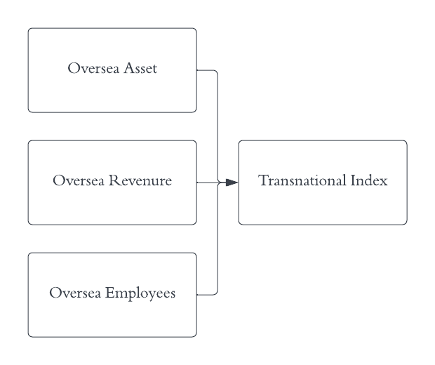

Transnational Index=0.0046Oversea Employees+0.000032Oversea Revenue+0.0018Oversea Asset

**C. Results:**

The following table demonstrates the different outcomes among variables like oversea assets, revenue, and oversea employees. The last variable cannot stand for the inner intensity of internationalization since the p-value here is 1 much larger than 0.05. The possible reason behind that may be the flexibility in network and diversity in local workforce environment.

In contrast, oversea asset and revenue, which represent the investment of the company and satisfaction degree from the market, can play that role with the p-value of 0.002 and 0.001

Table 5: Logical Regression Result

|  |  |  |  |  |  |  |  |  |  |
| --- | --- | --- | --- | --- | --- | --- | --- | --- | --- |
| Logical Regression Result | | | | | | | | | |
|  | Non-standardized coefficients | | standardized coefficients | *t* | *p* | VIF | *R* ² | *Adjusted R* ² | *F* |
| *B* | std | *Beta* |
| constant | 0 | 0 | - | -0.841 | 0.405 | - | 1 | 1 | *F* (3,46)=2.107662385284877e+31,*p*=0.000 |
| Oversea Asset | 1 | 0 | 1 | 7.75988E+15 | 0.002** | 1.05 |
| Oversea Revenue | 0 | 0 | 0 | 3.459 | 0.001** | 1.019 |
| Oversea Employees | 0 | 0 | 0 | 0 | 1 | 1.031 |
| Y variables：Transnational Index | | | | | | | | | |
| D-W value：0.087 | | | | | | | | | |
| * *p*<0.05 ** *p*<0.01 | | | | | | | | | |

### 4. Multiple-factor Models

#### 4.1 Background

Ignoring the existed general framework for oversea strategy, the inner indicators’ relationship also plays a vital role in explaining the future of domestic internationalization.

China Trade News Website published survey results targeted at 1st,2nd,3rd tier cities’ 5000 largest companies in 50 industries.

#### 4.2 Indicator Classification

Five categories of indicators classify the international companies

1. Company name

2. Company Business Indicators:

Sales Ranking (2020, 2021)

3. Company internationalization indicators

3.1 Overall Internationalization Metric:

Bran Transition

3.2 Subdivided internationalization metrics:

Asset Transition, Logistic Transition, Research and Development Transition, Human Resource Transition

4. Company additional attribute indicators

4.1 Industries

4.2 The city in which you are located

5. Company future international indicators:

Company international strategy

Table 6: Head of companies’ internationalization indicators ‘performance

|  |  |  |  |  |  |  |  |  |  |  |
| --- | --- | --- | --- | --- | --- | --- | --- | --- | --- | --- |
| Company's Name | Ranking in 2020 | Ranking in 2021 | Industry | Company  International  Strategy | Main City Location | Logistics  Transition | Asset Transition | Human Resource Transition | Brand Transition | R&D Transition |
| Lenovo | 1 | 2 | IT | 8.59 | Beijing | 8.58 | 7.69 | 8.47 | 6.91 | 7.56 |
| Huawei | 2 | 1 | IT | 8.89 | Guangdong | 8.21 | 7.4 | 7.84 | 6.82 | 8.36 |
| Haier | 3 | 4 | Domestic  Electric Application | 8.43 | Shandong | 7.56 | 7.79 | 7.89 | 0.47 | 7.47 |
| CNOOC | 4 | 19 | Resource and Mining | 8.62 | Beijing | 5.92 | 8.23 | 7.26 | 0.43 | 8.33 |
| SINOPEC | 5 | 10 | Resource and Mining | 8.00 | Beijing | 7.63 | 7.63 | 7.33 | 0.37 | 8.43 |

#### 4.3 Model Application

##### 4.3.1 Industry Analysis

###### (1) Model 1: Variance Analysis

**A. Advantages:**

Variance Analysis focuses on the variance between different variables to measure whether or not the differences show a significant difference.

It is one of the simplest and quickest ways for the large group data training, especially for financial analysis. Compared with other like PCA Scoring systems, this pre-processing procedure can make sure all the results can be interpreted in one table

**B.Results:**

The following table shows the differences between traditional and innovative industries (5.25,37.89). The more similar the two sectors are, the fewer variance scores will receive, which reminds us to propose more technology-oriented industries’ development when balancing the basic manufacturing support

Table 7: Variance Analysis Results

| Analysis Variance Results | | | | | | | | | | | | | | | | | | | | | | |
| --- | --- | --- | --- | --- | --- | --- | --- | --- | --- | --- | --- | --- | --- | --- | --- | --- | --- | --- | --- | --- | --- | --- |
|  | Industry (Average Value +-standard deviation) | | | | | | | | | | | | | | | | | | *F* | | *p* | |
| Agriculture(*n*=1) | Airplane(*n*=1) | Architecture and Manufacture(*n*=3) | Chemistry(*n*=1) | Domestic Electric Application(*n*=6) | Electric Operation(*n*=1) | Engineer and Manufacture(*n*=6) | Finance(*n*=2) | Food and Drinks(*n*=1) | General(*n*=4) | IT(*n*=4) | Logistics(*n*=1) | Medicine(*n*=2) | Resource and Mining(*n*=6) | The Internet(*n*=1) | Vehicle(*n*=3) | Vehicle and Factors(*n*=2) |  | |  | |
| Brand Transition | 5.68±null | 5.25±null | 5.25±0.87 | 6.56±null | 5.07±2.50 | 6.51±null | 6.25±1.22 | 5.44±1.24 | 5.37±null | 4.85±2.21 | 6.92±0.42 | 4.56±null | 5.05±0.32 | 4.71±3.38 | 4.93±null | 6.17±1.06 | 6.63±1.83 | 0.377 | | 0.978 | |
| Asset Transition | 4.34±null | 7.40±null | 7.57±0.76 | 4.47±null | 6.45±1.41 | 5.59±null | 5.31±1.38 | 4.97±0.71 | 4.56±null | 5.75±1.46 | 7.48±0.35 | 7.00±null | 5.93±0.92 | 7.17±1.43 | 6.34±null | 6.14±1.17 | 7.86±1.17 | 1.759 | | 0.093 | |
| * *p*<0.05 ** *p*<0.01 | | | | | | | | | | | | | | | | | | | | | | |

Table Note:The above table reveals the great variance among different industries for Brand Transition and Asset Transition

###### (2) Model 2: Classification Analysis

**A. Model mechanism:**

Classification is the assignment of data with certain characteristics to a flag (or label) and classification according to this flag. Classification is to produce a classification function or classification model (also called a classifier). It contains the characteristics of a data set that predicts whether some unknown data will conform to the category.

Such classifiers can reflect unknown data items in a dataset into one of a predetermined type. Classification and regression are generally predictable, but the difference may be that the output of regression is an ordered value linear value, while the output of classification is a nonlinear type of value

**B.Model result:**

Table 8: ANOVA Intermediate Process Value Result

|  |  |  |  |  |  |  |
| --- | --- | --- | --- | --- | --- | --- |
| ANOVA intermediate process values | | | | | | |
| Item | Variance | Squares Sum | Freedom | Mean Square | *F* | *p* value |
| Brand Transition | Between Groups error | 25.758 | 16 | 1.61 | 0.377 | 0.978 |
| Within-group error | 119.575 | 28 | 4.271 |  |  |
| Sum | 145.332 | 44 |  |  |  |
| Asset Transition | Between Groups error | 43.296 | 16 | 2.706 | 1.759 | 0.093 |
| Within-group error | 43.071 | 28 | 1.538 |  |  |
| Sum | 86.367 | 44 |  |  |  |

Table Note；The ANOVA reveals the variance and expectation for Brand Transition and Asset Transition which implies that tangible principle of enterprises like current asset and non-current asset varies larger than general indicators

Figure 3: Liner Relationship Score for Classification



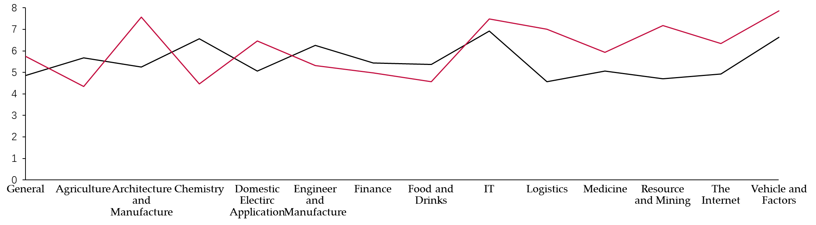

Figure Note: Brand Transition=Asset_Transition*0.98+0.052

The above table shows the changing trends among multiple sectors from Agriculture to Medicine which is applied with the previous insights that suggest

1. The domestic industries invest more in the light-asset industries like IT when maintaining the structure for Architecture Manufacture that stands for the heavy assets’ reputation.
2. The delay between 2 lines shows that brand’s transition will be partly demonstrated in asset transition but will also partly be influenced by other important factors.
3. **C. Overview of the Results:**

Figure 4: Bar Distribution for multiple industries

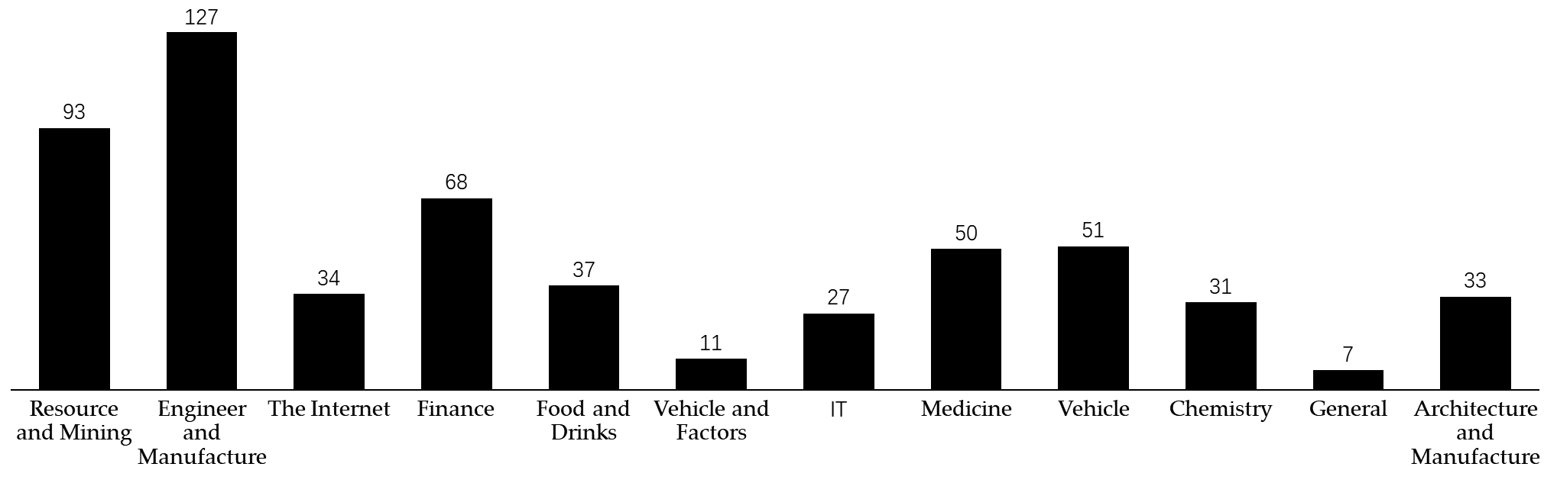

Figure note: y axis refers as the accumulated frequencies for industry(x variable)

##### 4.3.2 Location Analysis

Figure 5: Plot-Box Distribution for Domestic Location

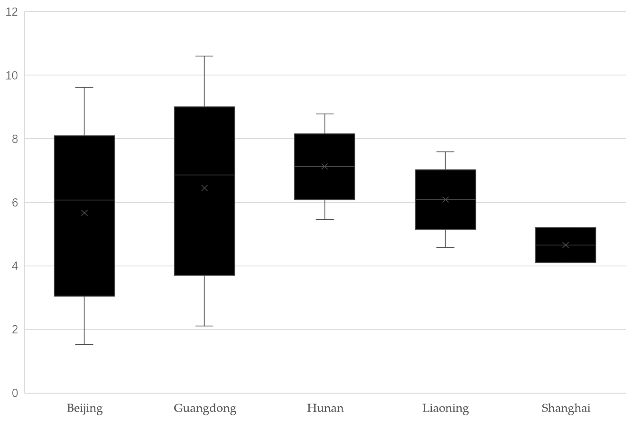

Figure note:y axis refers to the average Transition Index(Internationlization Index) for location(x variable)

Figure 6: Accumulated Plot-Box Distribution for Domestic Location

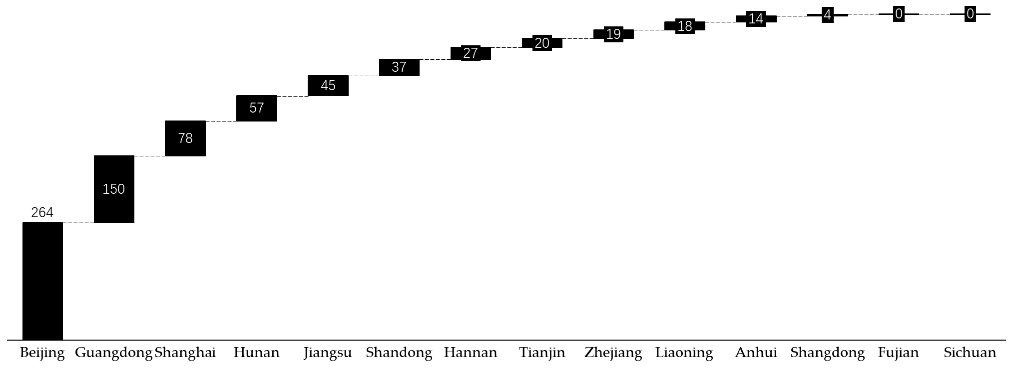

Figure note: y axis refers as the accumulated percentage of 1st tier, 2nd tier, and 3rd tier cities in the largest 100 MNEs.

The results show that

1. Beijing and other near-sea cities like Guangdong and Shanghai, which regulates the cross-board transaction from 40 years ago, take the critical role in promoting the sustainable development of Chinese enterprises’ internationalization.
2. The financial policies and political regulations should be carried out since the predominated provinces from the joint benefit of GDP increasing rate.
3. The potential for island provinces like Sichuan should not be ignored which might be the next era’s benchmark for Chinese internationalization

##### 4.3.3 International Performance Analysis

**A.Internationalization Indicators Inner Analysis**

**(1) R&D Transitional Index**

The model: Descriptive profiling

Model Result:

Table 9: Summary Statistics R&D Transitional Index Results

|  |  |  |  |  |  |  |
| --- | --- | --- | --- | --- | --- | --- |
| Basic Indicators | | | | | | |
| Title | Sample Amount | Min | Max | Average Value | Standard Deviation | Medium |
| R&D Transition | 45 | 0.57 | 8.76 | 5.87 | 1.955 | 5.47 |

Figure note:the R&D Transitional Index varies from 0.57 to 8.76

**B. Group Analysis on the Internationalization Indicators**

**(2) Human Resource Transitional and Logistics Transitional**

1. **The model applied:** Relationship Analysis
2. **Model mechanism:**

(Canonical correlation analysis)

A.Concept

A multivariate statistical analysis method uses the correlation between synthetic pairs of variables to reflect the overall correlation between two sets of indicators.

B.Principle:

To grasp the correlation between the two sets of indicators as a whole, the representative two comprehensive variables U1 and V1 (the linear combination of the variables in the two variables are extracted from the two sets of variables, respectively) and the correlation between the two comprehensive variables is used to reflect the overall correlation between the two sets of indicators

1. **Model result:**

We do not find a statistically significant relationship between Human Resource Transitional and Logistics Transitional which is applied with the market business logic.

Table 10: Pearson Ecoefficiency Result

| Pearson Model | |
| --- | --- |
|  | Human Resource Transition |
| Logistics Transition | -0.061 |
| * *p*<0.05 ** *p*<0.01 | |

**(3) Brand Transition and Asset Transition**

1. **Applied model**： Paired t-test
2. **Model mechanism:**
3. The principle:

To find the difference between each pair of data

(1) if there is no difference between the two treatments, the population mean of the difference should be 0, and the mean of the sample drawn from the population should also fluctuate around 0

(2) if there is a difference between the two treatments, the population mean of the difference should be far away from 0, and the sample mean should also be far away from 0

1. The consumption

The applicable conditions are equivalent to the 1-sample T-test, but care should be taken to look at the difference rather than the raw data

H0:αd=0, there is no difference between the two groups

H1:αd≠0, there is no difference between the two groups

1. The calculation



n= the number of groups

1. **Model result:**

Table 11: Paired t-test Analysis Results

|  |  |  |  |  |  |
| --- | --- | --- | --- | --- | --- |
| Paired t-test analysis results | | | | | |
| title | Pairing (mean ± standard deviation) | | Difference (paired 1 - paired 2) | *t* | *p* |
| Pair 1 | Pair 2 |
| Brand Transition paired with  Asset Transition | 5.57±1.82 | 6.33±1.40 | -0.76 | -1.985 | 0.053 |
| * p<0.05 ** p<0.01 | | | | | |

Figure note:There is a significant positive relationship between Brand Transition and asset Transition

**C. Internationalization Indicators Mechanism Analysis**

**i. Model used**：OLS Regression

**ii. Model mechanism:**

1. The principle:

OLS (least squares) is mainly used for parameter estimation of linear regression.

To find some sum of squares that makes the difference between the actual value and the model estimate reach the minimum value and use it as a parameter estimate.

The least-squares method makes it easy to find unknown data and minimizes the sum of squares of the error between these obtained data and the actual data.

Brand Transition=

Human Resource Transition*0.301-Asset Transition*0.3-0.195*R&D Transition+Logistics Transition*0.071

Table 12: OLS Regression Mechanism

| OLS Regression Analysis Results - Simplified Format | |
| --- | --- |
|  | Regression coefficients |
| constant | 6.280** (2.969) |
| Human Resource Transition | 0.301 (1.252) |
| Asset Transition | -0.300 (-1.465) |
| Research and Development Transition | -0.195 (-1.293) |
| Logistics Transition | 0.071 (0.395) |
| Sample Size N | 45 |
| *R* ² | 0.128 |
| *Adjusted R* ² | 0.040 |
| *F* value | *F* (4,40) =1.462,*p*=0.232 |
| Y variables：Brand Transition | |
| D-W value：1.578 | |
| * *p*<0.05 ** *p*<0.01 | |

The above table shows the significant relationship between different indicators, which means there will be a joint effect for the long-term internationalization in one enterprise

iii. **Model results:**

Considering the possibility for heteroscedasticity, Heteroscedasticity tests to observe whether the fluctuation degree (i.e. variance) of the residual changes with the explained variable a

Table 13: Results for the Heteroscedasticity Test

| Heteroscedasticity test results | | | |
| --- | --- | --- | --- |
| *White* Heteroscedasticity test | | *BP* Heteroscedasticity test | |
| χ² | *p* | χ² | *p* |
| 21.405 | 0.42 | 12.451 | 0.34 |

Table Note:p value >0.5,the variance can be recognized as the same which means the OLS Model results are appliable.

## Future Advice for Chinese Enterprise

### 1. Future International Strategy

From the last part of the quantitative analysis, the importance and emergency of increasing valuable investment and promoting positive market feedback must be highlighted hereby increasing the 3E model (Economy, Effectiveness, and Efficiency) in one enterprise, the strength and resources can combine under the strategic planning

In the future, the strategy for one enterprise may follow the path listed in the following figure.

Figure7: Relationship between Enterprises Innovation and Internationalization[7]

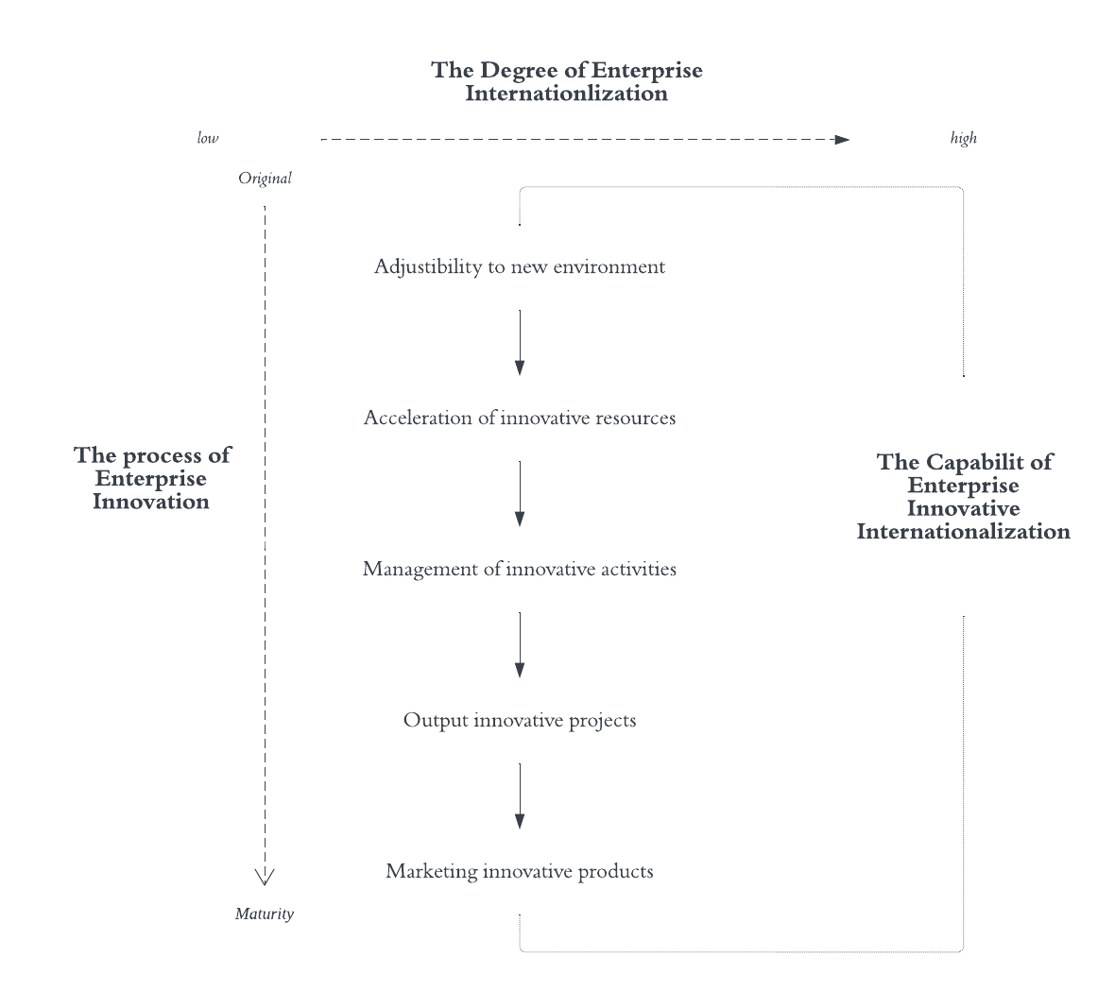

### Section Three:

### Future Internationalization Prediction in China

#### 1. Grey Predictive Model Overview

##### 1.1 Model Overview

###### 1.1.1 Principle

Grey forecasting is a method of predicting systems that contain uncertainties.

Grey prediction identifies the degree of difference in the development trend between system factors, that is, conducts correlation analysis, and generates the original data to find the law of system change, generates a data series with strong regularity, and then establishes a corresponding differential equation model to predict the future development trend of things.

###### 1.1.2 Classification:

**A.Gray time series prediction;**

that is, the gray prediction model is constructed by using the observed time series reflecting the characteristics of the prediction object to predict the argentometric quantity at a certain time in the future, or the time to reach a certain eigenvalue.

**B.Distortion prediction**

that is, predicting the time when the outlier appears through the gray model, and predicting when the outlier will appear in a specific time zone.

**C.System prediction.**

by establishing a set of interrelated gray prediction models for system behavior characteristic indicators, predict the changes in the mutual coordination relationship between many variables in the system.

**D.Topological prediction.**

the original data is used as a curve, and all the time points where the fixed value occurs are found on the curve, and the time point column is formed with the fixed value as the framework, and then a model is established to predict the time point at which the fixed value occurs

###### 1.1.3 Model Advantage

The model considers some uncertain variables to make sure that reasonable predictions can be achieved, and it shows better performance especially involving in the future years’ prediction for more than 20 years

##### 1.2 Model Factors

Table 14: Grey Predictive Model Factors

|  |  |  |  |
| --- | --- | --- | --- |
| Model Details | | | |
| Development Coefficient a | Gray action b | Posterior difference ratio C value | Small error probability p-value |
| -0.0001 | 181.3016 | 0.9822 | 0.689 |

##### Model Factors

The x variables here are mainly in industry variance because, from the earlier analysis, the largest variance lies among industry instead of other inner indicators for R&D, Logistics, or Human Resources.

###### (1) Historical Statistics:

Table 15: Historical Statistical Results by Industry

|  |  |  |
| --- | --- | --- |
| A table of model-predicted values | | |
| Items | Original Value | Predicted values |
| Resource and Mining | 0.43 | 5.338 |
| Domestic Electric Application | 0.47 | 5.327 |
| General | 1.72 | 5.368 |
| Logistics | 4.56 | 5.471 |
| The Internet | 4.93 | 5.574 |
| Food and Drinks | 5.37 | 5.543 |
| Agriculture | 5.68 | 5.708 |
| Architecture Engineer and Manufacture | 6.26 | 5.389 |
| Finance | 6.32 | 5.492 |
| Electric Operation | 6.51 | 5.636 |
| Chemistry | 6.56 | 5.512 |
| IT | 6.91 | 6.91 |
| Transportation | 7.93 | 5.358 |

Table Note:The variance consistency for predicted value and principle value

###### (2) Future Prediction

The following results shows the strong relationship between time series and Enterprise Internationalization which is the directed indicator for the future development.This means the consumption for closing door in China shouldn’t be prioritized and the era’s technology requirements also

**A. Domestic Enterprise Internationalization Strategy**

The indicator of Strategy for Internationalization heralds a steady growth of China's international enterprises in the future, with 1 period representing one month

X axis strands for the Internationalization Preference,considering the starting point of 5.6 and slow moving speed of no more than 0.5,the oversea strategy should be made stable and cautious. The industry’s choice and location’s distribution should be prioritized first as mentioned in the earlier analysis

Figure8: Future Moving Forward Prediction

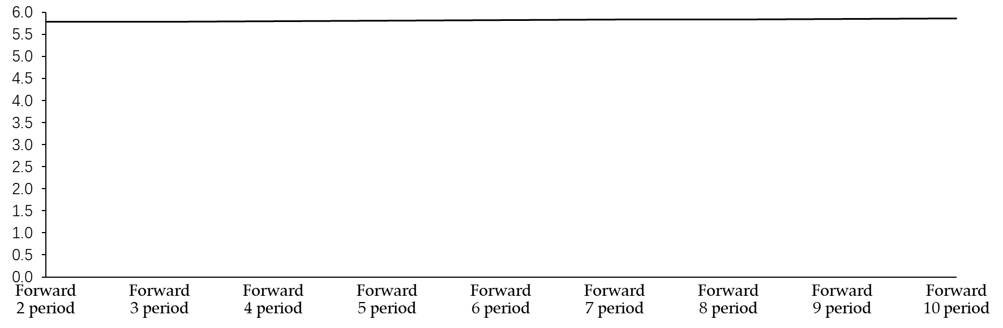

1. Domestic Enterprise Internationalization Industry

Figure 6: The scatter distribution for industry’s performance

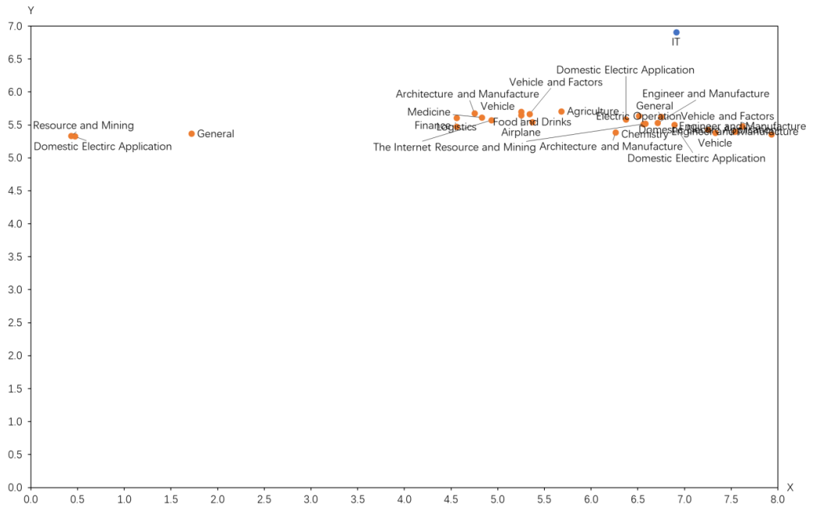

Figure note:scar figure from SPUSS

The intensified area mainly falls between 4.5 and 6.0 which means the leading industries in the international markets.

The minor industries like Resource and Mining and Demoestic Electric Application are less developed sectors out of resource limitation or security regulation.

## Conclusion

The future developing strategy should mainly focuses on local-characterized oversea strategy instead of the general domestic developing strategy and more reviews should be implemented in the Business Model analysis in existed technology field.

1. Prioritized 1st near-sea cities like Beijing ,Shanghai, Guangzhou to win a more positive reputation for Chinese Enterprises’Internationlization.
2. The technology oriented industries, including Intelligent Medicine,IT, Electric historical govern
3. ents’ support is sufficient enough to lead for the new stage of going abroad.
4. The past enterprises’ internationalization review mainly focuses on empirical analysis instead of quantitative verification, which sometimes ignores the geography and industry differences.
5. The future global environment and domestic supply-demand markets’ situation both provides an excellent opportunity for traditional enterprises to revolutionize conventional structure like monopoly and reach nearby countries like Thailand and India to take the 1st step

## To conclude, under the systematic framework, Chinese enterprises’ next 10 years will be welcomed.

# References

[1] Qin Bin. (2019).Quality Management of Education Internationalizations in Henan's Provincial Middle Schools from a Perspective of Sustainable Development..(eds.)*Proceedings of the 2019 Northeast Asia International Symposium on Linguistics, Literature and Teaching(2019 NALLTS)(Volume B)(pp.176-192).New Vision Press.*  
[2]International Monetary Institute(2013).*The Internationalization of the Renminbi. Taylor and Francis.*[3] Silberman Linda. (2002). The Costs and Benefits of the Internationalization of Family Law. Proceedings of the ASIL Annual Meeting.

[4] Xu Ying & Miao Weisman.(2010).*The Internationalization of Chinese English-Language Humanities and Social Science Journals: Their Status and Challenges. Journal of Scholarly Publishing (4)*.   
[5] Chidlow Agnieszka, Wang Juelle Xiaohui & Xie Ying qi.(1997)*.A co-evolution perspective of EMNE internationalization and institutions: An integrative framework of 5Cs. International Business Review(4).*  
[6] Chan Chui Shiam & Pattnaik Chinmay.(2021).Coevolution of home country support and internationalization of emerging market firms. *International Business Revi*ew (4).

[7] Costa Inês.(2021).*The Winner Takes It All? The Impact of Awards on the Internationalization of the Portuguese Children's Publisher Planeta Tangerina. Bookbird: A Journal of International Children's Literature (2)*.   
[8] Yi Changjun,Zhang Jipeng,Zhan Yun,Yan Xiaojuan & Chen Chu sheng.(2021).Internationalization speed and subsidiary survival of EMNCs: *The moderating roles of CEO international experience and state ownership. Journal of Asian Economics(prepublish).*

1. Nbshttp://www.stats.gov.cn/
2. Table here mainly comes from the *Report on the Globalization of Chinese Enterprises*
3. Li,2021, *the technological innovation ability of enterprises*
4. Li,2021, *the technological innovation ability of enterprises*
5. China Enterprise Union Website: http://www.cec1979.org.cn/
6. Figure from SPASS Logical Regression Result
7. Long Tan,Yun Liu,Wei Pan*Analysis of the internationalization ability of enterprise technological innovation And the construction of the assessment system* [*https://kjpj.bit.edu.cn/docs/2014-09/20140910211738796490.pdf*](https://kjpj.bit.edu.cn/docs/2014-09/20140910211738796490.pdf)