DEAD WEIGHT.

**GOAL OF THE GAME:**

Collect 4 limbs: 2 arms and 2 legs and return to the gatekeeper in the middle to win.

**GAME SET UP:**

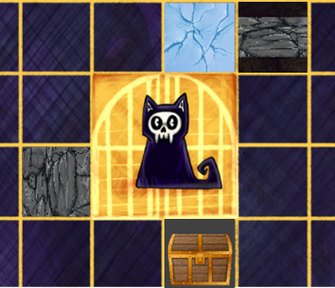

1. Put the players in the centre (corresponds to 4 yellow tiles) of the board by the **gatekeeper (cat**). Each player starts as a **ghost with no limbs**.
2. Roll the d4. Highest number starts. Then continue clockwise.
3. Each player must draw **5** tiles. **5** is the **limit of pieces** (tiles & limbs) each player can hold **for the rest of the game**. Tiles are found in yellow bag.
4. 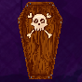Each player then must put at least 1 of their tiles **anywhere on the board**. Advice: place several tiles around the start point to be able to move on the map in the next round (see example on the left).
5. A cartoon of a wolf sitting on a box

   Description automatically generatedThrow a d4 and place the **vendor (dog)** on the spot corresponding to the number in d4.

Vendor moves at the end of every complete

round in ascending order. Dog spots are **not** tiles. Round is complete when each player has played their turn.

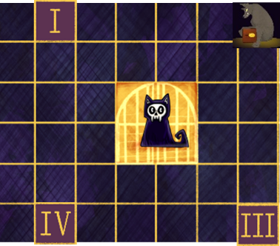 **THIS IS HOW EVERY TURN GOES:**



1. If you are a ghost with NO limbs, get a new card.

In the game **only cards are secret** from others. Players  
  
 can use cards only on their turn.

1. Throw a d4. You can move **up to** **that number** of steps for this turn in “+” shape (see example on the left). Once you land, stop moving.

Players are allowed to stand on the same tile.

1. Draw new tiles to fill up your **5** pieces inventory (if it’s not full already). Inventory is tiles & limbs, **not** cards!
2. Place **as many tiles as you want** anywhere on the map (except dog tiles) to continue building it the way it suits you.

|  |  |
| --- | --- |
| AS A GHOST WITH NO LIMBS:  -Move: can cross any tile & limb.  -Cards: 1 new card every turn. Used cards go to discard pile.  -Limb: to pick up a limb, land on it/closed chest. To drop a limb, place it on the tile you are standing on. Limbs are found in white bag. | AS A GHOST WITH ANY LIMBS:  -Move: can cross tiles that only your limbs allow + ground tiles/chests/limbs.  -Cards: can only get new cards from vendor, if you stand on the same spot with him. Get 2 cards. Used cards go to discard pile.  -Limb: to pick up a limb, land on it/closed chest. If you can’t pass the tile under it, you can’t have this limb. To drop a limb, place it on the tile you are standing on. Limbs are found in white bag.  -If you land on vendor spot before vendor: allowed both card and movement. |

**TILES & LIMBS.**

|  |  |
| --- | --- |
| Regular Ground.  Who can pass: anyone. | Direction Ground.  Who can pass: anyone, but follow the direction. |
| Cracked Ground.  Who can pass: anyone.  NOTE: breaks after being passed by a ghost with limbs. Discard back in tiles pile after breaking. | Rope.  **Who can pass:** ghost with no limbs  OR ghost with “rope” arm. |
| Spikes.  Who can pass: ghost with no limbs  OR ghost with “spikes” leg. | Water.  **Who can pass:** ghost with no limbs  OR ghost with “water” leg. |
| Ice.  Who can pass: ghost with no limbs  OR ghost with “ice” arm. | Chest. Contains limb inside (left). Empty (right).  **Who can pass:** anyone.  **How to pick a limb:** land on closed chest.  **Remember to flip after emptying! (press F).** |
| Lava.  Who can pass: ghost with no  limbs. | Bush.  **Who can pass:** ghost with no limbs  OR ghost with “scissor” arm. |

**TILES & LIMBS.**

|  |  |
| --- | --- |
| “Ice” arm.  Allows to pass: ice. | “Rope” arm.  Allows to pass: rope. |
| “Scissor” arm.  Allows to pass: bush. | “Fast” leg.  **Gives: +1 step every turn**. |

|  |  |
| --- | --- |
| A cartoon of a hand and a snowflake  Description automatically generated  “Water” leg.  Allows to pass: water. | “Spikes” leg.  Allows to pass: spikes. |

We encourage you to sabotage others during the gameplay! 😉

Age group: 8+

Tiles: 99.

Limbs:24.

Dice: 1 d4.

Bags: 2. Yellow for tiles, white for limbs.

Dog: 1 piece.

Cards: 32.

The game takes: 1,5 hours.

Number of players: 2-4.