# Introduction

### Project Profile

Bookopia.com is a Web Based PHP Application with MySQL Database which provides a platform to book readers and authors to rate, review and search books based on popularity, genres, ratings and much more. It also allows its users (registered only) to communicate with one another through live chats, groups. User can also participate in forums created by Administrators and Authors.

|  |  |
| --- | --- |
| Project Title | bookopia.com |
|  |  |
| Organization | Ashvi Consultancy Service |
| Front End Tools | PHP, MVC, JavaScript, JQuery, AJAX |
| Back End Tools | MYSQLi |
| Other Tool | HTML5, CSS3, BOOTSTRAP |
| Project Category | Web Based Application |
| Project Associates | Three |
| Duration | Three Months |
| Internal Project Guide | Mrs Veena Jokhakar  Dr Devndra Pandey |
| External Project Guide | Mr Ganpat Dhameliya |
| Submitted By | Mr Riken Kantilal Kantharia  Ms Ujala Mahendrabhai Patel  Mr Vishal Prashantkumar Rana |
| Submitted To | Department Of ICT,VNSGU |

Company Profile**: -**

**Ashvi Consultancy Service**

Ashvi Consultancy Service is a place where you can find only the most reliable Web designs, Web development and Windows development solutions to use in creating professional Software. Our company was established in 2007 and it started to offer various types of Web designs and development solutions. We are the specialists in Banking Products and also provide School/College Management Software Service. At Ashvi Consultancy Service we don't just doing web designing, we provide complete web design solutions that make you stand out, work in conjunction with your business and make a difference to your bottom line. We work alongside you to identify key areas where we create extra value for you and your business.

* Technologies :-

PHP, Word-press, Java, Asp

* Platforms :-

Android, Mac, Windows

# Proposed System

1.1 Scope

* Admin

Admin can manage books, authors, reviewers, awards, genres, forums and other entities of database.

* User
* Author

Author can manage his profile, review and rate books, chat, create or join groups, start forums, participate in forums, write blogs, post updates, like other posts and comments.

* User

User can manage his profile, review and rate books, search books, create or join groups, participate in forums, like/comment on posts, follow authors, join live chats.

1.2 Objectives

* Provide System Administrator with easy interface for different administrative tasks such as Searching, Addition, Deletion and Updating Different entities.
* The System should properly maintain user privileges i.e. it should not allow unregistered users to access certain features.
* The System should also provide different features to different types of users i.e. Authors and Reviewers (normal users).
* Only Administrator will have all privileges.

1.3 Feasibility Study

Feasibility study involves research relating to different aspects that go into developing software. Feasibility study of the problem definition or requirement was done to determine if the requirement can be solved effectively given the budgetary, operational & technical and scheduled constraints in place. The aim of feasibility study is to identify the best solution under the circumstances by identifying the effects of this solution on the organisation.

The feasibility of our project has been judged on the basis of time, technology, resources available, behavioural feasibility & cost of development.

1.3.1 Duration Feasibility

Project initiated with pre-stated deadlines. The duration is allotted keeping in mind the entire task & is practically feasible.

1.3.2 Implementation Feasibility

A proper implementation is essential to provide a reliable system to meet requirements of the organization. Implementation is the stage in the project where the theoretical design is turned into a working system. The most critical stage in achieving a new successful system is to improve the performance of the existing system and to deliver system effective application.

1.3.3 Operational Feasibility

It will help in time saving and fast processing and dispersal. From the Admin perspective our application requires basic knowledge about policies of Cyber World.

1.3.4 Technical Feasibility

Minimum system required for admin, user and visitor is computer connected with internet with compatible browser. ➢ The system is suitable for multi user operations. With the available resources robust system with data security can be developed. It uses PHP which has been tested & approved to be sufficiently robust, scalable & efficient to develop such an application. Hence technically there is no limitation for development of the system.

1.3.5 Resource Feasibility

The system requires well trained software developers. Besides that network connectivity, MySQL servers are needed. Tools for documentation & editing are required. ➢These resources are available and feasible

1.3.6 Behavioural Feasibility

Benefits of proposed system were assessed. Having realized the benefit of new system the users’ response was studied before the inception of system development. They reacted positively towards the proposal. Since all the users involved in project development are familiar with internet no explicit training will be required to learn the usage of new system. Simple guidance would suffice

1.3.7 Economic Feasibility

The cost of software and hardware required for system including storage of bulk of data server. ➢ No budgetary constraints were imposed on the system. More importantly since all free software were used only hardware, usage & internet costs were to be considered. These were quite limited & well within feasibility.

Based on above study it can be stated that designing & developing this system is certainly feasible if executed well within stated guidelines. So based on these positive results, the new system was approved for development.

# 2. SYSTEM Environment

2.1 Technology Description

PHP, MVC, JavaScript, JQuery, AJAX

MYSQLi

HTML5, CSS3, BOOTSTRAP

2.2 Software Requirement

* Any web browser with live internet connection

2.3 Hardware Requirement

* Laptop or PC with the internet connection.

# 3. SYSTEM Analysis AND MODELING

3.1 System Architecture

3.2 Software Requirement Specification

3.2.1 Functional Requirement

* Provide Attractive and Interactive interface to Admin & User.
* Searching books
* Searching authors
* Live Chat
* Follow authors
* Like/Comment
* Add blogs
  + Post Updates
* Rate/Review books
* Create and join groups
* Follow forums

3.2.2 Non-Functional Requirement

* User, Admin Login & Logout
* Database
* Book genre
* Less known book facts
* Author category
* List of awards

3.3 Data Flow Diagram

Level 0:

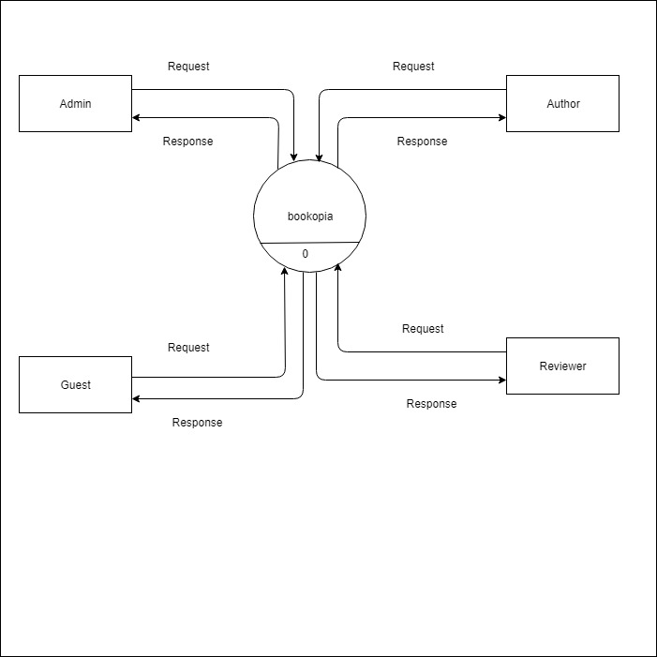

Level 1:

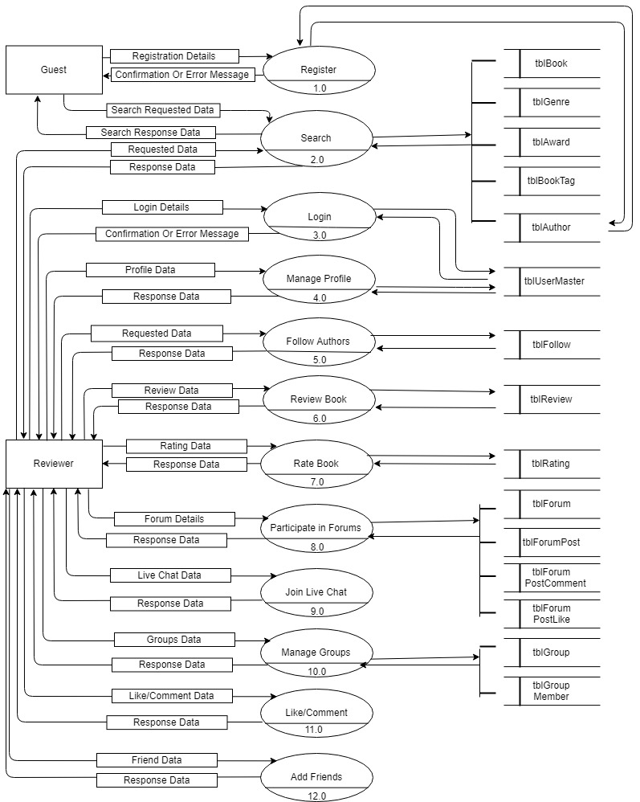

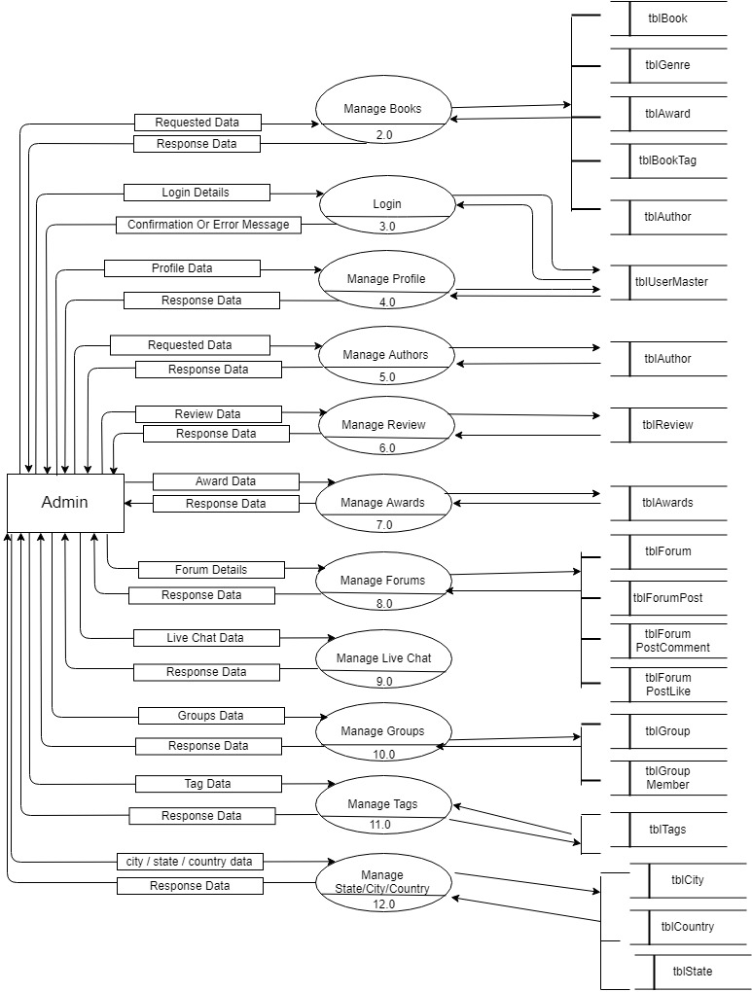

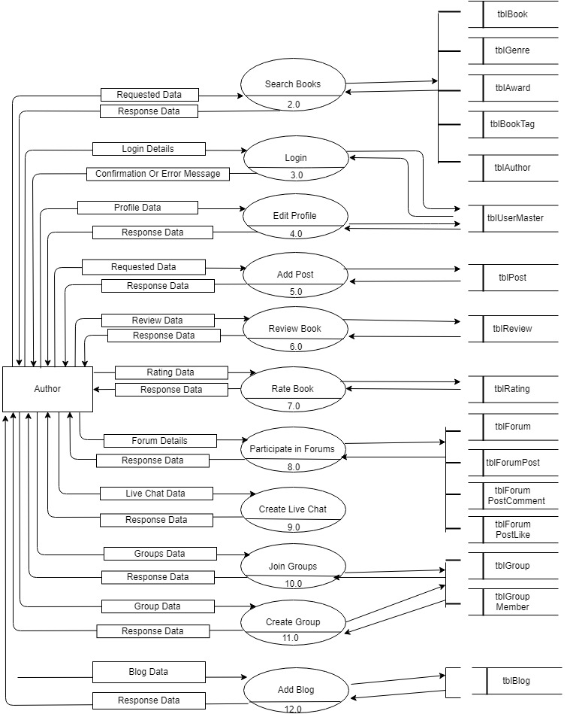

3.4 Use Case Diagram

Admin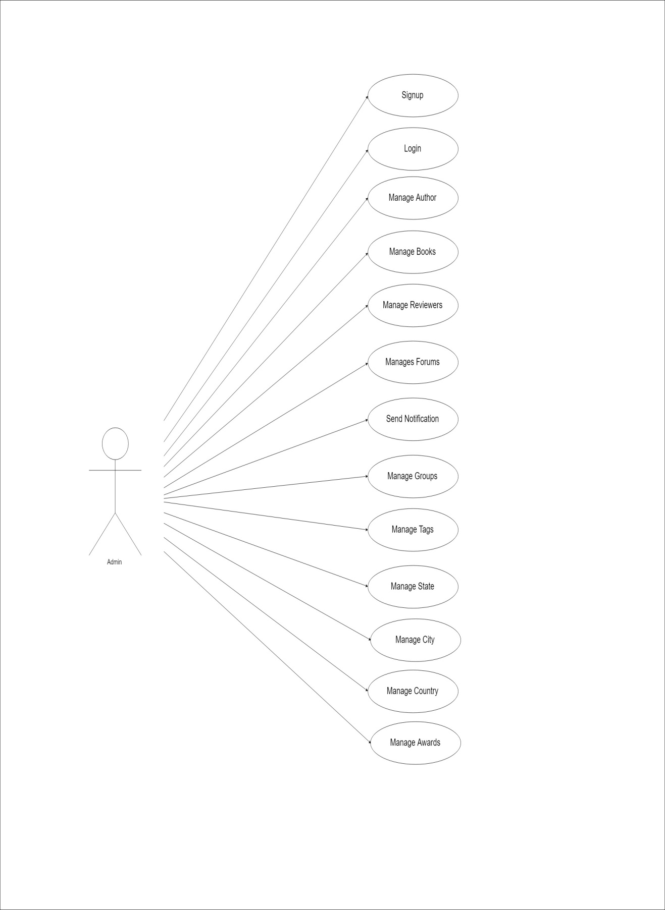

Author

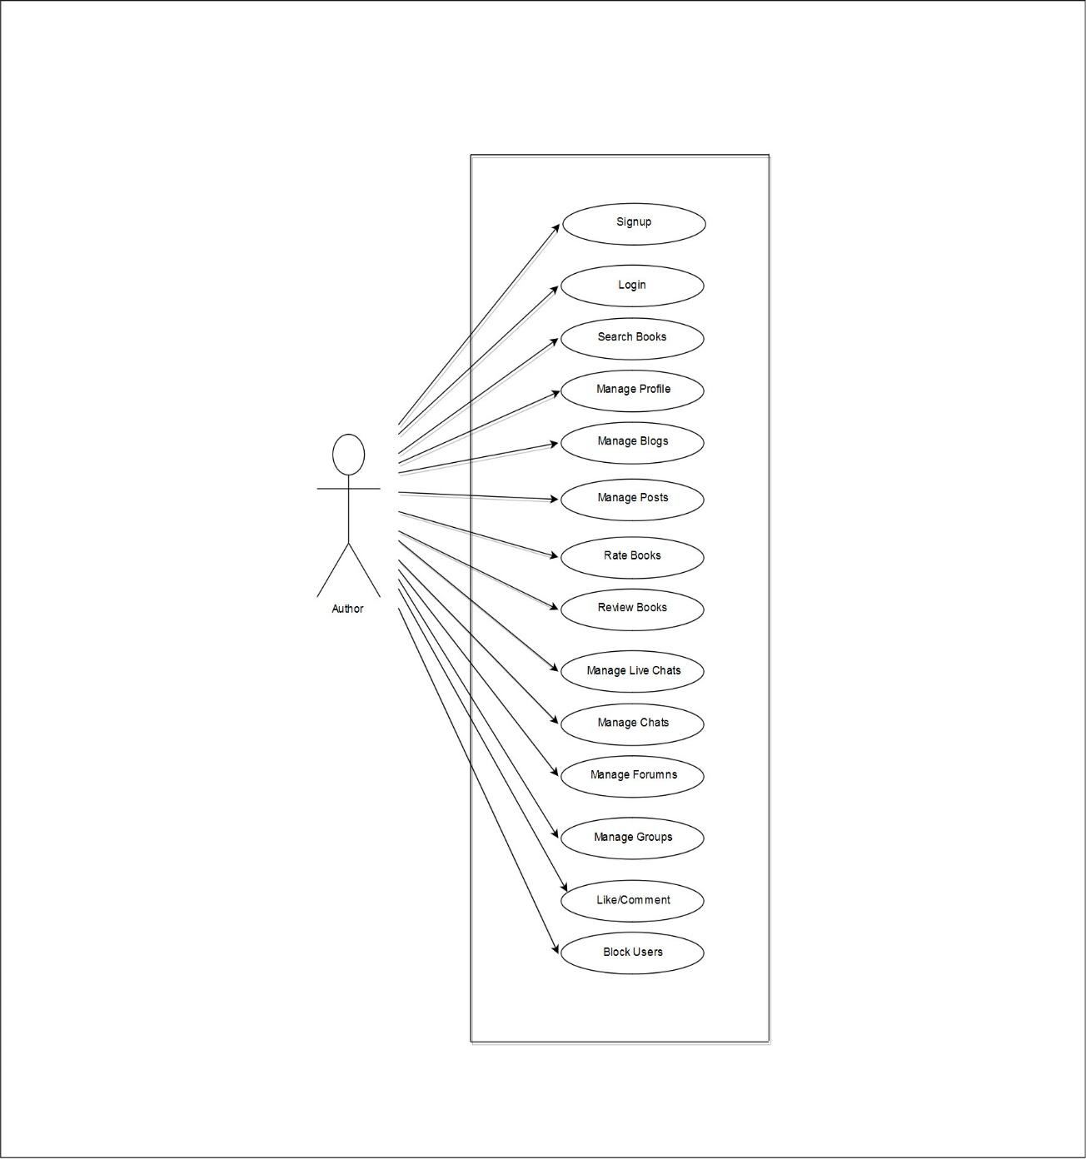

user

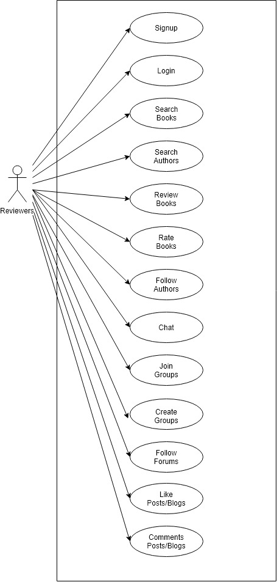

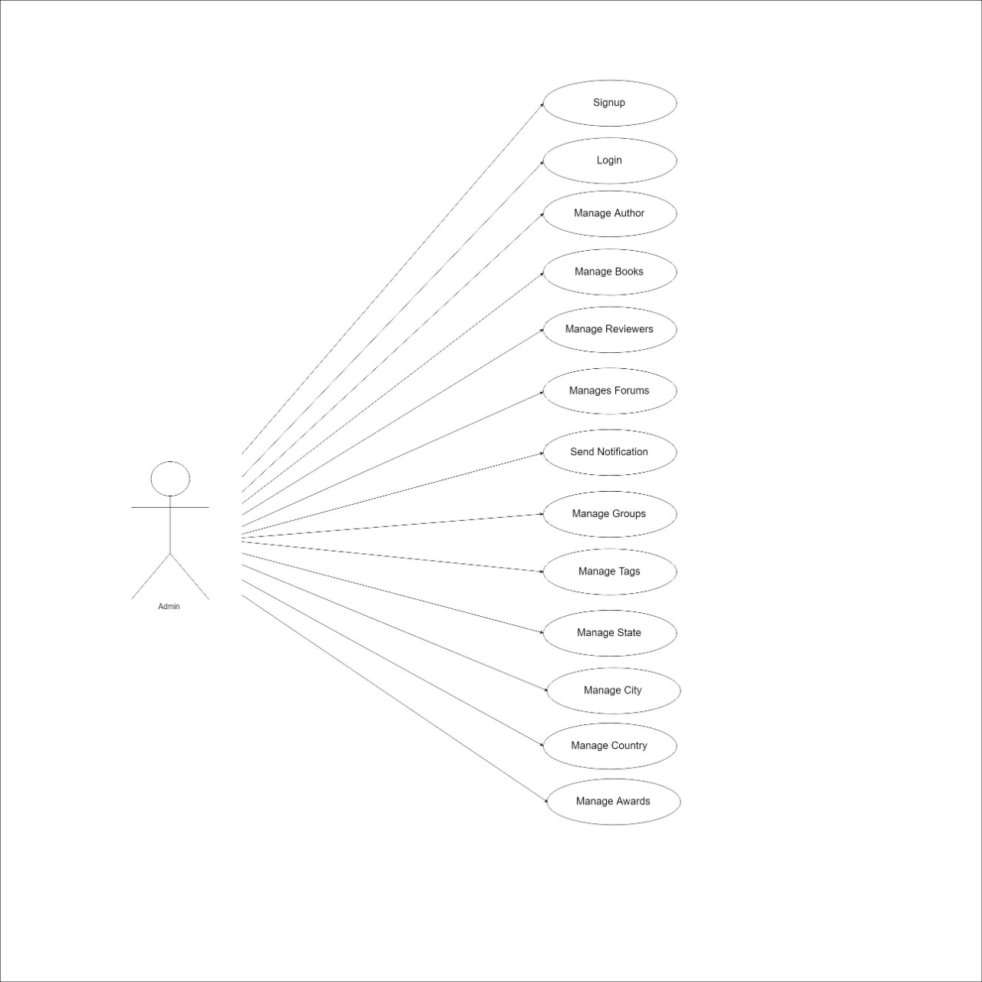

3.5 Class Diagram: -

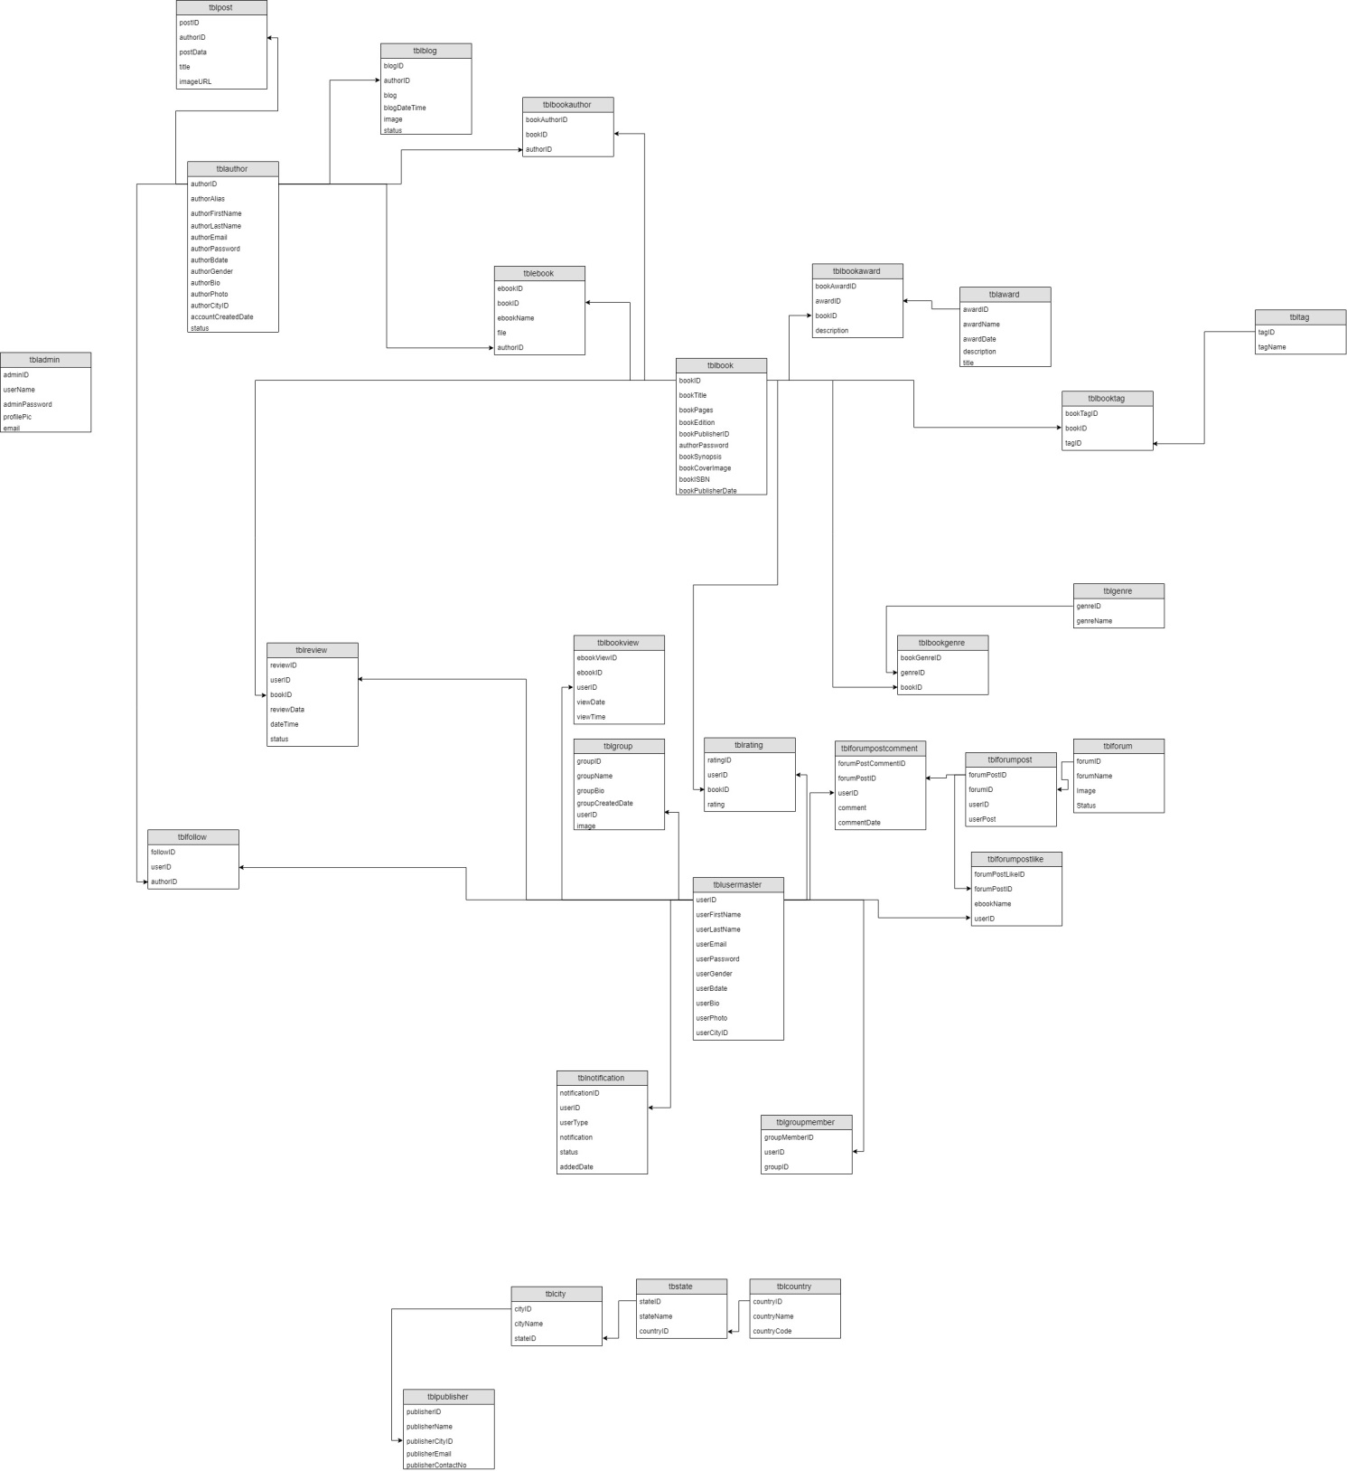

3.6 Data Dictionary

tbladmin

|  |  |  |  |  |  |
| --- | --- | --- | --- | --- | --- |
| Element Name | Element Description | Data Types | Size | Modules | Constraint |
| adminID | ID | Int | 3 |  | Primary Key |
| userName | User Name | Varchar | 50 |  | Not Null |
| adminPassword | Password | Varchar | 100 |  | Not Null |
| profilePic | Image | Varchar | 500 |  | Not Null |
| email | Email | Varchar | 100 |  | Not Null |

tblauthor

|  |  |  |  |  |  |
| --- | --- | --- | --- | --- | --- |
| Element Name | Element Description | Data Type | Size | Modules | Constraint |
| authorID | ID | Int | 3 |  | Primary Key |
| authorAlias | Alias Name | Varchar | 100 |  | Not Null |
| authorFirstName | First Name | Varchar | 50 |  | Not Null |
| authorLastName | Last Name | Varchar | 50 |  | Not Null |
| authorEmail | Email | Varchar | 100 |  | Not Null |
| authorPassword | Password | Varchar | 100 |  | Not Null |
| authorBdate | BirthDate | Timestamp |  |  | Not Null |
| authorGender | Gender | Varchar | 10 |  | Not Null |
| authorBio | Short Bio | Varchar | 500 |  | Not Null |
| authorPhoto | Image | Varchar | 500 |  | Not Null |
| authorCityId | ID | Int | 3 |  | Foreign Key |
| accountCreatedDate | Date of join | Timestamp |  |  | Not Null |
| status | Have profile or not | Tinyint | 4 |  | Not Null |

tblaward

|  |  |  |  |  |  |
| --- | --- | --- | --- | --- | --- |
| Element Name | Element Description | Data Types | Size | Modules | Constraint |
| awardId | ID | Int | 3 |  | Primary Key |
| awardName | Name of award | Varchar | 50 |  | Not Null |
| awardDate | Date of award receive | TimeStamp |  |  | Not Null |
| description | Image | Varchar | 100 |  | Not Null |
| title | Award title | Varchar | 100 |  | Not Null |

tblblog

|  |  |  |  |  |  |
| --- | --- | --- | --- | --- | --- |
| Element Name | Element Description | Data Types | Size | Modules | Constraint |
| blogID | ID | Int | 3 |  | Primary Key |
| authorID | Author’s ID | Int | 3 |  | Foreign Key |
| blogTitle | Title of Blog | varchar | 300 |  |  |
| blog | Blog | Varchar | 10000 |  | Not Null |
| blogDateTime | Date Published | TimeStamp |  |  | Not Null |
| image | Image | Varchar | 500 |  | Not Null |
| status | Status of Blog | TinyInt | 4 |  | Not Null |

tblbook

|  |  |  |  |  |  |
| --- | --- | --- | --- | --- | --- |
| Element Name | Element Description | Data Types | Size | Modules | Constraint |
| bookID | ID | Int | 3 |  | Primary Key |
| bookTitle | Book’s Title | Varchar | 50 |  | Not Null |
| bookPages | No of Pages | Int | 3 |  | Not Null |
| bookEdition | Edition of book | Int | 3 |  | Not Null |
| bookPublisherId | ID | Int | 3 |  | Foreign Key |
| bookSynopsis | Synopsis of book | varchar | 1500 |  | Not Null |
| bookCoverImage | Image | Varchar | 500 |  | Not Null |
| bookISBN | ISBN number | Varchar | 50 |  | Not Null |
| bookPublishDate | Published Date | TimeStamp |  |  | Not Null |

tblbookauthor

|  |  |  |  |  |  |
| --- | --- | --- | --- | --- | --- |
| Element Name | Element Description | Data Types | Size | Modules | Constraint |
| bookAuthorID | ID | Int | 3 |  | Primary Key |
| bookID | ID | Int | 3 |  | Foreign Key |
| authorID | ID | Int | 3 |  | Foreign Key |

tblbookaward

|  |  |  |  |  |  |
| --- | --- | --- | --- | --- | --- |
| Element Name | Element Description | Data Types | Size | Modules | Constraint |
| bookAwardID | ID | Int | 3 |  | Primary Key |
| awardID | ID | Int | 3 |  | Foreign Key |
| bookID | ID | Int | 3 |  | Foreign Key |
| description | description | Varchar | 500 |  |  |

tblbookgenre

|  |  |  |  |  |  |
| --- | --- | --- | --- | --- | --- |
| Element Name | Element Description | Data Types | Size | Modules | Constraint |
| bookGenreID | ID | Int | 3 |  | Primary Key |
| genreID | ID | Int | 3 |  | Foreign Key |
| bookID | ID | Int | 3 |  | Foreign Key |

tblbooktag

|  |  |  |  |  |  |
| --- | --- | --- | --- | --- | --- |
| Element Name | Element Description | Data Types | Size | Modules | Constraint |
| bookTagID | ID | Int | 3 |  | Primary Key |
| bookID | ID | Int | 3 |  | Foreign Key |
| tagID | ID | Int | 3 |  | Foreign Key |

tblcity

|  |  |  |  |  |  |
| --- | --- | --- | --- | --- | --- |
| Element Name | Element Description | Data Types | Size | Modules | Constraint |
| cityID | ID | Int | 3 |  | Primary Key |
| cityName | Name of City | Varchar | 50 |  | Not Null |
| stateID | ID | Int | 3 |  | Foreign Key |

tblcountry

|  |  |  |  |  |  |
| --- | --- | --- | --- | --- | --- |
| Element Name | Element Description | Data Types | Size | Modules | Constraint |
| **countryID** | ID | Int | 3 |  | Primary Key |
| countryName | Name of City | Varchar | 50 |  | Not Null |
| countryCode | ID | Int | 3 |  | Foreign Key |

tblebook

|  |  |  |  |  |  |
| --- | --- | --- | --- | --- | --- |
| Element Name | Element Description | Data Types | Size | Modules | Constraint |
| ebookID | ID | Int | 3 |  | Primary Key |
| bookID | ID | Int | 3 |  | Foreign Key |
| ebookName | Name of Book | Varchar | 50 |  | Not Null |
| file | File of Book | Varchar | 500 |  | Not Null |
| authorID | ID | Int | 3 |  | Foreign Key |

tblebookview

|  |  |  |  |  |  |
| --- | --- | --- | --- | --- | --- |
| Element Name | Element Description | Data Types | Size | Modules | Constraint |
| **ebookViewID** | ID | Int | 3 |  | Primary Key |
| ebookID | ID | Int | 3 |  | Foreign Key |
| userID | ID | Int | 3 |  | Foreign Key |
| viewDate | Last Read Date | TimeStamp |  |  | Not Null |
| viewTime | Last Read Time | TimeStamp |  |  | Not Null |

tblfollow

|  |  |  |  |  |  |
| --- | --- | --- | --- | --- | --- |
| Element Name | Element Description | Data Types | Size | Modules | Constraint |
| followID | ID | Int | 3 |  | Primary Key |
| userID | ID | Int | 3 |  | Foreign Key |
| authorID | ID | Int | 3 |  | Foreign Key |

tblforum

|  |  |  |  |  |  |
| --- | --- | --- | --- | --- | --- |
| Element Name | Element Description | Data Types | Size | Modules | Constraint |
| forumID | ID | Int | 3 |  | Primary Key |
| forumName | Name of Forum | Varchar | 50 |  | Not Null |
| image | Forum image | Varchar | 500 |  | Not Null |
| status | Active/ Deactive | tinyint | 4 |  | Not Null |

tblforumpost

|  |  |  |  |  |  |
| --- | --- | --- | --- | --- | --- |
| Element Name | Element Description | Data Types | Size | Modules | Constraint |
| **forumPostID** | ID | int | 3 |  | Primary Key |
| forumID | ID | int | 3 |  | Foreign Key |
| userID | ID | int | 3 |  | Foreign Key |
| userPost | Post in Forum | varchar | 500 |  | Not Null |

tblforumpostcomment

|  |  |  |  |  |  |
| --- | --- | --- | --- | --- | --- |
| Element Name | Element Description | Data Types | Size | Modules | Constraint |
| **forumPostCommentID** | ID | int | 3 |  | Primary Key |
| forumPostID | ID | int | 3 |  | Foreign Key |
| userID | ID | int | 3 |  | Foreign Key |
| comment | Comment on post | varchar | 500 |  | Not Null |
| commentDate | Date of comment | timestamp |  |  | Not Null |

tblforumpostlike

|  |  |  |  |  |  |
| --- | --- | --- | --- | --- | --- |
| Element Name | Element Description | Data Types | Size | Modules | Constraint |
| **forumPostLikeID** | ID | int | 3 |  | Primary Key |
| forumPostID | ID | int | 3 |  | Foreign Key |
| userID | ID | int | 3 |  | Foreign Key |

tblgenre

|  |  |  |  |  |  |
| --- | --- | --- | --- | --- | --- |
| Element Name | Element Description | Data Types | Size | Modules | Constraint |
| **genreID** | ID | int | 3 |  | Primary Key |
| genreName | Genre of Book | varchar | 50 |  | Not Null |

tblgroup

|  |  |  |  |  |  |
| --- | --- | --- | --- | --- | --- |
| Element Name | Element Description | Data Types | Size | Modules | Constraint |
| **groupID** | ID | int | 3 |  | Primary Key |
| groupName | Name of Group | varchar | 50 |  | Not Null |
| groupBio | Short Bio | varchar | 500 |  | Not Null |
| groupCreatedDate | Date of Creation | TimeStamp |  |  | Not Null |
| userID | ID | int | 3 |  | Foreign Key |
| image | Group Photo | varchar | 500 |  | Not Null |

tblgroupmember

|  |  |  |  |  |  |
| --- | --- | --- | --- | --- | --- |
| Element Name | Element Description | Data Types | Size | Modules | Constraint |
| **groupMemberID** | ID | int | 3 |  | Primary Key |
| userID | ID | int | 3 |  | Foreign Key |
| groupID | ID | int | 3 |  | Foreign Key |

tblnotification

|  |  |  |  |  |  |
| --- | --- | --- | --- | --- | --- |
| Element Name | Element Description | Data Types | Size | Modules | Constraint |
| **notificationID** | ID | int | 3 |  | Primary Key |
| userID | ID | int | 3 |  | Foreign Key |
| usertype | Type of User | varchar | 50 |  | Not Null |
| notification | Notification Title | varchar | 500 |  | Not Null |
| status | Received or not | tinyint | 4 |  | Not Null |
| adddedDate | Date of Notification | timestamp |  |  | Not Null |

tblpost

|  |  |  |  |  |  |
| --- | --- | --- | --- | --- | --- |
| Element Name | Element Description | Data Types | Size | Modules | Constraint |
| **postID** | ID | int | 3 |  | Primary Key |
| authorID | ID | int | 3 |  | Foreign Key |
| postData | Data of Post | varchar | 280 |  | Not Null |
| title | Post Title | varchar | 50 |  | Not Null |
| imageURL | Path of Image | varchar | 500 |  | Not Null |

tblpublisher

|  |  |  |  |  |  |
| --- | --- | --- | --- | --- | --- |
| Element Name | Element Description | Data Types | Size | Modules | Constraint |
| **publisherID** | ID | int | 3 |  | Primary Key |
| publisherName | Name of Publisher | varchar | 50 |  | Not Null |
| publisherCityID | City ID | int | 3 |  | Foreign Key |
| publisherEmail | Email of publisher | varchar | 100 |  | Not Null |
| publisherContactNo | Contact number | int | 10 |  | Not Null |

tblrating

|  |  |  |  |  |  |
| --- | --- | --- | --- | --- | --- |
| Element Name | Element Description | Data Types | Size | Modules | Constraint |
| **groupMemberID** | ID | int | 3 |  | Primary Key |
| userID | ID | int | 3 |  | Foreign Key |
| groupID | ID | int | 3 |  | Foreign Key |
| rating | Rating out of 10 | float |  |  | Not Null |

tblreadlist

|  |  |  |  |  |  |
| --- | --- | --- | --- | --- | --- |
| Element Name | Element Description | Data Types | Size | Modules | Constraint |
| **readListID** | ID | int | 3 |  | Primary Key |
| userID | ID | int | 3 |  | Not Null |
| bookID | ID | int | 3 |  | Not Null |

tblreview

|  |  |  |  |  |  |
| --- | --- | --- | --- | --- | --- |
| Element Name | Element Description | Data Types | Size | Modules | Constraint |
| **reviewID** | ID | int | 3 |  | Primary Key |
| userID | ID | int | 3 |  | Not Null |
| bookID | ID | int | 3 |  | Not Null |
| reviewData | Review of Data | varchar | 3000 |  | Not Null |
| dateTime | Date of Review | timestamp |  |  | Not Null |
| status | Block / Unblock | tinyint | 4 |  | Not Null |

tblstate

|  |  |  |  |  |  |
| --- | --- | --- | --- | --- | --- |
| Element Name | Element Description | Data Types | Size | Modules | Constraint |
| **stateID** | ID | int | 3 |  | Primary Key |
| stateName | Name of State | varchar | 50 |  | Not Null |
| countryID | ID | int | 3 |  | Not Null |

tbltag

|  |  |  |  |  |  |
| --- | --- | --- | --- | --- | --- |
| Element Name | Element Description | Data Types | Size | Modules | Constraint |
| **tagID** | ID | int | 3 |  | Primary Key |
| tagName | Name of Tag | varchar | 50 |  | Not Null |

tblusermaster

|  |  |  |  |  |  |
| --- | --- | --- | --- | --- | --- |
| Element Name | Element Description | Data Type | Size | Modules | Constraint |
| userID | ID | Int | 3 |  | Primary Key |
| userFirstName | First Name | Varchar | 50 |  | Not Null |
| userLastName | Last Name | Varchar | 50 |  | Not Null |
| userEmail` | Email | Varchar | 100 |  | Not Null |
| userPassword | Password | Varchar | 100 |  | Not Null |
| userBdate | BirthDate | Timestamp |  |  | Not Null |
| userGender | Gender | Varchar | 10 |  | Not Null |
| userBio | Short Bio | Varchar | 500 |  | Not Null |
| userPhoto | Image | Varchar | 500 |  | Not Null |
| authorCityId | ID | Int | 3 |  | Foreign Key |

3.7 Process Specification

Admin Side:

Process: - 1

Process Name: - Login Process

Description: -

This process will take login information as input from admin and will compare that information with data stored in admin table. If provided data is correct then system will create a session else will show an error.

Process: - 2

Process Name: - Manage Books

Description: -

Insert new books, update data of particular books, delete books.

Process: - 3

Process Name: - Manage Authors

Description: -

Insert new author, update information of existing authors, delete author.

Process: - 4

Process Name: - Manage Reviewers

Description: -

Update information of reviewers, block reviewer from website.

Process: - 5

Process Name: - Manage Genre

Description: -

Insert, update, delete genre.

Process: - 6

Process Name: - Manage City, State, Country

Description: -

Insert, update or delete city, state and country.

Process: - 7

Process Name: - Logout Process

Description: -

This process will log out the admin i.e. it will unset the current session

User Side:

Process: - 1

Process Name: - Login

Description: -

This process will take login information as input from user and will compare that information with data stored in user table. If provided data is correct then system will create a session else will show an error.

Process: - 2

Process Name: - Sign Up (Register)

Description: -

This process will register new user to the website by taking information from user.

Process: - 3

Process Name: - Search Books

Description: -

User can find out details of particular book by searching it.

Process: - 4

Process Name: - Manage Profile

Description: -

User will be able to add or remove his/her information and update it on profile.

Process: - 5

Process Name: - Follow Author

Description: -

User can follow particular author to get updates from the author.

Process: - 6

Process Name: - Review Book

Description: -

User can add review of books multiple times.

Process: - 7

Process Name: - Rate Book

Description: -

User can rate any book out of 10.

Process: - 8

Process Name: - Participate in Forums

Description: -

Join the forum and put a post and do comment and like the post of others.

Process: - 9

Process Name: - Join Live Chat

Description: -

Participate in live chat of particular author.

Process: - 10

Process Name: - Create Group

Description: -

User can create new group and add members into it.

Process: - 11

Process Name: - Join Group

Description: -

User can join the existing group.

Process: - 12

Process Name: - Add Friends

Description: -

Process: - 13

Process Name: - Liking the Post

Description: -

User can like the post of authors.

Process: - 14

Process Name: - Comment on Post

Description: -

User can comment on the post of authors.

Author Side:

Process: - 1

Process Name: - Login

Description: -

This process will take login information as input from author and will compare that information with data stored in author table. If provided data is correct then system will create a session else will show an error.

Process: - 2

Process Name: - Register

Description: -

This process will register new user to the website by taking information from author.

Process: - 3

Process Name: - Search Books

Description: -

Author can find out details of particular book by searching it.

Process: - 4

Process Name: - Manage Profile

Description: -

Author will be able to add or remove his/her information and update it on profile.

Process: - 5

Process Name: - Add Post

Description: -

Author can add post to share updates and information with fans.

Process: - 6

Process Name: - Review Book

Description: -

Author can add review of books multiple times.

Process: - 7

Process Name: - Rate Book

Description: -

Author can rate any book out of 10.

Process: - 8

Process Name: - Participate in Forums

Description: -

Process: - 9

Process Name: - Create Live Chat

Description: -

Author can create live chat for fans.

Process: - 10

Process Name: - Join Group

Description: -

Author can join the existing groups.

Process: - 11

Process Name: - Create Group

Description: -

Author can create new groups and manage it.

Process: - 12

Process Name: - Add Blog

Description: -

Author can create a blog on our website.

**3.8 E-R Diagram**

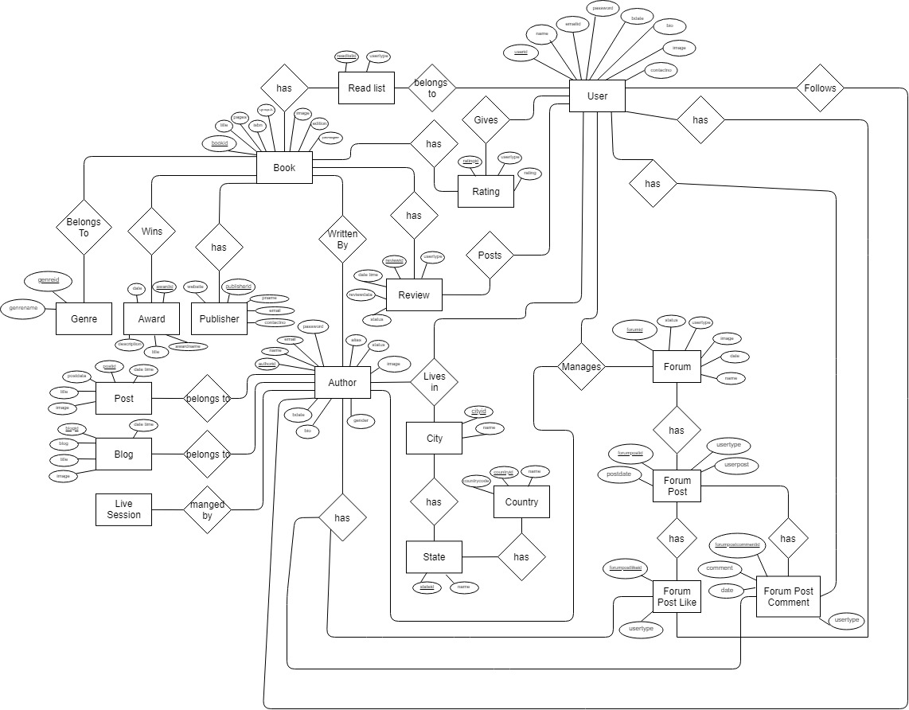

4. Designing

4.1 Database Design

Table**:** tbladmin

Data: admin username and password

Where & how used**:** manages admin username, password and its profile image.

Columns**:**

|  |  |  |  |  |
| --- | --- | --- | --- | --- |
| Column Name | Description | Data Types | Size | Constraint |
| adminID | ID | Int | 3 | Primary Key |
| userName | User Name | Varchar | 50 | Not Null |
| adminPassword | Password | Varchar | 100 | Not Null |
| profilePic | Image | Varchar | 500 | Not Null |
| email | Email | Varchar | 100 | Not Null |

Table**:** tblauthor

Data**:** author details

Where & how used:

Columns**:**

|  |  |  |  |  |
| --- | --- | --- | --- | --- |
| Column Name | Description | Data Type | Size | Constraint |
| authorID | ID | Int | 3 | Primary Key |
| authorAlias | Alias Name | Varchar | 100 | Not Null |
| authorFirstName | First Name | Varchar | 50 | Not Null |
| authorLastName | Last Name | Varchar | 50 | Not Null |
| authorEmail | Email | Varchar | 100 | Not Null |
| authorPassword | Password | Varchar | 100 | Not Null |
| authorBdate | BirthDate | Timestamp |  | Not Null |
| authorGender | Gender | Varchar | 10 | Not Null |
| authorBio | Short Bio | Varchar | 500 | Not Null |
| authorPhoto | Image | Varchar | 500 | Not Null |
| authorCityId | ID | Int | 3 | Foreign Key |
| accountCreatedDate | Date of join | Timestamp |  | Not Null |
| status | Have profile or not | Tinyint | 4 | Not Null |

Table: tblaward

Data:

Where & how used:

Columns:

|  |  |  |  |  |
| --- | --- | --- | --- | --- |
| Column Name | Description | Data Types | Size | Constraint |
| awardId | ID | Int | 3 | Primary Key |
| awardName | Name of award | Varchar | 50 | Not Null |
| awardDate | Date of award receive | TimeStamp |  | Not Null |
| description | Image | Varchar | 100 | Not Null |
| title | Award title | Varchar | 100 | Not Null |

Table: tblblog

Data:

Where & how used:

Columns:

|  |  |  |  |  |
| --- | --- | --- | --- | --- |
| Column Name | Description | Data Types | Size | Constraint |
| blogID | ID | Int | 3 | Primary Key |
| authorID | Author’s ID | Int | 3 | Foreign Key |
| blogTitle | Title of Blog | varchar | 300 |  |
| blog | Blog | Varchar | 10000 | Not Null |
| blogDateTime | Date Published | TimeStamp |  | Not Null |
| image | Image | Varchar | 500 | Not Null |
| status | Status of Blog | TinyInt | 4 | Not Null |

Table: Tblbook

Data:

Where & how used:

Columns:

|  |  |  |  |  |
| --- | --- | --- | --- | --- |
| Column Name | Description | Data Types | Size | Constraint |
| bookID | ID | Int | 3 | Primary Key |
| bookTitle | Book’s Title | Varchar | 50 | Not Null |
| bookPages | No of Pages | Int | 3 | Not Null |
| bookEdition | Edition of book | Int | 3 | Not Null |
| bookPublisherId | ID | Int | 3 | Foreign Key |
| bookSynopsis | Synopsis of book | varchar | 1500 | Not Null |
| bookCoverImage | Image | Varchar | 500 | Not Null |
| bookISBN | ISBN number | Varchar | 50 | Not Null |
| bookPublishDate | Published Date | TimeStamp |  | Not Null |

Table: tblbookauthor

Data:

Where & how used:

Columns:

|  |  |  |  |  |
| --- | --- | --- | --- | --- |
| Column Name | Description | Data Types | Size | Constraint |
| bookAuthorID | ID | Int | 3 | Primary Key |
| bookID | ID | Int | 3 | Foreign Key |
| authorID | ID | Int | 3 | Foreign Key |

Table: tblbookaward

Data:

Where & how used:

Columns:

|  |  |  |  |  |
| --- | --- | --- | --- | --- |
| Column Name | Description | Data Types | Size | Constraint |
| bookAwardID | ID | Int | 3 | Primary Key |
| awardID | ID | Int | 3 | Foreign Key |
| bookID | ID | Int | 3 | Foreign Key |
| description | description | Varchar | 500 |  |

Table: tblbookgenre

Data:

Where & how used:

Columns:

|  |  |  |  |  |
| --- | --- | --- | --- | --- |
| Column Name | Description | Data Types | Size | Constraint |
| bookGenreID | ID | Int | 3 | Primary Key |
| genreID | ID | Int | 3 | Foreign Key |
| bookID | ID | Int | 3 | Foreign Key |

Table: tblbooktag

Data:

Where & how used:

Columns:

|  |  |  |  |  |
| --- | --- | --- | --- | --- |
| Column Name | Description | Data Types | Size | Constraint |
| bookTagID | ID | Int | 3 | Primary Key |
| bookID | ID | Int | 3 | Foreign Key |
| tagID | ID | Int | 3 | Foreign Key |

Table: tblcity

Data:

Where & how used:

Columns:

|  |  |  |  |  |
| --- | --- | --- | --- | --- |
| Column Name | Description | Data Types | Size | Constraint |
| cityID | ID | Int | 3 | Primary Key |
| cityName | Name of City | Varchar | 50 | Not Null |
| stateID | ID | Int | 3 | Foreign Key |

Table: tblcountry

Data:

Where & how used:

Columns:

|  |  |  |  |  |
| --- | --- | --- | --- | --- |
| Column Name | Description | Data Types | Size | Constraint |
| **countryID** | ID | Int | 3 | Primary Key |
| countryName | Name of City | Varchar | 50 | Not Null |
| countryCode | ID | Int | 3 | Foreign Key |

Table: tblebook

Data:

Where & how used:

Columns:

|  |  |  |  |  |
| --- | --- | --- | --- | --- |
| Column Name | Description | Data Types | Size | Constraint |
| ebookID | ID | Int | 3 | Primary Key |
| bookID | ID | Int | 3 | Foreign Key |
| ebookName | Name of Book | Varchar | 50 | Not Null |
| file | File of Book | Varchar | 500 | Not Null |
| authorID | ID | Int | 3 | Foreign Key |

Table: tblebookview

Data:

Where & how used:

Columns:

|  |  |  |  |  |
| --- | --- | --- | --- | --- |
| Column Name | Description | Data Types | Size | Constraint |
| **ebookViewID** | ID | Int | 3 | Primary Key |
| ebookID | ID | Int | 3 | Foreign Key |
| userID | ID | Int | 3 | Foreign Key |
| viewDate | Last Read Date | TimeStamp |  | Not Null |
| viewTime | Last Read Time | TimeStamp |  | Not Null |

Table: tblfollow

Data:

Where & how used:

Columns:

|  |  |  |  |  |
| --- | --- | --- | --- | --- |
| Column Name | Description | Data Types | Size | Constraint |
| followID | ID | Int | 3 | Primary Key |
| userID | ID | Int | 3 | Foreign Key |
| authorID | ID | Int | 3 | Foreign Key |

Table: tblforum

Data:

Where & how used:

Columns:

|  |  |  |  |  |
| --- | --- | --- | --- | --- |
| Column Name | Description | Data Types | Size | Constraint |
| forumID | ID | Int | 3 | Primary Key |
| forumName | Name of Forum | Varchar | 50 | Not Null |
| image | Forum image | Varchar | 500 | Not Null |
| status | Active/ Deactive | tinyint | 4 | Not Null |

Table: tblforumpost

Data:

Where & how used:

Columns:

|  |  |  |  |  |
| --- | --- | --- | --- | --- |
| Column Name | Description | Data Types | Size | Constraint |
| **forumPostID** | ID | int | 3 | Primary Key |
| forumID | ID | int | 3 | Foreign Key |
| userID | ID | int | 3 | Foreign Key |
| userPost | Post in Forum | varchar | 500 | Not Null |

Table: tblforumpostcomment

Data:

Where & how used:

Columns:

|  |  |  |  |  |
| --- | --- | --- | --- | --- |
| Column Name | Description | Data Types | Size | Constraint |
| **forumPostCommentID** | ID | int | 3 | Primary Key |
| forumPostID | ID | int | 3 | Foreign Key |
| userID | ID | int | 3 | Foreign Key |
| comment | Comment on post | varchar | 500 | Not Null |
| commentDate | Date of comment | timestamp |  | Not Null |

Table: tblforumpostlike

Data:

Where & how used:

Columns:

|  |  |  |  |  |
| --- | --- | --- | --- | --- |
| Column Name | Description | Data Types | Size | Constraint |
| **forumPostLikeID** | ID | int | 3 | Primary Key |
| forumPostID | ID | int | 3 | Foreign Key |
| userID | ID | int | 3 | Foreign Key |

Table: tblgenre

Data:

Where & how used:

Columns:

|  |  |  |  |  |
| --- | --- | --- | --- | --- |
| Column Name | Description | Data Types | Size | Constraint |
| **genreID** | ID | int | 3 | Primary Key |
| genreName | Genre of Book | varchar | 50 | Not Null |

Table: tblgroup

Data:

Where & how used:

Columns:

|  |  |  |  |  |
| --- | --- | --- | --- | --- |
| Column Name | Description | Data Types | Size | Constraint |
| **groupID** | ID | int | 3 | Primary Key |
| groupName | Name of Group | varchar | 50 | Not Null |
| groupBio | Short Bio | varchar | 500 | Not Null |
| groupCreatedDate | Date of Creation | TimeStamp |  | Not Null |
| userID | ID | int | 3 | Foreign Key |
| image | Group Photo | varchar | 500 | Not Null |

Table: tblgroupmember

Data:

Where & how used:

Columns:

|  |  |  |  |  |
| --- | --- | --- | --- | --- |
| Column Name | Description | Data Types | Size | Constraint |
| **groupMemberID** | ID | int | 3 | Primary Key |
| userID | ID | int | 3 | Foreign Key |
| groupID | ID | int | 3 | Foreign Key |

Table: tblnotification

Data:

Where & how used:

Columns:

|  |  |  |  |  |
| --- | --- | --- | --- | --- |
| Column Name | Description | Data Types | Size | Constraint |
| **notificationID** | ID | int | 3 | Primary Key |
| userID | ID | int | 3 | Foreign Key |
| usertype | Type of User | varchar | 50 | Not Null |
| notification | Notification Title | varchar | 500 | Not Null |
| status | Received or not | tinyint | 4 | Not Null |
| adddedDate | Date of Notification | timestamp |  | Not Null |

Table: tblpost

Data:

Where & how used:

Columns:

|  |  |  |  |  |
| --- | --- | --- | --- | --- |
| Column Name | Description | Data Types | Size | Constraint |
| **postID** | ID | int | 3 | Primary Key |
| authorID | ID | int | 3 | Foreign Key |
| postData | Data of Post | varchar | 280 | Not Null |
| title | Post Title | varchar | 50 | Not Null |
| imageURL | Path of Image | varchar | 500 | Not Null |

Table: tblpublisher

Data:

Where & how used:

Columns:

|  |  |  |  |  |
| --- | --- | --- | --- | --- |
| Column Name | Description | Data Types | Size | Constraint |
| **publisherID** | ID | int | 3 | Primary Key |
| publisherName | Name of Publisher | varchar | 50 | Not Null |
| publisherCityID | City ID | int | 3 | Foreign Key |
| publisherEmail | Email of publisher | varchar | 100 | Not Null |
| publisherContactNo | Contact number | int | 10 | Not Null |

Table: tblrating

Data:

Where & how used:

Columns:

|  |  |  |  |  |
| --- | --- | --- | --- | --- |
| Column Name | Description | Data Types | Size | Constraint |
| **groupMemberID** | ID | int | 3 | Primary Key |
| userID | ID | int | 3 | Foreign Key |
| groupID | ID | int | 3 | Foreign Key |
| rating | Rating out of 10 | float |  | Not Null |

Table: tblreadlist

Data:

Where & how used:

Columns:

|  |  |  |  |  |
| --- | --- | --- | --- | --- |
| Column Name | Description | Data Types | Size | Constraint |
| **readListID** | ID | int | 3 | Primary Key |
| userID | ID | int | 3 | Not Null |
| bookID | ID | int | 3 | Not Null |

Table: tblreview

Data:

Where & how used:

Columns:

|  |  |  |  |  |
| --- | --- | --- | --- | --- |
| Column Name | Description | Data Types | Size | Constraint |
| **reviewID** | ID | int | 3 | Primary Key |
| userID | ID | int | 3 | Not Null |
| bookID | ID | int | 3 | Not Null |
| reviewData | Review of Data | varchar | 3000 | Not Null |
| dateTime | Date of Review | timestamp |  | Not Null |
| status | Block / Unblock | tinyint | 4 | Not Null |

Table: tblstate

Data:

Where & how used:

Columns:

|  |  |  |  |  |
| --- | --- | --- | --- | --- |
| Column Name | Description | Data Types | Size | Constraint |
| **stateID** | ID | int | 3 | Primary Key |
| stateName | Name of State | varchar | 50 | Not Null |
| countryID | ID | int | 3 | Not Null |

Table: tbltag

Data:

Where & how used:

Columns:

|  |  |  |  |  |
| --- | --- | --- | --- | --- |
| Column Name | Description | Data Types | Size | Constraint |
| **tagID** | ID | int | 3 | Primary Key |
| tagName | Name of Tag | varchar | 50 | Not Null |

Table: tblusermaster

Data:

Where & how used:

Columns:

|  |  |  |  |  |
| --- | --- | --- | --- | --- |
| Column Name | Description | Data Type | Size | Constraint |
| userID | ID | Int | 3 | Primary Key |
| userFirstName | First Name | Varchar | 50 | Not Null |
| userLastName | Last Name | Varchar | 50 | Not Null |
| userEmail` | Email | Varchar | 100 | Not Null |
| userPassword | Password | Varchar | 100 | Not Null |
| userBdate | BirthDate | Timestamp |  | Not Null |
| userGender | Gender | Varchar | 10 | Not Null |
| userBio | Short Bio | Varchar | 500 | Not Null |
| userPhoto | Image | Varchar | 500 | Not Null |
| authorCityId | ID | Int | 3 | Foreign Key |

5. Testing

The main objective of testing is to identify all defects existing in software. Basically the testing software consists of providing the program with a set of test inputs (test case) & observing that whether the software behaves as expected.

Testing is the process of executing a program with explicit intention of finding errors, which makes program fail. The tester is actually trying to make program fail. A successful test is the one that find errors.

5.1 Unit Testing

This testing focuses on verification effort on the smallest unit of software design - the component or module. Using the component- level design description as a guide, important control paths are tested to uncover errors within the boundary of the module. The relative complexity of tests and the error those tests uncover is limited by constrained scope established for the unit testing. The unit testing focuses on internal processing logic and data structure with boundaries of the component. This type of testing can be conducted in parallel for multiple components.

5.2 Test Cases

6. Limitations

* Not available in application format for Android or iOS
* User can’t buy books from bookopia

**Advantages:-**

7. Future Scope

* To provide a platform to authors for publishing their book online
* Paid promotion for publishers and self-publishing authors
* Bookstores near user’s location
* Annual Bookopia awards for different genres
* Online book reader like kindle
* Web novels for registered users only [ future of eBooks ]
* Give points per review and as per points give amazon gift card or books as reward
* Customised book boxes

8. REFERENCES

[www.w3schools.com](http://www.w3schools.com)

[www.stackoverflow.com](http://www.stackoverflow.com)

[www.youtube.com](http://www.youtube.com)

[www.google.com](http://www.google.com)

[www.goodreads.com](http://www.goodreads.com)

[www.bookbub.com](http://www.bookbub.com)

www.geeksforgeeks.org