**Cloud Computing Experiment – 1**

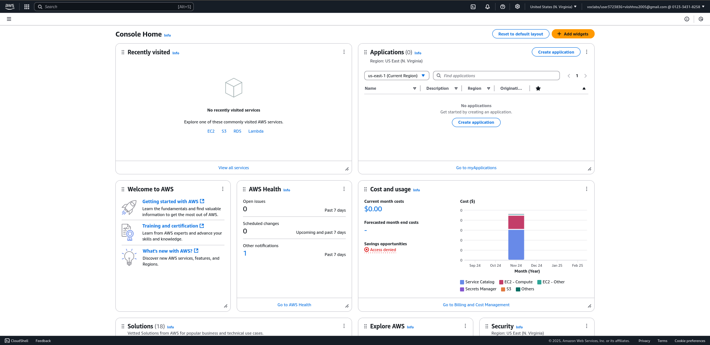

Search for EC2

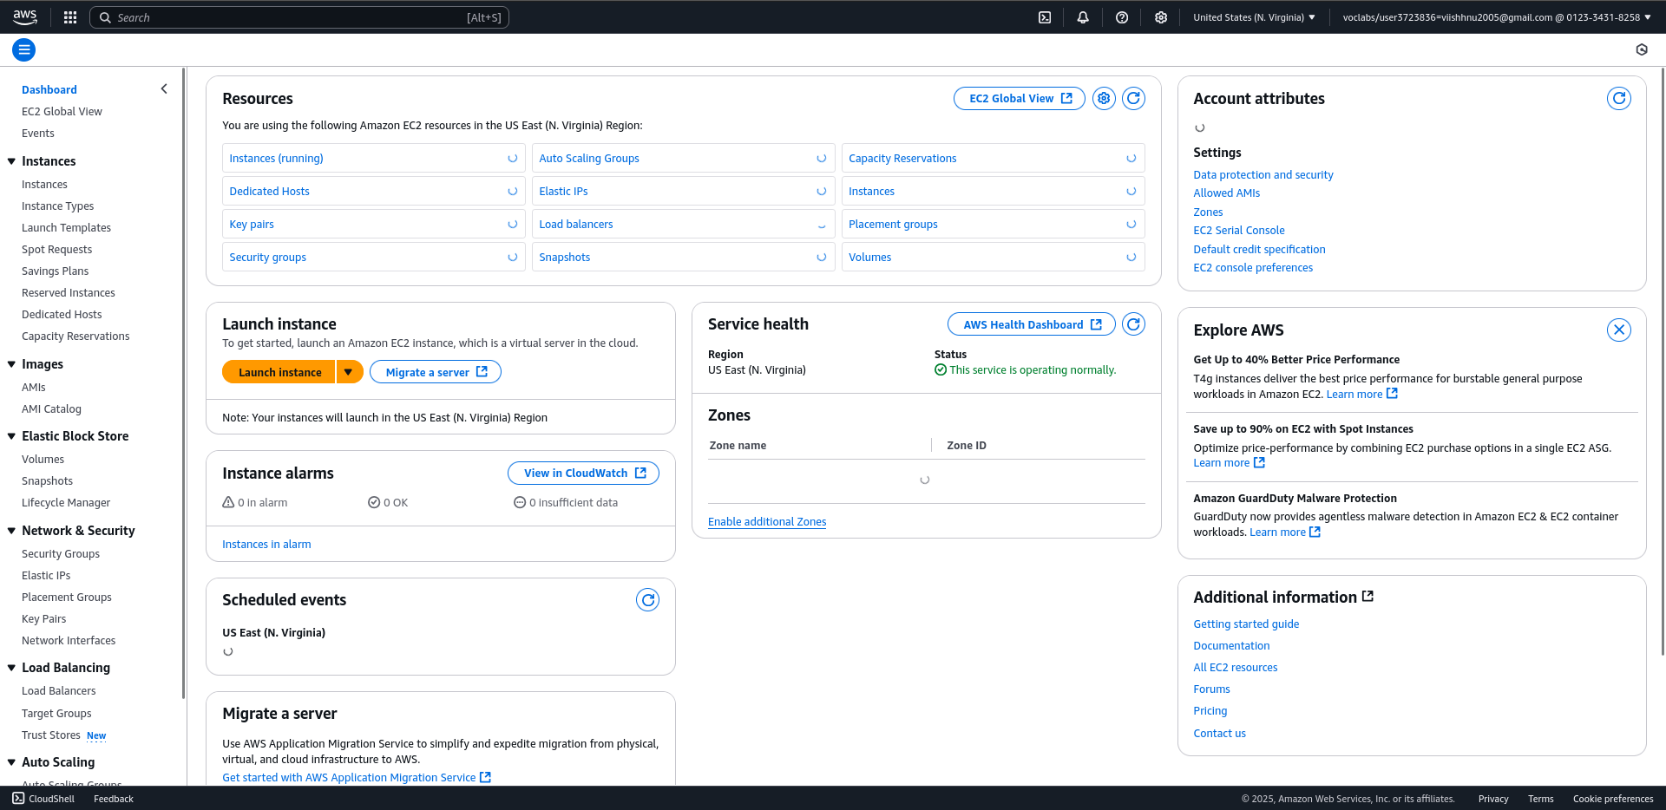

Click on Launch instance

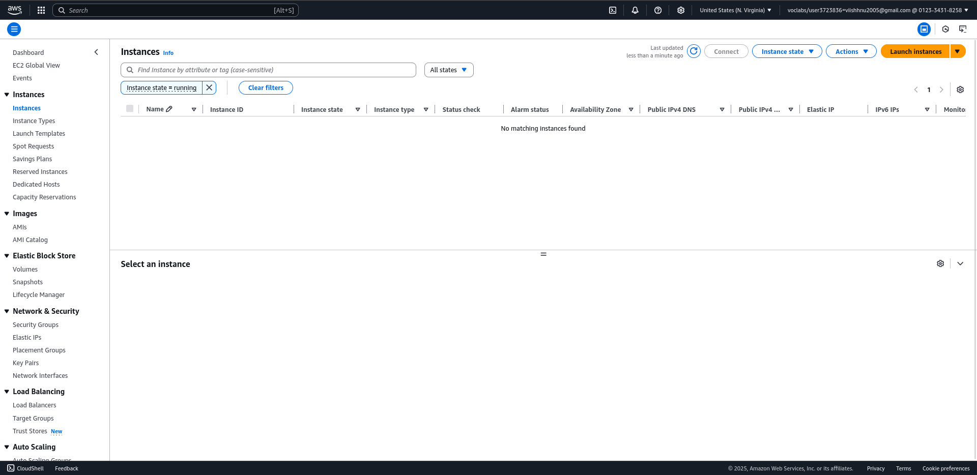

Select configurations

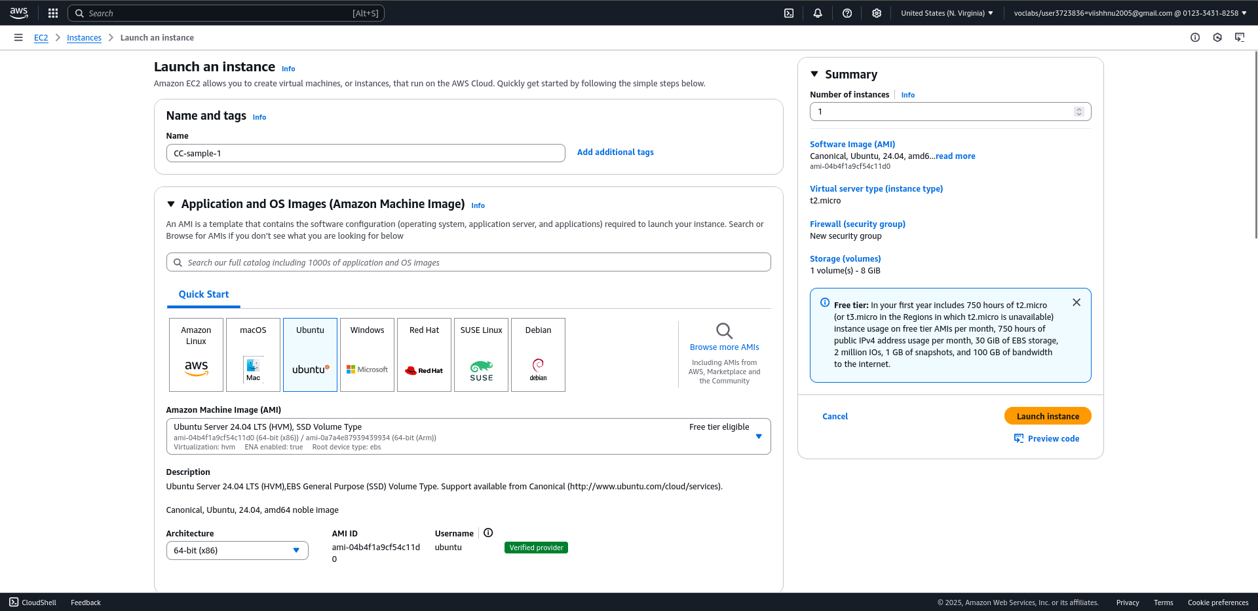

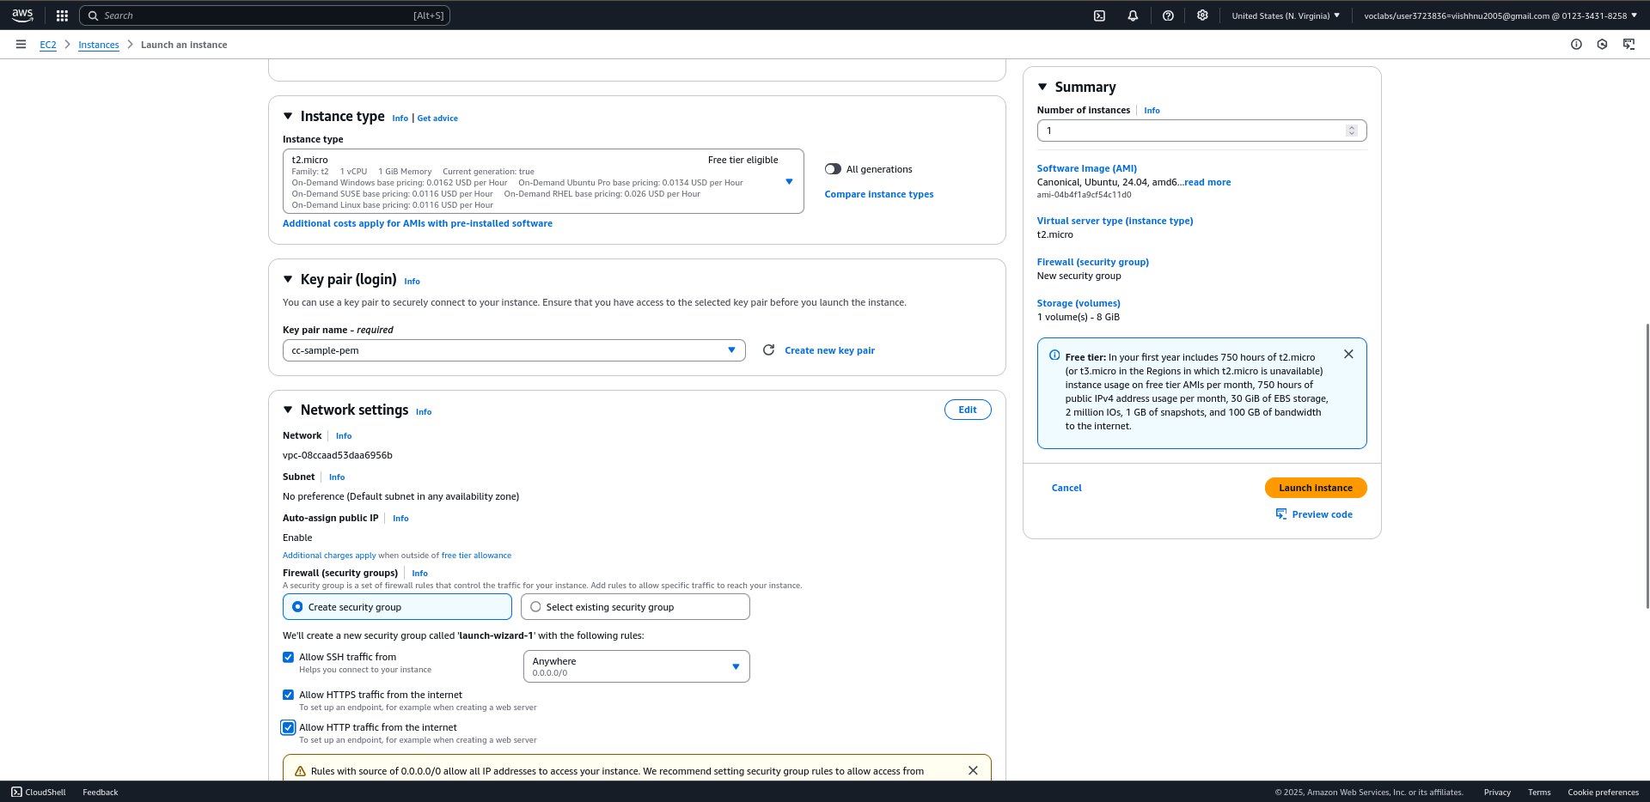

Lauanch the instance

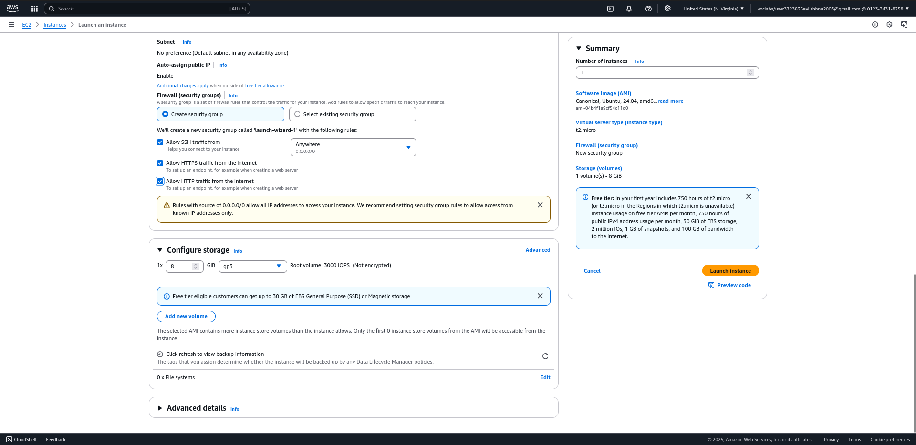

Click on connect

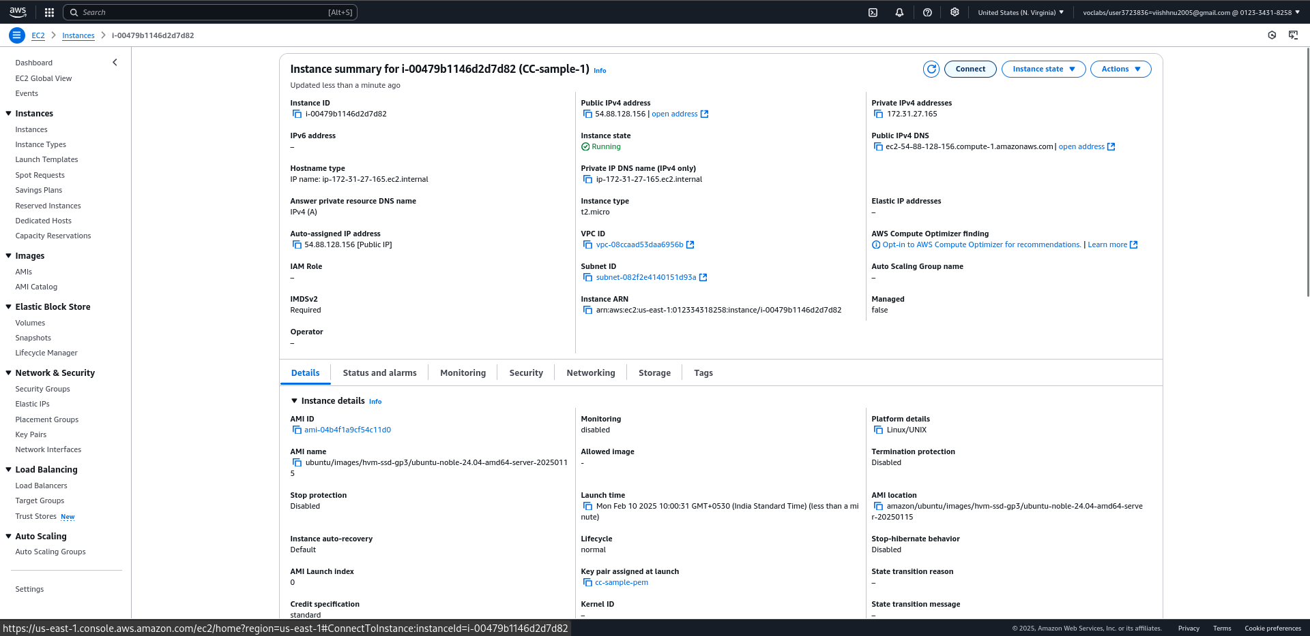

Allow permissions for .pem

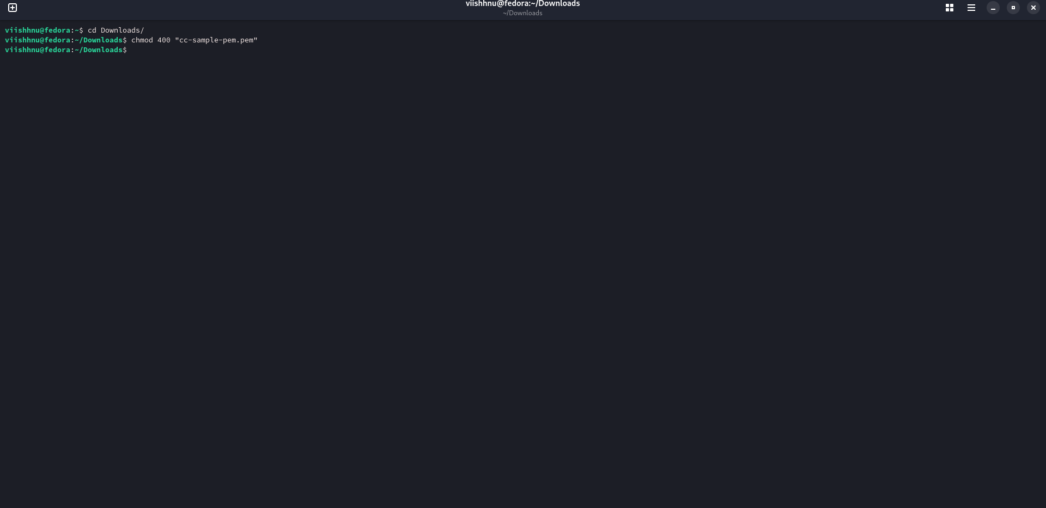

Connect via terminal to SSH client

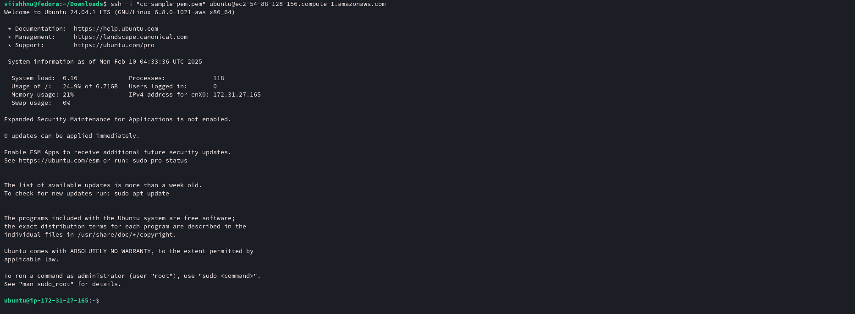

Install nginx via sudo apt install nginx

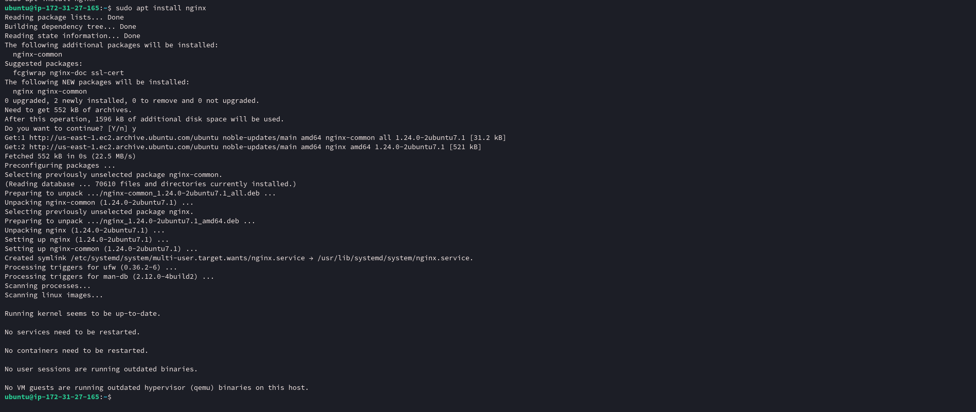

check nginx version



Start nginx service

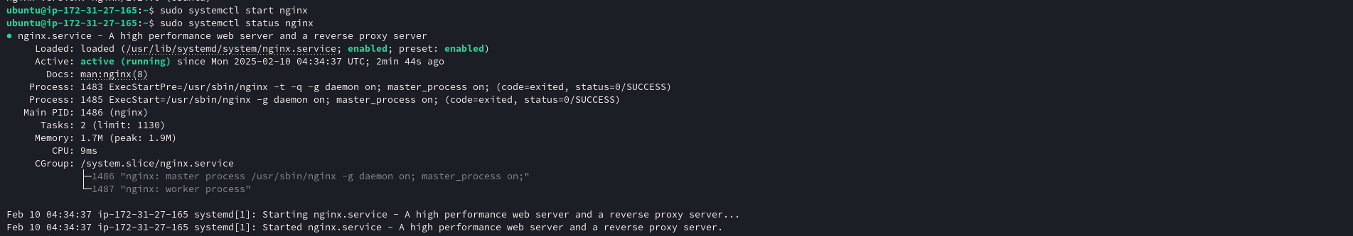

Go the path where nginx is installed /var/www/html



Now navigate to the public IP address(54.88.128.156) to view the html page

