**Demonstrate the execution of a simple Python program using AWS Lambda functions.**

**1) Create a new S3 bucket with ACL’s enabled and uncheck block public access**

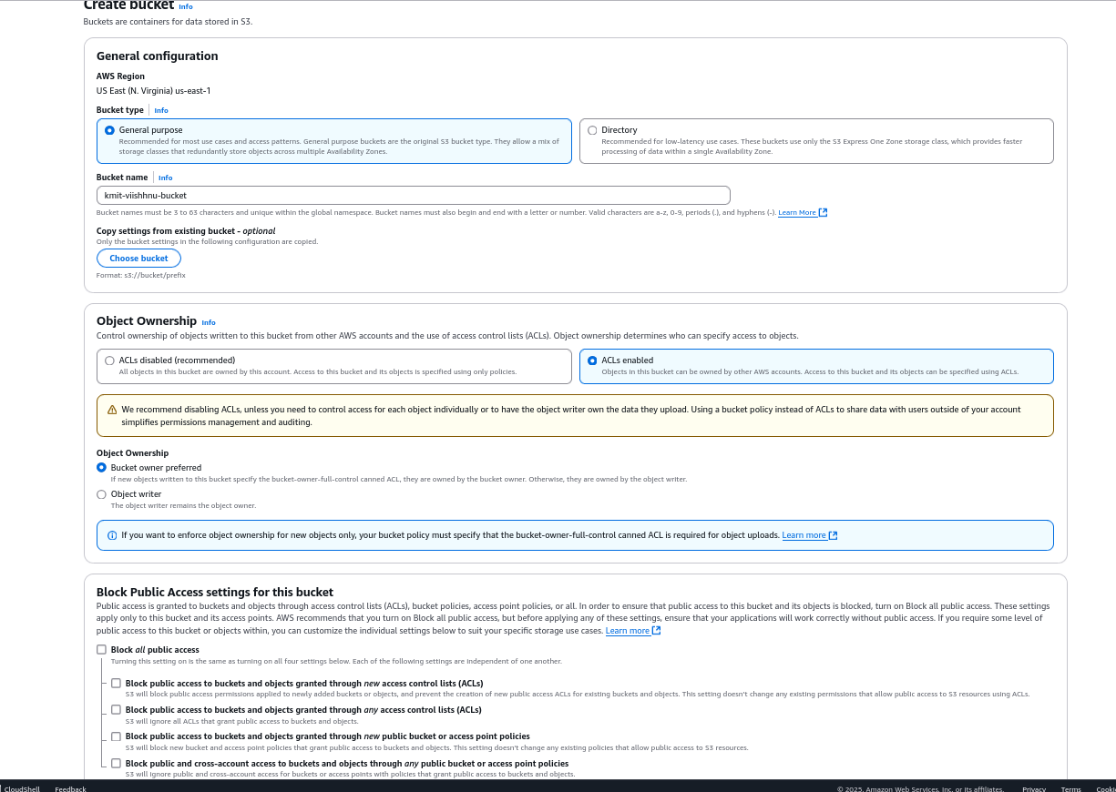

**2) Create a table in DynamoDB with “emp_id” as the partition key.**

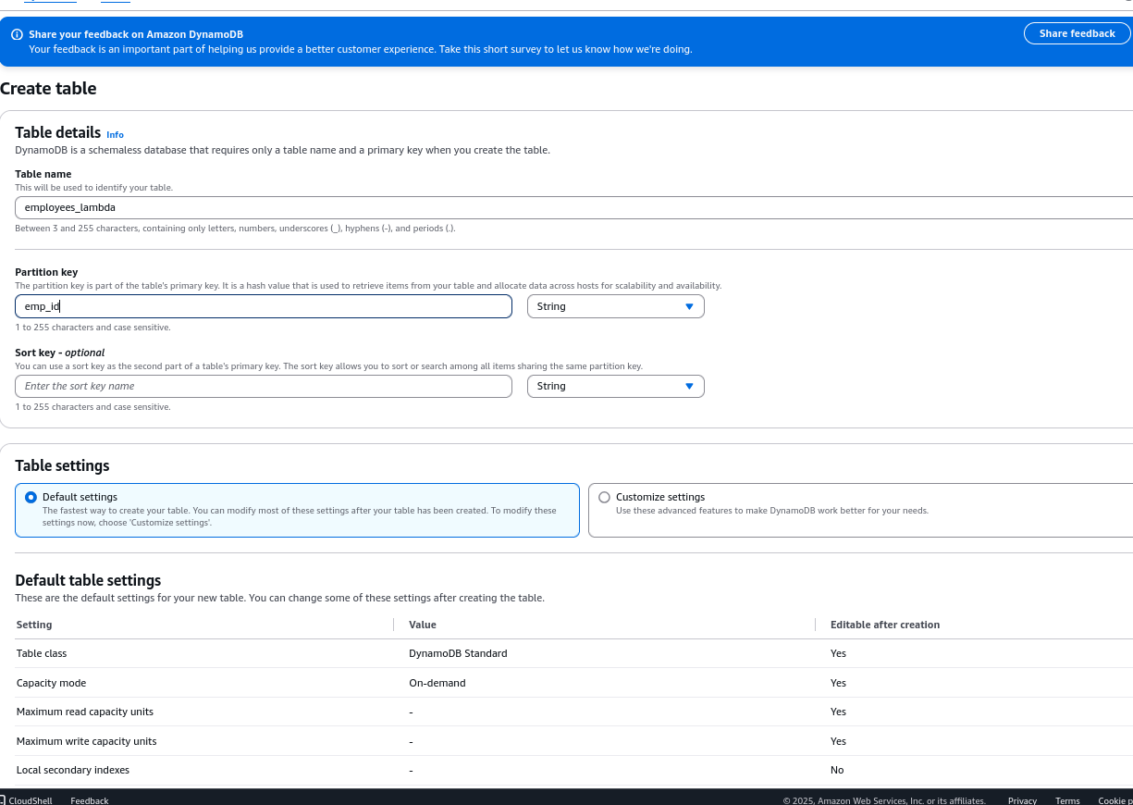

**3) Create a function under Lambda by selecting Python as the runtime and LabRole as execution role.**

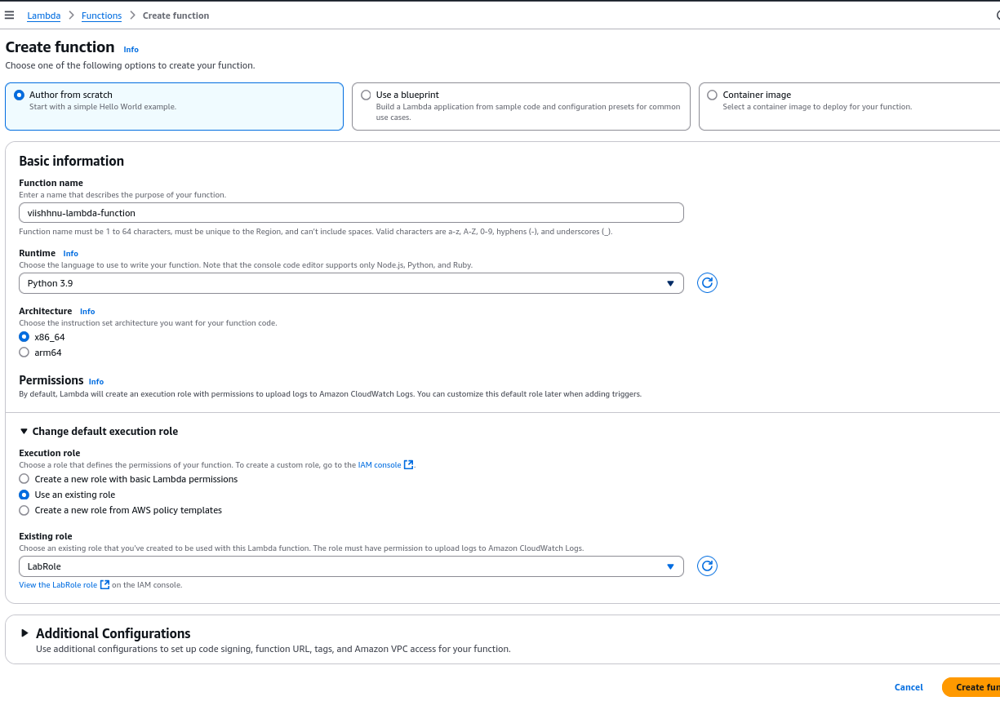

**4) Add a trigger under Lambda by giving the previoulsy created S3 bucket path**

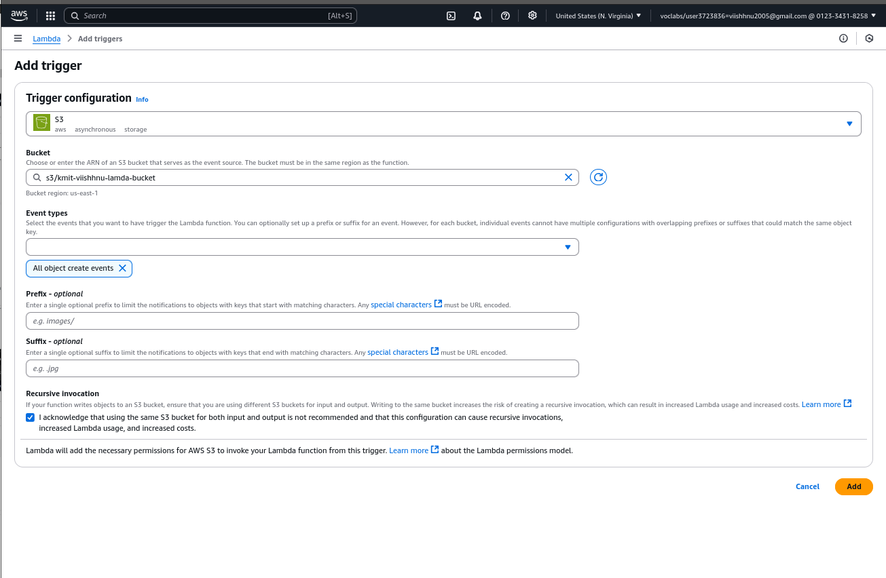

**5) Add python code snippet**

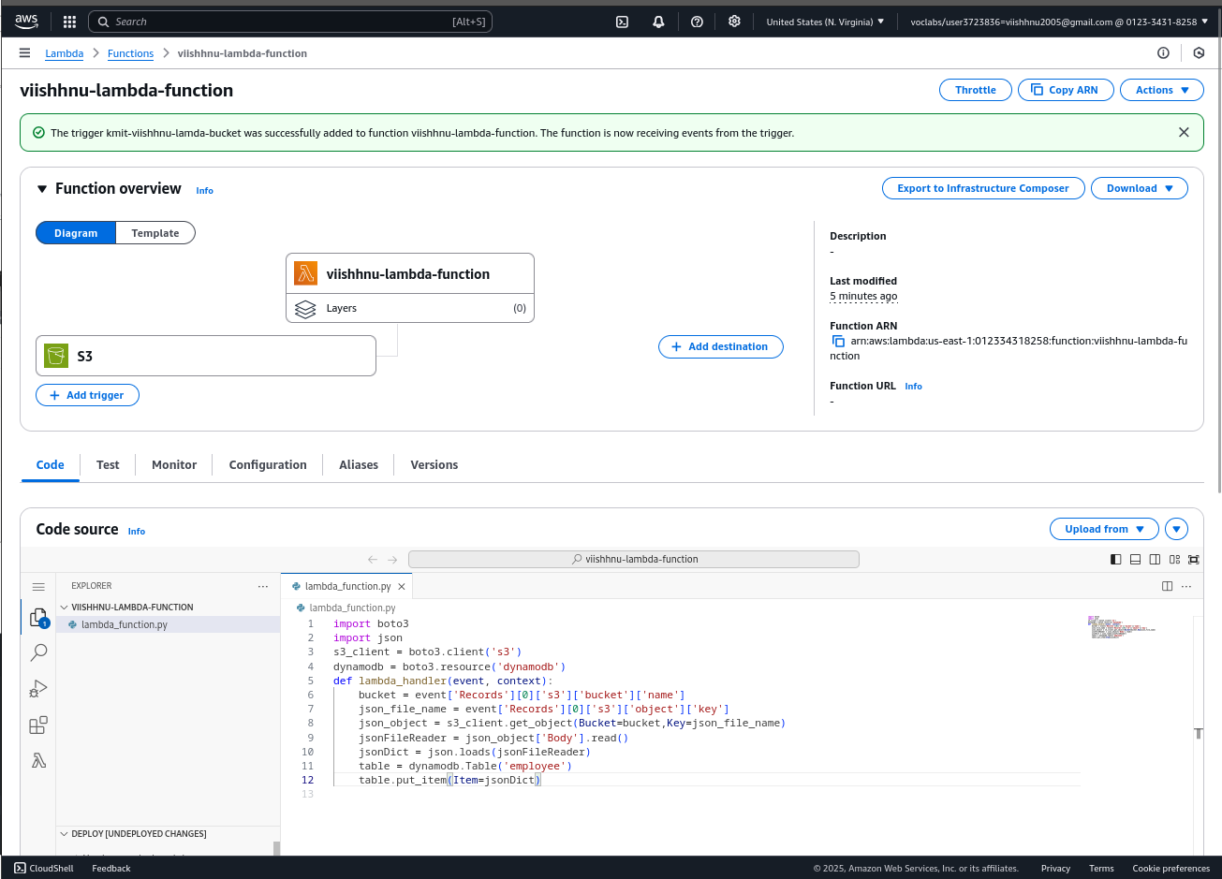

**6) Create a json file with a an employee details**

**­**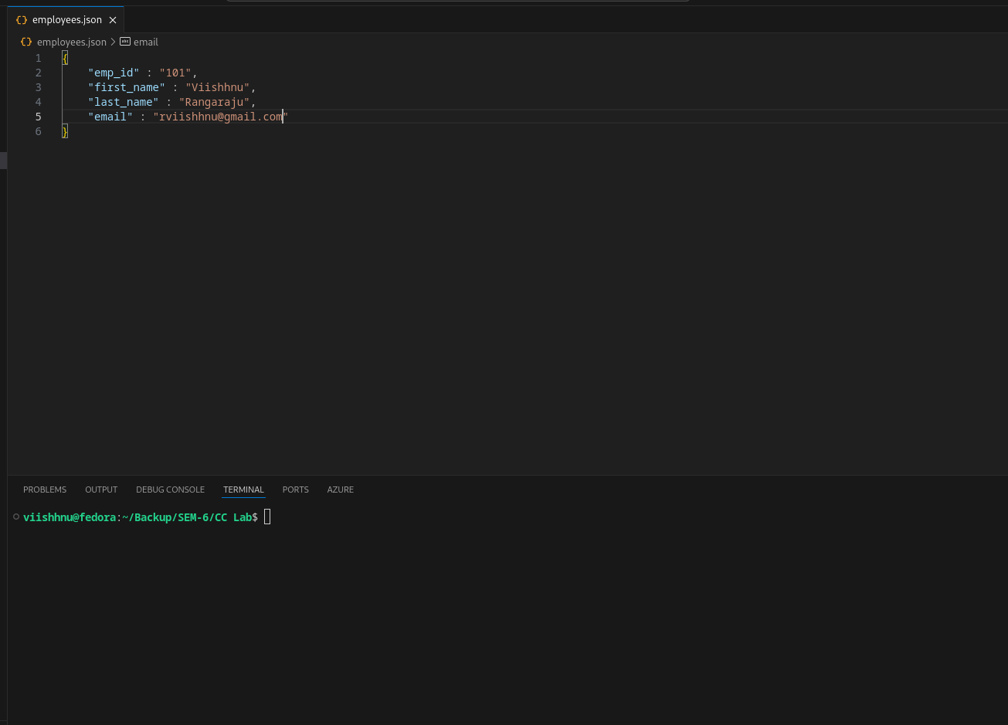

**7) Upload the json file in the S3 bucket**

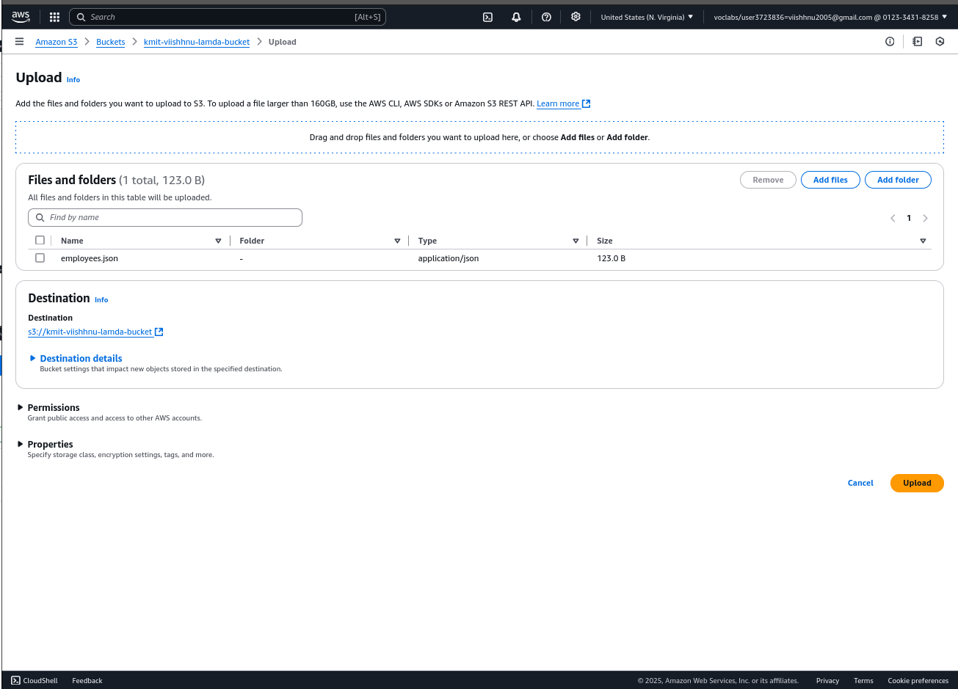

**8) The employee details are reflected in the table under DynamoDB**

