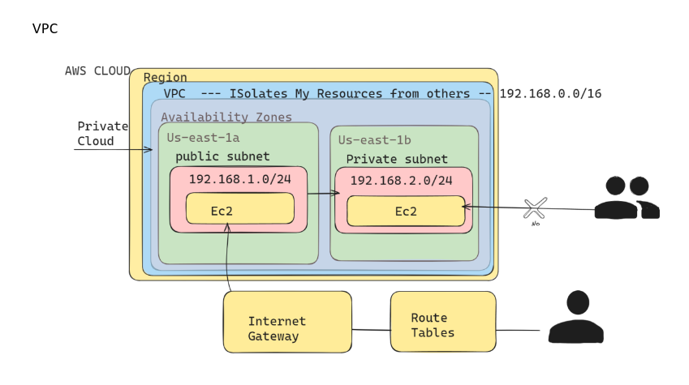

Create a VPC with IPv4 CIDR as 192.168.0.0/16

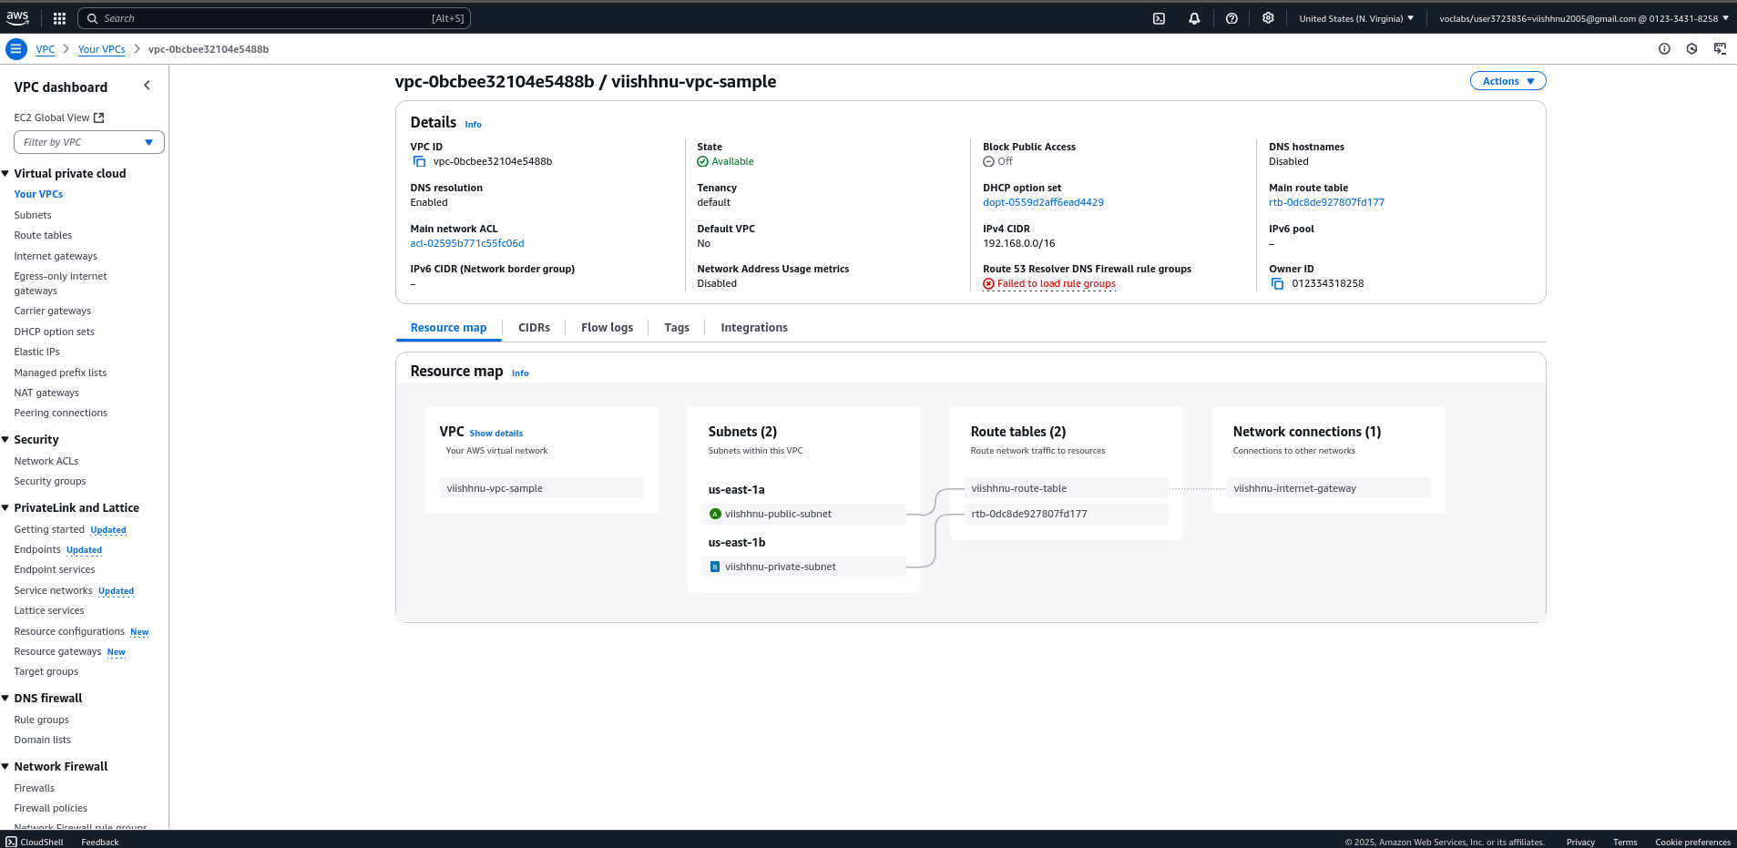

Create public and private subnets in the same region in two availability zones (us-east-1a

and us-east-1b)

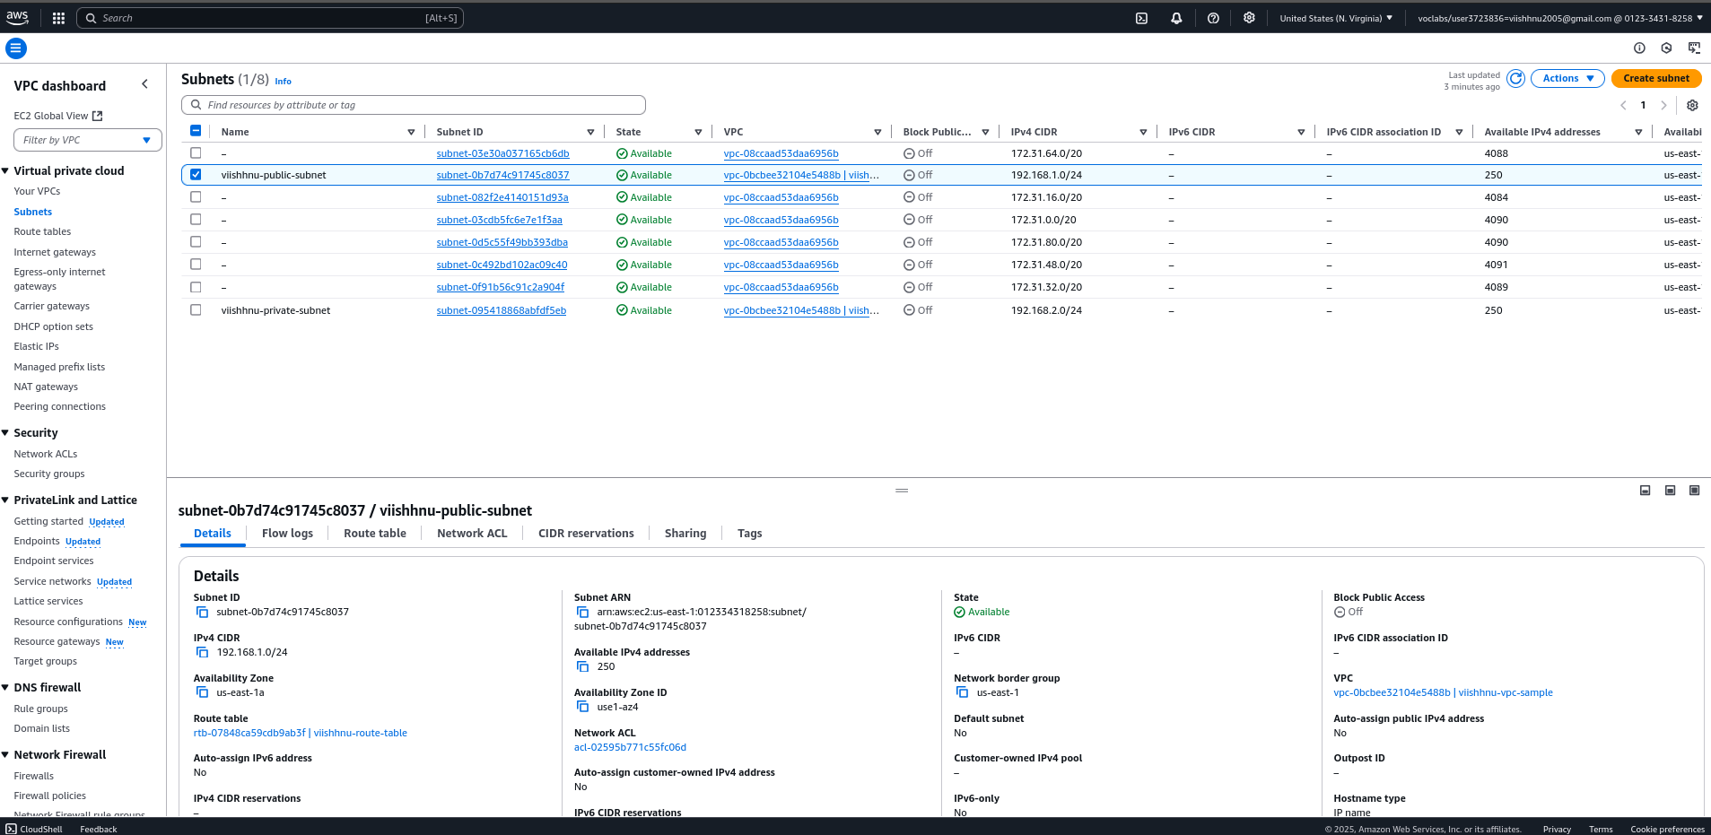

Create an Internet Gateway and attach it to the created VPC

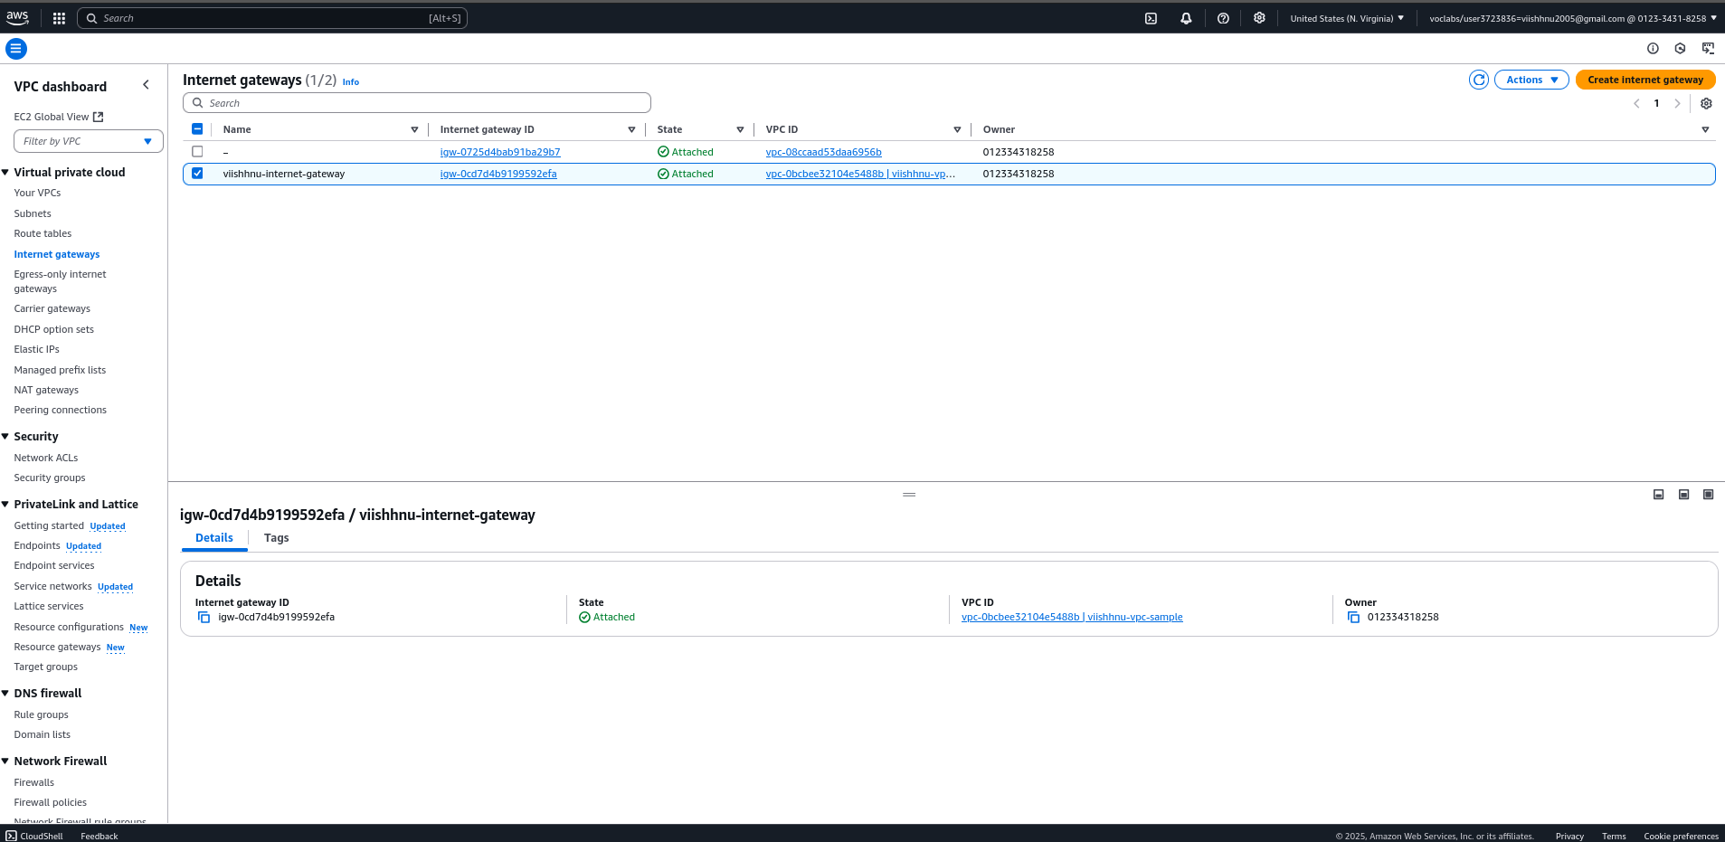

Create a Route Table and add a route for the VPC with CIDR 192.168.0.0/16

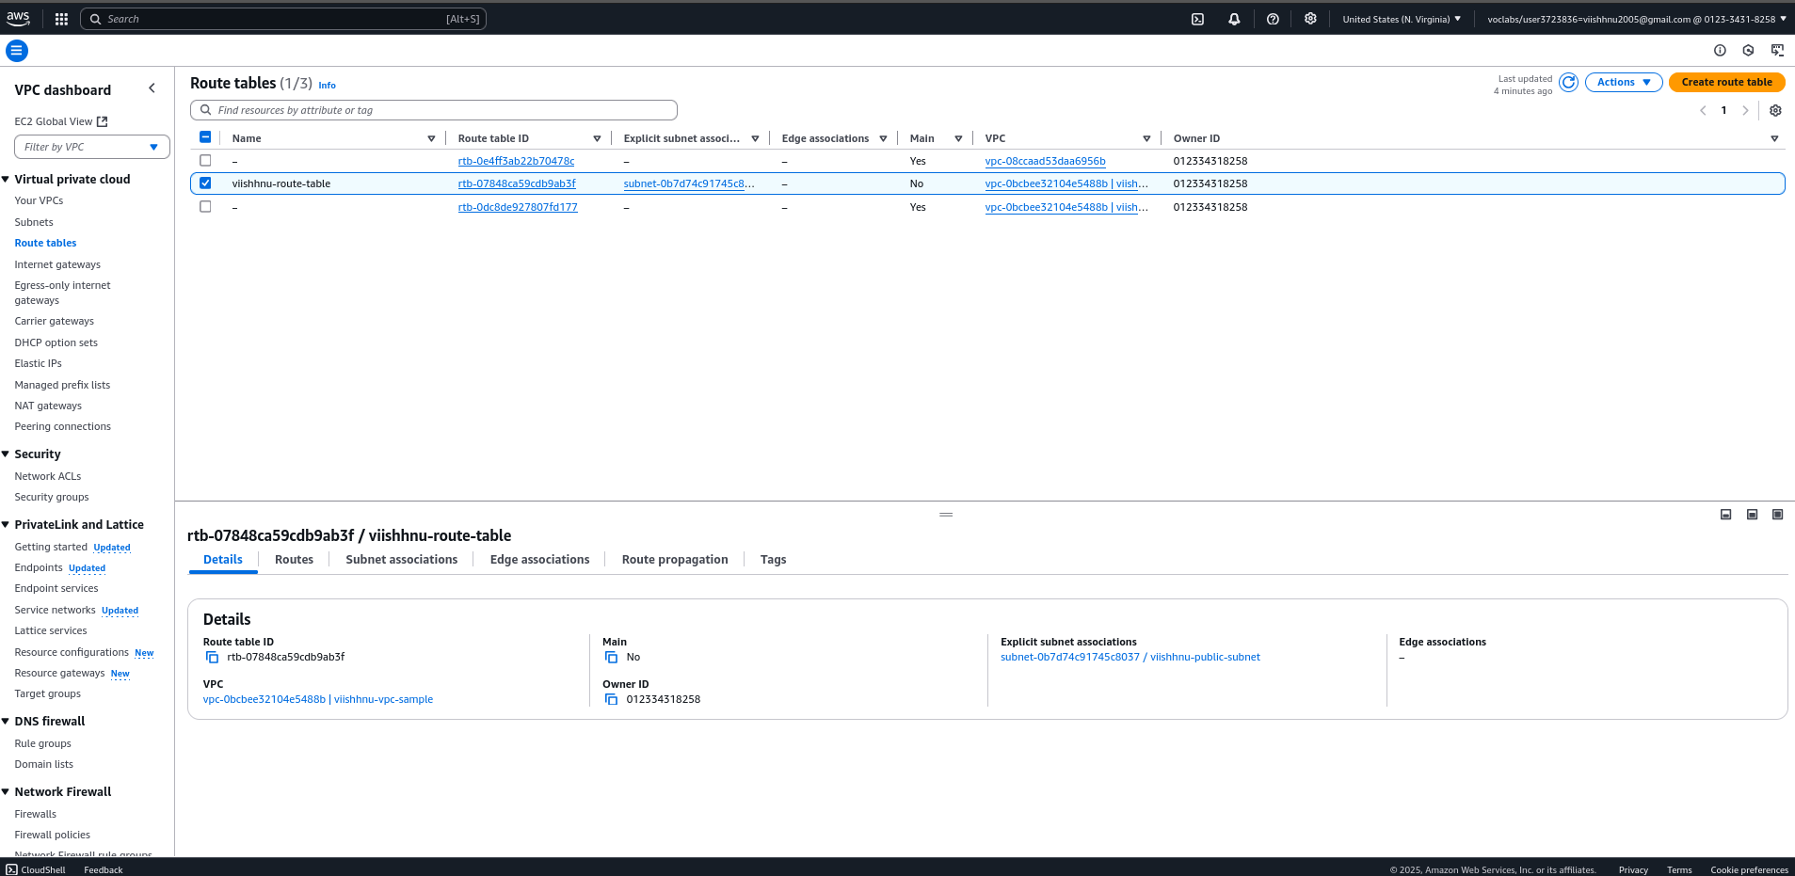

Create two instances with Windows AMI and two instances with Linux/Ubuntu AMI, each

configured with a public and private subnet

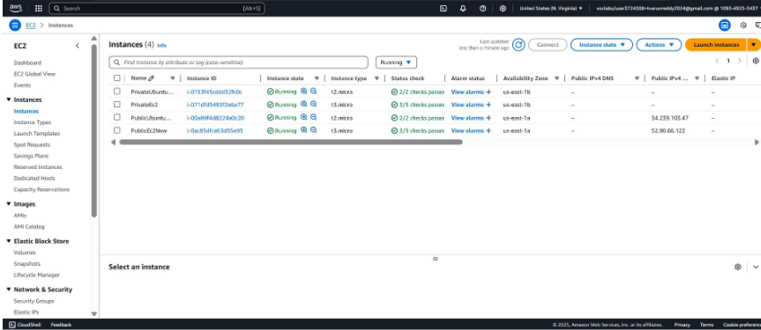

Connect to the public Windows Ec2 instance using RDP client and enter the private IP of the

private EC2 instance

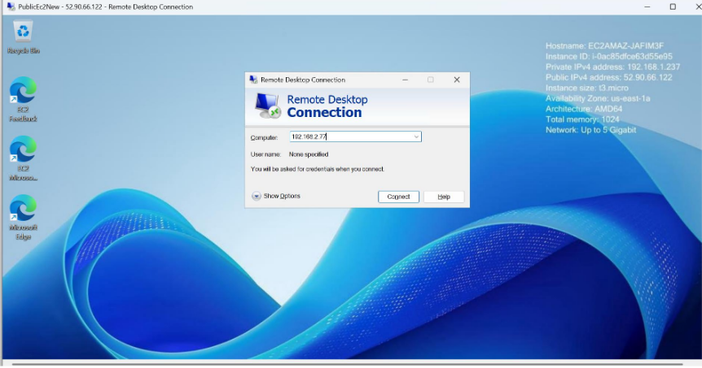

Upon successful connection, a new window opens displaying the desktop connection of the

private instance

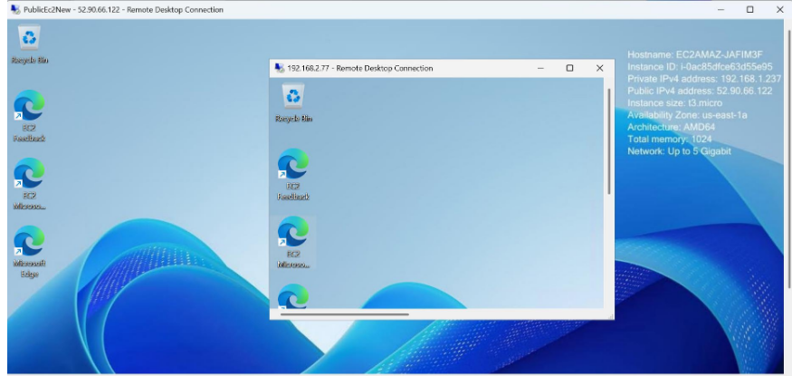

The same process is followed to connect two Ubuntu instances using SSH client. The .pem

file is copied into the public instance using scp command and later access the private

instance using the .pem file

