This time select OS as Windows and click on Launch instance

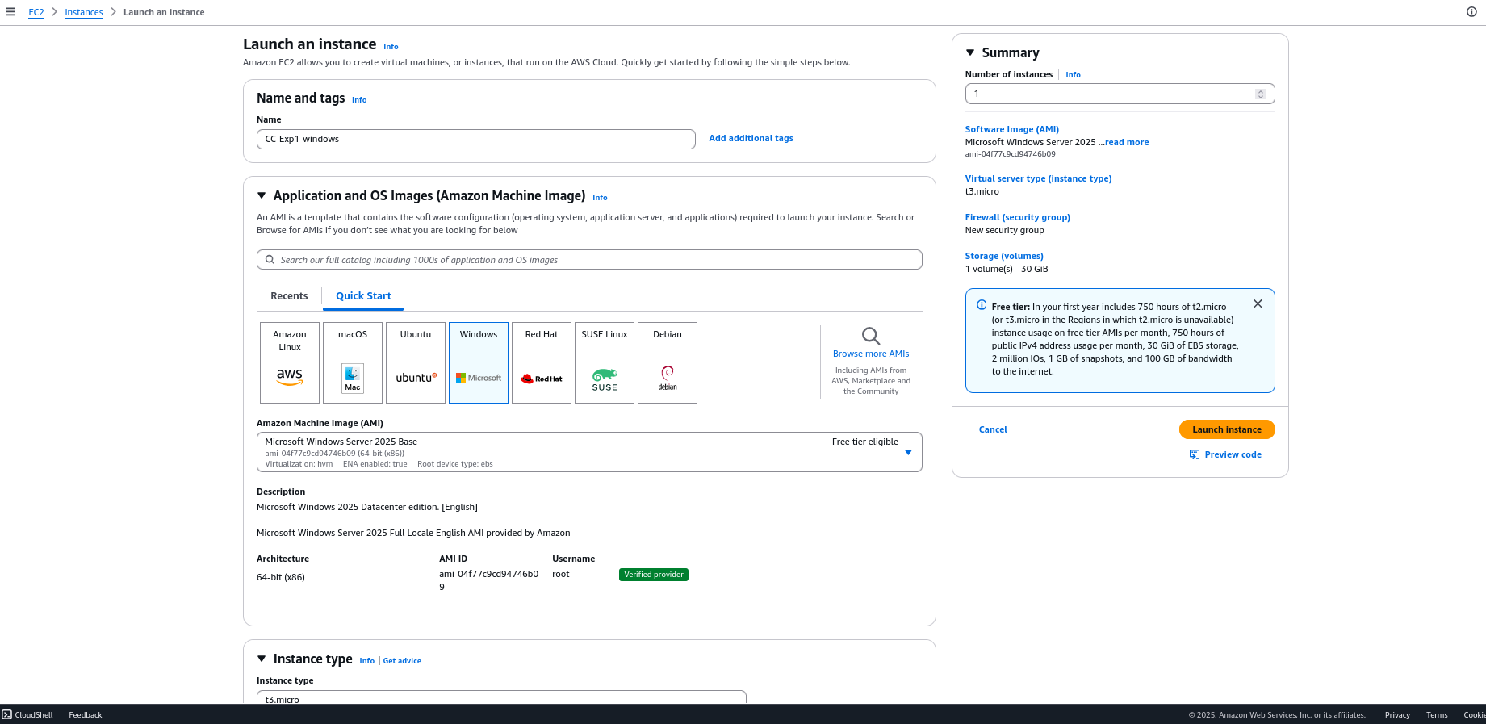

Click on Download remote desktop file

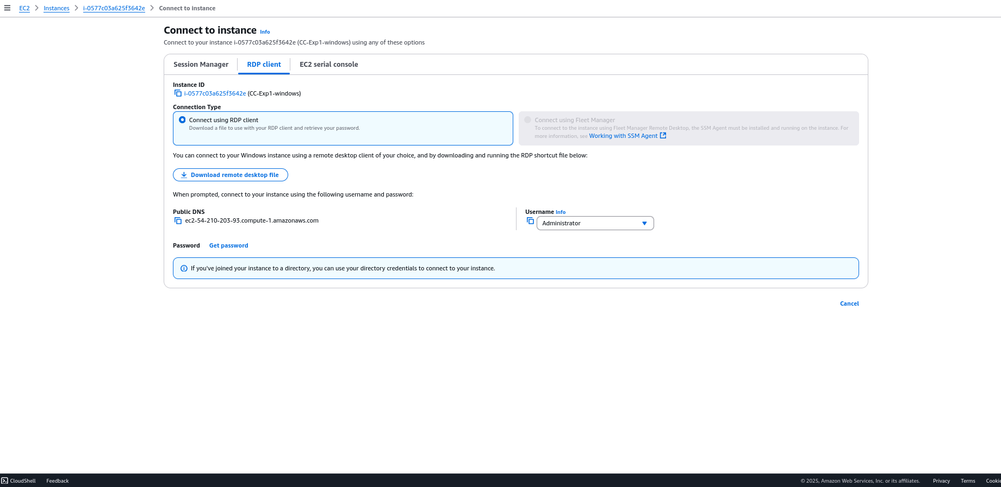

Upload the private key

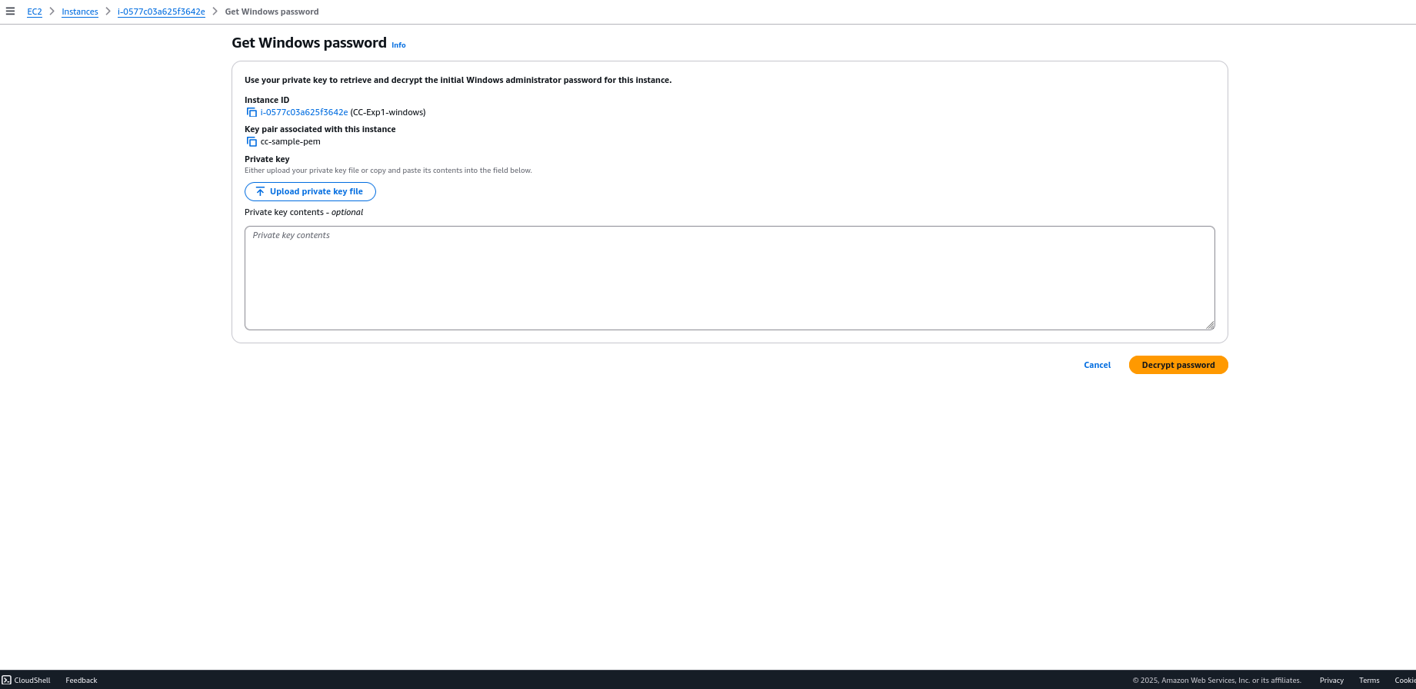

Once uploaded the private key and clicked on decrypt password you will get a password

Download a suitable client to deal with RDP

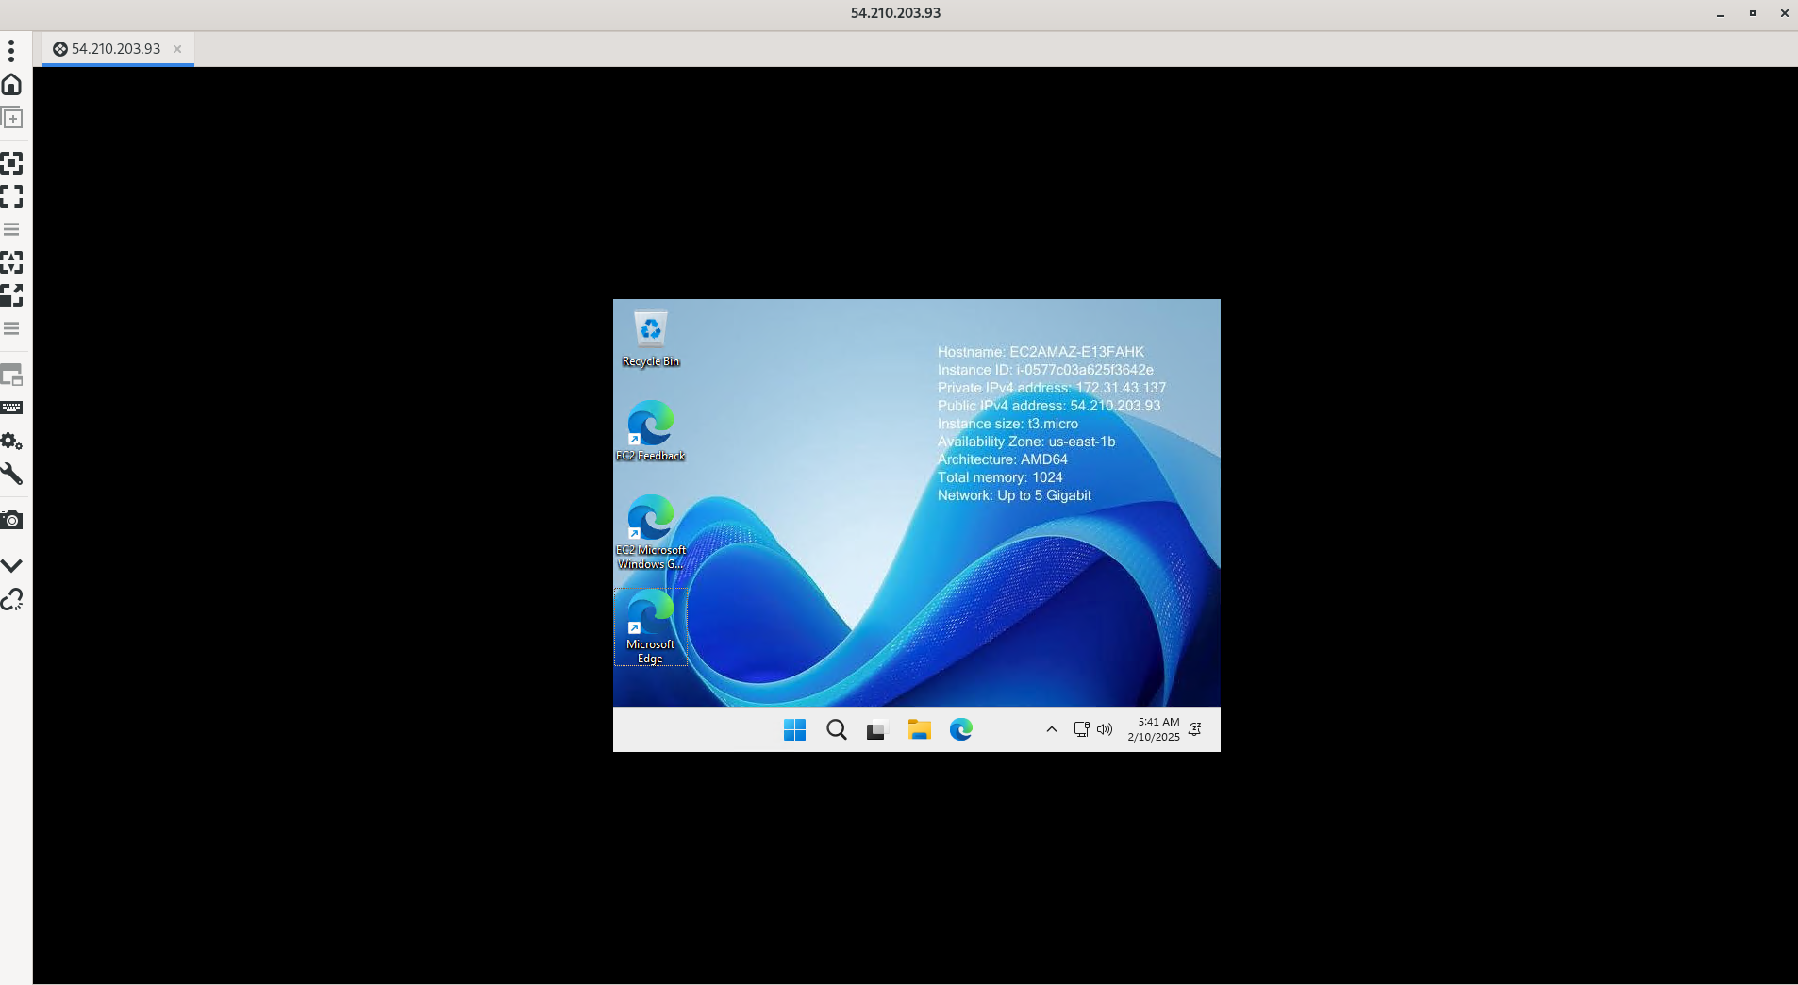

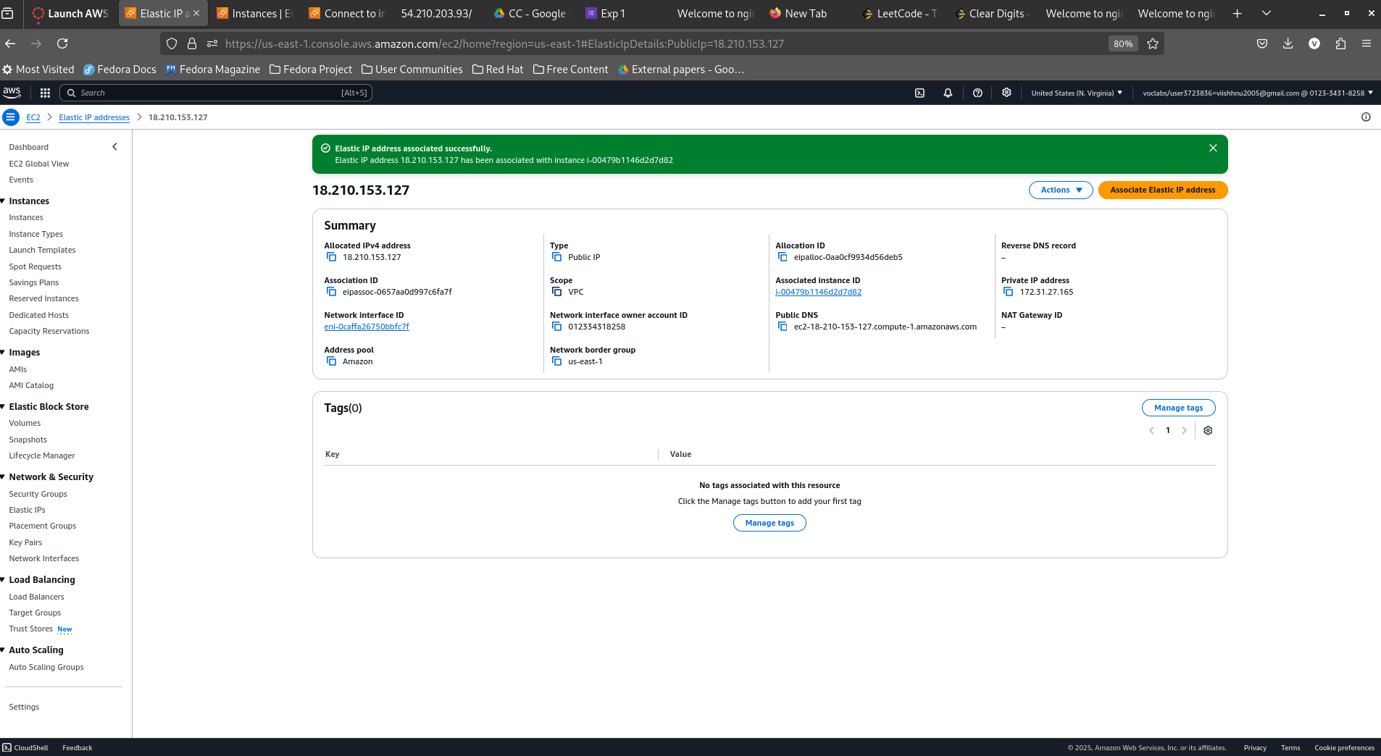

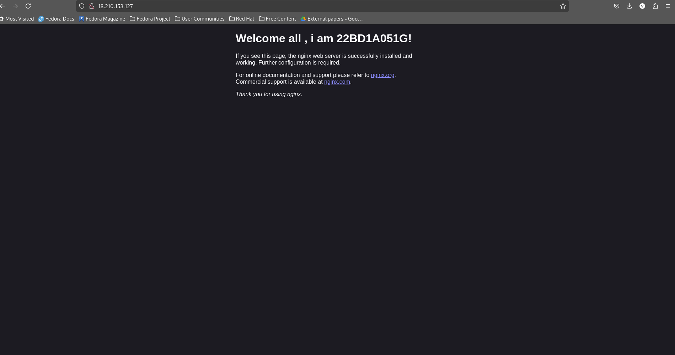

Now all my instances are stopped

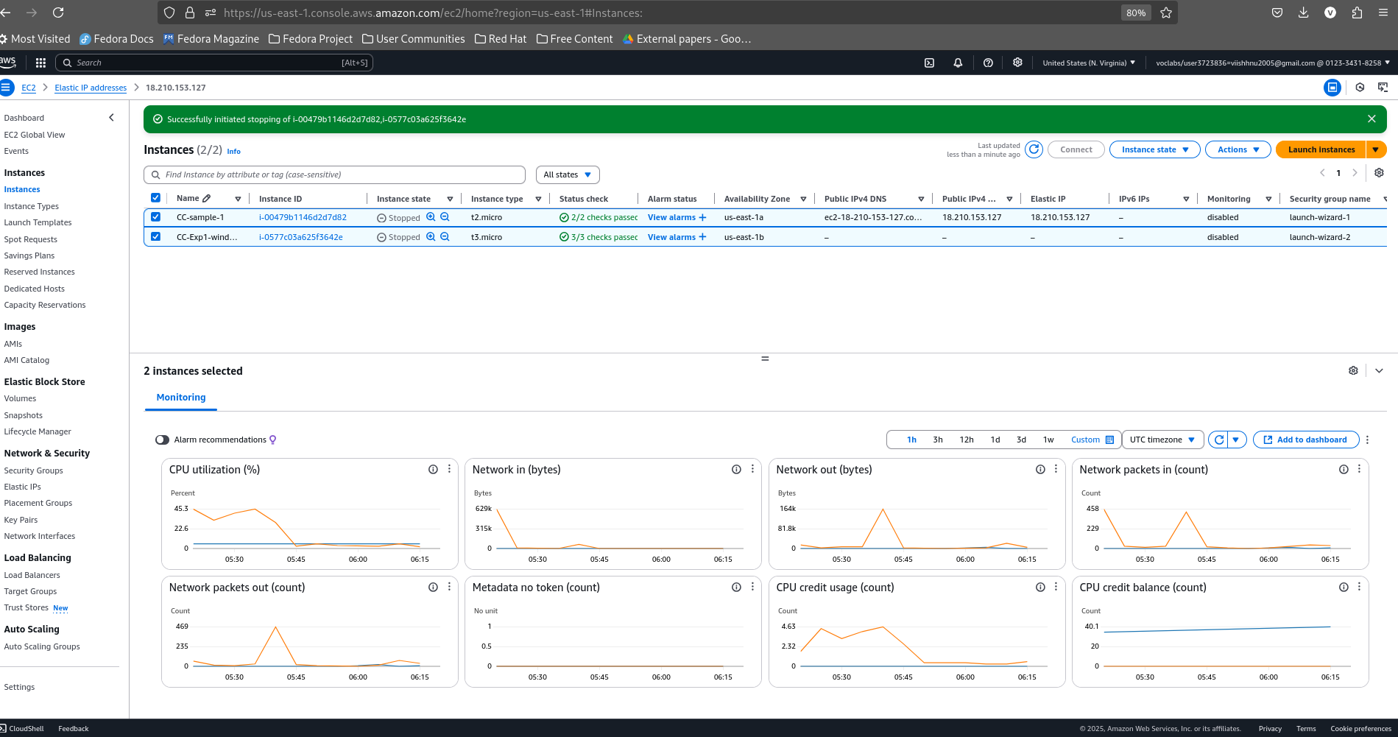

As you can see the same IP address has been allocated for CC-sample-1

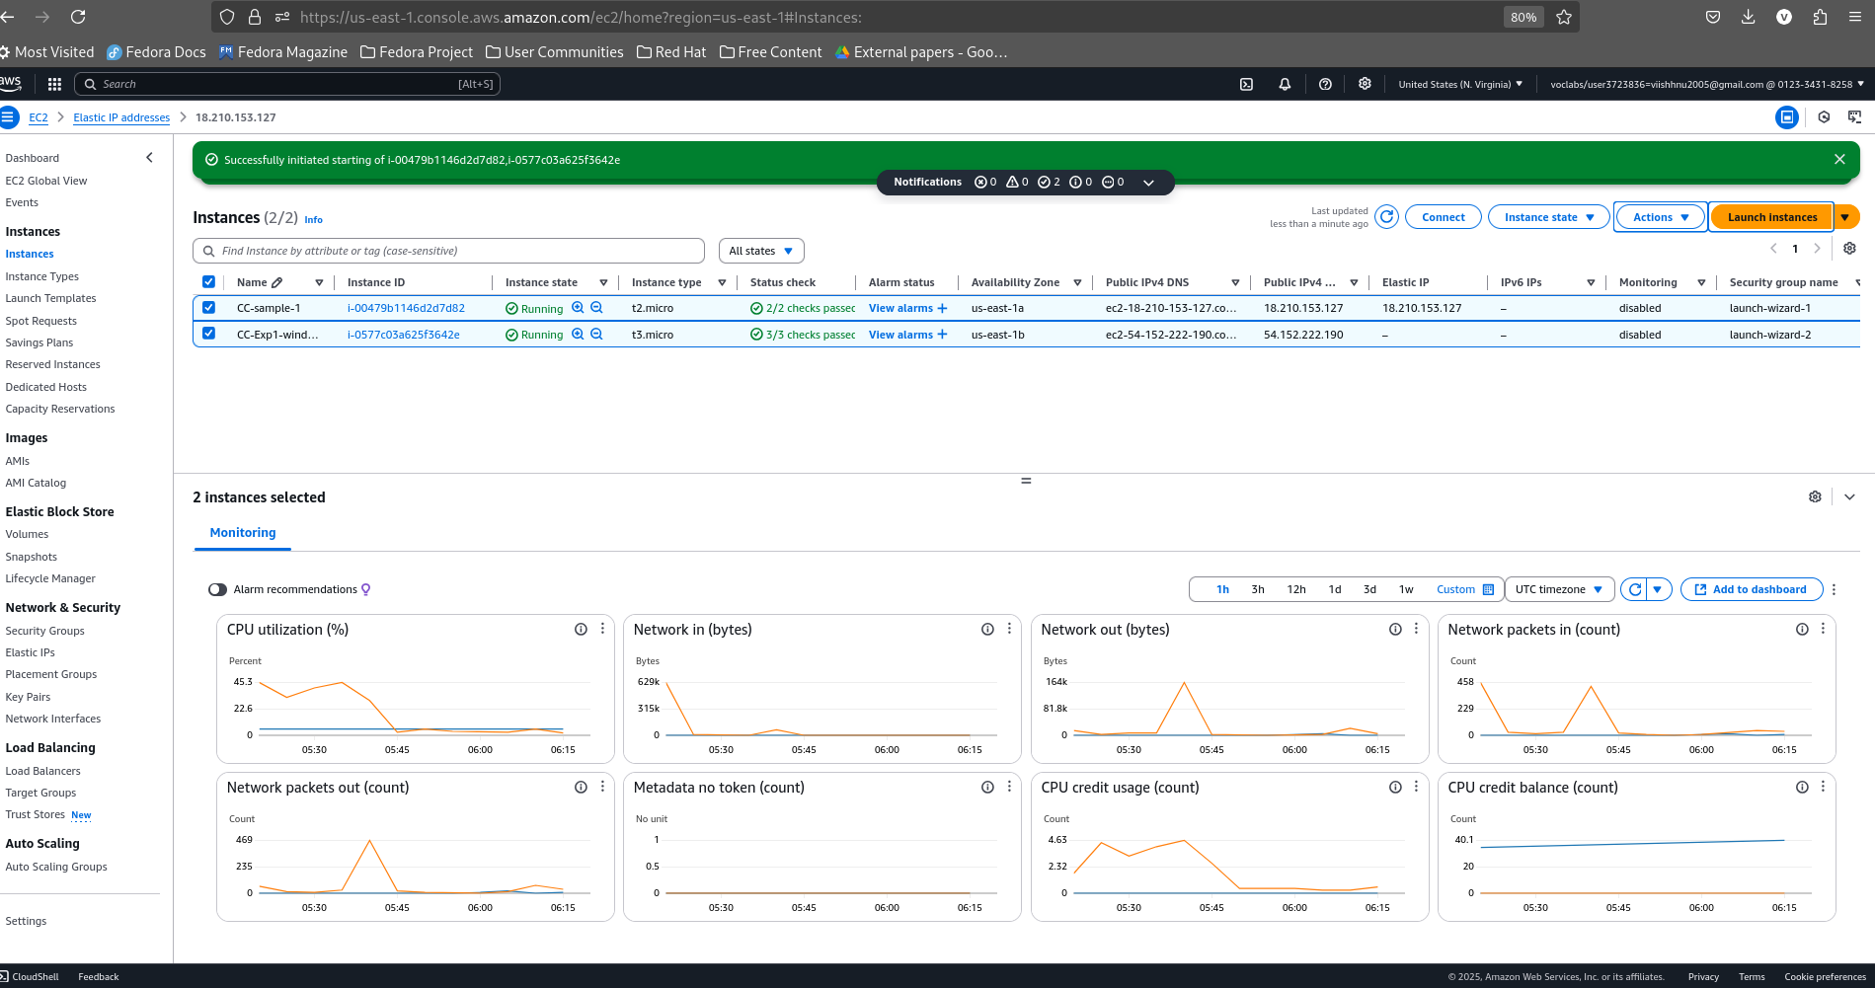

Launch a instance for putty

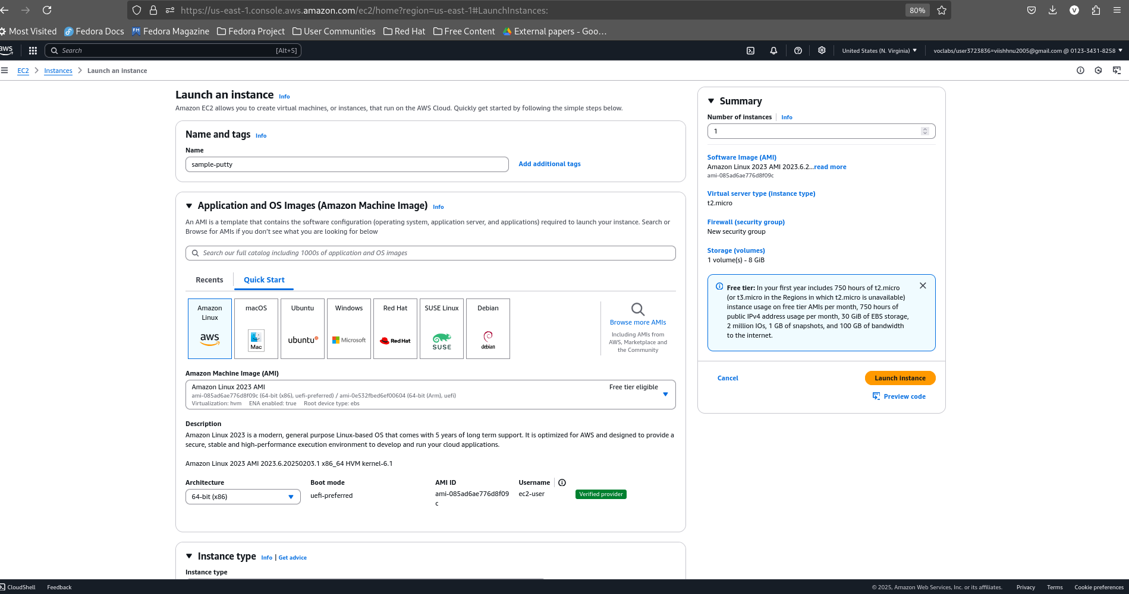

Use a new key pair putty (download a .ppk file) and launch instances

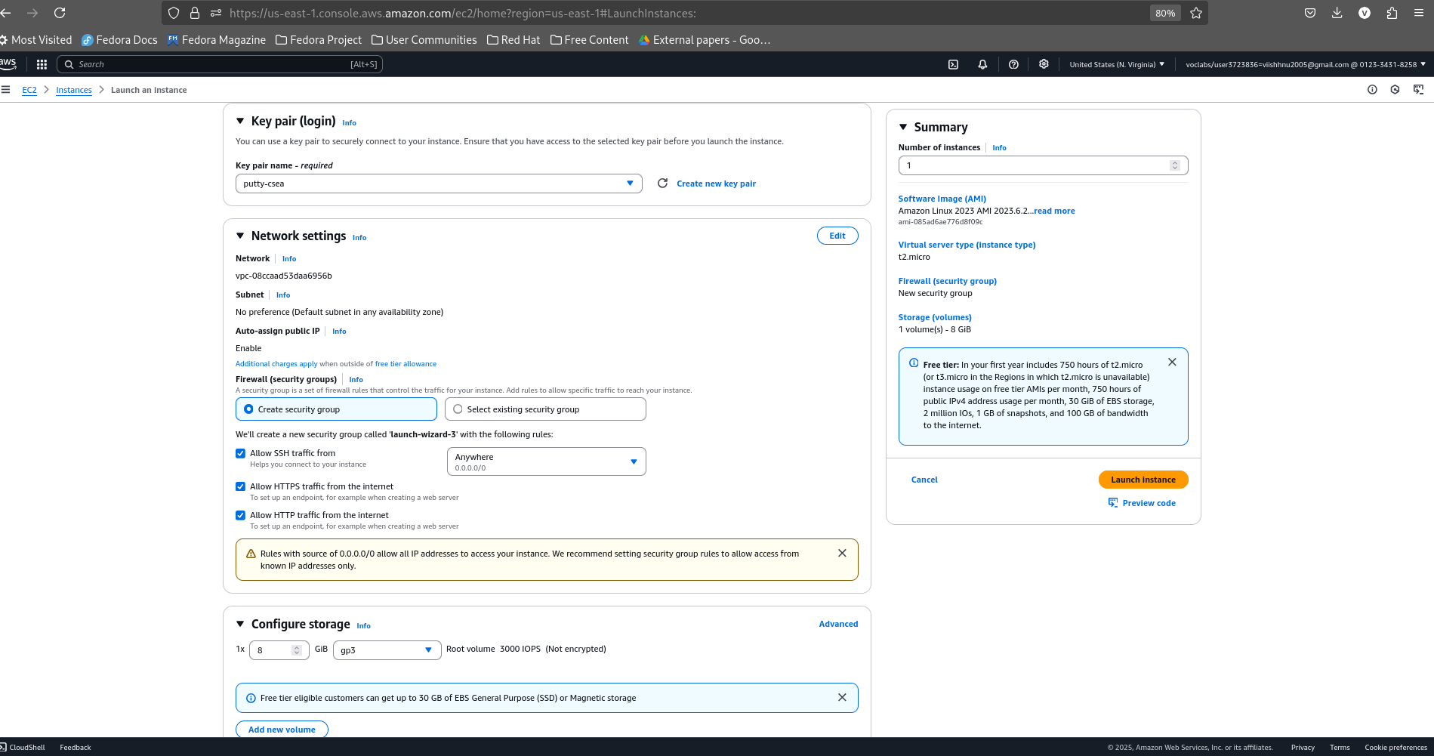



Now convert the .ppm to .ppk and connect to the instance-1

