1.Sprint Training
Pat is an ordinary kid who works hard to be a great runner. As part of training, Pat must run
sprints of different intervals on a straight trail. The trail has numbered markers that the coach
uses as goals. Pat's coach provides a list of goals to reach in order. Each time Pat starts at,
stops at, or passes a marker it is considered a visit. Determine the lowest numbered marker that is
visited the most times during Pat’s Day of training.

Example
n=5
sprints = [2, 4, 1, 3]

if the number of markers on the trail, n=5, and assigned sprints= [2, 4, 1, 3], Pat first sprints
from position 2→ 4. The next sprint is from position 4-1, and then 1-3. A marker numbered position
pits considered to be visited each time Pat either starts or ends a sprint there and each time it is
passed while sprinting. The total number of visits to each position in the example is calculated
like so

Total Visits Per Position
-------------------------------
Sprint | 1 | 2 | 3 | 4 | 5
2 -> 4 |  | -> | -> | ->
4 -> 1 | <- | <- | <- | <-
1 -> 3 | -> | -> | ->
Total Visits | 2 | 3 | 3 | 2 | 0

Pat has visited markers 2 and 3 a total of 3 times each. Since 2 <3, the lowest numbered maker that is visited the most times during Pat’s Day of training is 2.

Function Description
Complete the function getMostVisited in the editor below.

getMostVisited has the following parameter(s):
int n: an integer denoting the number of markers along the trail
int sprints[m]: an array of integers denoting the sequence of markers to reach beginning at the marker shown in sprints(0)

Returns
int: an integer denoting Pat's most visited position on the trail after performing all m-1 sprints .if
there are multiple such answers, return the smallest one.

Constraints
1≤n≤105
2≤m≤105
1 ≤sprints[i] ≤m (where 0≤i≤m)
sprints[i-1] != sprints[i] (where 0<i<m)

Sample Case 1
Sample Input 1
STDIN Function Parameters
10 -> n = 10
4 -> sprints[] size m = 4
1 -> sprints = [1, 5, 10, 3]
5
10
3

Sample Output 1
5

2.Two Operations
==============
Two integer operations are defined as
ADD_1: Increment the integer by 1
MULTIPLY_2. Multiply the integer by 2

Given an integer value k, determine the minimum number of operations it takes to get from 0 to k using the two operations specified above.

Example
KValues[i] = 8

Starting from 0, add 1, then multiply by 2 three times. takes a minimum of 4 operations to get to 8, so store 4 in index 0 of the return array.
Function Description
Complete the function getMinOperations in the editor

getMinOperations has the following parameter(s):
kValues[n]: the given k values
Returns:
Int[n] answers to a list of queries in the given order
Constraints
1<=n<=10^4
0<=kValues ≤ 10^16
▼ Sample Case 1
Sample Input
STDIN Function
2 → kValues[] size n = 2
5 → kValues =[5, 3]
3

Sample Output
4
3

3.Minimize Path Value

There is a weighted undirected graph with N nodes and M edges.The stress with N nodes and M edges . The stress level of a path between two nodes is defined as the weight of the edge with the maximum value present in the path.
Given a source node “source” and a destination node “destination,”.Find a path with the minimum stress level .if no such path exists, report -1.

Example
Consider the following example below where source = 1 and destination = 3
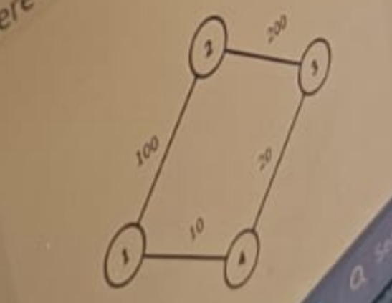

There are two paths ,from node 1 to node 3.
1.The max weighted edge/stress level in path 1-> 2-> 3 is 200.
2.The max weighted edge/stress level in path 1-> 4-> 3 is 20.

Return 20,the lower stress level from the second path.

Function Description
Complete the function leastStressfulPath in the editor below.
leastStressfulPath has the following parameter(s):
int graph_nodes:number of nodes
int graph_from :one end node for an edge
int graph_to[m]:one end node for an edge
int graph_weight[m]:the weights of the edges
int source:the source node
int destination: the destination node

Returns
Int: the value of the least stressful path. If no path exists, return -1.
Note: Even though edge endpoints are called graph_from and graph_to[j],this is an undirected graph.

4.Highly Profitable Months

The stocks of a company are being surveyed to analyze the net profit of the company over a period.
For an analysis parameter k,an interval of k consecutive months is said to be highly profitable if the values of the stock prices are strictly increasing for the months.Given the stock prices of the company for n months and the analysis parameter k, Find the number of highly profitable intervals.

Example
stockPrices =[ 5,3,5,7,8]
k=3

the Answer is 2.

Note: if the interval length is 1 , each subarray of length 1 is highly profitable.

Function Description
Complete the function countHighlyProfitableIntervals in the editor below.
countHighlyProfitableIntervals has the following parameters:
int stockPrices[n]: the stock prices for n months
int k: the analysis parameter

Returns
Int : the number of highly profitable intervals

Constraints
1<=k<=n<=2*10^5
1<=stockPrices[i]<=10^9

Sample Case
Sample input
STDIN Function
6 stockPrices[] size,n=6
1 stockPrices=[1, 2, 3, 3, 4, 5]
2
3
3
4
5
3 k= 3

Sample Output
2

5.Largest Subset Sum
For each number in an array, get the sum of its factors. Return an array of results.
Example.
arr = [12]
The factors of arr[0] =12 are [1,2,3,4,6,12].The sum of these factors is 28.
Return the array [28].
Function Description
Complete the function maxSubsetSum in the editor below.
maxSubsetSum has the following parameter(s):
int arr(n): an array of integers
Returns
Long[n]: the sums calculated for each arr[i]
Constraints
1<=n<=10^3
1<=arr[i]<=10^9
Sample Case
Sample input 1
STDIN FUNCTION
-------- --------------
2 arr[] size n =2
2 arr = [2,4]
4

Sample output 1
3
7

5.Cleaning-up Tasks
Which standard library function can be used to call clean-up tasks that should be executed before terminating the program?
- at_abort function
- atexit function
- atterminate function
- at_return function

6.What is the output of the following program?

int foo( int x )
{
If (x <=0 )
return 0;
else
return foo(x-2)+x;
}
Int main()
{
cout << foo (8);
Return 0;
}

A.20
B.18
C.21
D.0

7.Logic Puzzles 8
Given:

A+B means A is the sister of B
A*B means A is the son of B
A%B means B is the daughter of A

Now, Consider the following relation: M+N%O+R.
How is M related to R?

A.maternal aunt
B.paternal aunt
C.daughter
D.either A or B

