Operating System

1: You have joined K company and are working as a support engineer. Suppose an unknown user hacks your FTP server, and you need to restore all servers. How would you restore the Linux system?

A. You need to reinstall the entire operating system from a tape device backup.
B. You need to reinstall the core operating system and then restore files and user data from the tape backup device.
C. You need to add more security to the FTP server.
D. You need to add a firewall for the FTP server.

2: You are working for X company. Your developer received an error as the file system is fully functioning on the Linux system, but space is available on the system. How will you resolve this problem?

A. Need to check partitions and add extra memory to the drive.
B. Stop all services that are using a large space of the system.
C. You need to free the space in anode storage.
D. You need to free the space drive.

3: Consider a scenario where we are in need to allocate a process to one partition of the main memory which has a number of partitions of fixed size. When this process terminates, we need to allocate that partition to another process from the input queue. Which of the following memory allocation mechanisms serves this purpose?

A. Paging.
B. Fragmentation.
C. Single-partition allocation.
D. Multiple-partition allocation.

4:You need to use a type of software which is used to control the operations, the file management and disk management of your computer. Which one will you choose?

A. Application Software
B. Utility Software
C. System Software
D. Communication Software

Database Concepts

1: Physical data independence has the ability to alter physical storage devices without affecting the conceptual level because the changes made would be immersed by the mapping between the internal and conceptual levels. Which of the given changes is/are possible under physical data dependence?

A. Switching to the parallel locations of data.
B. Alterations to compression techniques.
C. Changing the review method.
D. Finding the actual location of file organization.

2: Given that the below relation is not in 2NF (Second Normal Form). How many relations will be created if this is normalized?
Employee
| Employee_name | Project_id | hours | Pname | Plocation |
|------------------------|--------------|----------|-----------|-------------|
| 289 | p23 | 200 | ABC | Bangalore |
| 276 | p45 | 100 | XYZ | Bangalore |
| 260 | p67 | 300 | PQR | Mangalore |
| 240 | p89 | 190 | XYZ | Mangalore |

A. 2
B. 4
C. 3
D. 1

3: Consider you are creating a table using the below query:
(Schools table contains columns SchoolId and School Name and SchoolId is the primary key)

CREATE TABLE Students
(
StudentId INT CONSTRAINT pk_students_sid PRIMARY KEY,
SchoolId INT CONSTRAINT fk_schools_pid FOREIGN KEY REFERENCES Schools(SchoolId),
StudentName VARCHAR(25)
);
Which one of the following integrity rules has been implemented in this design?

A. Only Entity Integrity.
B. Referential Integrity.
C. Both Entity Integrity and Referential Integrity.
D. No Integrity rules have been followed.

4:In a movie ticket reservation system, two people start booking the tickets on the website. Let the two transactions be T1 and T2. The operation done by the transactions T1 and T2 are shown in the table given below.
Consider X=50, N=4, M=5. What will be the end value of X, when both transactions are completed?

Given table:
| Time | T1 | T2 |
|--------|-----|-----|
| 1 | read_item(X) | |
| 2 | X:=X-N; | |
| 3 | | read_item(X); |
| 4 | | X:=X+M |
| 5 | write_item(X); | |
| 6 | read_item(Y) | |
| 7 | | write_item(X); |
| 8 | Y:=Y+N; | |
| 9 | write_item(Y); | |
Note: Concurrency control is not implemented in the transactions.

A. 59.0
B. 54.0
C. 46.0
D. 45.0

Oops concepts

1: Consider the class 'Student' includes the attributes of First_Name and Last_Name. These attributes are local to the Student class and assigned with the value of 'John' and 'Adam' respectively by creating two objects, s1 and s2 for the class Student.

Which is being denoted as instance in the above-declared Student class?

A. First_Name and Last_Name are the instances of an object for the class Student. The two are unique and exist independent of each other.
B. s1 and s2 are the instances of an object of the class Student. The two are sharing the same memory.
C. First_Name and Last_Name are the instances of an object for the class Student. The two are sharing the same memory.
D. s1 and s2 are the instances of an object for the class Student. The two are unique and exist independent of each other.

2.Which of the following code snippets will compile and demonstrate runtime polymorphism?

- class Y { Protected void methodA(int num){} }
class x extends Y {
void methodA(int num1,int num2){}
}
Class Test(){
Public static void main(String[] args){
X x= new x();
x.methodA(1):
X.methodA(1,2);
}
}
- class Y { protected void methodA(int num)
{System.out.println(“methodA: in base”);} }
Class X extends Y{
Protected void methodA(int num)
{System.out.println(“methodA : in child”);}
void methodA(int num1,int num2){}
}
Class Test(){
Public static void main(string[] args) {
X x=new x();
x.methodA(1);
}
}

3: Go through the below program and then choose the access modifiers for data member 'double length' inside the class (Belt), so that it will print the length of the belt on the console.

#include <iostream>
using namespace std;
class Belt {
double length;
};
class BlackBelt:Belt{
public:
void setBeltLength(double _length);
double getBeltLength( void );
};
double BlackBelt::getBeltLength(void) {
return length;
}
void Blackbelt::setBeltLength( double _length ){
length = _length;
}

int main() {
Belt belt;
belt.setBeltLength(200.80);
cout << "Length of Belt : " << belt.getBeltLength() << endl;
return 0;
}

A. private and default
B. private
C. public and protected
D. private, public and protected

4: The following is the Pseudo-code fragment that defines the overriding method in the class extension.
Pseudo-code:

1 class Parent defines:
2 Private method sample ()
3 Print as 'Inside Parent class';
4 end
5 class child extends class Parent and defines:
6 Public method sample ()
7 Print as 'Inside child class';
8 end
9 The main function defines:
10 Create object c for the class child;
11 Invoke method sample using the object c;
12 end

What will be the expected output for the framed code when the method 'sample' is invoked using the object created for the class 'child'?

A. The method 'sample' will return 'Inside Parent class'.
B. It generates a compile-time error since only a public instance method in the superclass can be overridden in the subclass.
C. The method 'sample' will return 'Inside child class'.
D. It generates a compile-time error since a private instance method in the superclass can't be made public in the subclass.

5:What will be the output for the below snippet?
#include <iostream>
using namespace std;
class parent {
protected:
int i;
public:
virtual void action() = 0;
parent(int a)
{
i = a;
}
};
class child: public parent
{
int j;
public:
child(int a, int b):parent(a) { j = b; }
void action()
{
count << "i = " << j++ << ",j = " << j;
}
};

int main(void) {
child c(10, 11);
c.action();
return 0;
}

A. i=10, j=12
B. i=12, j=12
C. i=11, j=11
D. i=11, j=12

6:
1 public class calculator{
2 private int Additon(int value) {
3 return value+6;
4 }
5 }
6 class mobileCalculator extends calculator{
7 private static int value;
8 public mobileCalculator () {
9 value = 25;
10 }
11 public static void main(String[] args)
12 {
13 Calculator temp = new mobileCalculator();
14 Display (temp.Additon(9));
15 }
16 }
What is the output of the above code?

A. 15
B. Error in code hence no output
C. 34
D. No output

7:A developer wants to create a collection of methods which (s)he wants certain classes to compulsorily define. Initially, (s)he wants to add 2 methods - myMethod1() and myMeth2(String) to the collection. Which of the following options would be ideal to carry out this implementation?

A.
public class sampleCollection { void myMeth1();
void myMeth2(String input);
}
B.
public interface sampleCollection {
void myMeth1();
void myMeth2(String input);
}
C.
public static class sampleCollection { void myMeth1();
void myMeth2(String input);
}
D.
public static interface sampleCollection { protected void myMeth1(){
//Define method implementation here
}
protected void myMeth2(String input){
//Define Method mplementation here
}
}

Data Structures
1: A connected and undirected graph is given in the image below. You need to construct a minimum spanning tree using Kruskal's Minimum spanning tree (MST) algorithm. What will be the weight of the MST constructed?

Given graph: Vertices: A, B, C, D, E, F

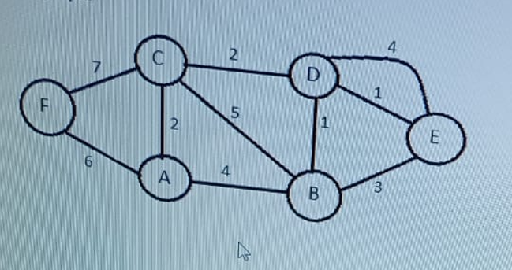
A. 11.0
B. 12.0
C. 15.0
D. 19.0

2.What is the final All Pair shortest path(APSP) matrix and center vertex obtained using Floyd’s algorithm for the digraph given below?
Given digraph:
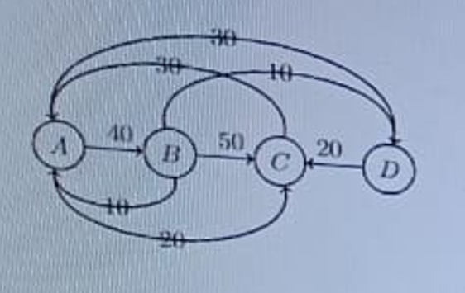

A.
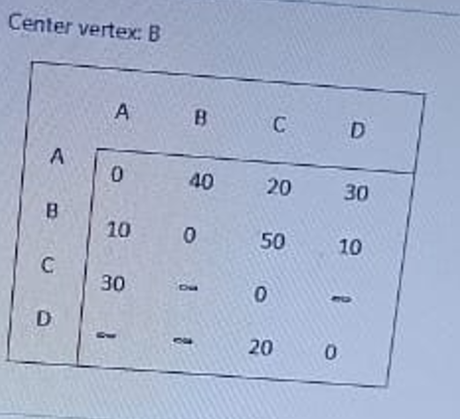
B.
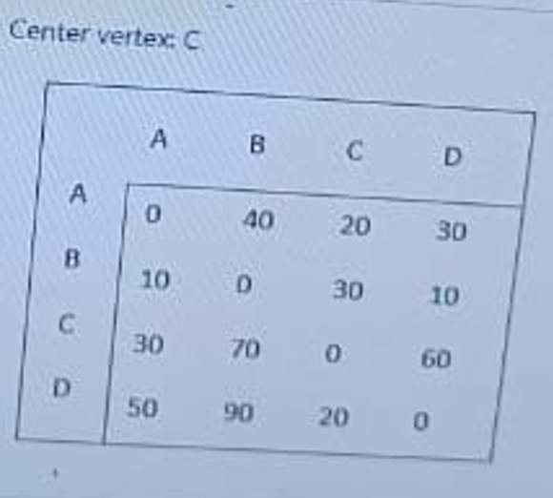

Cognitive Ability
1: There are three numbers. The first two numbers are 30% and 80% more than the third number respectively. What is the ratio of the first two numbers?

A. 3/8
B. 13/18
C. 13/5
D. 18/13

2: Choose the option that correctly rephrases the Underlined part of the given sentence.
Sentence: Partisanship in editorial comment, which knowingly departs from the truth, is against the very spirit of journalism: in the news columns, it is submissive of a fundamental principal of the professions.

A. is submissive of fundamental principal of the professions
B. is subversive of a fundamental principle of the profession
C. is subversive of a fundamental principal of the professions
D. is submissive of a fundamental principal of the profession

3: Read the following passage and answer the given below.

Manufacturers have to do more than build large manufacturing plants to realize economies of scale.It is true that as the capacity of a manufacturing operation rises costs per unit of output fall as plant size approaches " minimum efficient scale," where the cost per unit of output reaches a minimum ,determined roughlty by the state of existing technology and size of the potential market.However,minimum efficient scale cannot be fully realized unless a steady "throughput needed to maintain the optimal scale of production requires careful coordination not only of the flow of input from suppliers and the flow of unit costs rise sharply and profits disappear.A manufacturer's fixed costs and "sunk costs"(original capital investment in the physical plant) do not decrease when production declines due to inadequate supplies of raw materials,problems on the factory floor,or inefficient sales networks.Consequently ,potential economies of scale are based on the physical and engineering characteristics of the production facilities -- that is ,on tangible capital-- but realized economics of scale are operational and organizational ,and depend on knowledge, skills,experience,and teamwork--that is on organized human capabilities,or intangible capital.

The importance of investing in intangible capital becomes obvious when one looks at what happens in new capital-intensive manufacturing industries. Such industries are quickly dominated not by the first firms to acquire technologically sophisticated plants of theoretically optimal size, but rather by the first to exploit the full potential of such plants. Once some firms achieve this, a market becomes extremely hard to enter. Challenges must construct comparable plants and do so after the first movers have already worked out problems with suppliers or with new production processes.Challengers must create distribution networks and marketing systems in markets managment teams to complete eith those that have already mastered these functional and strategic activities.

Question : Fill in the blank(s).
The role of the second paragraph of the above passage can be best summarized as _______________.

A. supporting the argument in the first paragraph
B. assessing the strategies discussed in the first paragraph
C. undermining the argument in the first paragraph
D. preventing the possible threats of a commonly used strategy

4: Rearrange the given phrases to form a complete sentence.
A. the yard
B. by the time
C. moved in,
D. mass of weeds
E. Eugene's family
F. was a tangled

Options:
A. ABCDEF
B. DBAFEC
C. BECAFD
D. BCDAFE

5.Find the missing figure which follows the same pattern/rule and mark it as the answer
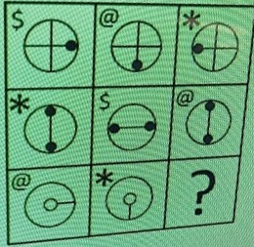

6.Find the missing figure ,which follows the same pattern/rule and mark it as the answer.
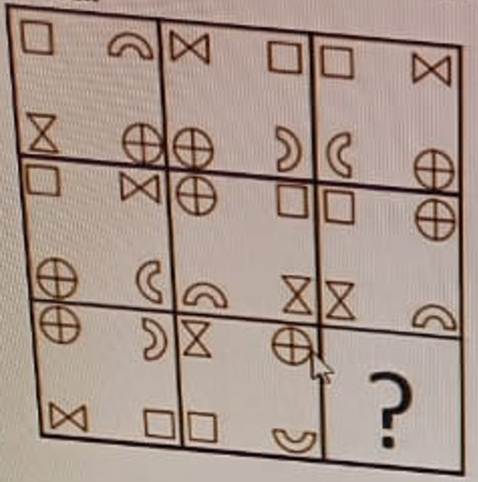

Options:
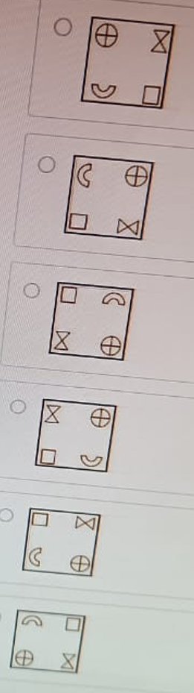

Networking
1:The router manufacturer has set the SSID for the router as TEST_WIFI. Wireless LAN provider sets up the LAN and provides a new name to the SSID as NEW_TEST_WIFI. Identify the correct SSID to be used to connect to the network by the user.

A. TEST_WIFI
B. NEW_WIFI
C. NEW_TEST_WIFI
D. WIFI

2:A company requires a network of 2000 IP addresses to be set up. Which class IP address method is suitable to address 2000 IP addresses?

A. Class A
B. Class B
C. Classless Inter-Domain
D. Class C

3:A subnet1 is connected to LAN of bandwidth 200Mbps and subnet2 with serial links 10 Mbps. Subnet1 with a delay of 200µsec has 4 nodes. Subnet2 has a delay of 20000 µsec. What is the EIGRP metric for subnet 1?
Note:if K5 is set to Zero,the last part of the EIGRP metric calculation formula (K%/(Reliability + K4))is takenn as 1.

A. 37400.0
B. 35840.0
C. 35740.0
D. 33280.0

4:In Mesh technology, the same data is transmitted to all the network nodes; it is unlikely to lose the data and at times leads to unwanted load over the network. Which technique is used to transmit the data in this scenario?

A. Routing
B. Flooding
C. Linking
D. Flowing

5:An IT company wants to set up a network having clusters of high-performance computers. The network performance should be having fast local network performance and should be used for distributed processing applications. Which type of network should be used in this scenario?

A. WLAN
B. Local Area Network
C. Wide Area Network
D. System Area Network

