VISVESVARAYA TECHNOLOGICAL UNIVERSITY
“JNANA SANGAMA”, BELAGAVI -590 018.
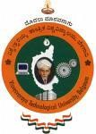
2025 – 2026
An Internship Report on
“Title”
Submitted in partial fulfillment for the award of the degree of BACHELOR OF ENGINEERING
in

Department of Information Science and Engineering

Submitted By

Yashwanth H M [1JB22IS188]

Under the guidance of

Mrs Gayathri. S Mr Yashas M H
Internal Guide Name
Asst Professor, Dept. of ISE
External/Industry Guide Name
Program Manager, SuprMentr Technologies Pvt Ltd

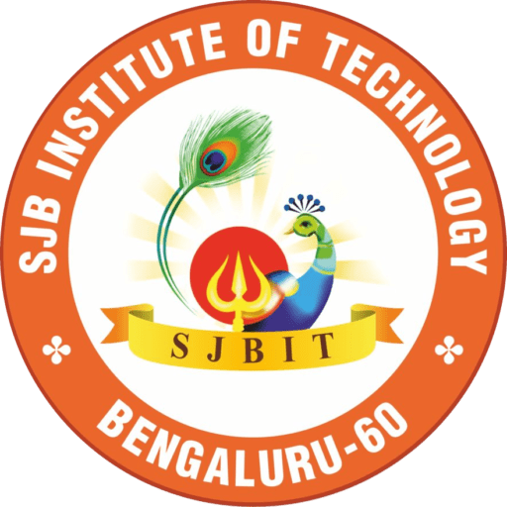
Company Logo

DEPARTMENT OF INFORMATION SCIENCE AND ENGINEERING

SJB INSTITUTE OF TECHNOLOGY
No. 67, BGS Health & Education City, Dr. Vishnuvardhan Road, Kengeri, Bengaluru - 560 060

2025 - 2026

||Jai Sri Gurudev||
Sri Adichunchanagiri Shikshana Trust ®
SJB INSTITUTE OF TECHNOLOGY
No. 67, BGS Health & Education City, Dr. Vishnuvardhan Road, Kengeri, Bengaluru - 560 060
An Autonomous Institute under VTU
Approved by AICTE - New Delhi, Accredited by NAAC A+, Accredited by NBA

DEPARTMENT OF INFORMATION SCIENCE AND ENGINEERING


CERTIFICATE

Certified that the internship work entitled “Title” is carried out by Yashwanth H M (1JB22IS188), a bonafide student of SJB Institute of Technology in partial fulfilment for the award of “BACHELOR OF ENGINEERING” in DEPARTMENT OF ISE as prescribed by VISVESVARAYA TECHNOLOGICAL UNIVERSITY, BELAGAVI during the academic
year 2025 - 26. It is further certified that all corrections/suggestions indicated for internal assessment have been incorporated in the report deposited in the departmental library. The internship report has been duly approved as it satisfies the academic requirements for the internship as prescribed for the said degree.

Name of Guide Name of HOD …………………
Guide & Designation Professor & Head Principal
Dept. of ISE, SJBIT Dept. of ISE, SJBIT SJBIT

EXTERNAL VIVA-VOCE

Name of Examiners Signature with Date
1.

2.

Internship Offer Letter
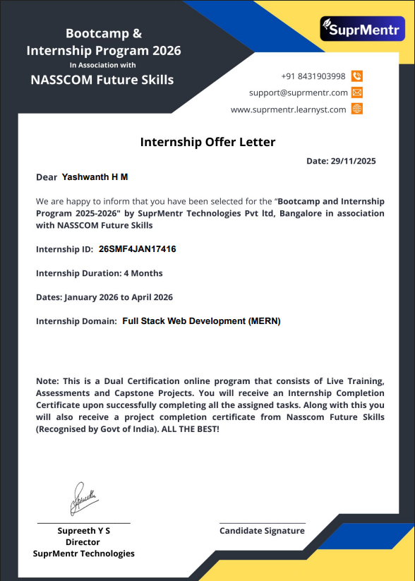

Certificate by the industry/company/organization





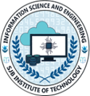
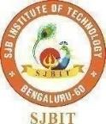
ACKNOWLEDGEMENT

I would like to express my profound gratitude to His Divine Soul Jagadguru PadmaBhushan Sri Sri Sri Dr. Balagangadharanatha Mahaswamiji and His Holiness Jagadguru Sri Sri Sri Dr. Nirmalanandanatha Swamiji for providing us an opportunity to be a part of this esteemed institution.
I would also like to express my sincere thanks to Revered Sri Sri Dr. Prakashnath Swamiji, Managing Director of SJB Institute of Technology, for his continuous support in providing the necessary support to by this esteemed institution.
I express our heartfelt gratitude to Dr. Puttaraju, Academic Director of the BGS & SJB Group of Institutions, Dr. K.V.Mahendra Prashanth, Principal of SJB Institute of Technology, Dr Babu N V, Academic Dean of SJB Institute of Technology and Dr. Gopalakrishna M.T, Professor & Head of the Department of Information Science & Engineering for providing me with their unwavering support, state-of-the-art facilities, and the enriching academic environment, which were instrumental in the successful completion of my Internship.
I extend my heartfelt gratitude to all the Deans of SJB Institute of Technology for their unwavering support, cutting-edge facilities, and the inspiring academic environment, all of which played a pivotal role in the successful completion of my internship.
I wish to express my heartfelt gratitude to my guide, Guide Name, Designation for her/his valuable guidance, suggestions, and encouragement during the entire period of my internship.
I extend my sincere thanks to SuprMentr Technologies for providing me with the opportunity to undertake internship and gain valuable industry experience. I am grateful for the supportive and professional environment, which has contributed immensely in learning and skill development.
I express my truthful thanks to Internship coordinators, Dept. of Information Science & Engineering for their valuable support.
Finally, I take this opportunity to extend my earnest gratitude and respect to our parents, the teaching & technical staff of the department, the library staff, and all my friends, who have directly or indirectly supported me during the period of my internship.

Regards,
Yashwanth H M [1JB22IS188]

 | ||Jai Sri Gurudev||  Sri Adichunchanagiri Shikshana Trust ®  SJB INSTITUTE OF TECHNOLOGY  No. 67, BGS Health & Education City, Dr. Vishnuvardhan Road, Kengeri, Bengaluru - 560 060  An Autonomous Institute under VTU  Approved by AICTE - New Delhi, Accredited by NAAC A+, Accredited by NBA

DEPARTMENT OF INFORMATION SCIENCE AND ENGINEERING

DECLARATION

I hereby declare that the entire work embodied in this internship report has been carried out under the supervision of <Guide Name with designation> in partial fulfilment for the award of “BACHELOR OF ENGINEERING” in Dept. of Information Science and Engineering as prescribed by Visvesvaraya Technological University, Belagavi during the academic year 2025 – 26.

Students Name [USN] Signature

Executive Summary

A concise overview of the internship, including key points like your role, primary tasks, achievements, and skills developed.
This section should be no longer than half a page, providing the essence of the report for quick readers.

Table of Contents

Chapter No | Particulars | Page
Acknowledgement |  | i
Declaration |  | ii
Executive Summary |  | iii
Table of contents |  | iv
List of figures |  | v
List of tables |  | v
1 | Introduction
2 | About the Organization
3 | Objectives of Internship
4 | Internship Activities and Tasks
5 | Learning Experiences
6 | Learning Outcomes
7 | Reflection and Analysis
8 | Conclusion/Summary
9 | Reference
10 | Appendices (If applicable)

List of figures

Figure | Particulars | Page

List of Tables

Table | Particulars | Page

Internship Title 2025-26

Chapter 1

Introduction

- Objectives of the Internship:

- The primary academic objective of this internship was to bridge the gap between theoretical knowledge and practical implementation in the field of software development. As a student, I had learned various concepts related to programming, web development, and database management, and this internship provided an opportunity to apply those concepts in real-world projects.
- Another key objective was to gain hands-on experience in full stack development using the MERN stack (MongoDB, Express.js, React.js, Node.js). This helped me understand how modern web applications are built, deployed, and maintained in an industry environment.
- The internship also aimed to enhance my understanding of software development lifecycle (SDLC), including requirement analysis, design, development, testing, and deployment processes.
- From a personal perspective, one of the major goals was to improve my problem-solving and logical thinking skills by working on real-time tasks and debugging issues during development.
- Additionally, I aimed to develop professional skills such as communication, teamwork, time management, and adaptability in a corporate environment.
- Another important objective was to gain exposure to industry tools and technologies, version control systems like Git, and collaborative development practices followed in IT companies.
- Finally, the internship helped me explore my career interests in full stack development, enabling me to understand industry expectations and prepare myself for future job opportunities.

Overview of the Organization

- SuperMentr Technologies Pvt Ltd is a private limited company based in Bengaluru, Karnataka, operating in the IT and education/skill development domain.
- The company was established in July 2023 and is officially registered under the Ministry of Corporate Affairs (MCA) as an active organization.

- It is a startup-level organization with a small team size of approximately 2–10 employees, focusing on innovation and skill-based learning.
- The organization primarily works as a career mentorship and training platform, helping students connect with industry experts, gain real-world skills, and improve employability.
- The company provides various services including technical training programs, certification courses, and industry-oriented learning, especially in fields like IT, software development, and emerging technologies.
- The mission of the organization is to empower students with practical knowledge and industry-relevant skills, enabling them to succeed in their careers and secure opportunities in top companies.
- The company operates from its registered office in Bangalore, Karnataka, and focuses on delivering high-quality training and development programs to students and professionals.
- Being a startup, the organization emphasizes innovation, hands-on learning, and real-time project exposure, making it a suitable environment for interns to gain practical experience.

3. Internship Role / Position
- During my internship at SuperMentr Technologies Pvt Ltd, I worked as a Full Stack Developer Intern (MERN Stack) in the development domain.
- I was part of the software development team, where I contributed to building and improving web-based applications using modern technologies.
- My role involved working with the MERN stack, which includes MongoDB for database management, Express.js and Node.js for backend development, and React.js for frontend development.
- I was responsible for developing user interfaces, handling backend logic, and integrating APIs, ensuring smooth communication between frontend and backend components.
- The internship also required me to perform tasks such as debugging code, testing applications, and optimizing performance to improve user experience.
- I worked under the guidance of experienced mentors who provided continuous feedback and helped me understand industry standards and best practices.
- Additionally, I participated in team discussions, project planning, and collaborative development, which enhanced my teamwork and communication skills.
- Through this role, I gained practical exposure to real-world project development, version control systems, and agile development methodologies.

Internship Title 2025-26

Chapter 2

About the Organization

1. Organization Overview
- Name: SuperMentr Technologies Pvt Ltd
- Location: Bengaluru, Karnataka, India
- Type of Organization: Private Limited Company (Startup)
- SuperMentr Technologies Pvt Ltd is an emerging startup operating in the Information Technology (IT) and EdTech domain, focusing on bridging the gap between academic learning and industry requirements.
- The organization was established in 2023 with the objective of providing career mentorship, skill development, and industry-oriented training to students and young professionals.
- Since its inception, the company has focused on creating a platform where learners can gain practical exposure through internships, real-time projects, and expert guidance.
- Being a startup, the company is agile, innovative, and continuously evolving to meet the changing demands of the technology industry.
2. Vision, Mission, and Objectives
Vision:
- To become a leading platform that transforms students into industry-ready professionals by providing practical and skill-based education.
Mission:
- To deliver high-quality training programs aligned with industry needs
- To connect learners with experienced mentors and professionals
- To promote hands-on learning through real-time projects and internships
Objectives:
- To enhance employability of students through practical exposure
- To bridge the gap between theoretical knowledge and industry expectations

- To provide affordable and accessible technical education
- To support continuous learning and professional growth
3. Products and Services
- SuperMentr Technologies Pvt Ltd offers a variety of education and technology-based services, including:
Main Services:
- Technical Training Programs: Courses in programming, web development, and emerging technologies
- Internship Programs: Real-time internship opportunities for students to gain hands-on experience
- Mentorship Programs: Guidance from industry experts to help students build their careers
- Project-Based Learning: Opportunities to work on live projects
Target Customers:
- College students and fresh graduates
- Individuals seeking career transition into IT
- Professionals looking to upgrade their technical skills
- The organization mainly serves the education and IT sectors, focusing on improving the employability of learners.
4. Organizational Structure
- As a startup, SuperMentr Technologies Pvt Ltd follows a simple and flexible organizational structure.
- Hierarchy Overview:
- Top Management: Founders / Directors
- Core Team: Technical Leads, Trainers, and Mentors
- Development Team: Developers and Interns
- Support Functions: HR, Operations, and Marketing
- The company promotes a flat hierarchy, allowing easy communication and faster decision-making.
My Department:
- I worked in the Software Development Department as a Full Stack Developer Intern (MERN Stack)
Role of Department:
- Responsible for designing, developing, and maintaining web applications
- Works on frontend and backend technologies
- Collaborates with other teams to deliver complete software solutions

5. Work Environment and Culture

- The work environment at SuperMentr Technologies Pvt Ltd is professional, collaborative, and learning-oriented.
- The organization encourages:
  - Continuous learning and skill development
  - Open communication between team members
  - Innovation and creativity in problem-solving
- Interns are provided with:
  - Proper guidance from mentors
  - Opportunities to work on real-time projects
  - A supportive environment to learn and grow
- The company follows good work ethics, including:
  - Timely completion of tasks
  - Accountability and responsibility
  - Respect for team collaboration
- Flexible work practices and a startup culture make it easier for interns to adapt and contribute effectively.

Internship Title 2025-26

Chapter 3

Objectives of Internship

1. Purpose of the Internship
- The internship was undertaken as part of my academic curriculum requirement, aimed at providing practical exposure to complement theoretical knowledge gained during my course.
- It served as an opportunity to gain hands-on experience in the IT industry, particularly in the field of full stack web development.
- The internship also focused on skill development, enabling me to work with modern technologies and tools used in real-world software development.
- Another important purpose was to understand the professional work environment, including teamwork, communication, and project execution in an organization.
- Additionally, the internship helped in gaining industry exposure, allowing me to understand current trends, technologies, and expectations in the software development domain.

2. Learning Objectives
Technical Skills:
- To gain practical knowledge of the MERN stack (MongoDB, Express.js, React.js, Node.js)
- To understand frontend and backend integration in web applications
- To learn database management and API development
- To improve coding, debugging, and problem-solving abilities
- To gain exposure to version control systems like Git and collaborative development
Soft Skills:
- To enhance communication and interpersonal skills
- To develop teamwork and collaboration abilities
- To improve time management and task prioritization
- To build professional discipline and work ethics
- Domain Knowledge:
- To understand the software development lifecycle (SDLC)
- To gain insights into real-time project development and deployment
- To learn about industry standards and best practices

Alignment with Academic Program:
- The internship aligns with my academic program by allowing me to apply theoretical concepts in practical scenarios
- It supports my coursework in programming, web development, and database systems
- It strengthens my overall understanding of software engineering principles

3. Career Relevance
- The internship is directly related to my career goal of becoming a Full Stack Developer.
- It provided me with practical experience in technologies that are highly demanded in the industry, especially the MERN stack.
- The experience gained helps in improving my technical portfolio, which is essential for future job opportunities.
- It enhanced my confidence in working on real-world projects, making me better prepared for professional roles.
- The internship also improved my employability skills, including problem-solving, teamwork, and communication.
- Overall, it serves as a strong foundation for pursuing a career in the software development and IT industry.

  - Organizational Objectives

- The organization expected me to actively participate in development-related tasks as a Full Stack Developer Intern.
- I was expected to contribute to building and maintaining web applications using the MERN stack.
- The company aimed to utilize my skills in coding, debugging, and testing to support ongoing projects.
- I was also expected to learn quickly and adapt to the working environment and technologies used by the organization.
- Another expectation was to collaborate effectively with team members and follow professional work practices.
- The organization provided mentorship with the expectation that I would apply the learning to deliver meaningful contributions.

5. Scope of Work
- The scope of my internship was primarily focused on full stack web development using modern technologies.
- My work involved both:
  - Frontend Development: Designing user interfaces using React.js
  - Backend Development: Creating APIs and handling server-side logic using Node.js and Express.js
- I also worked with:
  - Database Management: Using MongoDB for storing and retrieving data
  - Application Testing and Debugging
- The internship was limited to the Software Development Department, but involved collaboration with other team members when required.
- The focus areas included:
  - Web application development
  - API integration
  - Performance improvement and bug fixing
- The internship provided exposure to real-time project work, but within a guided and learning-oriented environment.

Internship Title 2025-26

Chapter 4

Internship Activities and Tasks

- Tasks and Responsibilities: During my internship as a Full Stack Developer Intern, my responsibilities were divided into distinct phases across the software development lifecycle:
- Requirements Analysis & Planning: Studied existing e-learning platforms to define a three-tier client-server architecture and designed the database schema across five MongoDB collections (User, Instructor, Course, Thread, OTP).
- Backend Development: Engineered a robust RESTful API using Node.js and Express.js, developing over 40 endpoints to handle role-based user routing (Student, Instructor, Admin). Implemented stateless authentication using JSON Web Tokens (JWT) and bcrypt for password hashing.
- Frontend Development: Designed and built a responsive Single Page Application (SPA) using React.js and Vite. Developed reusable UI components (headers, sidebars, course cards) and managed application state across 20+ distinct page views.
- System Integration: Integrated third-party cloud services, specifically Cloudinary for scalable image and video hosting, and Nodemailer for an OTP-driven password recovery flow.
- Testing and Debugging: Conducted manual API testing using Postman and debugged client-server request cycles to ensure seamless data flow and error handling.

- Tools and Technologies Used: Frontend: React.js 18, Vite 5, Bootstrap 5, React-Bootstrap, React Router DOM v6, Axios, Chart.js.
- Backend: Node.js, Express.js 4.
- Database: MongoDB, Mongoose ODM 8.
- Security & Auth: JSON Web Tokens (JWT), bcryptjs.
- Cloud & Utilities: Cloudinary CDN (Media Storage), Multer (File Uploads), Nodemailer (Email/OTP), Puppeteer (PDF Certificate Generation).
- Development Tools: Visual Studio Code, Git, GitHub, Postman.
- Projects Involved in:
Project Title: LearnHub E-Learning Platform
- Description: LearnHub is a comprehensive, full-stack, role-based e-learning web application. It enables students to browse, purchase, and consume video-based courses, while allowing instructors to create, manage, and monetize their educational content.
- Objectives: To build a production-ready application addressing gaps in existing platforms by integrating video hosting, threaded discussion forums, granular progress tracking, and automated PDF certificate generation.
- My Contributions: I was responsible for the end-to-end development of the platform. This included building the MongoDB schemas, creating the Express server and API routes, developing the React UI, and implementing complex logic such as the automated certificate generation using Puppeteer and the course progress tracking matrix.
- Course[s] Abstract (NSDC/SEC)

- As part of the dual-certification Bootcamp and Internship Program in association with NASSCOM Future Skills, I completed structured training modules focusing on advanced JavaScript, modern React hooks, Node.js server architecture, and NoSQL database management, which directly informed my work on the LearnHub project.
Internship Title 2025-26

Chapter 5

Learning Experiences

• Knowledge Gained
- The internship provided deep insights into modern web architecture. I learned the principles of RESTful API design, understanding how to structure HTTP methods and status codes effectively. I also gained a solid theoretical and practical understanding of stateless authentication flows using JWTs and role-based access control (RBAC).
• Technical Skills Developed
- Advanced React.js: Achieved high proficiency in functional components, React Hooks (useState, useEffect), and protected client-side routing.
- Backend Architecture: Mastered setting up Express servers, writing custom middleware for route protection, and managing environment variables safely.
- Database Management: Developed skills in NoSQL database design, executing complex CRUD operations, managing document relationships via ObjectId references, and utilizing MongoDB array update operators.
- Third-Party Integrations: Learned to seamlessly connect cloud services, utilizing Multer with Cloudinary for media uploads and Puppeteer for headless browser automation.
• Soft Skills and Professional Development
- Working in an agile startup environment at SuprMentr honed my time-management and task-prioritization skills, as I had to deliver complex modules within strict deadlines. I improved my problem-solving adaptability—learning to break down large application features into manageable logic steps.
• Challenges Faced and Solutions

- Challenge: Implementing dual authentication flows for both students and instructors without causing route conflicts.
    - Solution: Organized backend routes into distinct prefixed route groups (/users and /instructors) and managed isolated state contexts on the React frontend.

- Challenge: Managing media uploads across four different categories (course videos, course images, student profiles, instructor profiles).
    - Solution: Created a centralized cloudinary.js utility that exported pre-configured Multer storage instances tailored to each specific file type and CDN destination folder.

- Challenge: Rendering pixel-perfect PDF certificates dynamically.
    - Solution: Utilized Puppeteer with explicitly defined viewport dimensions and custom CSS to inject Google Fonts and dynamic user data into the HTML template before PDF conversion.

• Practical Exposure
- This experience bridged the gap between academic theory and industry practice. I was exposed to the full Software Development Life Cycle (SDLC)—from gathering initial requirements and wireframing, to writing clean, modular code, keeping secrets out of source control using .env files, and preparing the application for serverless deployment on Vercel.

Internship Title 2025-26

Chapter 6

Learning Outcomes

- Skills Gained:
      - Technical: Full-stack SPA development, NoSQL database schema design, RESTful routing, token-based authentication, cloud media storage integration, and version control using Git.
      - Operational: Agile workflow adaptation, API endpoint testing, and serverless deployment configuration.
- Results & Discussions:
- Delivery of a unified backend handling 40+ RESTful endpoints.
- Creation of a responsive frontend comprising over 20 tailored pages across three distinct user roles.
- Take aways:
The primary takeaway is the realization of how modularity impacts scalability. By separating concerns—keeping business logic in routes, cross-cutting concerns in middleware, and UI elements in reusable React components—I learned how to build software that is not just functional, but maintainable and scalable.

Internship Title 2025-26

Chapter 7

Reflection and Analysis

- Application of Academic Knowledge: Academic concepts from Database Management Systems (DBMS) were vital when designing the MongoDB collections and ensuring referential integrity using Mongoose. Furthermore, principles of Software Engineering guided the initial planning phases, ensuring that user roles and system requirements were clearly defined before a single line of code was written.
- Insights Gained: I gained a profound appreciation for the complexities of user state management and security. I learned that security is not an afterthought; practices like bcrypt password hashing and CORS configuration must be integrated into the foundation of the application. I also realized the importance of the open-source community and reading official documentation (React, Node, Cloudinary) to solve undocumented bugs.
- Areas for Improvement: While the project was a success, the experience highlighted areas for future technical growth. I identified a need to deepen my knowledge of automated software testing (such as writing unit tests with Jest) rather than relying solely on manual Postman testing. Additionally, I aim to learn how to integrate actual payment processing gateways like Stripe or Razorpay, rather than using simulated payment flows.
- Career Impact: This internship has definitively shaped my career trajectory. Successfully building a full-stack application from scratch has given me the confidence to pursue a career as a Full Stack Software Engineer. It validated my interest in the MERN stack and provided me with a tangible, complex portfolio piece to showcase to future employers.
Internship Title 2025-26

Chapter 8

Conclusion

The internship at SuprMentr Technologies proved to be a highly rewarding and transformative experience. By developing the LearnHub E-Learning Platform, I successfully transitioned from understanding isolated programming concepts to engineering a cohesive, full-scale web application.

The project encompassed the entirety of the software development lifecycle, allowing me to build practical expertise in React.js, Node.js, MongoDB, and modern cloud integrations. Navigating the challenges of authentication, media management, and dynamic document generation significantly sharpened my technical problem-solving skills. Ultimately, this internship not only fulfilled my academic requirements but also equipped me with the industry-relevant skills, professional discipline, and confidence necessary to excel in the software engineering sector.
Internship Title 2025-26

References
[1]
[2]
.
.
.
.
.

Institute Vision

Institute Mission

Department Vision

Department Mission

