InsightDraft: Enterprise-Wide Intelligent Document & Data Platform

Proposal Name: InsightDraft - Enterprise Intelligent Document & Data Analysis Platform
Date: February 11, 2026

1. Executive Summary

Our enterprise maintains millions of critical business documents and generates thousands of Excel/CSV data files daily. Every employee creates reports regularly by manually searching documents, analyzing spreadsheets, and synthesizing information—a process that consumes 3-5 days per comprehensive report.
InsightDraft is an enterprise-wide Agentic AI platform that combines three capabilities:
- Scalable Knowledge Base System - RAG-powered document search with hybrid retrieval
- Intelligent Data Analysis Agent - Automated Excel/CSV analysis with statistical insights
- Unified Report Generation - Professional DOCX/PDF/PPTX combining document + data insights
Transformation: 5-day manual workflow to 35-minute automated process (98.5% time reduction)
Business Impact:
- Scalable architecture: Starting with 15,000 documents (3 knowledge bases), expandable to 250,000+ over 18 months
- 98.5% time reduction per report (40 hours to 0.6 hours)
- Year 1 conservative: 30% adoption saves 70,920 hours annually
- Year 2 aggressive: 70% adoption saves 331,000 hours annually
- Enterprise-wide deployment for all employees' daily reporting needs

2. Description of Currently Ongoing Work

We conduct comprehensive report creation work through multiple stages, including document search, data analysis, and report drafting.
① Document & Data Collection:
Before the report is created, employees search for relevant documents and data files across multiple systems. This step focuses on gathering all information needed from various sources including SharePoint sites, shared drives, and local folders. It also involves collecting Excel/CSV files for analysis and organizing all materials by topic.
Pain Points:
- NO enterprise-wide unified search capability
- Documents and data files stored in siloed systems (SharePoint, shared drives)
- Must manually download 30-80 documents and 5-15 Excel/CSV files
- Navigate inconsistent folder structures
- Critical information hidden across departments
Time Required: 1-2 full working days
② Content Review & Data Analysis:
As the main analytical step, employees read through all collected documents and analyze data files. This involves reading hundreds of pages manually, creating pivot tables in Excel, performing calculations (averages, growth rates, variances), cross-referencing document insights with data patterns, and tracking sources.
Pain Points:
- Must read hundreds of pages to extract key information
- Manual data analysis in Excel is time-consuming and error-prone
- Difficult to correlate document insights with data patterns
- No automated statistical analysis or pattern detection
- Lose track of which information came from which source
Time Required: 2-3 full working days

③ Report Drafting & Formatting:
This step involves synthesizing insights from BOTH documents AND data analysis to create the final report. Employees write executive summaries combining qualitative and quantitative insights, organize narrative sections with supporting data visualizations, format tables and charts to company standards, create presentation slides if needed, add table of contents and citations, perform multiple review iterations, and export to final format.
Pain Points:
- Starting from blank page is cognitively demanding
- Manually integrating document insights with data findings
- Formatting is extremely time-intensive
- Difficult to maintain consistency across reports
- Quality depends heavily on individual expertise
- Every department creates reports regularly: Compliance, Finance, Engineering, Operations, HR, Sales, Marketing
- Conservative estimate: 500-1,000 comprehensive reports per month
- Total time spent: 20,000-40,000 hours monthly on manual report creation
Time Required: 1-2 full working days
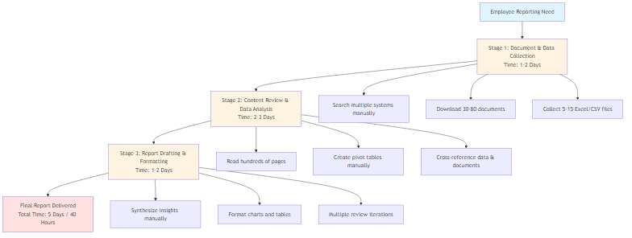
Enterprise-Wide Impact

3. Change in the Tasks After Implementation of AI

InsightDraft transforms the report creation process through an integrated 3-component AI platform.
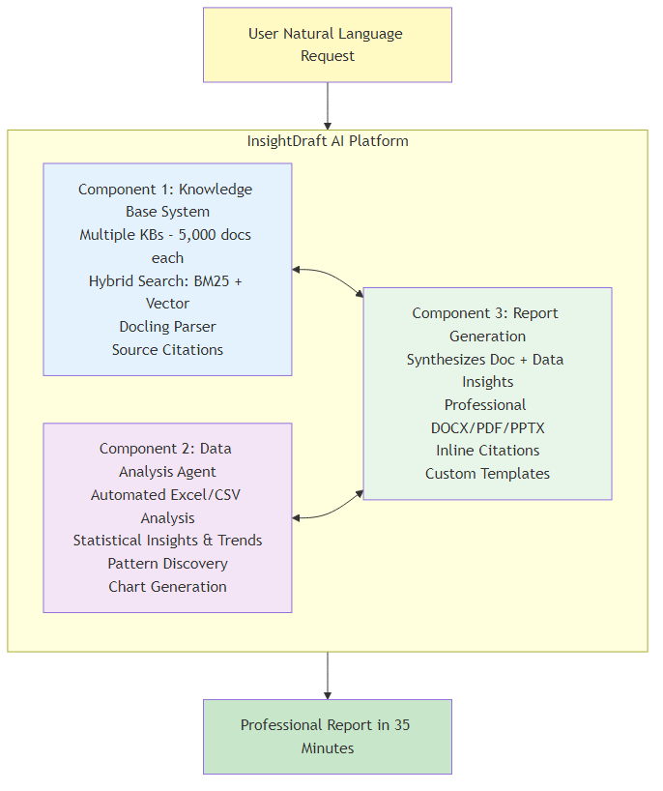
① AI-Powered Query & Search:
Once the reporting objective is clearly defined in plain English, the AI automatically determines which knowledge bases to search and which data files to analyze. It continuously processes the request until achieving the desired results, allowing employees to finalize their requirements in a short span of time (2 minutes vs. 1-2 days).
How It Works:
- Employee types single natural language request
- Example: "Create quarterly business review combining financial performance from Q4_financials.xlsx, market analysis from Market Research knowledge base, and operational metrics from Operations knowledge base"
- AI automatically determines:
- Which knowledge bases to search
- Which data files to analyze
- Whether to combine documents + data
- Output format (DOCX/PDF/PPTX)
Time Required: 2 minutes
② Automated Processing & Analysis:
When conducting the report creation, the amount of work required from employees is minimized. The AI processes everything automatically, and progress can be monitored until completion (3 minutes vs. 2-3 days).
Component 1 - Knowledge Base Search:
- Searches relevant knowledge base(s) from enterprise collection
- Hybrid search (BM25 + Vector) with 99% retrieval accuracy
- Extracts information with Docling technology
- Maintains source citations for every fact
Component 2 - Data Analysis:
- Reads Excel/CSV files automatically
- Performs statistical analysis (descriptive stats, trends, variances, correlations)
- Identifies outliers, anomalies, seasonal patterns
- Generates professional charts (bar, line, pie, scatter)
Component 3 - Report Generation:
- Synthesizes document insights + data analysis into coherent narrative
- Applies company formatting standards
- Creates executive summary, table of contents, structured sections
- Embeds inline citations and data source references
- Generates DOCX/PDF/PPTX based on request
Time Required: 3 minutes
③ Quality Review & Finalization:
There is no need to manually verify past data or recreate analysis. Even in the case of a change in person-in-charge, the quality of result reports won't decrease due to differences in analytical know-how. All sources are cited and verifiable (30 minutes vs. 1-2 days).
User Activities (Quality Control Only):
- Review AI-generated content (20 minutes)
- Verify critical facts via clickable citation links (5 minutes)
- Verify data accuracy from source files (2 minutes)
- Add strategic commentary (3 minutes)
- Report is complete and ready for distribution
Time Required: 30 minutes
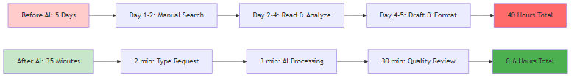
Time Comparison:
Stage | Traditional | InsightDraft | Reduction
Search & Collection | 1-2 days | 2 minutes | 99%
Review & Analysis | 2-3 days | 3 minutes | 99.8%
Drafting & Formatting | 1-2 days | 30 minutes | 97%
TOTAL | 40 hours | 0.6 hours | 98.5%

4. Effect of Agentic AI Application

Time Investment & Efficiency
- It takes almost no human time investment to conduct the report research and analyze data to produce the final report (35 minutes vs. 5 days)
- There is no need to manually analyze past data, and memory-based error analysis can be reduced through automated citation tracking
Quantified Impact per Report:
- Time savings: 39.4 hours per report
- Efficiency gain: 98.5% reduction
- Quality improvement: Consistent professional output regardless of employee experience level

Enterprise-Wide Productivity Impact

Conservative Case (Year 1 - 30% Adoption Rate):
- 500 reports/month × 30% = 150 reports on InsightDraft
- 150 × 39.4 hours saved = 5,910 hours/month saved
- Annual: 70,920 hours saved
- Productivity improvement: 60-70% for participating employees
Aggressive Case (Year 2 - 70% Adoption Rate):
- 1,000 reports/month × 70% = 700 reports on InsightDraft
- 700 × 39.4 hours = 27,580 hours/month saved
- Annual: 331,000 hours saved
- Productivity improvement: 85-90% enterprise-wide

Breaking Down Information Silos

Current Problem:
- Document knowledge trapped in departmental silos
- Data insights locked in individual Excel files
- Expertise concentrated in senior employees
- Cross-functional analysis nearly impossible
InsightDraft Solution:
- Unified access to multiple knowledge bases across departments
- Cross-domain synthesis: Combine compliance docs + financial data + engineering specs in one report
- Democratized expertise: Junior employee produces same quality as senior analyst
- Knowledge preservation: Institutional memory captured in knowledge bases instead of lost

Scalable Architecture for Growth
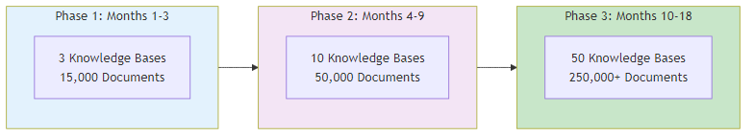
Multi-Knowledge Base Design:
- Each knowledge base: 5,000 documents for optimal performance (sub-5 second queries)
- Scalability: Adding new knowledge bases requires no architectural redesign
- Department ownership: Each department maintains their own KB
- Cost-effective: PostgreSQL + pgvector handles this scale efficiently
Growth Path:
- Phase 1 (Month 1-3): 3 knowledge bases = 15,000 documents
- Phase 2 (Month 4-9): 10 knowledge bases = 50,000 documents
- Phase 3 (Month 10-18): 50 knowledge bases = 250,000 documents

Integrated Data Analysis - The Key Differentiator

What sets InsightDraft apart from standard solutions:
Ability to combine document intelligence with data analysis in ONE unified report.
Real-World Example:
User Request: "Create Q4 business review combining financial performance from Q4_financials.xlsx with market trends from Market_Research knowledge base"
InsightDraft Process:
- Data Analysis Agent analyzes Q4_financials.xlsx automatically
- Calculates: Revenue growth +12.3% YoY
- Identifies: Top product (Product A - 35% of revenue)
- Detects: Expense anomaly (December spike +45%)
- Generates: Revenue trend charts and product mix visualizations
- Knowledge Base System searches Market_Research KB automatically
- Retrieves: Competitive analysis documents
- Finds: Industry growth rate cited as 8%
- Extracts: Q1 2026 analyst predictions
- Report Generation synthesizes both sources
- Output: "Q4 revenue growth of 12.3% outpaced industry average of 8% [Source: Industry_Report_2025.pdf, p.12], driven by Product A performance [Source: Q4_financials.xlsx, Revenue Summary sheet]"
Result: Professional DOCX report delivered in 35 minutes vs. 5 days manually, with 100% verifiable sources.

Trust Through Verification

Document Sources: Every fact includes inline citation with clickable link to exact page in source document
Data Sources: Every data insight shows source file name, sheet name, and calculation method
Impact: Users trust the platform because they can verify any claim instantly by clicking citations or checking original data files.

Technical Feasibility

Technology Stack:
- Component 1: PostgreSQL + pgvector, Hybrid search (Elasticsearch BM25 + Vector), Docling parser
- Component 2: Python (pandas, numpy, scipy), matplotlib/seaborn for visualization
- Component 3: python-docx, ReportLab (PDF), python-pptx, on-premise LLM
Development Resources:
- Team: 2-3 developers from Agentic AI_G
- Timeline: 12 months (3-month MVP, 6-month expansion, 3-month enterprise deployment)
- Infrastructure: Standard cloud (Azure/AWS), on-premises option for sensitive data
- Feasibility: 100% buildable with current technology stack, no specialized AI hardware required
Performance Benchmarks:
- Knowledge base query: Sub-5 seconds
- Data analysis: 10-30 seconds (typical Excel 10K-100K rows)
- Report generation: 1-2 minutes
- Total end-to-end: 3-5 minutes automated processing

5. Key Differentiators

Unique Capabilities:
- Only solution combining document RAG + automated data analysis + professional output
- Scalable from day one with multi-knowledge base architecture (15K to 250K+ documents)
- Professional deliverables (DOCX/PDF/PPTX), not just chat answers
- Daily utility for ALL employees across all departments
- 100% verifiable with document citations and transparent data sources
- Zero learning curve - plain English interface
vs. Data Analysis Tools:
- Standard: Excel/BI tools requiring manual expertise
- InsightDraft: Automated analysis combined with document context

6. Risk Mitigation

Risk | Mitigation Strategy
Data accuracy concerns | Mandatory inline citations for documents; data source transparency; spot-check protocol
User adoption resistance | Pilot with enthusiastic early adopters; demonstrate time savings with real examples; executive sponsorship
System performance at scale | Scalable multi-KB architecture; performance monitoring; gradual rollout ensures stability
Data security & privacy | On-premises deployment option; role-based access control; KB permissions aligned with existing policies
Knowledge base maintenance | Self-service KB management; automated quality checks; department ownership of KBs

7. Conclusion

InsightDraft transforms enterprise knowledge work by combining document intelligence and data analysis into a single platform that delivers professional reports in 35 minutes instead of 5 days.
The Impact:
- 98.5% time reduction per report (40 hours to 0.6 hours)
- Conservative Year 1: 70,920 hours saved annually (30% adoption)
- Aggressive Year 2: 331,000 hours saved annually (70% adoption)
- Scalable architecture: 15,000 to 250,000+ documents over 18 months
- 100% verifiable with citations and transparent data sources
- Zero learning curve for enterprise-wide adoption

The Bottom Line:
This platform fundamentally changes how knowledge work gets done. Every day, thousands of employees get back hours of productive time. Every year, institutional knowledge grows stronger instead of disappearing with retiring employees.
This is the future of enterprise productivity.

