The main Project’s C file:

Step1:

Open the project name: Peripheral with Uart

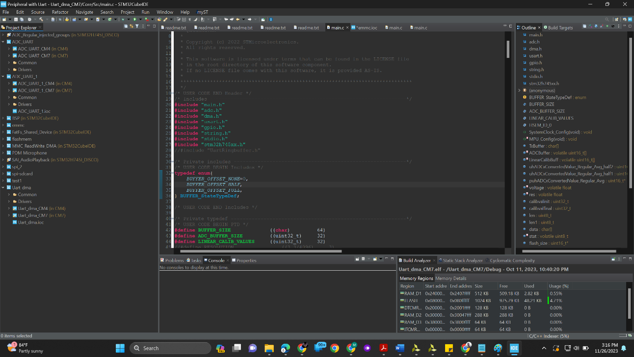

The final project is in: main.c file

Step2: main.c file location:

“Peripheral with Uart”> Uart_dma> Uart_dma_CM7>Core>Src>main.c