**Welcome to ATM Java project below are the artifacts for the project**

**Initial Project Run**

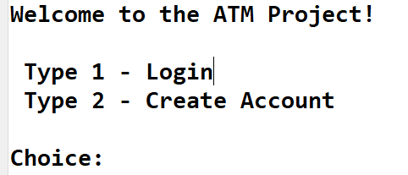

**Case 1: Login with wrong account number**

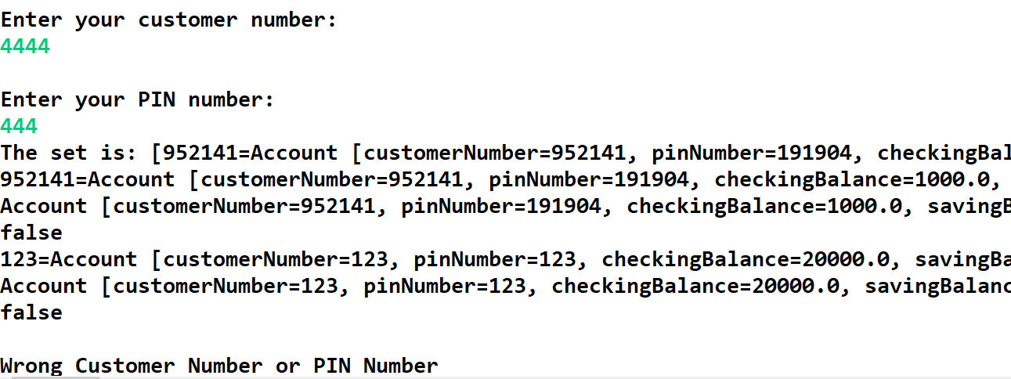

**Case 2: Entering wrong character**

**Case 3: entering first customer credentials**

**Case 4: first customer checking account**

**Case 5: 1st customer account balance**

**Case 6: 1st customer Transfer Funds**

**Case 7:  1st customer check- Withdraw Funds**

**Case 8 1st customer check Deposit Funds**

**Case 9: 1st customer check - Exit**

**Case 10: 1st customer saving acc view balance**

**Case 11: 1st customer saving acc withdrawfunds**

**Case 12: 1st customer saving accDeposit Funds**

**Case 13: 1st customer saving acc Transfer Funds**

**Case 14: 1st customer saving acc exit**

* **14 for 2nd customer**

**Case 29: 2 - Create Account**