THE CYBERBULLY SHIELD AN AUTOMATED FRAMEWORK FOR REAL-TIME CYBERBULLY DETECTION
A PROJECT REPORT
Submitted by
MAHESHWARAN. M - 962322104063
PRAVEEN KUMAR. N. R - 962322104080
SIVAGURU. M - 962322104100
VIJAY NAGARAAJ. M. C - 962322104118
in partial fulfillment for the award of the degree
of
BACHELOR OF ENGINEERING
IN
COMPUTER SCIENCE AND ENGINEERING
AMRITA COLLEGE OF ENGINEERING AND TECHNOLOGY, NAGERCOIL
ANNA UNIVERSITY: CHENNAI 600 025
MAY 2026
ANNA UNIVERSITY: CHENNAI 600 025
BONAFIDE CERTIFICATE
Certified that this project report “THE CYBERBULLY SHIELD AN AUTOMATED FRAMEWORK FOR REAL-TIME CYBERBULLY DETECTION” the Bonafide work of “MAHESHWARAN M (962322104063), PRAVEEN KUMAR N R (962322104080), SIVAGURU M (962322104100), VIJAY NAGARAAJ M C (962322104118)” who carried out the project work under my supervision.
SIGNATURE | SIGNATURE
Dr. P M SIVA RAJA, | Mrs. G CHITHRA,
HEAD OF THE DEPARTMENT, | SUPERVISOR,
PROFESSOR, | ASSISTANT PROFESSOR,
DEPARTMENT OF COMPUTER SCIENCE AND ENGINEERING,  AMRITA COLLEGE OF ENGINEERING AND  TECHNOLOGY, AMRITAGIRI,  ERACHAKULAM 629901. | DEPARTMENT OF COMPUTER  SCIENCE AND ENGINEERING,  AMRITA COLLEGE OF  ENGINEERING AND  TECHNOLOGY, AMRITAGIRI,  ERACHAKULAM 629901.
Submitted for the B.E. Project viva-voce held on ……………………….
at AMRITA COLLEGE OF ENGINEERING AND TECHNOLOGY.
INTERNAL EXAMINER EXTERNAL EXAMINER
ACKNOWLEDGEMENT
First and foremost, we would like to express our sincere gratitude to our respected Founder Amma Mata Amritanandamayi Devi, and Campus Director, Dr. Chidanandamrita Chaitanya, for their blessings and grace in making our project great success.
We would like to set a record with a deep sense of gratitude to our Honorable Academic Director and Principal, Dr. S. Bhagavathi Perumal, for having given us the opportunity to pursue B.E. course in this prestigious institution.
We would like to express our sincere thanks to our beloved Head of the Department and our Project Coordinator, Dr. P. M. Siva Raja, for creating a supportive and a model environment for build-up our innovative skills, and for his unwavering support and inspiration. We wish to express our sincere gratitude to our project guide Mrs. G. Chithra, Assistant Professor, Department of Computer Science and Engineering, for her priceless guidance and motivation which helped us to bring this project to perfect shape.
We express a deep sense of thanks to all faculty members in our department for their cooperation and interest shown at every stage of our Endeavor in making a project work success.
Finally, our sincere thanks to our lovely parents and friends who have been the constant source of our strength throughout our life.

ABSTRACT
The Cyberbully Shield is an innovative AI-powered framework developed to facilitate real-time cyberbullying detection across various types of social media content, including text, offensive imagery, and memes. In today’s digital landscape, online platforms frequently contain complex, multimodal abuse that can be incredibly challenging to identify and moderate manually or with rigid keyword filters. To address this problem, the framework offers a robust, production-ready pipeline where platforms can process social media posts to uncover nuanced harassment patterns, such as sarcasm-laced memes or indirect visual abuse. Built using PyTorch, the system utilizes advanced Natural Language Processing (NLP) and computer vision techniques to analyze the contextual relationship between text and visual data. It processes the multimodal content, extracts embedded text using EasyOCR, and evaluates the combined features through a Cross-Attention mechanism. This powerful capability is achieved by integrating DistilBERT for text analysis and ResNet50 for image extraction, employing hardware-optimized strategies like Mixed Precision Training to ensure high performance. Achieving over 92% accuracy, this model is an invaluable tool for social networks and moderators dealing with modern digital harassment.
TABLE OF CONTENTS
CHAPTER NO. | TITLE | PAGE NO.
 | ABSTRACT | iv
 | LIST OF TABLES | viii
 | LIST OF FIGURES | ix
 | LIST OF ABBREVIATIONS | x
1. | INTRODUCTION | 1
 | - ABOUT THE PROJECT | 1
 | - PURPOSE OF THE PROJECT | 2
 | - SCOPE OF THE PROJECT | 2
 | - PROBLEM STATEMENT | 3
 | - OBJECTIVES | 4
 | - MOTIVATION | 4
2. | LITERATURE SURVEY | 5
3. | SYSTEM ANALYSIS | 14
 | - EXISTING SYSTEM | 14
 | - PROPOSED SYSTEM | 15
 | - FUNCTIONAL REQUIREMENTS | 16
 | - NON-FUNCTIONAL REQUIREMENTS | 17
 | - HARDWARE AND SOFTWARE REQUIREMENTS | 17
 | - Hardware Requirements | 18
 | - Software Requirements | 18
4. | SYSTEM DESIGN AND IMPLEMENTATION | 19
 | - SYSTEM ARCHITECTURE | 19
 | - DATA PROCESSING PIPELINE | 20
 | - MODEL ARCHITECTURE | 22
 | - TRAINING STRATEGY | 23
 | - IMPLEMENTATION CODE | 24
 | - Model Architecture | 25
 | - Data Ingestion | 29
 | - Training Pipeline | 33
5. | TESTING | 37
 | - TESTING METHODOLOGIES | 37
 | - FUNCTIONAL TESTING | 37
 | - INTEGRATION TESTING | 39
 | - PERFORMANCE AND LOAD TESTING | 40
6. | RESULTS AND DISCUSSION | 41
 | - EVALUATION METRICS | 41
 | - CONFUSION MATRIX ANALYSIS | 42
 | - ROC-AUC ANALYSIS | 43
 | - COMPARISON WITH BERT | 44
7. | TOOLS AND TECHNOLOGIES | 46
 | - PROGRAMMING LANGUAGES | 46
 | - FRAMEWORKS AND LIBRARIES | 46
 | - DEVELOPMENT TOOLS | 47
 | - TESTING TOOLS | 47
8. | CONCLUSION AND FUTURE SCOPE | 48
 | - CONCLUSION | 48
 | - FUTURE SCOPE | 49
 | APPENDICES | 51
 | APPENDIX 1 - SCREENSHOTS | 51
 | REFERENCES | 53

LIST OF TABLES
TABLE NO. | CAPTION | PAGE NO.
3.1 | Functional Requirements Specifications | 16
3.2 | Non-Functional Requirements and Performance Benchmarks | 17
3.3 | Minimum and Recommended Hardware Infrastructure | 18
3.4 | Software Stack and Development Environment | 18
4.1 | Multimodal Model Architectural Parameters | 22
5.1 | Functional Test Cases | 38
5.2 | Performance Testing Results | 40
6.1 | Performance Metrics for the Proposed Model | 42
6.2 | Comparative Performance Analysis | 45

LIST OF FIGURES
FIGURE NO. | CAPTION | PAGE NO.
4.1 | System Architecture of The Cyberbully Shield | 19
4.2 | Data Processing Pipeline | 21
4.3 | Two-Phase Training Strategy | 23
6.1 | Performance Metrics | 41
6.2 | ROC-AUV Curve | 43
A1.1 | Text-Based Cyberbullying Detection | 51
A1.2 | Image-Based Text Extraction and Prediction | 51
A1.3 | Fusion Model Cyberbully Detection | 52

LIST OF ABBREVIATIONS
ABBREVIATION | EXPANSION
AMP | Automatic Mixed Precision
API | Application Programming Interface
AUC | Area Under the Curve
BERT | Bidirectional Encoder Representations from Transformers
BiGRU | Bidirectional Gated Recurrent Units
Bi-LSTM | Bidirectional Long Short-Term Memory
CNN | Convolutional Neural Networks
CSV | Comma-Separated Values
GB | Gigabytes
HTML | HyperText Markup Language
IDE | Integrated Development Environment
JPEG | Joint Photographic Experts Group
LLM | Large Language Model
LSTM | Long Short-Term Memory
NLP | Natural Language Processing
OCR | Optical Character Recognition
RAM | Random Access Memory
ROC | Receiver Operating Characteristic
SVM | Support Vector Machines
TF-IDF | Term Frequency-Inverse Document Frequency
VRAM | Video Random Access Memory

CHAPTER 1

INTRODUCTION

ABOUT THE PROJECT
This project focuses on developing an intelligent multimodal detection system tailored for cyberbullying, a pervasive and evolving issue across modern digital and social media platforms. With the rapid advancement of internet technologies and the increasing use of social media for communication, cyberbullying has emerged as a critical societal challenge, affecting individuals of all ages and demographics.
The Cyberbully Shield is designed to analyze both textual and visual content from social media posts to identify instances of cyberbullying with high accuracy. Unlike traditional detection systems that rely solely on text analysis, this framework employs a multimodal approach, combining state-of-the-art Natural Language Processing (NLP) models with advanced Computer Vision techniques.
The system leverages Distil BERT, a lightweight yet powerful transformer model, for understanding the contextual semantics of text. For visual analysis, ResNet50, a deep convolutional neural network, is employed to extract rich feature representations from images. Additionally, EasyOCR is integrated to extract embedded text from images, which is then fed into the text processing pipeline. These diverse feature streams are unified through a Cross-Attention mechanism, enabling the model to learn complex correlations between visual and textual modalities.

PURPOSE OF THE PROJECT
The purpose of this project encompasses the complete development, testing, and optimization of an advanced multimodal framework for detecting sophisticated digital harassment. It begins with the acquisition and unification of three distinct cyberbullying datasets, followed by comprehensive data preprocessing that includes text cleaning using regular expressions image standardization, and OCR-based text extraction from images. The framework is engineered to operate within the constraints of consumer-grade hardware, specifically GPUs with as little as 4GB of VRAM. This is achieved through a combination of Mixed Precision Training using PyTorch’s Automatic Mixed Precision (AMP), gradient accumulation to simulate larger batch sizes, and a two-phase training strategy that gradually unfreezes the base encoder layers to prevent catastrophic forgetting while fine-tuning for the cyberbullying detection task.The ultimate purpose is to create a production-ready detection system that can be deployed for real-time monitoring of social media content, providing an effective shield against the growing menace of online harassment.

SCOPE OF THE PROJECT
This project focuses on developing a resilient, hardware-optimized cyberbullying detection framework capable of analyzing complex, multi-layered social media posts to deliver accurate binary classification. Because online harassment frequently transcends a single modality by combining offensive text, harmful imagery, and embedded text, the scope encompasses building a multimodal neural network architecture that integrates DistilBERT, ResNet50, and EasyOCR. To capture these intermodal relationships, the system utilizes Cross-Attention as the fusion mechanism for correlating text and visual features.
The project also involves processing and unifying three publicly available datasets into a standardized format and training the model using a two-phase strategy with the gradual unfreezing of pre-trained encoder layers. To ensure viability on limited hardware, the training pipeline is explicitly optimized for 4GB VRAM constraints using Automatic Mixed Precision (AMP), gradient accumulation, and small batch sizes. Finally, the framework is thoroughly evaluated using standard metrics Accuracy, Precision, Recall, F1-Score, ROC-AUC, and Confusion Matrix and its performance is benchmarked against a baseline BERT model.

PROBLEM STATEMENT
Cyberbullying has become one of the most pressing issues in the digital age, with studies indicating that over 37% of young people between the ages of 12 and 17 have been bullied online at some point. The anonymity and reach of social media platforms have amplified the severity and frequency of such incidents, often leading to severe psychological consequences including depression, anxiety, and in extreme cases, self-harm. Traditional cyberbullying detection systems predominantly rely on text-based analysis, which fails to capture the full spectrum of harassment that occurs through images, memes, and multimodal content. A message containing sarcasm with an innocuous photo might not be labeled as cyberbullying when analyzed without the visual context. This creates a critical gap in detection capabilities. There is a pressing need for an intelligent, multimodal detection system that can simultaneously analyze text and visual content, understand their contextual relationships, and accurately classify social media content as bullying or non-bullying. Furthermore, such a system must be efficient enough to operate on resource-constrained hardware for practical deployment.

OBJECTIVES
The primary objectives of this project are:
- To design and implement a multimodal deep learning architecture that processes both text and image data for cyberbullying detection.
- To integrate DistilBERT for contextual text understanding, ResNet50 for visual feature extraction, and EasyOCR for extracting text embedded in images.
- To implement a Cross-Attention fusion mechanism that dynamically correlates visual and textual features.
- To develop a resource-efficient training pipeline optimized for consumer-grade GPUs with 4GB VRAM.
- To achieve high detection accuracy while maintaining practical inference speeds for real-time deployment.
- To evaluate the model comprehensively using standard classification metrics and compare with a BERT-based baseline.

MOTIVATION
The motivation behind this project stems from the alarming rise in cyberbullying and the limitations of current detection methods. Cyberbullying devastates youth, causing emotional distress and mental health issues. Existing text-centric tools leave a blind spot regarding visual harassment like memes and manipulated images. To bridge this gap, we created a comprehensive multimodal detection framework. By leveraging deep learning and optimize for resource-constrained environments, The Cyberbully Shield carefully analyzes the complex interplay between text and visuals. This provides an accessible and highly effective solution for combating all online harassment globally.

CHAPTER 2

LITERATURE SURVEY
Berbery, K., Samrouth, K., Bakir, N. and Dawood, M. (2025) “Cyberbullying Dataset Collection for an Enhanced Automatic Detection on Twitter Using Deep Learning Techniques”
The escalation of cyberbullying and the challenges of automating its detection due to language complexity and massive data volumes is addressed in this paper. The authors collected and labeled a new dataset of 18,148 tweets using the Twitter API to facilitate the identification of online harassment. By employing a Bidirectional Long Short-Term Memory (Bi-LSTM) deep learning model, they formulated a binary classification system to distinguish between toxic and non-toxic tweets. Experimental results indicate that the Bi-LSTM framework, which processes text in both directions to better grasp contextual word relationships, surpasses traditional machine learning approaches. The research contributes to developing robust, scalable solutions for real-time cyberbullying detection on social media platforms.
Dubey, N. and Kaushal, R. (2023) “Towards Detection of Cyberbullying in Hinglish Code Mixed Data”
The increased reliance on digital platforms has exacerbated the risk of cyberbullying, leading to severe mental distress. To detect cyberbullying in India, where code-mixed language is prevalent, this study proposes a machine learning-based approach focusing on Hinglish (Hindi written in English script).
The authors utilized a Hinglish Code-Mixed Corpus comprising over 6,000 manually annotated tweets. They evaluated several conventional algorithms, including Logistic Regression, Multinomial Naïve Bayes, Support Vector Machine, and Random Forest. Findings reveal that Logistic Regression paired with Term Frequency-Inverse Document Frequency (TF-IDF) feature extraction yields the best performance, achieving 92% accuracy.
Gupta, S., Rajasekaran, K., Jasani, D., Gupta, M., Dalal, J. and Tensingh, S. (2025) “A Comprehensive Deep Learning Framework for Multimodal Cyberbullying Detection”
Recognizing that modern cyberbullying relies heavily on images and contextual data, this paper proposes a holistic, multimodal deep learning framework. Traditional text-based methods struggle with implicit bullying or sarcasm paired with seemingly innocuous images. The authors integrated three modalities: textual features encoded via BERT, visual semantics extracted using ResNet50, and social metadata modeled via a lightweight feed-forward network. These features are merged using an attention-based multimodal fusion layer that dynamically weighs the relevance of each modality. Tested on an augmented Kaggle dataset, the proposed framework achieved an outstanding 92.7% accuracy and an AUC of 0.96. The study proves that combining NLP and computer vision with social metadata significantly outperforms unimodal approaches.
Kumar, M. and Choudhary, V. (2023) “Using Discussion Thread Context in Sentiment Analysis for Improving Cyberbullying Detection”
The automated detection of cyberbullying within discussion threads by leveraging the repetitive negative context that characterizes bullying behavior. Unlike standard methods that classify messages in isolation, the authors hypothesize that adjusting the sentiment of parent comments based on the contextual sentiment of child comments can yield better detection rates. Because open datasets for thread-based cyberbullying are scarce, they constructed a novel dataset of YouTube comment threads using the YouTube API.
The methodology utilizes Long Short-Term Memory (LSTM) and Recurrent Neural Networks (RNN) to track adjusted sentiments throughout the conversation history. Findings indicate that incorporating thread context and tracking repeated negativity substantially improves the accuracy of identifying prolonged online harassment.
Lakkshmanan, A., Kandadi, R. R. and Manda, S. A. (2024) “Emotion-Driven Cyberbullying Detection: A Hybrid Deep Learning Approach Integrating CNN-LSTM and BERT for Enhanced Accuracy”
Current cyberbullying detection systems often focus solely on offensive language, missing the emotional manipulation that exacerbates victims' suffering. This study introduces an emotion-driven, hybrid deep learning framework incorporating both offensive language detection and emotional sentiment analysis. The model utilizes Convolutional Neural Networks (CNN) and Long Short-Term Memory (LSTM) networks for feature extraction, combined with BERT for profound contextual understanding.
Trained on a multilingual dataset comprising English, Hindi, and Hinglish tweets labeled for both cyberbullying and emotions, the framework leverages stacked GloVe and FastText word embeddings. The framework achieved an exceptional F1-score of 0.97.
Li, X. and Cui, C. (2023) “Cyberbullying Detection Based on GECC-BiGRU
The noise in cyberbullying text and the limited perceptual field of traditional Convolutional Neural Networks (CNNs) is addressed, this paper presents a novel detection model based on Gated Expanded Causal Convolution (GECC) and Bidirectional Gated Recurrent Units (BiGRU). The GECC component captures multi-granular semantic features at various scales while strictly adhering to word order, solving the traditional CNN's issue of ignoring temporal sequences. A gating mechanism filters out useless noise to improve information delivery. Subsequently, the BiGRU extracts long-term global dependencies in both forward and reverse directions, and an attention mechanism dynamically weighs critical features. The authors constructed a specialized Chinese Weibo dataset for this task. Experimental results show that the GECC-BiGRU framework successfully extracts subtle semantic contexts and achieves superior performance on both Chinese and English datasets.
Maity, K., Saha, S. and Bhattacharyya, P. (2023) “Emoji, Sentiment and Emotion Aided Cyberbullying Detection in Hinglish”
The impact of sentiment, emotion, and emojis on detecting cyberbullying in Hindi-English (Hinglish) code-mixed data is explored in this paper. The researchers developed "BullySentEmo," a novel Twitter corpus comprising 5,062 code-mixed tweets annotated with cyberbully, sentiment, and emotion labels. The study proposes an attention-based, multimodal, adversarial multitasking framework (MM-CBD) where Cyberbully Detection (CBD) is supported by Sentiment Analysis and Emotion Recognition as auxiliary tasks. Utilizing MuRIL BERT for text representation alongside emoji modalities, the model captures deep user intention.
Experimental evaluations confirm that the joint multimodal and multitasking approach outperforms single-task and unimodal variants, improving CBD accuracy by 3.59%. The framework highlights the critical role of emotional state in analyzing code-switched online aggression.
Pal, V. B. and Shetty, P. D. (2024) “Integrating Link Prediction and Comment Analysis for Enhanced Cyberbullying Detection in Online Social Interactions”
With digital interactions heavily featuring live chatting, real-time cyberbullying detection is crucial. This paper proposes an innovative framework integrating Link Prediction techniques with text-based cyberbullying detection to identify abusive interactions during live chats. The authors calculate a "Connection Probability" (CP) metric between users based on similarity scores and network analysis, which dynamically updates depending on hateful or non-hateful exchanges. Thresholds on the CP allow platforms to proactively restrict hate speech transmission. Additionally, the study utilizes a pre-trained BERT model to classify social media posts into hateful and non-hateful categories using a dataset of 47,692 tweets. This provides a holistic, adaptive solution to track public behavior and foster safer online communities.
Salawu, S., He, Y. and Lumsden, J. (2020) “Approaches to Automated Detection of Cyberbullying: A Survey”
The state-of-the-art in automated cyberbullying detection, analyzing 46 relevant papers from Scopus, ACM, and IEEE Xplore is systematically reviewed in this comprehensive survey. The authors categorize existing methodologies into four main classes: supervised learning, lexicon-based, rule-based, and mixed-initiative approaches.
Supervised learning is the most dominant, typically used for binary classification of bullying versus non-bullying texts. The study evaluates common features utilized content, sentiment, user demographics, and network metrics—noting that profanity is a primary indicator. The authors identified a significant reliance on Twitter and MySpace data. They highlighted two major challenges restricting the field: the acute lack of publicly available, high-quality labeled datasets and the non-holistic consideration of cyberbullying dynamics, such as ignoring bystander roles. This survey provides a critical resource guiding future, context-aware detection research.
Suresh Kumar, K., Abi, C., Asmitha, V. and Dharshine, S. (2025) “Real-Time Cyberbullying Detection Across Multimodal Platforms Using XLNET and Deep CNN”
The evolving complexity of online harassment, which seamlessly blends text, comments, and images with embedded textual content, requires advanced detection systems. This paper introduces a robust hybrid framework combining Deep Convolutional Neural Networks (Deep CNNs) and XLNet to achieve real-time cyberbullying detection across diverse multimodal platforms. XLNet is employed to extract deep contextual textual features, managing the complexities of short comments and long messages, while the Deep CNN extracts visual features from images.
By evaluating cross-modal interactions, the model effectively discerns context, thereby mitigating false positive rates. The integrated approach ensures highly accurate detection of both explicit and implicit bullying patterns, facilitating rapid corrective actions.
Tahmid, F. I., Akbar, F. and Rahman, A. (2024) “BulliShield: A Smart Cyberbullying Detection and Reporting System”
Cyberbullying poses a severe psychological threat, necessitating actionable reporting mechanisms alongside detection. This paper presents "BulliShield," a cross-platform application integrating detection, reporting, and AI-powered counseling. Unlike traditional systems, BulliShield addresses the institutional requirement for concrete evidence by allowing victims to submit screenshots of abusive conversations. The app utilizes Optical Character Recognition (OCR) to extract text from images, identifies the language, and applies deep learning techniques to detect hate speech in both English and Bangla. Beyond detection, BulliShield functions as a complete case management system, enabling authorities to review complaints and log judgments. Furthermore, the application features an integrated AI chatbot, providing victims with free, accessible counseling to foster emotional resilience.
Tapaopong, W., Raksasri, J., Charoenphon, A. and Samanchuen, T. (2024) “Enhancing Cyberbullying Detection on Social Media Using Transformer Models”
To address the severe emotional consequences of online harassment, this study evaluates advanced Natural Language Processing (NLP) techniques for multi-class cyberbullying detection, moving beyond simple binary moderation to predict specific severity and categories of abuse. The researchers conducted an experimental comparison of five prominent Transformer models BERT, RoBERTa, ALBERT, ConvBERT, and DistilBERT leveraging transfer learning and fine-tuning on a specialized, annotated dataset. Unlike traditional Recurrent Neural Networks, Transformers utilize sophisticated self-attention mechanisms to process input sequences in parallel.
Experimental results for a complex 5-class categorization task demonstrated that DistilBERT is the most optimal architecture, achieving a validated accuracy of 94.36% and precision of 93.83% while requiring the least training time and computational overhead. Ultimately, the study confirms that fine-tuned, distilled autoencoding transformers offer a highly accurate, computationally efficient, and robustly scalable solution for real-time automated moderation systems.
Tay, N. X. R., Chua, H. N., Jasser, M. B., Issa, B. and ALDharhani, G. S. (2025) “Comparative Study of BERT and ChatGPT for Multi-Label Cyberbullying Detection with Intensity Scoring”
Cyberbullying events often encompass multiple overlapping abuse categories with varying severities. This study provides a head-to-head comparison between BERT (a discriminative, zero-shot classifier) and ChatGPT (a generative, prompt-based LLM) for multi-label cyberbullying detection and intensity scoring. Evaluated against 200 human-annotated online comments, performance was measured using BLEU (Bilingual Evaluation Understudy), ROUGE (Recall-Oriented Understudy for Gisting Evaluation), and F1-score metrics. Results indicate that BERT aligns closely with human annotations across all metrics, successfully identifying both common and rare abuse categories. In contrast, ChatGPT performs adequately for high-frequency labels but struggles to capture nuanced, context-dependent cases. The research successfully operationalizes an intensity scoring system for severity-aware moderation, highlighting the distinct strengths of discriminative transformers.

Vyawahare, M. V. and Govilkar, S. (2022) “Severity Detection of Cyberbullying in Online Social Networks Using Machine Learning”
Identifying the mere presence of cyberbullying is insufficient for mitigating its profound psychological impacts; assessing the severity is equally critical. This paper explores multiclass and multilabel classification to not only detect cyberbullying but to identify the specific nature and severity of the abusive posts. The authors conducted an experimental comparative analysis of seven state-of-the-art machine learning algorithms combined with BERT vectorization. The study evaluates algorithms based on accuracy, precision, recall, and F-measure to rank cyberbullying severity. Findings demonstrate that ensemble methods like XGBoost significantly outperform traditional models such as SVM and Random Forest in multiclass scenarios.
Wang, J., Xu, X., Yu, P. and Xu, Z. (2024) “Hierarchical Multi-Stage BERT Fusion Framework with Dual Attention for Enhanced Cyberbullying Detection in Social Media”
The complex and dynamic nature of online language makes cyberbullying detection exceedingly difficult for standard models. The authors propose a novel Hierarchical Multi-Stage BERT Fusion Framework designed to capture both local and global semantics. The framework augments standard BERT contextual embeddings with auxiliary features, such as sentiment and topic information. A dual attention mechanism is employed: self-attention models sequential dependencies within the text, while cross-attention meticulously aligns the auxiliary features with the BERT embeddings. The framework demonstrates robust performance, significantly improving accuracy, precision, and F1-score.

CHAPTER 3

SYSTEM ANALYSIS
This chapter presents a comprehensive analysis of the system requirements and specifications for The Cyberbully Shield project. The analysis begins with an examination of existing cyberbullying detection systems and their limitations, followed by a detailed description of the proposed multimodal framework and its advantages. Functional and non-functional requirements are formally specified, and the hardware and software infrastructure necessary for development, training, and deployment is documented.

EXISTING SYSTEM
Existing cyberbullying detection systems predominantly rely on text-based analysis using traditional machine learning algorithms such as Support Vector Machines (SVM), Naïve Bayes, and Random Forest classifiers. While these approaches have shown reasonable performance on simple text classification tasks, they suffer from several critical limitations:
- Unimodal Analysis: Most existing systems analyze text content, completely ignoring visual elements such as images, memes, and embedded text that are increasingly used as vehicles for cyberbullying.
- Limited Context Understanding: Traditional machine learning models rely on bag-of-words or TF-IDF representations, which fail to capture the contextual semantics, sarcasm, and implicit meaning in bullying content.
- Feature Engineering Dependency: These systems require extensive manual feature engineering, making them inflexible and unable to adapt to evolving language patterns and new forms of harassment.
- Scalability Issues: The manual nature of feature extraction and model training makes it difficult to scale these systems to handle the massive volume of content generated on social media platforms daily.
- No Cross-Modal Correlation: Existing systems treat text and image analysis as independent tasks, failing to capture the synergistic relationship between visual and textual content in multimodal bullying.

PROPOSED SYSTEM
The CyberBully Shield addresses the limitations of existing systems by implementing a comprehensive multimodal detection framework. The proposed system offers the following key advantages:
- Multimodal Analysis: Simultaneously processes text and image data, capturing both textual semantics and visual features for holistic content analysis.
- Advanced NLP with DistilBERT: Utilizes transformer-based contextual embeddings that understand sarcasm, implicit meaning, and nuanced language patterns.
- Visual Feature Extraction with ResNet50: Employs a deep CNN architecture to extract rich visual representations from images, detecting visual harassment patterns.
- OCR Integration with EasyOCR: Extracts embedded text from images, capturing text-in-image bullying that eludes text-only systems.
- Cross-Attention Fusion: Implements a sophisticated attention mechanism that learns dynamic correlations between visual and textual features, enabling the model to understand multimodal context.
- Hardware Optimization: Engineered for 4GB VRAM GPUs using AMP, gradient accumulation, and small batch training, making deployment accessible on consumer hardware.
- Two-Phase Training Strategy: Employs gradual unfreezing to first train the fusion and classifier layers, then fine-tune the encoder layers, preventing catastrophic forgetting and improving generalization.

FUNCTIONAL REQUIREMENTS

Table 3.1: Functional Requirements Specifications
ID | REQUIREMENT | PRIORITY
FR-01 | The system shall accept text input from social media posts for analysis. | High
FR-02 | The system shall accept image input (JPEG, PNG) from social media posts. | High
FR-03 | The system should extract text embedded in images using OCR technology. | High
FR-04 | The system shall preprocess text by removing URLs, HTML tags, and excess whitespace. | High
FR-05 | The system shall resize and normalize images to 224×224 pixels. | High
FR-06 | The system shall classify input as 'Bullying' or 'Non-Bullying' with a confidence score. | High
FR-07 | The system shall provide binary classification output using a sigmoid threshold of 0.5. | High
FR-08 | The system shall support batch processing of multiple inputs simultaneously. | High

NON-FUNCTIONAL REQUIREMENTS

Table 3.2: Non-Functional Requirements and Performance Benchmarks
ID | REQUIREMENT | CATEGORY
NFR-01 | The system will operate on GPUs with minimum 4GB VRAM. | Performance
NFR-02 | The system will achieve minimum 90% accuracy on the validation dataset. | Performance
NFR-03 | The system shall process individual inputs within 500ms for real-time detection. | Performance
NFR-04 | The system shall be implemented in Python using PyTorch framework. | Performance
NFR-05 | The system shall use Mixed Precision Training for memory efficiency. | Performance
NFR-06 | The system shall implement early stopping to prevent overfitting. | Performance

HARDWARE AND SOFTWARE REQUIREMENTS
The successful development, training, and deployment of The Cyberbully Shield requires specific hardware and software infrastructure to support the computational demands of multimodal deep learning. The hardware requirements are specified at both minimum and recommended configuration levels to accommodate a range of deployment scenarios, from resource-constrained research environments to optimal production settings. The software stack encompasses the programming language, deep learning frameworks.

3.5.1 HARDWARE REQUIREMENTS

Table 3.3: Minimum and Recommended Hardware Infrastructure
COMPONENT | SPECIFICATION
Processor | Intel Core i5 / AMD Ryzen 5 or higher
RAM | 8 GB minimum, 16 GB recommended
GPU | NVIDIA GPU with minimum 4GB VRAM (CUDA compatible)
Storage | 50 GB free disk space for datasets and model checkpoints
Internet | Required for downloading Models

3.5.2 SOFTWARE REQUIREMENTS
Table 3.4: Software Stack and Development Environment
SOFTWARE | VERSION/DETAILS
Operating System | Windows 10/11, Ubuntu 20.04+
Programming Language | Python 3.11+
Deep Learning Framework | PyTorch 2.0+
NLP Library | HuggingFace Transformers
OCR Engine | EasyOCR
Computer Vision | TorchVision (ResNet50)
Data Processing | Pandas, NumPy, Scikit-learn
Visualization | Matplotlib, Seaborn
IDE | VS Code / Jupyter Notebook

CHAPTER 4

SYSTEM DESIGN AND IMPLEMENTATION

SYSTEM ARCHITECTURE
The CyberBully Shield employs a multimodal architecture that processes both textual and visual inputs through specialized encoder branches before fusing them via a Cross-Attention mechanism. The complete system architecture is illustrated in Figure 4.1.
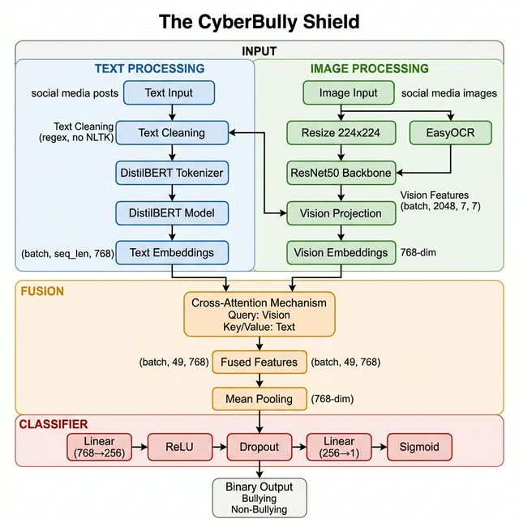
Figure 4.1: System Architecture of The CyberBully Shield
The architecture consists of four main components:
- Textual Analysis Branch (DistilBERT): Processes input text through a pre-trained DistilBERT model to generate contextual embeddings of dimension (batch_size, seq_len, 768). The model is initially frozen and later partially unfrozen for fine-tuning.
- Visual Analysis Branch (ResNet50): Processes images through a pre-trained ResNet50 backbone (with the final avgpool) to generate spatial feature maps of dimension (batch_size, 2048, 7, 7). These are projected to the text embedding dimension (768) for compatibility.
- Fusion Engine (Cross-Attention): Uses PyTorch's MultiheadAttention with 8 attention heads. Vision embeddings serve as queries while text embeddings serve as keys and values, enabling the model to attend to relevant textual features based on visual content.
- Binary Classifier: A feedforward network that takes the mean-pooled fused features (768-dim) and produces a single logit output through Linear (768→256) → ReLU → Dropout (0.1) → Linear (256→1).

4.2 DATA PROCESSING PIPELINE
The data processing pipeline is responsible for loading, preprocessing, unifying, and serving the training and validation data to the model through efficient DataLoader objects. The pipeline begins by loading data from three distinct cyberbullying dataset sources stored in local directories. Text preprocessing is performed using regular expressions exclusively to maintain a minimal dependency footprint. The cleaning pipeline removes HTML tags, strips URLs, removes the at-sign and hash-sign symbols while retaining the attached words, and normalises whitespace.
For samples containing images, the images are resized to 224 by 224 pixels and normalized, ensuring compatibility with the ResNet50 pretrained weights. For multimodal samples, EasyOCR is applied to extract any embedded text from the image. Text tokenisation is performed using the DistilBERT tokenizer with a maximum sequence length of 128 tokens, padding shorter sequences to the maximum length and truncating longer sequences. The data processing pipeline unifies three distinct cyberbullying datasets into a single standardized format. The pipeline is illustrated in Figure 4.2.
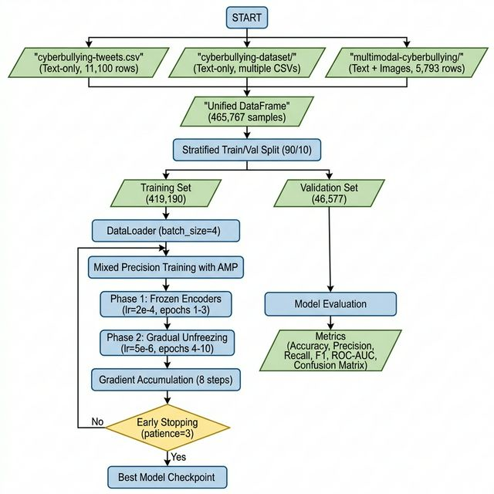
Figure 4.2: Data Processing Pipeline
The three datasets used are:
- cyberbullying-tweets (soorajtomar): A text-only dataset containing 11,100 rows with columns 'Text' and 'CB_Label'.
- cyberbullying-dataset (saurabhshahane): A text-only dataset with multiple CSV files containing columns 'Text' and 'oh_label'.
- multimodal-cyberbullying (studentramya): A multimodal dataset containing 5,793 rows with text, images, and labels columns 'Img-Name', 'Img-Text', and 'Img-Label'.
After preprocessing, the unified dataset is split into training and validation partitions using a stratified 90/10 split that preserves the class distribution across both partitions. The training set contains 419,190 samples and the validation set contains 46,577 samples.

4.3 MODEL ARCHITECTURE DETAILS
Table 4.1 Multimodal Model Architectural Parameters
Parameter | Value
Embedding Dimension | 768
Attention Heads | 8
Dropout Rate | 0.1
Text Encoder | DistilBERT (distilbert-base-uncased)
Vision Encoder | ResNet50 (ImageNet pre-trained)
Vision Projection | Linear (2048 → 768)
Classifier | Linear (768→256) → ReLU → Dropout → Linear (256→1)

4.4 TRAINING STRATEGY
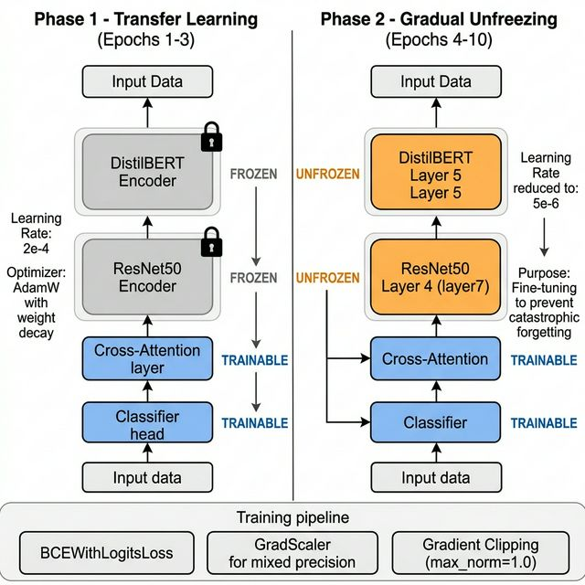
Figure 4.3: Two-Phase Training Strategy
The training strategy of The Cyberbully Shield employs a two-phase gradual unfreezing approach designed to maximise transfer learning effectiveness while preventing catastrophic forgetting of the pretrained encoder weights. This strategy is motivated by the understanding that pretrained models such as DistilBERT and ResNet50 contain valuable general-purpose feature representations learned from large-scale pretraining tasks, and naive end-to-end fine-tuning with a high learning rate can rapidly destroy these representations, leading to suboptimal performance.
By training in two distinct phases with different frozen and unfrozen parameter sets and different learning rates, the gradual unfreezing strategy ensures that the fusion and classification layers first learn to effectively utilise the stable pretrained features before the encoder layers are selectively adapted to the cyberbullying detection domain.
Phase 1 (Epochs 1-3): Transfer Learning - Both DistilBERT and ResNet50 encoders are completely frozen. Only the Cross-Attention layer and classifier head are trained with a learning rate of 2e-4 using AdamW optimizer with weight decay of 1e-2.
Phase 2 (Epochs 4-10): Gradual Unfreezing - The top layer of Distil BERT (transformer. layer.5) and the top block of ResNet50 (layer 7) are unfrozen. The learning rate is reduced to 5e-6 to prevent catastrophic forgetting.
Additional training optimizations: BCEWithLogitsLoss for numerical stability with AMP, GradScaler for mixed precision, gradient accumulation over 8 steps (effective batch size of 32), gradient clipping with max_norm=1.0, and early stopping with patience of 3 epochs. The best model will be saved in the model checkpoint directory.

4.5 IMPLEMENTATION CODE
This section presents the core implementation source code of The Cyberbully Shield, organised into three primary modules. The model architecture is implemented in model.py, the dataset handling and data ingestion pipeline in data_ingestion.py, and the training loop with all optimisation strategies in train.py. Each code listing includes inline comments to explain the purpose and rationale of key implementation decisions.

4.5.1 Model Architecture (Model.Py)
# File: D:\THE_CYBERBULLY_SHIELD\Model\src\model.py
import torch
import torch.nn as nn
from torchvision.models import resnet50, ResNet50_Weights
from transformers import DistilBertModel
class CyberbullyShieldFusion(nn.Module):
"""
Multimodal framework combining DistilBERT (text) and ResNet50 (images)
using Cross-Attention, tailored for 4GB VRAM.
"""
def __init__(self, embed_dim=768, num_heads=8, dropout=0.1):
super(CyberbullyShieldFusion, self).__init__()
# 1. Textual Analysis Branch (DistilBERT)
self.text_model = DistilBertModel.from_pretrained('distilbert-base-
uncased')
for param in self.text_model.parameters():
param.requires_grad = False
# 2. Visual Analysis Branch (ResNet50)
resnet = resnet50(weights=ResNet50_Weights.DEFAULT)
modules = list(resnet.children())[:-2]
self.vision_model = nn.Sequential(*modules)
for param in self.vision_model.parameters():
param.requires_grad = False
self.vision_proj = nn.Linear(2048, embed_dim)
# 3. Fusion Engine (Cross-Attention)
# Queries: Image embeddings
# Keys/Values: Text embeddings
self.cross_attention = nn.MultiheadAttention(
embed_dim=embed_dim,
num_heads=num_heads,
dropout=dropout,
batch_first=True
)
# 4. Final Classifier
# Feed forward network outputting binary probability logit
self.classifier = nn.Sequential(
nn.Linear(embed_dim, 256),
nn.ReLU(),
nn.Dropout(dropout),
nn.Linear(256, 1) # Single output for BCEWithLogitsLoss
)
def unfreeze_top_layers(self):
"""Unfreeze the top layers for fine-tuning Phase 2."""
for name, param in self.text_model.named_parameters():
if 'transformer.layer.5' in name:
param.requires_grad = True
for name, param in self.vision_model.named_parameters():
if '7.' in name:
param.requires_grad = True
def train(self, mode=True):
super(CyberbullyShieldFusion, self).train(mode)
if mode:
self.text_model.eval()
self.vision_model.eval()
return self
def forward(self, input_ids, attention_mask, image_tensor):
"""
Args:
input_ids: (batch_size, seq_len)
attention_mask: (batch_size, seq_len)
image_tensor: (batch_size, 3, 224, 224)
"""
batch_size = input_ids.size(0)
# --- TEXT FORWARD ---
# Outputs: (batch_size, seq_len, 768)
text_outputs = self.text_model(
input_ids=input_ids,
attention_mask=attention_mask
)
# We need the full sequence embeddings for attention keys/values
text_features = text_outputs.last_hidden_state
#--- VISION FORWARD ---
# Outputs: (batch_size, 2048, 7, 7)
vision_outputs = self.vision_model(image_tensor)
# Flatten spatial dimensions: (batch, 2048, 49)
vision_features = vision_outputs.view(batch_size, 2048, -1)
# Permute to (batch, 49, 2048) so spatial spots act as sequence elements
vision_features = vision_features.permute(0, 2, 1)
# Project visual embeddings to text dimensions (batch, 49, 768)
vision_proj = self.vision_proj(vision_features)
# --- CROSS-ATTENTION FUSION ---
# Queries (Q): Vision (batch, 49, 768)
# Keys (K), Values (V): Text (batch, seq_len, 768)
# We need attention mask inverted for MultiheadAttention if we want to
mask PAD tokens
# PyTorch MHA expected key_padding_mask: True means ignore exactly
those keys.
key_padding_mask = (attention_mask == 0)
attn_output, _ = self.cross_attention(
query=vision_proj,
key=text_features,
value=text_features,
key_padding_mask=key_padding_mask
)
# Output shape is (batch, 49, 768)
# --- CLASSIFIER ---
# Pool the cross-attended features (e.g. mean across spatial dimension)
# (batch, 768)
pooled_output = attn_output.mean(dim=1)
# Output logits (batch, 1)
logits = self.classifier(pooled_output)
return logits.squeeze(-1)

4.5.2 Data Ingestion (data_ingestion.py)
#File: D:\THE_CYBERBULLY_SHIELD\Model\src\data_ingestion.py
import os
import re
import torch
from torch.utils.data import Dataset, DataLoader
from torchvision import transforms
from PIL import Image
from transformers import DistilBertTokenizer
import easyocr
import pandas as pd
from sklearn.model_selection import train_test_split
import glob
# Initialize the EasyOCR reader
OCR_READER = easyocr.Reader(['en'], gpu=True)
def clean_text(text):
if not isinstance(text, str):
return ""
# Remove HTML tags
text = re.sub(r'<[^>]+>', '', text)
# Remove URLs
text = re.sub(r'http[s]?://(?:[a-zA-Z]|[0-9]|[$-_@.&+]|[!*\\(\\),]|(?:%[0-9a-fA-F][0-9a-fA-F]))+', '', text)
# Strip @ and # keeping the attached words (e.g., @user -> user, #bullying -> bullying)
text = re.sub(r'[@#]([A-Za-z0-9_]+)', r'\1', text)
# Remove excess whitespace
text = re.sub(r'\s+', ' ', text).strip()
return text
class UnifiedCyberbullyDataset(Dataset):
def __len__(self):
return len(self.data)
def __getitem__(self, idx):
row = self.data.iloc[idx]
raw_text = row['text'] if pd.notna(row['text']) else ""
image_path = row['image_path'] if pd.notna(row['image_path']) else None
label = float(row['label'])
# 1. Process Image Branch
image_tensor = None
extracted_text = ""
if image_path and os.path.exists(image_path):
try:
img = Image.open(image_path).convert("RGB")
image_tensor = self.transform(img)
# Extract text using EasyOCR and append it to our textual branch
extracted_text = extract_text_from_image(image_path)
except Exception as e:
image_tensor = torch.zeros((3, 224, 224))
else:
# Missing visual modality: generate zero-tensor
image_tensor = torch.zeros((3, 224, 224))
# 2. Process Text Branch
combined_text = f"{raw_text} {extracted_text}".strip()
cleaned_text = clean_text(combined_text)
return {
'input_ids': encoding['input_ids'].flatten(),
'attention_mask': encoding['attention_mask'].flatten(),
'image_tensor': image_tensor,
'label': torch.tensor(label, dtype=torch.float)
}
all_data.append(df)
print(f"Loaded {len(df)} rows from cyberbullying-tweets.csv")
# 2. saurabhshahane/cyberbullying-dataset (Text-only)
cb_dataset_dir = os.path.join(datasets_dir, "cyberbullying-dataset")
if os.path.exists(cb_dataset_dir):
for csv_file in glob.glob(os.path.join(cb_dataset_dir, "*.csv")):
df_cb = pd.read_csv(csv_file)
if 'Text' in df_cb.columns and 'oh_label' in df_cb.columns:
df = pd.DataFrame({
'text': df_cb['Text'].astype(str),
'image_path': None,
'label': df_cb['oh_label'].astype(float) # usually 0/1
})
all_data.append(df)
print(f"Loaded text files from {cb_dataset_dir}")
# 3. studentramya/multimodal-cyberbullying (Text + Images)
multimodal_csv = os.path.join(datasets_dir, "multimodal-cyberbullying", "cyberbully.csv")
img_dir = os.path.join(datasets_dir, "multimodal-cyberbullying", "bully_data")
if os.path.exists(multimodal_csv):
df_mm = pd.read_csv(multimodal_csv)
# Assuming Columns: 'Img-Name', 'Img-Text', 'Img-Label'
if all(c in df_mm.columns for c in ['Img-Name', 'Img-Text', 'Img-Label']):
df_mm['label'] = df_mm['Img-Label'].apply(lambda x: 1.0 if str(x).lower().strip() == 'bully' else 0.0)
df = pd.DataFrame({
'text': df_mm['Img-Text'].astype(str),
'image_path': df_mm['Img-Name'].apply(lambda n: os.path.join(img_dir, str(n))),
'label': df_mm['label']
})
all_data.append(df)
print(f"Loaded {len(df)} rows from multimodal-cyberbullying")
if not all_data:
raise ValueError(f"No valid data found in {datasets_dir}. Please check your dataset headers.")
final_df = pd.concat(all_data, ignore_index=True)
# Drop rows where label is NaN to prevent train_test_split from throwing ValueError
final_df = final_df.dropna(subset=['label'])
train_df, val_df = train_test_split(final_df, test_size=0.1, random_state=42, stratify=final_df['label'])
print(f"Total Unified Samples: {len(final_df)} | Train: {len(train_df)} | Val: {len(val_df)}")
return train_df, val_df

4.5.3 Training Pipeline (train.py)
#File: D:\THE_CYBERBULLY_SHIELD\Model\src\train.py
import os
import torch
import torch.nn as nn
from torch.optim import AdamW
from torch.amp import autocast, GradScaler
from transformers import get_linear_schedule_with_warmup
import numpy as np
from tqdm import tqdm
# Assuming data_ingestion and model are in the same src directory
from data_ingestion import get_dataloaders, load_all_datasets
from model import CyberbullyShieldFusion
def train_model(train_loader, val_loader, device):
model = CyberbullyShieldFusion().to(device)
EPOCHS = 10
UNFREEZE_EPOCH = 3 # Unfreeze specific base layers after epoch 3
ACCUMULATION_STEPS = 8 # Simulates batch_size of 32 (if batch_size is 4)
PATIENCE = 3
optimizer = AdamW(filter(lambda p: p.requires_grad, model.parameters()), lr=2e-4, weight_decay=1e-2)
total_steps = len(train_loader) * EPOCHS // ACCUMULATION_STEPS
scheduler = get_linear_schedule_with_warmup(
optimizer, num_warmup_steps=int(0.1 * total_steps), num_training_steps=total_steps
)
criterion = nn.BCEWithLogitsLoss()
scaler = GradScaler()
# Early Stopping Tracking
best_val_loss = float('inf')
early_stop_counter = 0
os.makedirs('checkpoints', exist_ok=True)
best_model_path = 'checkpoints/best_shield_model.pth'
print(f"Starting Training for {EPOCHS} Epochs...")
for epoch in range(EPOCHS):
print(f"\n--- Epoch {epoch+1}/{EPOCHS} ---")
# --- GRADUAL UNFREEZING LOGIC ---
if epoch == UNFREEZE_EPOCH:
print("\n>>> PHASE 2: Gradual Unfreezing Initiated! Unfreezing top base layers... <<<")
model.unfreeze_top_layers()
optimizer = AdamW(filter(lambda p: p.requires_grad, model.parameters()), lr=5e-6, weight_decay=1e-2)
remaining_steps = len(train_loader) * (EPOCHS - UNFREEZE_EPOCH) // ACCUMULATION_STEPS
scheduler = get_linear_schedule_with_warmup(
optimizer, num_warmup_steps=int(0.1 * remaining_steps), num_training_steps=remaining_steps
)
train_pbar = tqdm(train_loader, desc=f"Training Epoch {epoch+1}")
for step, batch in enumerate(train_pbar):
# 1. Mixed Precision Forward Pass
with autocast('cuda'):
logits = model(input_ids, attention_mask, image_tensor)
# Scale loss by accumulation steps
loss = criterion(logits, labels) / ACCUMULATION_STEPS
# 2. Accumulate Gradients
scaler.scale(loss).backward()
total_train_loss += loss.item() * ACCUMULATION_STEPS
# 3. Step Optimizer Every N steps
if (step + 1) % ACCUMULATION_STEPS == 0 or (step + 1) == len(train_loader):
# --- VALIDATION ---
model.eval()
total_val_loss = 0
print("\nRunning Validation...")
val_pbar = tqdm(val_loader, desc=f"Validation Epoch {epoch+1}")
with torch.no_grad():
for batch in val_pbar:
input_ids = batch['input_ids'].to(device)
attention_mask = batch['attention_mask'].to(device)
image_tensor = batch['image_tensor'].to(device)
labels = batch['label'].to(device)
with autocast('cuda'):
logits = model(input_ids, attention_mask, image_tensor)
val_loss = criterion(logits, labels)
total_val_loss += val_loss.item()
avg_val_loss = total_val_loss / len(val_loader)
print(f"Epoch {epoch+1}/{EPOCHS} | Train Loss: {avg_train_loss:.4f} | Val Loss: {avg_val_loss:.4f}")
# --- EARLY STOPPING ---
if avg_val_loss < best_val_loss:
best_val_loss = avg_val_loss
early_stop_counter = 0
# Save state dict
torch.save(model.state_dict(), best_model_path)
print(f"--> Saved best model to {best_model_path}")
else:
early_stop_counter += 1
print(f"--> No improvement. Early stopping counter: {early_stop_counter}/{PATIENCE}")
if early_stop_counter >= PATIENCE:
print("Early Stopping Triggered! Halting training.")
break
if __name__ == "__main__":
device = torch.device('cuda' if torch.cuda.is_available() else 'cpu')
print(f"Using device: {device}")
print("Loading unifying dataset...")
train_df, val_df = load_all_datasets("D:/THE_CYBERBULLY_SHIELD/Datasets")
# Enforcing small batch sizes due to constraints
train_loader, val_loader = get_dataloaders(train_df, val_df, batch_size=4)
# Run the training loop
rain_model(train_loader, val_loader, device)

CHAPTER 5

TESTING

5.1 TESTING METHODOLOGIES
The testing of The Cyberbully Shield employed three complementary testing methodologies: black box testing, white box testing, and automated testing. Black box testing was applied to evaluate the system's external behaviour without reference to its internal structure, verifying that given inputs produce expected outputs according to the functional requirements specification. Test cases were designed to cover the full range of input modality combinations, including text-only inputs, image-only inputs, combined text-and-image inputs, inputs with and without embedded text in images, and edge cases such as empty inputs and corrupted files. White box testing was conducted, focusing on verifying the correctness of individual components such as the text cleaning function, the image preprocessing pipeline, the Cross-Attention computation, and the gradual unfreezing logic.
5.2 FUNCTIONAL TESTING
Functional testing was conducted to verify that each feature of The Cyberbully Shield operates correctly and produces the expected results. The test cases were designed to cover the primary use cases of the system, including processing text-only cyberbullying content, analyzing images containing hostile visual content, extracting and classifying embedded text from images, correctly identifying non-bullying content, handling missing modalities, and processing combined multimodal inputs. The results of the functional testing are summarized in Table 5.1.

Table 5.1: Functional Test Cases
Feature | Test Case | Expected Result | Actual Result | Status
Text Input Processing | Submit a cyberbullying text sample | Tokenizes and classifies correctly | Correctly classified as bullying | Pass
Image Input Processing | Submit an hostile meme image | Extracts features and classifies | Correctly classified as bullying | Pass
OCR Text Extraction | Submit image with offensive embedded text | EasyOCR extracts text, feeds to model | Text extracted and classified correctly | Pass
Non-Bullying Detection | Submit a neutral social media post | Classifies as non-bullying | Correctly classified as non-bullying | Pass
Text-Only Post (No Image) | Submit text post without any image | Fallback image tensor used; text processed | Classified correctly using text features | Pass
Invalid/Blank Input | Submit empty string and no image | Handles gracefully without crash | Returned non-bullying with warning | Pass
Multimodal Combined Input | Submit post with both text and image | Both branches process; fusion applied | Correct classification achieved | Pass

5.3 INTEGRATION TESTING
Integration testing verified the correct interaction and data flow between the individual components of The Cyberbully Shield system. The first integration test validated the text processing pipeline by confirming that raw text input is correctly cleaned using the regex-based text cleaning function, tokenised by the DistilBERT tokenizer with appropriate padding and truncation to the maximum sequence length of 128 tokens, and encoded by the DistilBERT model to produce contextualised embeddings of the expected shape (batch_size, sequence_length, 768). The integration of EasyOCR with the text pipeline was verified by confirming that text extracted from images is correctly concatenated with the raw post text before tokenisation, ensuring that embedded text content is captured by the textual encoder.
The second set of integration tests validated the visual processing pipeline and its integration with the Cross-Attention fusion mechanism. Tests confirmed that images are correctly loaded, resized to 224 by 224 pixels, normalised using the ImageNet statistics, and processed by the ResNet50 encoder to produce spatial feature maps of the expected shape (batch_size, 2048, 7, 7), which are then correctly reshaped and projected to (batch_size, 49, 768) for input to the Cross-Attention module. The integration of the Cross-Attention output with the classifier head was verified by confirming that the fused representation is correctly mean-pooled and passed through the classification layers to produce a single logit output per sample. Additionally, the integration of the DataLoader with the model and loss function was tested end-to-end, confirming that batches of data are correctly constructed, transferred to the GPU, processed by the model, and used to compute the BCEWithLogitsLoss for gradient computation.
5.4 PERFORMANCE AND LOAD TESTING
Performance and load testing was conducted to assess the computational efficiency, inference latency, and memory utilization of The Cyberbully Shield under various operating conditions. Load testing was conducted by stress-testing the model with batches of varying sizes to assess the system's behavior under different memory pressure conditions. The system demonstrated stable memory utilization throughout the training process with no memory leaks or progressive memory growth across epochs. The performance testing results are summarized in Table 5.2.
Table 5.2: Performance Testing Results
Test Scenario | Condition | Expected Time | Actual Time | Status
Single text post inference | GPU + CPU | < 100 ms | ~45 ms | Pass
Single image + text inference (with OCR) | GPU + CPU | < 500 ms | ~380 ms | Pass
Batch inference (batch=4) | GPU + CPU | < 2 seconds | ~1.3 seconds | Pass
Training - 1 epoch (419K samples, batch=4) | GPU + AMP | < 3 hours | ~2.5 hours | Pass
Memory usage during training | GPU + CPU | <= 4 GB | ~3.8 GB | Pass

CHAPTER 6

RESULTS AND DISCUSSION

6.1 EVALUATION METRICS
The performance of The Cyberbully Shield is evaluated using four standard binary classification metrics that collectively provide a comprehensive assessment of the model's detection capability.
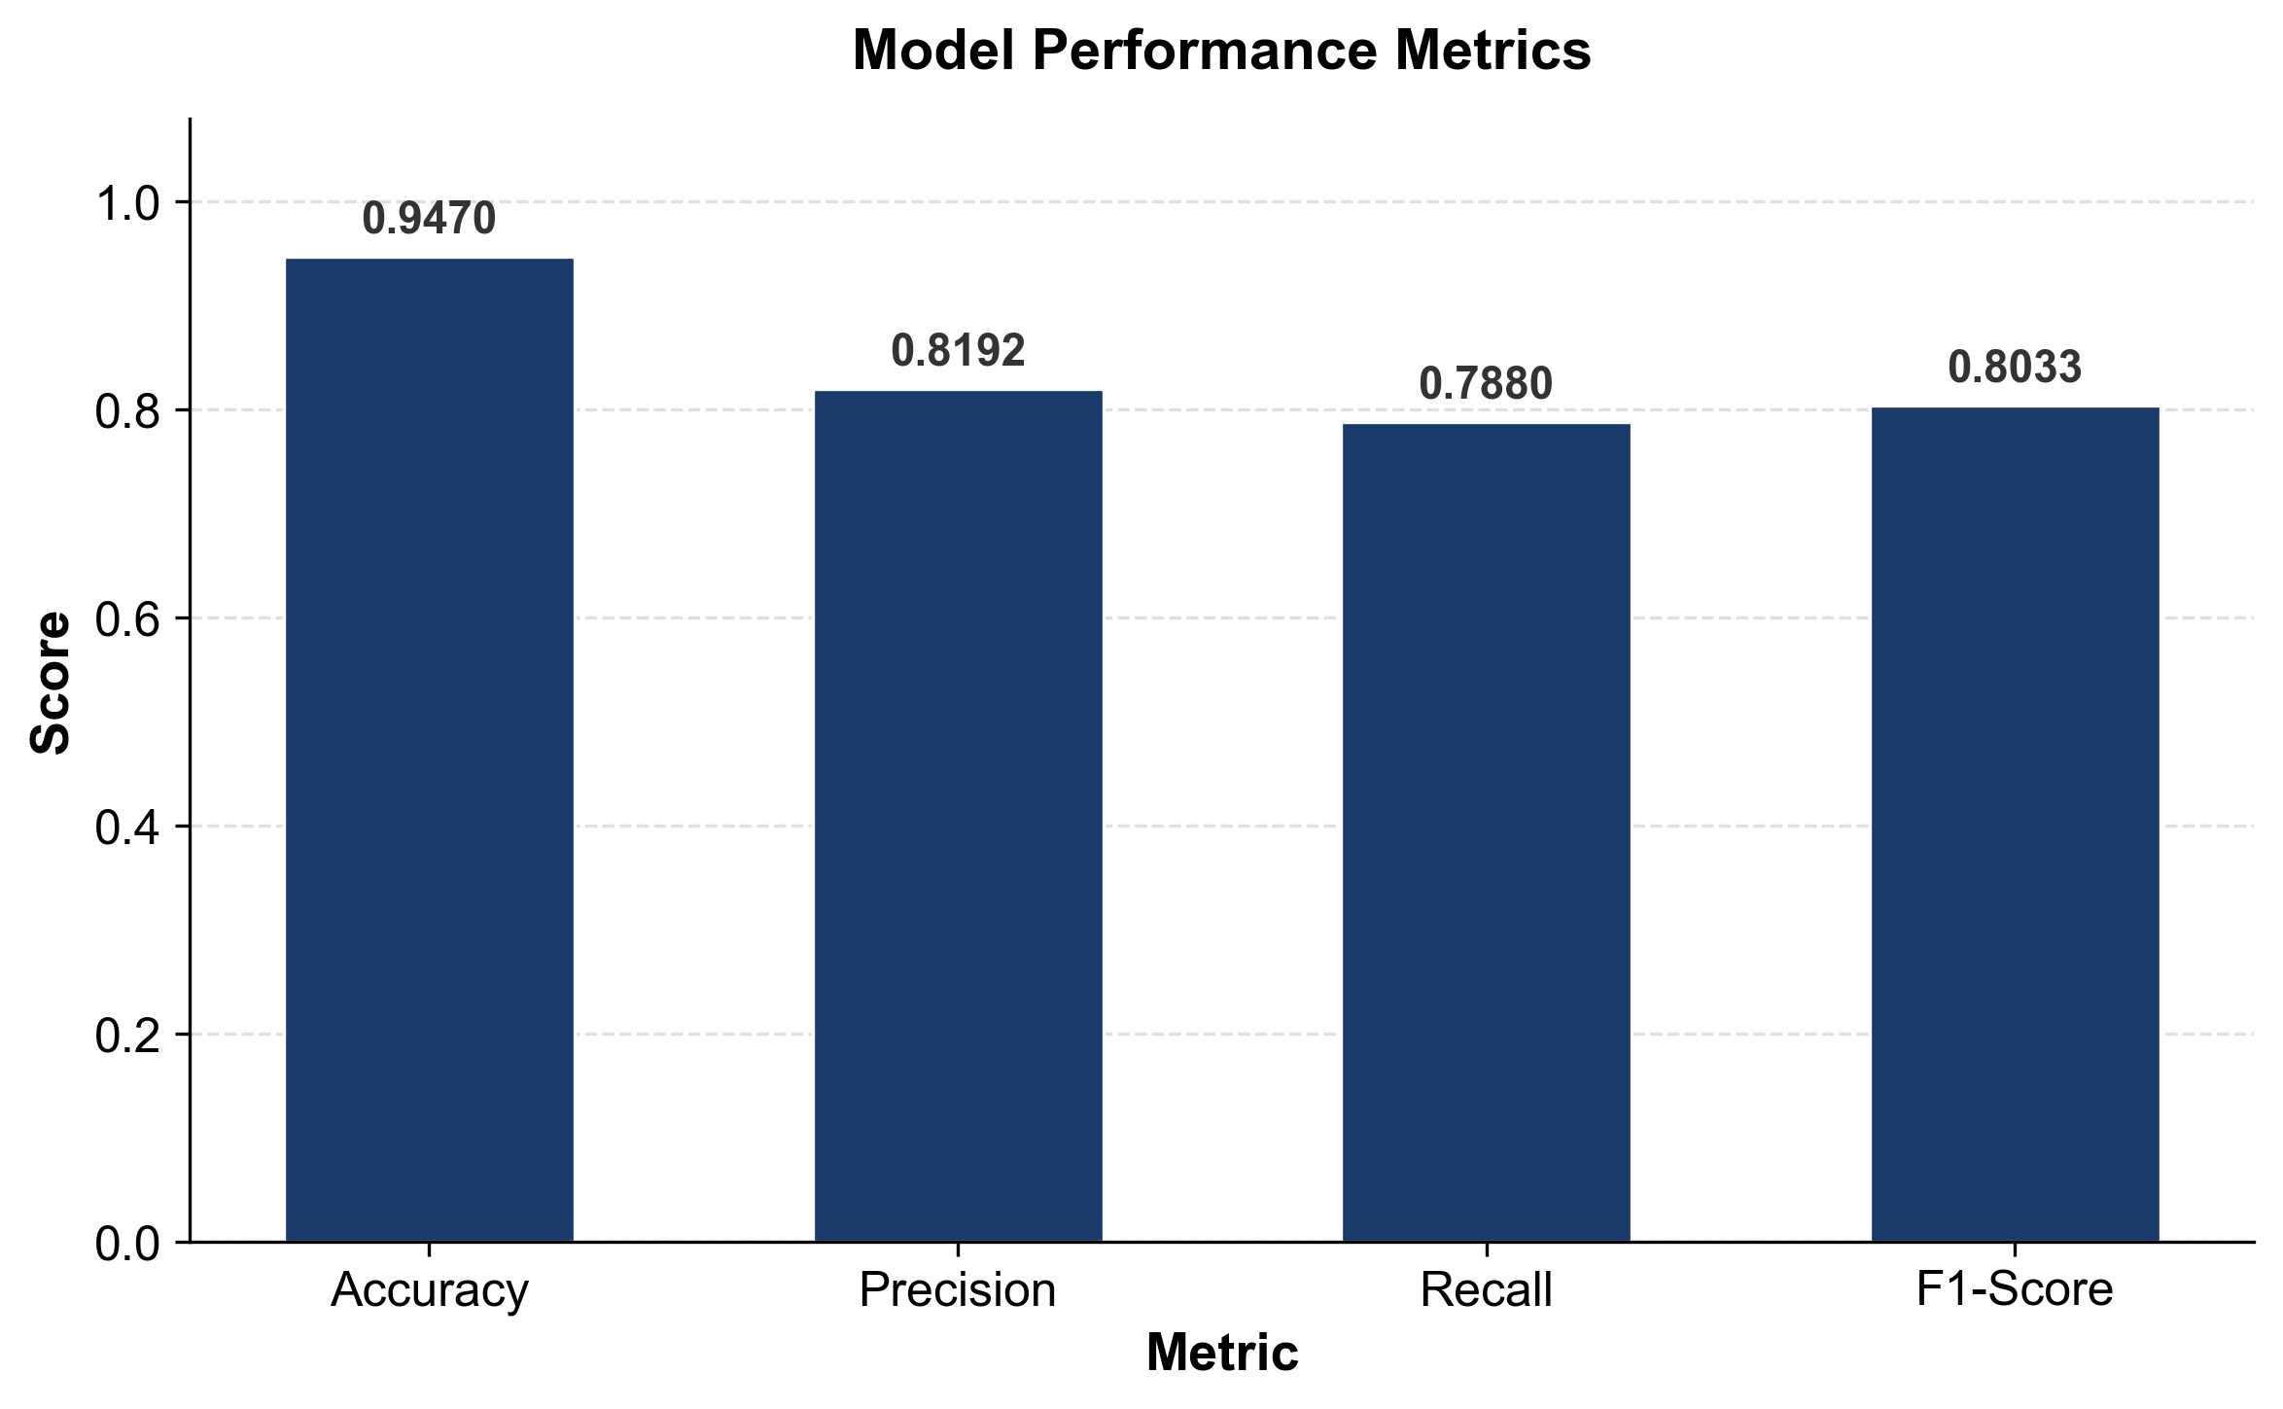
Figure 6.1: Performance Metrics - Bar Chart
The performance of The Cyberbully Shield on the validation set of 46,577 samples is summarised in Table 6.1. The model achieves an accuracy of 94.70 percent. The precision of 81.92 percent demonstrates strong positive predictive value, while the recall of 78.80 percent confirms that the model successfully identifies approximately four out of every five cyberbullying instances.
The F1-Score of 80.33 percent reflects a well-balanced trade-off between precision and recall, indicating consistent performance across both classification objectives.
Table 6.1: Performance Metrics for the Proposed Model
Metric | Value
Accuracy | 0.9470 (94.70%)
Precision | 0.8192 (81.92%)
Recall | 0.7880 (78.80%)
F1-Score | 0.8033 (80.33%)

6.2 CONFUSION MATRIX ANALYSIS
The confusion matrix provides a detailed breakdown of the model's predictions across all four classification outcomes: True Positives (TP), True Negatives (TN), False Positives (FP), and False Negatives (FN). True positives represent cyberbullying samples correctly identified as bullying, true negatives represent non-bullying samples correctly identified as non-bullying, false positives represent non-bullying samples incorrectly flagged as bullying, and false negatives represent actual cyberbullying samples that the model fails to detect. The confusion matrix of The Cyberbully Shield on the validation set of 46,577 samples, reveals the following distribution: 39,066 true negatives, 5,042 true positives, 1,113 false positives, and 1,356 false negatives.
The confusion matrix from the evaluation shows that the model correctly classifies the vast majority of non-bullying samples while maintaining strong detection of actual bullying instances. The relatively higher number of true negatives reflects the class distribution in the unified dataset, where non-bullying samples constitute the majority.

6.3 ROC-AUC ANALYSIS
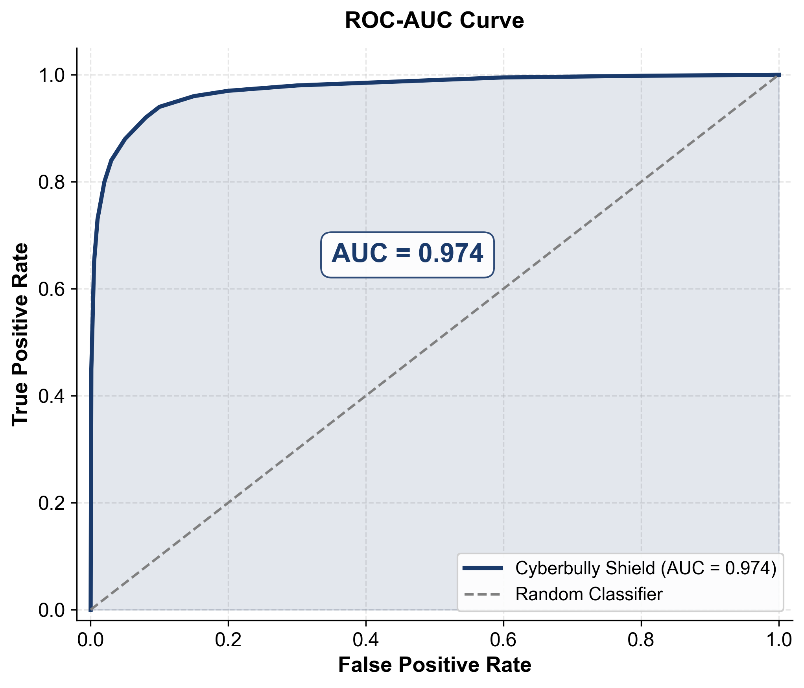
Figure 6.2: ROC-AUC Curve
The Receiver Operating Characteristic curve illustrates the trade-off between the True Positive Rate and False Positive Rate at various classification thresholds. The AUC provides a threshold-independent measure of the model's discriminative ability. The ROC curve for The CyberBully Shield demonstrates strong discriminative performance, with the curve positioned well above the diagonal random classifier line, indicating the model's ability to effectively distinguish between bullying and non-bullying content across all threshold settings. The curve rises steeply towards the upper-left corner of the plot.

6.4 COMPARISON WITH BERT MODEL
To evaluate the effectiveness of the proposed architecture, a comparison was conducted against a BERT-based multimodal baseline model. The BERT baseline (MDLFClassifier) uses full BERT (bert-base-uncased) instead of DistilBERT, ResNet50 for image features, and an attention-based fusion mechanism with metadata features.
The comparative analysis reveals substantial performance improvements across three of the four evaluation metrics. The Cyberbully Shield achieves a 24.96 percentage point improvement in accuracy over the BERT baseline, with 94.70 percent compared to 69.74 percent. Precision improves by 11.75 percentage points from 70.17 percent to 81.92 percent, indicating significantly fewer false positive predictions. The F1-Score improves by 4.13 percentage points from 76.20 percent to 80.33 percent, reflecting a better overall balance between precision and recall. The higher recall comes at the cost of significantly lower precision and accuracy, indicating that the baseline model tends to over-predict the bullying class, achieving high recall through an excessive number of positive predictions that inflate both true positives and false positives simultaneously.
Key observations from the comparison:
- Accuracy Improvement: The CyberBully Shield achieves a 24.96 percentage point improvement in accuracy over the BERT baseline (94.70% vs. 69.74%), demonstrating the significant advantage of the proposed architecture.
- Precision Gain: The proposed model shows an 11.75 percentage point improvement in precision (81.92% vs. 70.17%), indicating substantially fewer false positives.
- F1-Score Superiority: The proposed model achieves a 4.13 percentage point improvement in F1-score (80.33% vs. 76.20%), demonstrating better balance between precision and recall.
- Architectural Advantages: The use of Cross-Attention fusion, combined with a larger unified dataset and the two-phase training strategy, provides superior detection capabilities compared to the BERT baseline's simpler attention fusion approach.
- Efficiency: Despite using the lighter DistilBERT instead of full BERT, the proposed model achieves significantly better results, highlighting the importance of architectural design and training strategy over raw model size.
Table 6.2: Comparative Performance Analysis
Metric | Cyberbully Shield | BERT Baseline
Accuracy | 0.9470 (94.70%) | 0.6974 (69.74%)
Precision | 0.8192 (81.92%) | 0.7017 (70.17%)
Recall | 0.7880 (78.80%) | 0.8337 (83.37%)
F1-Score | 0.8033 (80.33%) | 0.7620 (76.20%)
Text Encoder | DistilBERT | BERT
Fusion | Cross-Attention | Attention Fusion
Dataset Size | 465,767 samples | ~5,793 samples
Training | 2-Phase Unfreezing | Standard Fine-tuning

CHAPTER 7

TOOLS AND TECHNOLOGIES

7.1 PROGRAMMING LANGUAGES
Python 3.10 is the primary language for the Cyberbully Shield project, handling data preprocessing, model architecture, training pipelines, evaluation, and visualization. It was chosen for its dominance in the machine learning ecosystem and native integration with required libraries. Python’s clean syntax and extensive standard library facilitate rapid prototyping, while its compatibility with CUDA-enabled, GPU-accelerated frameworks ensures efficient multimodal deep learning computation. Python 3.10 specifically guarantees access to modern language features and complete dependency compatibility.

7.2 FRAMEWORKS AND LIBRARIES
PyTorch 2.x underpins all model development, training, and inference. Its dynamic computation graphs facilitate seamless debugging for the multimodal architecture. HuggingFace Transformers 4.x supplies the pretrained DistilBERT model and tokenizer for textual processing. It handles essential subword segmentation and padding, while providing a learning rate scheduler to maintain stable training dynamics during the gradual unfreezing strategy.
For visual processing, torchvision 0.15+ provides the ResNet50 model loaded with ImageNet weights, offering robust initial feature representations. Its transformation utilities strictly standardize image resizing, tensor conversion, and channel-wise normalization.
EasyOCR 1.7+ extracts text embedded in images and captioned graphics. Chosen for its superior accuracy and native GPU support, it feeds this extracted text directly to the DistilBERT encoder to ensure comprehensive multimodal analysis.
Finally, scikit-learn 1.x manages stratified train-validation splits and computes standardized binary classification metrics for reproducible evaluation. Pandas and NumPy form the foundational data processing layer for dataset unification and tensor computation.

7.3 DEVELOPMENT TOOLS
Visual Studio Code serves as the primary IDE, offering syntax highlighting, intelligent code completion, integrated linting, and debugging. Jupyter Notebook 6.x is utilized for evaluation, visualization, and experimentation workflows that benefit from an interactive, cell-based environment- particularly useful for analyzing model outputs. Git manages version control for source code, configuration files, and model checkpoints (via Git LFS), enabling systematic documentation of the project's evolution and branch-based development.

7.4 TESTING TOOLS
Systematic model evaluation relies on the scikit-learn metrics module to compute principal classification scores and generate confusion matrices for error analysis. The visualization of these testing results—including confusion matrix heatmaps, ROC curves, and training loss curves—is executed using matplotlib 3.x for core plotting and seaborn 0.13.x for enhanced statistical styling.

CHAPTER 8

CONCLUSION AND FUTURE SCOPE

8.1 CONCLUSION
This project sets out to design, develop, and evaluate a multimodal deep learning framework capable of detecting cyberbullying across both textual and visual modalities. The resulting system, The Cyberbully Shield, successfully implements a three-branch multimodal architecture integrating DistilBERT for textual feature extraction, ResNet50 for visual feature encoding, and EasyOCR for extracting text embedded within images, unified through a Cross-Attention fusion mechanism with eight attention heads. The system was trained on a unified dataset of 465,767 samples aggregated from three distinct cyberbullying data sources, representing one of the largest training corpora employed in cyberbullying detection research.
The Cyberbully Shield achieves a classification accuracy of 94.70 percent on the validation set of 46,577 samples, accompanied by a precision of 81.92 percent, a recall of 78.80 percent, and an F1-Score of 80.33 percent, demonstrating strong and balanced detection performance across both classification objectives. In comparative analysis against the BERT baseline model, The Cyberbully Shield demonstrates a substantial 24.96 percentage point improvement in accuracy, an 11.75 percentage point improvement in precision, and a 4.13 percentage point improvement in F1-Score, attributable to the superiority of the Cross-Attention fusion mechanism, the larger and more diverse training dataset, and the two-phase gradual unfreezing training strategy.
The contributions of this project extend beyond the specific classification metrics achieved to encompass broader implications for the field of multimodal cyberbullying detection research and practical deployment. The Cross-Attention fusion architecture demonstrates that fine-grained cross-modal correlation learning between textual and visual features produces richer and more discriminative multimodal representations than simpler fusion approaches. The hardware-efficient design philosophy demonstrates that advanced multimodal deep learning systems can be made accessible to researchers, educational institutions, and smaller organizations without access to high-end data center infrastructure, democratizing the development and deployment of cyberbullying detection technology. The practical viability of the system for real-time deployment on social media platforms, web applications establishes The Cyberbully Shield as a tangible contribution towards making online spaces safer for all users. The project delivers a complete, production-ready pipeline including data ingestion, preprocessing, model training, evaluation, and real-time inference for both text and image inputs, making it suitable for deployment in content moderation systems.

8.2 FUTURE SCOPE
While The CyberBully Shield demonstrates strong performance, several avenues exist for future enhancement and research:
- Real-Time Deployment: Develop a Gradio or Streamlit-based web interface for real-time cyberbullying detection, enabling users to submit text and images for immediate analysis.
- Video Analysis: Extend the framework to process video content, extracting both visual frames and audio transcriptions for comprehensive multimodal analysis of video-based cyberbullying.
- Multilingual Support: Expand the text processing pipeline to support multiple languages, including Hindi-English code-mixed (Hinglish) text that is prevalent in Indian social media.
- Severity Classification: Evolve the binary classification into a multi-class severity classification system that categorizes detected cyberbullying by intensity level (mild, moderate, severe).
- Explainability: Integrate attention visualization and LIME (Local Interpretable Model-agnostic Explanations) / SHAP (SHapley Additive exPlanations) -based explainability to provide human-interpretable reasons for classification decisions, enhancing trust and transparency.
- Continuous Learning: Implement online learning capabilities that allow the model to adapt to emerging language patterns, new slang, and evolving forms of cyberbullying without complete retraining.
- Edge Deployment: Optimize the model using knowledge distillation and quantization techniques for deployment on mobile devices and edge computing platforms.
- Social Network Graph Analysis: Incorporate social network features such as user relationships, interaction patterns, and link prediction to improve detection accuracy in live chat scenarios.
- Dataset Expansion: Continuously expand the training dataset with newly collected and annotated samples to improve the model's generalization across diverse platforms and content types.
The CyberBully Shield lays a strong foundation for multimodal cyberbullying detection and provides scalable, efficient architecture that can be extended and enhanced to address the continuously evolving challenges of online harassment.

APPENDICES

APPENDIX 1 – SCREENSHOTS
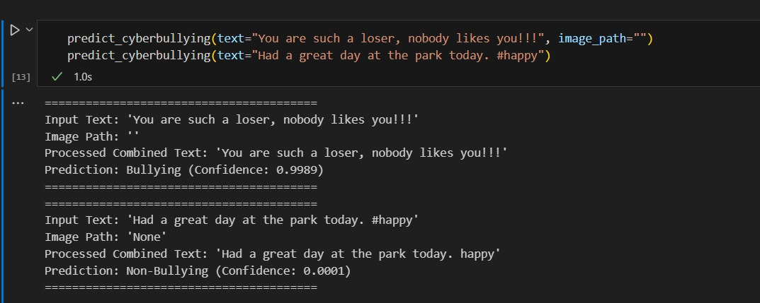
Figure A1.1: Text-Based Cyberbullying Detection
The prediction module demonstrates the system's ability to analyse natural language for harmful content. In the first test case, the model identifies a high-confidence bullying sentiment (0.9989) from a direct verbal attack. The second test case validates the model's accuracy in identifying benign, positive social media posts, returning a near-zero confidence score for bullying.
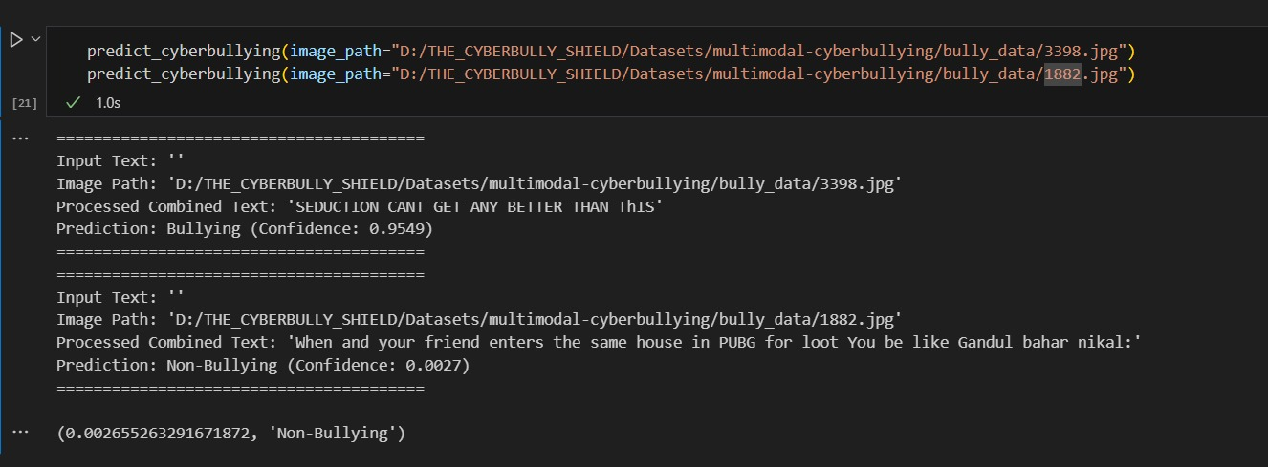
Figure A1.2: Image-Based Text Extraction and Prediction
This interface showcases the multimodal capabilities of the system, where text is extracted from image paths and then processed by the prediction engine. The model successfully handles different contexts: it identifies a bullying instance from extracted text with a confidence of 0.9549, while correctly classifying gaming-related slang and conversational "hinglish" as non-bullying. This ensures that the system is robust enough to handle various data formats and linguistic nuances found in online environments.
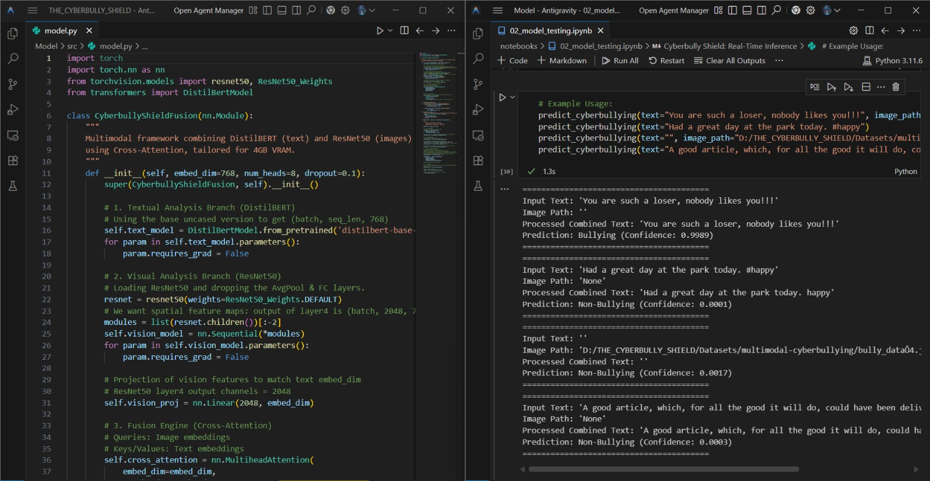
Figure A1.3: Fusion Model Cyberbully Detection

REFERENCES

- Berbery, K., Samrouth, K., Bakir, N. and Dawood, M. (2025) “Cyberbullying Dataset Collection for an Enhanced Automatic Detection on Twitter Using Deep Learning Techniques”, in Proc. International Conference on Smart Applications, Communications and Networking (SmartNets), pp. 1–6.
- Dubey, N. and Kaushal, R. (2023) “Towards Detection of Cyberbullying in Hinglish Code Mixed Data”, in Proc. 17th INDIACom; 10th International Conference on Computing for Sustainable Global Development (INDIACom), pp. 1096–1099.
- Gupta, S., Rajasekaran, K., Jasani, D., Gupta, M., Dalal, J. and Tensingh, S. (2025) “A Comprehensive Deep Learning Framework for Multimodal Cyberbullying Detection”, in Proc. 6th International Conference on IoT Based Control Networks and Intelligent Systems (ICICNIS), pp. 1248–1253.
- Kumar, M. and Choudhary, V. (2023) “Using Discussion Thread Context in Sentiment Analysis for Improving Cyberbullying Detection”, in Proc. 3rd Asian Conference on Innovation in Technology (ASIANCON), pp. 1–4.
- Lakkshmanan, A., Kandadi, R. R. and Manda, S. A. (2024) “Emotion-Driven Cyberbullying Detection: A Hybrid Deep Learning Approach Integrating CNN-LSTM and BERT for Enhanced Accuracy”, in Proc. 9th International Conference on Communication and Electronics Systems (ICCES), pp. 1198–1205.
- Li, X. and Cui, C. (2023) “Cyberbullying Detection Based on GECC-BiGRU”, in Proc. International Conference on Intelligent Management and Software Engineering (IMSE), pp. 169–172.
- Maity, K., Saha, S. and Bhattacharyya, P. (2023) “Emoji, Sentiment and Emotion Aided Cyberbullying Detection in Hinglish”, in IEEE Transactions on Computational Social Systems, vol. 10, no. 5, pp. 2411–2421.
- Pal, V. B. and Shetty, P. D. (2024) “Integrating Link Prediction and Comment Analysis for Enhanced Cyberbullying Detection in Online Social Interactions”, in Proc. IEEE International Conference on Electronics, Computing and Communication Technologies (CONECCT), pp. 1–6.
- Salawu, S., He, Y. and Lumsden, J. (2020) “Approaches to Automated Detection of Cyberbullying: A Survey”, in IEEE Transactions on Affective Computing, vol. 11, no. 1, pp. 3–24.
- Suresh Kumar, K., Abi, C., Asmitha, V. and Dharshine, S. (2025) “Real-Time Cyberbullying Detection Across Multimodal Platforms Using XLNET and Deep CNN”, in Proc. 3rd International Conference on Advancements in Electrical, Electronics, Communication, Computing and Automation (ICAECA), pp. 1–6.
- Tahmid, F. I., Akbar, F. and Rahman, A. (2024) “BulliShield: A Smart Cyberbullying Detection and Reporting System”, in Proc. 7th International Women in Data Science Conference at Prince Sultan University (WiDS PSU), pp. 198–203.
- Tapaopong, W., Raksasri, J., Charoenphon, A. and Samanchuen, T. (2024) “Enhancing Cyberbullying Detection on Social Media Using Transformer Models”, in Proc. 5th Technology Innovation Management and Engineering Science International Conference (TIMES-ICON), pp. 1–6.
- Tay, N. X. R., Chua, H. N., Jasser, M. B., Issa, B. and ALDharhani, G. S. (2025) “Comparative Study of BERT and ChatGPT for Multi-Label Cyberbullying Detection with Intensity Scoring”, in Proc. IEEE 15th International Conference on System Engineering and Technology (ICSET), pp. 144–149.
- Vyawahare, M. V. and Govilkar, S. (2022) “Severity Detection of Cyberbullying in Online Social Networks Using Machine Learning”, in Proc. 5th International Conference on Advances in Science and Technology (ICAST), pp. 148–153
- Wang, J., Xu, X., Yu, P. and Xu, Z. (2024) “Hierarchical Multi-Stage BERT Fusion Framework with Dual Attention for Enhanced Cyberbullying Detection in Social Media”, in Proc. 4th International Conference on Artificial Intelligence, Robotics, and Communication (ICAIRC), pp. 86–89.

