

**NAVRACHANA UNIVERSITY**

# SCHOOL OF ENGINEERING & TECHNOLOGY

**BTech-IT**

**PROJECT**

**RECORD**

**(Review Phase -2)**

**Final Year BTech-IT**

**SEMESTER: 7**

# COURSE:IN HOUSE PROJECT

**COURSE CODE:**

# ACADEMIC YEAR: 2022-23 SEMESTER: AUTUMN

**TEAM ID:23**

# PROJECT NAME: Green Leaf.

**MEMBER IDs & NAMES: 19125059-Vijay Vaghela, 19125060-**

# Gauatam Shah.

**PHASE -2 SYSTEM REQUIREMENT ANALYSIS AND SYSTEM MODELLING**

# TASK 1: SDLC Model

We are using Waterfall model in our E-commerce website.

Waterfall methodology or Waterfall development cycle is known as the traditional development technique. It generally focuses on planning the project thoroughly and outlines out all of the specific steps like a waterfall.

Everything you require done flows above and spills into the project until everything’s been coded, then you call it done.

During the first stage, steps and operations are determined for the whole project, and the choices are frozen. There is no flexibility for making changes, although it always does.

#### Diagram:

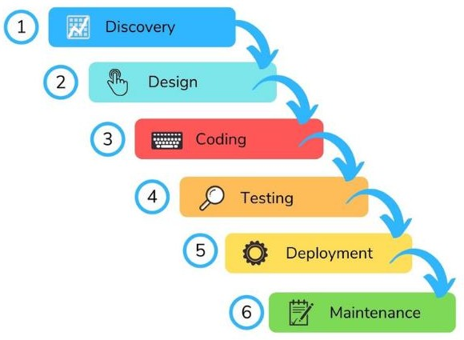

*Why Choose Waterfall?*

You’d be surprised to know that decision making may be an unconscious activity and there’s a high chance that you’d pick the waterfall despite not choosing it consciously.

Most human brains like to stick to a task, complete it, and then move to the second one. So, you can say the waterfall model is partly embodied in our subconscious mind.

Since it reeks of naturalism the waterfall web development approach automatically makes things easier for eCommerce development.

# Literature survey

1. Zomato
2. SpiceBox
3. My Dabba Food

### Zomato:

Zomato initially named as Foodie bay was started in 2008 by Mr. Deepinder Goyal. It is a restaurant searching platform providing in-depth details with autonomous reviews and ratings. Foodie bay, the initial name was changed to Zomato in November 2010 to increase their reach among people.

* To make homemade Tiffin easily available to users and tracking the vendor for delivery.
* Useful for college students, hostel residents and employees.

As the application will provide a platform for ordering a home-made meal on the go.

### SpiceBox:

Name– SpiceBox Location – Mumbai and Navi-Mumbai.

Working – This program provides vegetarian and vegetarian diets to users (customers). Provides other veg / non-veg diet dates. SpiceBox also offers a discounted price, if one offers tiffin orders for food for a period of days

Limits – 1. Do not give different foods every week. 2. It is not easy to use.

### My Dabba Food

Name - My Dabba Food Location - Provided in various locations in India.

Working - This website provides Tiffin services in various locations in India. The organization's plan is to provide a Tiffin Centre location for local users / markers. It shows the location of the Tiffin Centre near his place.

Benefits - A customer (Tiffin supplier) can easily grow his business in his area.

# Business Drivers

Thus the online retail business can deliver more advanced services faster because of three main factors: scalability, intricacy, and velocity – which are crucial key drivers of ecommerce.

# Business model

* An e-commerce business model is how your e-commerce business is structured conceptually in order to reach customers and drive sales. There are several types of e-commerce business models that enable different kinds of companies to position themselves in the market and reach their customers in an effective way.

# Functional and System Requirements

#### Functional Requirements:

* + Mobile-friendliness.
  + Unique, recognizable design.
  + Shipping & payment systems integration.
  + Live chat. System Requirements:
  + Fast, stable & secure web hosting.
  + Highly-responsive mobile site.
  + User-friendly web design.
  + Fast checkout process.

# Technical requirements

* + Fast, stable & secure web hosting. ...
  + Highly-responsive mobile site. ...
  + User-friendly web design. ...
  + Robust operation systems. ...
  + Fast checkout process. ...
  + Transparent brand information pages. ...
  + SEO-friendly web pages. ...
  + Smooth sales channels integration.

# System qualities

* Content management capabilities.
* Promotion & discount code tools.
* An easy-to-use checkout.
* SEO friendly code and layout.
* Advanced E-Commerce SEO capabilities.
* Reporting tools & custom report features.
* An integrated blog or articles section.

# Constraints and assumptions

#### Constraints:

The most frequently cited challenges to e-commerce, among firms with no online sales, include the cost together with uncertainty about return on investment. These firms also often mentioned inadequate connectivity and information technology (IT) infrastructure as substantial hurdles.

#### Assumptions:

* + Target Relevant Market.
  + Improved Brand & Product Awareness.
  + Simple Global Coverage.
  + Increased Customer Retention.
  + International Exposure.
  + Economical Business Solution.

# Acceptance criteria

The Acceptance Criteria Search for a product by name or category. View products by category. View images and details for each product. Add to cart from the detail or search pages.

# TASK 2: context model

In context model customer will send order and do payment then the sales department will send invoice to reception department and it will forward the payment details and order details to sales department then the sales department will send order details to warehouse and then the message to the department and message will be send to customer that payment is received.

**DIAGRAM:**

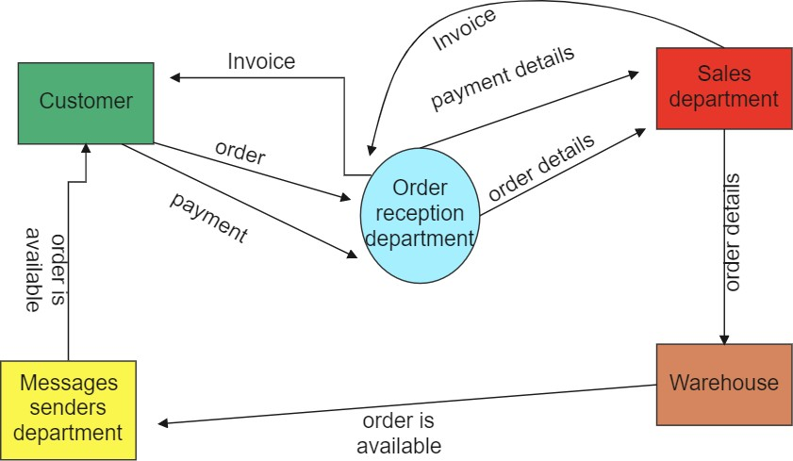

**TASK 3: UML Diagrams**

We have created a Use case Diagram, ERdiagram, Class diagram, Object diagram, Activity diagram and a Sequence diagram for our service that we are modelling.

# Use Case

The use cases represent the main processes in E-commerce Website. Then they will be broken down into more specific use cases depending on the included sub-processes. Each of these use cases explains how the system handles the actions or scenarios requested by the user.

This diagram shows the general processes or function that the system could do. These processes are based on the activities done in the website.

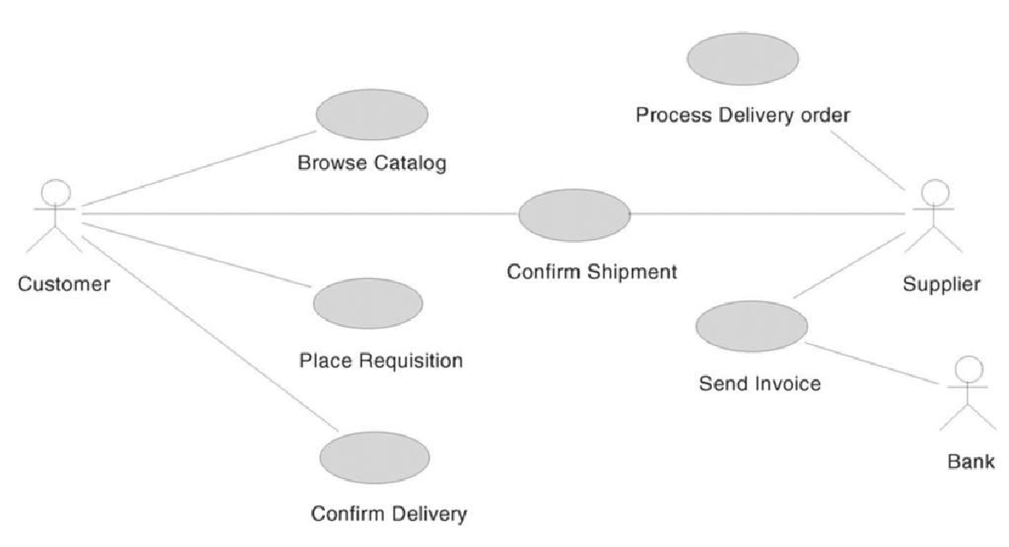

# ER- diagram

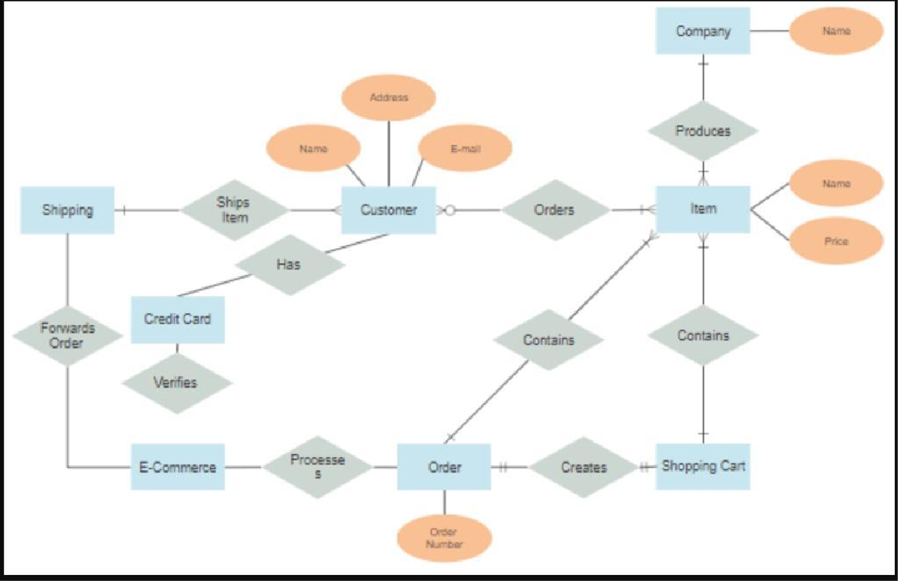

**Class Diagram**

The Class diagram for E-Commerce Website shows the structures data that will be handled in the website. These data or information will be represented by classes. Each of the classes will have their attributes in accord to the methods they will use.

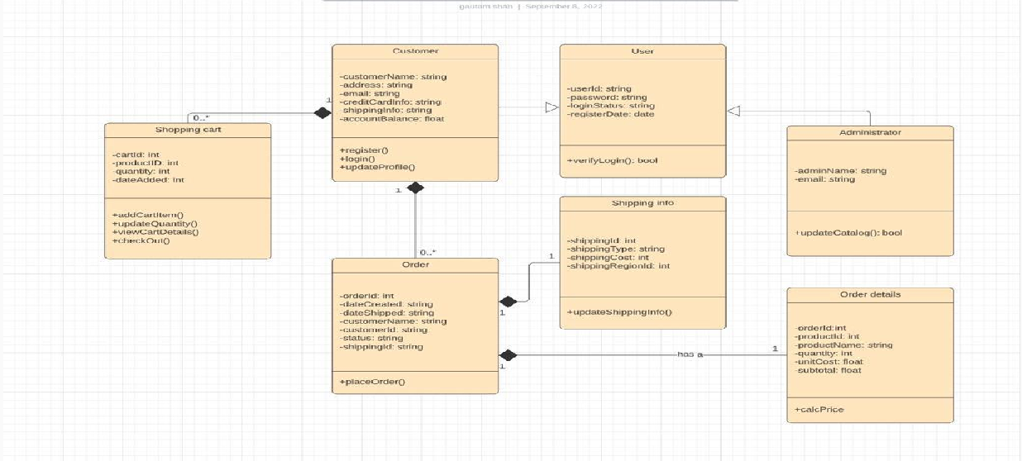

# Object Diagram

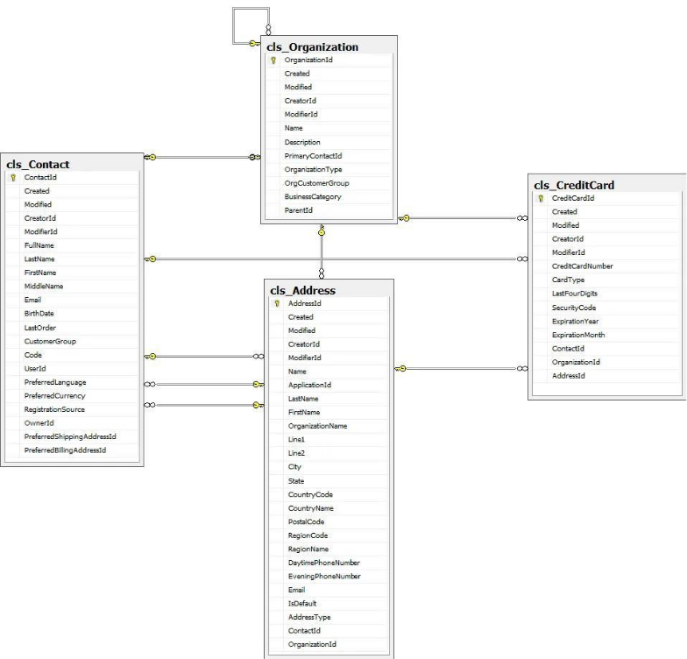

**Activity Diagram**

The UML Activity Diagram is used to show the interaction between the user and E- Commerce Website. You’ll see the flaws of the system and avoid it using Activity Diagram on the project development.

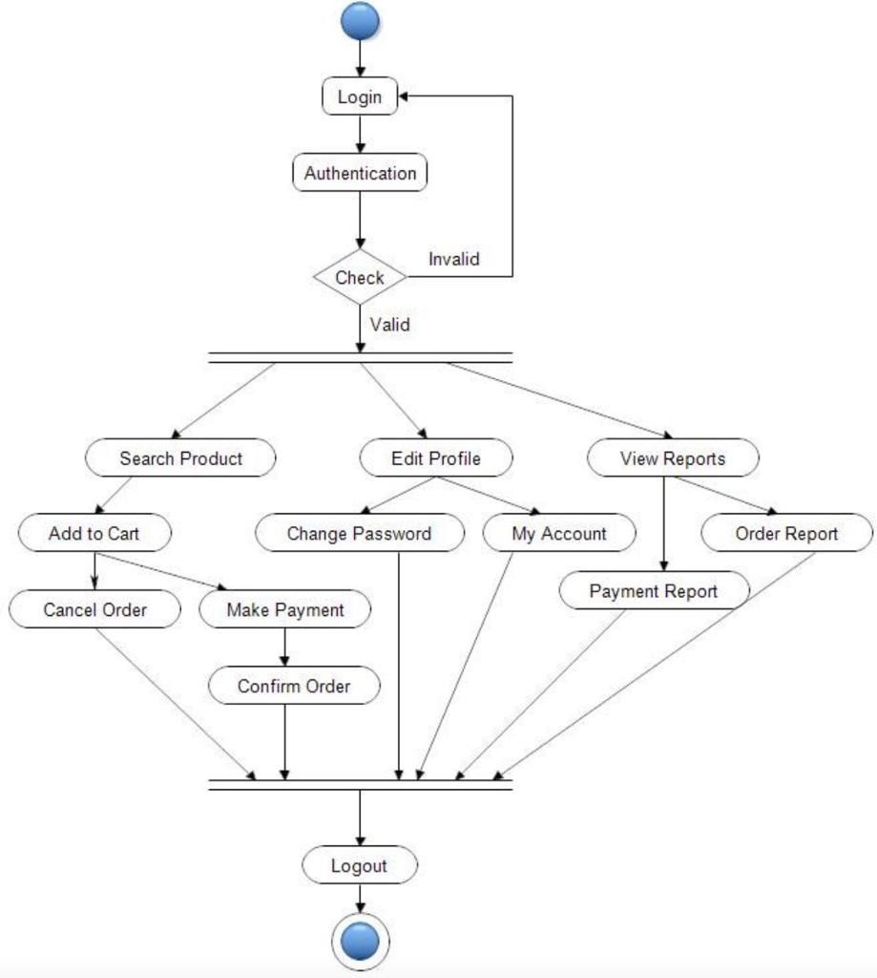

# Sequence Diagram:

The designed sequence diagram shows the series of events that occurs in E-Commerce Website. The actors are represented by a stick man and the transactions or classes are represented by objects. This gives you clear explanation E-Commerce Website behavior in terms of processing the flow of instructions. This designed sequence diagram is able to show programmers and readers about the sequence of messages between the actor and the objects.

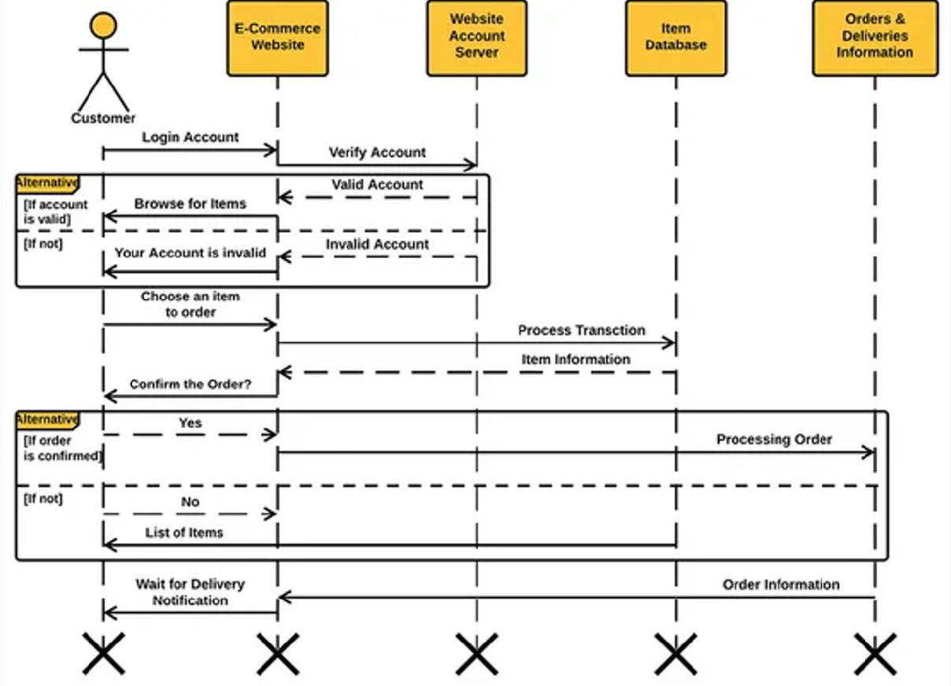

# CONCLUSION

As a whole, the UML Diagrams works together to achieve the most desired functions of the E-Commerce Website Project. All of these were designed to guide programmers and beginners about the behavior and structure of E-Commerce Website.

By completing all the given Diagrams, the E-Commerce Website development would be much easier and attainable. So those UML diagrams were given to teach you and guide you through your project development journey. You can use all of the given UML diagrams as your reference, or have them for your project development. The ideas presented in UML Diagrams were all based on E-Commerce Website requirements.

# FUTURE SCOPE

## Review History:

|  |  |  |
| --- | --- | --- |
| **Review**  **No.** | **Suggestions** | **Changes incorporated** |
| 1 | Think about business model. Think about  mobile application along with website application. | We have applied business model  in or project and we are Thinking to add mobile application. |
|  |  |  |
|  |  |  |

### Actionable Items:

* Application Development
* Business model

# REFERENCES

1. [https://www.googleadservices.com/pagead/aclk?sa=L&ai=DChcSEwjq-](https://www.googleadservices.com/pagead/aclk?sa=L&ai=DChcSEwjq-anG7Ir0AhULupYKHS3yCLIYABAAGgJ0bA&ae=2&ei=VS-KYaDTK8-7qtsP1KW18AQ&ohost=www.google.com&cid=CAESQOD2bSZAhqGatj782fxNExJw-rJBzHrOG1XB8xphNegJf4HrEOeR_ZBivZCbPpEwBzb9fgQyk1vJJfVWpeourxo&sig=AOD64_1WJ5LokEefyBcX-v5pRVFsDNwytg&q&sqi=2&adurl&ved=2ahUKEwjg0ZbG7Ir0AhXPnWoFHdRSDU4Q0Qx6BAgCEAE) [anG7Ir0AhULupYKHS3yCLIYABAAGgJ0bA&ae=2&ei=VS-KYaDTK8-](https://www.googleadservices.com/pagead/aclk?sa=L&ai=DChcSEwjq-anG7Ir0AhULupYKHS3yCLIYABAAGgJ0bA&ae=2&ei=VS-KYaDTK8-7qtsP1KW18AQ&ohost=www.google.com&cid=CAESQOD2bSZAhqGatj782fxNExJw-rJBzHrOG1XB8xphNegJf4HrEOeR_ZBivZCbPpEwBzb9fgQyk1vJJfVWpeourxo&sig=AOD64_1WJ5LokEefyBcX-v5pRVFsDNwytg&q&sqi=2&adurl&ved=2ahUKEwjg0ZbG7Ir0AhXPnWoFHdRSDU4Q0Qx6BAgCEAE) [7qtsP1KW18AQ&ohost=www.google.com&cid=CAESQOD2bSZAhqGatj782fxNExJw-](https://www.googleadservices.com/pagead/aclk?sa=L&ai=DChcSEwjq-anG7Ir0AhULupYKHS3yCLIYABAAGgJ0bA&ae=2&ei=VS-KYaDTK8-7qtsP1KW18AQ&ohost=www.google.com&cid=CAESQOD2bSZAhqGatj782fxNExJw-rJBzHrOG1XB8xphNegJf4HrEOeR_ZBivZCbPpEwBzb9fgQyk1vJJfVWpeourxo&sig=AOD64_1WJ5LokEefyBcX-v5pRVFsDNwytg&q&sqi=2&adurl&ved=2ahUKEwjg0ZbG7Ir0AhXPnWoFHdRSDU4Q0Qx6BAgCEAE) [rJBzHrOG1XB8xphNegJf4HrEOeR_ZBivZCbPpEwBzb9fgQyk1vJJfVWpeourxo&sig=AOD](https://www.googleadservices.com/pagead/aclk?sa=L&ai=DChcSEwjq-anG7Ir0AhULupYKHS3yCLIYABAAGgJ0bA&ae=2&ei=VS-KYaDTK8-7qtsP1KW18AQ&ohost=www.google.com&cid=CAESQOD2bSZAhqGatj782fxNExJw-rJBzHrOG1XB8xphNegJf4HrEOeR_ZBivZCbPpEwBzb9fgQyk1vJJfVWpeourxo&sig=AOD64_1WJ5LokEefyBcX-v5pRVFsDNwytg&q&sqi=2&adurl&ved=2ahUKEwjg0ZbG7Ir0AhXPnWoFHdRSDU4Q0Qx6BAgCEAE) [64_1WJ5LokEefyBcX-](https://www.googleadservices.com/pagead/aclk?sa=L&ai=DChcSEwjq-anG7Ir0AhULupYKHS3yCLIYABAAGgJ0bA&ae=2&ei=VS-KYaDTK8-7qtsP1KW18AQ&ohost=www.google.com&cid=CAESQOD2bSZAhqGatj782fxNExJw-rJBzHrOG1XB8xphNegJf4HrEOeR_ZBivZCbPpEwBzb9fgQyk1vJJfVWpeourxo&sig=AOD64_1WJ5LokEefyBcX-v5pRVFsDNwytg&q&sqi=2&adurl&ved=2ahUKEwjg0ZbG7Ir0AhXPnWoFHdRSDU4Q0Qx6BAgCEAE) [v5pRVFsDNwytg&q&sqi=2&adurl&ved=2ahUKEwjg0ZbG7Ir0AhXPnWoFHdRSDU4Q0](https://www.googleadservices.com/pagead/aclk?sa=L&ai=DChcSEwjq-anG7Ir0AhULupYKHS3yCLIYABAAGgJ0bA&ae=2&ei=VS-KYaDTK8-7qtsP1KW18AQ&ohost=www.google.com&cid=CAESQOD2bSZAhqGatj782fxNExJw-rJBzHrOG1XB8xphNegJf4HrEOeR_ZBivZCbPpEwBzb9fgQyk1vJJfVWpeourxo&sig=AOD64_1WJ5LokEefyBcX-v5pRVFsDNwytg&q&sqi=2&adurl&ved=2ahUKEwjg0ZbG7Ir0AhXPnWoFHdRSDU4Q0Qx6BAgCEAE) [Qx6BAgCEAE](https://www.googleadservices.com/pagead/aclk?sa=L&ai=DChcSEwjq-anG7Ir0AhULupYKHS3yCLIYABAAGgJ0bA&ae=2&ei=VS-KYaDTK8-7qtsP1KW18AQ&ohost=www.google.com&cid=CAESQOD2bSZAhqGatj782fxNExJw-rJBzHrOG1XB8xphNegJf4HrEOeR_ZBivZCbPpEwBzb9fgQyk1vJJfVWpeourxo&sig=AOD64_1WJ5LokEefyBcX-v5pRVFsDNwytg&q&sqi=2&adurl&ved=2ahUKEwjg0ZbG7Ir0AhXPnWoFHdRSDU4Q0Qx6BAgCEAE)
2. <https://itsourcecode.com/uml/e-commerce-website-uml-diagrams-complete/>
3. <https://www.canva.com/>
4. [https://www.academia.edu/36834610/Tiffin_Services_Application_and_Live_Tracki](https://www.academia.edu/36834610/Tiffin_Services_Application_and_Live_Tracking) [ng](https://www.academia.edu/36834610/Tiffin_Services_Application_and_Live_Tracking)
5. <https://www.irjet.net/archives/V9/i5/IRJET-V9I574.pdf>
6. [https://www.google.com/search?q=business+model+canvas+for+e-](https://www.google.com/search?q=business%2Bmodel%2Bcanvas%2Bfor%2Be-commerce%2Bshop&sxsrf=ALiCzsYVJTSevZmnlq5REQi5xvV9te_G0w%3A1663268492624&ei=jHYjY4ngJbPb4-EP3aak2Ak&oq=Business%2Bmodel%2Bcan%2Bfor%2BE-Commerce%2Bshop&gs_lcp=Cgdnd3Mtd2l6EAMYADIICCEQwwQQoAE6CggAEEcQ1gQQsAM6BAgjECc6BwgjELACECdKBAhBGABKBAhGGABQowNYhiFg-StoAnABeACAAeIBiAHpBpIBBTAuNC4xmAEAoAEByAEIwAEB&sclient=gws-wiz) [commerce+shop&sxsrf=ALiCzsYVJTSevZmnlq5REQi5xvV9te_G0w%3A166326849262](https://www.google.com/search?q=business%2Bmodel%2Bcanvas%2Bfor%2Be-commerce%2Bshop&sxsrf=ALiCzsYVJTSevZmnlq5REQi5xvV9te_G0w%3A1663268492624&ei=jHYjY4ngJbPb4-EP3aak2Ak&oq=Business%2Bmodel%2Bcan%2Bfor%2BE-Commerce%2Bshop&gs_lcp=Cgdnd3Mtd2l6EAMYADIICCEQwwQQoAE6CggAEEcQ1gQQsAM6BAgjECc6BwgjELACECdKBAhBGABKBAhGGABQowNYhiFg-StoAnABeACAAeIBiAHpBpIBBTAuNC4xmAEAoAEByAEIwAEB&sclient=gws-wiz) [4&ei=jHYjY4ngJbPb4-EP3aak2Ak&oq=Business+model+can+for+E-](https://www.google.com/search?q=business%2Bmodel%2Bcanvas%2Bfor%2Be-commerce%2Bshop&sxsrf=ALiCzsYVJTSevZmnlq5REQi5xvV9te_G0w%3A1663268492624&ei=jHYjY4ngJbPb4-EP3aak2Ak&oq=Business%2Bmodel%2Bcan%2Bfor%2BE-Commerce%2Bshop&gs_lcp=Cgdnd3Mtd2l6EAMYADIICCEQwwQQoAE6CggAEEcQ1gQQsAM6BAgjECc6BwgjELACECdKBAhBGABKBAhGGABQowNYhiFg-StoAnABeACAAeIBiAHpBpIBBTAuNC4xmAEAoAEByAEIwAEB&sclient=gws-wiz) [Commerce+shop&gs_lcp=Cgdnd3Mtd2l6EAMYADIICCEQwwQQoAE6CggAEEcQ1gQQ](https://www.google.com/search?q=business%2Bmodel%2Bcanvas%2Bfor%2Be-commerce%2Bshop&sxsrf=ALiCzsYVJTSevZmnlq5REQi5xvV9te_G0w%3A1663268492624&ei=jHYjY4ngJbPb4-EP3aak2Ak&oq=Business%2Bmodel%2Bcan%2Bfor%2BE-Commerce%2Bshop&gs_lcp=Cgdnd3Mtd2l6EAMYADIICCEQwwQQoAE6CggAEEcQ1gQQsAM6BAgjECc6BwgjELACECdKBAhBGABKBAhGGABQowNYhiFg-StoAnABeACAAeIBiAHpBpIBBTAuNC4xmAEAoAEByAEIwAEB&sclient=gws-wiz) [sAM6BAgjECc6BwgjELACECdKBAhBGABKBAhGGABQowNYhiFg-](https://www.google.com/search?q=business%2Bmodel%2Bcanvas%2Bfor%2Be-commerce%2Bshop&sxsrf=ALiCzsYVJTSevZmnlq5REQi5xvV9te_G0w%3A1663268492624&ei=jHYjY4ngJbPb4-EP3aak2Ak&oq=Business%2Bmodel%2Bcan%2Bfor%2BE-Commerce%2Bshop&gs_lcp=Cgdnd3Mtd2l6EAMYADIICCEQwwQQoAE6CggAEEcQ1gQQsAM6BAgjECc6BwgjELACECdKBAhBGABKBAhGGABQowNYhiFg-StoAnABeACAAeIBiAHpBpIBBTAuNC4xmAEAoAEByAEIwAEB&sclient=gws-wiz) [StoAnABeACAAeIBiAHpBpIBBTAuNC4xmAEAoAEByAEIwAEB&sclient=gws-wiz](https://www.google.com/search?q=business%2Bmodel%2Bcanvas%2Bfor%2Be-commerce%2Bshop&sxsrf=ALiCzsYVJTSevZmnlq5REQi5xvV9te_G0w%3A1663268492624&ei=jHYjY4ngJbPb4-EP3aak2Ak&oq=Business%2Bmodel%2Bcan%2Bfor%2BE-Commerce%2Bshop&gs_lcp=Cgdnd3Mtd2l6EAMYADIICCEQwwQQoAE6CggAEEcQ1gQQsAM6BAgjECc6BwgjELACECdKBAhBGABKBAhGGABQowNYhiFg-StoAnABeACAAeIBiAHpBpIBBTAuNC4xmAEAoAEByAEIwAEB&sclient=gws-wiz)
7. [https://www.google.com/search?q=Business+model+for+E-](https://www.google.com/search?q=Business%2Bmodel%2Bfor%2BE-Commerce%2Bshop&oq=Business%2Bmodel%2Bfor%2BE-Commerce%2Bshop&aqs=chrome..69i57j0i22i30j0i390l3.4269j0j7&sourceid=chrome&ie=UTF-8) [Commerce+shop&oq=Business+model+for+E-](https://www.google.com/search?q=Business%2Bmodel%2Bfor%2BE-Commerce%2Bshop&oq=Business%2Bmodel%2Bfor%2BE-Commerce%2Bshop&aqs=chrome..69i57j0i22i30j0i390l3.4269j0j7&sourceid=chrome&ie=UTF-8) [Commerce+shop&aqs=chrome..69i57j0i22i30j0i390l3.4269j0j7&sourceid=chrome&i](https://www.google.com/search?q=Business%2Bmodel%2Bfor%2BE-Commerce%2Bshop&oq=Business%2Bmodel%2Bfor%2BE-Commerce%2Bshop&aqs=chrome..69i57j0i22i30j0i390l3.4269j0j7&sourceid=chrome&ie=UTF-8) [e=UTF-8](https://www.google.com/search?q=Business%2Bmodel%2Bfor%2BE-Commerce%2Bshop&oq=Business%2Bmodel%2Bfor%2BE-Commerce%2Bshop&aqs=chrome..69i57j0i22i30j0i390l3.4269j0j7&sourceid=chrome&ie=UTF-8)
8. [https://www.google.com/search?q=business+Drivers+for+e-](https://www.google.com/search?q=business%2BDrivers%2Bfor%2Be-commerce%2Bshop&oq=business%2BDrivers%2Bfor%2Be-commerce%2Bshop&aqs=chrome..69i57j33i15i22i29i30j33i22i29i30.10317j0j15&sourceid=chrome&ie=UTF-8) [commerce+shop&oq=business+Drivers+for+e-](https://www.google.com/search?q=business%2BDrivers%2Bfor%2Be-commerce%2Bshop&oq=business%2BDrivers%2Bfor%2Be-commerce%2Bshop&aqs=chrome..69i57j33i15i22i29i30j33i22i29i30.10317j0j15&sourceid=chrome&ie=UTF-8) [commerce+shop&aqs=chrome..69i57j33i15i22i29i30j33i22i29i30.10317j0j15&sourc](https://www.google.com/search?q=business%2BDrivers%2Bfor%2Be-commerce%2Bshop&oq=business%2BDrivers%2Bfor%2Be-commerce%2Bshop&aqs=chrome..69i57j33i15i22i29i30j33i22i29i30.10317j0j15&sourceid=chrome&ie=UTF-8) [eid=chrome&ie=UTF-8](https://www.google.com/search?q=business%2BDrivers%2Bfor%2Be-commerce%2Bshop&oq=business%2BDrivers%2Bfor%2Be-commerce%2Bshop&aqs=chrome..69i57j33i15i22i29i30j33i22i29i30.10317j0j15&sourceid=chrome&ie=UTF-8)
9. [https://www.google.com/search?q=Acceptance+Criteria+of+e-](https://www.google.com/search?q=Acceptance%2BCriteria%2Bof%2Be-commerce%2Bwebsite&sxsrf=ALiCzsZxgBVJHwF6Lt2Q_1H1qDl4QAks2A%3A1663270727994&ei=R38jY6qmPJf2wAOW1JqACg&ved=0ahUKEwjq5aCnxpf6AhUXO3AKHRaqBqAQ4dUDCA4&uact=5&oq=Acceptance%2BCriteria%2Bof%2Be-commerce%2Bwebsite&gs_lcp=Cgdnd3Mtd2l6EAMyBQgAEKIEMgcIABAeEKIEMgUIABCiBDoKCAAQRxDWBBCwA0oECEEYAEoECEYYAFDhBVjhBWDZCWgCcAF4AIABtQGIAbUBkgEDMC4xmAEAoAECoAEByAEIwAEB&sclient=gws-wiz) [commerce+website&sxsrf=ALiCzsZxgBVJHwF6Lt2Q_1H1qDl4QAks2A%3A166327072](https://www.google.com/search?q=Acceptance%2BCriteria%2Bof%2Be-commerce%2Bwebsite&sxsrf=ALiCzsZxgBVJHwF6Lt2Q_1H1qDl4QAks2A%3A1663270727994&ei=R38jY6qmPJf2wAOW1JqACg&ved=0ahUKEwjq5aCnxpf6AhUXO3AKHRaqBqAQ4dUDCA4&uact=5&oq=Acceptance%2BCriteria%2Bof%2Be-commerce%2Bwebsite&gs_lcp=Cgdnd3Mtd2l6EAMyBQgAEKIEMgcIABAeEKIEMgUIABCiBDoKCAAQRxDWBBCwA0oECEEYAEoECEYYAFDhBVjhBWDZCWgCcAF4AIABtQGIAbUBkgEDMC4xmAEAoAECoAEByAEIwAEB&sclient=gws-wiz) [7994&ei=R38jY6qmPJf2wAOW1JqACg&ved=0ahUKEwjq5aCnxpf6AhUXO3AKHRaqBq](https://www.google.com/search?q=Acceptance%2BCriteria%2Bof%2Be-commerce%2Bwebsite&sxsrf=ALiCzsZxgBVJHwF6Lt2Q_1H1qDl4QAks2A%3A1663270727994&ei=R38jY6qmPJf2wAOW1JqACg&ved=0ahUKEwjq5aCnxpf6AhUXO3AKHRaqBqAQ4dUDCA4&uact=5&oq=Acceptance%2BCriteria%2Bof%2Be-commerce%2Bwebsite&gs_lcp=Cgdnd3Mtd2l6EAMyBQgAEKIEMgcIABAeEKIEMgUIABCiBDoKCAAQRxDWBBCwA0oECEEYAEoECEYYAFDhBVjhBWDZCWgCcAF4AIABtQGIAbUBkgEDMC4xmAEAoAECoAEByAEIwAEB&sclient=gws-wiz) [AQ4dUDCA4&uact=5&oq=Acceptance+Criteria+of+e-](https://www.google.com/search?q=Acceptance%2BCriteria%2Bof%2Be-commerce%2Bwebsite&sxsrf=ALiCzsZxgBVJHwF6Lt2Q_1H1qDl4QAks2A%3A1663270727994&ei=R38jY6qmPJf2wAOW1JqACg&ved=0ahUKEwjq5aCnxpf6AhUXO3AKHRaqBqAQ4dUDCA4&uact=5&oq=Acceptance%2BCriteria%2Bof%2Be-commerce%2Bwebsite&gs_lcp=Cgdnd3Mtd2l6EAMyBQgAEKIEMgcIABAeEKIEMgUIABCiBDoKCAAQRxDWBBCwA0oECEEYAEoECEYYAFDhBVjhBWDZCWgCcAF4AIABtQGIAbUBkgEDMC4xmAEAoAECoAEByAEIwAEB&sclient=gws-wiz) [commerce+website&gs_lcp=Cgdnd3Mtd2l6EAMyBQgAEKIEMgcIABAeEKIEMgUIABCi](https://www.google.com/search?q=Acceptance%2BCriteria%2Bof%2Be-commerce%2Bwebsite&sxsrf=ALiCzsZxgBVJHwF6Lt2Q_1H1qDl4QAks2A%3A1663270727994&ei=R38jY6qmPJf2wAOW1JqACg&ved=0ahUKEwjq5aCnxpf6AhUXO3AKHRaqBqAQ4dUDCA4&uact=5&oq=Acceptance%2BCriteria%2Bof%2Be-commerce%2Bwebsite&gs_lcp=Cgdnd3Mtd2l6EAMyBQgAEKIEMgcIABAeEKIEMgUIABCiBDoKCAAQRxDWBBCwA0oECEEYAEoECEYYAFDhBVjhBWDZCWgCcAF4AIABtQGIAbUBkgEDMC4xmAEAoAECoAEByAEIwAEB&sclient=gws-wiz) [BDoKCAAQRxDWBBCwA0oECEEYAEoECEYYAFDhBVjhBWDZCWgCcAF4AIABtQGIAbU](https://www.google.com/search?q=Acceptance%2BCriteria%2Bof%2Be-commerce%2Bwebsite&sxsrf=ALiCzsZxgBVJHwF6Lt2Q_1H1qDl4QAks2A%3A1663270727994&ei=R38jY6qmPJf2wAOW1JqACg&ved=0ahUKEwjq5aCnxpf6AhUXO3AKHRaqBqAQ4dUDCA4&uact=5&oq=Acceptance%2BCriteria%2Bof%2Be-commerce%2Bwebsite&gs_lcp=Cgdnd3Mtd2l6EAMyBQgAEKIEMgcIABAeEKIEMgUIABCiBDoKCAAQRxDWBBCwA0oECEEYAEoECEYYAFDhBVjhBWDZCWgCcAF4AIABtQGIAbUBkgEDMC4xmAEAoAECoAEByAEIwAEB&sclient=gws-wiz) [BkgEDMC4xmAEAoAECoAEByAEIwAEB&sclient=gws-wiz](https://www.google.com/search?q=Acceptance%2BCriteria%2Bof%2Be-commerce%2Bwebsite&sxsrf=ALiCzsZxgBVJHwF6Lt2Q_1H1qDl4QAks2A%3A1663270727994&ei=R38jY6qmPJf2wAOW1JqACg&ved=0ahUKEwjq5aCnxpf6AhUXO3AKHRaqBqAQ4dUDCA4&uact=5&oq=Acceptance%2BCriteria%2Bof%2Be-commerce%2Bwebsite&gs_lcp=Cgdnd3Mtd2l6EAMyBQgAEKIEMgcIABAeEKIEMgUIABCiBDoKCAAQRxDWBBCwA0oECEEYAEoECEYYAFDhBVjhBWDZCWgCcAF4AIABtQGIAbUBkgEDMC4xmAEAoAECoAEByAEIwAEB&sclient=gws-wiz)
10. <https://www.irjet.net/archives/V5/i3/IRJET-V5I3653.pdf>
11. <https://bbamantra.com/e-commerce-introduction/>
12. [https://www.google.com/search?q=is+website+a+service+or+system&oq=is+websit](https://www.google.com/search?q=is%2Bwebsite%2Ba%2Bservice%2Bor%2Bsystem&oq=is%2Bwebsite%2Ba%2Bservice%2Bor%2Bsys&aqs=chrome.1.69i57j33i160l3j33i22i29i30l5.21268j0j7&sourceid=chrome&ie=UTF-8) [e+a+service+or+sys&aqs=chrome.1.69i57j33i160l3j33i22i29i30l5.21268j0j7&sourcei](https://www.google.com/search?q=is%2Bwebsite%2Ba%2Bservice%2Bor%2Bsystem&oq=is%2Bwebsite%2Ba%2Bservice%2Bor%2Bsys&aqs=chrome.1.69i57j33i160l3j33i22i29i30l5.21268j0j7&sourceid=chrome&ie=UTF-8) [d=chrome&ie=UTF-8](https://www.google.com/search?q=is%2Bwebsite%2Ba%2Bservice%2Bor%2Bsystem&oq=is%2Bwebsite%2Ba%2Bservice%2Bor%2Bsys&aqs=chrome.1.69i57j33i160l3j33i22i29i30l5.21268j0j7&sourceid=chrome&ie=UTF-8)
13. <https://www.huptechweb.com/ecommerce-web-development-agile-waterfall/>
14. [https://www.webdesign-inspiration.com/article/ecommerce-web-development-](https://www.webdesign-inspiration.com/article/ecommerce-web-development-agile-vs-waterfall-methodology/) [agile-vs-waterfall-methodology/](https://www.webdesign-inspiration.com/article/ecommerce-web-development-agile-vs-waterfall-methodology/)
15. <https://www.edrawmax.com/templates/1006919/>