|  |
| --- |
| **NAVRACHANA UNIVERSITY** |
|  |
|  |
| **SCHOOL OF ENGINEERING & TECHNOLOGY** |
|  |
| **BTech-IT** |
|  |
|  |
| **PROJECT**  **RECORD**  **(Review Phase -4)** |
|  |
|  |
| **Final Year BTech-IT** |
|  |
| **SEMESTER: 7** |
|  |
|  |
| **COURSE:IN HOUSE PROJECT** |
|  |
| **COURSE CODE:** |
|  |
| **ACADEMIC YEAR: 2022-23 SEMESTER: AUTUMN** |
|  |
| **TEAM ID: 23.** |
|  |
| **PROJECT NAME: Green Leaf.** |
|  |
| **MEMBER IDs & NAMES: 19125059-Vijay Vaghela,**  **19125060- Gautam Shah.** |
|  |

**PHASE -4 STATUS OF IMPLEMENTATION**

Testing is a technique to check whether the actual product matches expected requirements and to ensure that product is fault free. It involves execution of system components using manual or automated tools to evaluate one or more modules of interest. The purpose of software testing is to recognize inaccuracies, gaps or missing requirements in disparity to actual requirements.

**Note:** These tasks are not exhaustive, if you want to add any additional information like explanation, notes, paragraphs of description, you can do so.

**TASK 1: Identify Testing Techniques:**

**typical test types.**

* Functional Testing
* Usability Testing
* Security Testing
* Performance Testing

**Risk Management**

**TASK 2: Design Test Cases:**

Enlist the test cases that will be used for testing the system’s reliability. There should be at least 15 test cases with scenarios or explanations related to them.

<https://bsscommerce.com/blog/writing-test-cases-guide-ecommerce-websites/>

### #1) Homepage

Homepages of retail sites are busy. They have a lot going on. But almost all of them have a Hero Image:

This is the kind of the clickable image (a slideshow of sorts) that occupies the majority of the page.

**The following are a few things to test:**

* Is it going to auto scroll?
* If yes, at what interval will the image be refreshed?
* When the user hovers over it, is it still going to scroll to the next one?
* Can it be hovered on?
* Can it be clicked on?
* If yes, is it taking you to the right page and right deal?
* Is it loading along with the rest of the page or loads last in comparison to the other elements on the page?
* Can the rest of the content be viewed?
* Does it render the same way in different browsers and different screen resolutions?

### #3) Product Details Page

Once a user finds a product either through search or by browsing or by clicking on it from the homepage, the user will be taken to the product information page.

**Check:**

* Image or images of the product
* Price of the product
* Product specifications
* Reviews
* Check out options
* Delivery options
* Shipping information
* In-stock/Out of stock
* Multiple color or variations options
* Breadcrumb navigation for the categories (highlighted in Red below). If navigation such as that is displayed, make sure every element of it is functional.

### #4) Shopping Cart

This is the penultimate stage before the user commits to the purchase.

**Test the following:**

* Add items to the cart and continue shopping
* If the user adds the same item to the cart while continuing to shop, the item count in the shopping cart should get incremented
* All items and their totals should be displayed in the cart
* Taxes as per location should be applied
* A user can add more items to the cart- total should reflect the same
* Update the contents added to the cart- total should reflect that too
* Remove items from the cart
* Proceed to checkout
* Calculate Shipping costs with [different shipping options](https://www.softwaretestinghelp.com/best-cheapest-shipping-companies/)
* Apply coupons
* Don’t check out, close the site, and come back later. The site should retain the items in the cart

### #5) Payments

* Check different payment options
* If allowing check out as Guest, simply finish the purchase and provide an option to register at the end
* Returning customers – Login to check out
* User sign up
* If storing customer Credit card or any other financial information, perform security testing around this to make sure it is secure.(PCI compliance is a must)
* If the user is signed up for a long time, make sure the session is timed out or not. Every site has a different threshold. For some, it is 10 minutes. For some, it might be different.
* Emails/Text confirmation with the order number generated

### #6) Categories/Featured Products/Related or Recommended Products

The most popular FAQ I get from E-commerce testers is: Do I have to test every category/every product?

The answer is NO.

If you are a returning customer you will be shown some recommended products on the home page or in your shopping cart.

Featured products also change almost every day.

Since these are dynamic elements, the best way to test these parts of the application is to test the algorithm based on which these sections are populated.

Check your Data mining/BI systems and check from the backend the queries that populate these sections.

### #7) After-Order Tests

**Check:**

* Change the Order
* Cancel the Order
* Track the Order
* Returns

### #8) Other Tests

* Login
* FAQs
* Contact Us page
* Customer Service page etc.

### Challenges Automating E-commerce Website

To remain on Safer Edge and deliver the desired results to the client you need to shift the focus on quality and performance of your E-commerce website while shrinking timeline as much as possible

In general Automation Testing starts by selecting right test automation framework which directly impacts on the result of the test automation project. The framework must include the test scripts and the scenarios of various automated processes.

Based on the framework, the testers can easily execute the tests and obtain relevant results by generating test reports. But selecting right tool to automate E-commerce Website depends on many key parameters.  It is always important to compare the available tools based on key parameters like features, performance, extensibility, licensing cost, maintenance cost, and Training and support.

You must take [advantage of many open source test automation tools](https://jackmartin6.wordpress.com/2015/12/02/a-look-into-the-future-of-test-automation-tools/) to automate more testing efforts without investing additional funds.

**#1)** E-commerce websites are much entangled in nature, automating each action is not possible because we cannot assume the nature of the customer.

**#2)** Continuous changes for e-commerce demands Regression so run regression test suit every day to keep track the effects of change.

**#3)** Always go with Automating Integration type of scenarios that should cover from selecting a link on home page till checkout and [payment gateway page.](https://www.softwaretestinghelp.com/best-payment-gateway/) Hereby, you can at least cover maximum user experience with E-commerce Website, so that adequate testing can be achieved by automating regression cycle.

**#4)** Never waste time automating on the unstable application. A simple change will affect your whole test suits and you have to recreate it.

**#5)** Homepage of E-commerce Website is very important and contents many information and 1000 of links associated with each product and these links grow up every day as new offers or product is added to a page. So before proceeding to regression testing its best to verify every link in page by using HTTP status code.

**#6)** When you are executing test scripts on a different browser at the same time. If a product is added to shopping cart or removed that information should be reflected in other browsers too.

**#7)** When you running test parallel this will obviously fail your script in such scenario you have to periodically refresh your page to retain cart information. In real-time you may come across this scenario such as a user may sometimes use mobile e-commerce app and also a mobile e-commerce web application.

**#8)** Don’t neglect to verify each product details and pricing details whether it is 10 products or 1000 products it should be as per the seller requirement. This is the phase where you can make or break a customer slight mistake will lead to a big loss.

**#9)** Create yourself a lot of interrupted scenarios that usually user come across design your script very robust so that your script affords it and still run and pass the script.

***For Example,*** you stored all the card information and clicked on submit due to low charge or network issue application stuck. In this case, a user is notified about his transaction status through email and message to phone you should validate this email or message in a test script.

**#10)** Web element of E-commerce website keeps changing so always Create manual xpath. Some Web Elements attributes will be the same so there will be no unique way of distinguishing in such scenario use contains() method of xpaths or scroll into view.

**#11)** Automate [Accessibility Testing](https://www.softwaretestinghelp.com/what-is-web-accessibility-testing/) by keyboard actions without using mouse action you definitely will come across some of the problems and fix it. This plays a significant role in user interface testing.

**#12)** Tester should be carefully designed the scenario and add initiate checkpoint and insert login script whenever it is required.

**#13)** Maintain different scripts for a different mode of payment to avoid confusion. Check if what happens if an order is canceling after payment.

**#14)** Performance testing in other hand plays a very crucial role. The factors you need to test here request per second, Transaction Per minute, Execution per click, a Response time of page load, duration of the task, Length of time between click and page display and DNS lookup.

**#15)** Security Testing is where customer trust is gained on which e-commerce is built so here you have to spend a lot of time testing on DENIAL OF SERVICE ATTACK, User Account security, Data confidentiality, content security, credit card security, disable non-essential services.SSL Certificate Validation.

**#16)** Automating  Localization testing is very challenging in e-commerce because of Compliance with accessibility standards to support multi-lingual markets and business regions.

## Conclusion

Now, that we have a few tests listed out, let’s move on to a couple of **finishing thoughts on eCommerce Testing**.

**TASK 3: Test Results:**

Enlist the test cases for which the system is working as per requirement and the test cases for which it is not. Example is given below:

<https://www.softwaretestinghelp.com/ecommerce-testing/>

|  |  |  |  |  |
| --- | --- | --- | --- | --- |
| **Sr. No.** | **Test Case** | **Working(√) / Not Working (X)** | **Reason for Not Working** | **Corrective Measures** |
|  | Login |  | - | - |
|  | Form data insertion | X | Incorrect query syntax for insert operation | Insert query syntax corrected |

Note: You can add any other details if you wish.

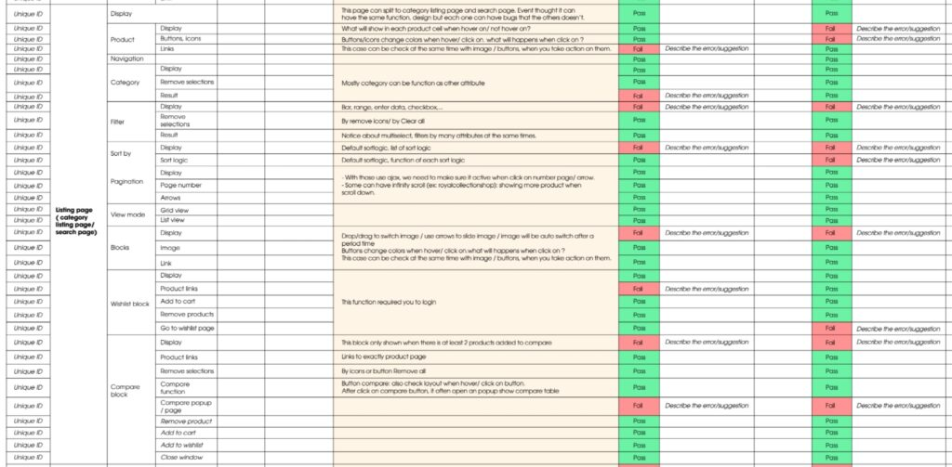

**FUTURE SCOPE**

**Review History:**

|  |  |  |
| --- | --- | --- |
| **Review No.** | **Suggestions** | **Changes incorporated** |
|  |  |  |
|  |  |  |
|  |  |  |

**Actionable Items:**

**REFERENCES**

1. [**https://www.softwaretestinghelp.com/software-testing-techniques-2/**](https://www.softwaretestinghelp.com/software-testing-techniques-2/)
2. [**https://www.google.com/search?q=ecommerc+website+Design+Test+Cases&tbm=isch&ved=2ahUKEwif_v3Xr7j7AhUWjtgFHTXdBu4Q2-cCegQIABAA&oq=ecommerc+website+Design+Test+Cases&gs_lcp=CgNpbWcQAzIECCMQJ1DpB1jpB2CRDGgAcAB4AIABfIgB9QGSAQMwLjKYAQCgAQGqAQtnd3Mtd2l6LWltZ8ABAQ&sclient=img&ei=ntB3Y5-3Apac4t4Ptbqb8A4&bih=613&biw=893&rlz=1C1RXQR_enIN1026IN1026#imgrc=-hN3joFyHccQKM**](https://www.google.com/search?q=ecommerc+website+Design+Test+Cases&tbm=isch&ved=2ahUKEwif_v3Xr7j7AhUWjtgFHTXdBu4Q2-cCegQIABAA&oq=ecommerc+website+Design+Test+Cases&gs_lcp=CgNpbWcQAzIECCMQJ1DpB1jpB2CRDGgAcAB4AIABfIgB9QGSAQMwLjKYAQCgAQGqAQtnd3Mtd2l6LWltZ8ABAQ&sclient=img&ei=ntB3Y5-3Apac4t4Ptbqb8A4&bih=613&biw=893&rlz=1C1RXQR_enIN1026IN1026#imgrc=-hN3joFyHccQKM)
3. [**https://bsscommerce.com/blog/writing-test-cases-guide-ecommerce-websites/**](https://bsscommerce.com/blog/writing-test-cases-guide-ecommerce-websites/)
4. [**https://www.softwaretestinghelp.com/ecommerce-testing/**](https://www.softwaretestinghelp.com/ecommerce-testing/)