|  |
| --- |
| **NAVRACHANA UNIVERSITY** |
|  |
|  |
| **SCHOOL OF ENGINEERING & TECHNOLOGY** |
|  |
| **BTech-IT Program** |
|  |
|  |
|  |
|  |
|  |
| **CLASS: LYIT** |
|  |
| **SEMESTER: 7** |
|  |
|  |
|  |
| **COURSE: Applications of IoT for Cloud Platform** |
|  |
| **SUBJECT CODE: IT409** |
|  |
| **ACADEMIC YEAR: 2022 -23 (AUTUMN)** |
|  |
|  |
|  |
| **STUDENT ID: 19125012, 19125059, 19125060.** |
|  |
| **NAME: Dhyey Patel, Vijay Vaghela, Gautam Shah.** |
| **POJECT TITLE: Water Measuring System.** |

***Certificate***



This is to certify that student **Dhyey, Vijay, Gautam** having student ID **19125012, 19125059, 19125060** from final year, semester VII of BTech- IT program at Navrachana University, School of Engineering and Technology has completed the requirements of mini project submission for the course Applications of IoT for Cloud Platform (IT409). This has been done as a part of work for Autumn semester of Academic Year 2022-23. The title of his/her project is **Water Measuring System.**

Signature

(Course In-charge)

|  |  |  |  |
| --- | --- | --- | --- |
| **Student ID: 19125012, 19125059,19125060.** | | **Student Name: Dhyey, Vijay, Gautam.** | |
|  |  | |  |
| **INDEX** | | | |
| **SR. NO.** | **PHASES** | | **Page No.** |
|  | PHASE – 1 BRAINSTORMING | | 1-2 |
|  | PHASE -2 SYSTEM MODELLING | | 3 |
|  | PHASE-3 IMPLEMENTATION | | 4 |
|  | REFERENCES | |  |

**PHASE – 1 BRAINSTORMING**

**TASK 1:**

Create a concept map for the system that you are modelling. Explain it along with diagram.

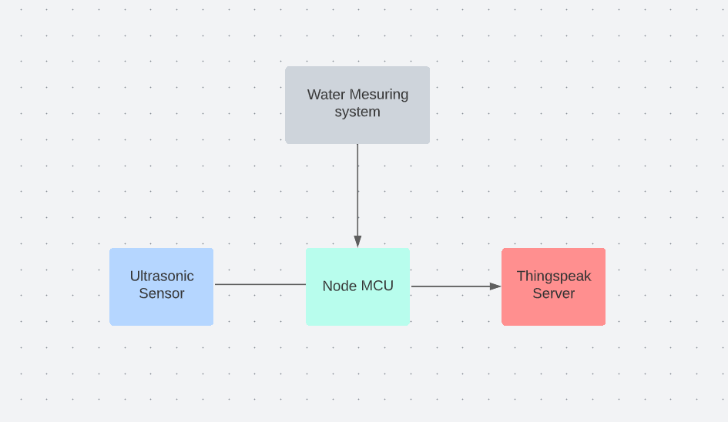

**TASK 2:**

Create a flowchart for showing the different steps of execution in the system that you are modelling. Explain it along with diagram.

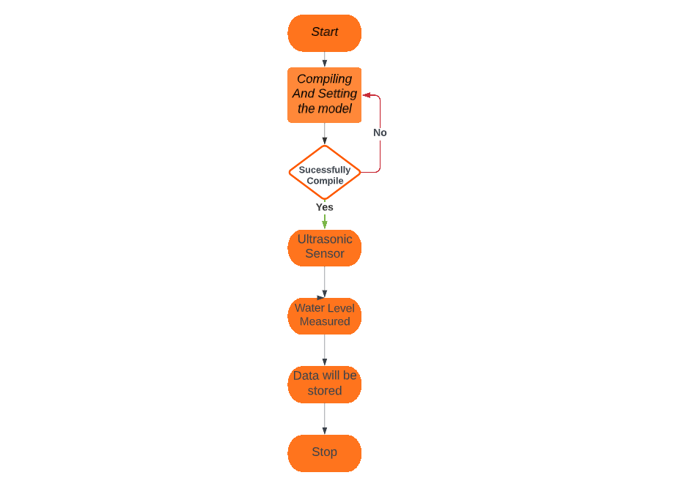

**System Name: Water measuring System**

**System Description: In this system we have used ultrasonic sensor to measure the data and send data to ThingSpeak.**

**PHASE -2 SYSTEM MODELLING**

**TASK 1:**

**Sequence Diagram:**

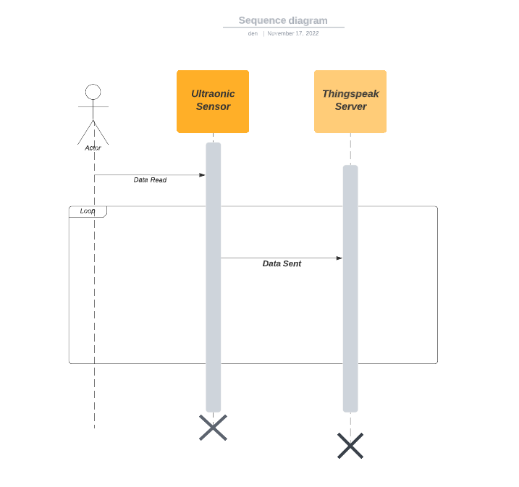

**PHASE-3 IMPLEMENTATION**

**TASK 1: Project Schematic**

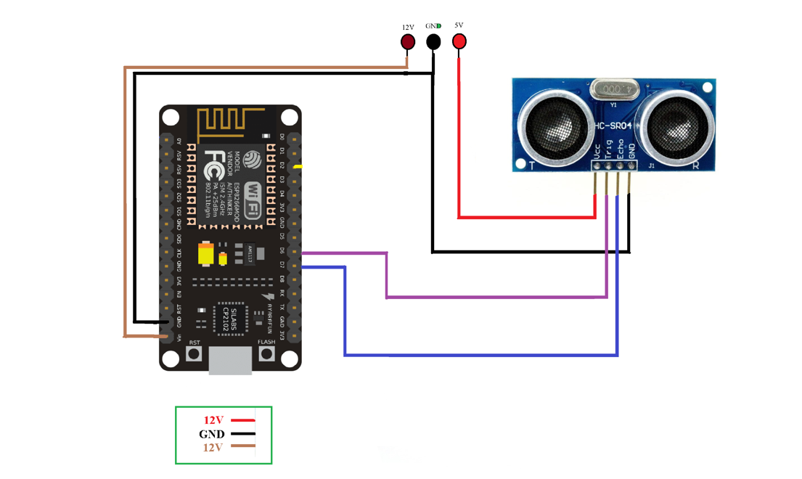

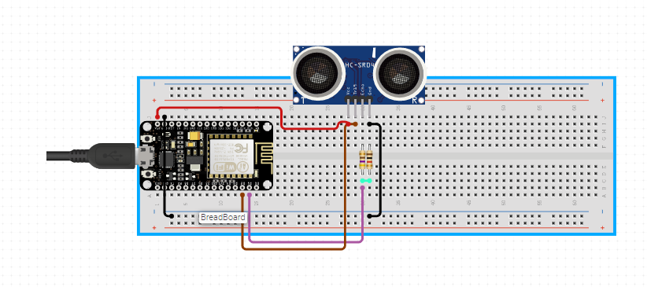

**TASK 2: Circuit Design**

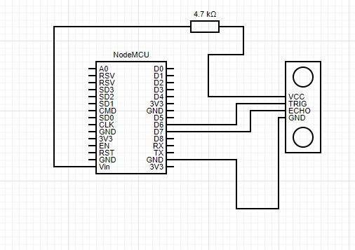

**TASK 3: Specifications**

-Ultrasonic Sensor

-Breadboard

- Jumper wires

-NodeMCU

-Power supply

- Registor (1k)

**TASK 4: Output**

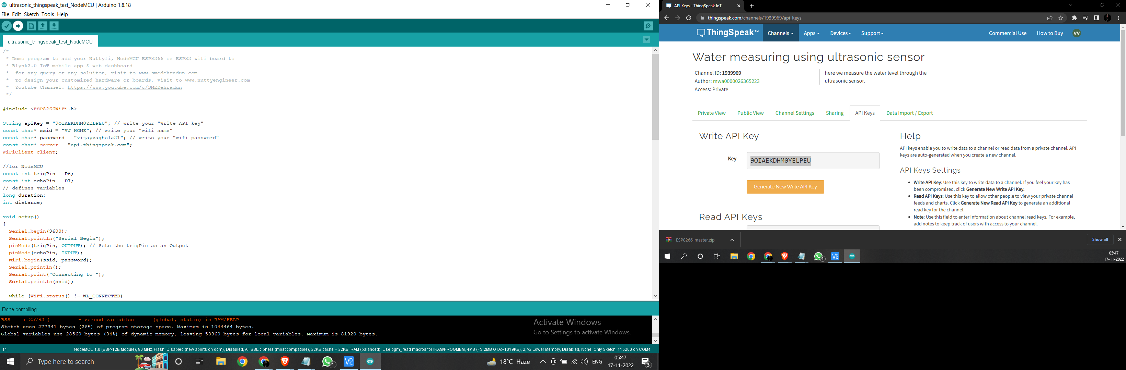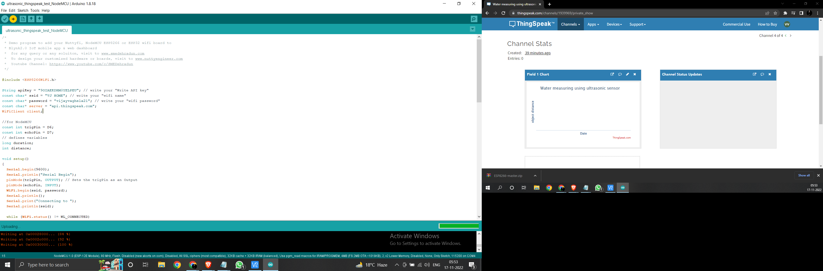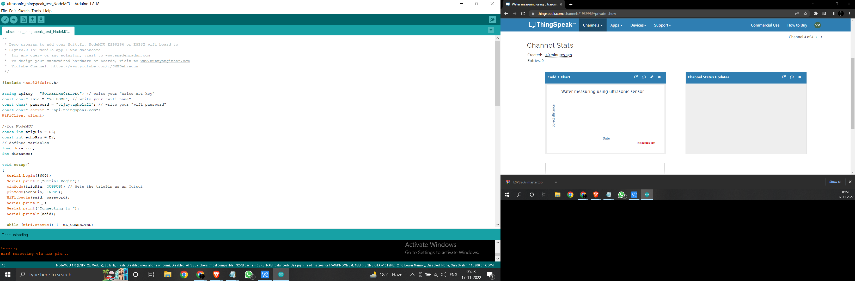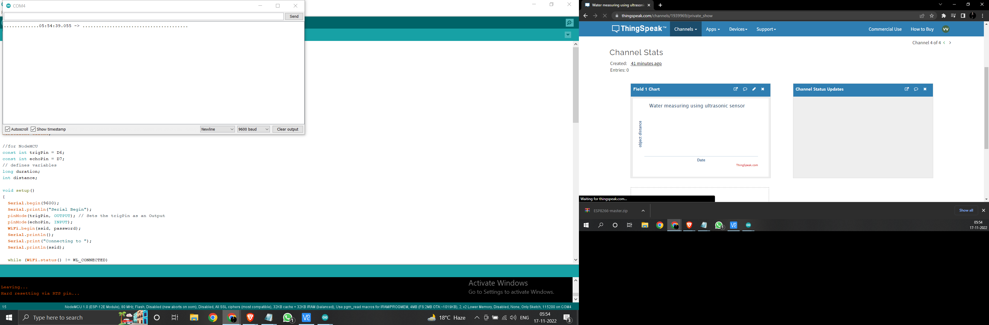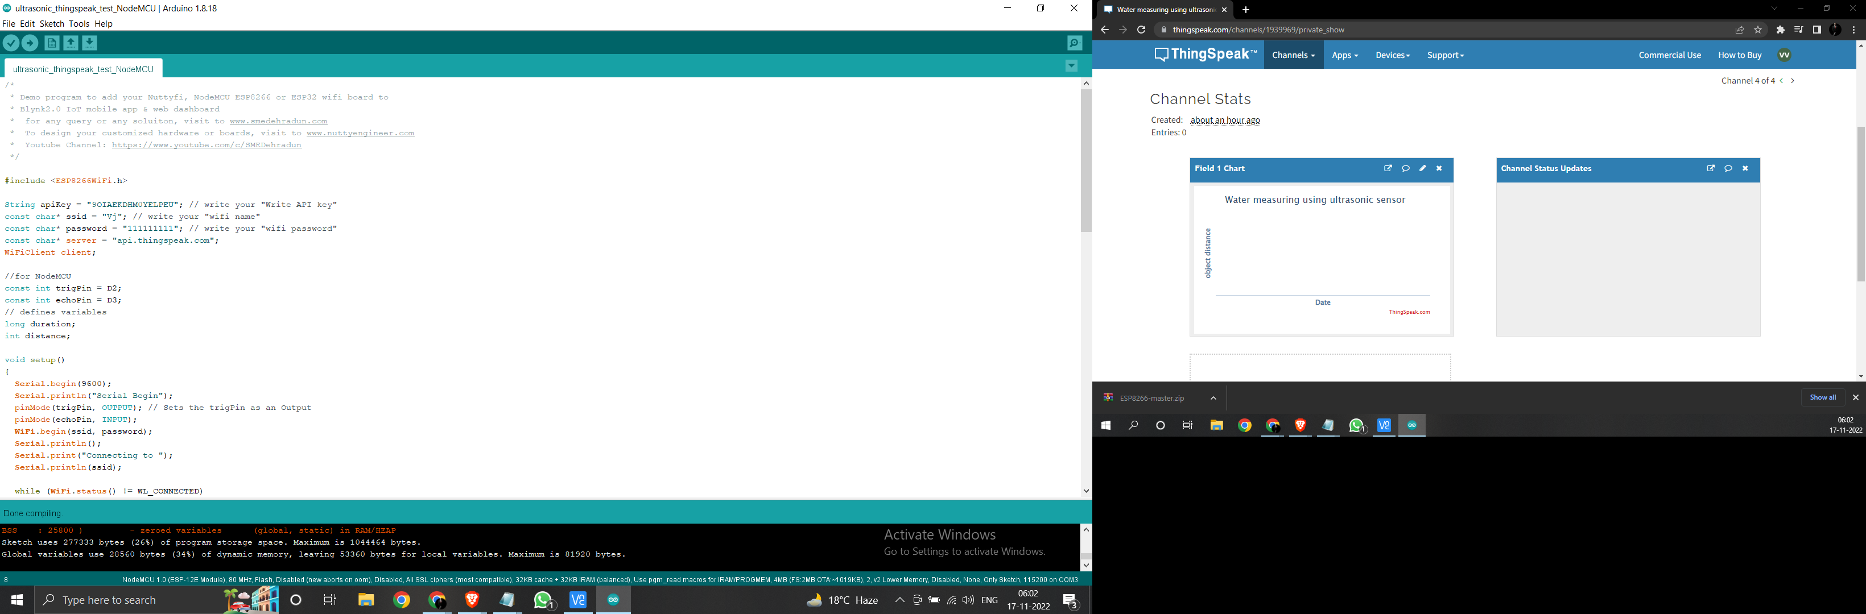

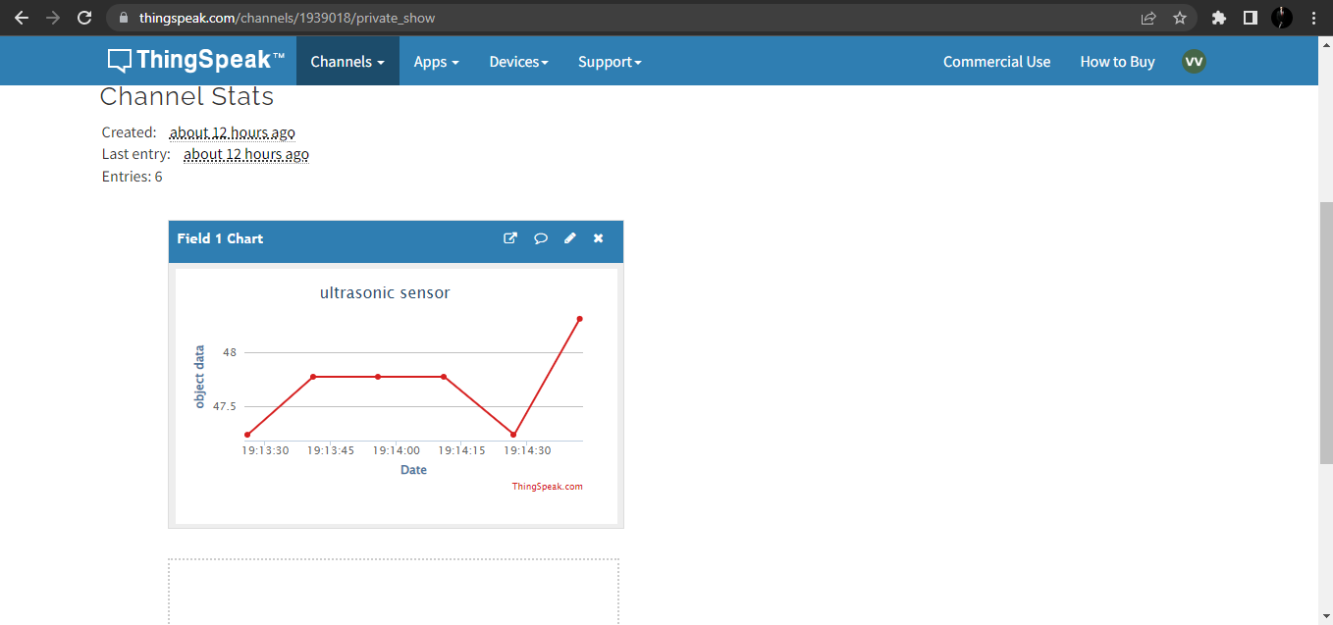

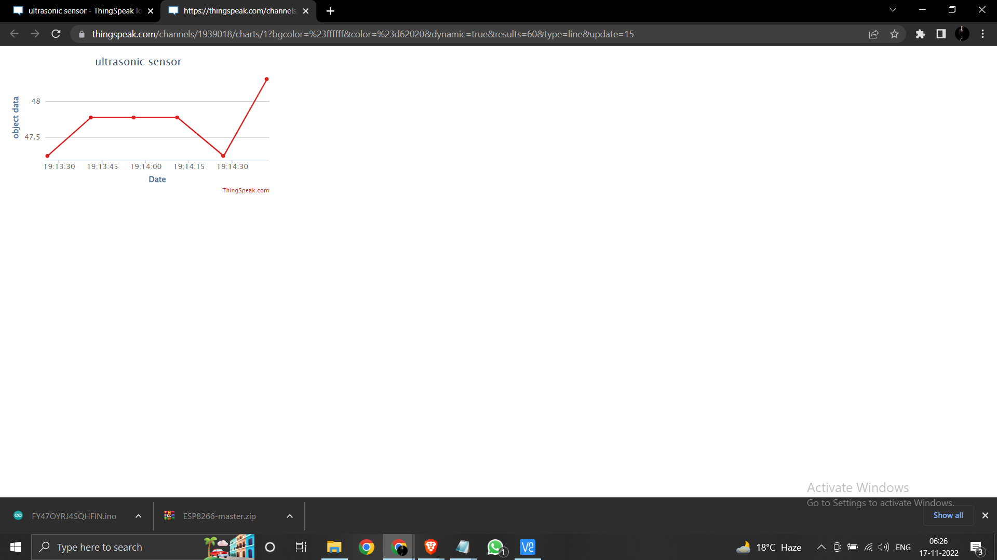

**REFERENCES**

1. <https://www.circuito.io/app?components=513,13959,360216>
2. <https://www.arduino.cc/en/donate/>
3. <https://github.com/esp8266/Arduino>
4. <https://thingspeak.com/channels/1939018/private_show>
5. <https://www.circuit-diagram.org/editor/>