1. After creating master and slave deployed .war application into Tomcat slave

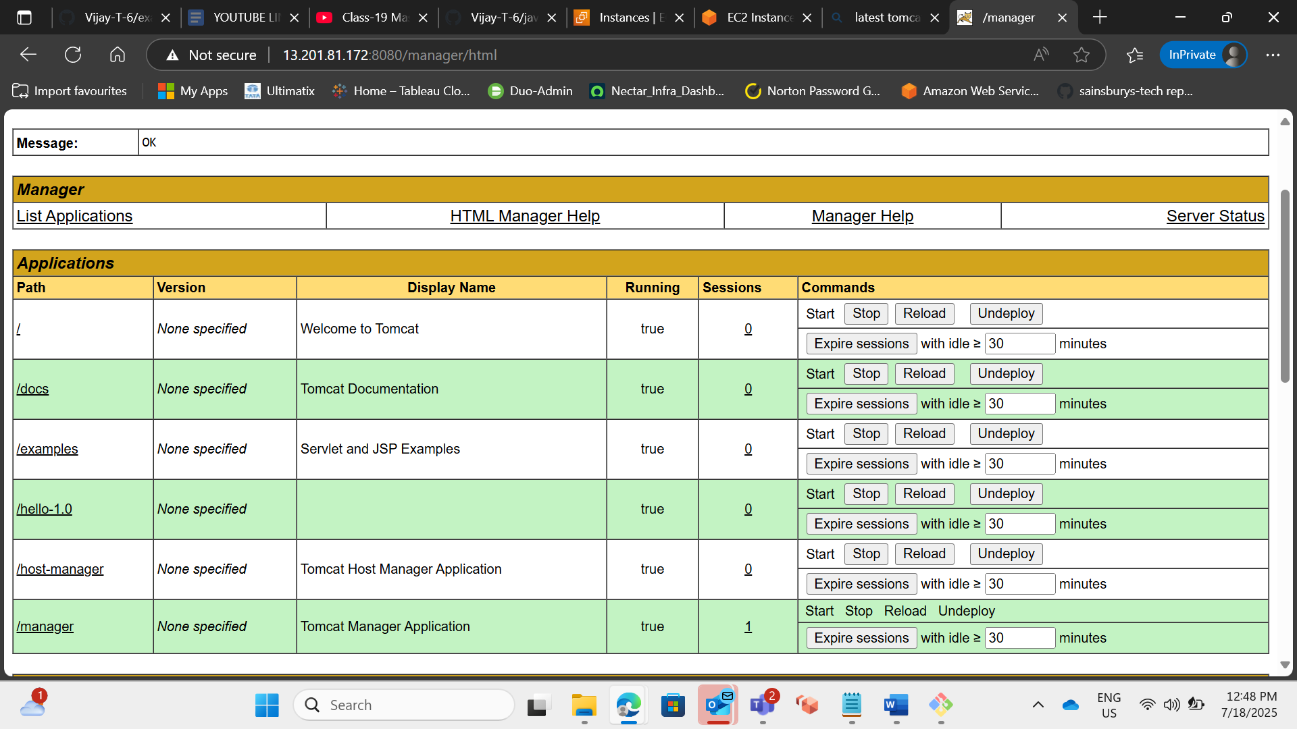

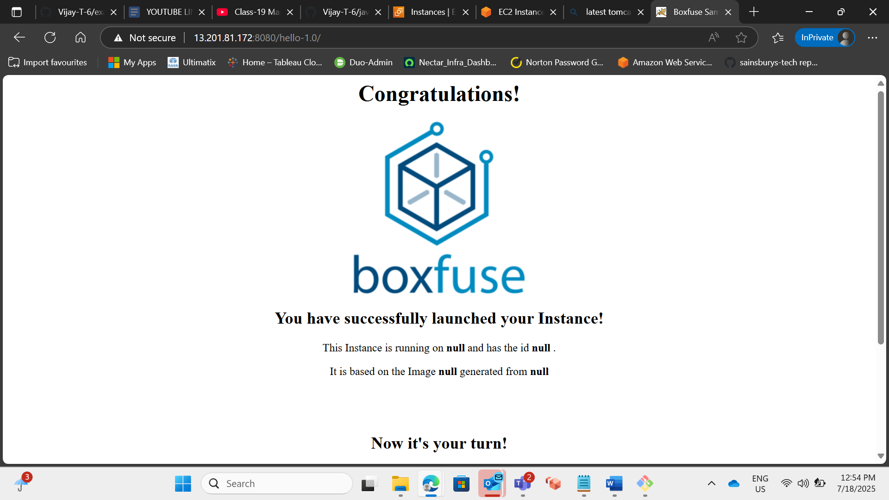

1. Setup Matrix Based Security

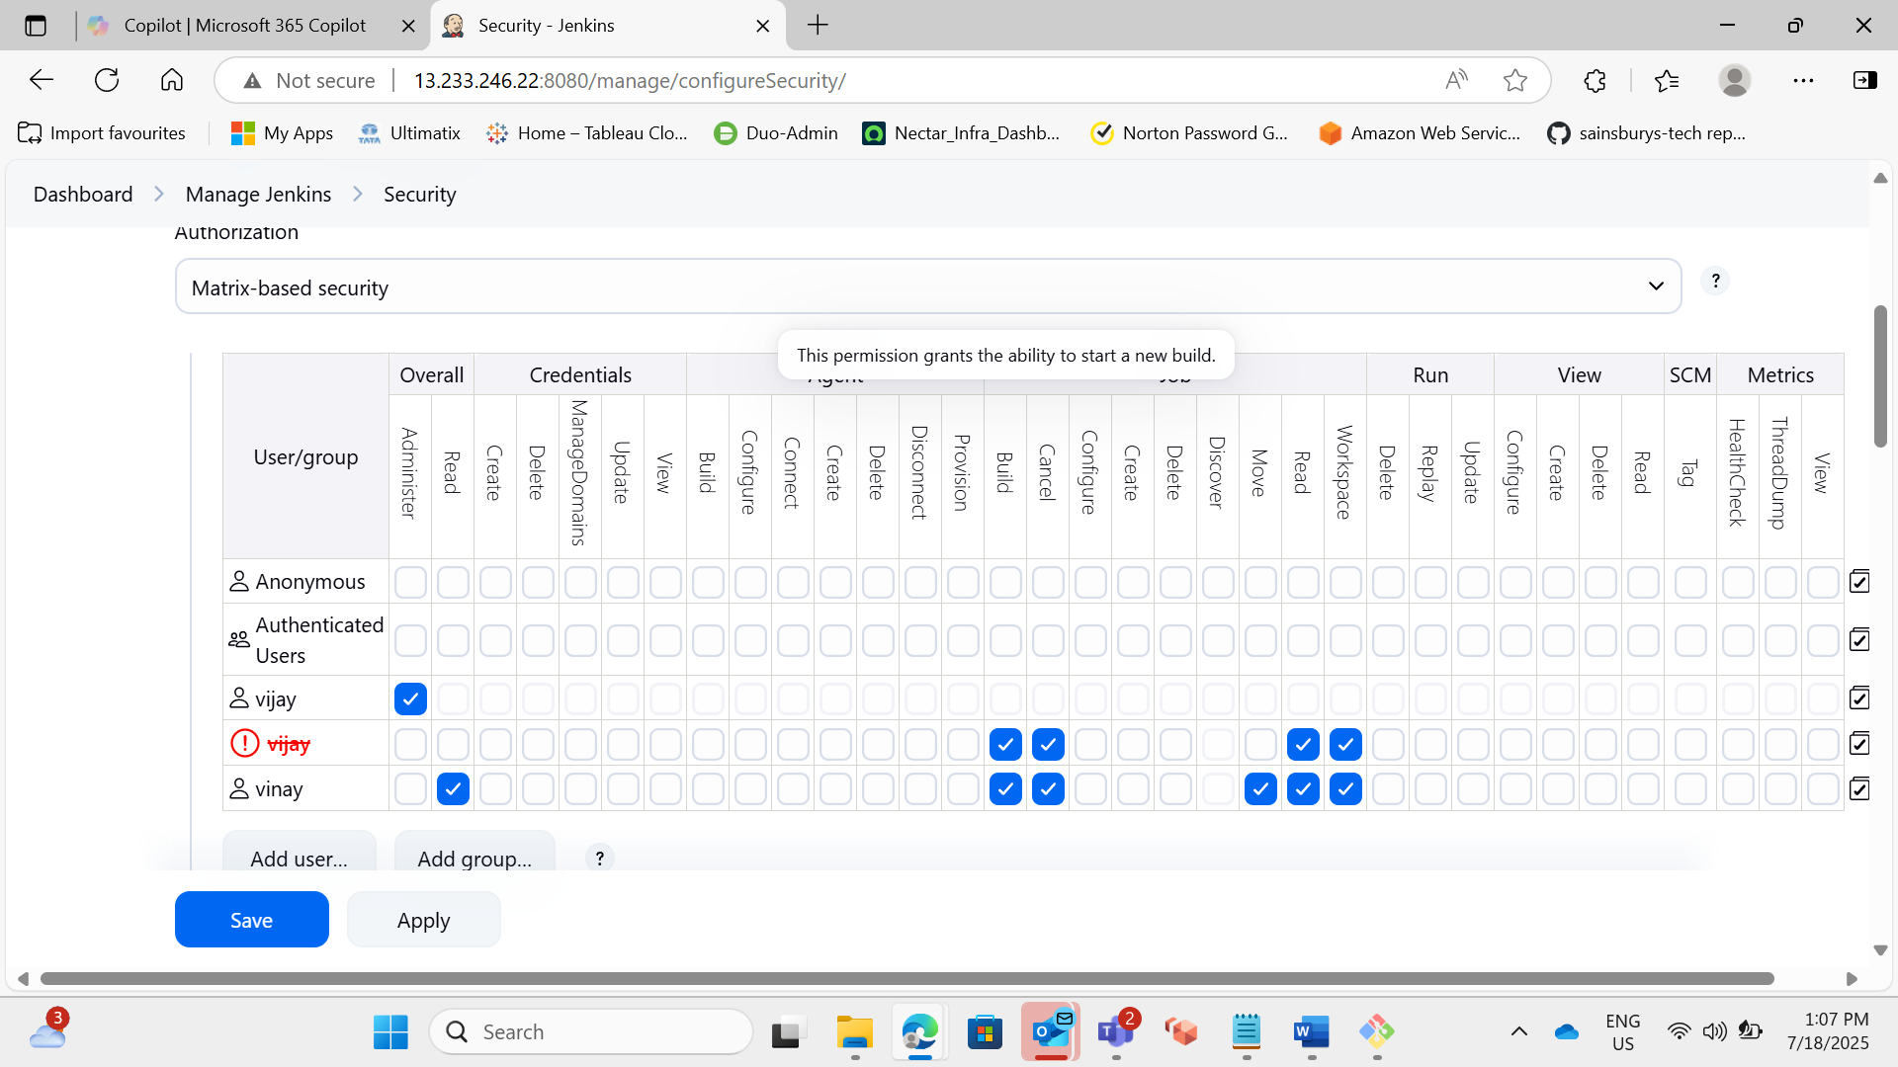

1. Setup Project Based Security

1. Setup Role-Based Authorization strategy and limit the access on the Folder level

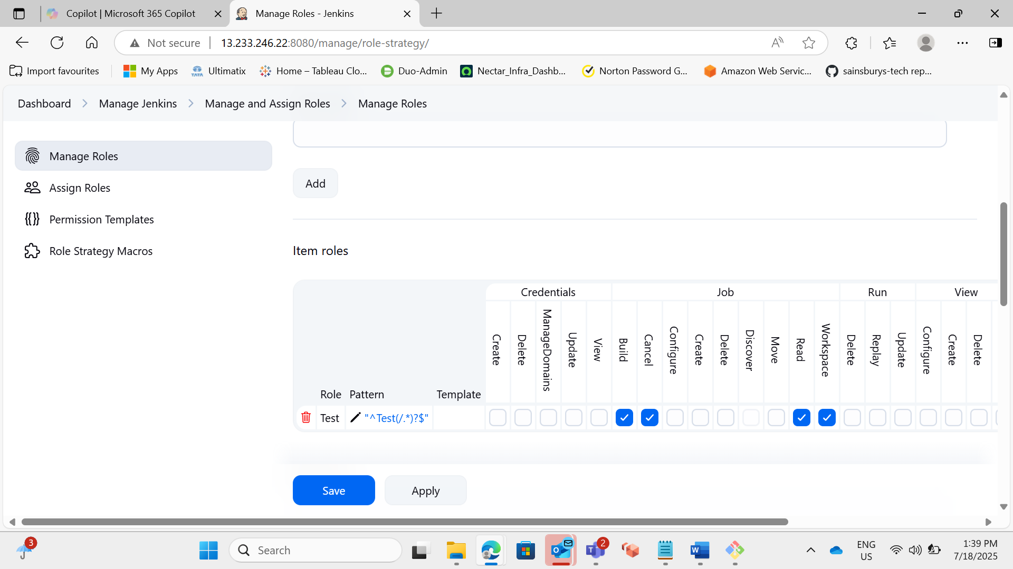

1. Change the default port of Jenkins (8080) to 8070

