- After creating master and slave deployed .war application into Tomcat slave
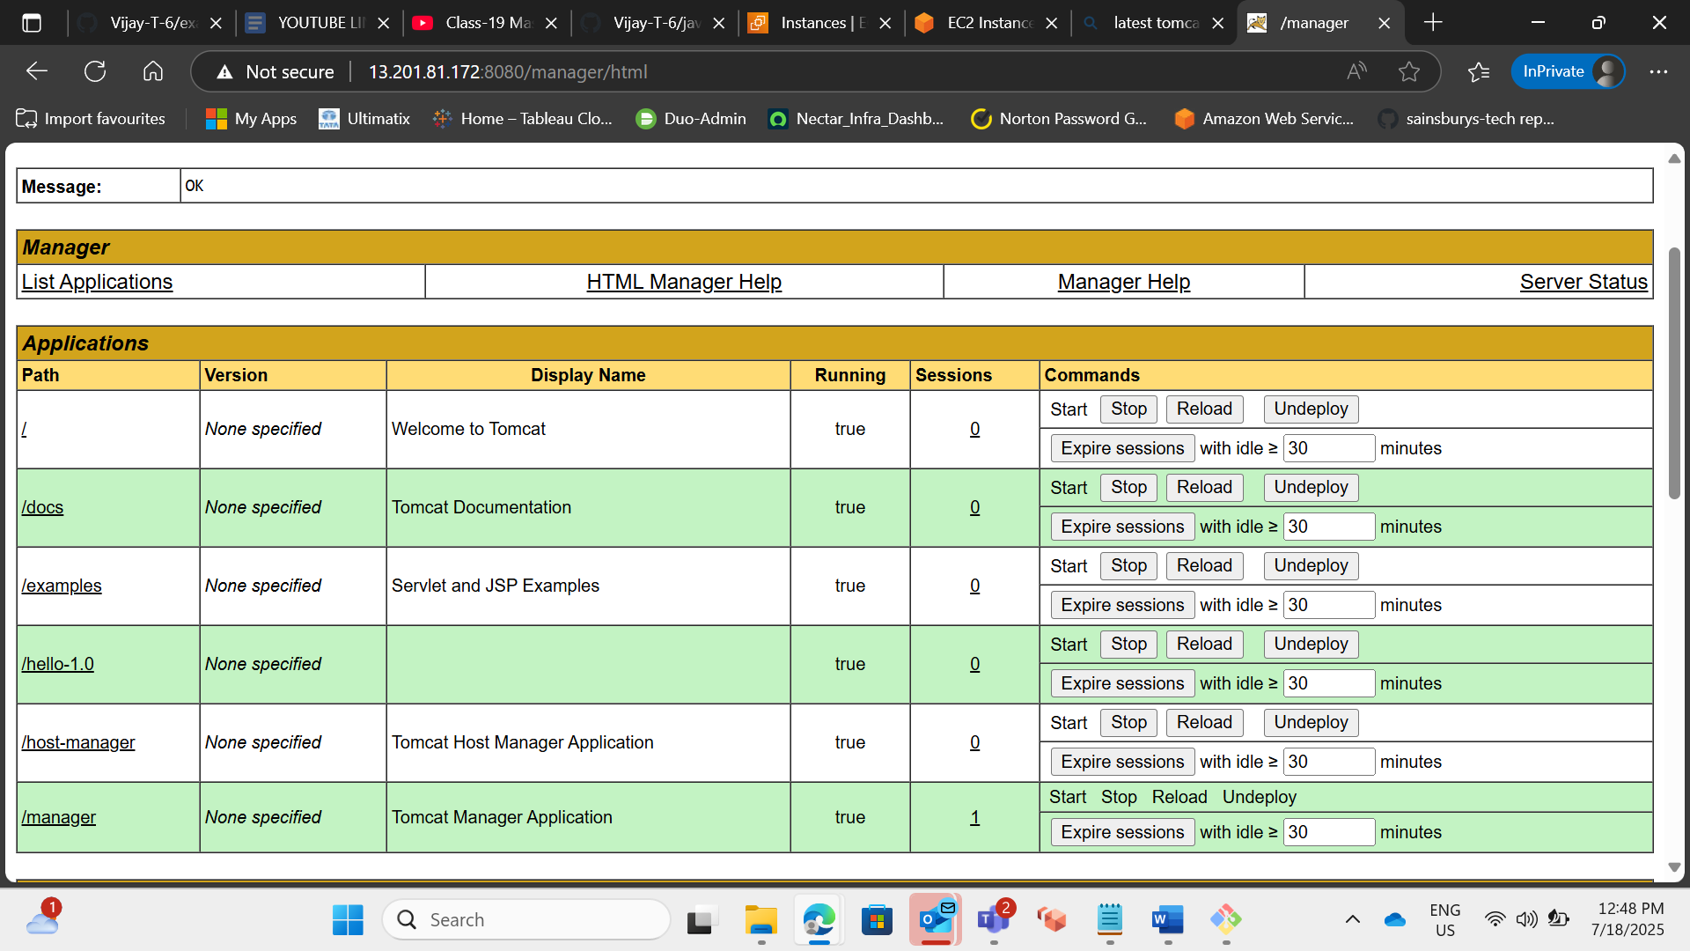
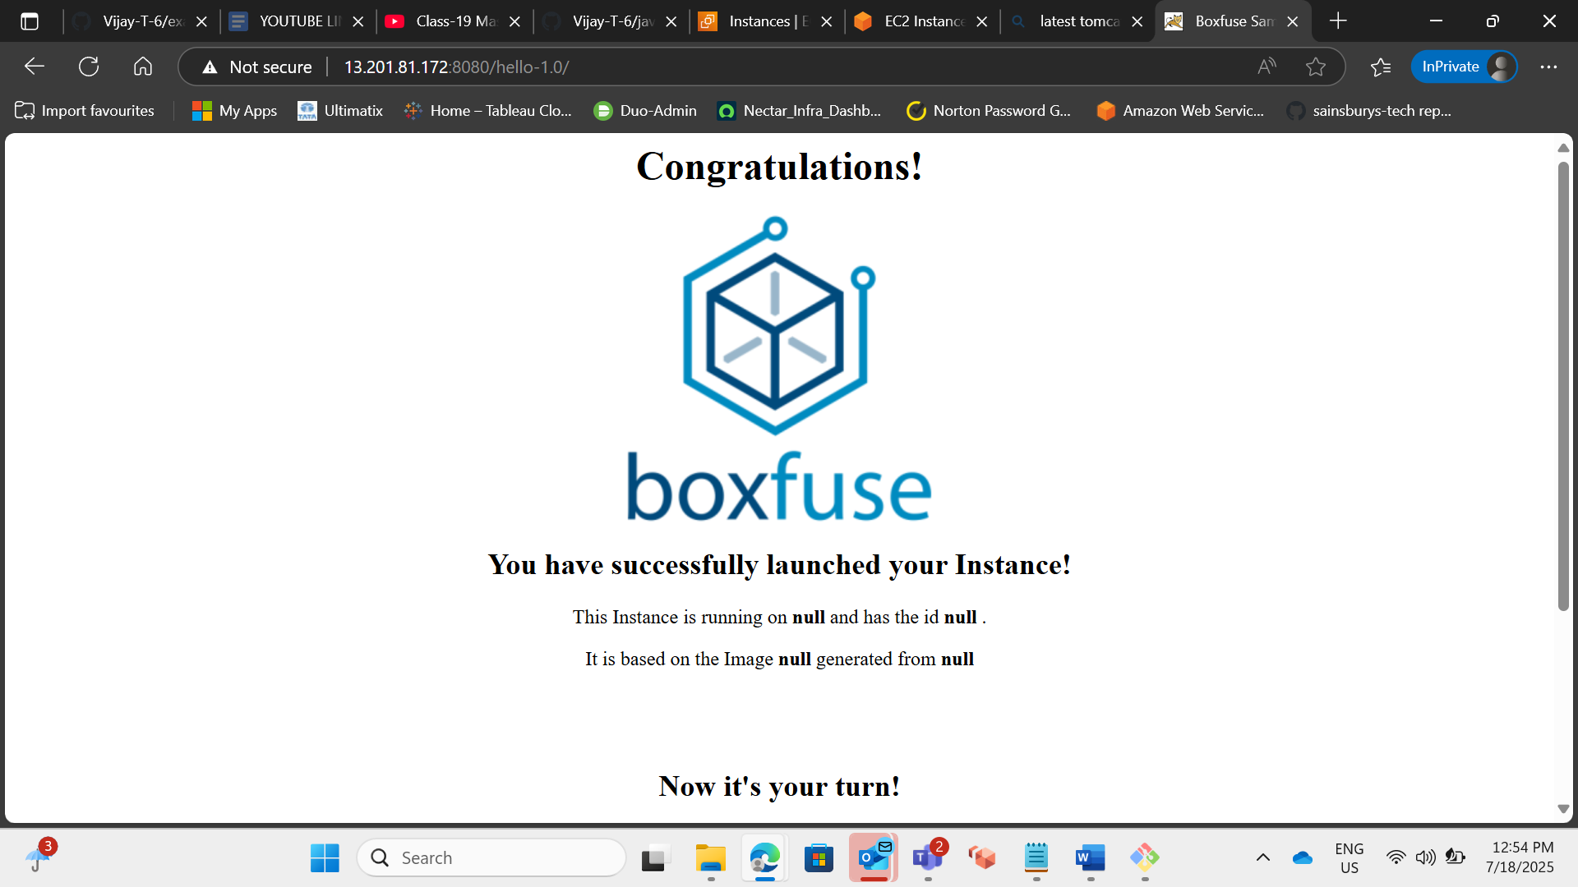

- Setup Matrix Based Security
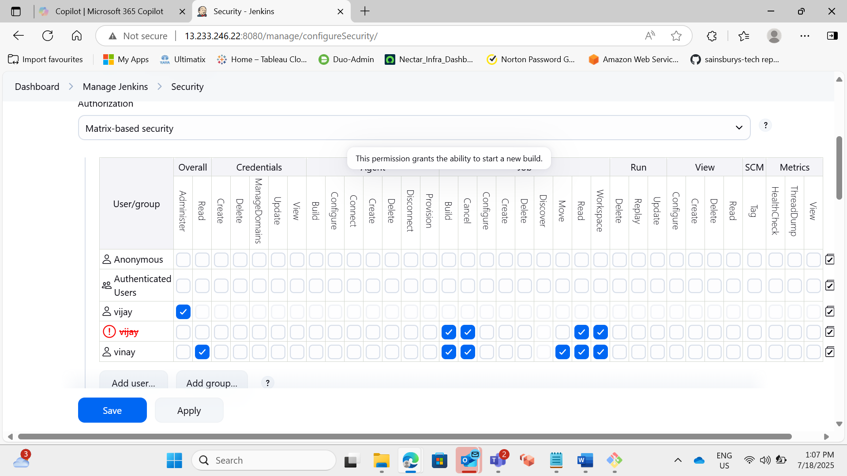

- Setup Project Based Security
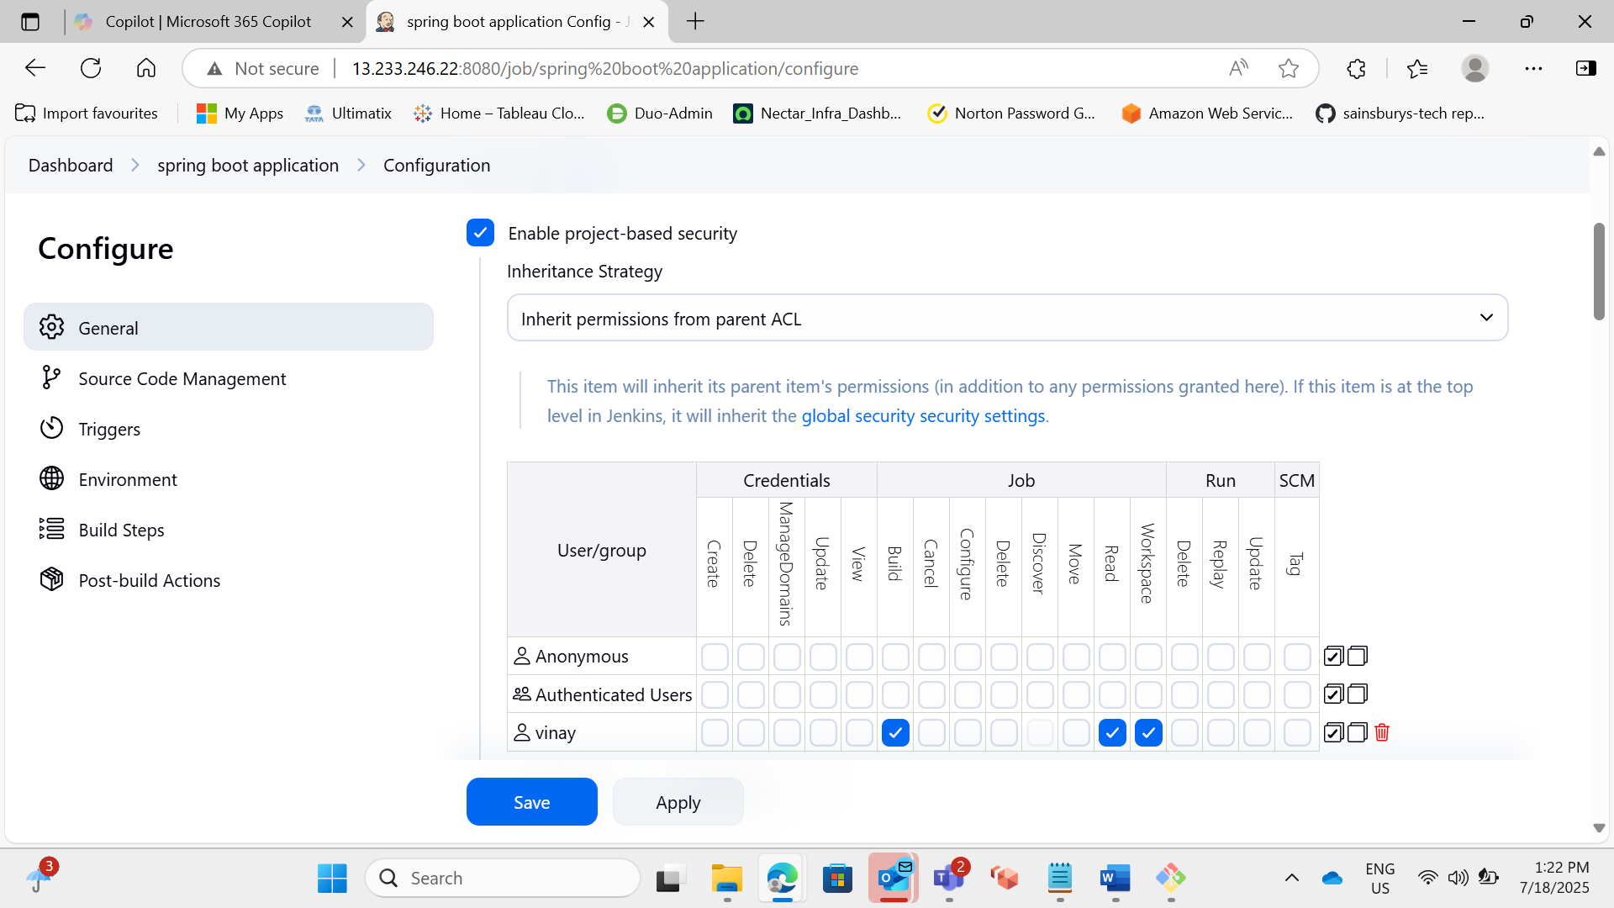

- Setup Role-Based Authorization strategy and limit the access on the Folder level
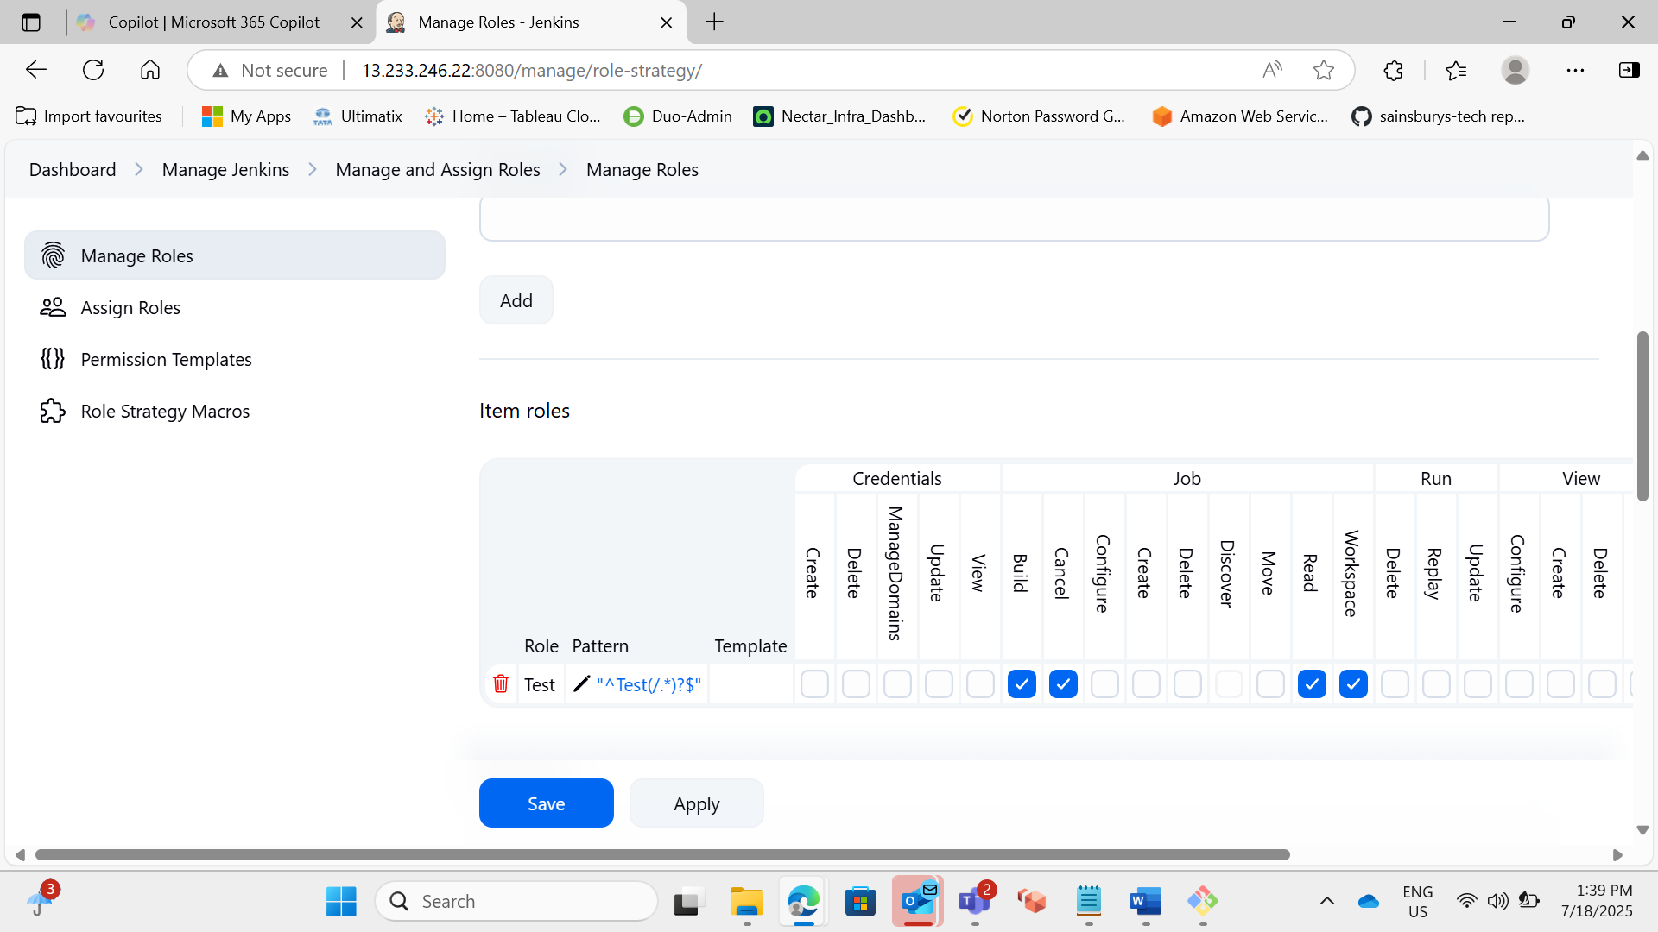

- Change the default port of Jenkins (8080) to 8070
