**CREATING WELL-STRUCTURED OUTPUT FOR API CLIENTS USING POSTMAN TO GET WEATHER REPORT.**

**DESCRIPTION:**

You are asked to create a well-structured output for their API client using Postman, which will hit that URL and get a detailed report on the weather in a quicker way.

**BACKGROUND OF THE PROBLEM STATEMENT:**

To get the weather report in a well-structured output, we need to have a set of APIs of the weather application and automatable tool like Postman.

* Postman
* Endpoint URL(<https://samples.openweathermap.org/data/2.5/weather?q=London,uk&appid=b6907d289e10d714a6e88b30761fae22>)

**THE FOLLOWING REQUIREMENTS SHOULD BE MET:**

**●**        A few of the source codes should be tracked on GitHub repositories. You need to document the tracked files that are ignored during the final push to the GitHub repository.

●        The submission of your GitHub repository link is mandatory. In order to track your task, you need to share the link of the repository in the document.

●        The step-by-step process involved in completing this task should be documented.

**GITHUB URL:** [**https://github.com/Vijay-Vel/Phase3-POSTMAN-PracticeProject.git**](https://github.com/Vijay-Vel/Phase3-POSTMAN-PracticeProject.git)

**EXPLANTION:**

Create a collection and by clicking on the collection and click on the (+) sign and enter the name for the collection.

And add request to the collection by clicking on the three dots and add the request and enter the name for the request.

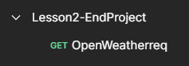

Choose the GET request and enter the API request

https://samples.openweathermap.org/data/2.5/weather?q=Chennai,uk&appid= f69b95c892d3aefdeef8eaee2b050f2f

From the above request the <https://samples.openweathermap.org/data/2.5/weather> is stored in the variable {{Base_URL}}

And {{City}} is the variable assigned for the storing the value for the query q

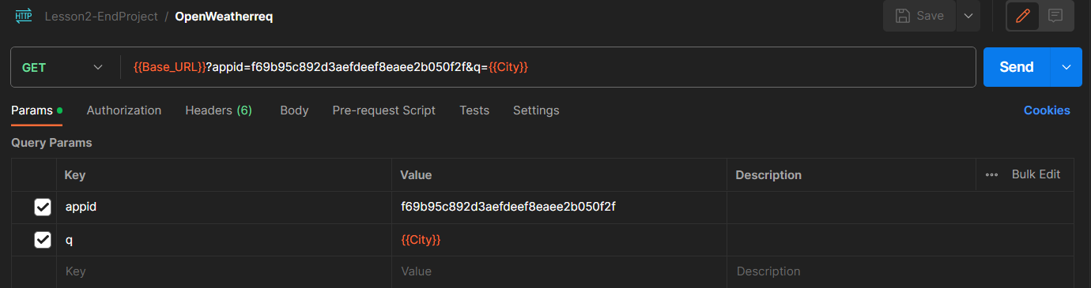

Environments are used to store the values for the variables.

The Environments are created by clicking + icon under the environments tab.

Enter the name for the environment and enter the name of the variable and its value.

Click on the save button to save the environment.

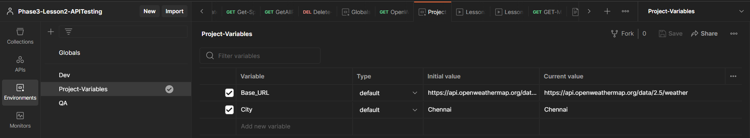

Click on the save button of the GET request and click on send button to run the API request.

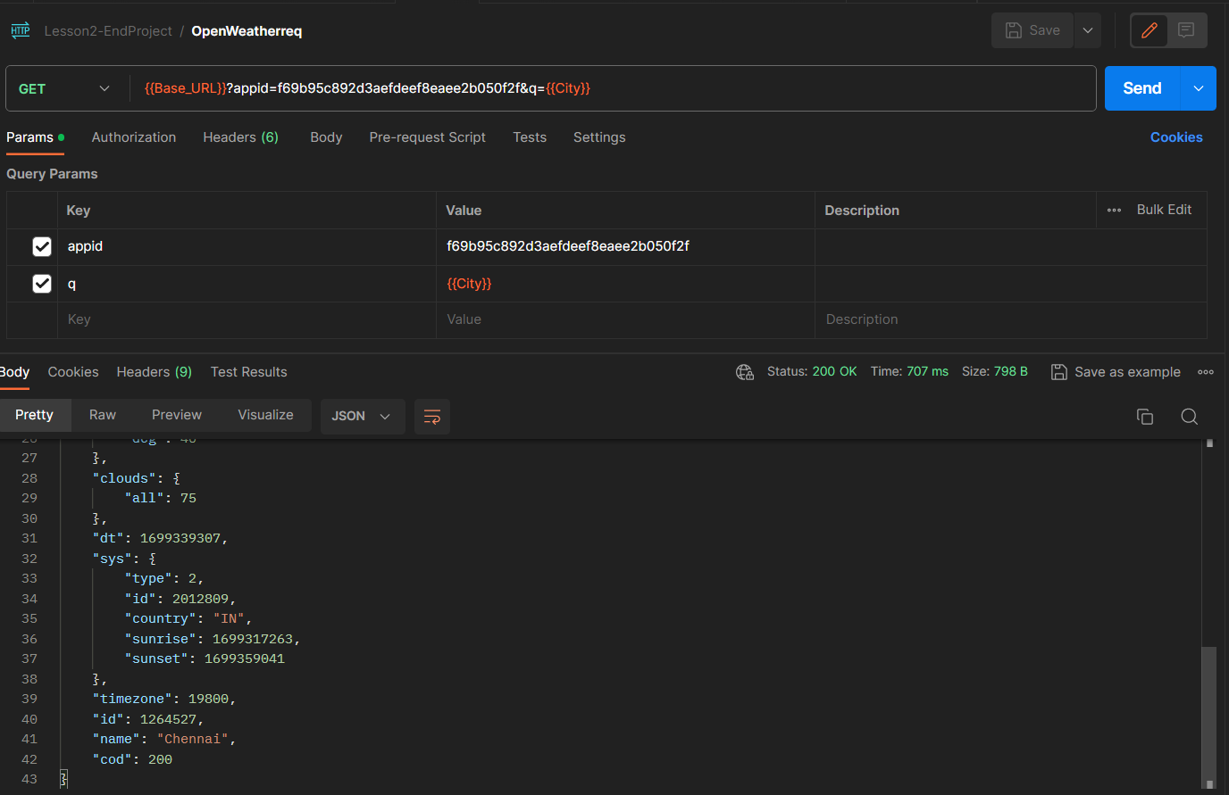

Run the collection by clicking on the three dots and choose the run collection option.

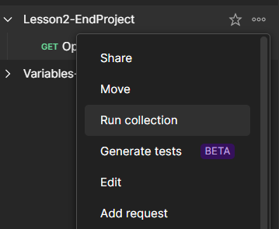

Create a CSV file and enter the values for the variables in the excel sheet here City is the variable and the values for the variables are given in the column

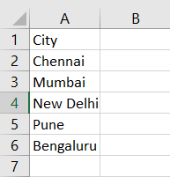

Run the collection and choose run manually for how to run the collection.

In the data choose the CSV data file and run the collection

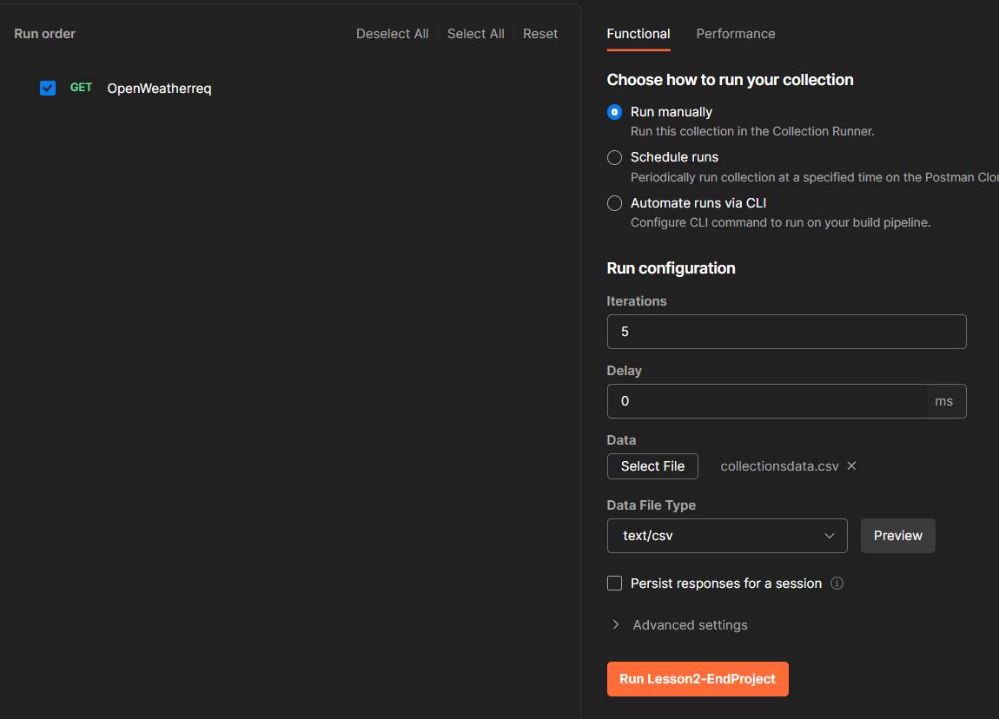

Click on the run collection to run the collection.

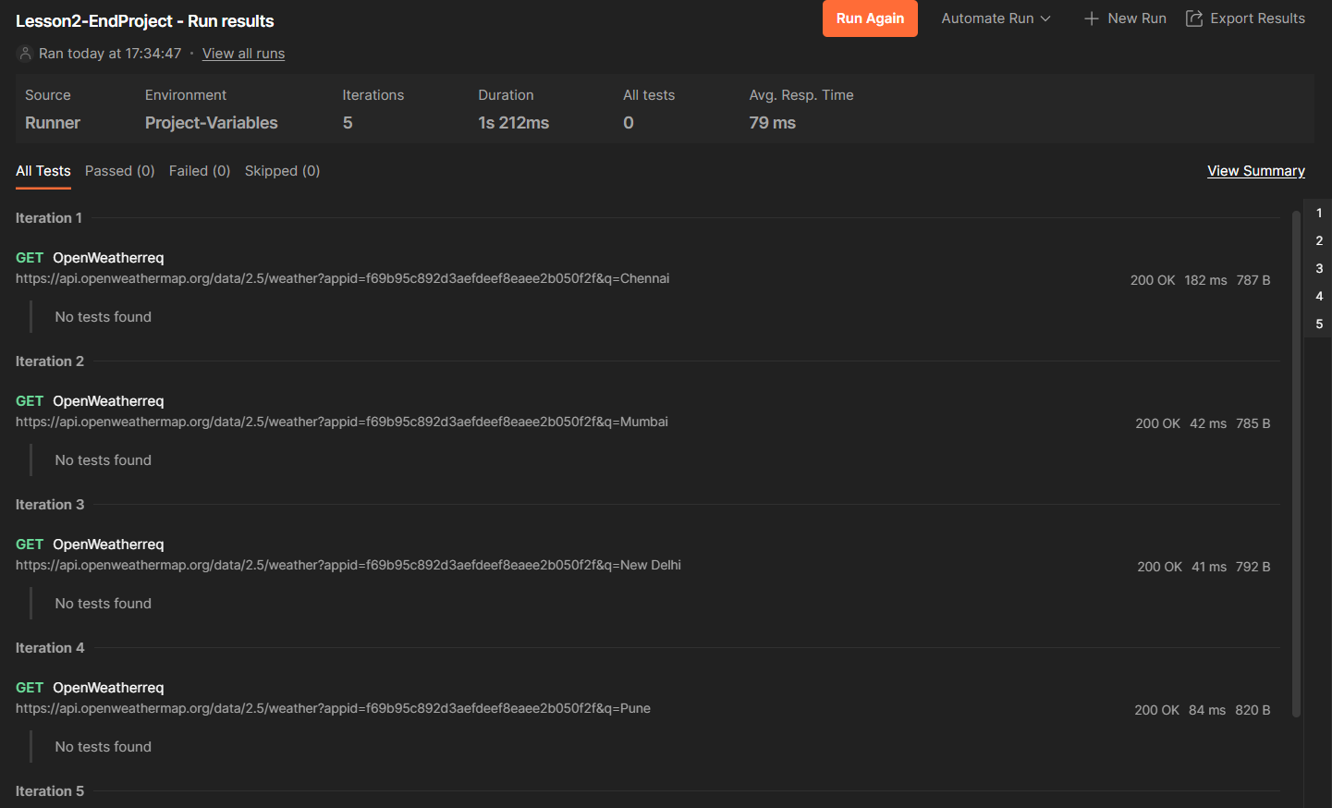

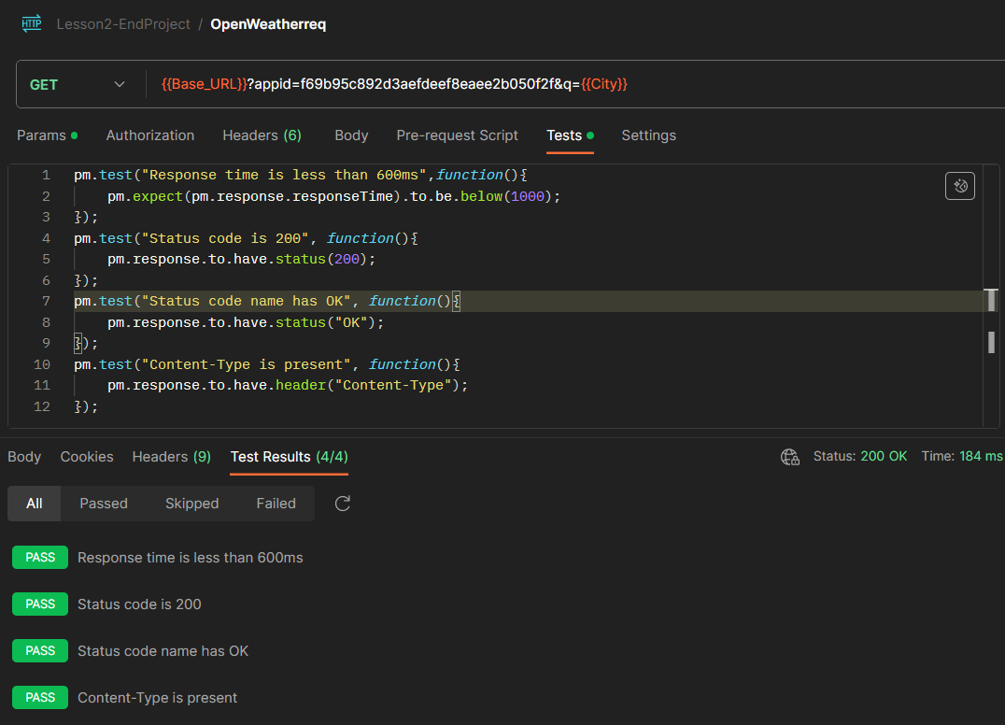

**To Run the Collection using Newman**

Download the Collection and the Environments used in the collection to run the collection.

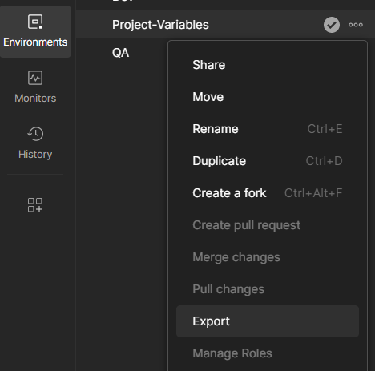

Click on export and select a path to save the Environment.

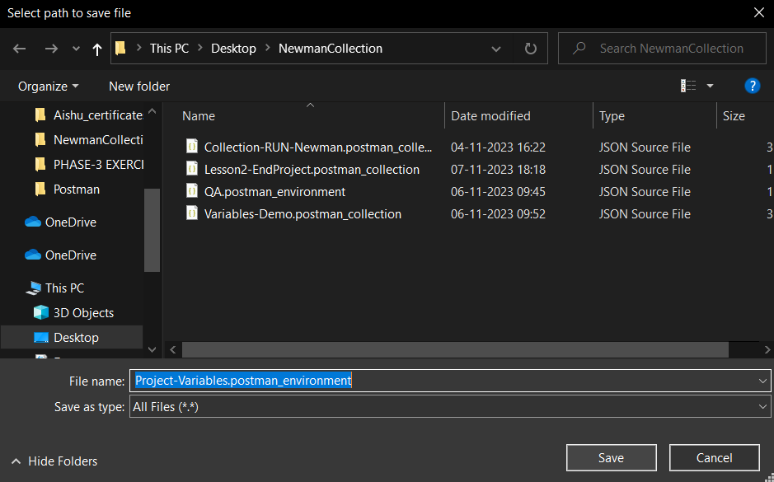

Open command prompt and run via newman using the command

#newman run <filename.json> -e <filename.json>

Run the exported collection and the environment variable to run the collection.

