Customer Shopping Behaviour Analysis

- Project Overview
This project analysis customer shopping behaviour using transactional data from 3900 purchases across various product categories. The goal is to uncover insights into spending patterns, customer segment, product preferences and subscription behaviour to guide strategic business decisions.

- Dataset Summary
-Rows: 3900
-Columns: 18
-Key Features:
- Customer demographics (Age, Gender, Location, Subscription Status)
- Purchase details (Item purchased, Category, Purchase Amount, Season, Size, Color)
- Shopping behaviour (Discount Applied, Promo code used, Previous purchases, Frequency of Purchases, Payment Method, Shipping Type, Discount applied)

- Using Python for EDA (Exploratory data analysis)

- The first is to import csv file, for that I used panda’s library and then import the file by using read.csv. After that for checking whether it is imported correctly or not, I used the head () function which by default shows the top 5 rows of the csv file.

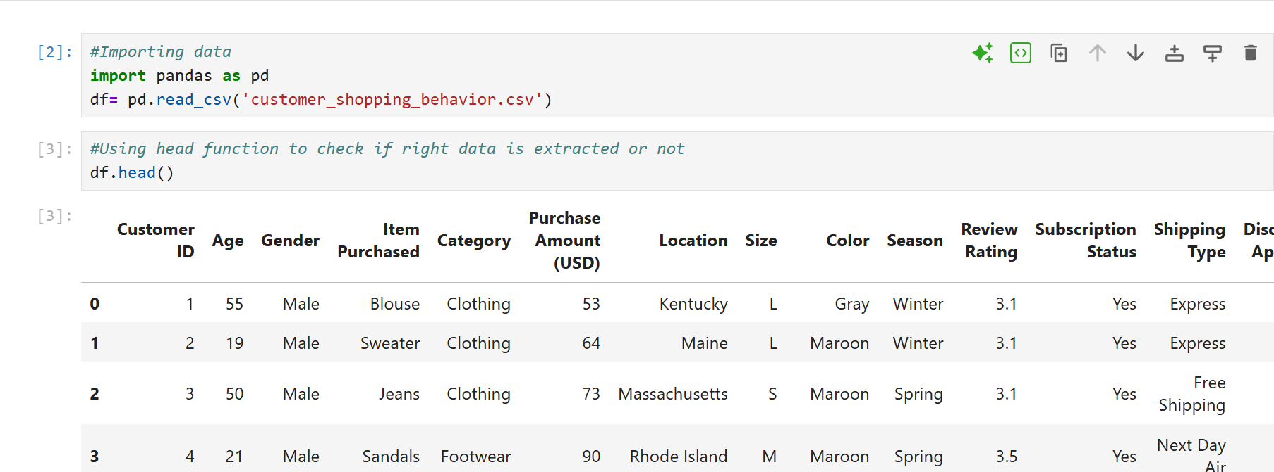

- Now, for checking all the information of the data, I used info () function which provide information related to Number of rows and columns, data type, null and non-null values.
- In the next step, I used to describe () function to extract all the statistical information like mean, median, count, max, min, standard deviation, etc.
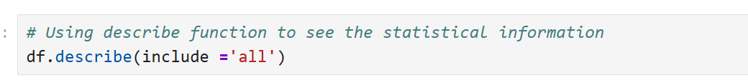
- Now we need to also check for null values, for that I used isnull () function and with that I used aggregate function which sums up all the null values.
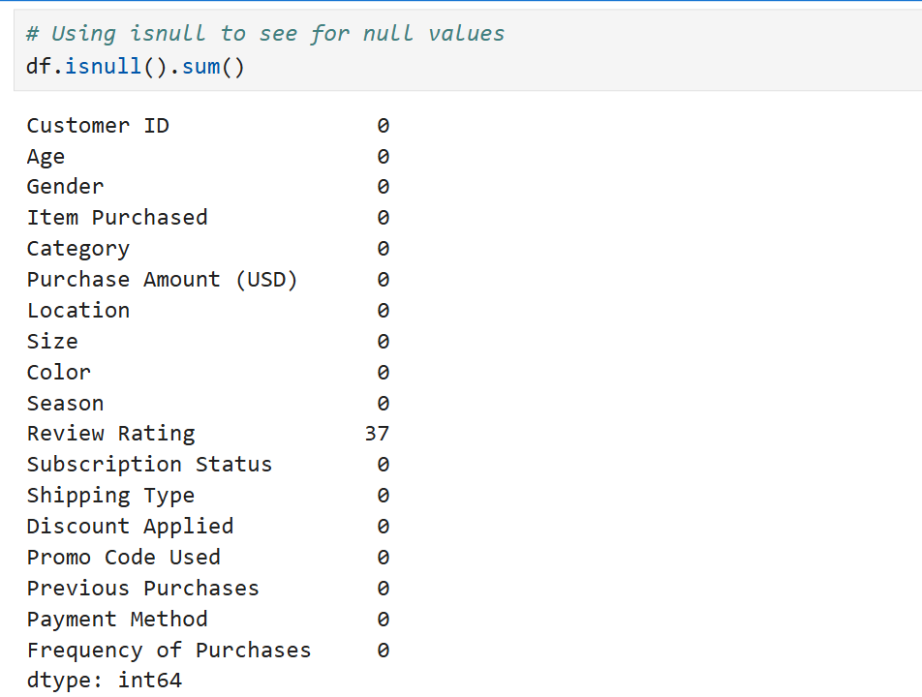
- From the above result, we found that Review rating has 37 null values, and now we need to take care of them otherwise results could be misleading.
We can either replace them with mean or median values, but in both cases, it will end up giving biased results. So here, instead of going with total median of all the data, we replace null values with the median which is category vies.
- Now we again check for null values to see if the changes that we made are reflecting there or not?
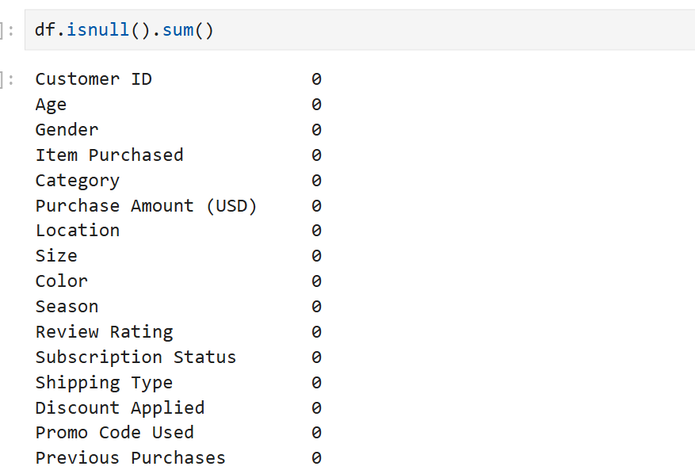
The review rating has been successfully replaced and now we have no null values.
- In next step, we converted all the columns and other heading in the snake pattern to bring symmetry in the writing style so that later it will be easy for us when we use them.
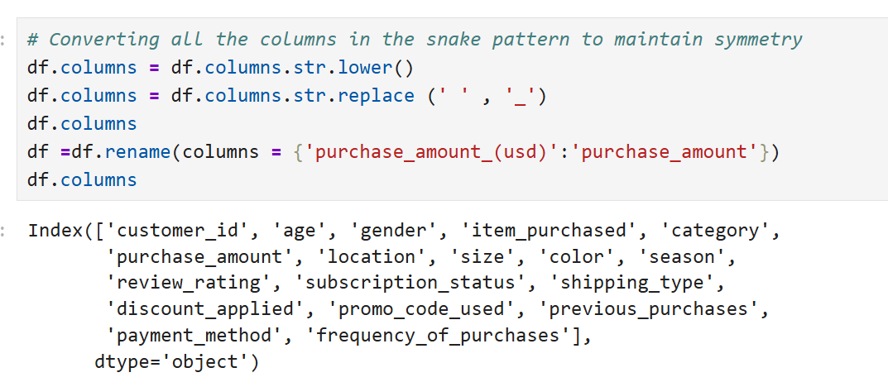
- Here, we created a new column as well where we divide age and made age groups and then gave them labels like ‘Young Adult’, ‘Adult’, ‘Middle-aged’, ‘Senior’.
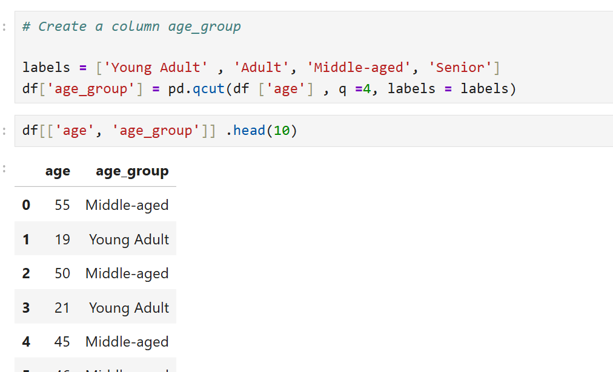

- Converting purchase_frequency_days into categorical from numerical.
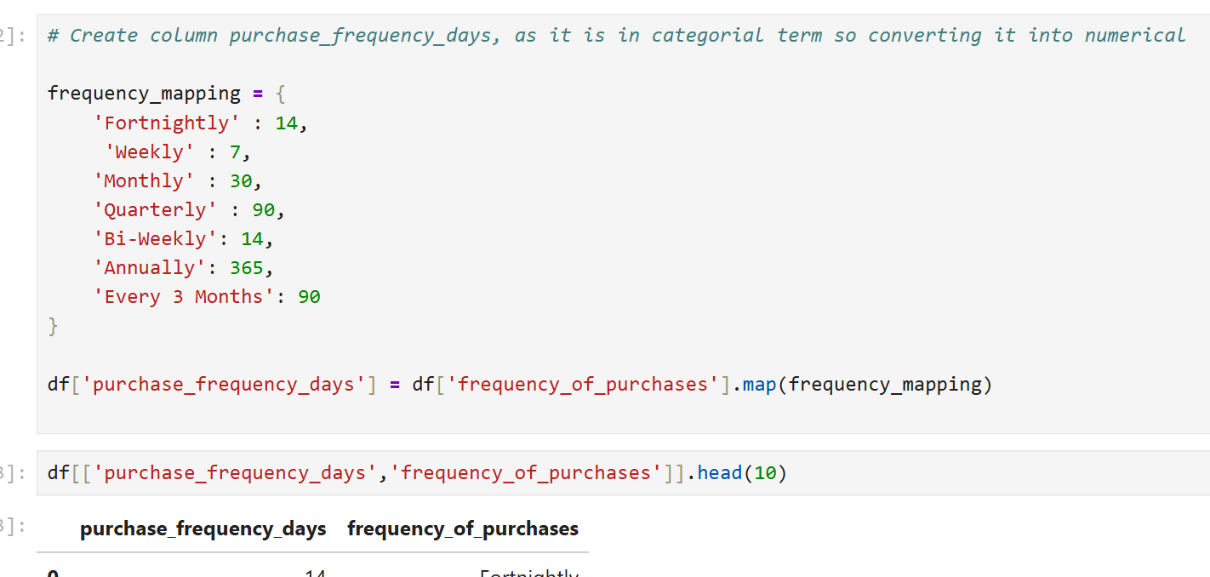
- Now, we look for duplicate values; we found that discount_Applied and promo_code_used are presenting the same data. When we check for it, we get TRUE as output which confirms that both the columns are same. Hence, we removed one.
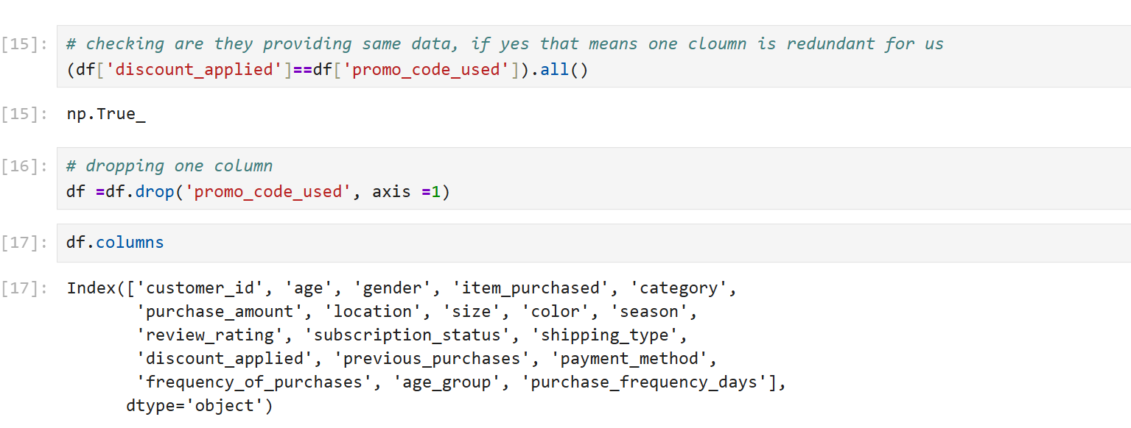
We are done here for EDA and now linked our python data and findings with SQL for further and deeper analysis. In python we did all the cleaning, transformation and modification now to understand the data better we moved to SQL.
- Connecting Python with MYSQL.
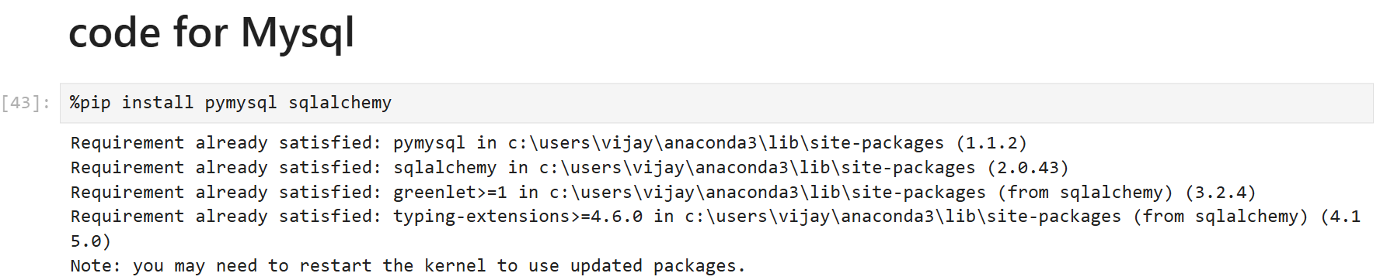

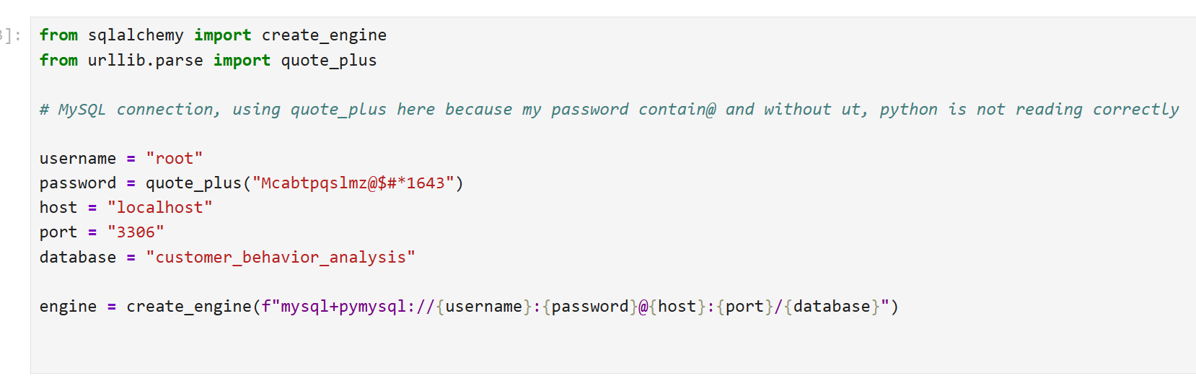
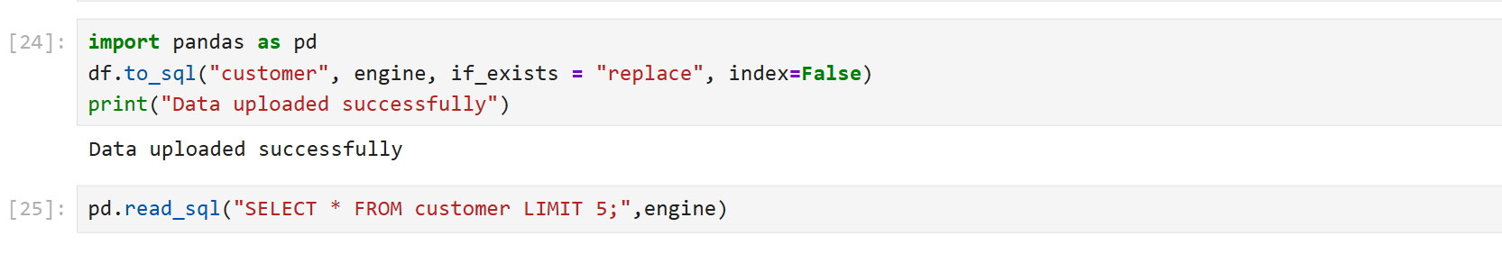
- Using MySQL for further and deeper analysis
Here, we find answers for some questions:
- What is the total revenue generated by male vs female customers?
SELECT gender, SUM(purchase_amount) AS total_revenue FROM customer GROUP BY gender;
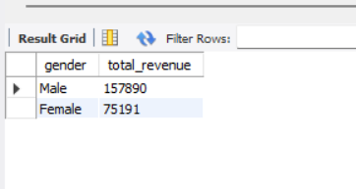

- Which customers used a discount but still spent more than the average purchase amount?

SELECT customer_id, purchase_amount FROM customer WHERE purchase_amount >=(SELECT AVG(purchase_amount) as Avg_amount FROM customer)
AND discount_applied = 'Yes';

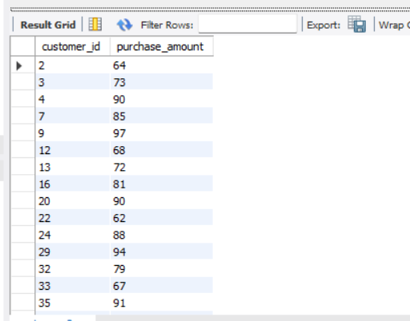

- Which are the Top 5 products with the highest average review rating?

SELECT item_purchased , ROUND(AVG(review_rating),2) as avg_rating FROM customer group by item_purchased ORDER BY AVG(review_rating) DESC LIMIT 5;
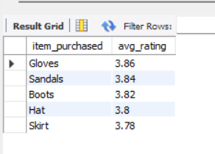

- Compare the average Purchase Amounts between Standard and Express Shipping

SELECT shipping_type, ROUND(AVg(purchase_amount),2) AS avg_amount FROM customer GROUP BY shipping_type HAVING shipping_type IN ('Express','Standard');

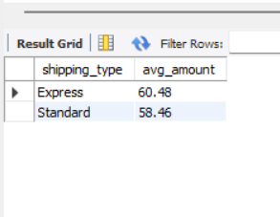

- Do subscribed customers spend more? Compare Avergae spend and total revenue between subscribers and non-subscribers

SELECT subscription_status,COUNT(*) as total_customers,ROUND(AVG(purchase_amount),2) as avg_spend,
ROUND(SUM(purchase_amount),2) as total_revenue FROM customer GROUP BY subscription_status;

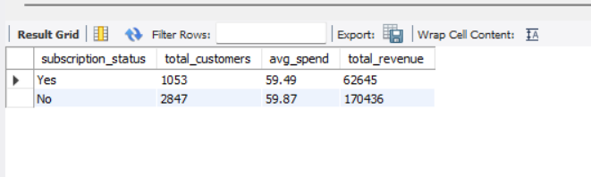
- Which 5 products have the highest percentage of purchases with discount applied?

SELECT item_purchased,
ROUND(100*SUM(CASE WHEN discount_applied = 'Yes' THEN 1 ELSE 0 END)/COUNT(*),2)
AS discount_rate
FROM customer GROUP BY item_purchased
ORDER BY discount_rate DESC
LIMIT 5;
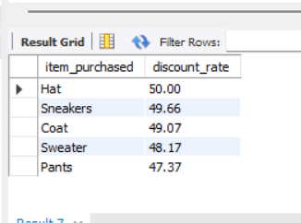

- Segment customers into New, Returning and loyal based on their total number of previous purchase and show the count of each segment.
WITH customer_types as (
SELECT customer_id, previous_purchases,
CASE
WHEN previous_purchases =1 THEN 'New'
WHEN previous_purchases BETWEEN 2 AND 10 THEN 'Returning'
ELSE 'Loyal'
END AS 'Customer_Status'
FROM customer
)

SELECT Customer_Status, count(*) as 'Number of Customers' FROM customer_types GROUP BY Customer_Status;

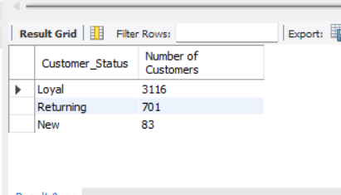

- What are the top 3 most purchased products within each category
WITH item_count as(

SELECT category, item_purchased, COUNT(*) AS total_purchase, ROW_NUMBER() OVER(PARTITION BY category ORDER BY COUNT(*) DESC) AS product_rank FROM customer
GROUP BY category, item_purchased)

SELECT product_rank, category, item_purchased, total_purchase FROM item_count WHERE product_rank <=3;
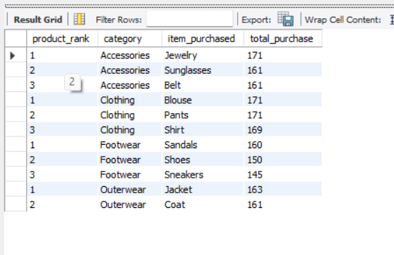
- Are Customers who are repeat buyers (more than 5 previous purchases) also likely to subscribe?
SELECT subscription_status, count(*) as repeat_customers from customer WHERE previous_purchases>5 GROUP BY subscription_status;
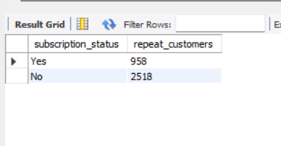
- Using Power BI to show our findings using dashboard
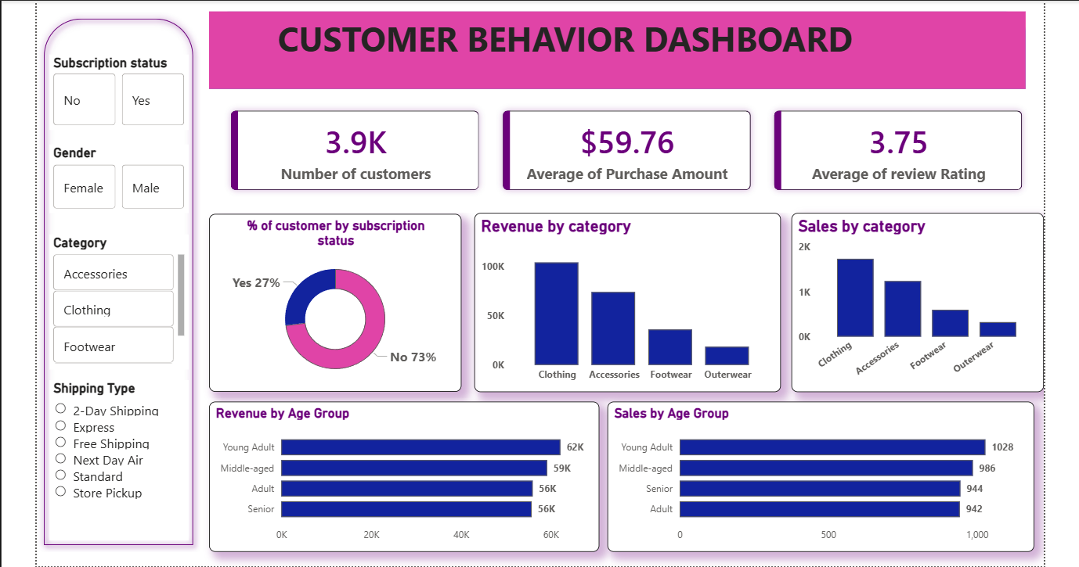

- Findings
- KPI’s: Number of customers = 3.9k
Average of purchase Amount = $59.76
Average of Review Rating = 3.75
Clothing comes out as the highest revenue generating item which is being sold at the highest time, it is followed by Accessories, Footwear and Outerwear. The Age-group which is generating highest revenue and buying things at the highest time is ‘Young Adult’.
- Clothing: No. of males (1.181K) > No. of Females (556), highlighting that males are more engaged in clothing shopping as compared to females.
For males out of 1.181k only 457 are the one who has taken subscription, on the other hand, none of the female engaged in clothing shopping has taken any subscription. For shipping type Express and Store pickup are the popular ones and the age group which is mostly engaged in clothing category is Young Adult.
Average purchasing amount of clothing ($60.03)> overall average purchasing amount ($59.76).

- Actions and Recommendations
- The subscription status for majorly of the customers in No, there is a need to introduce special and attractive offers or exclusive benefits engaged with this subscription so that more customers are willing to take it, this will improve customer retention.
- From the analysis, it is also found that females are not engaging as much as men when it comes to shopping. Need to introduced products that are specially targeting women for spending more. Also need to improve target marketing strategy and product offering which are tailored for females.
- As “Young Adult” comes out as the highest spending age group, more programs and discount policy and rates should focus more on them. Business should focus on personalized promotions, loyalty programs and targeted discount to convert this into maximum revenue generation.
- The shipping type which is most popular are ‘Express’ and ‘Store Pickup’, that means speed and flexibility are key drivers for customer satisfaction and business should give priority to optimize delivery channels.

