Project 1

By VIJAY YERUVA
Version 1.1
09/14/2020

TABLE OF CONTENTS
1 Introduction 3
2 SYSTEM DOCUMENTATION 3
2.1 High Level Dataflow Diagram 3
2.2 List of Routines 3
2.3 Implementation Detail 4
3 TEST Documentation 4
3.1 Testing methodology 4
3.2 Tests 4
4 USER DOCUMENTATION 5
4.1 Source location 5
4.2 How to Run 5
4.3 Parameters
5

Introduction
This is a simple project which constitutes two executables one transmitter and one receiver to communicate through bit data file. The is project which demonstrates the communication through data layers

SYSTEM DOCUMENTATION

HIGH-LEVEL dataflow diagram

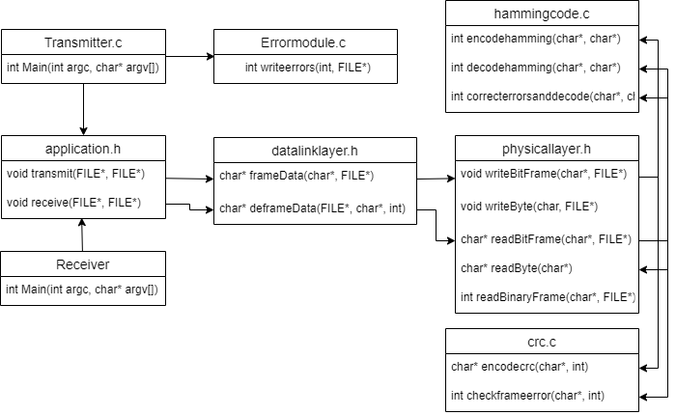

LIST OF ROUTINES
- PhysiclLayer.h
- void writeByte(char, FILE*): Write a char into 0s and 1s format in the file
- char* writeByteToArray(char, char*): Write a char into an array of ‘0’s and ‘1’s
- void writeBitFrame(char*, FILE*, int): writes the char frame into 0s and 1s format in the file after encoding based on encoding type.
- void writeBitFrameCRC(char*, FILE*):Encodes the entire frame with CRC
- void writeBitFrameHamming(char*, FILE*):Encodes every bit into (7,4) hamming code.
- char readByte(char*): reads eight 0s and 1s and transforms them into a char
- int readBitFrame(char*, FILE*, int): reads the 0s and 1s frame from the file and decodes that into chars based on encoding type.
- int checkFrameError(FILE*): checks for errors in frame while reading in CRC encoded mode
- int readCRCremainder(char*, FILE*): function reads the CRC remainder part of the message
- int readBinaryFrame(char*, FILE*): functions reads the message from intermediate file in binary format
- char readHammingByte(char*): Reads hamming codes and transforms that into a byte char
- int readHammingBitFrame(char*, FILE*): Reads hamming encoded bit frame from file
- hammingcode.h
- int encodehamming(char*, char*): encodes each byte into two 7,4 hamming codes
- int decodehamming(char*, char*): decodes each hamming code without error checking
- int correcterrorsanddecode(char*, char*): decodes each hamming code after error correction
- errormodule.h
- errorlocation writeerror(FILE*): writes a single error randomly on intermediate file after sleeping for 1 second and returns a error location
- errorlocation* writeerrors(int, FILE*): writes multiple errors randomly on intermediate file
- datalinklayer.h
- char* frameData(char*, FILE*, int): makes char frames out of the char buffer and writes into the file based on encoding type
- int deframeData(FILE*,char*, int, int): makes char buffer from the 0s and 1s frame and writes into the file.
- crc.h
- char* encodecrc(char*, int): function encode the frame with given CRC polynomial
- int checkcrcerror(char*, int): checks the error in a given frame with CRC remainder at the end
- application.h
- void transmit(FILE*, FILE*, int): transmits from a char file to a intermediate file in 0s and 1s format based on encoding type
- void receive(FILE*, FILE*, int): receives from an intermediate file in 0s and1s based on encoding type and transforms into a text file

IMPLEMENTATION DETAIL

The transmitter or receiver is an implementation on top of application functions. The application open files and read/writes through char buffers. The application calls data link layer functions to frame/deframe the char buffers. The data link layer calls physical layer functions to convert the char frames to 0s and 1s. The message is transformed and encoded based on encoding type passed through application at physical layer while writing to intermediate file. A number of errors are randomly introduced from application layer as requested by the user.

TEST DOCUMENTATION

TEST METHODS

Executed the tests through command line

TESTS
No Encoding

command: ./transmitter.out Input.txt 0

prompts: How many errors you want to introduce?

If entered 0 this will not write any errors and produce Bit.txt without any encoding
If entered 1 it will open the intermediate file and write errors at random location and display the Frame, Byte and Bit where the error is introduced.

command: ./receiver.out Output.txt 0

Result: produced Output.txt with the same content as that of Input.txt if the no of errors is 0 otherwise error will be produced in the final out.
CRC Encoding

command: ./transmitter.out Input.txt 1

prompts: How many errors you want to introduce?

If entered 0 this will not write any errors and produce Bit.txt with CRC encoding
If entered 1 it will open the intermediate file after CRC encoding and write errors at random location and display the Frame, Byte and Bit where the error is introduced.
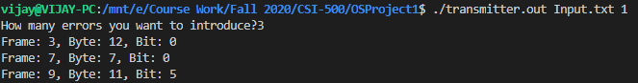

command: ./receiver.out Output.txt 1

Result: produced Output.txt with the same content as that of Input.txt if there are no errors is 0 otherwise it will prompt the frame where the error occurred and will be produced in the final output with errors.

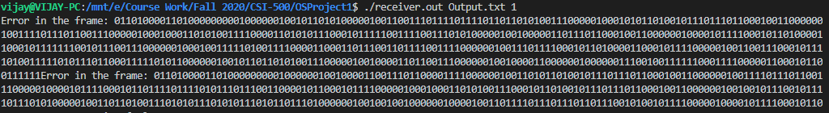
CRC Encoding

command: ./transmitter.out Input.txt 2

prompts: How many errors you want to introduce?

If entered 0 this will not write any errors and produce Bit.txt with Hamming encoding
If entered 1 it will open the intermediate file and write errors at random location and display the Frame, Byte and Bit where the error is introduced.

command: ./receiver.out Output.txt 2

Result: produced Output.txt with the same content as that of Input.txt irrespective of errors due to Hamming code correction. There will be another error.txt will be produced without hamming correction

USER DOCUMENTATION

SOURCE LOCATION
Github: https://github.com/Vijay-yeruva/OSProject1.git

Blackboard: All the files are uploaded to blackboard

HOW TO RUN
Transmitter

code compiling command: gcc -g physicallayer.c datalinklayer.c application.c transmitter.c -o transmitter.out

exection command: ./transmitter.out Input.txt

Receiver

code compiling command: gcc -g crc.c errormodule.c physicallayer.c datalinklayer.c application.c receiver.c -o receiver.out

exection command: ./receiver.out Output.txt

parameters
The input file name and encoding type for transmitter and output file name and encoding type for receiver

