MYSHELL

By VIJAY YERUVA
Version 1.0
03/02/2020

TABLE OF CONTENTS
1 Introduction 3
2 SYSTEM DOCUMENTATION 4
2.1 High Level Dataflow Diagram 4
2.2 List of Routines 6
2.3 Implementation Detail 7
3 TEST Documentation 8
3.1 Testing methodology 8
3.2 Tests 8
4 USER DOCUMENTATION 12
4.1 Source location 12
4.2 How to Run 12
4.3 Parameters 12

Introduction
This is simple shell project where we build a custom shell with the help of system calls on a Linux machine to mimic system shell on a Unix system. The objective of this project is to understand the system calls process management.

SYSTEM DOCUMENTATION

HIGH-LEVEL dataflow diagram

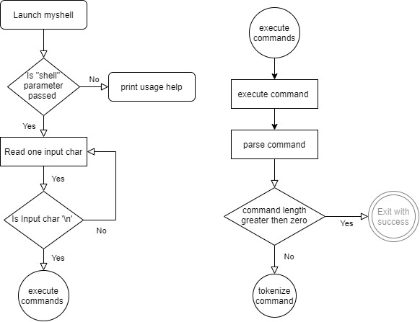

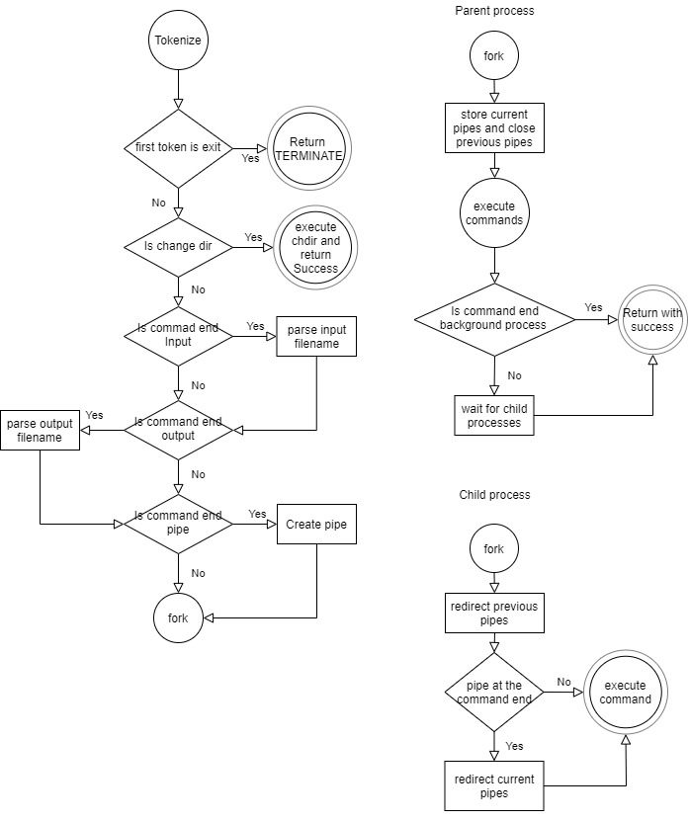

LIST OF ROUTINES
- void print_user(): Prints the device's username along with current directory
- char getch(FILE*): Gets character from the file pointer
- void delete(int, char*): deletes the current character.
- char switch_keypad(char): Determines which special character is processed.
- int copybuff(char*, char**): Copies from null terminated buffer to destination
- FILE* openfile(char*): opens a file with given file path
- void closefile(FILE* fp): closes the given file
- void trimtrailingspace(char** ptrline): function to trim space at the end of strings
- void shell(char*): Processes the input and determine whether it is a user interface operation or a set of commands that will need to be executed.
- short execute_commands(char*): The execute_commands function will process and execute the commands in the variable line.
- short execute_command(char**, char*,int**): The execute_command function will process and execute the commands recursively one after the other.
- int parseCommand(char**, char**, char*): The parseCommand function will extracts the first command from commands and removes it from the commands
- int tokenize_cmd(char*, char**): The tokenize_cmd function will tokenize the command into command and arguments based on spaces between them.
- short awaitChildren():The awaitChildren function waits for all the child process to die

IMPLEMENTATION DETAIL

The executeCommand function is called recursively on input line until it reaches the end of the line. The parseCommand function extracts the leading command from the input line and shortens it. The recursion will end when the input line length is zero.

The pipes are created recursively every two piped commands. The input and output redirection are handled just before creating the fork for child process and the redirection happens only on child process.

The maximum possible length for all the commands is 1023

The maximum length for a single command including arguments is 256 and maximum number of arguments for a single command is 9

TEST DOCUMENTATION

TEST METHODS

Executed the all the command listed in the project document. Executed the commands one after the other and recorded the output screen shots.

TESTS

command: myshell shell

command: cd and ls
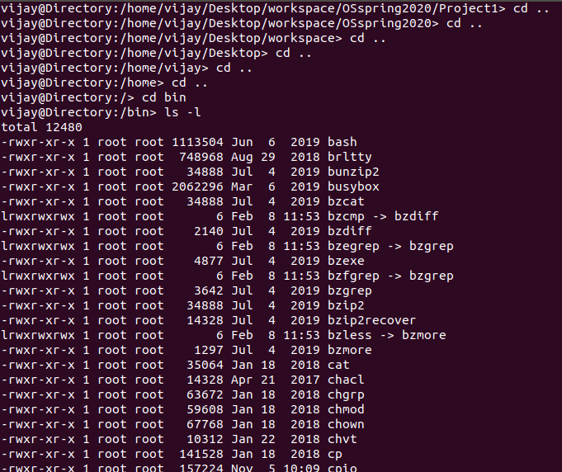

commands: ls -a and ls -l
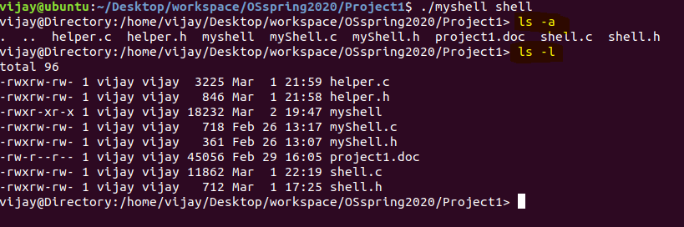

command: ls -l > foo

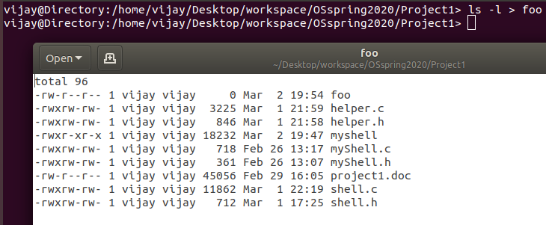

command: sort < testfile

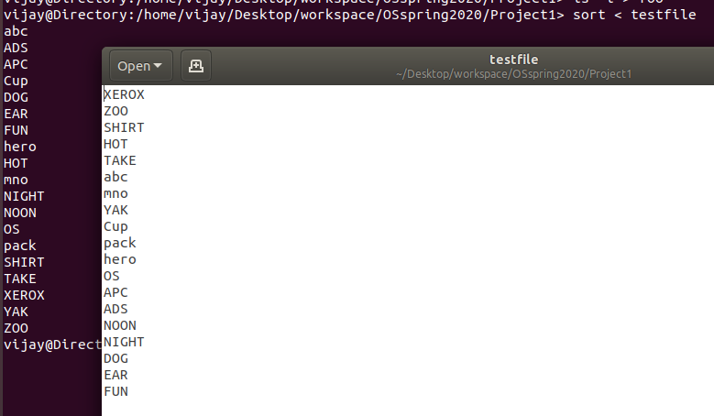

command: sort < testfile > sortedfile

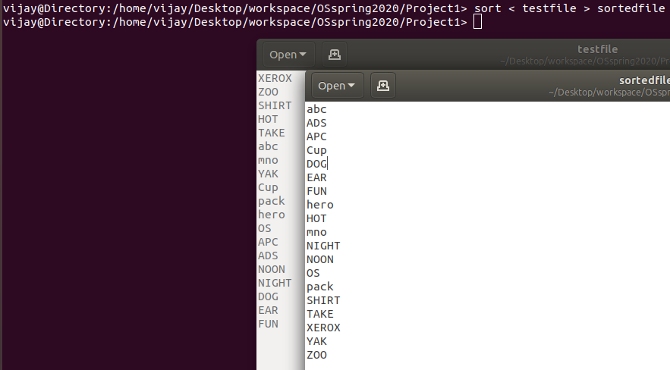

command: ls -a | sort | more

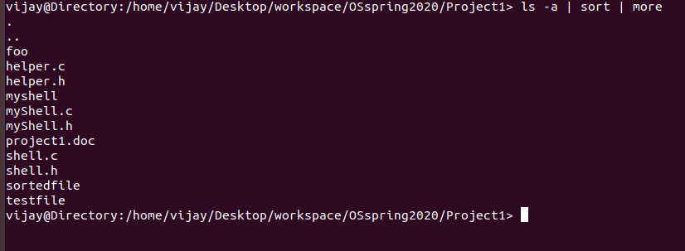

command: ls -a &

the prompt is returned ahead of child process that is why output is printed after the prompt

USER DOCUMENTATION

SOURCE LOCATION

Github: https://github.com/Vijay-yeruva/OSspring2020.git project1 folder

Blackboard: All the files are uploaded to blackboard

HOW TO RUN

code compiling command: gcc helper.c shell.c myShell.c -o myshell

exection command: ./myshell shell filename<optional>

will prompt as new line with username@Direcotry: <currentpath>>

Type any command at the prompt it will executed as that of a regular shell

parameters

shell: need to send shell as a argument to myshell program. This is compulsory requirement.

filename: This is an optional argument. If this is not provided myshell will read from standard input. If it is provided it will read from the file

