MYSHELL 2.0

By VIJAY YERUVA
Version 2.0
05/05/2020

TABLE OF CONTENTS
1 Introduction 3
2 SYSTEM DOCUMENTATION 4
2.1 High Level Dataflow Diagram 4
2.2 List of Routines 7
2.3 Implementation Detail 8
3 TEST Documentation 9
3.1 Testing methodology 9
3.2 Tests 9
4 USER DOCUMENTATION 15
4.1 Source location 15
4.2 How to Run 15
4.3 Parameters 15

Introduction
The goal of this exercise is to gain an understanding of distributed processing by extending the functionality of a simple Linux shell behavior. The system to be created will be able to manipulate the contents stored in other machines that share a network connection.

SYSTEM DOCUMENTATION

HIGH-LEVEL dataflow diagram

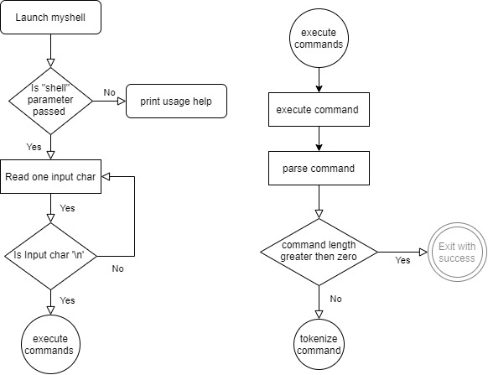

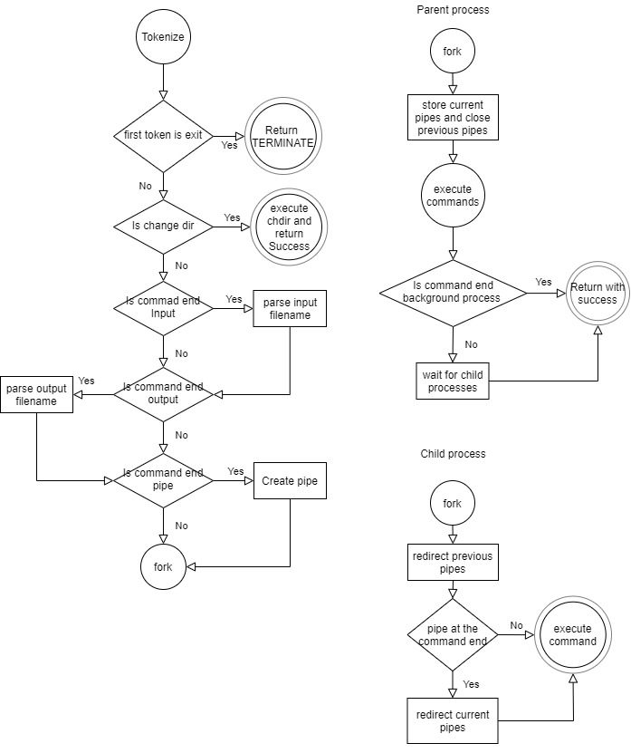

This is a normal mode of operation when running on single machine.
In distributed mode the redirection happens to the sockets in the child process created

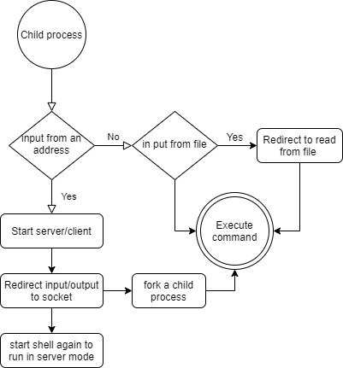

When running Myshell in client/server mode we need a dummy server/client to communicate with Myshell.

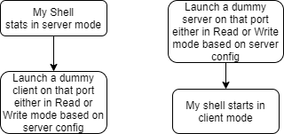

LIST OF ROUTINES
- void print_user(): Prints the device's username along with current directory
- char getch(FILE*): Gets character from the file pointer
- void delete(int, char*): deletes the current character.
- char switch_keypad(char): Determines which special character is processed.
- int copybuff(char*, char**): Copies from null terminated buffer to destination
- FILE* openfile(char*): opens a file with given file path
- void closefile(FILE* fp): closes the given file
- void trimtrailingspace(char** ptrline): function to trim space at the end of strings
- void shell(FILE*): Processes the input and determine whether it is a user interface operation or a set of commands that will need to be executed.
- short execute_commands(char*): The execute_commands function will process and execute the commands in the variable line.
- short execute_command(char**, char*,int**): The execute_command function will process and execute the commands recursively one after the other.
- int parseCommand(char**, char**, char*): The parseCommand function will extracts the first command from commands and removes it from the commands
- int tokenize_cmd(char*, char**): The tokenize_cmd function will tokenize the command into command and arguments based on spaces between them.
- short awaitChildren():The awaitChildren function waits for all the child process to die
- int startserver(int, int*): starts the server at a given port number and outputs the client connection file descriptor
- int startclient(char*, int*): starts the client and connects to the server at the given hostname and port number and output the socket file descriptor
- void error(const char*): function writes the given error message to perror function
- void startwriting(int): This function is to write to a given file descriptor
- void startreading(int): This function is to read from a given file descriptor

IMPLEMENTATION DETAIL
Myshell:The executeCommand function is called recursively on input line until it reaches the end of the line. The parseCommand function extracts the leading command from the input line and shortens it. The recursion will end when the input line length is zero.
The pipes are created recursively every two piped commands. The input and output redirection are handled just before creating the fork for child process and the redirection happens only on child process.
If the output is redirected starting with @s then Myshell will launch a server and execute the command in a child process and the file redirection happens to the port supplied.
If the output redirection starts with @c then Myshell will launch in a client mode connected to the server launched at the given hostname and port number
The maximum possible length for all the commands is 1023. The maximum length for a single command including arguments is 256 and maximum number of arguments for a single command is 9
Server: This is dummy server which lunches on a given port number and writes to or reads from the client connected to it. This can be started in read or write mode which ever required based on Myshell in client mode reading or writing.
Client: This is dummy client which connects to the server at the given hostname and port no and reads from and writes to the connected server based on read or write mode.

TEST DOCUMENTATION

TEST METHODS

Executed the all the command listed in the project document. Executed the commands one after the other and recorded the output screen shots.

TESTS

command: myshell shell

command: cd and ls
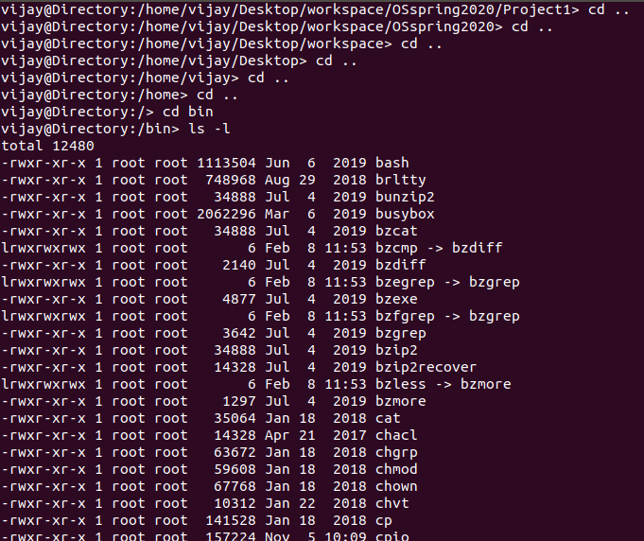

commands: ls -a and ls -l
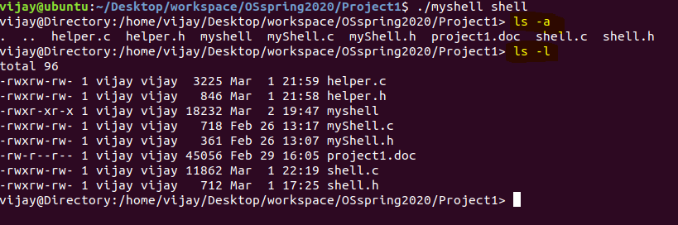

command: ls -l > foo

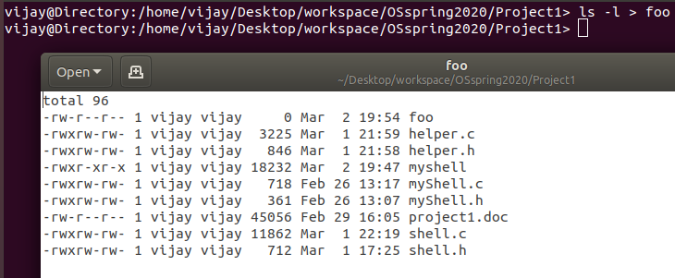

command: sort < testfile

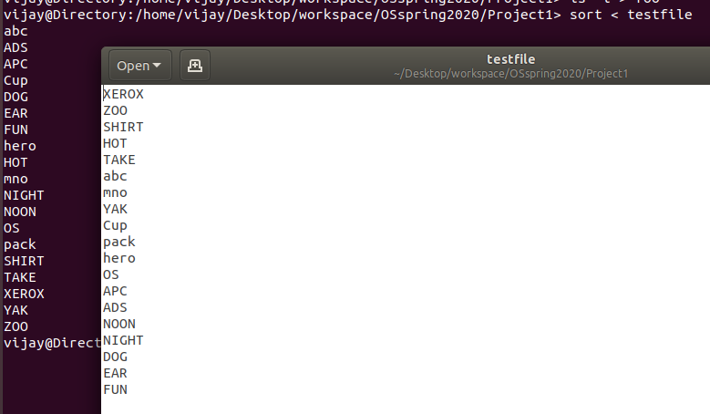

command: sort < testfile > sortedfile

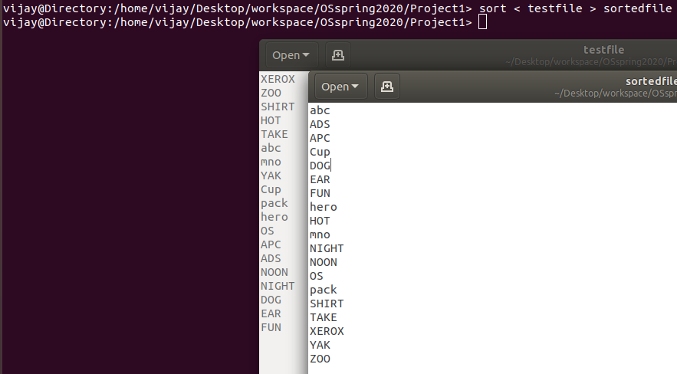

command: ls -a | sort | more

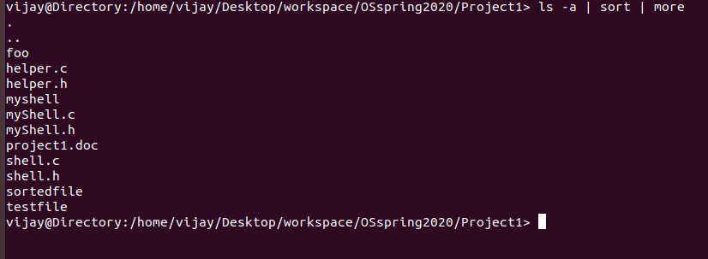

command: ls -a &

the prompt is returned ahead of child process that is why output is printed after the prompt

command: ls -a>@s 8910

command is given in the myshell server window and the result are shown at the dummy client window as show in the below image
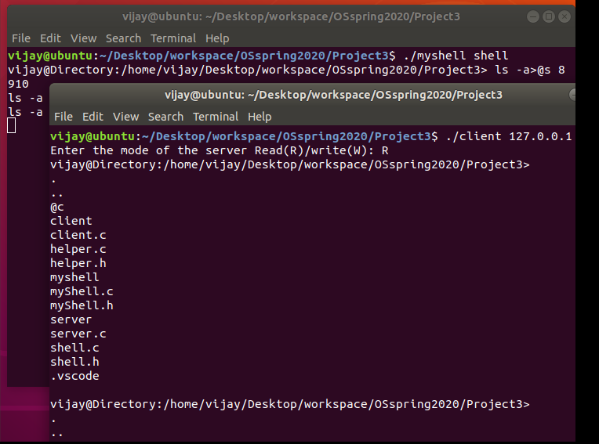

command: <@s 8910 in myshell and ls -a in dummy client
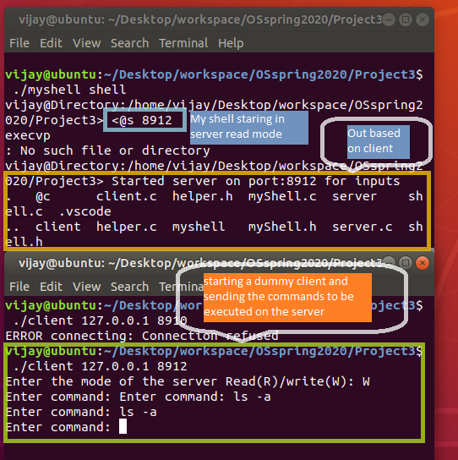

Command: ls -a>@c 127.0.0.1.8913

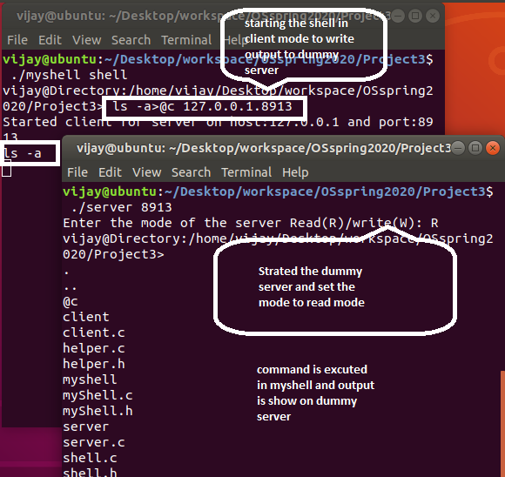
Command: <@c 127.0.0.1.8914 on dummy server: ls -a
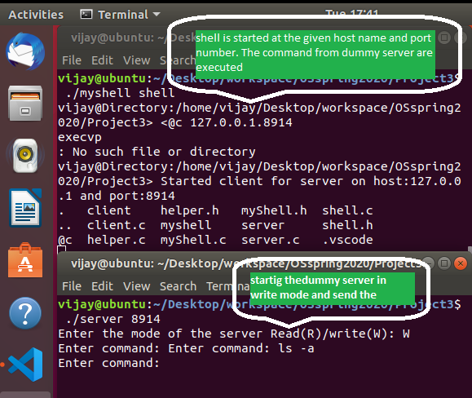

USER DOCUMENTATION

SOURCE LOCATION

Github: https://github.com/Vijay-yeruva/OSspring2020.git project3 folder

Blackboard: All the files are uploaded to blackboard

HOW TO RUN

code compiling command: gcc helper.c shell.c myShell.c -o myshell

code compiling command: gcc helper.c server.c -o server

code compiling command: gcc helper.c client.c -o client

exection command: ./myshell shell filename<optional>

will prompt as new line with username@Direcotry: <currentpath>

Type any command at the prompt it will executed as that of a regular shell
If >@s or <@s is entered it will be executed in server mode and we need the dummy client to read and write the output and input values
If >@c or <@c is entered shell will run in client mode and we need a dummy server to read and write from the shell.

parameters

shell: need to send shell as an argument to myshell program. This is compulsory requirement.

filename: This is an optional argument. If this is not provided myshell will read from standard input. If it is provided it will read from the file

server: need to send port as an argument

client: need to send host name and port as an argument

