Single Inheritance – A S Vijay(CH.EN.U4CCE22001)

Program:

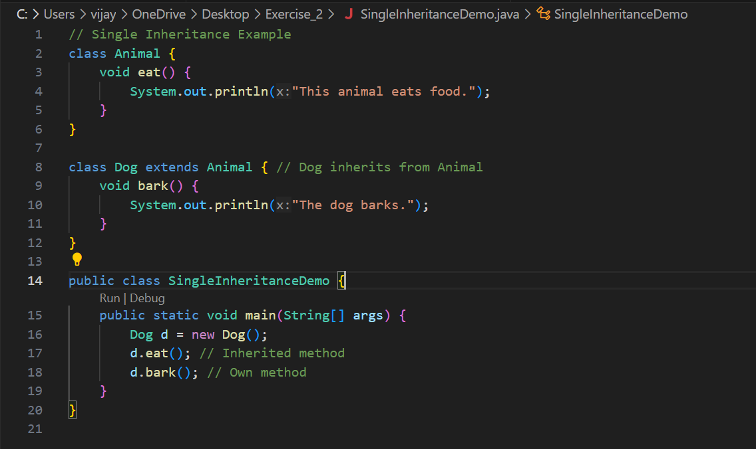

Output:

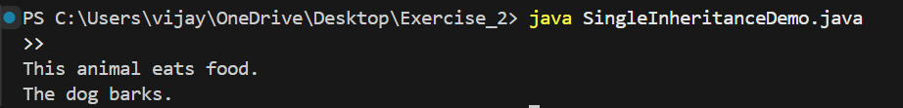

Multilevel Inheritance

Program:

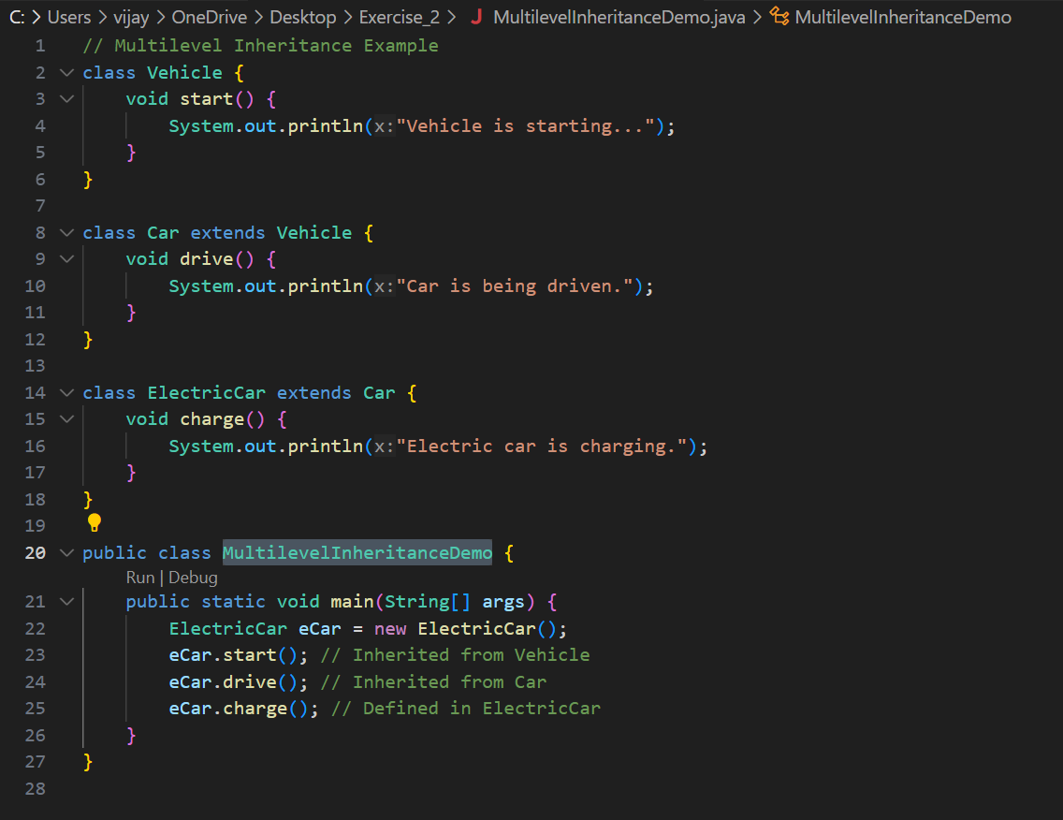

Output:

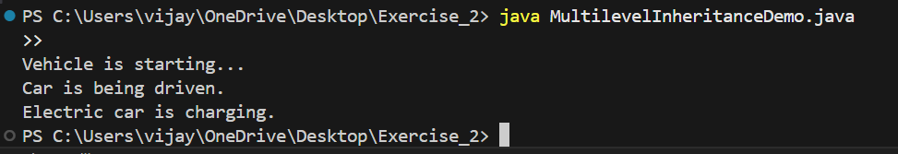

Hierarchical Inheritance

Program:

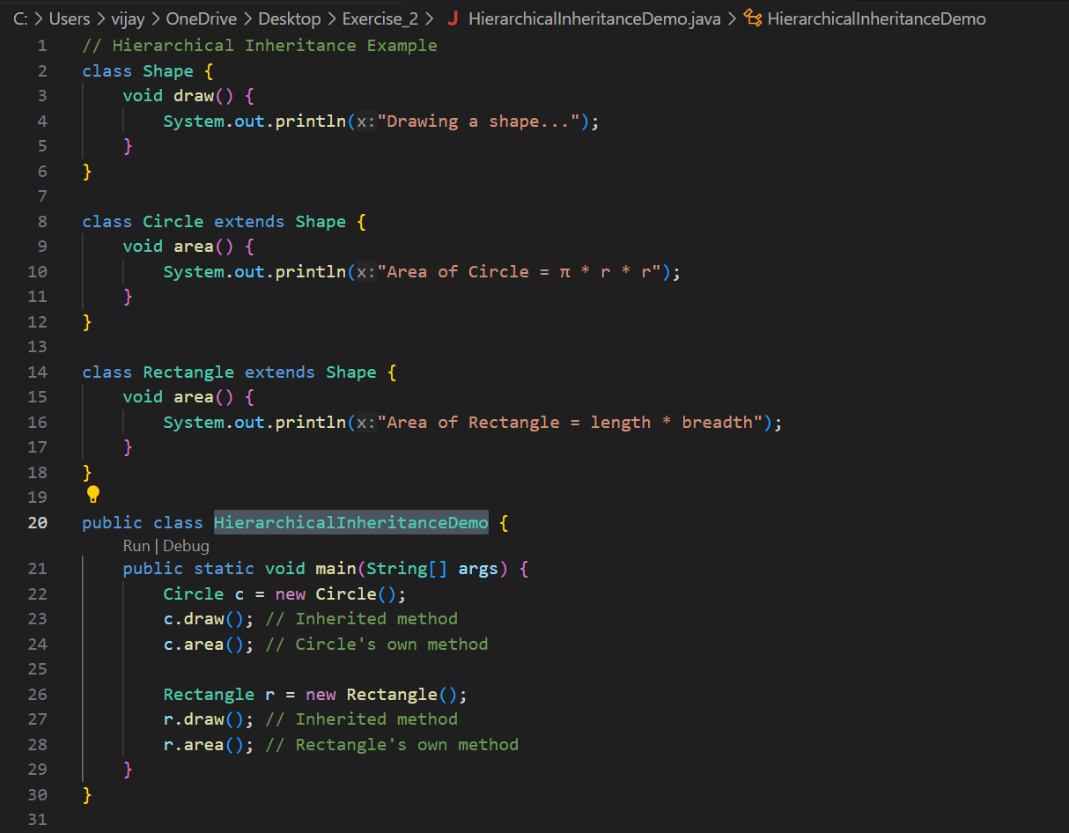

Output:

