Compile-time Polymorphism (Method Overloading) – A S Vijay(CH.EN.U4CCE22001)

Program:

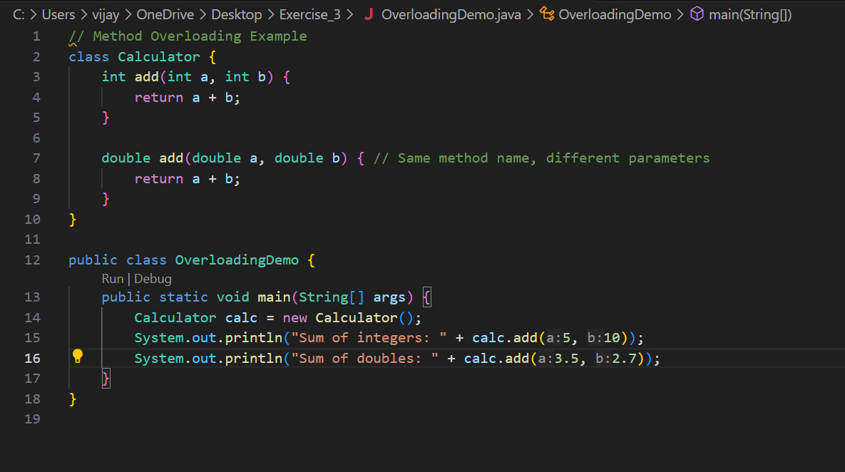

Output:

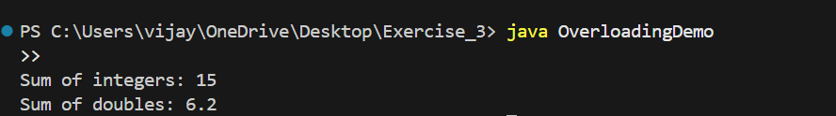

Runtime Polymorphism (Method Overriding)

Program:

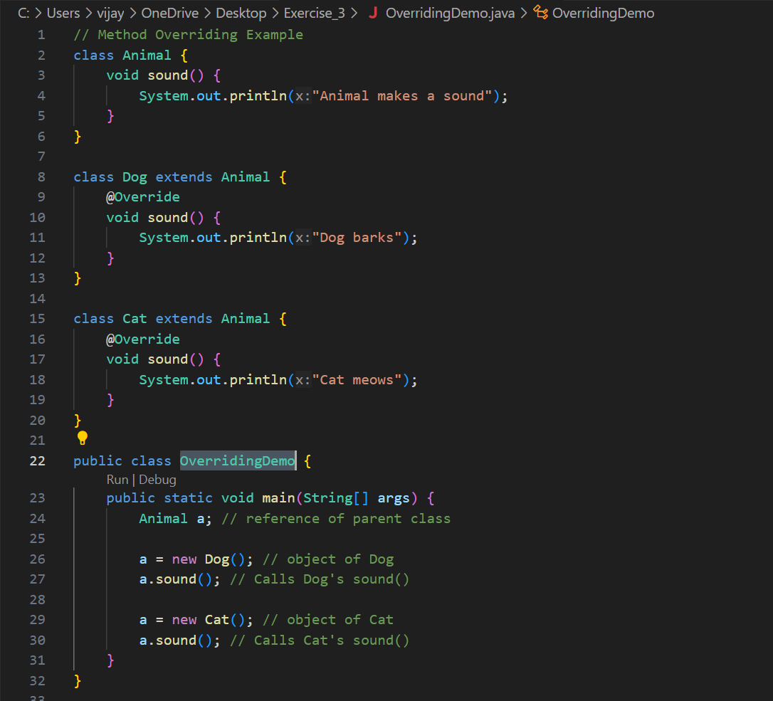

Output:

