**Exercise - 1**

Hello World – A S Vijay(CH.EN.U4CCE22001)

Program:

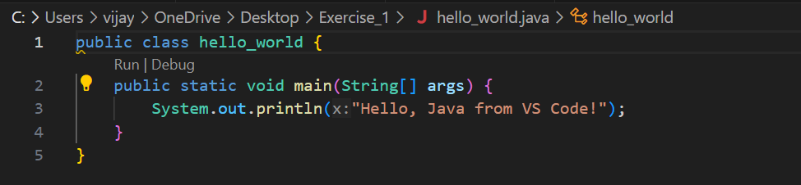

Output:

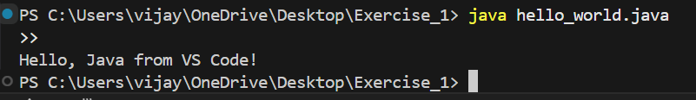

Basic Input and Output Statements

Program:

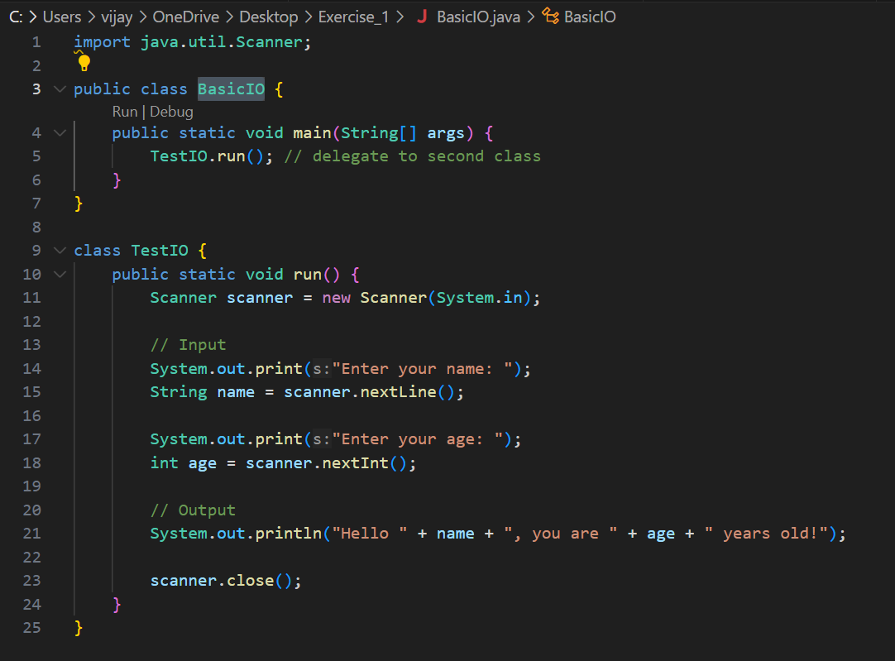

Output:

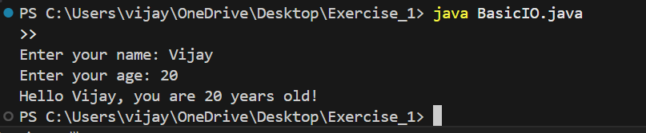

Data Types

Program:

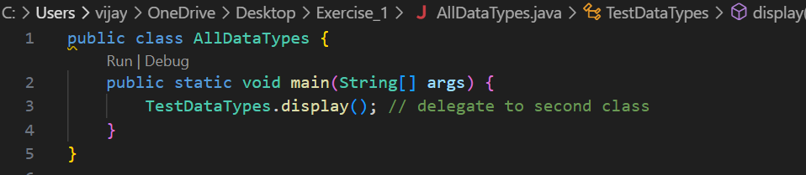

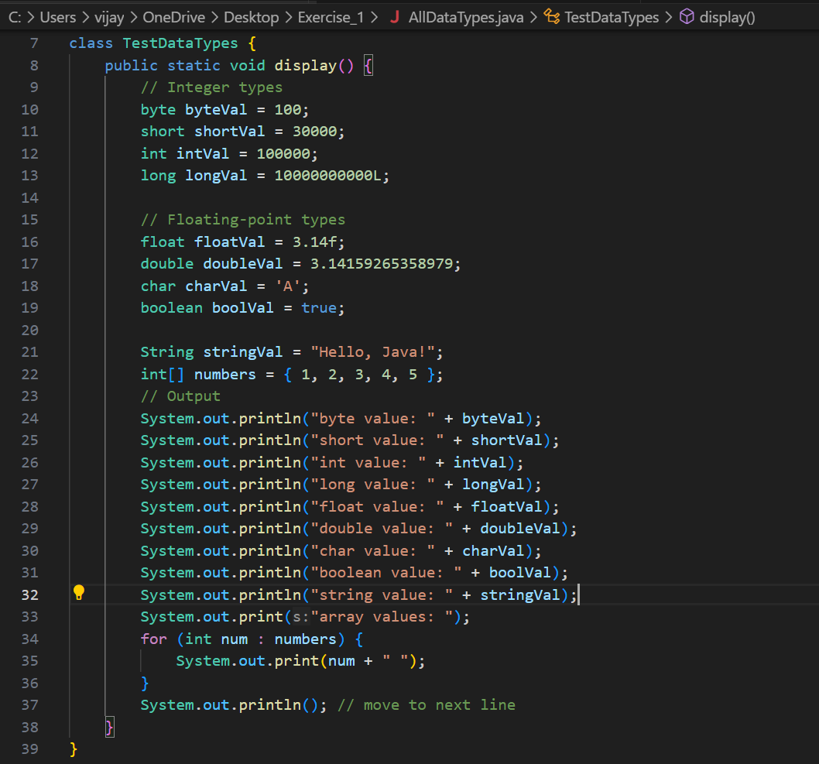

Output:

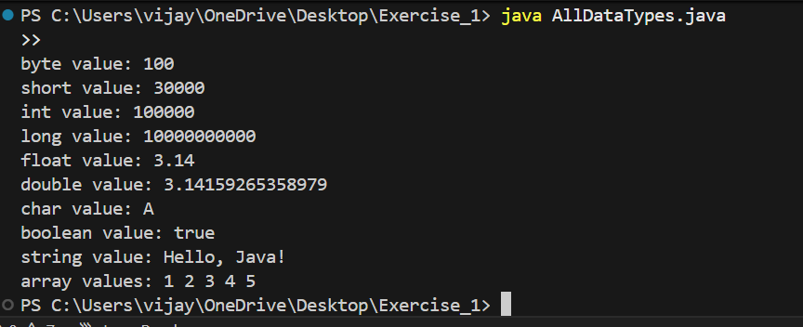

Data Operations

Program:

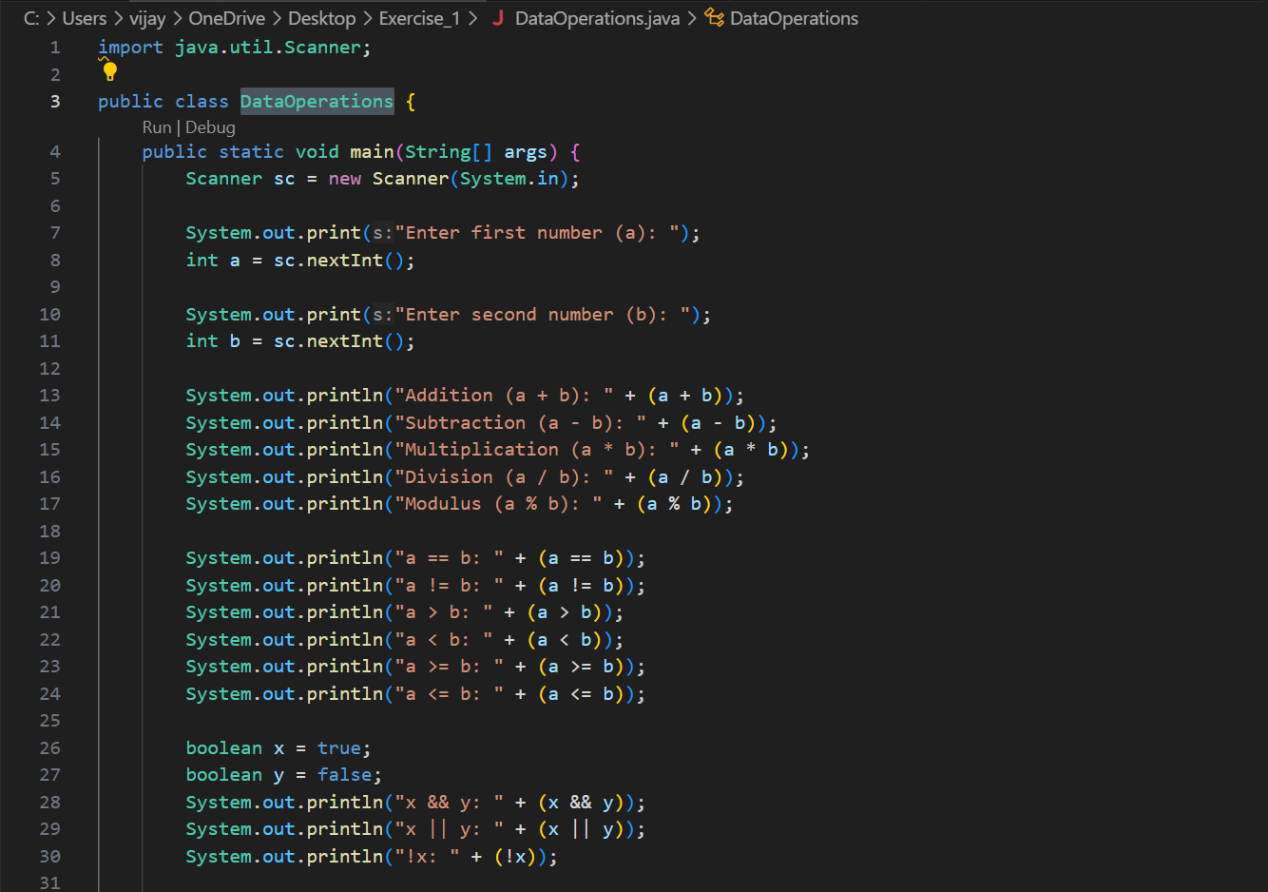

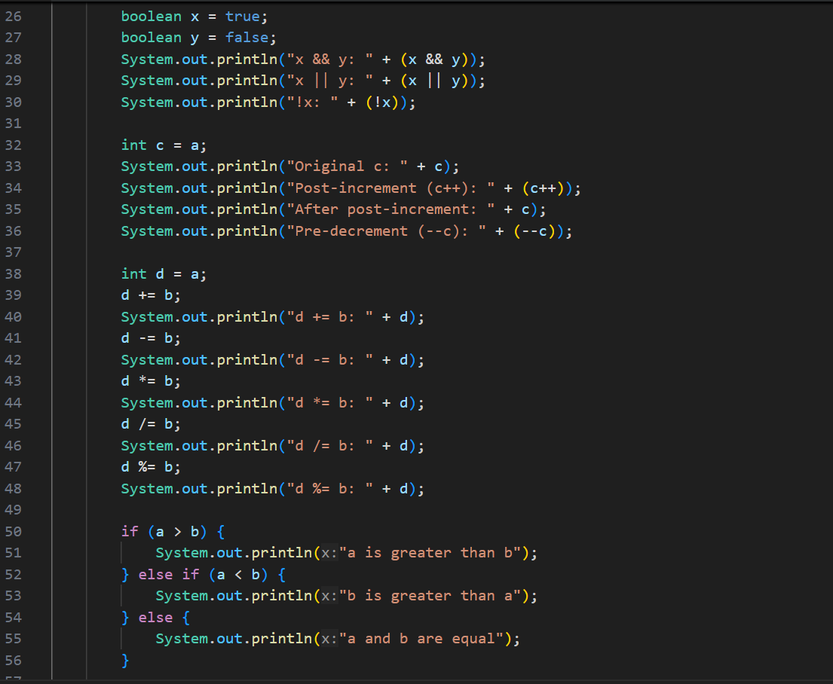

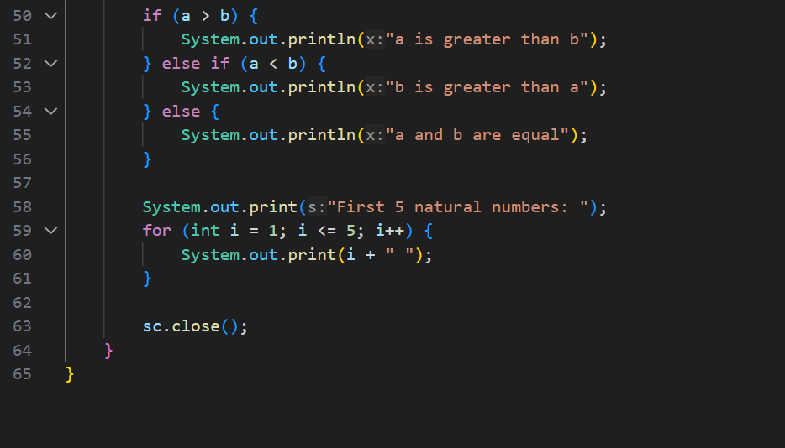

Output:

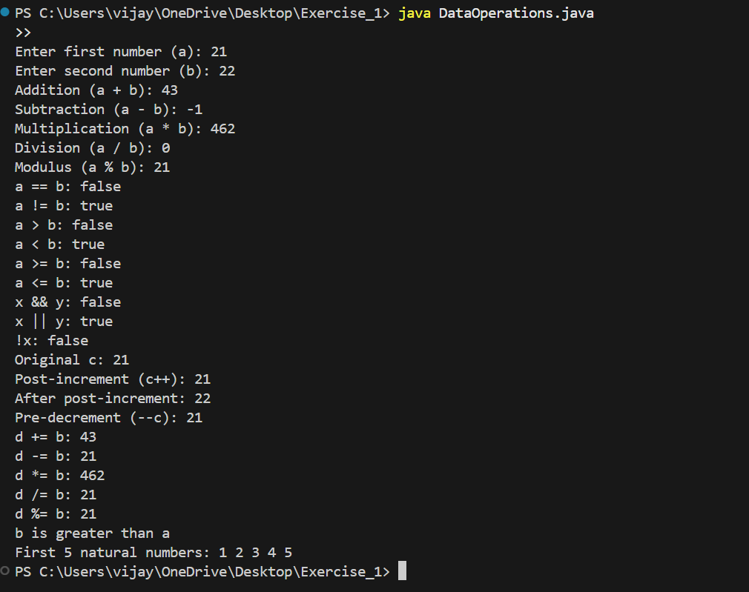

Control Statements

Program:

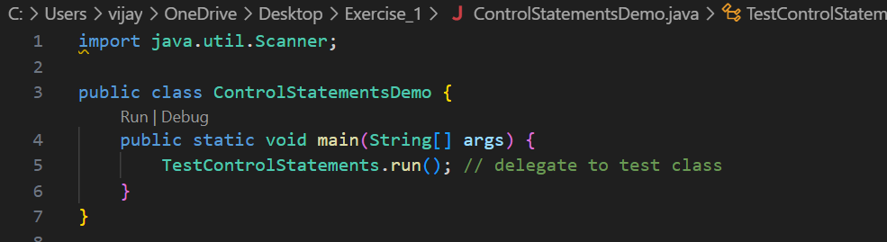

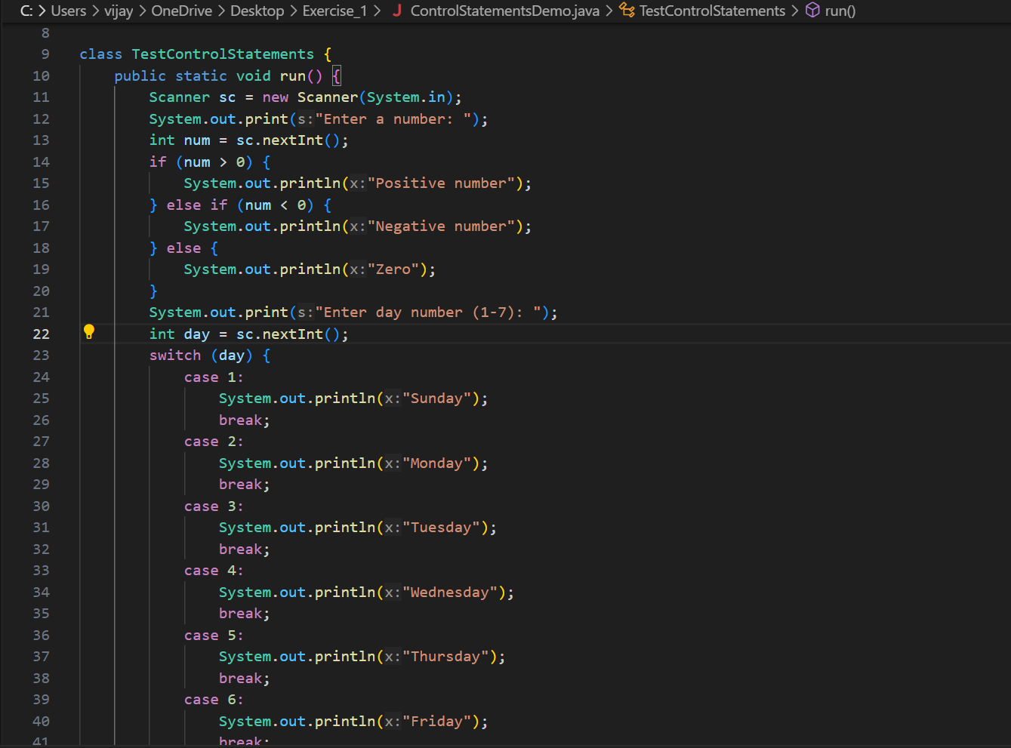

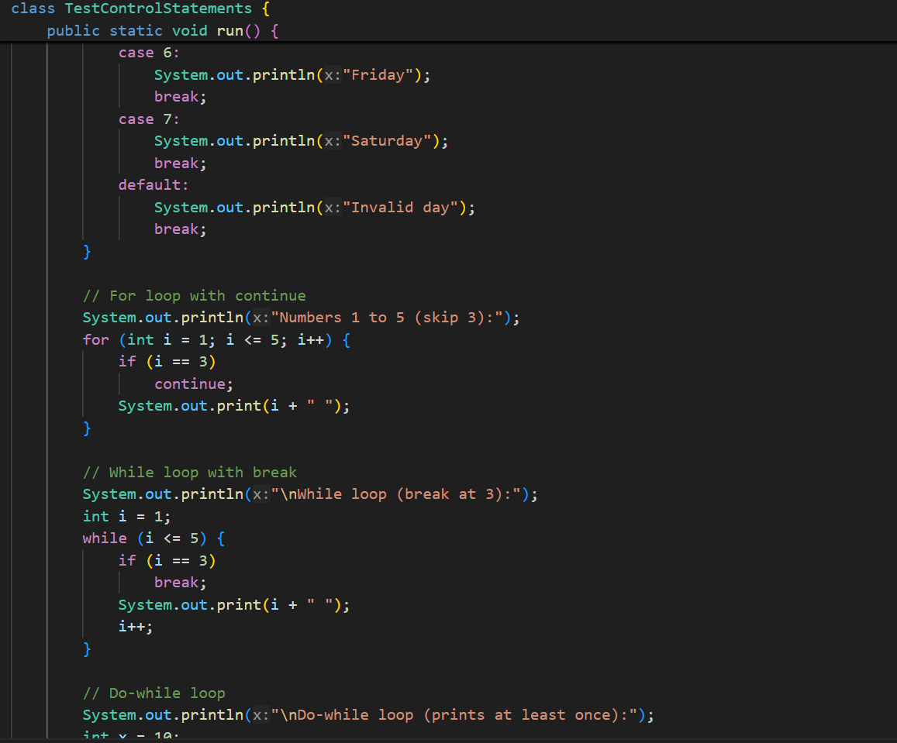

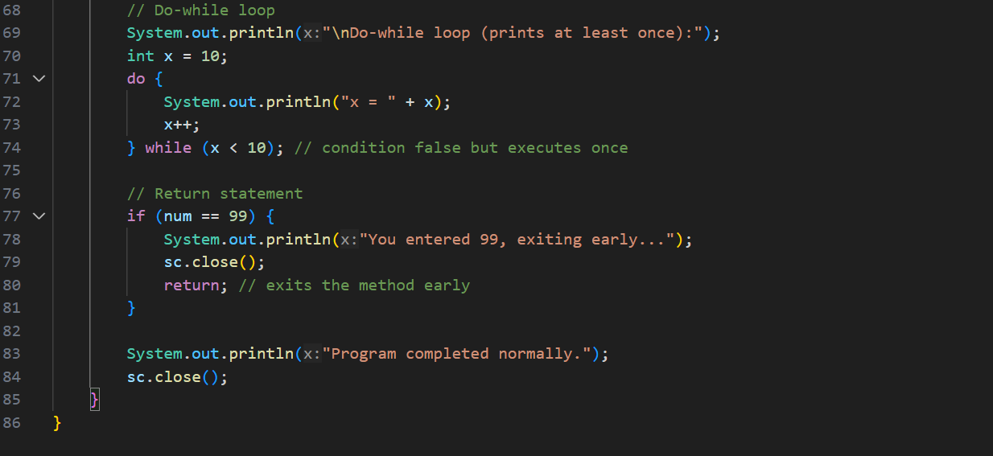

Output:

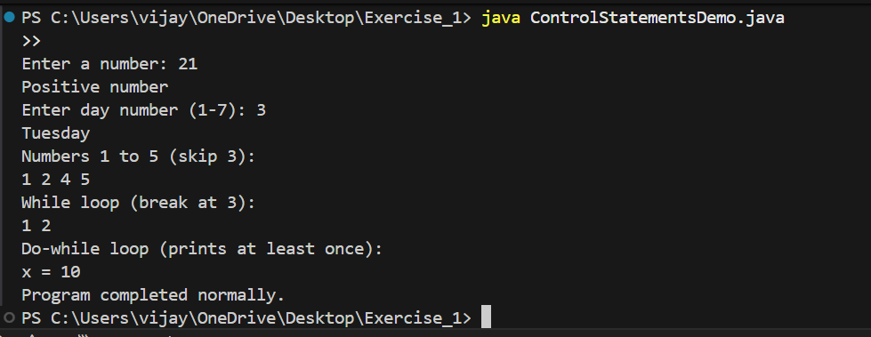

Access Modifiers

Program:

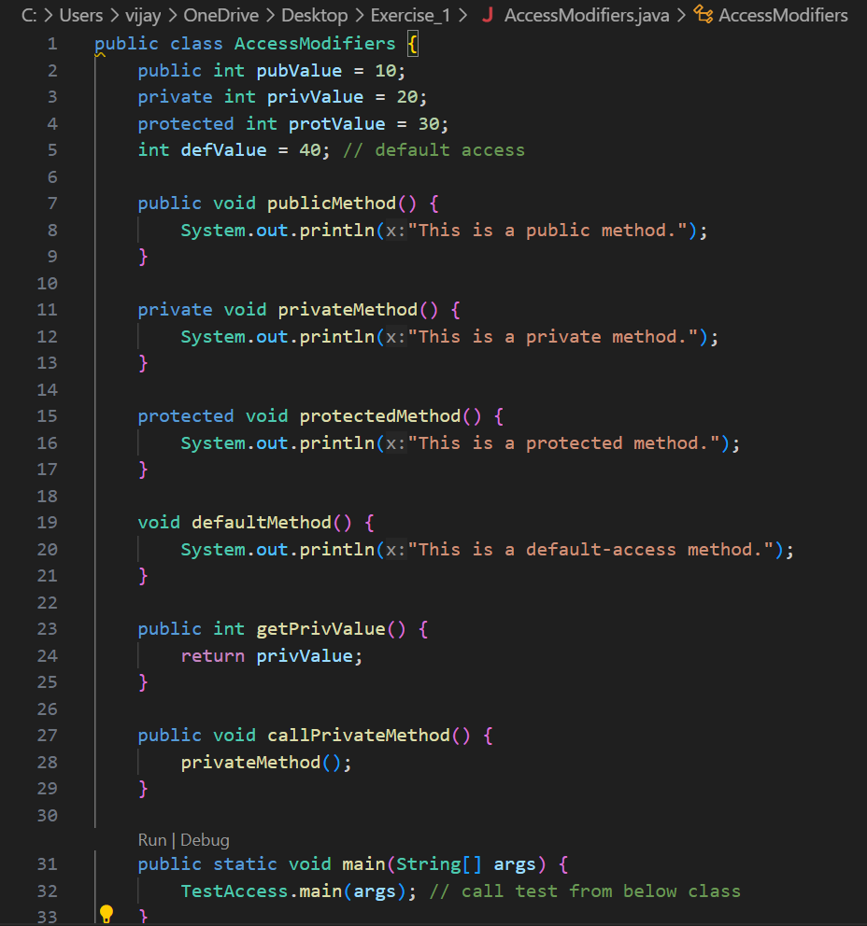

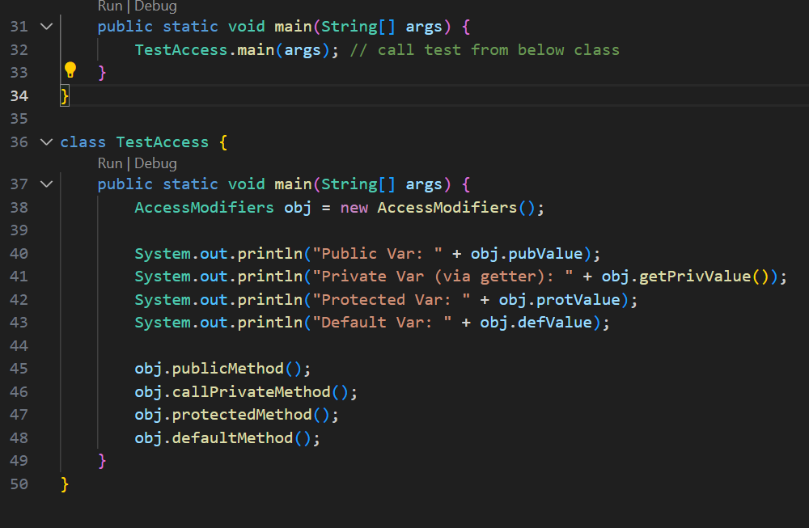

Output:

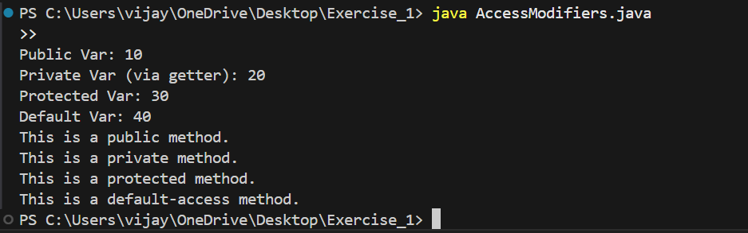

**Exercise - 2**

Single Inheritance – A S Vijay(CH.EN.U4CCE22001)

Program:

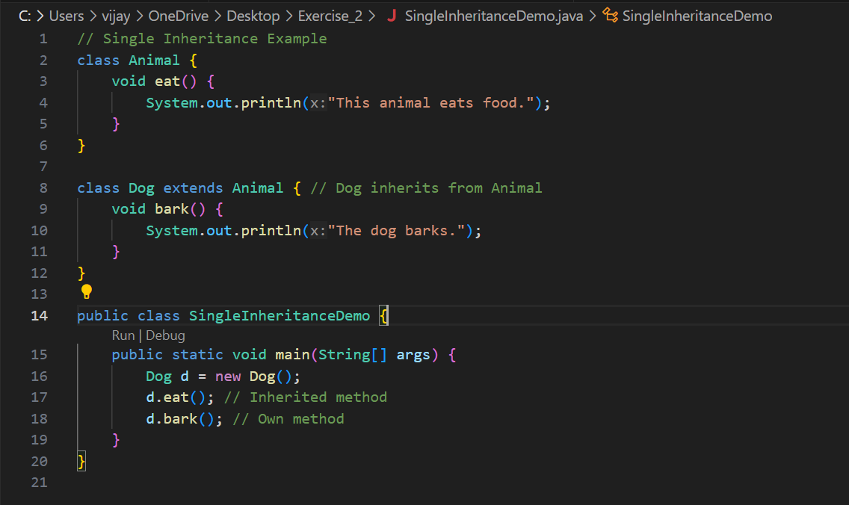

Output:

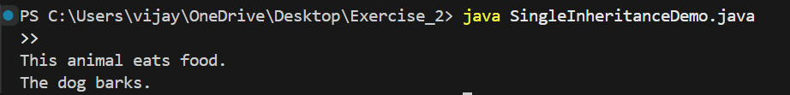

Multilevel Inheritance

Program:

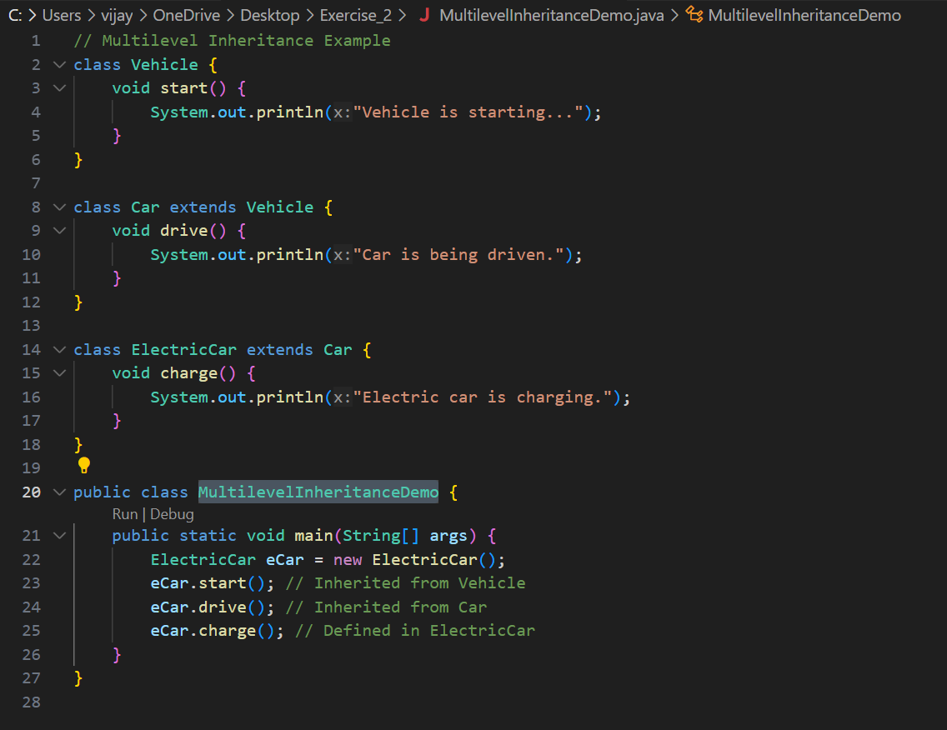

Output:

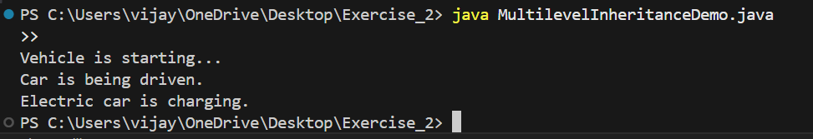

Hierarchical Inheritance

Program:

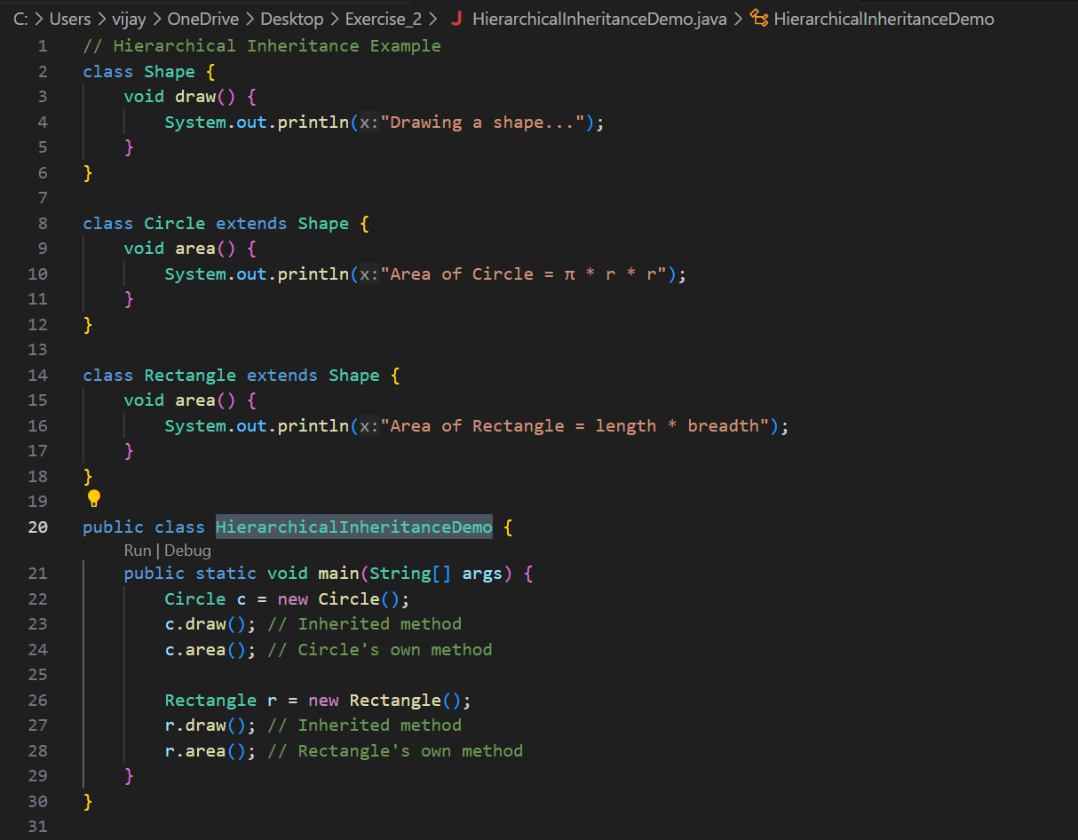

Output:

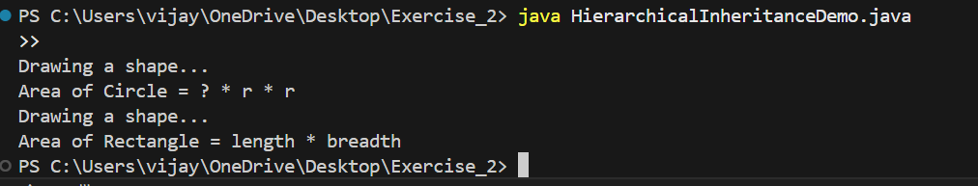

**Exercise - 3**

Compile-time Polymorphism (Method Overloading) – A S Vijay(CH.EN.U4CCE22001)

Program:

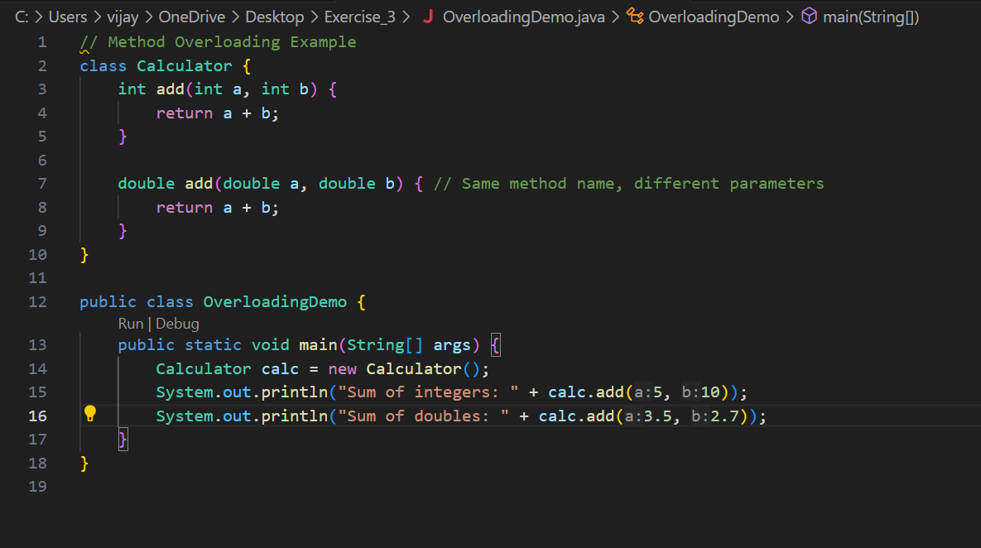

Output:

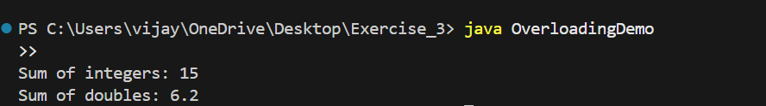

Runtime Polymorphism (Method Overriding)

Program:

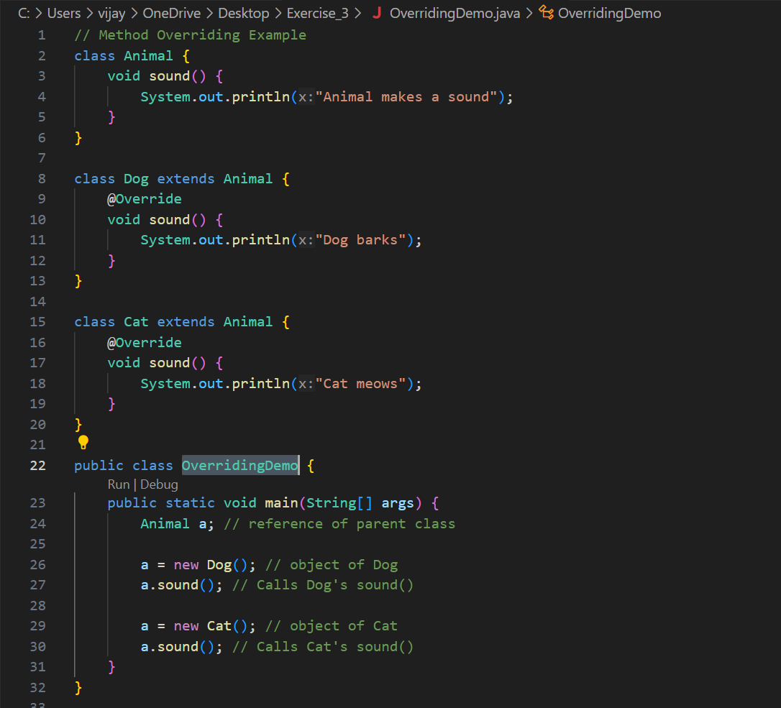

Output:

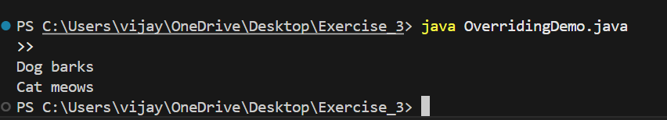

Encapsulation:

Program:

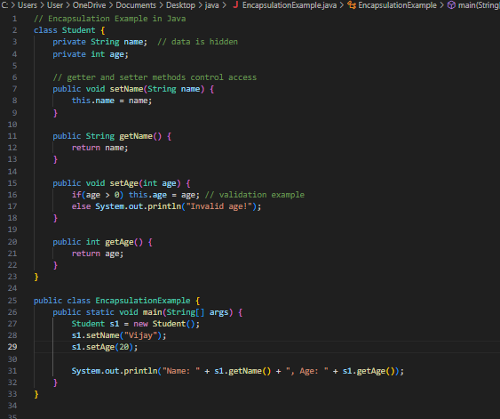

Output:



Abstraction:

Program:

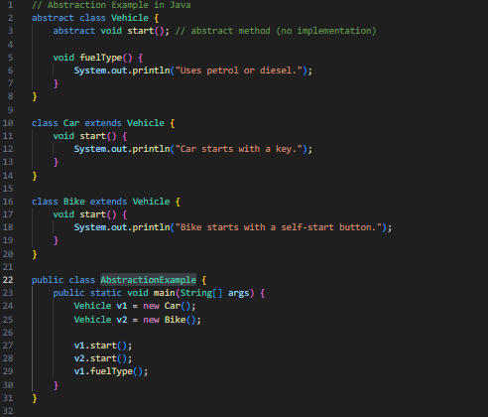

Output:

