

***Barriers to BAME Employees' Employment and Progression in UK Workplace***

**Time series Forecasting using SPSS and Tableau**



**Vijay Kasotia**

**Email: vk73742@gmail.com**

**LinkedIn: https://www.linkedin.com/in/vijay-kasotia-5602a6134/**

**Github: https://github.com/Vijay290197**

# **Abstract**

|  |
| --- |
| *The study analyzed the working age employment rate in the UK across various ethnic groups including BAME, Black, Indian, Mixed Ethnic group, Other Ethnic group, Pakistani/Bangladeshi, and White. The data shows that there are significant disparities in employment rates among different ethnic groups, with the Indian and mixed ethnic groups having the highest employment rates and the BAME group having the lowest. This suggests that there are barriers to employment for individuals from BAME backgrounds.*  *Additionally, the study found that the employment rate for different ethnic groups is increasing, but at different rates. For example, the employment rate for the Indian ethnic group has consistently been higher than the other ethnic groups and has been increasing at a faster rate. On the other hand, the employment rate for the BAME group has been consistently lower than the other ethnic groups and has been increasing at a slower rate. This highlights the need for targeted policies and programs to address these disparities.*  *The study suggests that there are various barriers to employment faced by BAME individuals, such as discrimination, lack of access to education and training, and lack of targeted support for job seekers. Addressing these barriers will be crucial in reducing the employment rate disparities among different ethnic groups. In order to achieve this, the study recommends increasing access to education and training, addressing discrimination, providing targeted support for job seekers, encouraging employers to increase diversity, and encouraging more diversity in the workplace.* |

# **Table of Contents**

**Contents**

**Abstract** 1

**Table of Contents** 2

**Introduction** 3

**Data Analysis (SPSS)** 5

**Data Visualization (Tableau)** 8

**Conclusion** 11

**Recommendations** 12

**References** 13

# **Introduction**

Employees of Black, Asian, and minority ethnic (BAME) backgrounds in the United Kingdom frequently encounter a number of obstacles to employment and career advancement. These obstacles may consist of prejudice and discrimination, a lack of role models and representation, as well as a lack of networking and mentoring possibilities. These problems, which have their roots in structural inequality, have the potential to limit the potential of BAME employees by reducing diversity and inclusivity in the workplace.

Discrimination and racial prejudice are two significant obstacles that BAME employees may experience. This can take both extreme and hidden forms, and it can show itself in a variety of ways, including being passed over for promotions, receiving less money than their non-BAME peers, or dealing with harassment or bullying at work. Additionally, according to research, BAME workers are more likely to be employed in low-paying positions and to be underemployed, which may further restrict their career options.

Lack of representation and role models may be another obstacle that BAME employees must overcome. BAME workers may be the only person of colour on their team in many companies, which can make them feel alone and unsupported. Additionally, it may be challenging for BAME workers to envision themselves in executive roles or to locate mentors or role models who resemble them in disciplines and businesses where BAME persons are underrepresented.

For BAME workers, not having access to networking and mentoring opportunities can be a major obstacle. Networking is frequently regarded as one of the most important ways to progress one's career, yet BAME employees may be shut out of unofficial networks that can result in job openings or promotions. The same is true for mentorship relationships, which can be crucial for professional development, but BAME employees do not always have the same access to these opportunities as non-BAME employees do. Further, cultural obstacles may also have an impact on how far BAME employees can advance in their careers. These can include a lack of awareness or respect for BAME employees' cultural origins and experiences, which can hinder their ability to fully integrate into the workplace. Additionally, when it comes to scheduling time off for cultural holidays or celebrations, BAME employees may encounter a lack of flexibility. Further obstacle that BAME employees could encounter is unconscious bias. Unconscious views or stereotypes that people may possess can influence their behaviour and decision-making are referred to as unconscious bias. This can lead to BAME workers in the workplace being passed over for promotions or job openings, even though they are qualified for the position.

In this study, we use a government-based data set, provides insight on “Barriers to BAME employees' employment and progression in UK workplace”. This study highlights the fact of BAME employees in the UK workplace face a number of barriers to employment and progression, including discrimination and bias, lack of representation and role models, lack of access to networking and mentoring opportunities, cultural barriers, unconscious bias and lack of career development opportunities. These barriers are rooted in systemic inequalities and it is important for employers to take active steps to address these issues in order to create more inclusive and diverse workplaces.

# **Data Analysis (SPSS)**

This section highlights the forecasting working age employment rate for BAME in United Kingdom for next two years using SPSS.

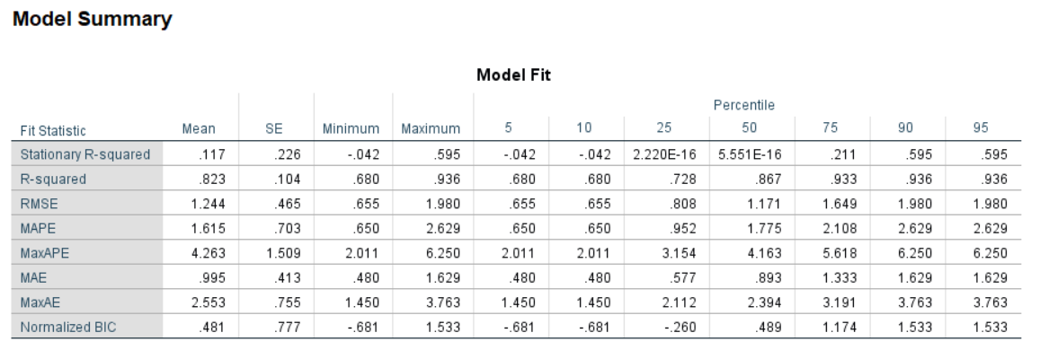

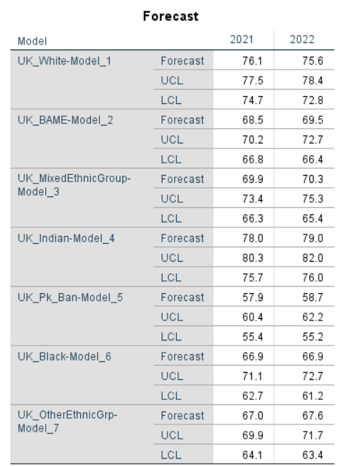

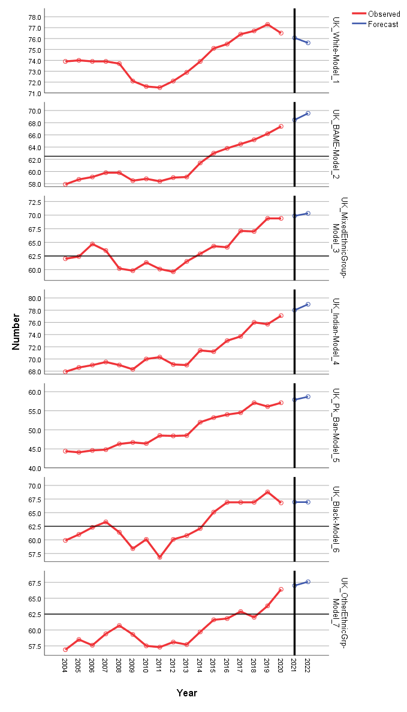

This above analysis presents forecasts for different ethnic groups in the UK for the years 2021 and 2022. Each ethnic group has a separate model, with the models being referred to as UK_White-Model_1, UK_BAME-Model_2, and so on. The table includes forecasts for seven different ethnic groups: White, BAME (Black, Asian, and Minority Ethnic), Mixed Ethnic Group, Indian, Pakistani/Bangladeshi, Black, and Other Ethnic Group.

For each model, there is a forecast for both the years 2021 and 2022. Along with the forecast, there are also upper and lower confidence limits (UCL and LCL) for each year. The UCL and LCL values indicate the range within which the actual outcome is likely to fall, with a certain level of confidence. For example, for the UK_White-Model_1, the forecast for 2021 is 76.1, with an upper confidence limit of 77.5 and a lower confidence limit of 74.7. This means that there is a high level of confidence that the actual outcome will fall between 74.7 and 77.5.

Overall, this analysis provides a detailed and specific forecast for various ethnic groups in the UK for the next two years, which can be used for a variety of purposes, such as budgeting, planning, and decision-making. The inclusion of the UCL and LCL values also provides a sense of the level of uncertainty associated with these predictions, which can be useful information for anyone relying on these forecasts.

# **Data Visualization (Tableau)**

1.1 Working age employment rate for BAME in United Kingdom.

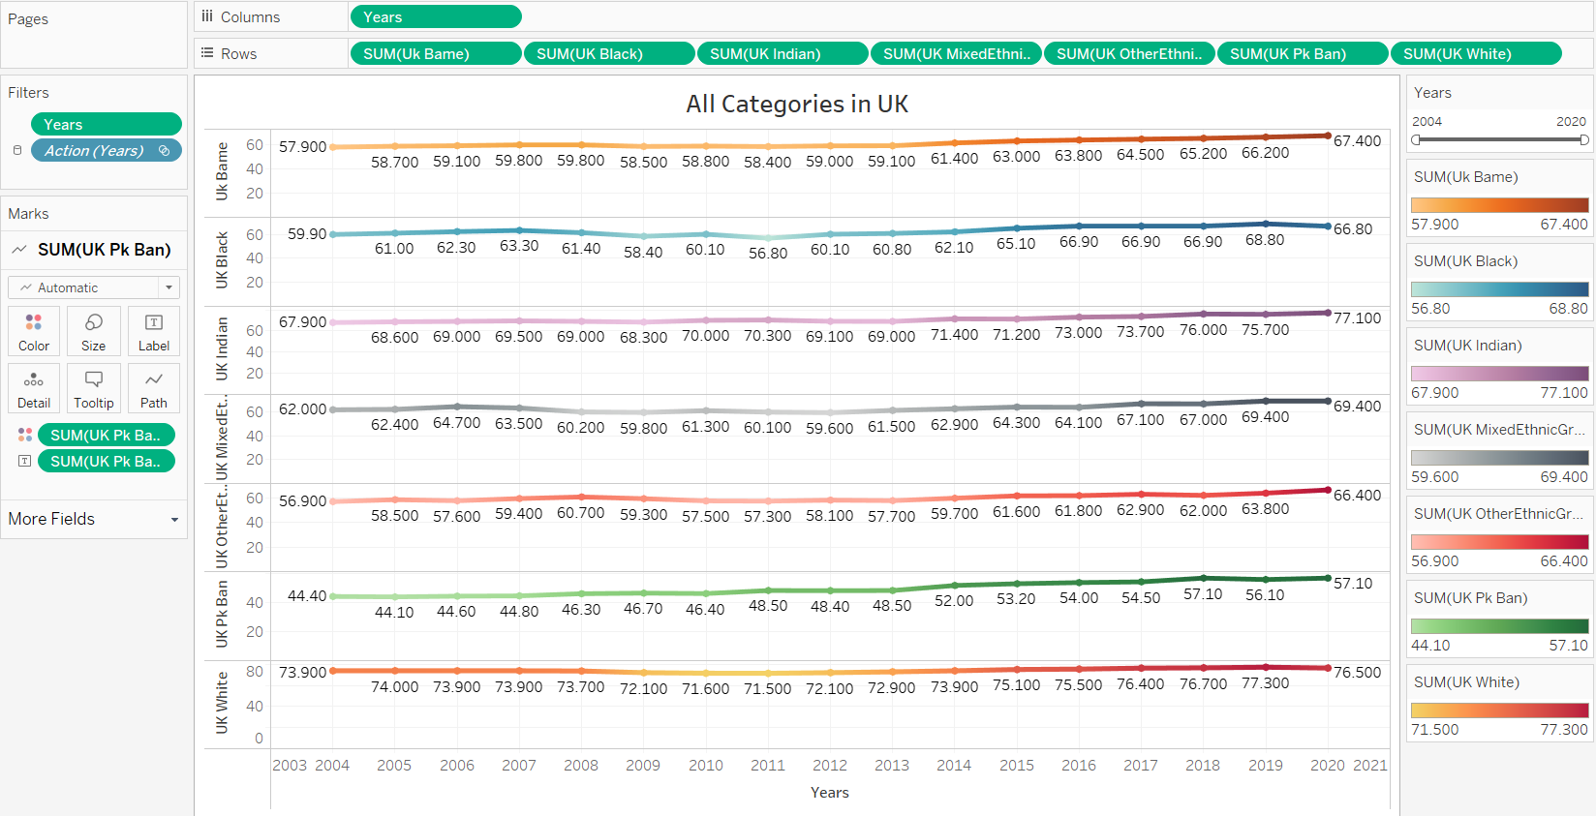

The data indicates that the working age employment rate in the UK between 2004 and 2020, broken down by different ethnic groups. The data shows the percentage of people in the working age population (typically defined as those between the ages of 16 and 64) who are in employment. The ethnic groups included in the data are BAME (black, Asian, and minority ethnic), Black, Indian, mixed ethnic group, other ethnic groups, Pakistani/Bangladeshi, and White.

Firstly, when looking at the overall trend, it can be seen that the working age employment rate for all ethnic groups increased from 2004 to 2020. The percentage of people in the working age population who are employed increased from 57.9% for BAME in 2004 to 67.4% in 2020. Similarly, the percentage of working-age Black people who are employed increased from 59.9% in 2004 to 66.8% in 2020. The percentage of working-age Indian people who are employed increased from 67.9% in 2004 to 77.1% in 2020. The percentage of working-age mixed ethnic group people who are employed increased from 62% in 2004 to 69.4% in 2020. The percentage of working-age other ethnic groups people who are employed increased from 56.9% in 2004 to 66.4% in 2020. The percentage of working-age Pakistani/Bangladeshi people who are employed increased from 44.4% in 2004 to 57.1% in 2020. The percentage of working-age white people who are employed increased from 73.9% in 2004 to 76.5% in 2020.

It is worth noting that the data does not provide information on the underlying reasons for these trends. The data is simply showing the numbers or percentage, and it would be important to understand the context, such as changes in the economy, labor market, and policies, to fully interpret the trend.

When looking at the trend of different ethnic groups separately, it can be seen that the Indian and White groups have the highest employment rate among all groups. The percentage of Indian people who are employed in 2020 is 77.1%, which is the highest among all groups. Similarly, the percentage of White people who are employed in 2020 is 76.5%, which is also relatively high among all groups. It is important to note that these groups have a relatively high representation in certain sectors such as retail and hospitality, which may have been less affected by the economic downturn during the given period.

On the other hand, the Pakistani/Bangladeshi has the lowest employment rate among all groups. The percentage of Pakistani/Bangladeshi people who are employed in 2020 is 57.10%, which is the lowest among all groups. This could be due to a number of factors such as discrimination, lack of access to education and training, and structural barriers to employment. It is important to note that, this group has a relatively high representation in certain sectors such as low-skilled and low-paid jobs, which may have been more affected by the economic downturn during the given period.

Overall, the data suggests that the UK is becoming more diverse in terms of ethnic makeup, and the employment rate among all ethnic groups has increased over the years. However, the employment rate for the Pakistani/Bangladeshi remains relatively low and further research is needed to understand the underlying causes and implications of this trend. More generally, this data is providing an overall trend, it's important to understand that it's not a comprehensive representation of the situation of each ethnic group in the UK, as it does not take into account the variation within each ethnic group, and it does not provide information about the quality of employment.

1.2 Forecasting working age employment rate for BAME in United Kingdom for next two years.

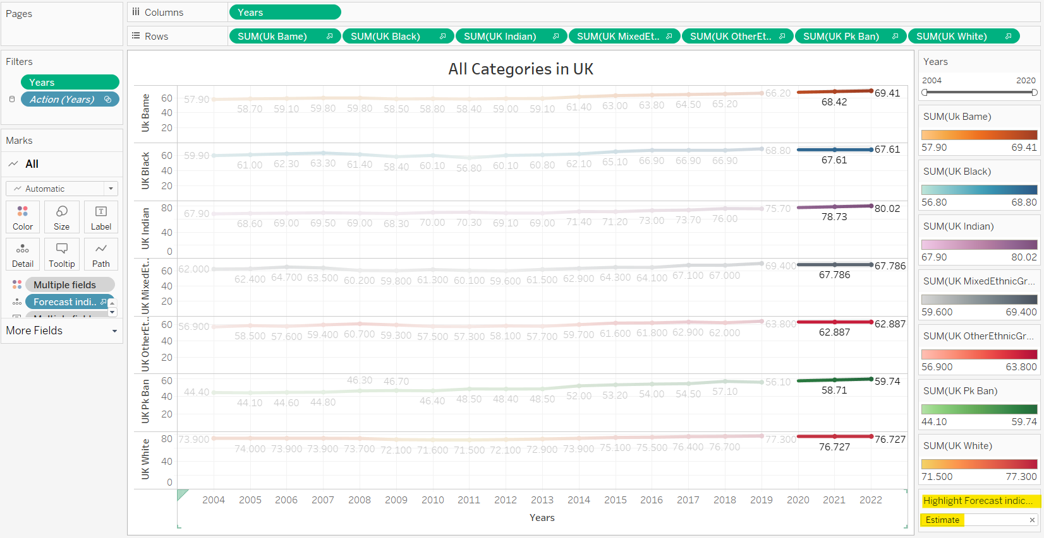

When looking at the trend of different ethnic groups separately, it can be seen that the Indian group has the highest employment rate among all groups. The forecast employment rate for Indian people in 2022 is 80.01%. Similarly, the forecast employment rate for BAME people in 2022 is 69.41%. On the other hand, the Pakistani/Bangladeshi has the lowest employment rate among all groups. The forecast employment rate for BAME people in 2022 is 76.727% (same in 2021). This could be due to a number of factors such as discrimination, lack of access to education and training, and structural barriers to employment.

# **Conclusion**

Overall, the data suggests that the employment rate for different ethnic groups in the UK is increasing, but at different rates. While the Indian and mixed ethnic groups have the highest employment rate, the BAME group has the lowest employment rate, this could be due to a number of factors such as discrimination, lack of access to education and training, and structural barriers to employment.

However, it's important to remember that this data is just a forecast and does not take into account the underlying reasons for these trends. Furthermore, the actual data from 2004 to 2019, is also provided, which shows an overall trend of increasing employment rate for all ethnic groups.

However, it is important to note that the increase in employment rate is not consistent across all groups. The Indian and mixed ethnic groups have seen a relatively steady increase in employment rate over the years, while the Pakistani/Bangladeshi and BAME groups have seen a more gradual increase. The Black group also experienced a decrease in employment rate between 2011 and 2012, but has since seen an increase.

It's also worth noting that the White group, which has the highest employment rate among all groups, has seen a slight decrease in employment rate between 2008 and 2009, and a small increase between 2019 and 2020.

# **Recommendations**

Based on the study, it appears that specific policies and programmes are required to address the discrepancies in employment rates between various ethnic communities in the UK. Following are some suggestions for addressing these disparities:

* Increasing access to education and training may involve increasing financing for schools and organisations that offer vocational training in locations with sizable BAME and Pakistani/Bangladeshi populations.
* In order to combat discrimination, companies and employees may choose to create anti-discrimination policies in the workplace and receive education and training on how to identify and prevent discrimination.
* Giving job searchers targeted help: This could entail offering mentorship and coaching programmes for those from underrepresented groups as well as giving job seekers with disabilities, mental health issues, and other employment-related challenges targeted support.
* Providing tax incentives for firms who hire a diverse staff and establishing diversity goals for large public and private sector employers are two ways to encourage employers to hire more diversely.
* Promoting flexible working hours, remote work, and other regulations that would assist people with families or other commitments to work would all contribute to encouraging more diversity in the workplace.

It's crucial to keep in mind that these are merely a few possible suggestions and that any effective plan will probably need to be adjusted to the particular requirements of various ethnic groups and take into account additional factors like geographic location, accessibility to education and training, and discrimination.

# **References**

*Atewologun, ’D. and Singh, V. (2010) “Challenging ethnic and gender identities,” Equality, Diversity and Inclusion: An International Journal, 29(4), pp. 332–347. Available at:* [*https://doi.org/10.1108/02610151011042394*](https://doi.org/10.1108/02610151011042394)*.*

*Budjanovcanin, A. and Guest, D.E. (2021) “Understanding the unobserved influences on the careers of ethnic minority women: Implications for human resource management,” The International Journal of Human Resource Management, pp. 1–26. Available at:* [*https://doi.org/10.1080/09585192.2021.1969586*](https://doi.org/10.1080/09585192.2021.1969586)*.*

*Katito, G. and Davies, E. (2021) “Exploring the social-ecological factors related to physical activity participation among black, Asian and minority ethnic immigrants,” Health Education, 121(6), pp. 614–631. Available at:* [*https://doi.org/10.1108/he-01-2021-0014*](https://doi.org/10.1108/he-01-2021-0014)*.*

*Phillips, D., Law, I. and Turney, L. (no date) “Widening participation in United Kingdom universities: The Challenges of Achieving Race Equality,” Higher Education in a Global Society: Achieving Diversity, Equity and Excellence, pp. 227–247. Available at:* [*https://doi.org/10.1016/s1479-358x(05)05011-4*](https://doi.org/10.1016/s1479-358x(05)05011-4)*.*