Docker File:
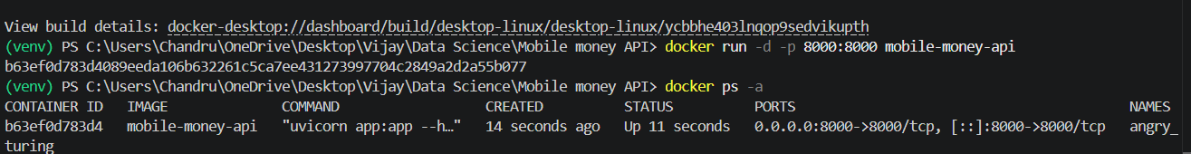

Swagger UI
http://localhost:8000/docs#/default/predict_predict_post

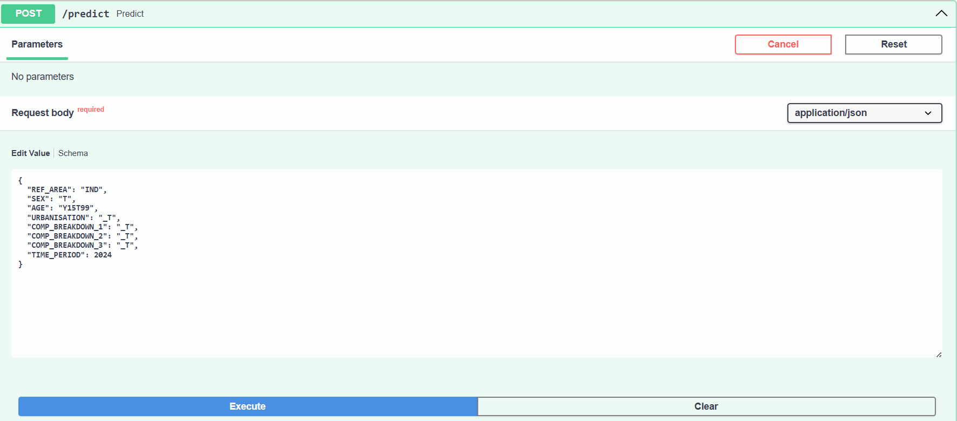

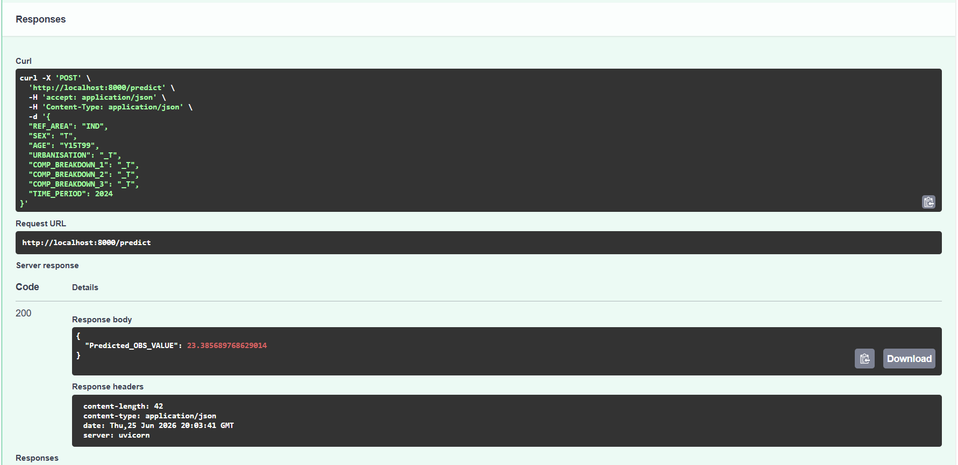

Visualizations
Observation of Distribution - Histogram
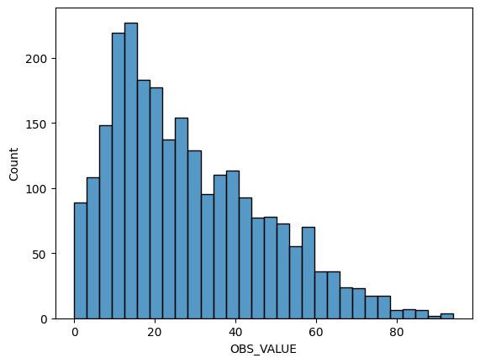

2. Observation of Outliers – Box plot

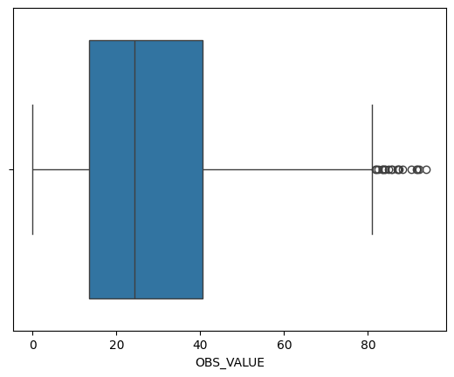

3. Observation of mobile account ownership rises over the year – Line Plot
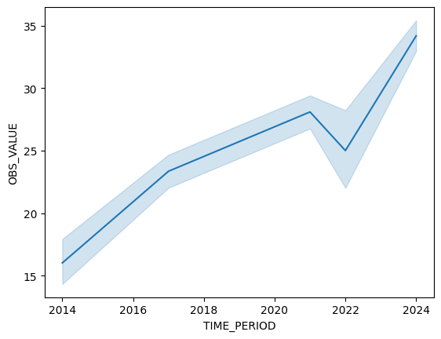
4. Country Comparison – Bar Plot
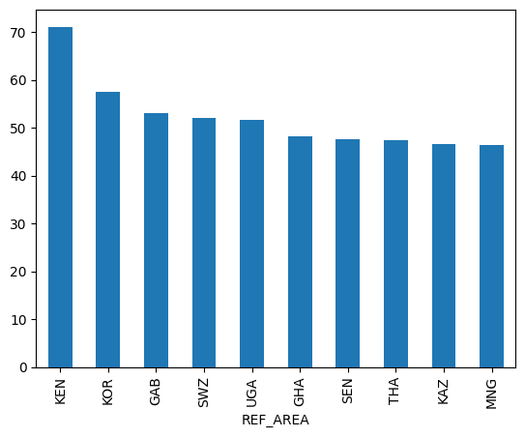

5. Observation of Sex value – Box plot
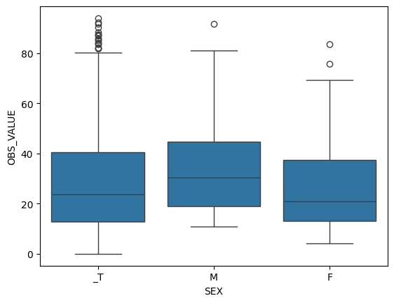
6. Urban Vs Rural population – Box plot
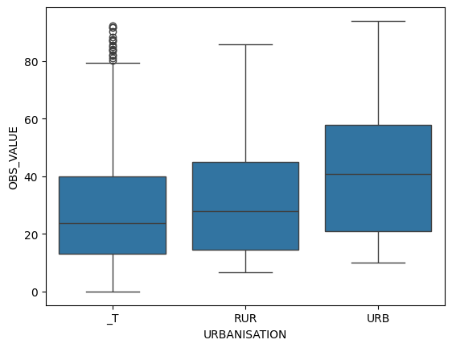

7. Age group Analysis – Boxplot
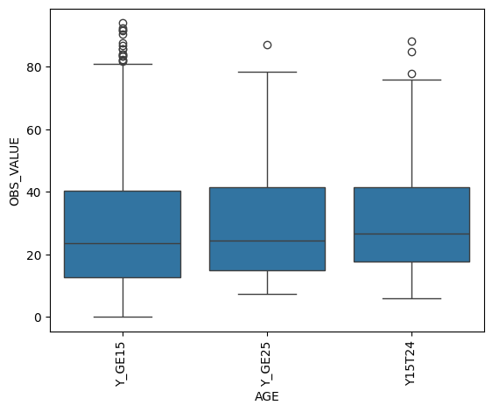

8. Correlation Analysis -Heat map
