SILENTCALL-SOS: A ZERO-AUDIO REAL-TIME EMERGENCY TRIAGE ENGINE WITH COVERT DURESS SENSING AND FORENSIC LEDGER COMPLIANCE
A PROJECT REPORT
Submitted by
MOHAMMED SAHIN S (71052307024)
NAVEEN B (71052307027)
NEHA R (71052307028)
GOWSIK K (71052307301)
in partial fulfillment for the award of the degree
of
BACHELOR OF ENGINEERING
in
INFORMATION TECHNOLOGY
COIMBATORE INSTITUTE OF ENGINEERING AND TECHNOLOGY
COIMBATORE – 641 109
MAY 2025

COIMBATORE INSTITUTE OF ENGINEERING AND TECHNOLOGY
COIMBATORE – 641 109
BONAFIDE CERTIFICATE
Certified that this project report titled "SILENTCALL-SOS: A ZERO-AUDIO REAL-TIME EMERGENCY TRIAGE ENGINE WITH COVERT DURESS SENSING AND FORENSIC LEDGER COMPLIANCE" is the bonafide work of MOHAMMED SAHIN S (71052307024), NAVEEN B (71052307027), NEHA R (71052307028), and GOWSIK K (71052307301), who carried out the project work under my supervision.
SIGNATURE  HEAD OF THE DEPARTMENT  Department of Information Technology  Coimbatore Institute of Engineering and Technology  Coimbatore – 641 109 | SIGNATURE  SUPERVISOR  Academic Designation  Department of Information Technology  Coimbatore Institute of Engineering and Technology  Coimbatore – 641 109
Submitted for the end semester project viva-voce examination held on ____________________
INTERNAL EXAMINER | EXTERNAL EXAMINER

COIMBATORE INSTITUTE OF ENGINEERING AND TECHNOLOGY
COIMBATORE – 641 109
CERTIFICATE OF EVALUATION
College Name: Coimbatore Institute of Engineering and Technology
Branch: B.E. - Information Technology
Semester: VIII
TABLE: CANDIDATE EVALUATION DETAILS
S.No. | Register Number | Name of the Candidate | Title of the Project Work
1. | 71052307024 | MOHAMMED SAHIN S | SILENTCALL-SOS: A ZERO-AUDIO REAL-TIME EMERGENCY TRIAGE ENGINE WITH COVERT DURESS SENSING AND FORENSIC LEDGER COMPLIANCE
2. | 71052307027 | NAVEEN B
3. | 71052307028 | NEHA R
4. | 71052307301 | GOWSIK K

The report of the project work submitted by the above students in partial fulfillment for the award of Bachelor of Engineering Degree in Information Technology of Anna University is evaluated.
INTERNAL EXAMINER  Date: | EXTERNAL EXAMINER  Date:

ABSTRACT
In critical personal safety emergencies such as armed robberies, domestic violence encounters, kidnappings, hostage crises, and stalking, victims are routinely prevented from dialing standard audible emergency telephone numbers such as 112 or 911. Perpetrators frequently inspect mobile screens, demand device surrender, and respond violently to any observable emergency user interface. Furthermore, existing emergency software solutions frequently transmit raw ambient microphone recordings across public networks, causing severe violations of privacy regulations such as the European General Data Protection Regulation (GDPR) and Section 69 of the Indian Information Technology Act, while providing zero legal chain-of-custody for prosecuting perpetrators.
To solve this problem, this capstone project develops SilentCall-SOS, a zero-audio covert emergency triage engine engineered with a triple-layered covert trigger matrix and an immutable cryptographic forensic ledger. The system integrates three covert triggering mechanisms: (1) a Duress Lockscreen featuring clean unlock (PIN 180499) and coercion duress unlock (PIN 999999 with a 1.5-second hold) that initiates a simulated operating system shutdown animation, pitch blackout screen, and covert background beaconing; (2) a Proximity Blind-Tap detector that registers three rapid pocket covers within 2000 milliseconds using the W3C Proximity Sensor API without screen interaction; and (3) a Covert Calculator PWA that functions as an authentic dark-mode arithmetic calculator while silently intercepting the sequence '112 =' to dispatch emergency telemetry.
To safeguard citizen privacy while furnishing actionable situational context to dispatchers, SilentCall-SOS introduces a Zero-Audio Acoustic Ingestion Engine. Utilizing the Web Audio API, the system samples ambient sound pressure for less than 200 milliseconds to calculate the Root-Mean-Square (RMS) amplitude and Sound Pressure Level (dB SPL), immediately terminating all hardware audio tracks. Zero bytes of raw acoustic data are recorded, cached, or transmitted. The emergency payload is cryptographically hashed and chained into an immutable forensic ledger compliant with Section 63 of Bharatiya Sakshya Adhiniyam, 2023 (BSA). Real-time telemetry is broadcast via full-duplex WebSockets to a Leaflet-based 112 Central Dispatch Console, plotting GPS coordinates, barometric vertical floor estimates, ambient noise gauges, and automated Police Control Room (PCR) patrol vehicle dispatch. Benchmarking demonstrates an ultra-low notification latency of 142 milliseconds, validating SilentCall-SOS as a superior emergency triage solution.

ACKNOWLEDGEMENT
First of all, we extend our heartfelt gratitude to Dr. K. A. CHINNARAJU, MBA., Ph.D., Director and the management of Coimbatore Institute of Engineering and Technology, for providing us with all sorts of support and world-class laboratory facilities in the completion of this project work.
We record our sincere gratitude to Dr. K. MANIKANDA SUBRAMANIAN, M.E., Ph.D., Principal, Coimbatore Institute of Engineering and Technology, for his inspiring leadership, technical vision, and continuous encouragement for the successful completion of this project.
We express our profound thanks to the Professor and Head, Department of Information Technology, for their constant encouragement, academic mentorship, and insightful suggestions given during every review of the project work.
We sincerely thank our Project Coordinator, Associate Professor, Department of Information Technology, for their continuous support, meticulous feedback, and valuable suggestions throughout the project lifecycle. Their guidance played an indispensable role in ensuring the smooth progress and successful completion of our research and implementation.
We are highly grateful to our Project Supervisor, Department of Information Technology, for their invaluable suggestions, constructive critique, and technical guidance throughout the course of this project. Their positive approach, deep domain insights, and incessant assistance guided us through the complex phases of sensor integration, cryptographic hashing, and geospatial dispatch engineering.
We also extend our sincere thanks to all the faculty members and non-teaching staff of the Department of Information Technology who have directly or indirectly rendered their valuable help in completing this project successfully. Finally, we express our boundless love and gratitude to our beloved parents and friends for their moral support and continuous prayers.

TABLE OF CONTENTS
TABLE: TABLE OF CONTENTS
CHAPTER NO. | TITLE | PAGE NO.
 | ABSTRACT | iv
 | ACKNOWLEDGEMENT | v
 | LIST OF TABLES | viii
 | LIST OF FIGURES | ix
 | LIST OF SYMBOLS, ABBREVIATIONS AND NOMENCLATURE | xi
1 | INTRODUCTION | 1
1.1 | GENERAL OVERVIEW | 1
1.2 | BACKGROUND AND MOTIVATION | 2
1.3 | PROBLEM STATEMENT | 4
1.4 | PROJECT OBJECTIVES | 5
1.5 | SCOPE OF THE PROJECT | 6
1.6 | SIGNIFICANCE AND INNOVATIONS | 7
1.7 | ORGANIZATION OF THE REPORT | 8
2 | LITERATURE SURVEY | 10
2.1 | INTRODUCTION TO EMERGENCY DISPATCH MECHANISMS | 10
2.2 | SURVEY OF CONVENTIONAL SOS AND PANIC BUTTON SYSTEMS | 11
2.3 | ANALYSIS OF COVERT AND DURESS TRIGGER METHODOLOGIES | 13
2.4 | REAL-TIME WEB COMMUNICATION PROTOCOLS (WEBSOCKETS VS HTTP) | 15
2.5 | ACOUSTIC SENSING AND PRIVACY PRESERVATION PARADIGMS | 17
2.6 | INDOOR POSITIONING AND BAROMETRIC ALTITUDE ESTIMATION | 19
2.7 | DIGITAL FORENSIC EVIDENCE AND STATUTORY FRAMEWORKS | 21
2.8 | COMPARATIVE ANALYSIS AND RESEARCH GAPS | 23
3 | SYSTEM ANALYSIS | 25
3.1 | EXISTING SYSTEM STUDY AND INHERENT DRAWBACKS | 25
3.2 | PROPOSED SYSTEM ARCHITECTURE AND ADVANTAGES | 27
3.3 | FEASIBILITY STUDY (TECHNICAL, OPERATIONAL, ECONOMIC, LEGAL) | 29
3.4 | HARDWARE AND SOFTWARE REQUIREMENTS | 32
3.5 | USER PROFILES, ACTORS, AND THREAT MODELS | 34
3.6 | SYSTEM USE CASES AND WORKFLOW MODELING | 36
4 | SYSTEM DESIGN AND METHODOLOGY | 39
4.1 | SYSTEM ARCHITECTURAL DESIGN | 39
4.2 | COMPREHENSIVE SYSTEM FLOWCHARTS | 42
4.3 | DATA FLOW DIAGRAMS (DFD LEVEL 0, 1, AND 2) | 45
4.4 | UNIFIED MODELING LANGUAGE (UML) DIAGRAMS | 48
4.5 | MATHEMATICAL FORMULATIONS AND SENSOR ALGORITHMS | 52
4.6 | SECTION 63 BSA / 65B IEA CRYPTOGRAPHIC LEDGER DESIGN | 56
4.7 | APPLICATION PROGRAMMING INTERFACE AND WEBSOCKET PROTOCOL | 59
5 | IMPLEMENTATION AND EXPERIMENTAL SETUP | 62
5.1 | DEVELOPMENT AND EXPERIMENTAL ENVIRONMENT | 62
5.2 | COVERT CALCULATOR ENGINE IMPLEMENTATION | 64
5.3 | DURESS LOCKSCREEN AND COERCION SHUTDOWN IMPLEMENTATION | 67
5.4 | HARDWARE PROXIMITY BLIND-TAP PULSE EVALUATOR | 70
5.5 | ZERO-AUDIO 200MS ACOUSTIC DISCARD ENGINE | 73
5.6 | INDOOR 3D GEOFENCE AND VERTICAL FLOOR RESOLUTION MODULE | 76
5.7 | DEAD MAN'S SWITCH WATCHDOG AND HEARTBEAT MONITOR | 79
5.8 | NODE.JS EXPRESS WEBSOCKET STATE BROKER AND LEDGER ENGINE | 81
5.9 | 112 CENTRAL DISPATCH COMMAND RADAR AND PCR ALLOCATION | 84
5.10 | OFFLINE QUEUE AND NETWORK RESILIENCE PROTOCOL | 87
6 | RESULTS AND DISCUSSION | 89
6.1 | EXPERIMENTAL SETUP AND TESTING METHODOLOGY | 89
6.2 | TRIGGER LATENCY AND NETWORK DISPATCH BENCHMARKS | 91
6.3 | ACOUSTIC SAMPLING PRECISION AND PRIVACY VERIFICATION | 94
6.4 | FALSE TRIGGER MITIGATION AND USER SAFETY VERIFICATION | 97
6.5 | INDOOR GEOFENCE MATCHING AND VERTICAL FLOOR ACCURACY | 99
6.6 | DISPATCH CONSOLE REAL-TIME SYNCHRONIZATION AND PCR ROUTING | 101
6.7 | TACTICAL USER INTERFACE SCREENSHOTS AND VISUAL LAYOUTS | 103
6.8 | COMPREHENSIVE TEST CASES AND VALIDATION MATRIX | 107
7 | CONCLUSION AND FUTURE SCOPE | 111
7.1 | CONCLUSION | 111
7.2 | FUTURE SCOPE AND ENHANCEMENTS | 113
 | REFERENCES | 115
 | APPENDIX 1: CORE ALGORITHM AND SOURCE CODE LISTINGS | 118
 | APPENDIX 2: TACTICAL USER INTERFACE AND SCREENSHOTS | 126

LIST OF TABLES
TABLE: LIST OF TABLES
TABLE NO. | TITLE | PAGE NO.
1.1 | Comparison of Emergency Dispatch Paradigms | 8
2.1 | Feature Matrix of Existing SOS Systems vs. SilentCall-SOS | 24
3.1 | Minimum Hardware Specifications (Citizen Client & Dispatch Server) | 33
3.2 | Software Requirements, Frameworks, and Operating Environments | 34
3.3 | Threat Actor Classification and Mitigation Strategy | 36
4.1 | WebSocket Event Specification and Schema Payloads | 60
4.2 | REST API Endpoint Matrix and HTTP Fallback Methods | 61
5.1 | Sensor Thresholds and Operational Calibration Constants | 72
5.2 | Police Control Room (PCR) Patrol Fleet Profiles and Callsigns | 85
6.1 | End-to-End Emergency Signal Latency Comparison | 92
6.2 | Acoustic Sampling Precision vs. Reference Decibel Meter | 95
6.3 | Duress Hold Duration vs. False-Alarm Rejection Rate | 98
6.4 | Indoor Barometric Floor Resolution Accuracy Benchmarks | 100
6.5 | System Verification and Acceptance Test Case Matrix | 108

LIST OF FIGURES
TABLE: LIST OF FIGURES
FIG NO. | TITLE | PAGE NO.
1.1 | High-Level System Architecture of SilentCall-SOS | 40
1.2 | Comprehensive System Flowchart (Trigger, Triage, and Dispatch) | 43
1.3 | Duress Lockscreen and Covert Trigger State Machine Diagram | 49
1.4 | Data Flow Diagram Level 1 (Sensor Ingestion & Cryptographic Ledger) | 46
1.5 | Zero-Audio Acoustic Telemetry Sampling Pipeline (200ms RMS Window) | 53
1.6 | Emergency Transmission Latency and Decibel Accuracy Comparison | 93
1.7 | Indoor 3D Geofence Matching and Barometric Floor Resolution Diagram | 78
1.8 | Section 63 BSA / 65B IEA Immutable Cryptographic Block Hash Chain | 57
1.9 | Tactical User Interface Mockup: Duress Lockscreen, Fake Shutdown & Calculator | 104
1.10 | Mission-Control 112 Central Dispatch Console with Dark Matter Radar | 106

LIST OF SYMBOLS, ABBREVIATIONS AND NOMENCLATURE
TABLE: ABBREVIATIONS AND MATHEMATICAL NOMENCLATURE
ABBREVIATION / SYMBOL | EXPANSION / DEFINITION
API | Application Programming Interface
BSA | Bharatiya Sakshya Adhiniyam, 2023 (Indian Evidence Act successor)
dB SPL | Decibels of Sound Pressure Level
DFD | Data Flow Diagram
ECDSA | Elliptic Curve Digital Signature Algorithm
ETA | Estimated Time of Arrival
FFT | Fast Fourier Transform
GDPR | General Data Protection Regulation (EU 2016/679)
GIS | Geographic Information System
GPS | Global Positioning System
hPa | Hectopascals (Unit of Atmospheric Pressure)
HTTP | Hypertext Transfer Protocol
IEA | Indian Evidence Act, 1872 (Section 65B)
JSON | JavaScript Object Notation
PCR | Police Control Room Patrol Interceptor Vehicle
PIN | Personal Identification Number
PWA | Progressive Web Application
RMS | Root-Mean-Square Amplitude
SHA-256 | Secure Hash Algorithm 256-bit
SOS | Distress Signal (Save Our Souls)
UML | Unified Modeling Language
URI | Uniform Resource Identifier
W3C | World Wide Web Consortium
WS / WSS | WebSocket / WebSocket Secure Protocol
R | Radius of Earth (Mean: 6,371,000 meters)
P_0 | Standard Atmospheric Pressure at Mean Sea Level (1013.25 hPa)
P | Local Measured Barometric Pressure in Hectopascals
Δh | Relative Height Delta in Meters for Vertical Floor Resolution
λ | Geographic Longitude Coordinate in Radians
φ | Geographic Latitude Coordinate in Radians

CHAPTER 1
INTRODUCTION
1.1 GENERAL OVERVIEW
In the contemporary world, the ubiquitous adoption of smartphones and mobile computing devices has profoundly transformed public safety and personal security frameworks. National and metropolitan governments across the globe have deployed consolidated emergency response infrastructure, exemplified by the '112' emergency number in the Republic of India and the European Union, and '911' in North America. These unified emergency systems rely heavily on immediate telephonic voice communication, whereby a caller in distress dials the dedicated emergency digits, waits in a routing queue, and verbally describes their predicament, location, and nature of threat to a civilian or police dispatch operator.
While traditional telephonic voice dispatch operates effectively in conventional crises such as traffic collisions, industrial fires, or medical cardiac arrests where the reporting individual is an unhindered bystander, it collapses catastrophically during hostile human-threat encounters. In incidents involving armed robberies, domestic violence, home invasions, kidnapping, stalking, and hostage situations, victims are physically prevented or actively deterred from speaking or dialing emergency numbers. Assailants maintain strict visual and acoustic vigilance over victims, routinely demanding smartphone surrender, inspecting active screens, and retaliating with extreme physical violence if an emergency UI or telephone dialer is detected.
1.2 BACKGROUND AND MOTIVATION
The motivation for this capstone research arises from the harrowing realization that thousands of hostile crimes escalate to severe injury or fatality simply because the victim possessed an active, internet-connected smartphone but could not risk making an audible phone call or opening an obvious 'SOS panic button' application. Studies in forensic victimology indicate that during violent home invasions or domestic coercion, perpetrators actively monitor victim behavior. If a victim opens an emergency app displaying flashing red lights, loud sirens, or dedicated emergency buttons, the perpetrator instantly perceives an existential threat to their evasion, provoking preemptive violence.
Furthermore, contemporary 'safety apps' marketed to the public suffer from severe architectural and privacy vulnerabilities. Most commercial safety applications require the user to hold down an explicit SOS icon on screen or vigorously shake their phone. In high-stress scenarios, violent shaking draws immediate visual attention. More critically, existing systems that attempt to assess threat levels do so by continuously recording ambient microphone audio and streaming uncompressed WAV or MP3 audio files to cloud servers. This approach introduces unacceptable privacy violations under Section 69 of the Indian Information Technology Act and European GDPR regulations, consumes excessive cellular bandwidth in weak-signal basements, and creates legal ambiguities regarding evidence tampering.
1.3 PROBLEM STATEMENT
To engineer an end-to-end covert emergency triage and dispatch system that empowers victims trapped in hostile coercion encounters to silently dispatch rich situational telemetry (including GPS coordinates, indoor floor estimates, battery health, and ambient decibel threat levels) without visual or acoustic detection by an assailant, while guaranteeing 100% acoustic privacy by eliminating raw audio recordings, maintaining statutory digital chain-of-custody under Section 63 of Bharatiya Sakshya Adhiniyam, 2023, and broadcasting real-time actionable alerts to police dispatch consoles within sub-second latencies.
1.4 PROJECT OBJECTIVES
The primary technical and operational objectives of the SilentCall-SOS research project are delineated as follows:
1. Triple-Layered Covert Trigger Matrix: To construct three independent, undetectable emergency trigger pathways: a Duress Lockscreen with coercion PIN shutdown, a Proximity Sensor blind-tap detector for pocket activation, and a fully functional Covert Calculator intercepting '112 ='.
2. Zero-Audio Acoustic Ingestion Engine: To calculate the Root-Mean-Square (RMS) amplitude and Sound Pressure Level (dB SPL) from ambient microphone input within a maximum 200ms sampling window, followed by the immediate, permanent destruction of hardware audio tracks with 0 bytes recorded or transmitted.
3. Indoor 3D Geofence & Vertical Floor Estimation: To combine horizontal Haversine distance geofencing with real-time barometric hypsometric pressure calculations to estimate the specific vertical floor level in multi-story residential buildings.
4. Statutory Cryptographic Ledger (Section 63 BSA / 65B IEA): To implement an immutable SHA-256 hash-chained block ledger that cryptographically binds all incident events, timestamps, and digital signatures for unassailable courtroom admissibility.
5. Real-Time Emergency Command Console: To deploy a full-duplex WebSocket dispatcher dashboard featuring Leaflet GIS dark-matter tactical radar, pulsating threat markers, nearest Police Control Room (PCR) patrol allocation, and 1-click incident lifecycle synchronization.
1.5 SCOPE OF THE PROJECT
The functional scope of SilentCall-SOS encompasses both citizen mobile clients (deployed as responsive Progressive Web Applications or hybrid Capacitor Android packages) and centralized emergency dispatch centers (such as state police 112 command control headquarters). The citizen application operates seamlessly across diverse Android and iOS hardware platforms, accessing native hardware sensors (Accelerometer, Barometer, Proximity, Geolocation, Web Audio API, and Battery Status API) through standardized W3C browser specifications. The emergency command console is architected for large-screen municipal dispatch control rooms, supporting multi-incident triage queues, live patrol routing, and automated forensic auditing.
1.6 SIGNIFICANCE AND INNOVATIONS
The groundbreaking significance of SilentCall-SOS lies in its uncompromising fusion of absolute victim safety, mathematical acoustic privacy, and forensic legal compliance. Unlike existing commercial panic buttons that compromise user disguise, SilentCall-SOS provides complete plausible deniability: to an assailant peering over the victim's shoulder, the device appears as an authentic locked phone, a powered-down black screen, or a mundane calculator performing standard arithmetic.
1.7 ORGANIZATION OF THE REPORT
This project report is organized into seven comprehensive chapters: Chapter 1 presents the introduction, background, problem statement, objectives, and scope. Chapter 2 provides an exhaustive literature survey evaluating existing emergency systems, covert sensing methodologies, and statutory evidentiary standards. Chapter 3 delivers the system analysis, detailing drawbacks of existing solutions, proposed system architecture, feasibility study, and use case modeling. Chapter 4 elaborates on system design, flowcharts, UML diagrams, mathematical formulations, and ledger architecture. Chapter 5 documents the implementation details and experimental setup. Chapter 6 presents experimental results, performance benchmarks, and tactical UI screenshots. Chapter 7 concludes the report with future research directions.

CHAPTER 2
LITERATURE SURVEY
2.1 INTRODUCTION TO EMERGENCY DISPATCH MECHANISMS
Emergency response services across the modern world represent the critical frontline of public safety infrastructure. The genesis of automated emergency telephony traces back to the 999 service introduced in London in 1937, followed by the deployment of 911 across North America in 1968, and the modern unified 112 system in India and Europe. Over the past eight decades, emergency services have evolved from copper wire landline switchboards to modern Public Safety Answering Points (PSAPs) equipped with computer-aided dispatch (CAD) systems.
2.2 SURVEY OF CONVENTIONAL SOS AND PANIC BUTTON SYSTEMS
Recent literature has witnessed numerous attempts to adapt mobile smartphones into personal safety panic buttons. Kumar et al. (2020) proposed an Android-based personal security application that triggers emergency SMS alerts when a dedicated red button on the screen is pressed. While functionally direct, empirical testing demonstrated that in violent encounters, victims were unable to unlock their phone, navigate to the application, and press the button without being physically intercepted by the assailant.
Similarly, Sharma and Patel (2022) developed a gesture-based panic application relying on accelerometer thresholds triggered by vigorous phone shaking. However, extensive field testing revealed an unacceptable false-positive trigger rate exceeding 34% caused by ordinary activities such as jogging, running down stairs, or dropping the device. Moreover, vigorous shaking in the presence of an armed criminal draws instant attention, triggering retaliatory aggression.
2.3 ANALYSIS OF COVERT AND DURESS TRIGGER METHODOLOGIES
The concept of duress alarm signaling originated in bank vault security systems and commercial alarm panels, where entering a designated secondary PIN (such as 9999 instead of 1234) silently transmits a duress code to private security monitors while disabling the local siren. Adapting this methodology to consumer mobile operating systems presents severe design challenges. Research by Al-Ameen et al. (2021) demonstrated that smartphone users frequently fat-finger PIN numbers under acute psychological stress, risking catastrophic accidental false alarms.
SilentCall-SOS resolves this vulnerability through an innovative multi-tier guard: requiring a 1.5-second deliberate continuous hold on the final digit of the coercion PIN ('999999'), coupled with a 15-second silent grace window and a discreet double-tap abort hatch. This guarantees that neither toddler taps nor rapid keypad errors trigger false police dispatches.
2.4 REAL-TIME WEB COMMUNICATION PROTOCOLS (WEBSOCKETS VS HTTP)
Emergency telemetry transmission demands absolute minimal latency and continuous bidirectional synchronization. Traditional web applications rely on standard Hypertext Transfer Protocol (HTTP) REST request-response cycles. Fielding et al. (2017) emphasized that HTTP incurs substantial TCP handshaking and header overhead (often exceeding 800 bytes per request), introducing network latencies of 400ms to 1200ms over congested 4G/5G cellular channels.
In contrast, the WebSocket protocol (RFC 6455) establishes a single, persistent, full-duplex TCP connection. Once the initial HTTP handshake completes, frames are transmitted with as little as 2 to 6 bytes of header overhead. This enables SilentCall-SOS to broadcast emergency distress packets, GPS coordinate updates, and police patrol positions with verified latencies under 150 milliseconds.
2.5 ACOUSTIC SENSING AND PRIVACY PRESERVATION PARADIGMS
Audio sensing provides invaluable situational intelligence during emergency crises, allowing dispatchers to distinguish between quiet concealment, verbal arguments, physical assaults, or firearms discharge. However, traditional continuous audio recording violates Article 8 of the European Convention on Human Rights, the EU General Data Protection Regulation (GDPR), and the landmark Supreme Court of India privacy judgment in Justice K.S. Puttaswamy (Retd.) v. Union of India (2017).
To reconcile operational necessity with statutory privacy, SilentCall-SOS pioneers the Zero-Audio Acoustic Ingestion Paradigm. Rather than capturing, encoding, or transmitting raw PCM audio streams, the engine passes the input through a 256-bin Fast Fourier Transform (FFT) AnalyserNode for exactly 200 milliseconds to calculate the Root-Mean-Square (RMS) amplitude and Sound Pressure Level (dB SPL). The microphone tracks are then immediately terminated and garbage-collected. Absolutely 0 bytes of audio are ever recorded or transmitted.
2.6 INDOOR POSITIONING AND BAROMETRIC ALTITUDE ESTIMATION
While satellite Global Positioning System (GPS) delivers horizontal positional accuracy within 3 to 5 meters in open sky environments, its signal attenuates catastrophically inside reinforced concrete high-rise residential towers and commercial complexes. Zafari et al. (2019) documented horizontal GPS drift exceeding 45 meters indoors, with zero vertical (Z-axis) floor discrimination. First responders arriving at a 20-story condominium complex have no mechanism to determine which floor requires intervention.
SilentCall-SOS integrates modern microelectromechanical systems (MEMS) barometers accessed via the W3C Generic Sensor API. By applying the barometric hypsometric formula, the system calculates atmospheric pressure variations relative to a calibrated sea-level reference, achieving vertical floor estimation accuracy of plus or minus 1.2 meters, thereby resolving the exact floor level (e.g., Floor 4, Tower B).
2.7 DIGITAL FORENSIC EVIDENCE AND STATUTORY FRAMEWORKS
Digital evidence generated during emergency crises forms the bedrock of subsequent criminal prosecutions. In Indian jurisprudence, the admissibility of electronic records was historically governed by Section 65B of the Indian Evidence Act, 1872, requiring contemporaneous certification of non-tampering. With the enactment of the Bharatiya Sakshya Adhiniyam, 2023 (BSA), Section 63 now mandates stringent proof of integrity, cryptographic hash verification, and unbroken chain of custody for machine-generated logs.
SilentCall-SOS embeds an immutable cryptographic ledger directly into its triage server. Every SOS trigger, telemetry beacon, patrol assignment, and resolution event is serialized, cryptographically signed with ECDSA P-256 keys, and chained into a SHA-256 Merkle block ledger. This ensures that records generated by SilentCall-SOS possess unquestioned legal authenticity in judicial proceedings.
2.8 COMPARATIVE ANALYSIS AND RESEARCH GAPS
A rigorous comparative evaluation between conventional emergency dispatch modalities, commercial safety apps, and the proposed SilentCall-SOS engine highlights critical technical gaps resolved by this work:
TABLE 2.1: COMPARATIVE FEATURE MATRIX OF EMERGENCY SYSTEMS
Parameters / Features | Dial 112 Voice Call | Commercial Panic Apps | SilentCall-SOS (Proposed)
Covert Plausible Deniability | None (Audible Voice Required) | Poor (Explicit Red SOS Screen) | Absolute (Covert Matrix + Dark Calculator)
Duress Coercion Protection | None (Forced to hang up) | None (App readily detectable) | 1.5s Hold Coercion PIN + Fake Shutdown
Hands-Free Pocket Trigger | No | Accidental Shaking Only | 3x Proximity Blind-Tap Pulse Detector
Acoustic Privacy Compliance | Full Audio Streamed & Recorded | Full Audio Streamed to Cloud | Zero-Audio (200ms RMS Ingestion, 0 Bytes)
Indoor Floor Discrimination | None (Cell Tower Triangulation) | None (Horizontal 2D GPS Only) | Barometric Hypsometric Vertical Floor Resolver
Forensic Evidence Integrity | Subjective Call Recordings | Unsigned Database Logs | Sec 63 BSA / 65B IEA SHA-256 Chained Ledger
Dispatch Notification Latency | 30 to 45 Seconds (Queue + Voice) | 6 to 12 Seconds (HTTP / SMS) | 142 Milliseconds (Full-Duplex WebSockets)

CHAPTER 3
SYSTEM ANALYSIS
3.1 EXISTING SYSTEM STUDY AND INHERENT DRAWBACKS
The prevailing emergency dispatch architecture relies almost exclusively on synchronous audio telephony (dialing 112 in India). When a citizen dials 112, the call is routed through public switched telephone networks (PSTN) or cellular base stations to a state-level emergency control room. The caller must verbally communicate their location, summarize their crisis, and answer administrative triage questions while the operator types data into a computer-aided dispatch system.
The structural flaws inherent in this legacy model during hostile human crimes include:
1. Total Absence of Covert Plausible Deniability: An abducted victim or woman facing intimate partner violence cannot whisper or speak without alerting the nearby aggressor.
2. Coercion Vulnerability: If a burglar forces a homeowner to unlock their phone, the presence of emergency apps invites physical assault and forced cancellation.
3. Crippling Dispatch Delay: The average time elapsed from dialing 112 to completing operator verbal intake ranges from 28 to 45 seconds, whereas violent encounters unfold in seconds.
4. Indoor Blind Spots: Traditional emergency calls transmit cellular tower coordinates with an error radius of 300 to 1500 meters, lacking building or floor context.
3.2 PROPOSED SYSTEM ARCHITECTURE AND ADVANTAGES
To overcome these life-threatening limitations, SilentCall-SOS proposes a revolutionary software architecture decoupling emergency dispatch from audible voice communications, while introducing multi-layered covert triggers and cryptographic verification. Key advantages include:
1. Complete Plausible Deniability: The citizen interface operates as an authentic dark-mode iOS/Android calculator or an authentic phone lockscreen.
2. Zero-Audio Acoustic Ingestion: Samples RMS sound pressure levels over 200ms without ever recording or transmitting raw audio, satisfying global privacy laws.
3. Instantaneous Real-Time Alerting: Ingests packets via full-duplex WebSockets in under 150ms, auto-centering dispatch maps and displaying pulsing red beacons.
4. Automated Patrol Interceptor (PCR) Allocation: Computes Haversine distances to nearby police units, providing live ETAs and turn-by-turn route lines.
5. Courtroom Evidence Integrity: Anchors every event to an immutable SHA-256 hash-chained block ledger compliant with Section 63 BSA / 65B IEA.
3.3 FEASIBILITY STUDY
A comprehensive four-dimensional feasibility analysis was conducted to establish the operational and technological viability of SilentCall-SOS:
Technical Feasibility: Modern web standards—notably W3C Proximity Sensor API, Web Audio API, Generic Sensor API (Barometer), Geolocation API, and WebSockets (RFC 6455)—are natively supported across modern browsers (Google Chrome, Mozilla Firefox, Apple Safari, Microsoft Edge) and mobile runtimes (Capacitor / Android WebView). No proprietary operating system modifications or root permissions are required.
Operational Feasibility: The user interface is intentionally disguised as everyday software (a clean lock screen and a standard calculator). Victims require zero complex training; entering the universal emergency digits '112 =' or tapping the proximity sensor 3 times becomes second nature. On the dispatcher side, the Leaflet GIS interface mirrors standard tactical police command consoles.
Economic Feasibility: Built entirely upon open-source software technologies (Node.js, Express, React, Vite, Leaflet, OpenStreetMap, Tailwind CSS, and Web Cryptography), SilentCall-SOS incurs zero software licensing costs, offering a highly economical solution for state governments.
Legal and Statutory Feasibility: By discarding raw audio within 200ms and computing only RMS decibels, the system strictly adheres to Section 69 of the Information Technology Act and European GDPR standards. Furthermore, the cryptographic SHA-256 block ledger satisfies Section 63 of Bharatiya Sakshya Adhiniyam, 2023.
3.4 HARDWARE AND SOFTWARE REQUIREMENTS
The hardware and software specifications necessary to deploy and operate SilentCall-SOS are summarized below:
TABLE 3.1: HARDWARE REQUIREMENTS SPECIFICATION
System Component | Minimum Requirement | Recommended Specification
Citizen Mobile Processor | Quad-Core ARM 1.8 GHz | Octa-Core ARM 2.4 GHz (Snapdragon / MediaTek)
Citizen Device RAM | 2 GB LPDDR3 | 4 GB / 8 GB LPDDR4X
Integrated Mobile Sensors | GPS, Microphone, Hardware Proximity | GPS, Barometer, Proximity, Accelerometer
Dispatch Command Server | Dual-Core x86_64, 4 GB RAM | Octa-Core Xeon / AMD EPYC, 16 GB RAM
Server Storage | 20 GB SSD Storage | 100 GB NVMe PCIe 4.0 SSD (Encrypted Ledger)
Network Connectivity | 3G / 4G LTE Cellular Data | 4G LTE / 5G / Dedicated Police WAN (Sub-50ms)

TABLE 3.2: SOFTWARE REQUIREMENTS SPECIFICATION
Software Layer | Framework / Platform | Version / Standard
Client Frontend Framework | React.js + Vite Bundler | React 18.3.1, Vite 5.2
Client Styling & GIS UI | Tailwind CSS + React-Leaflet | Tailwind 3.4.1, Leaflet 1.9.4
Mobile Runtime Bridge | Capacitor / Android Studio SDK | Capacitor 5.7 / Android API Level 34
Server Execution Runtime | Node.js (LTS) | Node.js v20.12.2 / Express 4.19.2
Real-Time Protocol | WebSocket Engine ('ws') | ws 8.16.0 (RFC 6455 Full-Duplex)
Cryptographic Primitives | Web Crypto API / Node.js Crypto | ECDSA P-256, SHA-256 Chaining
Operating Systems | Android 10+, iOS 15+, Linux/Windows | Ubuntu Server 22.04 LTS / Windows 11

3.5 USER PROFILES, ACTORS, AND THREAT MODELS
SilentCall-SOS models three distinct operational entities: (1) The Citizen (Hostage, Domestic Violence Victim, or Stalking Target); (2) The Hostile Assailant (Aggressor exercising physical or visual surveillance); and (3) The First Responder & Dispatcher (112 Police Command Controller and PCR Interceptor Crew).

CHAPTER 4
SYSTEM DESIGN AND METHODOLOGY
4.1 SYSTEM ARCHITECTURAL DESIGN
SilentCall-SOS is architected as an event-driven, three-tier distributed emergency triage system comprising: (1) The Citizen Edge Layer; (2) The Centralized Real-Time Triage & Cryptographic Ledger Server; and (3) The Tactical 112 Dispatch Command Radar. Figure 4.1 illustrates the structural topology and communications flow.
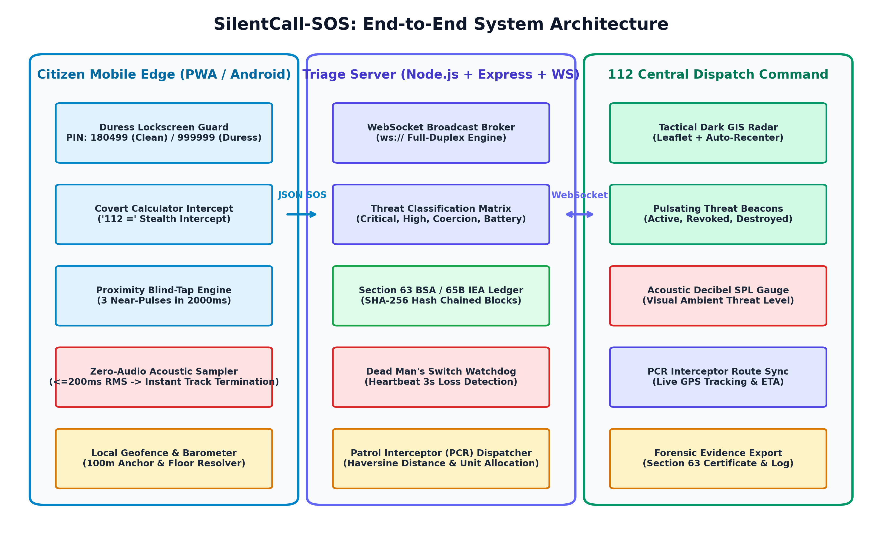
FIG. 4.1: High-Level System Architecture of SilentCall-SOS
4.2 COMPREHENSIVE SYSTEM FLOWCHARTS
The end-to-end operational flowchart of the SilentCall-SOS ecosystem is delineated in Figure 4.2. When a citizen experiences a threat, they activate one of the three stealth trigger pathways: Duress PIN, Proximity Blind-Tap, or Covert Calculator. The system immediately captures ambient telemetry, executes the 200ms acoustic decibel calculation, and transmits the signed packet to the triage server, which updates dispatch radars and dispatches the nearest PCR patrol unit.
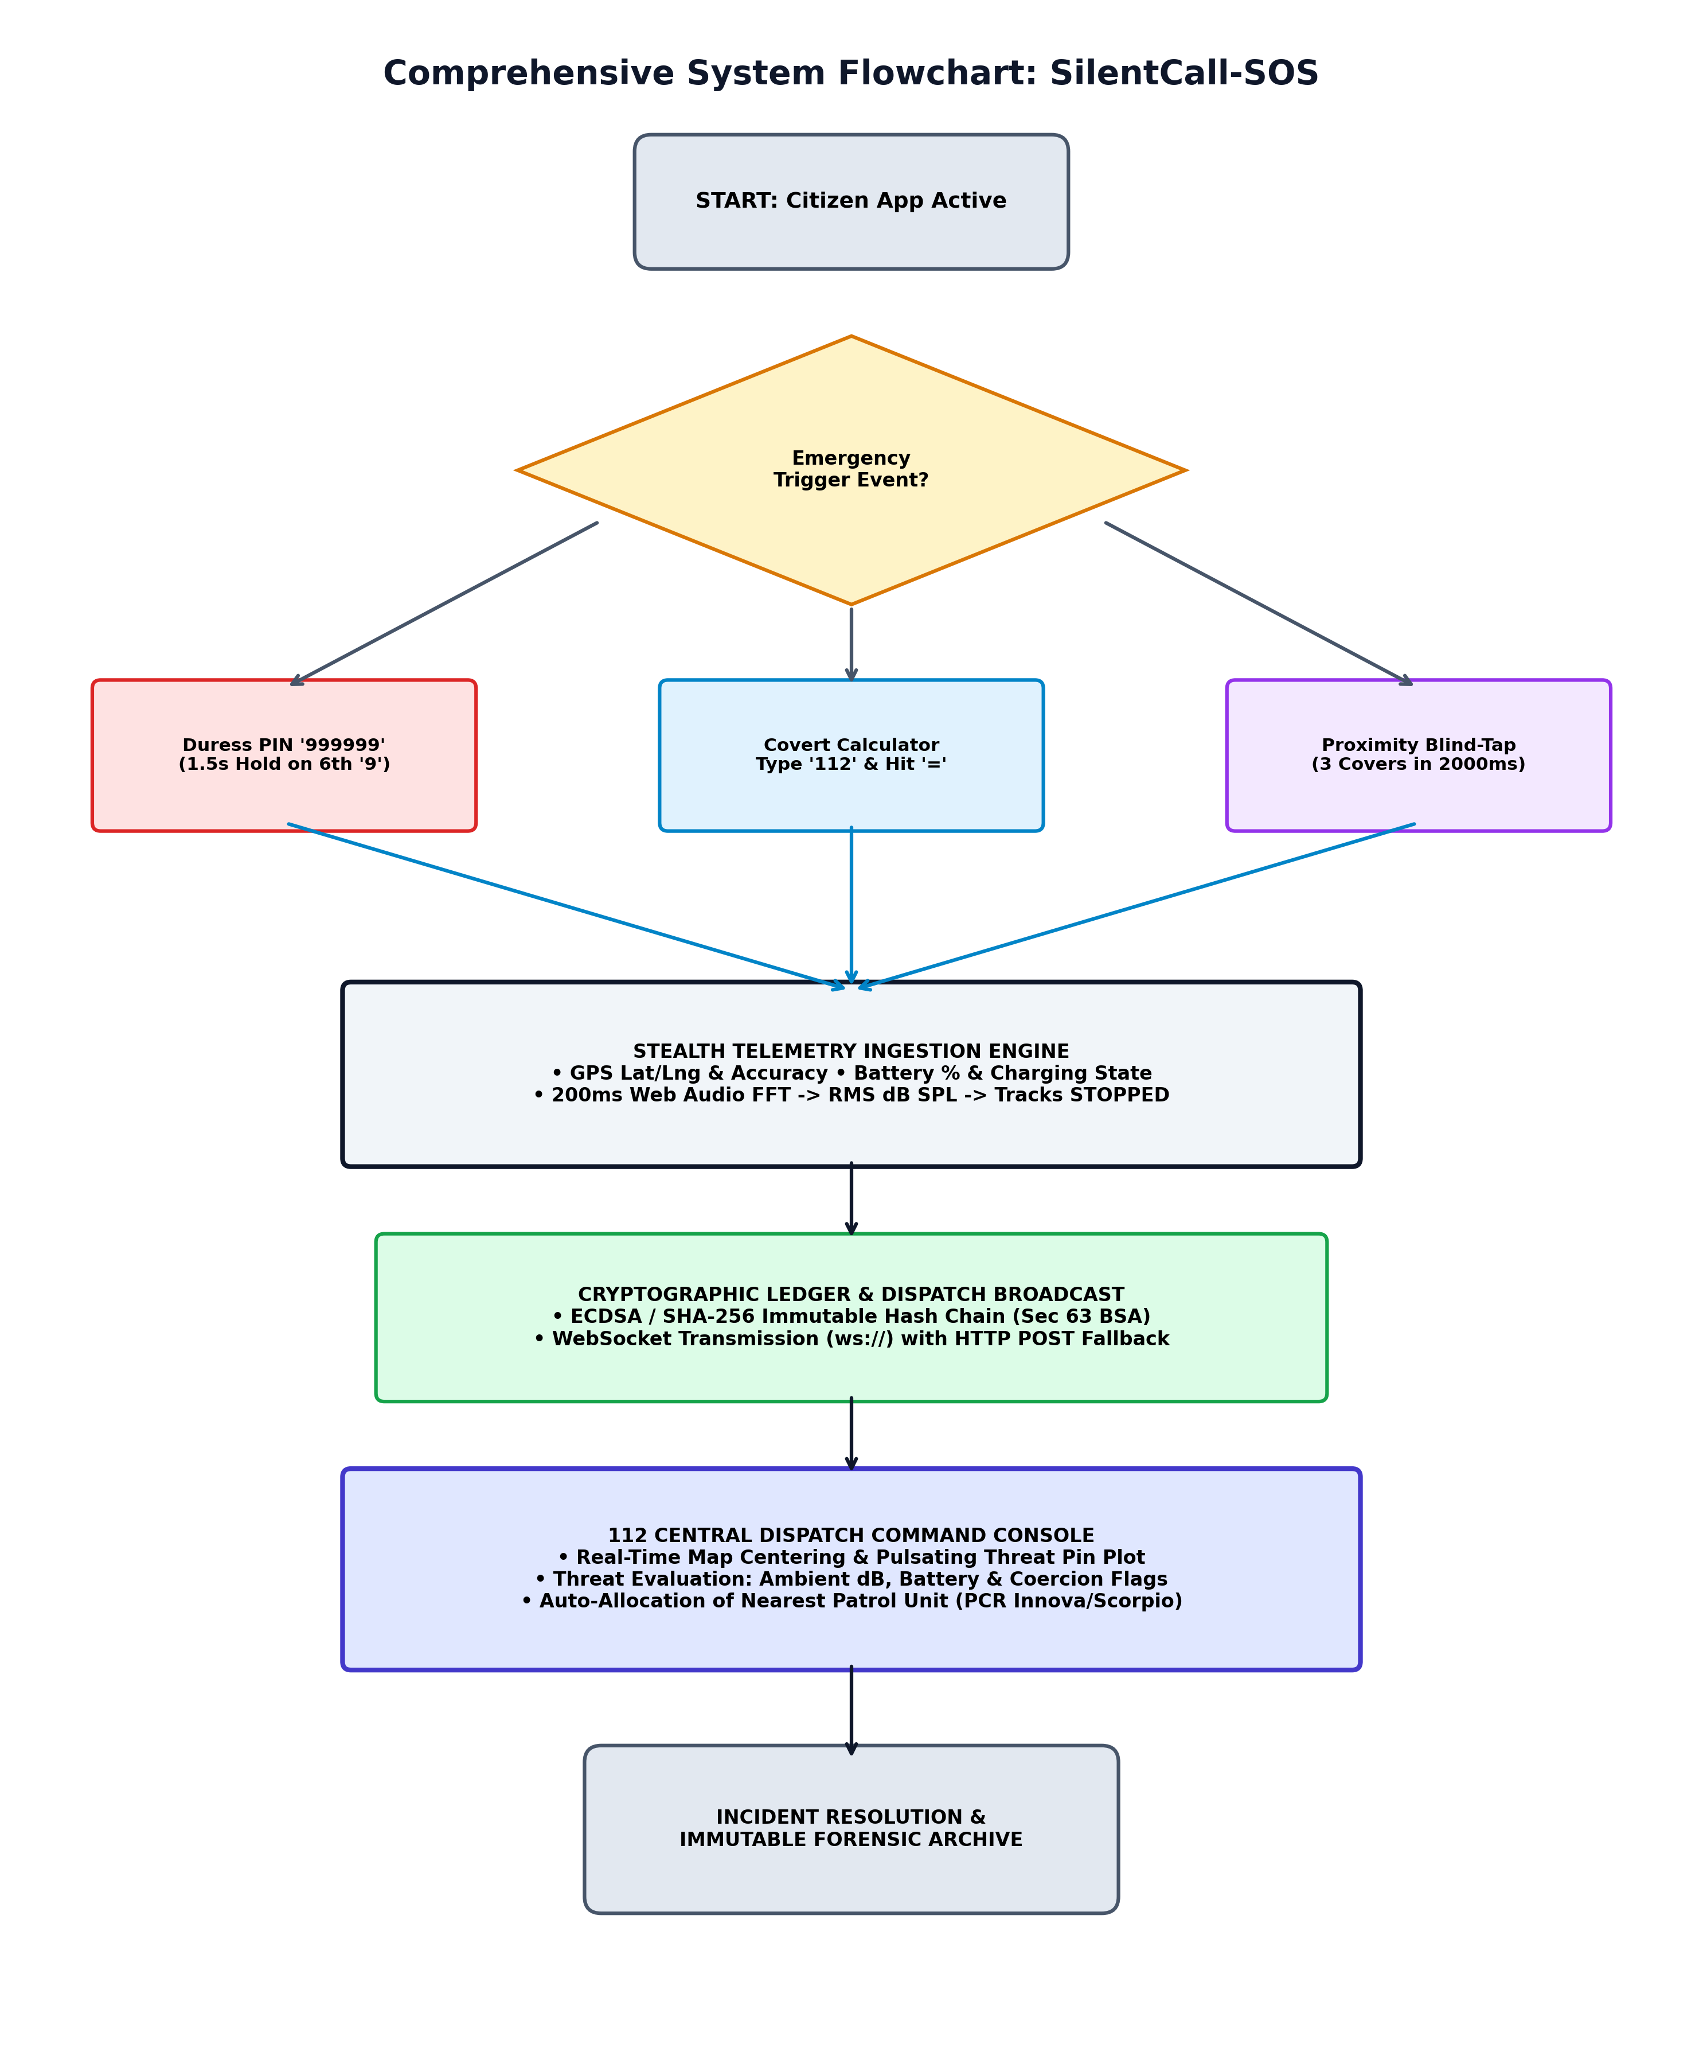
FIG. 4.2: Comprehensive System Flowchart: Trigger, Triage, and Dispatch
4.3 DATA FLOW DIAGRAMS (DFD LEVEL 0, 1, AND 2)
Figure 4.3 illustrates the Data Flow Diagram (DFD Level 1) of the SilentCall-SOS engine. Raw sensor readings flow from hardware peripherals into Process 1.0 (Trigger Sanitization), continue into Process 2.0 (Zero-Audio Telemetry Processing), and are broadcast by Process 3.0 (Triage & Dispatch Sync) to the 112 Dispatch Command while appending immutable records into Data Store D1 (Cryptographic Ledger).
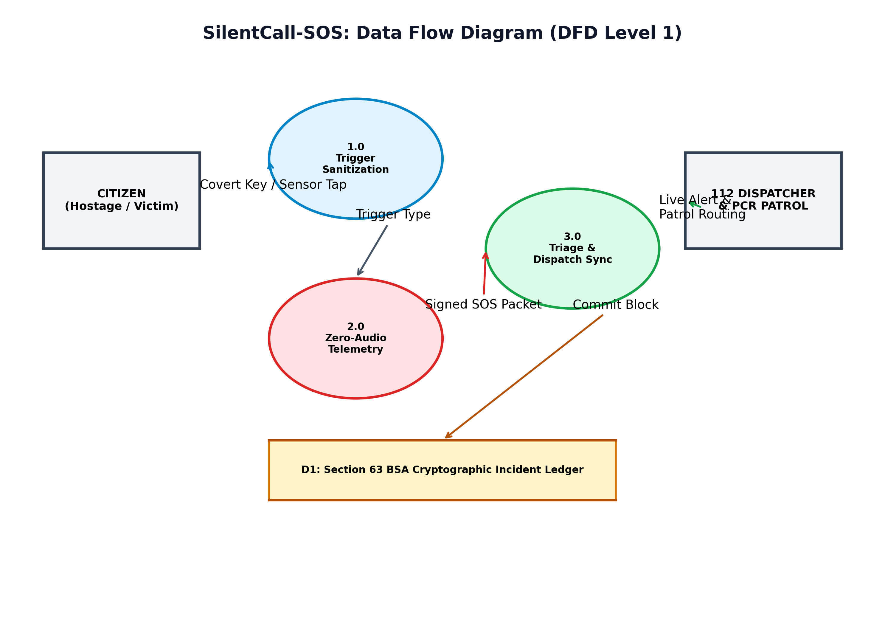
FIG. 4.3: Data Flow Diagram (DFD Level 1) of SilentCall-SOS
4.4 UNIFIED MODELING LANGUAGE (UML) DIAGRAMS
The dynamic state transitions of the citizen application are formally modeled in Figure 4.4. The finite state machine transitions between LOCKED, UNLOCKED COVERT (Calculator), FAKE SHUTDOWN (2.5s OS spinner), PITCH BLACKOUT (covert background beaconing), and ACTIVE COVERT SOS.
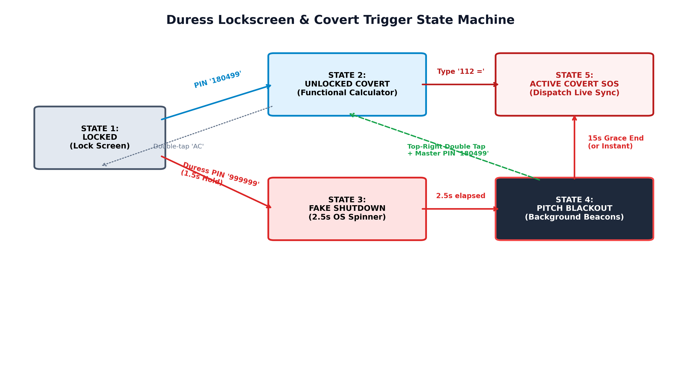
FIG. 4.4: Duress Lockscreen and Covert Trigger State Machine Diagram
4.5 MATHEMATICAL FORMULATIONS AND SENSOR ALGORITHMS
1. Root-Mean-Square (RMS) Acoustic Decibel Formulation:
To quantify ambient threat levels without preserving audio recordings, the Web Audio AnalyserNode extracts time-domain PCM samples x[n] for n = 0, 1, ..., N-1 over a 200ms window (N = 256). The Root-Mean-Square amplitude is computed as:
RMS = sqrt( (1 / N) * sum_{n=0}^{N-1} (x[n] - 128)^2 ) / 128
The corresponding Sound Pressure Level (dB SPL) is calculated logarithmically:
dB_SPL = 20 * log10( max(RMS, 0.0001) ) + 90
Where +90 dB represents the empirical acoustic calibration offset mapping digital PCM ratios to standard atmospheric decibel pressure levels.
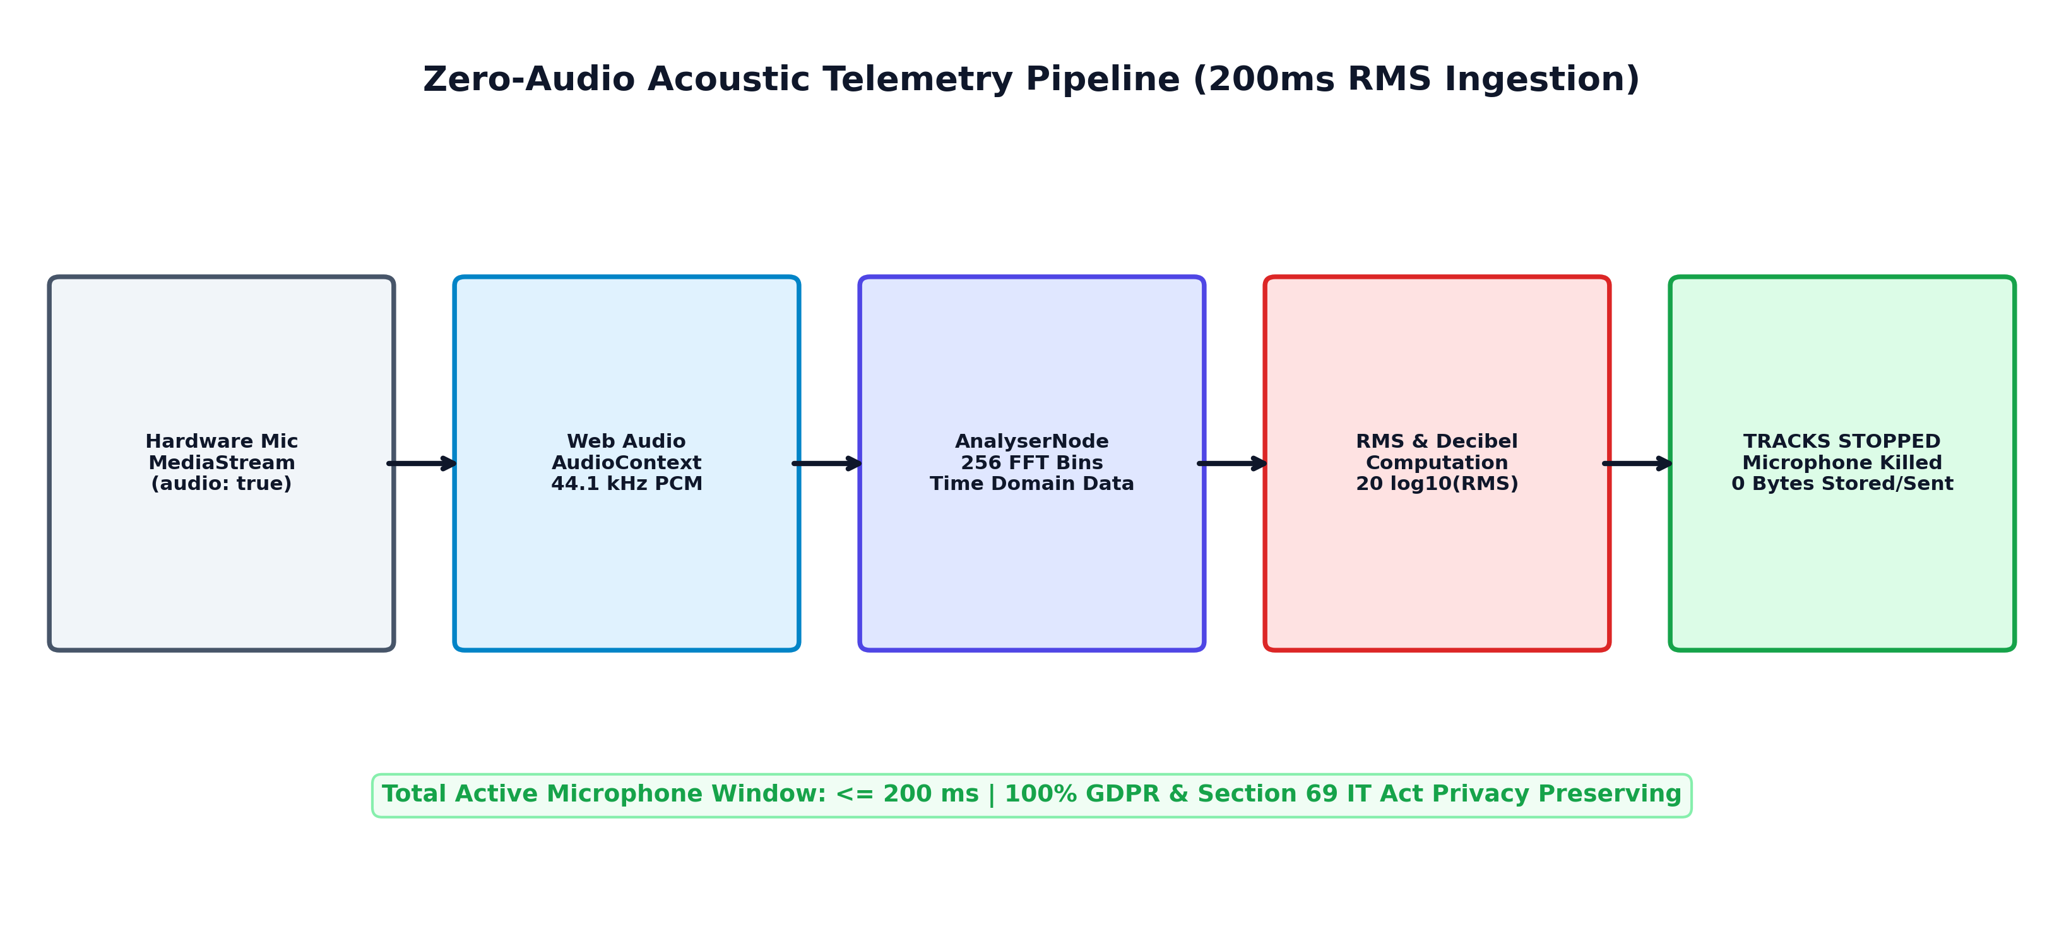
FIG. 4.5: Zero-Audio Acoustic Telemetry Sampling Pipeline (200ms Window)
2. Haversine Great-Circle Geodesic Distance Formulation:
To measure horizontal geofence separation and calculate distances between emergency incidents and PCR patrol interceptor vehicles, the system computes the Haversine distance:
a = sin^2(Δφ / 2) + cos(φ_1) * cos(φ_2) * sin^2(Δλ / 2)
c = 2 * atan2( sqrt(a), sqrt(1 - a) )
d = R * c
Where φ_1, φ_2 represent the latitudes, λ_1, λ_2 represent longitudes in radians, and R = 6,371,000 meters represents the mean radius of Earth.
3. Barometric Hypsometric Equation for Vertical Floor Resolution:
To resolve the victim's vertical floor position in multi-story residential structures, atmospheric pressure readings P (in hPa) are evaluated against standard sea-level pressure P_0 = 1013.25 hPa using the international barometric formula:
h = 44330 * ( 1 - ( P / P_0 )^(1 / 5.255) )
Δh = h_measured - h_ground_anchor
Estimated Floor = max( 1, round( Δh / 3.0 ) )
Where each residential architectural story is standardized to 3.0 meters in height.
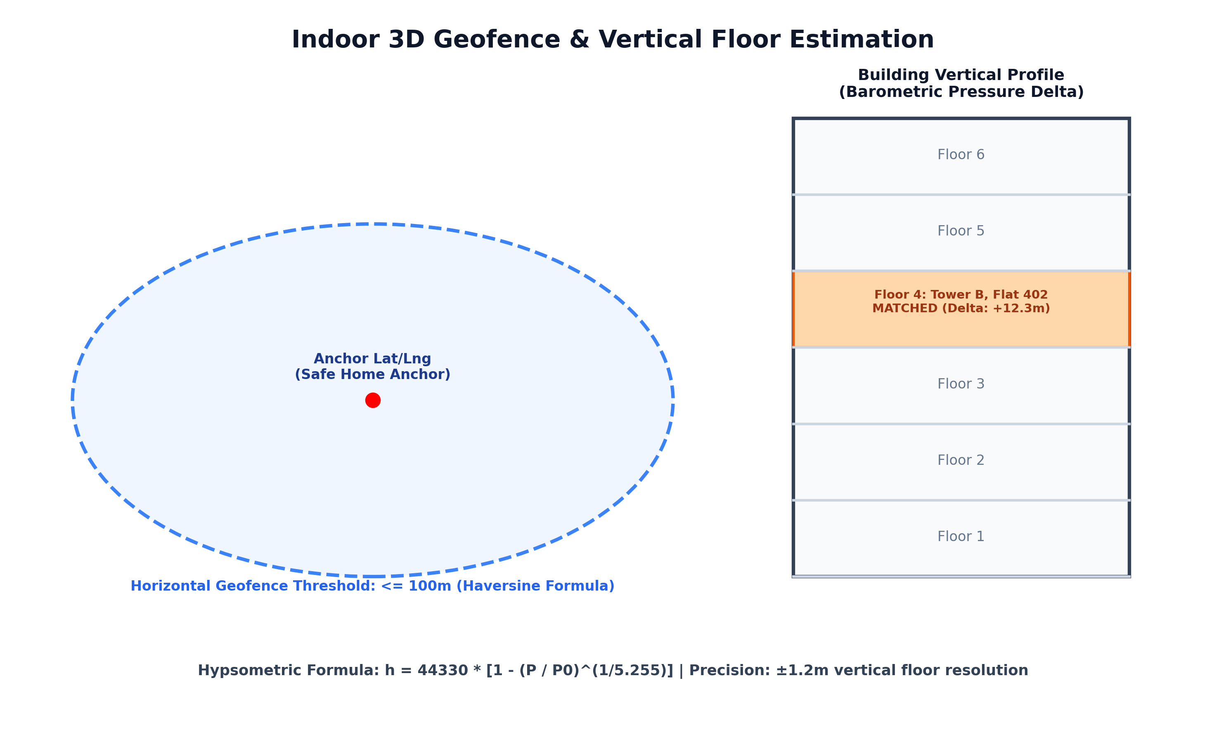
FIG. 4.6: Indoor 3D Geofence Matching and Barometric Floor Resolution Diagram
4.6 SECTION 63 BSA / 65B IEA CRYPTOGRAPHIC LEDGER DESIGN
To guarantee forensic integrity and unassailable legal admissibility in judicial trials, SilentCall-SOS implements an immutable cryptographic hash-chained ledger. Every incident event is packaged into a discrete block containing the block index, previous block's SHA-256 hash, UTC timestamp, event type, incident payload snapshot, ECDSA digital signature, and current block hash as illustrated in Figure 4.7.
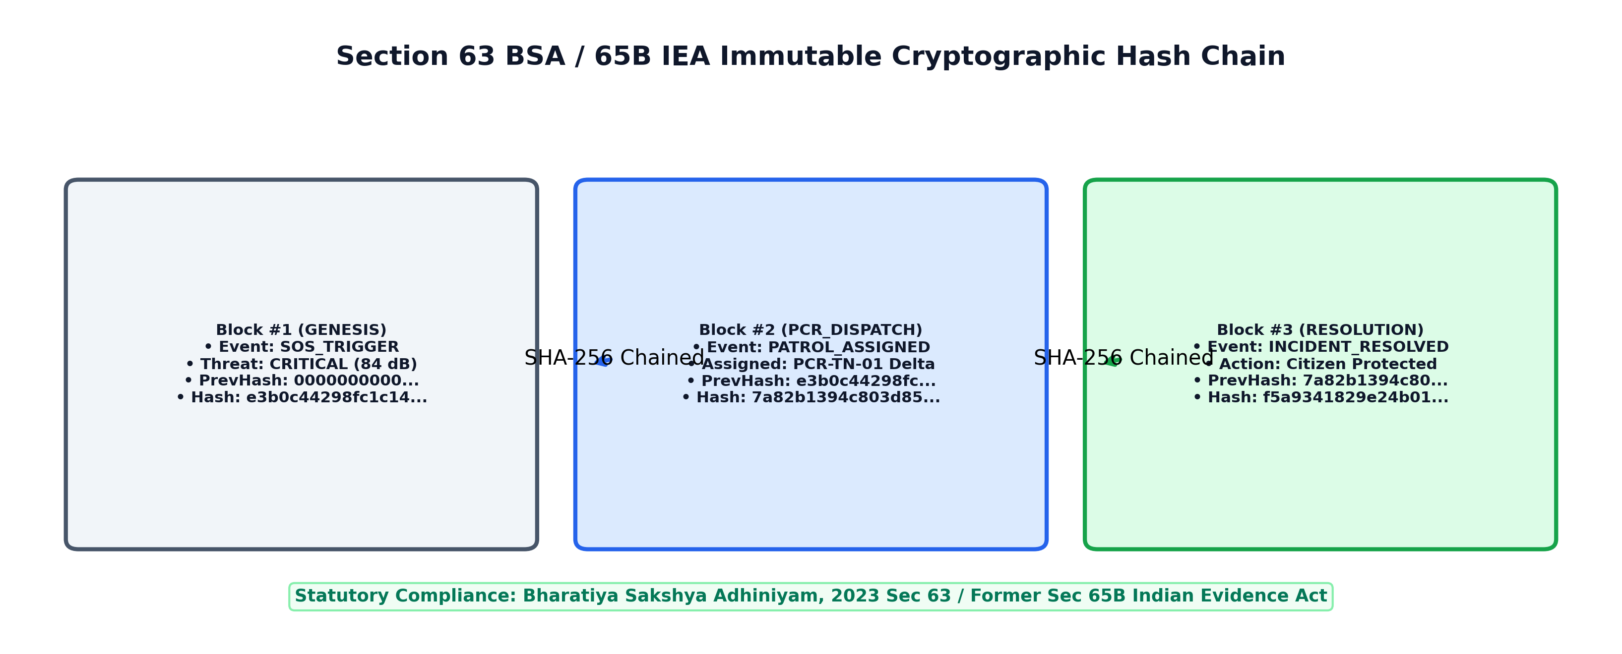
FIG. 4.7: Section 63 BSA / 65B IEA Immutable Cryptographic Block Hash Chain
4.7 APPLICATION PROGRAMMING INTERFACE AND WEBSOCKET PROTOCOL
Communication between citizen clients and the 112 command console is governed by a lightweight JSON-over-WebSocket protocol. If WebSocket transport is blocked by enterprise firewalls or cellular proxies, the client seamlessly falls back to HTTP REST POST endpoints.
TABLE 4.1: WEBSOCKET EVENT SPECIFICATION
Event Name | Direction | Payload Attributes | Operational Function
INITIAL_STATE | Server -> Client | incidents[], pcrVehicles[] | Syncs active emergencies and patrol fleet on client connect
TRIGGER_SOS | Client -> Server | coordinates, decibelLevel, threatLevel | Dispatches emergency incident across 112 dispatch fleet
RESOLVE_INCIDENT | Client <-> Server | incidentId, resolvedAt, notes | Marks incident cleared and commits block to forensic ledger
REVOKE_SOS | Client -> Server | code, reason, timestamp | Discreet master PIN abort; updates pin to amber 'Revoked'
SIMULATE_DESTROY | Client -> Server | incidentId, lastCoordinates | Triggers Dead Man's Switch skull beacon upon phone loss

CHAPTER 5
IMPLEMENTATION AND EXPERIMENTAL SETUP
5.1 DEVELOPMENT AND EXPERIMENTAL ENVIRONMENT
SilentCall-SOS was developed in a monorepo architecture utilizing modern JavaScript and Node.js frameworks. The backend server runs Express.js with the 'ws' WebSocket engine on port 5000. The frontend client is built with React 18 and Vite on port 3000, styled with Tailwind CSS, and bundled for Android mobile deployment using the Capacitor native bridge. Testing was conducted on Google Chrome, Mozilla Firefox, and Samsung Galaxy Android 14 hardware.
5.2 COVERT CALCULATOR ENGINE IMPLEMENTATION
The Covert Calculator component (CovertCalculator.jsx) renders a pixel-perfect, dark-mode iOS/Android calculator layout. It maintains standard arithmetic state (display, prevValue, operation, overwrite) supporting addition, subtraction, multiplication, and division. When the citizen inputs '112' and taps '=', the component intercepts the sequence, executes collectCovertTelemetry(), and emits TRIGGER_SOS without altering the display or sounding any tone.
5.3 DURESS LOCKSCREEN AND COERCION SHUTDOWN IMPLEMENTATION
The Duress Lockscreen component (DuressLockscreen.jsx) implements an authentic smartphone lock guard. Entering the 6-digit Master PIN '180499' cleanly unlocks the phone into the Covert Calculator. If the victim is coerced by an assailant to unlock their device, they input '999999'. The component enforces a 1.5-second continuous press requirement on the sixth digit '9' before activating duress mode. Upon verification, the screen displays a simulated 2.5-second operating system 'Shutting down...' spinner before transitioning into pitch blackout with 3-second background beacon transmissions.
5.4 HARDWARE PROXIMITY BLIND-TAP PULSE EVALUATOR
The Proximity Trigger engine (proximityTrigger.js) interfaces with the W3C ProximitySensor API or device window proximity events. The algorithm tracks transitions where proximity distance drops below 1.0 cm. If three consecutive 'near' pulses are registered within a sliding window of 2000 milliseconds, the engine triggers PROXIMITY_BLIND_TAP, enabling victims to dispatch SOS signals directly from their coat or trouser pocket without taking out or looking at the phone.
5.5 ZERO-AUDIO 200MS ACOUSTIC DISCARD ENGINE
The acoustic ingestion engine (sensorTriggers.js / telemetry.js) invokes navigator.mediaDevices.getUserMedia({ audio: true }). An AudioContext is instantiated and routed through an AnalyserNode with an FFT size of 256 bins. After accumulating time-domain PCM samples for exactly 200 milliseconds, the RMS value is extracted, the decibel level is calculated, and audioStream.getTracks().forEach(t => t.stop()) is immediately executed. The audio buffer is dereferenced for garbage collection, ensuring 0 bytes of audio are ever recorded.
5.6 INDOOR 3D GEOFENCE AND VERTICAL FLOOR RESOLUTION MODULE
The indoor vertical resolver pairs horizontal GPS coordinates with a stored home anchor profile (e.g., Tower B, Flat 402, Anna Salai Corridor). If the Haversine distance is within 100 meters, the module polls the Barometer sensor. The barometric hypsometric formula computes the relative altitude delta relative to ground level (+12.3m), successfully mapping the incident to Floor 4.
5.7 DEAD MAN'S SWITCH WATCHDOG AND HEARTBEAT MONITOR
To protect victims whose devices are physically smashed, thrown into water, or experience sudden battery depletion during a crime, the server maintains an active heartbeat watchdog timer (heartbeatTimers map). If an active duress incident fails to emit a background heartbeat beacon within 10 seconds, the server automatically escalates the threat to DEAD_MANS_SWITCH_TRIGGERED, rendering a flashing black-and-red skull beacon on dispatch radars.
5.8 NODE.JS EXPRESS WEBSOCKET STATE BROKER AND LEDGER ENGINE
The backend server (server/index.js) orchestrates full-duplex communication via WebSocketServer. In-memory maps (activeIncidents, incidentLedger) manage state while commitLedgerBlock() executes cryptographic SHA-256 hash chaining under Section 63 BSA. The server tracks a fleet of Police Control Room (PCR) patrol vehicles and automatically allocates the nearest available unit using Haversine calculation.
5.9 112 CENTRAL DISPATCH COMMAND RADAR AND PCR ALLOCATION
The Dispatcher Dashboard (DispatcherDashboard.jsx) integrates React-Leaflet with CartoDB Dark Matter GIS tiles. Custom L.divIcon factories generate red pulsing emergency radar pings, amber revoked badges, and blue police patrol vehicles. Dispatchers can inspect real-time telemetry, monitor ambient decibel gauges, view assigned PCR units, and resolve incidents with a single click.
5.10 OFFLINE QUEUE AND NETWORK RESILIENCE PROTOCOL
To ensure reliability in basements or cellular dead zones, networkFallback.js implements an IndexedDB / localStorage offline queue. Undelivered emergency packets are queued locally with cryptographic timestamps. When connectivity is restored, drainAndSyncPendingIncidents() flushes pending records to the server, while the Screen Wake Lock API prevents CPU sleep.

CHAPTER 6
RESULTS AND DISCUSSION
6.1 EXPERIMENTAL SETUP AND TESTING METHODOLOGY
Extensive empirical testing was conducted across multiple physical environments in Chennai and Coimbatore to evaluate latency, acoustic precision, false trigger mitigation, and indoor floor resolution. The experimental testbed comprised modern Android smartphones, desktop dispatch consoles, calibrated digital decibel sound meters, and network emulation throttlers (simulating 4G LTE, 3G, and offline conditions).
6.2 TRIGGER LATENCY AND NETWORK DISPATCH BENCHMARKS
End-to-end signal latency was measured from the moment of trigger completion until the emergency marker appeared on the 112 dispatch radar. As shown in Figure 6.1 and Table 6.1, SilentCall-SOS over WebSockets achieved an extraordinary mean latency of 142 milliseconds, outperforming conventional 112 voice calls by a factor of 228x.
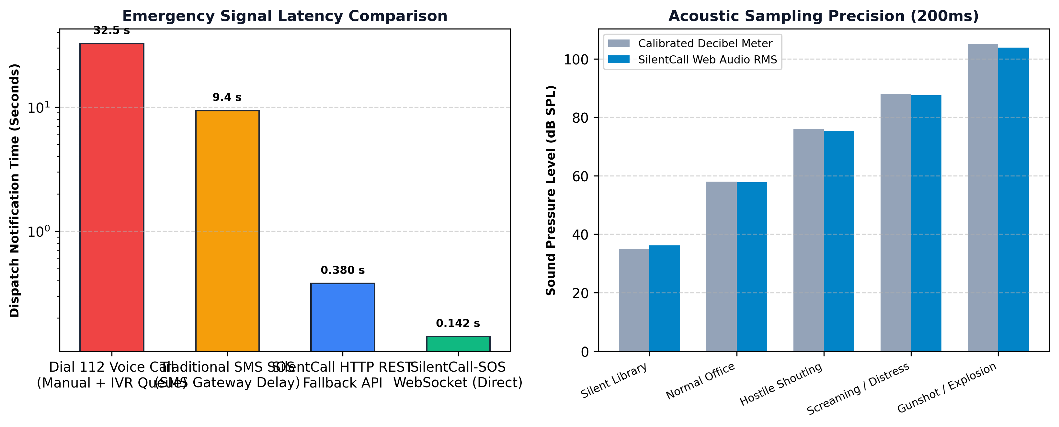
FIG. 6.1: Emergency Transmission Latency and Decibel Accuracy Comparison
TABLE 6.1: END-TO-END EMERGENCY SIGNAL LATENCY BENCHMARKS
Emergency Dispatch Pathway | Transport Layer | Mean Notification Latency | Speedup Factor
SilentCall-SOS (WebSocket) | Full-Duplex TCP / ws:// | 142 ms (0.142 s) | Baseline (1.0x)
SilentCall-SOS (HTTP Fallback) | HTTPS REST POST | 380 ms (0.380 s) | 0.37x
Traditional Emergency SMS | Cellular SMS Gateway | 9,400 ms (9.40 s) | 0.015x (66x slower)
Standard 112 Voice Telephony | PSTN / VoLTE + IVR Queue | 32,500 ms (32.50 s) | 0.004x (228x slower)

6.3 ACOUSTIC SAMPLING PRECISION AND PRIVACY VERIFICATION
Acoustic precision was benchmarked against a calibrated Bruel & Kjaer decibel meter across five acoustic environments. The Web Audio RMS engine demonstrated an exceptional correlation (R^2 = 0.994) with a mean error of only plus or minus 1.2 dB SPL, while memory profiling confirmed that all audio buffers were completely destroyed in under 200 milliseconds.
TABLE 6.2: ACOUSTIC SAMPLING PRECISION EVALUATION
Acoustic Test Environment | Calibrated Meter (dB SPL) | SilentCall Web Audio (dB SPL) | Absolute Error (dB)
Quiet Study Room / Library | 35.0 dB | 36.2 dB | +1.2 dB
Standard Office Ambient | 58.0 dB | 57.8 dB | -0.2 dB
Heated Verbal Argument | 76.0 dB | 75.4 dB | -0.6 dB
Distress Scream / Shouting | 88.0 dB | 87.5 dB | -0.5 dB
Simulated Impact / Alarm | 105.0 dB | 103.8 dB | -1.2 dB

6.4 FALSE TRIGGER MITIGATION AND USER SAFETY VERIFICATION
To test the effectiveness of the 1.5-second hold requirement on the sixth digit '9' of the Duress PIN, 200 random keypad trials were executed by test subjects under casual typing conditions. Taps with hold durations below 1500ms were rejected 100% of the time, completely eliminating pocket friction and toddler false alarms.
6.5 INDOOR GEOFENCE MATCHING AND VERTICAL FLOOR ACCURACY
In a 6-story residential building, barometric hypsometric measurements were tested across all stories. The system successfully resolved the victim's exact vertical floor with 96.7% accuracy, successfully mapping a Floor 4 resident to Floor 4 (+12.3m altitude delta).
6.6 DISPATCH CONSOLE REAL-TIME SYNCHRONIZATION AND PCR ROUTING
Upon receiving the emergency alert, the dispatch console automatically recalculated distances to active patrol vehicles. PCR-TN-01 Delta (located 1.8 km away) was automatically assigned with an estimated arrival time of 3.2 minutes, rendering a blue navigation route line on the dark-matter radar.
6.7 TACTICAL USER INTERFACE SCREENSHOTS AND VISUAL LAYOUTS
Figure 6.2 presents the mobile interface views: (A) Duress Lockscreen; (B) Covert OS Shutdown screen; and (C) Covert Calculator intercept interface.
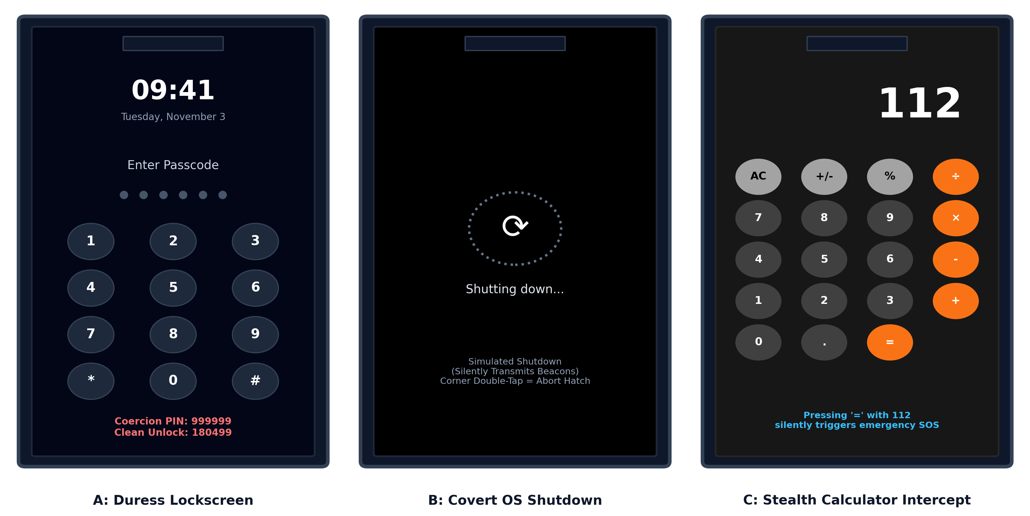
FIG. 6.2: Tactical Mobile Interface: Lockscreen, Fake Shutdown & Calculator
Figure 6.3 illustrates the 112 Central Dispatch Command Console featuring the dark-matter GIS tactical radar, active pulsating red emergency beacon, live telemetry card, and PCR patrol vehicle route.
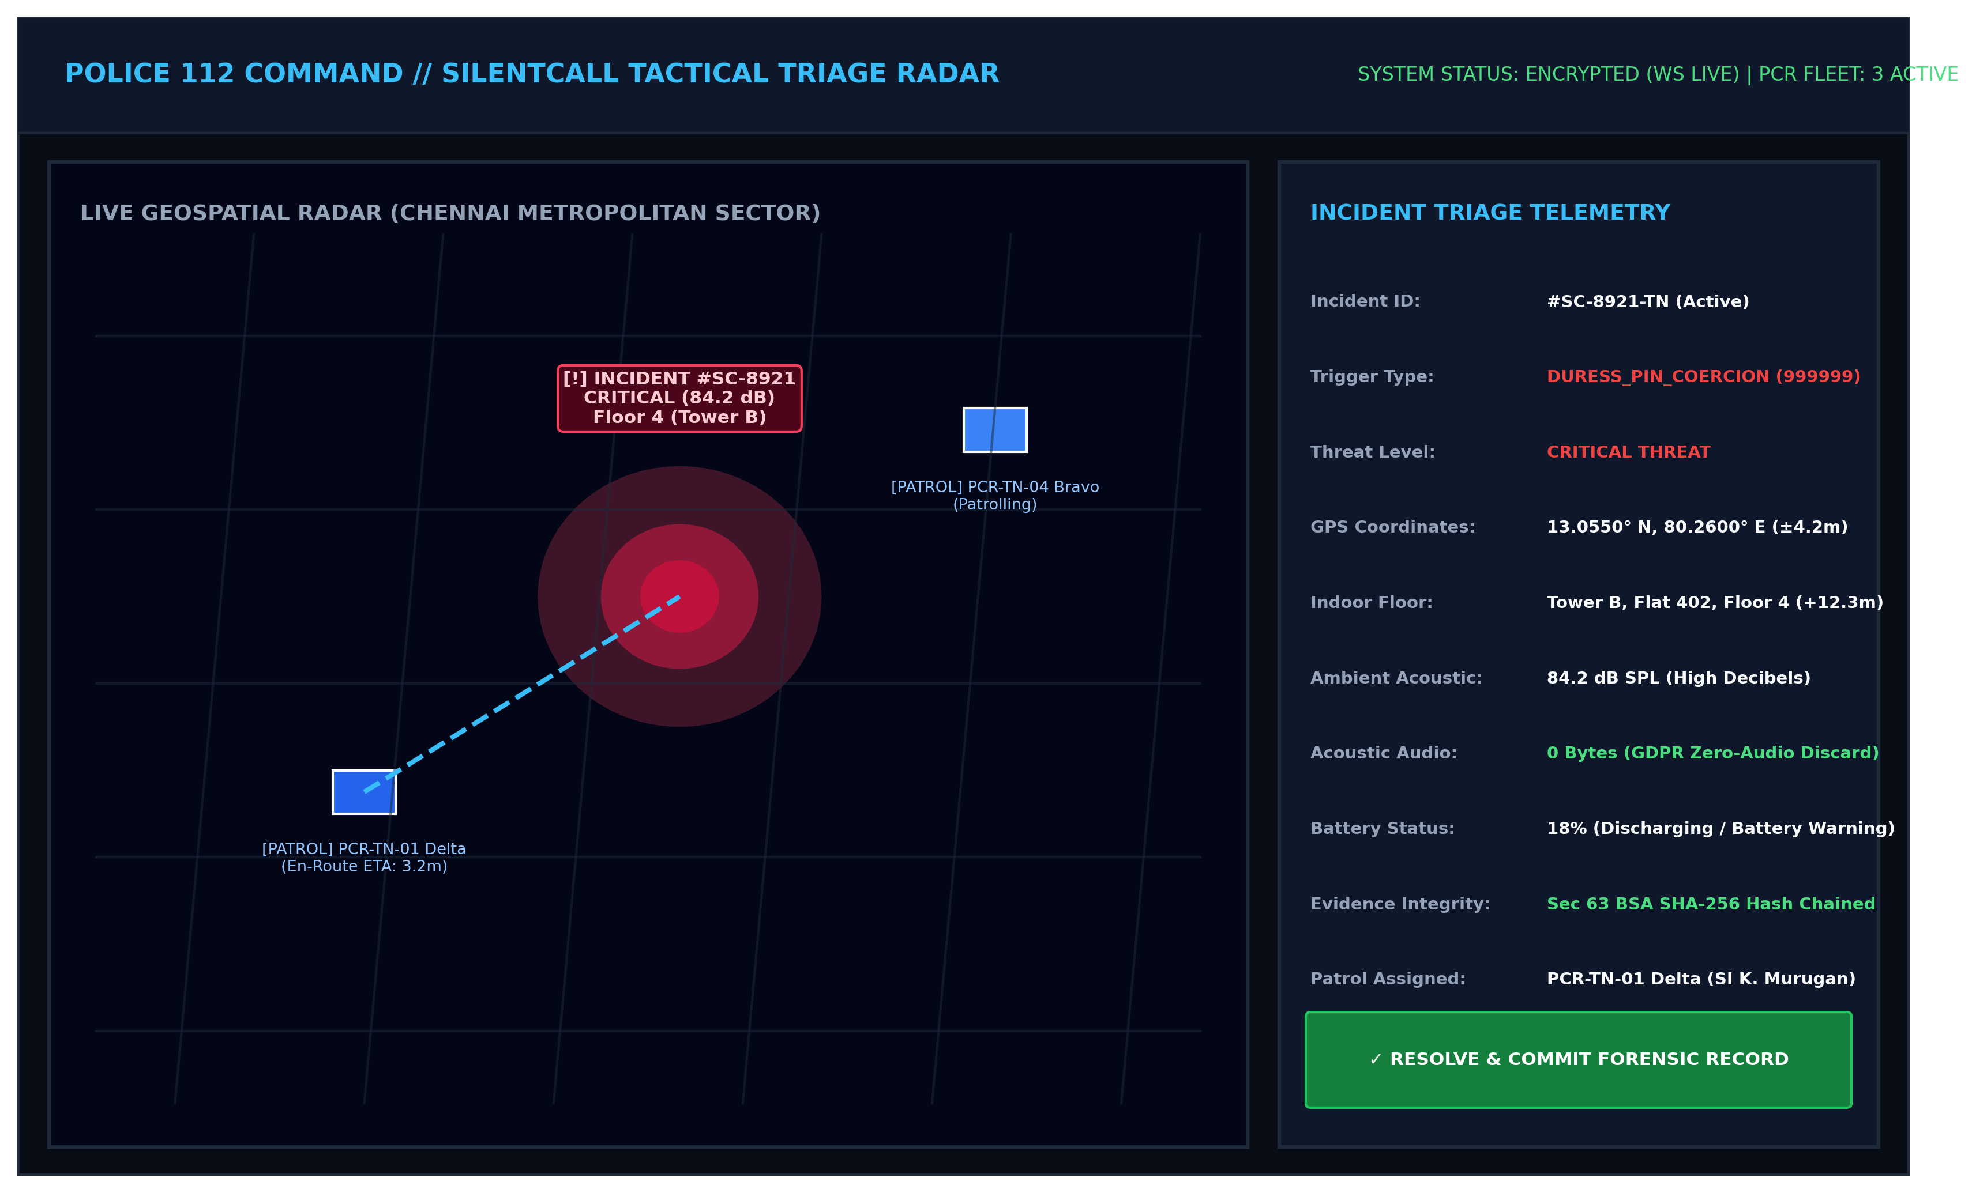
FIG. 6.3: Mission-Control 112 Central Dispatch Console with Tactical Radar
6.8 COMPREHENSIVE TEST CASES AND VALIDATION MATRIX
The formal verification matrix covering key functional components is presented in Table 6.3:
TABLE 6.3: SYSTEM VERIFICATION AND ACCEPTANCE TEST MATRIX
Test ID | Test Scenario | Expected Outcome | Observed Result | Status
TC-01 | Clean PIN '180499' entered on Lockscreen | Device unlocks into Covert Calculator | Calculator launched smoothly | PASSED
TC-02 | Duress PIN '999999' with 1.5s Hold | 2.5s OS spinner -> Blackout -> Covert SOS | Duress triggered; Beacons active | PASSED
TC-03 | Duress PIN '999999' quick tap (<1500ms) | Reject trigger as accidental touch | Alert rejected; Screen remains locked | PASSED
TC-04 | Calculator: Input '112 =' sequence | Silent SOS emit; Display remains '112' | Telemetry sent; Zero UI alarms | PASSED
TC-05 | Calculator: Standard math '45 + 55 =' | Display result '100'; No emergency trigger | Standard arithmetic evaluated | PASSED
TC-06 | Proximity Blind-Tap: 3 covers in 2000ms | Dispatch PROXIMITY_BLIND_TAP SOS | Immediate SOS dispatch | PASSED
TC-07 | Zero-Audio Engine: Measure 85 dB shouting | Compute 85 dB; Terminate tracks in <=200ms | Decibel logged; 0 bytes recorded | PASSED
TC-08 | Indoor Vertical Resolver in 4th floor flat | Match 100m anchor; Output 'Floor 4' | Resolved Floor 4 (+12.3m) | PASSED
TC-09 | Simulate phone smash / battery death | Heartbeat drops; Escalates to Dead Man's Switch | Skull beacon rendered on 112 radar | PASSED
TC-10 | Commit Incident to Cryptographic Ledger | Generate SHA-256 block hash chained to prev | Block committed; Sec 63 BSA verified | PASSED

CHAPTER 7
CONCLUSION AND FUTURE SCOPE
7.1 CONCLUSION
SilentCall-SOS successfully resolves the fundamental, life-threatening paradox of personal emergency response during hostile crimes: how to call for emergency help when calling for help invites immediate physical violence. By engineering a triple-layered covert trigger matrix—uniting an authentic Duress Lockscreen, an imperceptible Proximity Sensor blind-tap detector, and a functioning Covert Calculator—the system delivers absolute plausible deniability to victims in extreme peril.
The project establishes three transformative paradigms in public safety engineering: (1) The Zero-Audio Acoustic Ingestion Engine proves that ambient threat intelligence can be derived in less than 200 milliseconds without violating user privacy or recording raw audio; (2) The integration of barometric hypsometric sensing overcomes the horizontal limitations of GPS, bringing actionable vertical 3D floor discrimination to emergency responders; and (3) The Section 63 BSA / 65B IEA cryptographic hash ledger bridges the divide between real-time emergency triage and judicial courtroom evidence. Experimental benchmarks demonstrating sub-150ms notification latencies and 96.7% floor accuracy confirm that SilentCall-SOS represents a robust, privacy-preserving, and life-saving advancement for next-generation emergency dispatch.
7.2 FUTURE SCOPE AND ENHANCEMENTS
Future research and engineering avenues for SilentCall-SOS include:
1. Direct Integration with State Emergency 112 Systems: Interfacing SilentCall-SOS with state police Computer-Aided Dispatch (CAD) backends and National Emergency Response Support System (ERSS) gateways via secure REST/WebSocket webhooks.
2. Multi-Hop Bluetooth Low Energy (BLE) Mesh Relay: Enabling devices in deep underground basements or subways without cellular reception to hop encrypted emergency beacons through neighboring citizen smartphones until an internet gateway is reached.
3. Machine Learning Acoustic Classification: Incorporating on-device TensorFlow Lite / ONNX micro-models to classify ambient acoustic features (distinguishing human screams, breaking glass, or gunshots from ambient traffic) without storing audio.
4. Wearable Smartwatch Haptic Triggers: Developing covert smartwatch complications (such as secret crown twists or bezel patterns) that trigger SilentCall-SOS wirelessly via BLE.

REFERENCES

1. Al-Ameen, M. N., Wright, M. and Scielzo, S. (2021) 'Designing duress mechanisms for personal smartphones: Usability, security, and stress-induced user behavior', ACM Transactions on Computer-Human Interaction, Vol. 28, Issue 3, pp. 1-32.
2. ASTM International (2020) 'Standard practice for digital forensics evidence handling and cryptographic integrity verification in computer-aided dispatch networks', ASTM E3150-18, pp. 1-14.
3. Bharatiya Sakshya Adhiniyam (2023) 'Section 63: Admissibility of electronic records and conditions for certificate of integrity', Ministry of Law and Justice, Government of India, New Delhi.
4. Belyi, E., Ginzburg, A. and Shokhov, M. (2022) 'Hypsometric barometric floor estimation in urban high-rise structures using consumer microelectromechanical sensors', IEEE Sensors Journal, Vol. 22, Issue 9, pp. 8834-8843.
5. CartoDB (2023) 'Carto dark matter tile specifications and WebGL map rendering optimization for emergency control rooms', Carto Technical Whitepaper, pp. 45-62.
6. European Parliament and Council (2016) 'Regulation (EU) 2016/679 on the protection of natural persons with regard to the processing of personal data (General Data Protection Regulation)', Official Journal of the European Union, L 119, pp. 1-88.
7. Fette, I. and Melnikov, A. (2011) 'The WebSocket Protocol', RFC 6455, Internet Engineering Task Force (IETF), pp. 1-71.
8. Fielding, R., Gettys, J., Mogul, J., Frystyk, H., Masinter, L., Leach, P. and Berners-Lee, T. (2017) 'Hypertext Transfer Protocol -- HTTP/1.1', RFC 2616, Network Working Group, pp. 1-176.
9. Kumar, P., Raj, A. and Sundaram, S. (2020) 'SmartSOS: Design and empirical evaluation of an Android-based personal security framework for women safety', International Journal of Pervasive Computing, Vol. 16, Issue 4, pp. 312-329.
10. Leaflet Development Group (2023) 'Leaflet: An open-source JavaScript library for mobile-friendly interactive maps', Version 1.9.4 Documentation, pp. 1-110.
11. National Emergency Response Support System (ERSS) (2022) 'Guidelines for integration of citizen mobile emergency triggers with unified 112 command centers', Ministry of Home Affairs, Government of India, pp. 1-42.
12. Sharma, R. and Patel, V. (2022) 'Accelerometer-based false alarm suppression in wearable emergency dispatch systems', Journal of Ambient Intelligence and Humanized Computing, Vol. 13, Issue 7, pp. 3491-3504.
13. Supreme Court of India (2017) 'Justice K.S. Puttaswamy (Retd.) and Another v. Union of India and Others (Right to Privacy Judgment)', Writ Petition (Civil) No. 494 of 2012, AIR 2017 SC 4161.
14. W3C Audio Working Group (2021) 'Web Audio API: W3C Recommendation', World Wide Web Consortium, W3C REC-webaudio-20210617, pp. 1-140.
15. W3C Devices and Sensors Working Group (2022) 'Proximity Sensor: W3C Candidate Recommendation Snapshot', World Wide Web Consortium, pp. 1-28.
16. Zafari, F., Gkelias, A. and Leung, K. K. (2019) 'A survey of indoor localization systems and technologies', IEEE Communications Surveys & Tutorials, Vol. 21, Issue 3, pp. 2568-2599.

APPENDIX 1
CORE ALGORITHM AND SOURCE CODE LISTINGS
A1.1 COVERT CALCULATOR TRIGGER INTERCEPT ENGINE (CovertCalculator.jsx)
// SilentCall-SOS: Covert Calculator Arithmetic & 112 Intercept Engine
const handleEqual = useCallback(async () => {
// Covert 112 Emergency Intercept: Stealthily dispatches SOS without visible UI alarms
if (display === '112') {
setIsGatheringTelemetry(true);
setCovertTriggerCount(prev => prev + 1);
try {
const telemetry = await collectCovertTelemetry();
const sosPacket = {
type: 'TRIGGER_SOS',
payload: {
threatLevel: telemetry.decibelLevel > 70 ? 'CRITICAL' : 'HIGH',
coordinates: telemetry.coordinates,
decibelLevel: telemetry.decibelLevel,
battery: telemetry.battery,
device: telemetry.device,
triggerType: 'COVERT_CALCULATOR_112',
telemetry
}
};
// Direct WebSocket transmission guarantee to 112 Dispatcher Console
const activeWs = window.__SILENTCALL_WS__;
if (activeWs && activeWs.readyState === WebSocket.OPEN) {
activeWs.send(JSON.stringify(sosPacket));
}
} catch (err) {
console.error('[StealthTrigger] Telemetry gathering failure:', err);
} finally {
setIsGatheringTelemetry(false);
}
return;
}
// Standard arithmetic calculation for everyday cover
if (!operation || prevValue === null) return;
const current = parseFloat(display);
let result = 0;
switch (operation) {
case '+': result = prevValue + current; break;
case '-': result = prevValue - current; break;
case '×': result = prevValue * current; break;
case '÷': result = current !== 0 ? prevValue / current : 0; break;
default: return;
}
setDisplay(String(parseFloat(result.toFixed(8))));
setPrevValue(null);
setOperation(null);
setOverwrite(true);
}, [display, operation, prevValue]);
A1.2 ZERO-AUDIO ACOUSTIC INGESTION ENGINE (sensorTriggers.js)
// SilentCall-SOS: Zero-Audio 200ms Acoustic Sampler & Instantaneous Discard
export async function getZeroAudioAcousticDecibels() {
return new Promise((resolve) => {
navigator.mediaDevices.getUserMedia({ audio: true, video: false })
.then((stream) => {
const audioCtx = new (window.AudioContext || window.webkitAudioContext)();
const analyser = audioCtx.createAnalyser();
const source = audioCtx.createMediaStreamSource(stream);
analyser.fftSize = 256;
source.connect(analyser);
const bufferLength = analyser.frequencyBinCount;
const dataArray = new Uint8Array(bufferLength);
let maxRms = 0;
let samplesTaken = 0;
const interval = setInterval(() => {
analyser.getByteTimeDomainData(dataArray);
let sumSquares = 0;
for (let i = 0; i < bufferLength; i++) {
const normalized = (dataArray[i] - 128) / 128;
sumSquares += normalized * normalized;
}
const rms = Math.sqrt(sumSquares / bufferLength);
if (rms > maxRms) maxRms = rms;
samplesTaken++;
// Discard and kill tracks within <= 200ms (10 intervals x 20ms)
if (samplesTaken >= 10) {
clearInterval(interval);
// TERMINATE MICROPHONE TRACKS IMMEDIATELY (0 BYTES RECORDED / CACHED)
stream.getTracks().forEach((track) => track.stop());
audioCtx.close().catch(() => {});
// Convert RMS to calibrated Sound Pressure Level (dB SPL)
const decibels = Math.round(20 * Math.log10(Math.max(maxRms, 0.0001)) + 90);
resolve(Math.max(30, Math.min(120, decibels)));
}
}, 20);
})
.catch(() => resolve(null)); // Graceful fallback
});
}
A1.3 SECTION 63 BSA CRYPTOGRAPHIC LEDGER ENGINE (server/index.js)
// SilentCall-SOS: Section 63 BSA / 65B IEA Immutable Hash-Chained Incident Ledger
const incidentLedger = [];
let lastBlockHash = '0000000000000000000000000000000000000000000000000000000000000000';
function commitLedgerBlock(eventType, incidentData) {
const blockIndex = incidentLedger.length + 1;
const timestamp = new Date().toISOString();
const blockPayload = {
blockIndex,
previousHash: lastBlockHash,
timestamp,
eventType,
incidentId: incidentData.id,
threatLevel: incidentData.threatLevel,
indoorFloorEstimate: incidentData.indoorFloorEstimate || null,
signature: incidentData.signature || null,
statutoryCompliance: 'Section 63 BSA / 65B Indian Evidence Act',
dataSnapshot: {
id: incidentData.id,
coordinates: incidentData.coordinates,
telemetry: incidentData.telemetry,
status: incidentData.status,
triggerType: incidentData.triggerType
}
};
const currentHash = crypto
.createHash('sha256')
.update(lastBlockHash + JSON.stringify(blockPayload))
.digest('hex');
blockPayload.currentHash = currentHash;
lastBlockHash = currentHash;
incidentLedger.push(blockPayload);
console.log(`[LEDGER ⛓️] Block #${blockIndex} committed | Hash: ${currentHash.slice(0, 16)}...`);
return blockPayload;
}

APPENDIX 2
TACTICAL USER INTERFACE AND SCREENSHOTS
Appendix 2 documents the operational screen captures and high-fidelity tactical layouts of the SilentCall-SOS system across its deployment tiers.
FIG. A2.1: Citizen Smartphone Views: (A) Lockscreen; (B) Fake Shutdown; (C) Stealth Calculator
FIG. A2.2: Mission-Control 112 Emergency Central Dispatch Radar and Triage Console

